Abstract title (iEMSs Abstract title style)
Jane Author ª , Peter Author2 ^{b} , Sarah-Jane Author3 ^{c} (iEMSs Authors style, corresponding author underlined. Update the ORCiD badge link with that for the author - if an author does not have an ORCiD number, delete the badge)
(a) Affiliation 1 and country
(b) Affiliation 2 and country
(c) Affiliation 3 and country
(iEMSs Affiliation style, new line for each if space allows, otherwise separated by semicolon, if all authors are from same organisation, do not use letters either here or above)
Presenting author email: name@organisation.org (iEMSs Author email style)

Summary (iEMSs Sub heading style)
Brief text summarising the key messages of the abstract, max. 100 words. (All text except captions are to be iEMSs Text style. Do not change the margins etc. Text supplied here in blue or red forms additional instructions and should be deleted before submission. Note you must apply styles correctly, expand the styles box from the ribbon to make it easier to see them)

Introduction
Problem formulation and rationale of the work presented, setting the scene and describing the key aspects of the research. Graphs and formulae can be included in the text, as long as the entire abstract fits on one page.

Methodology and Results
Describe the methodology applied and present the key findings and results of the research. Highlight the relevance of the work described for advancing the state-of-the-art of environmental modelling and software development.
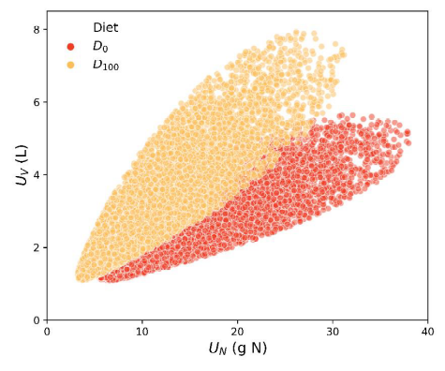
Figure 1. Embed figures or tables in the text or use a “text box” but remove the outline before submitting. Ensure that the caption is attached to the figure. iEMSs Figure/table caption style
Figures/tables such as Fig. 1 and Table 1 are welcome and usually serve to add interest to an extended abstract. See Fig. 1 for an example of figure formatting. If using a Word text box to make text flow around the figure please remove the outline (not done here) before submitting the abstract. Alternatively the figure can occupy the full width of the page simular to Table 1.

Conclusions
Present the outcomes and conclusions of the work presented, including potential or expected impacts. Where appropriate, refer to the overall objectives of iEMSs and the conference, and identify future directions and opportunities for this research. Please note, that abstracts may not exceed 2 pages in length following the formatting of this template!

Table 1. Tables (or figures) may occupy the page width if preferred. Ensure that the caption is above a table but below a figure. Use iEMSs Figure/table caption style
System (iEMSs table text style) | Herbage Grazed | Leached | Denitrified | Fixed
A | 1.029 | 0.902 | 0.962 | 0.967
E | 1.012 | 0.991 | 1.016 | n/a
F | 1.010 | 0.986 | 0.996 | 0.995

Acknowledgements
Any acknowledgements, data statements, funding sources.

References
Any references should be formatted as below (iEMSs References style). The paragraph formation is as for the main text but no spacing at the end of the paragraph. Feel free to “et al.” long author lists. The title may be abbreviated as long as the topic is clear. A URL as well as the bibliographic details is preferred.
Soler-Navarro DJ, Tenza-Peral A, Janssen MA, Gimenez A, Perez-Ibarra I. 2025. Environmental strategies increase the resilience of extensive livestock systems to adverse climate conditions. J Environ Manage. 388, 126004. https://doi.org/10.1016/j.jenvman.2025.126004.

