Default Lists- With all the books in context
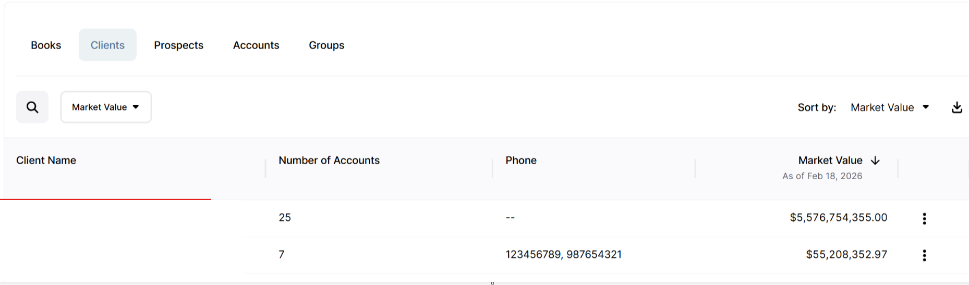

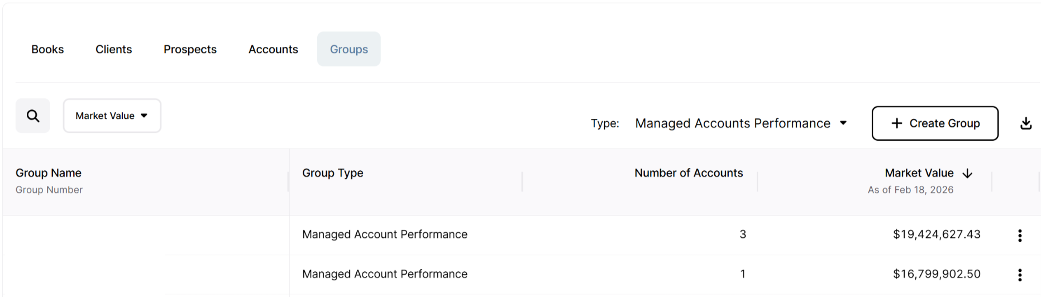
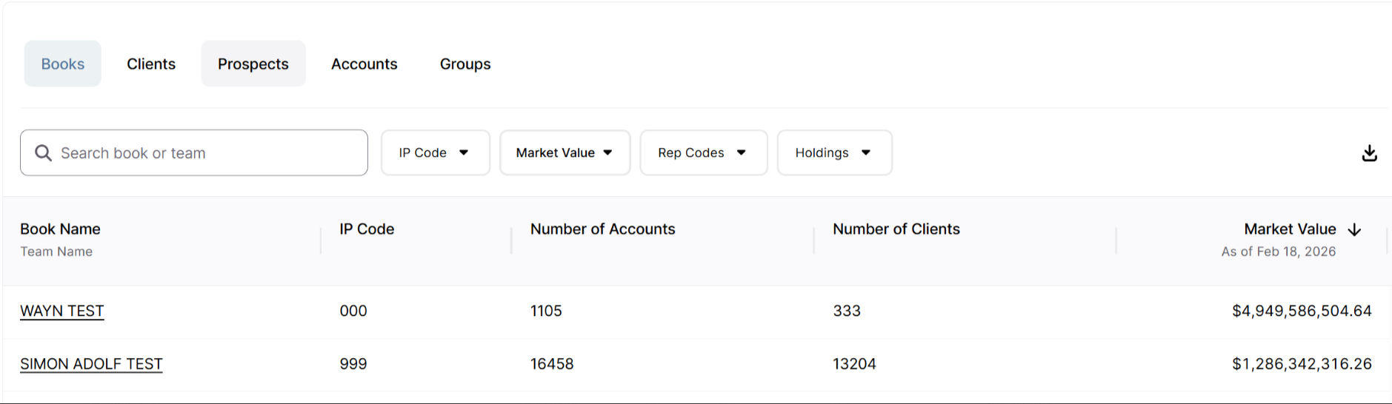

Book Overview – With single selected book in context
