In order to test any lab from the 13 labs here, you have two options :

**1) Option 1 : Use the terminal terminal**

In the terminal type : python <the-name-of-the-lab-file>.py an hit enter

for example if I want to test lab 5 part B, I will type :

python lab5B.py

like in the following screenshot

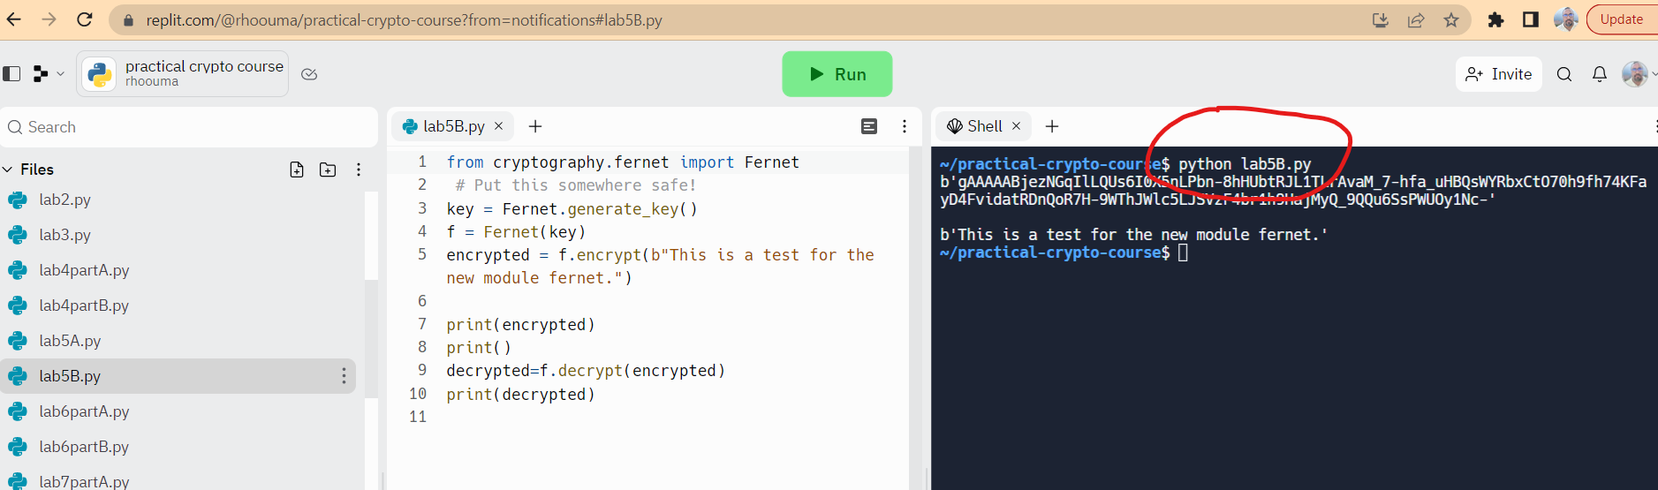

When you do that, output will be displayed on **Terminal.**

**2) Option 2 : Use the Run button of Replit**

Display the hidden files in the repl files explorer as follows :

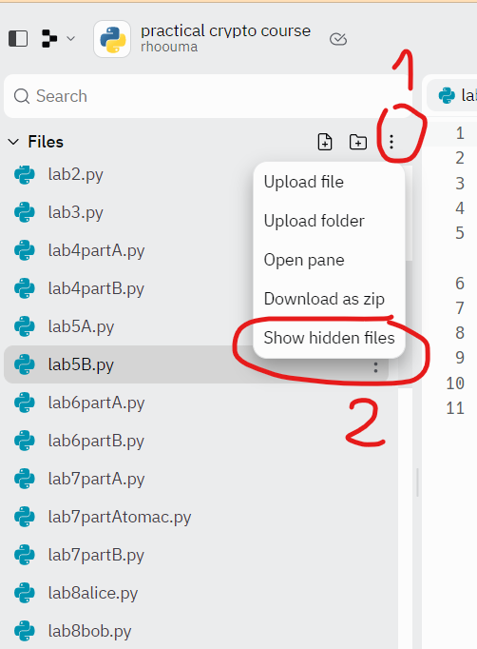

A hidden file named “ .replit” will be shown in the config files section as follows :

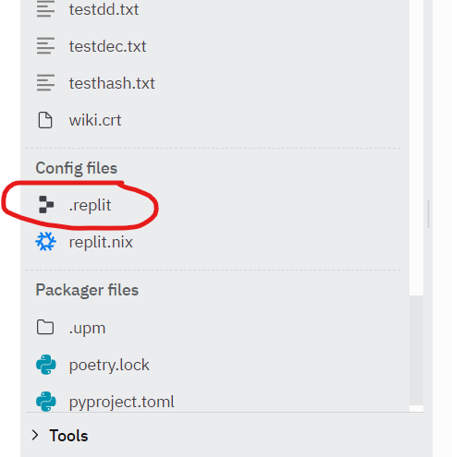

Open that file and change the following lines :

run = ["python3", "main.py"]

entrypoint = "main.py"

by

run = ["python3", "name-of-the-lab-file.py"]

entrypoint = " name-of-the-lab-file.py"

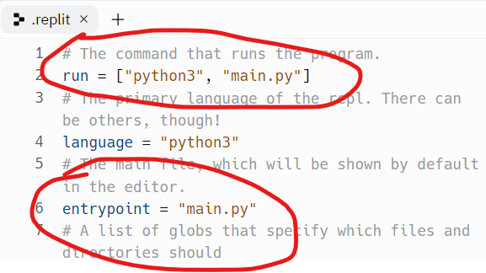

For example if I want to test Lab5B I will do those changes in .replit file :

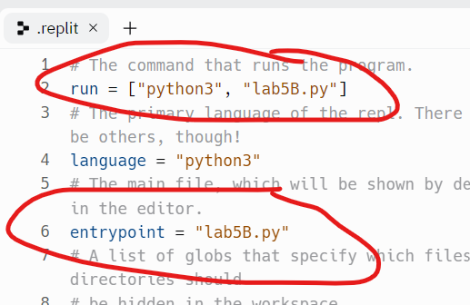

When you hit the button “Run” , output will be displayed on **console**