Fairfax County

## R Markdown

library(tidyverse)  
library(patchwork)  
library(extrafont)  
library(lubridate)  
  
theme_set(theme_minimal())

To add the Verdana font to your R installation, you will need to run the below code from the extrafont package.  
The code only needs to be done once but extrafont needs to be loaded to access any fonts you have added.

For this project, Verdana for Windows was added. The Verdana font file name for Windows is VERDANA.TTF. Linux and Mac probably have slightly different names.

# font_import(pattern="VERDANA.TTF", prompt=FALSE)  
# loadfonts(device = "win") #pick your os

get the daily data

url <- "https://data.virginia.gov/api/views/bre9-aqqr/rows.csv?accessType=DOWNLOAD&api_foundry=true"  
dest <- paste(getwd(), "/data/va_daily.csv",sep="")  
  
download.file(url, dest)

read data and select/rename desired fields

data <- read_csv("data/va_daily.csv" ,  
 col_types = cols('Report Date' = col_date(format = "%m/%d/%Y"),  
 'Total Cases' = col_integer(),  
 'Hospitalizations' = col_integer(),  
 'Deaths' = col_integer()))  
   
  
data <- data %>% select(date=`Report Date`, Locality, district=`VDH Health District`, cases=`Total Cases`, Hospitalizations, Deaths)  
  
data

## # A tibble: 25,137 x 6  
## date Locality district cases Hospitalizations Deaths  
## <date> <chr> <chr> <int> <int> <int>  
## 1 2020-03-17 Accomack Eastern Shore 0 0 0  
## 2 2020-03-17 Albemarle Thomas Jefferson 0 0 0  
## 3 2020-03-17 Alleghany Alleghany 0 0 0  
## 4 2020-03-17 Amelia Piedmont 0 0 0  
## 5 2020-03-17 Amherst Central Virginia 0 0 0  
## 6 2020-03-17 Appomattox Central Virginia 0 0 0  
## 7 2020-03-17 Arlington Arlington 13 1 0  
## 8 2020-03-17 Augusta Central Shenandoah 0 0 0  
## 9 2020-03-17 Bath Central Shenandoah 0 0 0  
## 10 2020-03-17 Bedford Central Virginia 0 0 0  
## # ... with 25,127 more rows

Filter for Fairfax Health District then calculate new cases, new hospitalizations, and new deaths.

Add fields to record sign of new cases differences and then add a column to calculate the streak of days with decreasing or zero new cases.

# Uncomment and use this code if graphing Fairfax Health District   
# fairfax <- data %>% filter(district == 'Fairfax') %>%   
# #group_by(date, district) %>%  
# #group_by(date) %>%   
# summarize(tot_cases = sum(cases), hosp=sum(Hospitalizations),dead=sum(Deaths)) %>%   
# arrange(date) %>%   
# #ungroup() %>%   
# #group_by(district) %>%  
# select(date, Locality, tot_cases, hosp, dead) %>%  
# mutate(new_cases = tot_cases - lag(tot_cases,1),  
# new_hosp = hosp - lag(hosp,1),  
# new_dead = dead - lag(dead,1)) %>%   
# # 1 means 0 or negative difference, 0 means positive difference  
# mutate(d_cases = if_else(sign(new_cases - lag(new_cases,1)) ==1,0,1,missing=0)) %>%  
# group_by(grp=cumsum(d_cases==0)) %>%   
# mutate(streak = ifelse(d_cases==1, lag(cumsum(d_cases==1))+1,0))  
  
  
#Use this code if graphing Fairfax County (not F.Church or Fairfax City)   
fairfax <- data %>% filter(Locality == 'Fairfax') %>%   
 select(date,cases,hosp=Hospitalizations,dead=Deaths ) %>%   
 arrange(date) %>%  
 mutate(new_cases = cases - lag(cases,1),  
 new_hosp = hosp - lag(hosp,1),  
 new_dead = dead - lag(dead,1),  
 new_dead = ifelse(new_dead<0, 0, new_dead)) %>%  
 # 1 means 0 or negative difference, 0 means positive difference, d_cases stands for difference in new cases  
 mutate(d_cases = if_else(sign(new_cases - lag(new_cases,1)) ==1,0,1,missing=0)) %>%  
 group_by(grp=cumsum(d_cases==0)) %>%  
 mutate(streak = ifelse(d_cases==1, lag(cumsum(d_cases==1))+1,0))  
  
  
fairfax %>% arrange(desc(date))

## # A tibble: 189 x 10  
## # Groups: grp [94]  
## date cases hosp dead new_cases new_hosp new_dead d_cases grp streak  
## <date> <int> <int> <int> <int> <int> <dbl> <dbl> <int> <dbl>  
## 1 2020-09-21 20305 2128 581 46 2 0 1 94 3  
## 2 2020-09-20 20259 2126 581 104 1 2 1 94 2  
## 3 2020-09-19 20155 2125 579 114 4 5 1 94 1  
## 4 2020-09-18 20041 2121 574 120 -2 1 0 94 0  
## 5 2020-09-17 19921 2123 573 84 4 1 1 93 1  
## 6 2020-09-16 19837 2119 572 105 8 3 0 93 0  
## 7 2020-09-15 19732 2111 569 74 -5 1 0 92 0  
## 8 2020-09-14 19658 2116 568 57 5 0 1 91 2  
## 9 2020-09-13 19601 2111 568 106 4 0 1 91 1  
## 10 2020-09-12 19495 2107 568 136 7 1 0 91 0  
## # ... with 179 more rows

Read in the trend line from the stan model

stan <- read_csv("trends/trend_today_dow.csv")

## Parsed with column specification:  
## cols(  
## date = col_date(format = ""),  
## trend = col_double(),  
## trend_hosp = col_double(),  
## trend_dead = col_double()  
## )

#Plot everything

#grab the maximum date  
today <- max(fairfax$date)  
  
# plot new cases  
n <- ggplot(fairfax, aes(x=date, y=new_cases)) +  
 geom_bar(stat="identity",fill="grey49", alpha=0.75) +  
 geom_line(data=stan, aes(x=date, y=trend), color="firebrick", size=2, linetype="solid")+  
 geom_text(data=subset(fairfax, date ==max(date)), aes(y=abs(new_cases), label=new_cases),  
 position = position_dodge(width = 0.5), vjust=-1.0, hjust=-0.25,color="grey32") +  
 theme(text = element_text(family='Verdana'),  
 plot.title = element_text(size = 14, face="bold"),  
 panel.grid.major = element_line(color="grey68")) +  
 labs(title="New Covid-19 Cases",  
 subtitle = sprintf("Total Cases: %s", format(max(fairfax$cases),big.mark=",")),  
 x=NULL, y=NULL) +  
 xlim(date("2020-03-17"), max(fairfax$date)+1) +  
 ylim(0, 500)  
  
  
  
# plot case streak  
a <- ggplot(fairfax, aes(x=date, y=streak)) +   
 geom_bar(stat="identity", fill="red",alpha=0.75) +  
 geom_text(data=subset(fairfax, date ==max(date)), aes(y=streak, label=streak),  
 position = position_dodge(width = 0.5), vjust=-.5, color="grey32") +  
 ylim(0,15) +  
 theme(text = element_text(family='Verdana'),  
 plot.title = element_text(size = 14, face="bold"),  
 panel.grid.major = element_line(color="grey68")) +  
 labs(title="Consecutive Days with Fewer New Covid-19 Cases",  
 x=NULL, y=NULL) +  
 xlim(date("2020-03-17"), max(fairfax$date)+1)  
  
# plot hospitalizations  
h <- ggplot(fairfax, aes(x=date, y=new_hosp)) +  
 geom_bar(stat="identity", fill = "purple", alpha=0.75, na.rm=TRUE) +  
 geom_line(data=stan, aes(x=date, y=trend_hosp), color="purple4", size=1.5, linetype="solid")+  
 geom_text(data=subset(fairfax, date ==max(date)), aes(y=new_hosp, label=new_hosp),  
 position = position_dodge(width = 0.5), vjust=-.5, color="grey32") +  
 theme(text = element_text(family='Verdana'),  
 plot.title = element_text(size = 14, face="bold"),  
 panel.grid.major = element_line(color="grey68")) +  
 labs(title="New Covid-19 Hospitalizations",  
 subtitle = sprintf("Total Hospitalizations: %s",max(fairfax$hosp)),  
 x=NULL, y=NULL) +  
 ylim(0, (max(fairfax$new_hosp)+10)) +  
 xlim(date("2020-03-17"), max(fairfax$date)+1)  
  
  
# plot deaths  
d <- ggplot(fairfax, aes(x=date, y=new_dead)) +  
 geom_bar(stat="identity", fill = "chocolate",alpha=0.75, na.rm=TRUE) + #was brown  
 geom_line(data=stan, aes(x=date, y=trend_dead), color="chocolate4", size=1.5, linetype="solid")+  
 geom_text(data=subset(fairfax, date ==max(date)), aes(y=new_dead, label=new_dead),  
 position = position_dodge(width = 0.5), vjust=-.5, color="grey32") +  
 theme(text = element_text(family='Verdana'),  
 plot.title = element_text(size = 14, face="bold"),  
 panel.grid.major = element_line(color="grey68")) +  
 labs(title="New Covid-19 Deaths",  
 subtitle = sprintf("Total Deaths: %s", fairfax$dead[fairfax$date==today]),  
 x=NULL, y=NULL) +  
 ylim(0, (max(fairfax$new_dead)+10)) +  
 xlim(date("2020-03-17"), max(fairfax$date)+1)  
  
  
  
# arrange the plots vertically  
patchwork <- n / a / h/ d   
  
#create final plot  
# final <- patchwork +   
# plot_layout(heights = c(2,1,1,1))+  
# plot_annotation(title=sprintf("Fairfax Health District: Covid-19 Summary for %s %s %s",  
# day(today), month.name[month(today)],year(today)),  
# subtitle= "Fairfax Health District includes Fairfax County, City of Fairfax, and City of Falls Church\nSource: Virginia Department of Health",  
# theme = theme(plot.title = element_text(size = 16))) &  
# theme(text = element_text(family='Verdana'),  
# plot.caption = element_text(face = 'italic'))   
  
final <- patchwork +   
 plot_layout(heights = c(2,1,1,1))+  
 plot_annotation(title=sprintf("Fairfax County: Covid-19 Summary for %s %s %s",  
 day(today), month.name[month(today)],year(today)),  
 subtitle= "Charts exclude numbers for City of Fairfax and City of Falls Church\nSource: Virginia Department of Health",  
 theme = theme(plot.title = element_text(size = 18, face="bold"))) &  
 theme(text = element_text(family='Roboto Condensed'),  
 plot.caption = element_text(face = 'italic'))   
  
final

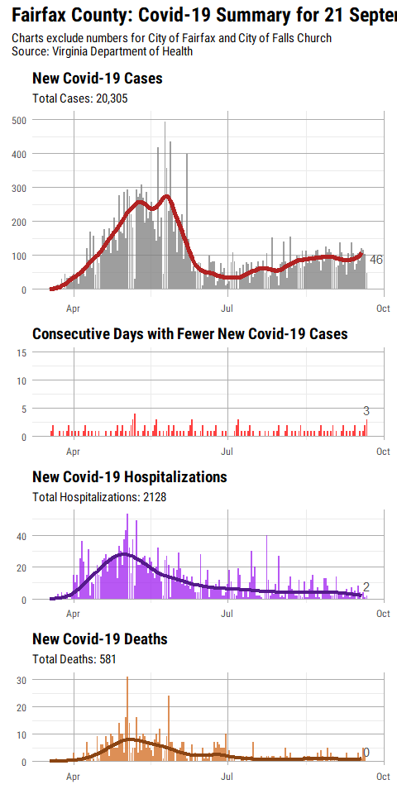

ggsave("covid_daily_ffx.png",width = 8.5, height=11.0)

## Warning: Removed 2 rows containing missing values (position_stack).

## Warning: Removed 1 rows containing missing values (geom_bar).

## Warning: Removed 8 rows containing missing values (position_stack).

## Warning: Removed 1 rows containing missing values (position_stack).