

**North South University**

*Department of Electrical And Computer Engineering*

CSE 311L (Database Management System)

Project Proposal

**Faculty:** Intisar Tahmid Naheen (ITN)

**Lab Officer:** Asif Ahmed Neloy

**Section:** 08

**Submission Date:** 30 March, 2020

**Group Number:** 03

**Project Name:** Website on a Robotics Society

**Submitted by:**

1. Ridwanul Haque – 1721144042

2. Nasim Mahmud – 1721387042

3. Md. Zobayer Ahmed - 1610766042

4. Asma Khanam Sarmin – 1811285042 (Dropped)

1. **Requirement analysis:**

The main priority of our project is to build a platform where (mostly students of different backgrounds) can learn, collaborate and contribute to the robotics society. In our country, robotics is mostly a new and open field for newbies and often they find it very hard to learn about basic robotics. That’s why we are trying to build a website where our main priority will be creating a robotics society open for all. Here, anyone who wishes to learn will find various types of info to start with robotics and also can participate in the vast world of robotics by contributing to the website.

User Requirement:

* Knowing how to learn from blogs.
* Date of upcoming robotics competitions
* Posting blog on the website
* Event links
* Equipment links to buy products

Data Requirement:

* A user can read the blog posts on the website but for that, h/she have to sign up
* Admin can accept or reject the blog the user wants to post in the website
* Admin can update the gallery, event links, event dates, view users profile, delete or update any existing links or blogs.

1. **Scope:**

Following are the scope of the developed system:

* For the user:
* Online registration
* View blog or events links
* Member board info
* Contact method
* For Admin:
* Access to user profile
* Editing events links
* Access of gallery and blogs

1. **ER-Diagram:**

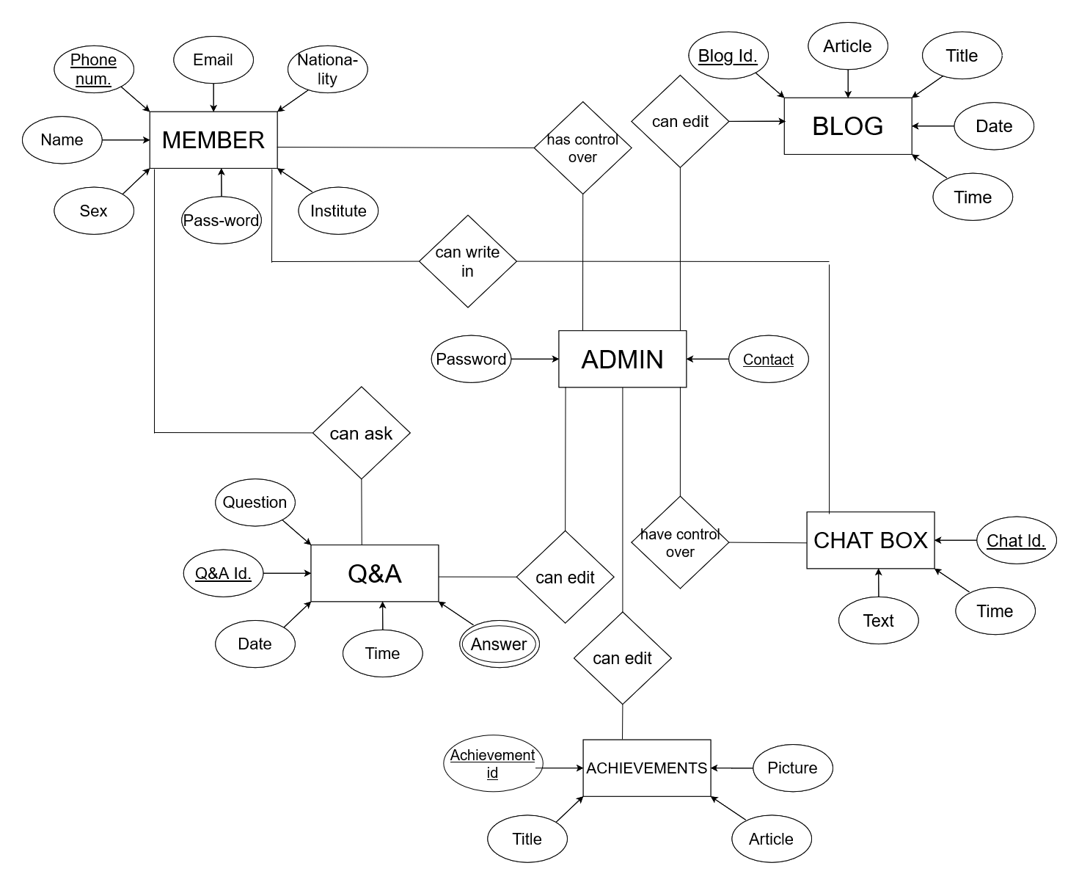

1. **Timeline:** (Trello)

