23CSE473

Foundations of Deep Learning

Laboratory Exercises

HARI SREERAM R
CH.SC.U4CSE23019

These exercises cover the fundamental concepts of deep learning, including perceptron, multi-layer perceptron, loss functions, backpropagation, optimization, and regularization.

Exercise 1: Evolution from Perceptron to Multi-Layer Perceptron (MLP)

Objective
Understand why the single-layer perceptron failed for certain problems and how the Multi-Layer Perceptron (MLP) overcame these limitations.

Tasks
- Explain the architecture of a single layer perceptron.
Input layer
- One output neuron
- No hidden layer
Each input is multiplied by a weight, summed together with a bias, and passed through an activation function. Mathematically,
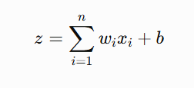
this is the equation of a single layer perceptron. The z is then passed to an activation function to get the final output. And thus, the output becomes,
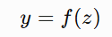

- w_{i} = weights
- x_{i} = inputs
- b = bias
- f(z) = activation function

The architecture of a single-layer perceptron with three input neurons is shown below. Although the figure illustrates three inputs, the perceptron can be generalized to handle any number of input features by adding corresponding weighted connections to the summation unit.

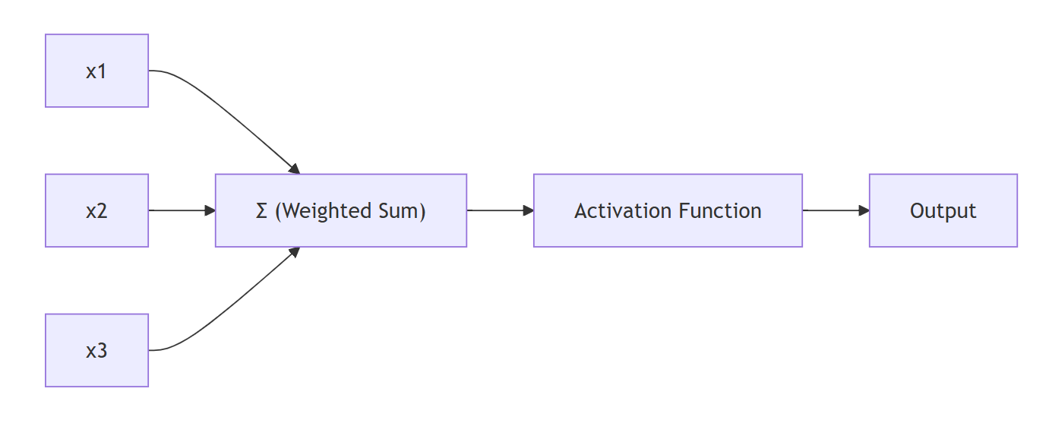 The perceptron creates only one linear decision boundary.

- Draw the XOR truth table.

x1 | x2 | XOR
0 | 0 | 0
0 | 1 | 1
1 | 0 | 1
1 | 1 | 0

- And Gate
The AND gate is a basic logic gate that produces an output of 1 only when both inputs are 1. If either or both inputs are 0, the output is 0. In the plotted graph, the three points (0,0), (0,1), and (1,0) belong to Class 0, while only (1,1) belongs to Class 1. The decision boundary clearly separates the single positive class from the negative class, demonstrating that the AND gate is linearly separable. A single-layer perceptron can correctly classify all input combinations using a straight-line decision boundary.

Truth Table:
Input (x₁) | Input (x₂) | Output
0 | 0 | 0
0 | 1 | 0
1 | 0 | 0
1 | 1 | 1

CODE:
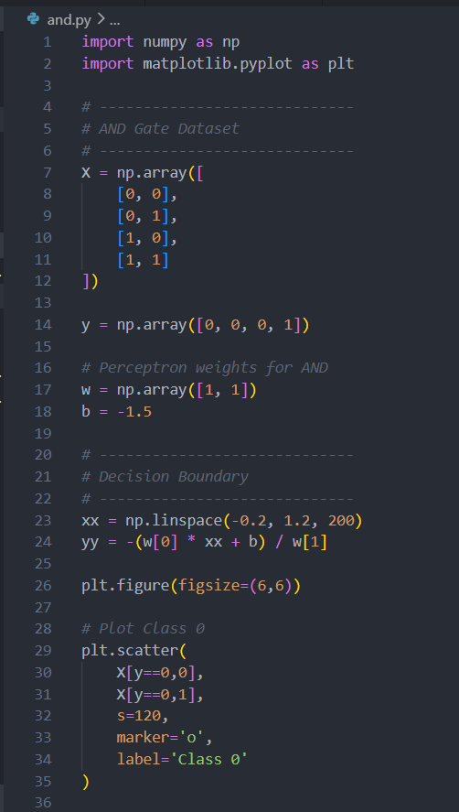

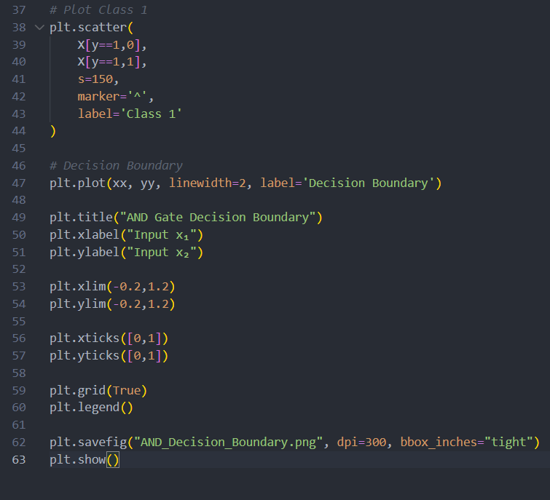
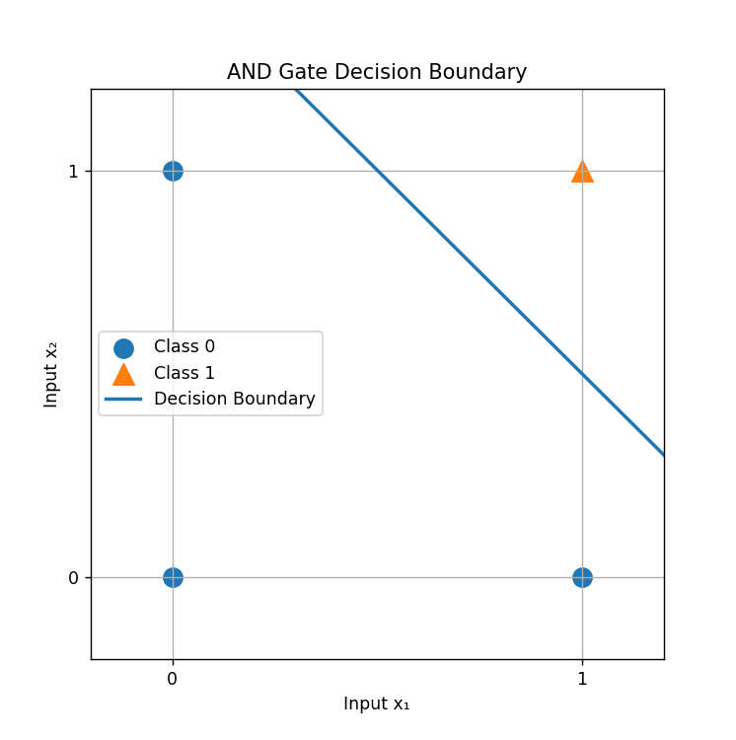

- Or Gate

The OR gate is a logic gate that produces an output of 1 whenever at least one input is 1. The output is 0 only when both inputs are 0. In the graph, the point (0,0) belongs to Class 0, while (0,1), (1,0), and (1,1) belong to Class 1. The decision boundary separates the single negative class from the positive class, showing that the OR gate is also linearly separable. Like the AND gate, it can be implemented using a single-layer perceptron with an appropriate linear decision boundary.

Truth table:
Input (x₁) | Input (x₂) | Output
0 | 0 | 0
0 | 1 | 1
1 | 0 | 1
1 | 1 | 1

CODE:
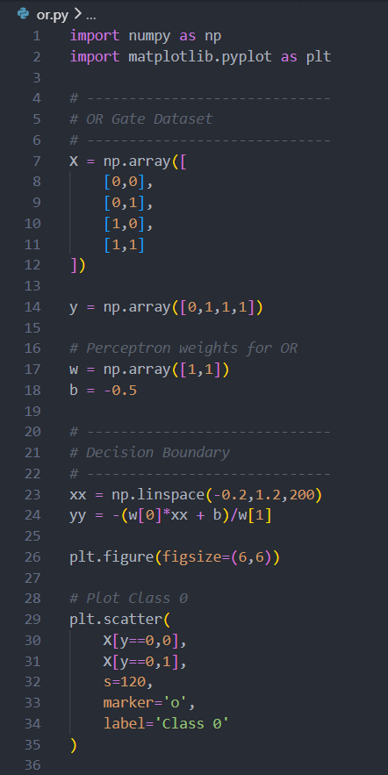

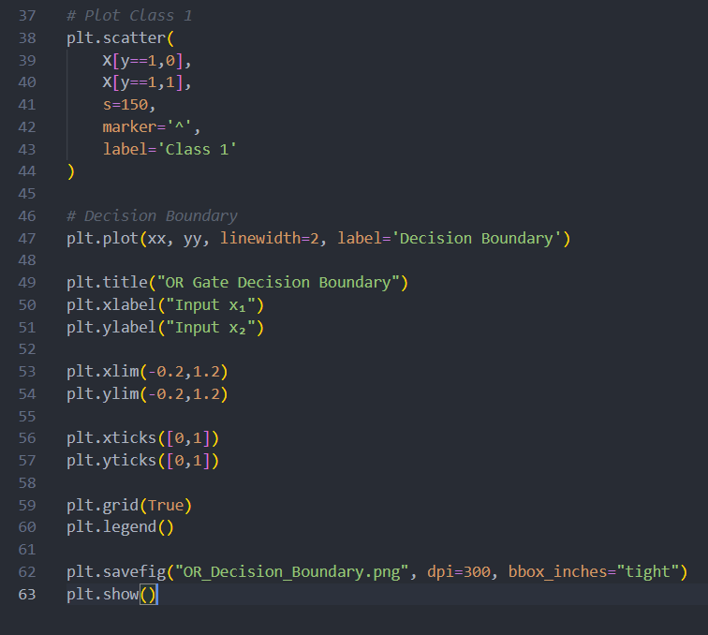

OUTPUT:
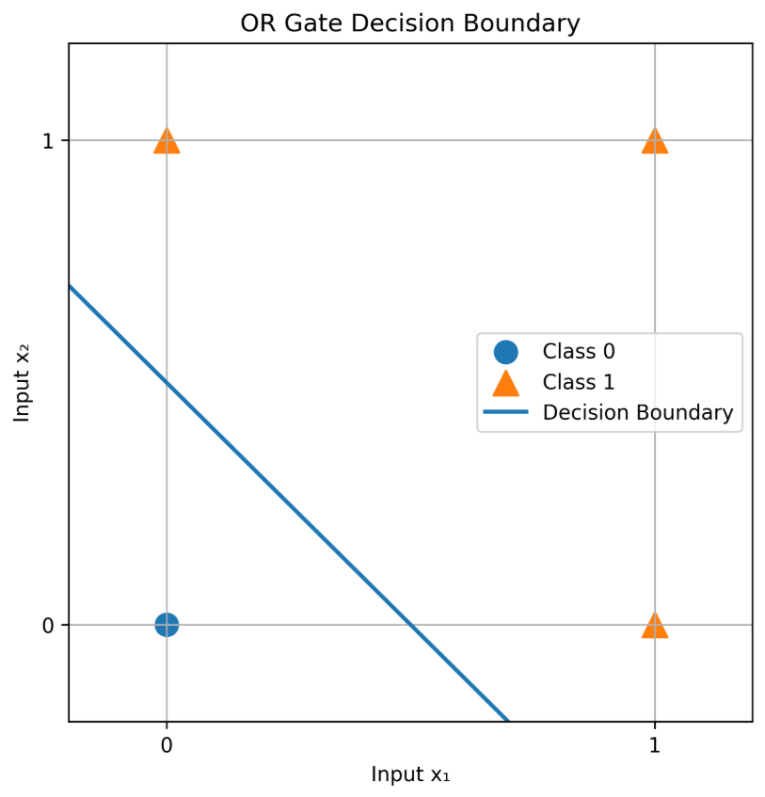

- Plot the XOR data points in a 2D coordinate system.
CODE:
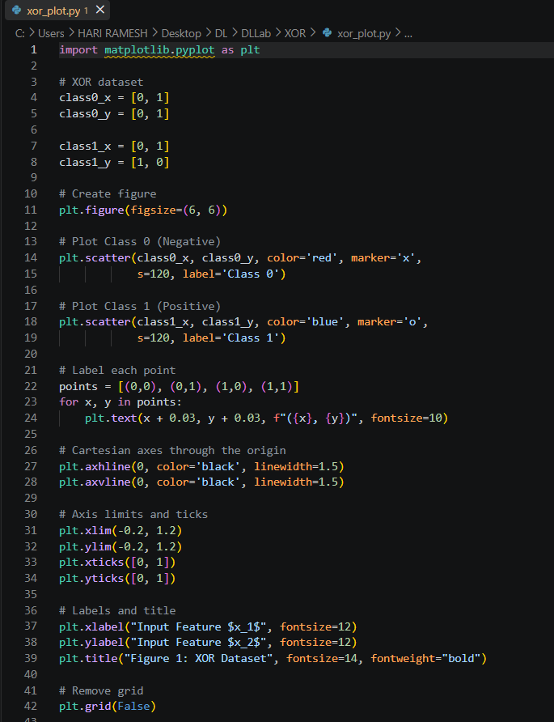
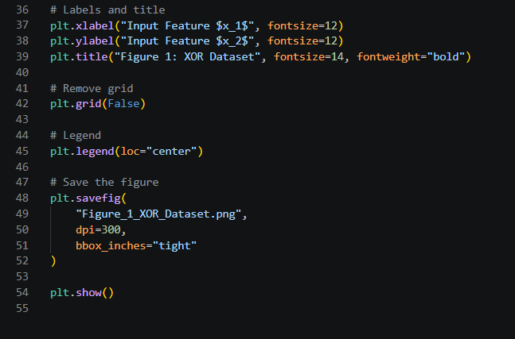

OUTPUT:

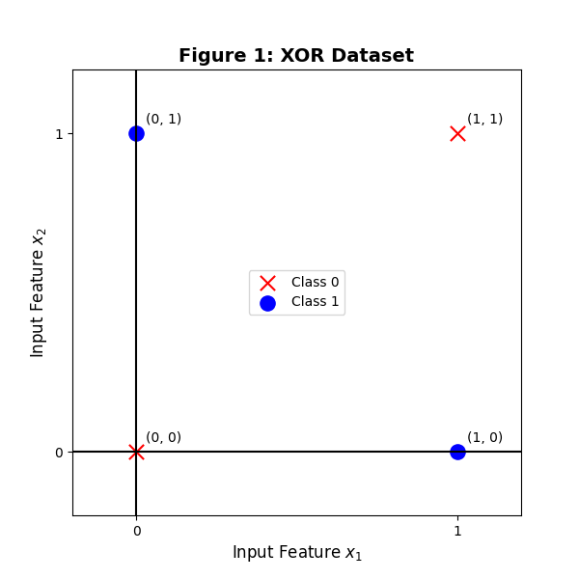
- Prove mathematically that XOR is not linearly separable.
A single-layer perceptron can correctly classify a dataset only if the data is linearly separable, meaning that a single straight line can separate the two classes.

For the XOR problem, the dataset is:
Input (x₁, x₂) | Output
(0,0) | 0
(0,1) | 1
(1,0) | 1
(1,1) | 0
Assume that there exists a linear classifier capable of perfectly classifying the XOR dataset.
The equation of a linear decision boundary is
w₁ x₁ + w₂ x₂ + b = 0
where,
- w₁ and w₂ are the weights,
- b is the bias.
For correct classification, the classifier must satisfy the following conditions:
- Output 0:
w₁ x₁ + w₂ x₂ + b < 0
- Output 1:
w₁ x₁ + w₂ x₂ + b > 0

Step 1: Apply the Conditions to Each XOR Input

Case 1: Point (0,0)
The desired output is 0.
Substituting the coordinates,
w₁(0) + w₂(0) + b < 0
Therefore,
b < 0

Case 2: Point (1,0)
The desired output is 1.
Substituting,
w₁(1) + w₂(0) + b > 0
which simplifies to
w₁ + b > 0

Case 3: Point (0,1)
The desired output is 1.
Substituting,
w₁(0) + w₂(1) + b > 0
Therefore,
w₂ + b > 0

Case 4: Point (1,1)
The desired output is 0.
Substituting,
w₁ + w₂ + b < 0
Thus,
w₁ + w₂ + b < 0

Step 2: Combine the Inequalities
From Cases 2 and 3,
w₁ + b > 0
and
w₂ + b > 0
Adding these two inequalities gives
(w₁ + b) + (w2 + b) > 0
or
w₁ + w₂ + 2b > 0

Step 3: Use the Result from Case 1
From Case 1,
b < 0
which means
− b > 0
Now
(w₁ + w₂ + 2b) − b = w₁ + w₂ + b
Since
w₁ + w₂ + 2b > 0
and
− b > 0,
adding the positive quantity (−b) gives
w₁ + w₂ + b > 0
Thus,
w₁ + w₂ + b > 0

Step 4: Contradiction
However, from Case 4 we already obtained
w₁ +w₂ + b < 0
Therefore, we have reached two contradictory statements:
w₁ +w₂ + b > 0
and
w₁ + w₂ + b < 0
Both cannot be true simultaneously.
Hence, our original assumption that a single linear classifier exists must be false.

Since no values of the weights w₁ , w₂ , and bias b satisfy all four inequalities simultaneously, no single linear decision boundary can correctly classify all XOR input combinations.

Therefore, The XOR function is not linearly separable.

This mathematical contradiction proves that a single-layer perceptron cannot solve the XOR problem. To correctly classify XOR, a neural network requires at least one hidden layer with a nonlinear activation function, such as a Multi-Layer Perceptron (MLP), which can learn nonlinear decision boundaries.

- Explain why no single linear decision boundary can correctly classify XOR.
A single-layer perceptron classifies data by drawing one linear decision boundary, which is represented by a straight line in a two-dimensional feature space. For a dataset to be correctly classified by such a model, all data points belonging to the same class must lie on the same side of the decision boundary.
In the XOR dataset, the two classes are arranged diagonally:
- Class 1 (Positive): (0,1) and (1,0)
- Class 0 (Negative): (0,0) and (1,1)
This arrangement creates a crisscross pattern where points of different classes alternate across the feature space. Because of this diagonal distribution, any straight line drawn through the plane will inevitably place at least one point from each class on the wrong side of the boundary.
For example, a vertical or horizontal line can separate either the left and right points or the top and bottom points, but it cannot simultaneously isolate the two diagonal points belonging to the same class. Similarly, a diagonal line will correctly classify one pair of points while misclassifying the other pair.
Since a straight line can divide the plane into only two half-spaces, it is impossible to group the two positive examples together while also grouping the two negative examples together.
Therefore, no single linear decision boundary can correctly classify all four XOR data points, making the XOR problem unsolvable by a single-layer perceptron. This limitation motivates the use of Multi-Layer Perceptrons (MLPs), which can combine multiple decision boundaries to form a nonlinear boundary capable of correctly separating the XOR classes.

- Discuss how introducing a hidden layer enables learning nonlinear decision boundaries.
A Multi-Layer Perceptron (MLP) overcomes the limitations of a single-layer perceptron by introducing one or more hidden layers between the input and output layers. These hidden layers enable the network to learn nonlinear decision boundaries, allowing it to solve problems such as XOR.
Each hidden neuron computes a weighted sum of the inputs, adds a bias, and applies a nonlinear activation function, such as the sigmoid function:
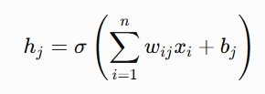

The outputs of the hidden neurons are then combined by the output neuron to produce the final prediction:
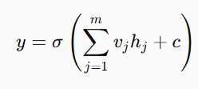
Unlike a single-layer perceptron, where only one linear boundary can be learned, each hidden neuron learns a different linear boundary. The output neuron combines these boundaries to form a nonlinear decision boundary capable of correctly separating the XOR classes.
The sigmoid activation function introduces nonlinearity into the network. Without a nonlinear activation function, multiple layers would behave like a single linear layer and still be unable to solve the XOR problem.
During training, the network uses backpropagation and Binary Cross-Entropy (BCE) loss to update its weights and biases. Over successive iterations, the hidden layer learns meaningful feature representations that enable the network to correctly classify all four XOR input combinations.
Therefore, the addition of a hidden layer transforms the perceptron into a model capable of learning complex nonlinear relationships, making the XOR problem solvable.

CODE:
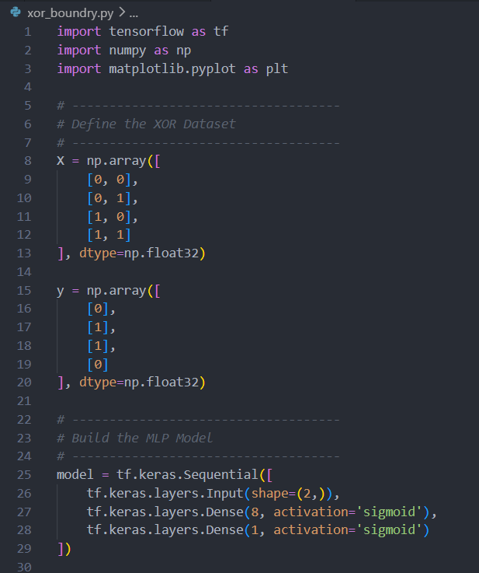
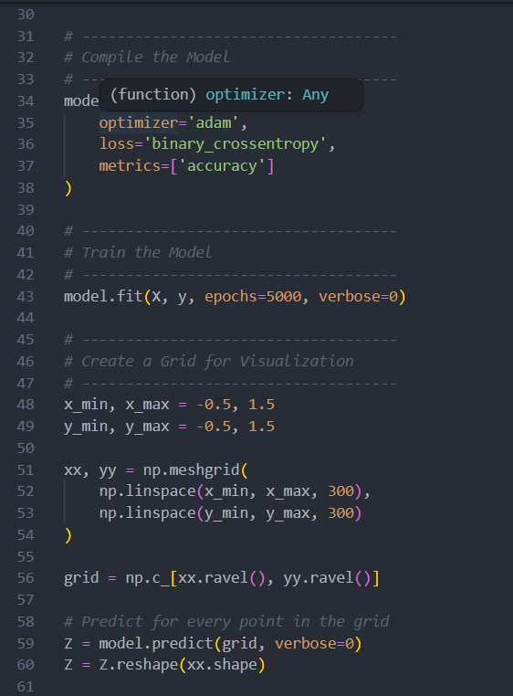
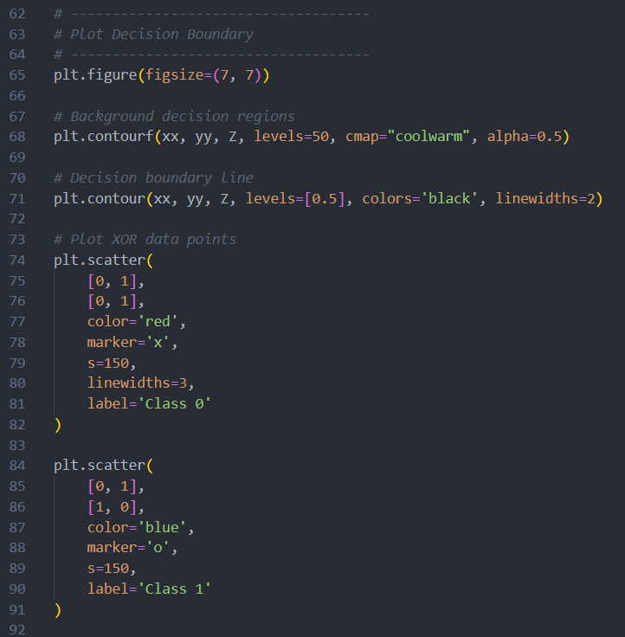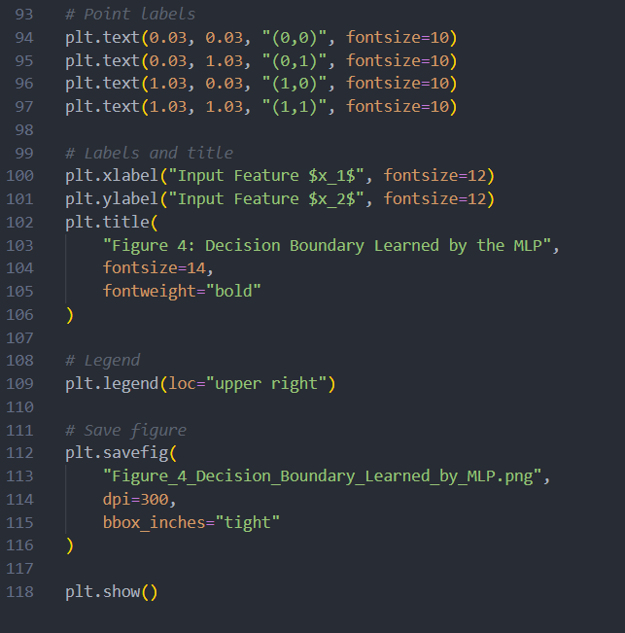

OUTPUT:
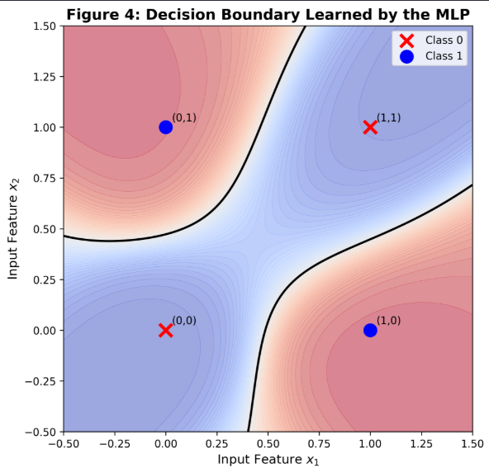

- Draw an MLP architecture capable of solving XOR.
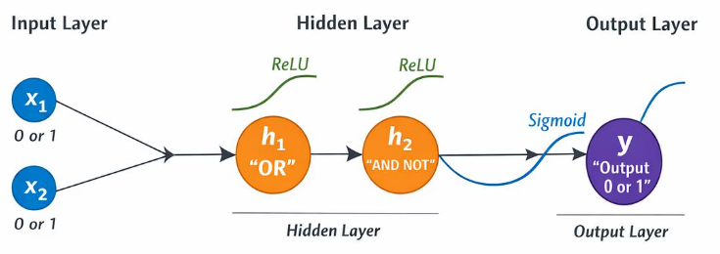

- Implement an XOR classifier using TensorFlow/PyTorch with one hidden layer, sigmoid activation, and Binary Cross Entropy loss.
CODE:
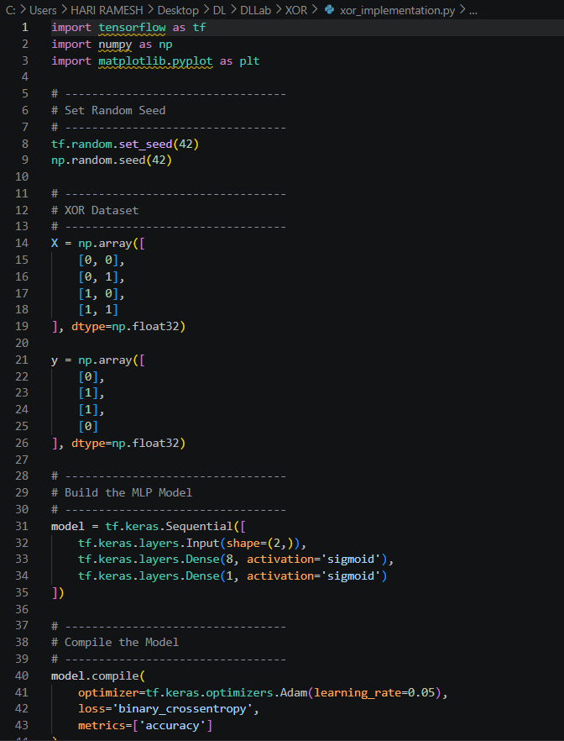

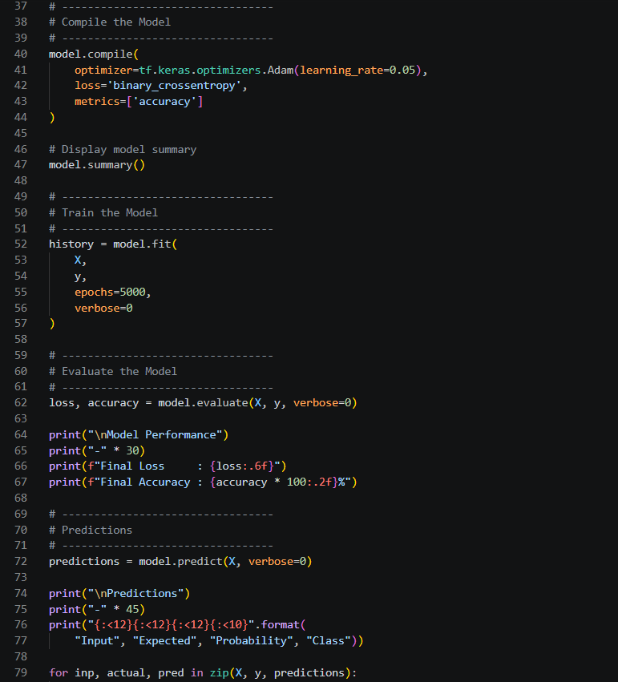
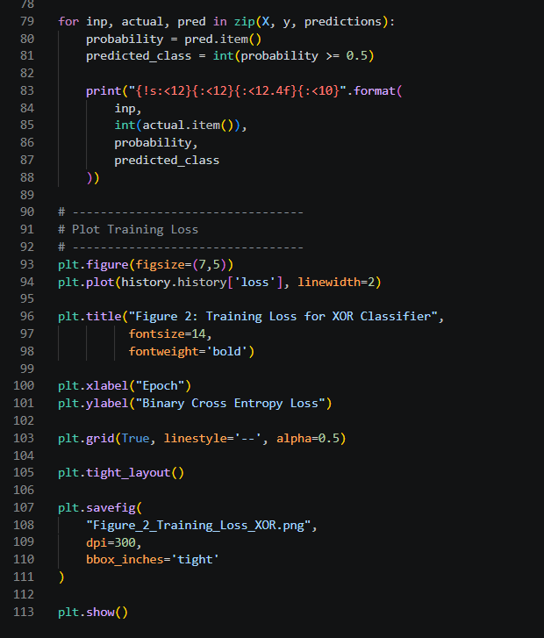

OUTPUT:

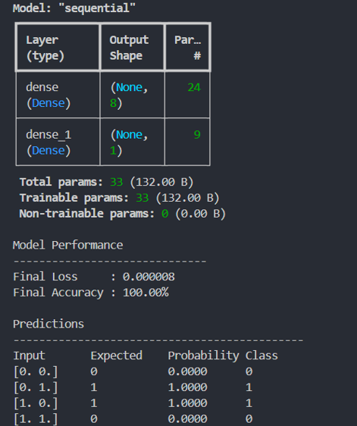

- Plot the training loss over epochs.
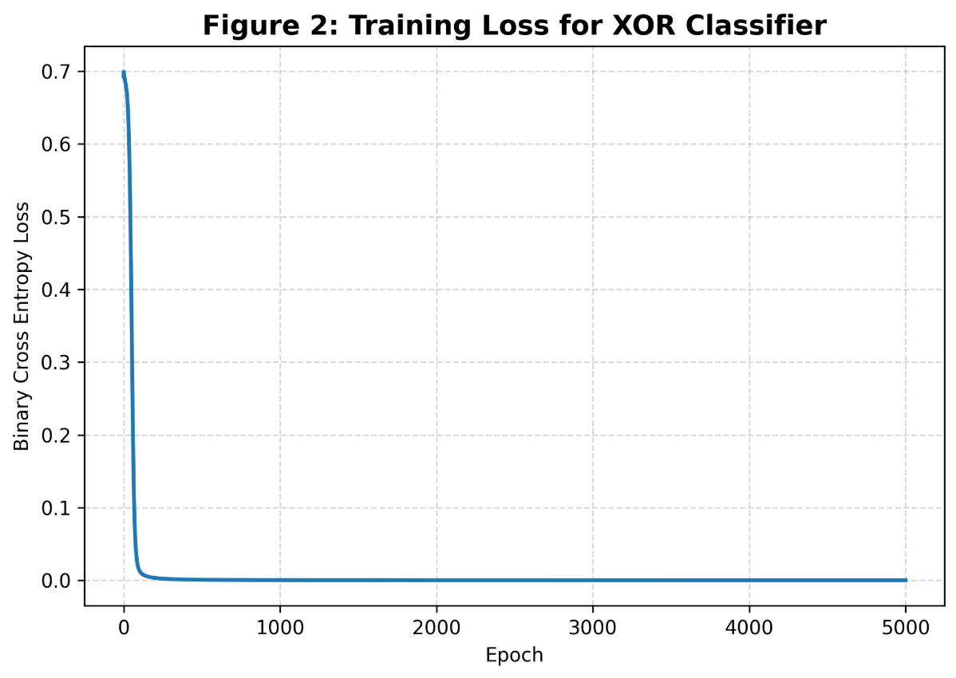

- Report the final prediction accuracy.
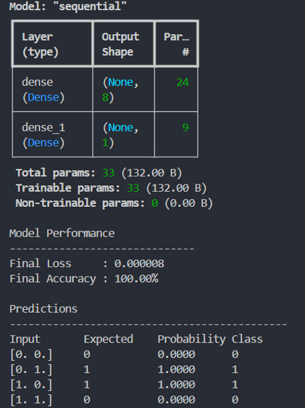
The trained Multi-Layer Perceptron achieved a Binary Cross-Entropy loss of 0.000008 and a prediction accuracy of 100% on the XOR dataset. The network correctly classified all four possible XOR input combinations. The predicted probabilities are very close to the expected values of 0 and 1, indicating that the model has successfully learned the nonlinear XOR relationship.

Deliverables
- Mathematical proof
- Decision boundary visualization
- Code implementation
- Training curve
- Short discussion (200 words)

Exercise 2: Understanding Loss Functions (MSE vs BCE)

Objective
Compare Mean Squared Error (MSE) and Binary Cross Entropy (BCE) for binary classification.

Tasks
- Given true labels [1,1,0,0] and predicted probabilities [0.95,0.80,0.30,0.10], compute the Mean Squared Error manually.
Given: True values (y) = [1, 1, 0, 0] Predicted values (y_pred) = [0.95, 0.80, 0.30, 0.10]
Formula: MSE = (1/n) * Σ(y - y_pred)^2
Step 1: Calculate squared errors
(1 - 0.95)^2 = 0.0025 (1 - 0.80)^2 = 0.0400 (0 - 0.30)^2 = 0.0900 (0 - 0.10)^2 = 0.0100
Step 2: Sum the squared errors
Sum = 0.0025 + 0.0400 + 0.0900 + 0.0100 Sum = 0.1425
Step 3: Divide by the number of observations
MSE = 0.1425 / 4 MSE = 0.035625
Final Answer: MSE = 0.035625

- Compute Binary Cross Entropy manually.

Given:
True labels (y) = [1, 1, 0, 0]
Predicted probabilities (y_pred) = [0.95, 0.80, 0.30, 0.10]
Formula:
BCE = -(1/n) * Σ[y * ln(y_pred) + (1-y) * ln(1-y_pred)]
Here, n = 4.
Step 1: Calculate the loss for each observation.
For y = 1, y_pred = 0.95:
Loss = -ln(0.95) = 0.0513
For y = 1, y_pred = 0.80:
Loss = -ln(0.80) = 0.2231
For y = 0, y_pred = 0.30:
Loss = -ln(1 - 0.30) = -ln(0.70) = 0.3567
For y = 0, y_pred = 0.10:
Loss = -ln(1 - 0.10) = -ln(0.90) = 0.1054
Step 2: Sum the losses.
Sum = 0.0513 + 0.2231 + 0.3567 + 0.1054
Sum = 0.7365
Step 3: Calculate the average loss.
BCE = 0.7365 / 4
BCE = 0.1841
Final Answer: Binary Cross Entropy = 0.1841

- Repeat the calculations for predictions [0.60,0.55,0.45,0.40].

Given:
True labels (y) = [1, 1, 0, 0]
Predicted probabilities (y_pred) = [0.60, 0.55, 0.45, 0.40]
PART A: Mean Squared Error (MSE)
Formula:
MSE = (1/n) * Σ(y - y_pred)^2
Step 1: Calculate squared errors.
(1 - 0.60)^2 = 0.16
(1 - 0.55)^2 = 0.2025
(0 - 0.45)^2 = 0.2025
(0 - 0.40)^2 = 0.16
Step 2: Sum the squared errors.
Sum = 0.16 + 0.2025 + 0.2025 + 0.16
Sum = 0.725
Step 3: Calculate MSE.
MSE = 0.725 / 4
MSE = 0.18125
Final Answer: MSE = 0.18125
PART B: Binary Cross Entropy (BCE)
Formula:
BCE = -(1/n) * Σ[y * ln(y_pred) + (1-y) * ln(1-y_pred)]
Step 1: Calculate the loss for each observation.
For y = 1, y_pred = 0.60:
Loss = -ln(0.60) = 0.5108
For y = 1, y_pred = 0.55:
Loss = -ln(0.55) = 0.5978
For y = 0, y_pred = 0.45:
Loss = -ln(1 - 0.45) = -ln(0.55) = 0.5978
For y = 0, y_pred = 0.40:
Loss = -ln(1 - 0.40) = -ln(0.60) = 0.5108
Step 2: Sum the losses.
Sum = 0.5108 + 0.5978 + 0.5978 + 0.5108
Sum = 2.2172
Step 3: Calculate BCE.
BCE = 2.2172 / 4
BCE = 0.5543
Final Answer: MSE = 0.18125
Binary Cross Entropy = 0.5543

- Compare the values.
True Labels | Predicted Probabilities | Mean Squared Error (MSE) | Binary Cross Entropy (BCE)
[1,1,0,0] | [0.95, 0.80, 0.30, 0.10] | 0.0356 | 0.1841
[1,1,0,0] | [0.60, 0.55, 0.45, 0.40] | 0.1813 | 0.5543

Comparison:
The first set of predictions is closer to the true labels, resulting in lower values for both MSE and BCE. In the second set, the predicted probabilities are much closer to 0.5, indicating greater uncertainty. Consequently, both loss functions increase.

However, the increase in Binary Cross Entropy is much larger than the increase in Mean Squared Error. This is because BCE penalizes uncertain or incorrect predictions more heavily than MSE. As predictions move away from the correct class probabilities, BCE increases rapidly, whereas MSE grows more gradually.

Therefore, BCE is more sensitive to classification errors and provides a stronger learning signal during training.

- Explain why BCE provides stronger gradients for classification.
Binary Cross Entropy (BCE) is specifically designed for binary classification tasks because it measures the difference between the predicted probability distribution and the true class labels. It produces larger loss values when the model makes confident but incorrect predictions.
For example, if the true label is 1 and the model predicts 0.01, the BCE loss becomes very large because
− log(0.01) = 4.605
This large loss results in strong gradients, causing significant weight updates during backpropagation. As a result, the network learns to correct its mistakes more quickly.
In contrast, Mean Squared Error computes only the squared difference between the predicted probability and the true label. As predictions approach the extreme values of 0 or 1, the gradients produced by MSE become smaller, slowing down the learning process. This phenomenon is particularly noticeable when sigmoid activation functions are used, where MSE can suffer from vanishing gradients.
Because BCE generates stronger and more informative gradients, it enables faster convergence, more stable optimization, and generally better performance for binary classification problems. For this reason, Binary Cross Entropy is the preferred loss function for neural networks performing binary classification.

- Train two identical neural networks: Model A (MSE) and Model B (BCE).

CODE:
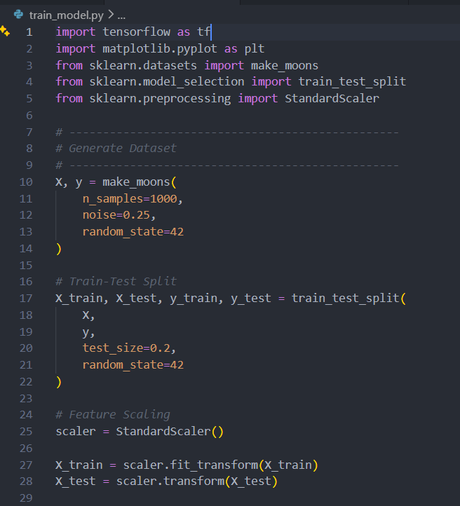
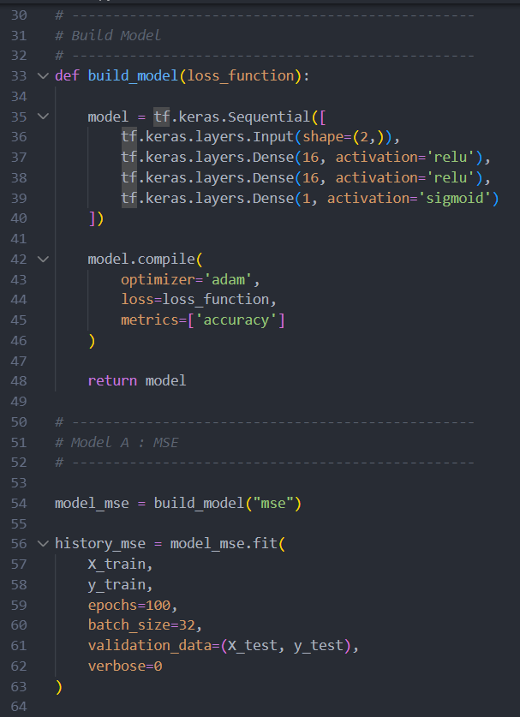
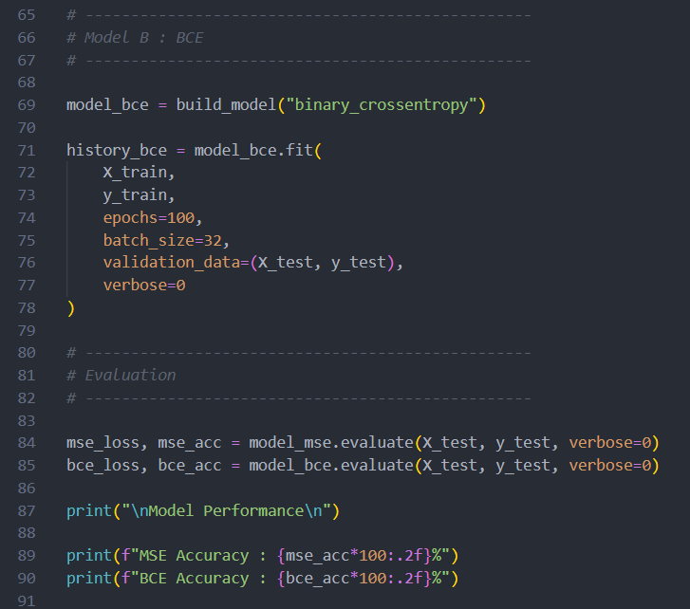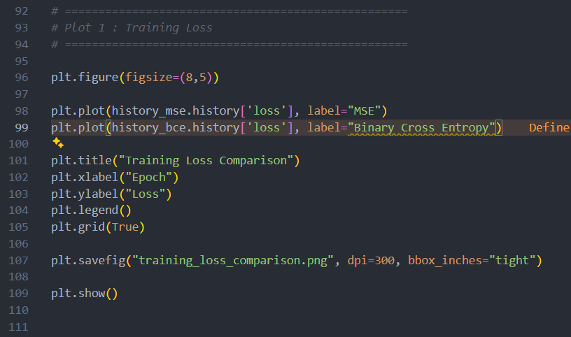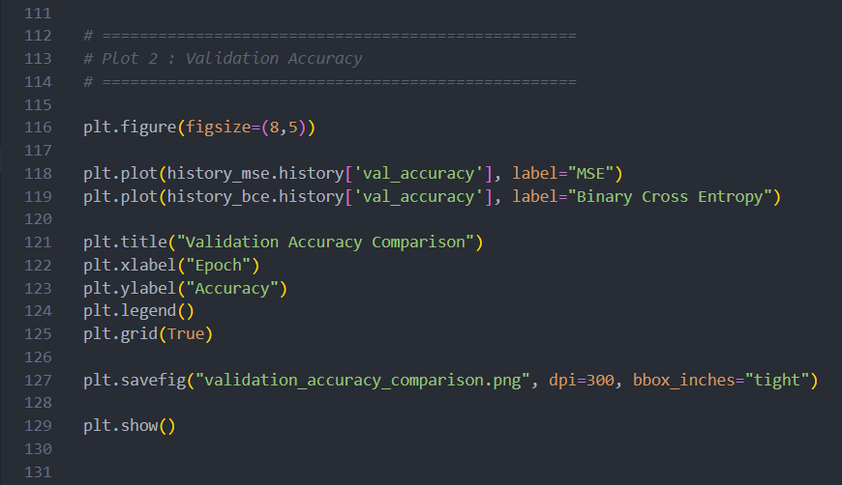
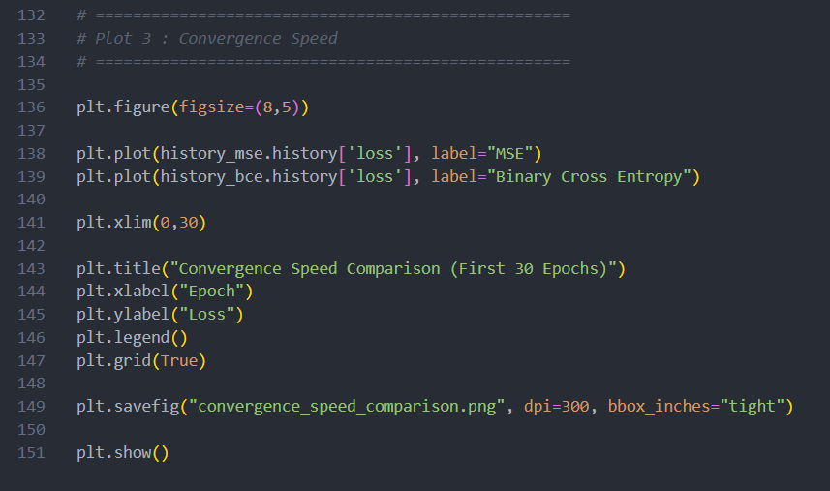

OUTPUT:
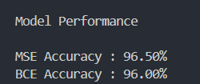

- Compare training loss, accuracy, and convergence speed.

Training Loss:
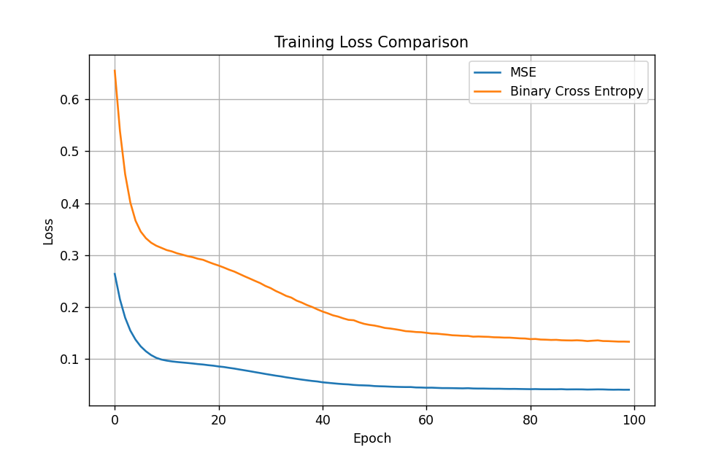

Accuracy:
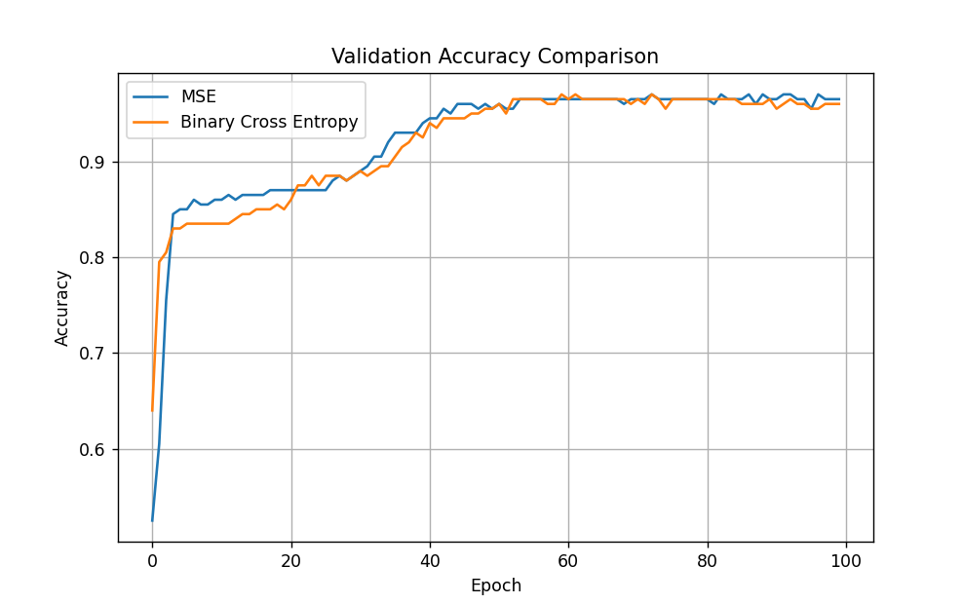

Convergence Speed:

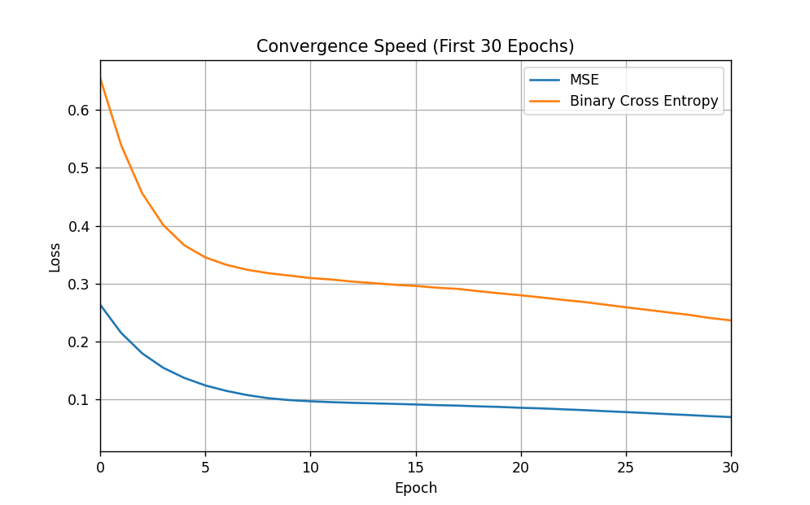

Feature | MSE | BCE
Full Form | Mean Squared Error | Binary Cross Entropy
Main Use | Regression | Binary Classification
Output Layer | Linear output | Sigmoid output
Error Calculation | Squared difference between values | Difference between predicted probability and actual class
Gradient Strength | Weaker for classification | Stronger for classification
Convergence Speed | Slower | Faster
Accuracy Improvement | Gradual | Faster
Probability Prediction | Less suitable | More suitable
Training Efficiency | Lower for classification | Higher for classification
Best Application | Predicting continuous values | Classifying two classes

Deliverables
- Manual calculations
- Python implementation
- Comparison table
- Loss curve
- Conclusion

Exercise 3: Backpropagation from Scratch

Objective
Understand how gradients are propagated through a neural network.

Tasks

- Use W1 = [[0.2,0.3], [0.4,0.1]], W2 = [[0.5], [0.6]], input x = [1,0], target y=1.

Perform forward propagation.

Compute hidden layer activations and output prediction.

Compute the loss.

Derive gradients manually using backpropagation.
Update the weights using gradient descent.
C) BACKPROPAGATION: CALCULATE GRADIENTS
Step 1: Calculate the gradient at the output neuron.
Loss function:
L = (y - y_pred)^2
Derivative of loss with respect to prediction:
dL/dy_pred = 2(y_pred - y)
dL/dy_pred = 2(0.6501 - 1)
dL/dy_pred = -0.6998
Step 2: Calculate the derivative of sigmoid at the output.
Sigmoid derivative:
σ'(z) = σ(z)(1 - σ(z))
σ'(z_out) = y_pred(1 - y_pred)
σ'(z_out) = 0.6501 × (1 - 0.6501)
σ'(z_out) = 0.2275
Step 3: Calculate the output error term.
δ_out = (dL/dy_pred) × σ'(z_out)
δ_out = -0.6998 × 0.2275
δ_out = -0.1592
Step 4: Calculate gradients for W2.
Gradient formula:
dL/dw = δ_out × hidden activation
For weight w1 = 0.5:
dL/dw1 = -0.1592 × 0.5498
dL/dw1 = -0.0875
For weight w2 = 0.6:
dL/dw2 = -0.1592 × 0.5744
dL/dw2 = -0.0914
Therefore:
dL/dW2 = [[-0.0875], [-0.0914]]
Step 5: Calculate hidden layer error terms.
For hidden neuron H1:
δ_h1 = δ_out × w1 × h1(1 - h1)
δ_h1 = -0.1592 × 0.5 × 0.5498 × (1 - 0.5498)
δ_h1 = -0.0197
For hidden neuron H2:
δ_h2 = δ_out × w2 × h2(1 - h2)
δ_h2 = -0.1592 × 0.6 × 0.5744 × (1 - 0.5744)
δ_h2 = -0.0233
Step 6: Calculate gradients for W1.
Gradient formula:
dL/dw = input × hidden error term
For weights connecting input X1 to hidden neurons:
dL/dw11 = 1 × (-0.0197)
dL/dw11 = -0.0197
dL/dw12 = 1 × (-0.0233)
dL/dw12 = -0.0233
For weights connecting input X2 to hidden neurons:
dL/dw21 = 0 × (-0.0197) = 0
dL/dw22 = 0 × (-0.0233) = 0
Therefore:
dL/dW1 = [[-0.0197, -0.0233], [0, 0]]
D) UPDATE WEIGHTS USING GRADIENT DESCENT
Learning rate:
η = 0.1
Weight update formula:
New weight = Old weight - η × Gradient
Step 1: Update W1.
w11_new = 0.2 - 0.1 × (-0.0197)
w11_new = 0.20197
w12_new = 0.3 - 0.1 × (-0.0233)
w12_new = 0.30233
w21_new = 0.4 - 0.1 × 0
w21_new = 0.4
w22_new = 0.1 - 0.1 × 0
w22_new = 0.1
Updated W1:
W1 = [[0.20197, 0.30233], [0.4, 0.1]]
Step 2: Update W2.
w1_new = 0.5 - 0.1 × (-0.0875)
w1_new = 0.50875
w2_new = 0.6 - 0.1 × (-0.0914)
w2_new = 0.60914
Updated W2:
W2 = [[0.50875], [0.60914]]
E) FINAL ANSWERS
- Hidden layer activations:
h1 = 0.5498
h2 = 0.5744
- Output prediction:
y_pred = 0.6501
- MSE loss:
Loss = 0.1224
- Gradients:
dL/dW1 = [[-0.0197, -0.0233], [0, 0]]
dL/dW2 = [[-0.0875], [-0.0914]]
- Updated weights:
W1 = [[0.20197, 0.30233], [0.4, 0.1]]
W2 = [[0.50875], [0.60914]]

- Verify the results using Python.
CODE:
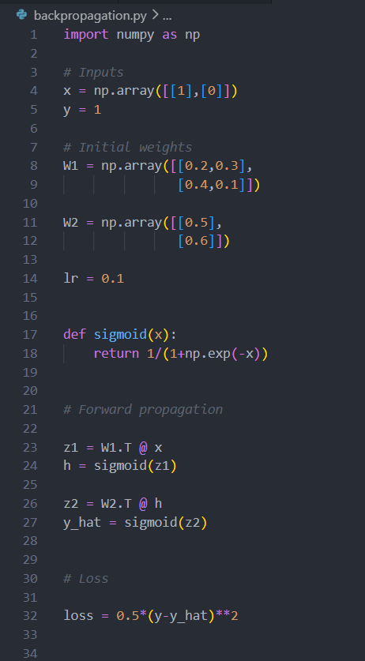
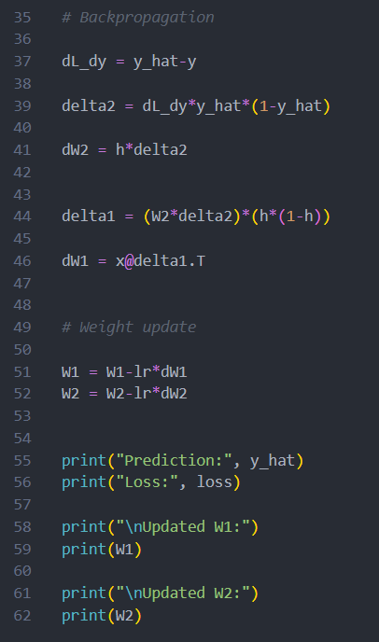

OUTPUT:

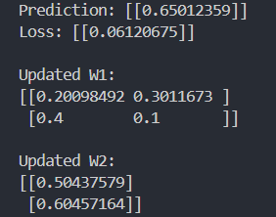

Deliverables
- Complete mathematical derivation
- Updated weights
- Python verification

