NUB CLASS ROUTINE MANAGEMENT SYSTEM
Submitted By
- Rayhan Hossain Siam
41190301415

- Ariful Islam
41190301410

- Ashif Hossain
41190301403
A Project Report Submitted in Partial Fulfillment of the Requirements for
the Degree of Bachelor of Science in Computer Science & Engineering.

DEPARTMENT OF COMPUTER SCIENCE AND ENGINEERING
Northern University Bangladesh
October, 2026

APPROVAL
The Project Report SCMS – Class Routine Management System submitted by Rayhan Hossain Siam (ID: CSE 41190301415), Ariful Islam (ID: CSE 41190301410)
, and Ashif Hossain (ID: CSE 41190301403) to the Department of Computer Science and Engineering, Northern University Bangladesh, has been accepted as satisfactory for the partial fulfillment of the requirements for the degree of Bachelor of Science in Computer Science and Engineering and approved as to its style and contents.
Board of Examiners
1 Muhammed Samsuddoha Alam (Supervisor)
2 (Examiner)
3 (Examiner)

----------------------------
Md. Raihan-ul-Masood
Associate Professor and Head
Department of Computer Science and Engineering

DECLARATION
We, hereby, declare that the work presented in this Project report is the outcome of the investigation performed by us under the supervision of Muhammed Samsuddoha Alam, Department of Computer Science and Engineering, Northern University Bangladesh. We also declare that no part of this Project has been or is being submitted elsewhere for the award of any degree or diploma.
Candidates' Signature

………………………………
Name: Rayhan Hossain Siam
(ID: CSE 41190301415)

………………………………
Name: Ariful Islam
(ID: CSE 41190301410)

………………………………
Name: Ashif Hossain
(ID: CSE 41190301403)

ACKNOWLEDGEMENTS
We would like to begin by expressing our sincere gratitude to Almighty Allah for giving us the strength, patience, and determination to complete our project, “NUB Class Routine Management System (SCMS).” Its completion would not have been possible without the guidance, encouragement, and support of many people.
We would like to express our deepest appreciation to our project supervisor, Muhammed Samsuddoha Alam, Department of Computer Science and Engineering, Northern University Bangladesh. His valuable guidance, constructive criticism, and continuous encouragement helped us improve our work at every stage, from system design and implementation to testing and the preparation of this report.
We are also grateful to the Head of the Department of Computer Science and Engineering, Md. Raihan-ul-Masood, and all the faculty members and staff of Northern University Bangladesh for their academic support and for the resources that helped us complete this project.
We thank everyone who contributed to the development of SCMS through discussions, feedback, and suggestions. The project gave us the opportunity to apply our knowledge of Python, Django, Django REST Framework, React, and SQLite to a practical academic scheduling problem.
Finally, we express our heartfelt gratitude to our parents, families, and friends for their patience, encouragement, and unwavering support throughout our studies and this project.
ABSTRACT
SCMS (Class Routine Management System) is a web-based application that automates the creation and management of academic class routines. It provides role-based interfaces for Administrators, Teachers, and Students. Administrators can manage teachers, courses, rooms, time slots, and routine requirements, generate conflict-free schedules, handle change requests, and import or export records using CSV, PDF, and Excel files. Teachers can view assigned routines, record attendance, and request schedule changes, while Students can view their courses and class routines. The system also supports attendance reporting and secure JWT-based authentication. SCMS was developed using Python, Django, Django REST Framework, React with Vite, and SQLite.

TABLE OF CONTENTS
CHAPTER I INTRODUCTION 9
1.1 Overview 9
1.2 Aim and Objectives of the Project 9
1.3 Background of the Project 10
1.4 Overview of the Project Report 10
CHAPTER II SYSTEM ANALYSIS, DESIGN & DEVELOPMENT TOOLS 11
2.1 System Tools 11
2.2 Flow Chart of the System 12
2.3 Entity Relationship (ER) Diagram 12
2.4 Database Design 13
2.5 Backend – Django & Django REST Framework 14
2.6 Frontend – React 14
2.7 Database – SQLite 14
2.8 Automatic Routine Generation 14
2.9 Bulk Data Management – CSV & Excel 15
2.10 Authentication – JWT 15
2.11 Project Structure (Source & Components) 15
2.12 Use Case Diagrams 15
CHAPTER III PROJECT DEMONSTRATION 17
3.1 Administrator Dashboard 18
3.2 Teachers Module 18
3.3 Courses Module 19
3.4 Routines Module 19
3.5 Rooms Module 20
3.6 Time Slots Module 20
3.7 Routine Requirements Module 20
3.8 Generate Routine (Auto-Scheduling) 21
3.9 Change Requests Module 22
3.10 Teacher Dashboard 22
3.11 Student Dashboard 23
CHAPTER IV SYSTEM TESTING & REPORTS 24
4.1 Report 25
4.2 Testing Overview 25
4.3 Errors & Bugs 26
4.4 Solutions 26
CHAPTER V CONCLUSION AND FUTURE SCOPE 27
5.1 Conclusion 28
5.2 Future Scope 28
REFERENCES 29

LIST OF FIGURES
Figure 2.1: Flow Chart of the System 12
Figure 2.2: Entity Relationship Diagram 13
Figure 2.3: Use Case Diagram for Administrator 16
Figure 2.4: Use Case Diagram for Teacher 16
Figure 2.5: Use Case Diagram for Student 17
Figure 3.1: Screenshot of Admin Dashboard & Teacher Attendance Report 18
Figure 3.2: Screenshot of Teachers Module 19
Figure 3.3: Screenshot of Courses Module 19
Figure 3.4: Screenshot of Routines Module 19
Figure 3.5: Screenshot of Rooms Module 20
Figure 3.6: Screenshot of Time Slots Module 20
Figure 3.7: Screenshot of Routine Requirements Module 21
Figure 3.8: Screenshot of Generate Routine (Auto-Scheduling) 21
Figure 3.9: Screenshot of Change Requests Module 22
Figure 3.10: Screenshot of Teacher Dashboard 22
Figure 3.11: Screenshot of Student Dashboard 23

LIST OF TABLES
Table 2.1: Technology Stack 11
Table 2.2: Database Design (Entities and Key Fields) 14
Table 4.1: Test Cases and Results 28

CHAPTER I
INTRODUCTION

1.1 Overview
This project builds a web application, SCMS, to manage the academic scheduling process between administrators, teachers, and students. The main objective of the system is to provide a centralized platform where an Administrator can build class routines automatically from a set of scheduling requirements, or manually when needed, while Teachers view their assigned routines and record attendance, and Students view the routines for their enrolled courses. The Administrator has full control over the system, including managing teacher, course, room, and time-slot records (individually or in bulk via CSV import), defining routine requirements, running the automatic routine generator, and reviewing change requests submitted by teachers.

1.2 Aim and Objectives of the Project
The aim of this project is to replace manual, spreadsheet-based routine management with a secure, centralized, and largely automated web application. The specific objectives are:
- An automatic routine-generation engine driven by configurable requirements (course, teacher, section, sessions per week, room type).
- Dynamic, role-based dashboards for Admin, Teacher, and Student.
- Bulk record management through CSV template download and import for teachers, courses, rooms, and time slots.
- Export of the generated routine as PDF or Excel, and the ability to import and replace an existing routine.
- Attendance tracking through teacher check-in / check-out, summarized as present/absent days on the Admin Dashboard.
- A change-request workflow so teachers can request routine corrections, which the Admin can approve or reject.
- Secure, JWT-based authentication protecting all API endpoints.

1.3 Background of the Project
In most departments, a large number of students are taught by a limited number of teachers across many courses, sections, and rooms. At the start of every semester, a class schedule must be prepared that avoids clashes between teachers, rooms, and sections – a task that is difficult and time-consuming to do by hand as the number of courses grows. To address this problem, SCMS was developed to let the institution define what needs to be scheduled (as “requirements”) and have the system automatically compute a conflict-free timetable, while still allowing the Administrator to review, adjust, and finalize the result. The system was built using Python (Django, Django REST Framework), React, and SQLite.

1.4 Overview of the Project Report
The rest of this report is organized as follows:
- Chapter II discusses the overall system analysis, design, and the development tools used for the project.
- Chapter III presents a demonstration of the system through its main modules and interfaces, with screenshots taken from the running application.
- Chapter IV covers system testing, reports generated by the system, and the testing methodology used.
- Chapter V concludes the report with a summary of the project and an outline of future scope. References are listed at the end of the report.
CHAPTER II
SYSTEM ANALYSIS, DESIGN & DEVELOPMENT TOOLS

2.1 System Tools
SCMS is a web-based application. The tools used to build it are listed below:
Layer | Technology Used
Frontend | React (Vite build tool), JavaScript, CSS
Backend | Python, Django, Django REST Framework (DRF)
Database | SQLite
API Communication | REST API via Axios
Authentication | JWT (JSON Web Token) based authentication, secure password hashing, protected API endpoints, and frontend route protection
Bulk Data Handling | CSV template download / import for Teachers, Courses, Rooms, and Time Slots; Excel export/import for Routines
Version Control | Git

Table 2.1: Technology Stack

2.2 Flow Chart of the System
The following flow chart describes the overall system flow of SCMS. After a user logs in, they are directed to a dashboard specific to their role. The Administrator can manage teachers, courses, rooms, and time slots; define routine requirements; auto-generate the routine; export or replace it; review attendance; and manage change requests. Teachers can view their routine, check in/out, and submit change requests. Students can view their routine and enrolled courses.
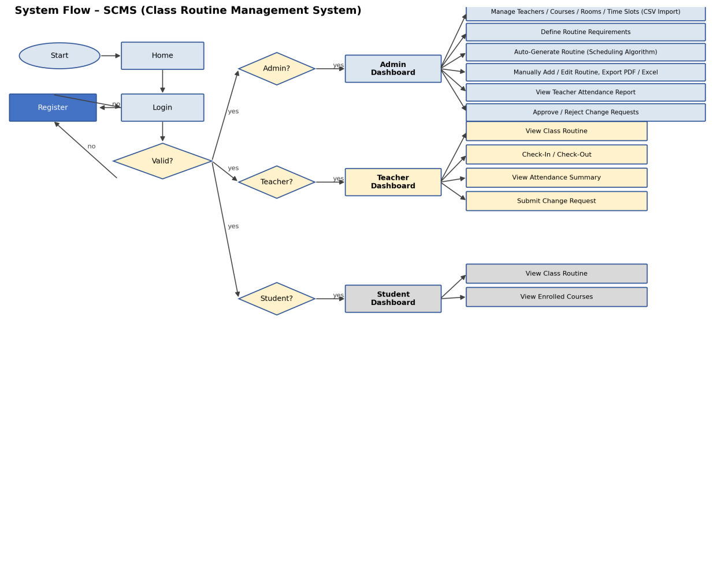
Figure 2.1: Flow Chart of the System

2.3 Entity Relationship (ER) Diagram
The ER diagram below shows the core entities of the system and how they relate to one another. A User is either a Teacher or a Student. A Teacher teaches Routine entries, submits Change Requests, and has CheckInOut (attendance) records. A Routine Requirement (course, teacher, section, sessions/week, room type) is auto-generated into concrete Routine entries, each of which uses a Course, a TimeSlot, and a Room. Students view the Routine entries relevant to their section.
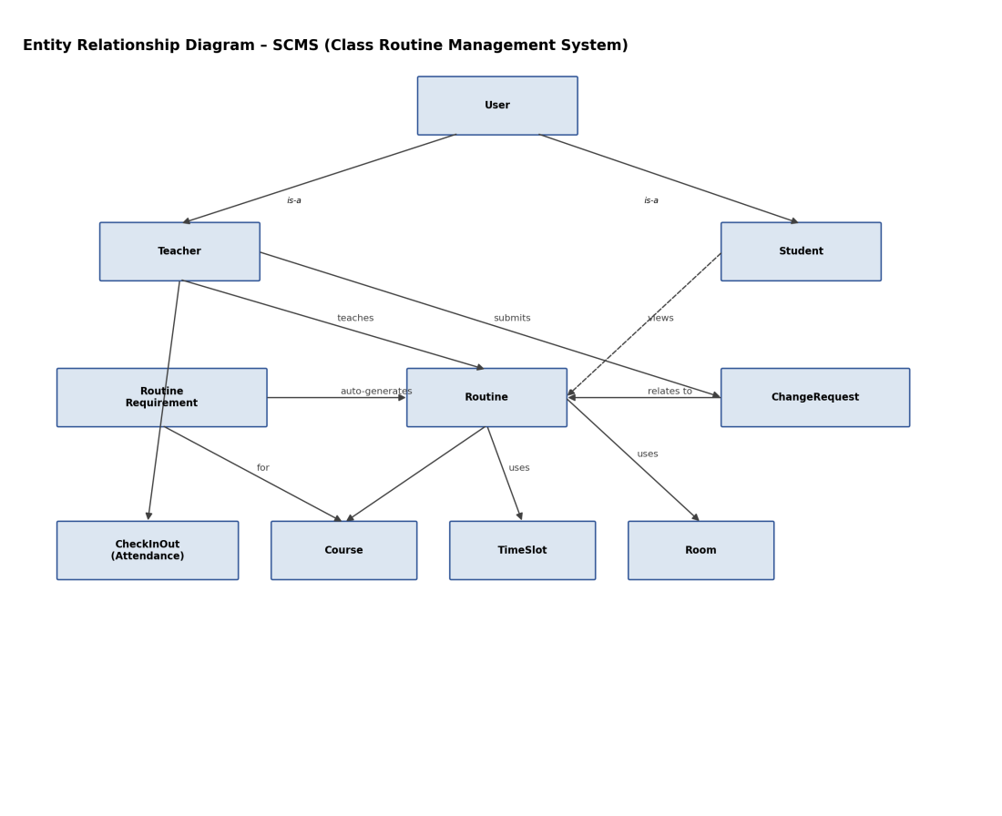
Figure 2.2: Entity Relationship Diagram

2.4 Database Design
Entity | Key Fields | Description
User | id, username, password, role | Base authentication record with a role flag (admin/teacher/student).
Teacher | id, user (FK), name, acronym, designation, department, mobile, specializations | Teacher-specific profile information.
Student | id, user (FK), name, section | Student-specific profile information.
Course | id, name, code, credit | A subject/course taught in the institution.
Room | id, name, type | A physical room (e.g., theory or lab) that can host classes.
TimeSlot | id, order, label, start_time, end_time | A defined period of the day (e.g., Morning 08:00–09:20).
RoutineRequirement | id, course (FK), teacher (FK), section, sessions_per_week, room_type | Defines what needs to be scheduled; feeds the auto-generation engine.
Routine | id, day, course (FK), section, teacher (FK), time_slot (FK), room (FK), students | A single scheduled class entry, whether auto-generated or manually created.
CheckInOut | id, teacher (FK), date, present, absent | Tracks teacher attendance, aggregated into present/absent day counts.
ChangeRequest | id, routine (FK), requested_by (FK), reason, status, date | Requests to modify a routine entry, reviewed by the Admin.

Table 2.2: Database Design (Entities and Key Fields)

2.5 Backend – Django & Django REST Framework
Django is a high-level Python web framework that encourages rapid development and clean, pragmatic design. Django REST Framework (DRF) extends Django to expose the application's data as RESTful API endpoints, using serializers to convert model instances to and from JSON. In this project, the backend defines the data models, serializers, views, URL routes, custom permission classes, and the routine auto-generation algorithm that assigns each required session to a day, time slot, and room without conflicts.

2.6 Frontend – React
React is a JavaScript library for building user interfaces from reusable components. This project uses Vite as the build tool for fast development and bundling. Pages such as the Dashboard, Teachers, Courses, Routines, Rooms, Time Slots, Requirements, Generate Routine, and Change Requests are implemented as individual React components sharing a common layout and navigation sidebar.

2.7 Database – SQLite
SQLite is a lightweight, file-based relational database that requires no separate server process, making it well-suited for small to medium institutional deployments. All application data – users, teachers, courses, rooms, time slots, routines, requirements, and attendance records – is stored and queried through Django's Object-Relational Mapper (ORM).

2.8 Automatic Routine Generation
A key feature of SCMS is its automatic routine-generation engine. The Administrator first defines Routine Requirements – specifying, for each course, the assigned teacher, section, number of sessions per week, and required room type. On the Generate Routine screen, the Administrator selects the requirements to schedule and clicks Generate Preview; the system's scheduling algorithm then assigns each session to a day, time slot, and room while avoiding teacher, section, and room clashes. The result is shown as a preview table with a Placed/Unplaced summary (for example, ‘14 placed / 0 unplaced of 14 sessions’), and each row's day, time slot, and room can still be adjusted through dropdowns before the Administrator finalizes the routine.

2.9 Bulk Data Management – CSV & Excel
To reduce manual data entry, the Teachers, Courses, Rooms, and Time Slots modules each provide a Download Template button (to obtain a correctly formatted CSV file) and an Import CSV button (to bulk-create or update records from a filled-in template). The Routines module additionally supports Export PDF and Export Excel for distributing the finalized routine, and an Import & Replace Routine option to bulk-update the schedule from an external file.

2.10 Authentication – JWT
The system uses JWT (JSON Web Token) based authentication. On successful login, the backend issues a signed token that the frontend stores and attaches to subsequent API requests to prove the user's identity and role. Passwords are stored using secure hashing rather than plain text, and protected frontend routes prevent unauthenticated users from directly navigating to pages outside their role.

2.11 Project Structure (Source & Components)
The project is organized into a Django backend and a React frontend:
- backend/config/ – project-level settings, URL routing, ASGI/WSGI configuration.
- backend/routine/ – the main app: models, views, serializers, URLs, permissions, the routine-generation algorithm, and tests.
- frontend/src/pages/ – Dashboard, Teachers, Courses, Routines, Rooms, Time Slots, Requirements, Generate Routine, and Change Requests pages.
- frontend/src/components/ – reusable layout, table, and modal components shared across pages.
- frontend/src/context/ – authentication context and hook for global auth state.
- frontend/src/api/ – Axios instance configuration for backend communication.

2.12 Use Case Diagrams
The following use case diagrams summarize the actions available to each type of user in the system.
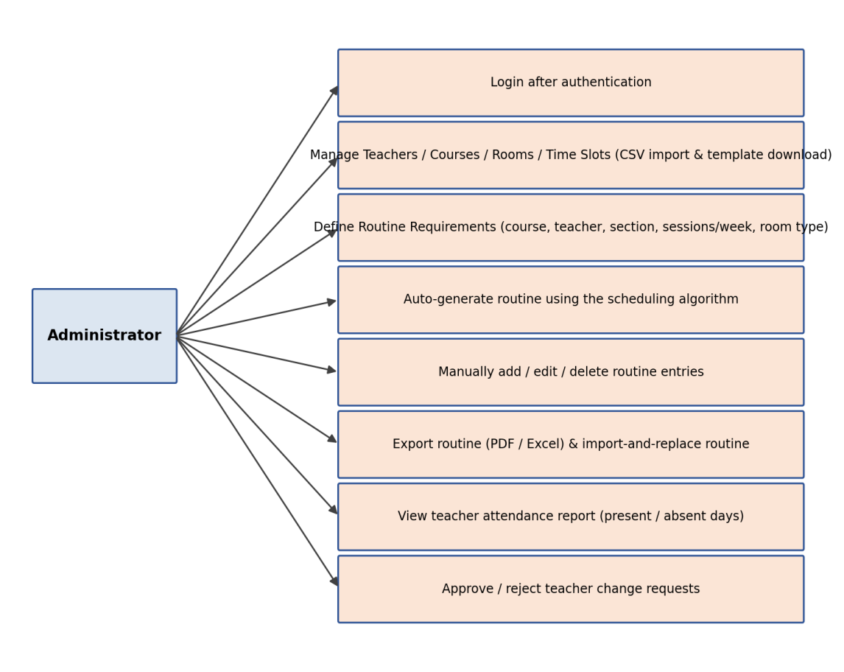
Figure 2.3: Use Case Diagram for Administrator
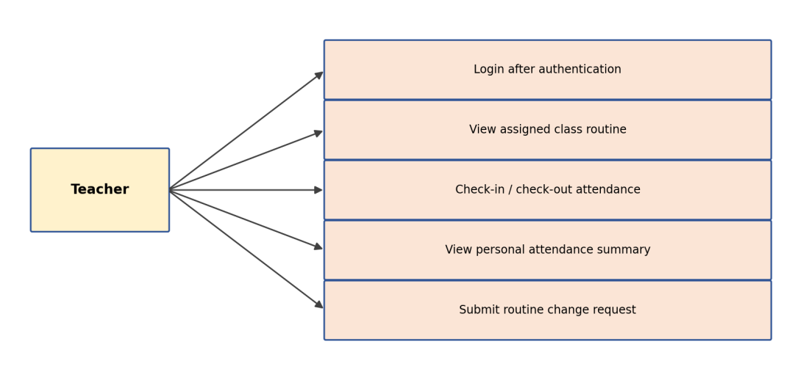
Figure 2.4: Use Case Diagram for Teacher
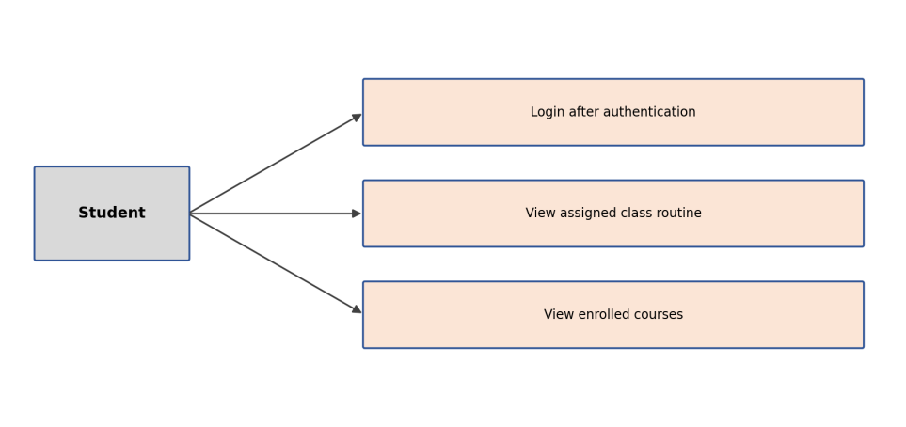
Figure 2.5: Use Case Diagram for Student
CHAPTER III
PROJECT DEMONSTRATION

This chapter presents the main interfaces of SCMS using screenshots captured from the running application.

3.1 Administrator Dashboard
The Administrator Dashboard shows an overview of the system – total Teachers, Courses, All Routines, and Change Requests – along with a Teacher Attendance report that can be filtered by teacher, month, year, and day, showing each teacher's present and absent day counts.
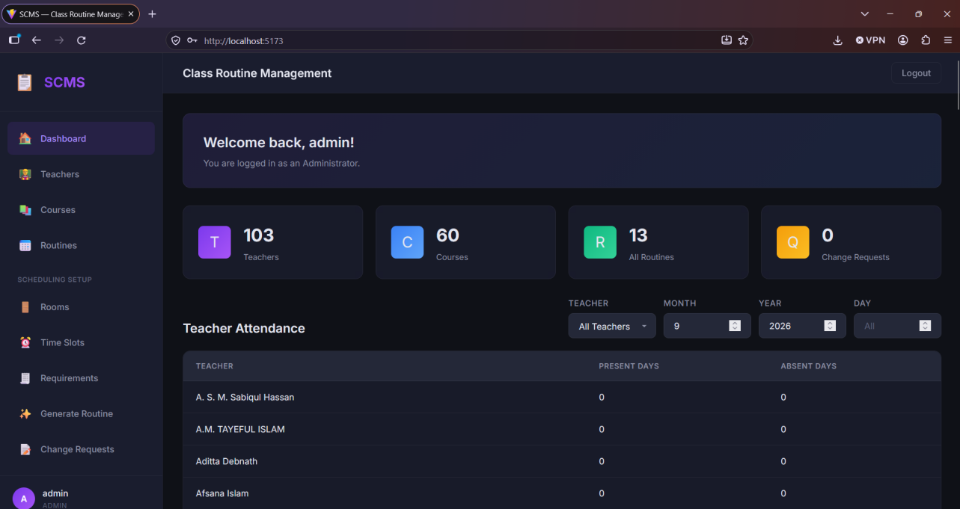
Figure 3.1: Screenshot of Admin Dashboard & Teacher Attendance Report 18

3.2 Teachers Module
The Teachers module lists every teacher with their ID, name, email, acronym, designation, department, mobile number, and specializations. The Administrator can add a teacher individually (+ Add Teacher), download a CSV template, or bulk-import teachers via Import CSV, in addition to editing or deleting existing records.
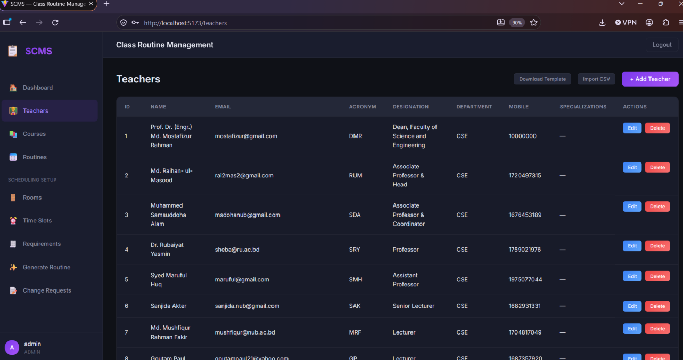
Figure 3.2: Screenshot of Teachers Module 19

3.3 Courses Module
The Courses module lists each course's ID, name, code, and credit value, with the same Download Template / Import CSV / Add Course tools and per-row Edit/Delete actions available to the Administrator.
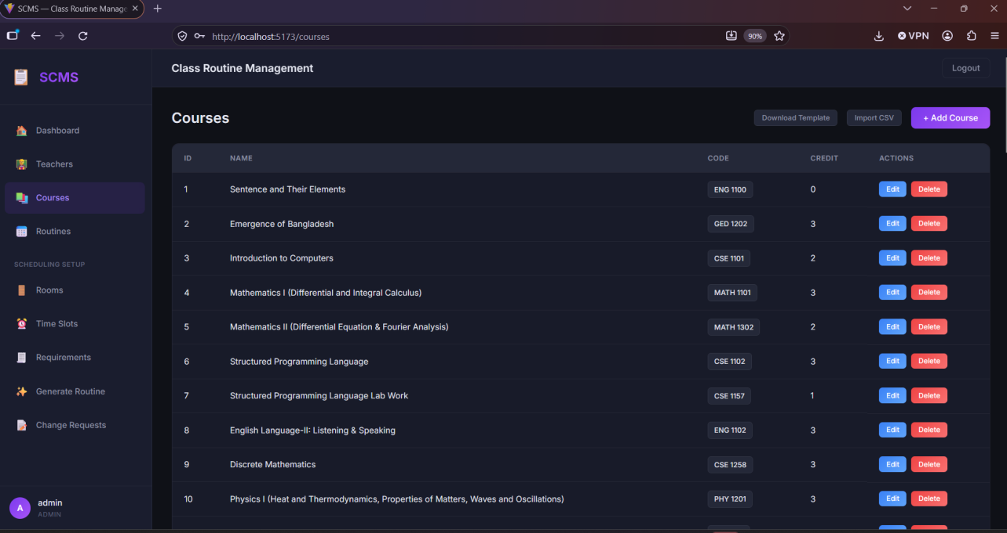
Figure 3.3: Screenshot of Courses Module 19

3.4 Routines Module
The Routines module lists every scheduled class entry with its day, course, section, teacher, time, room, and number of students assigned. From here the Administrator can Export PDF, Export Excel, Import & Replace Routine, or manually Add Routine, in addition to editing or deleting individual entries.
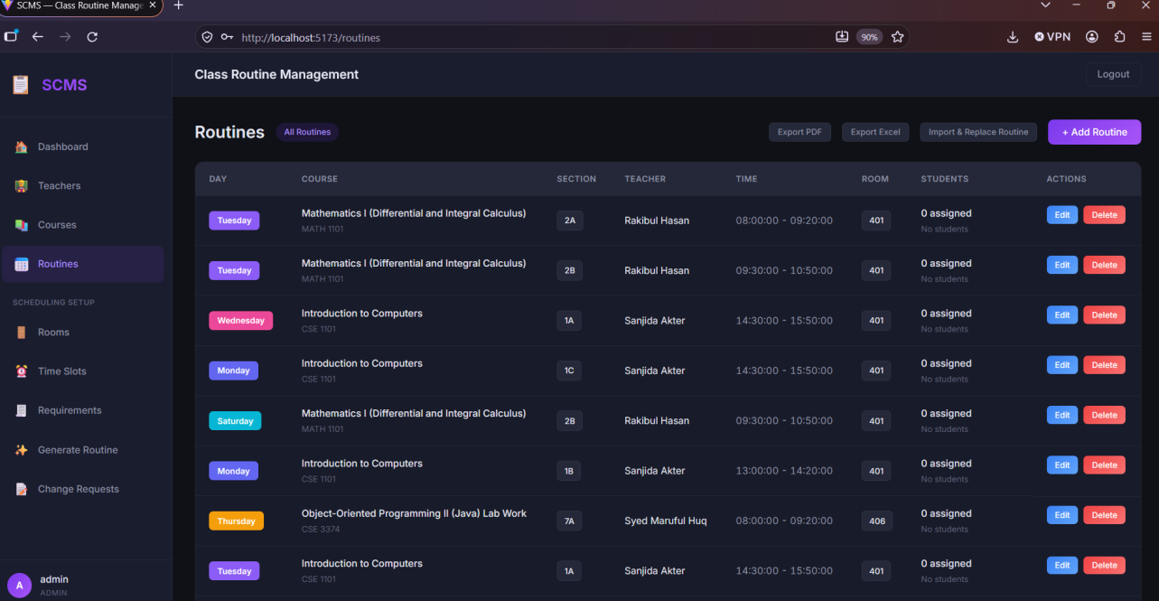
Figure 3.4: Screenshot of Routines Module 19

3.5 Rooms Module
The Rooms module manages the physical rooms available for scheduling, each with a name and type (e.g., Theory), and supports the same template download / CSV import / manual add workflow as the Teachers and Courses modules.
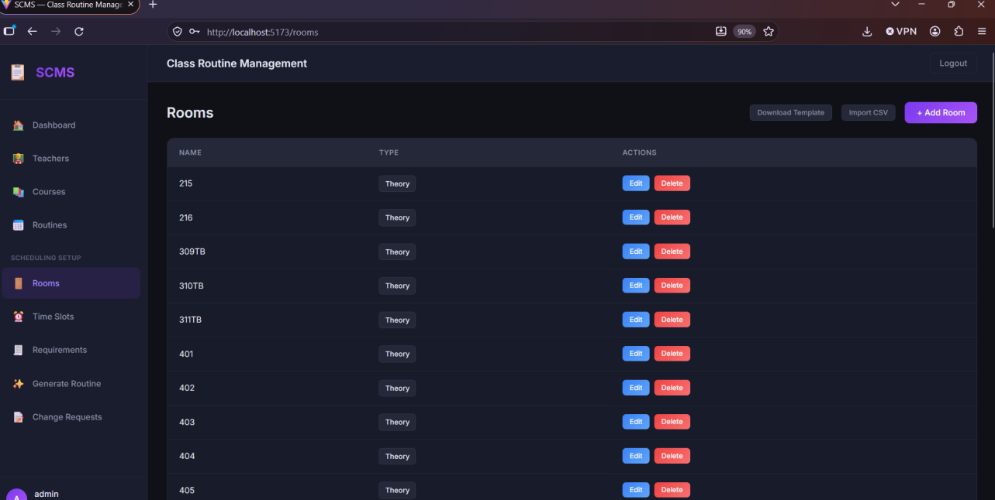
Figure 3.5: Screenshot of Rooms Module 20

3.6 Time Slots Module
The Time Slots module defines the ordered list of periods used when building a routine, each with a label (e.g., Morning, Evening), a start time, and an end time.
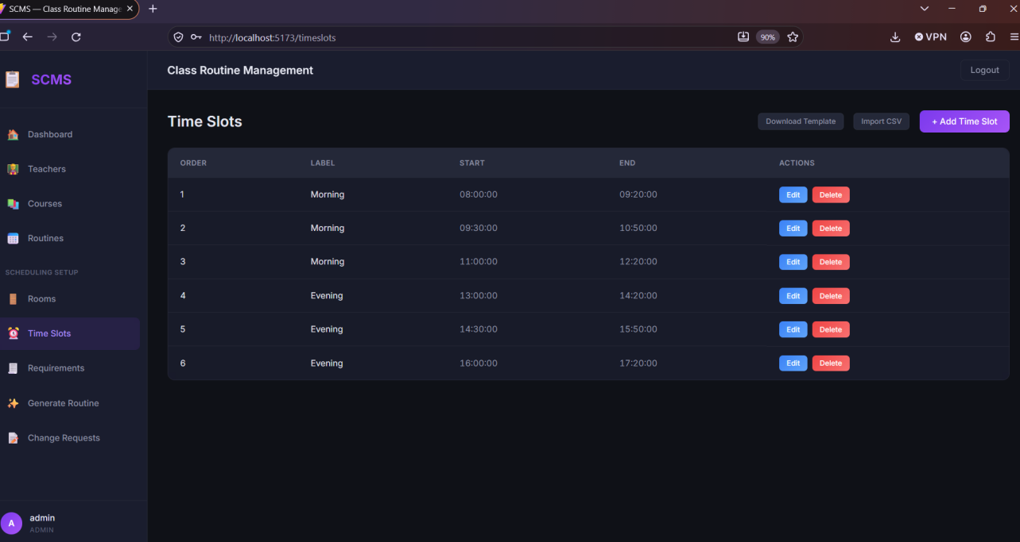
Figure 3.6: Screenshot of Time Slots Module 20

3.7 Routine Requirements Module
The Routine Requirements module is where the Administrator specifies what needs to be scheduled: for each course/teacher/section combination, how many sessions per week are needed and what room type is required. These requirements are the input to the automatic routine generator.
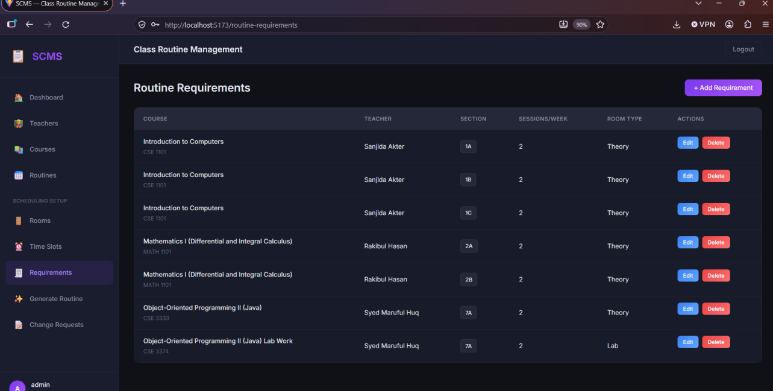
Figure 3.7: Screenshot of Routine Requirements Module 21

3.8 Generate Routine (Auto-Scheduling)
On the Generate Routine screen, the Administrator selects which requirements to schedule and clicks Generate Preview. The scheduling algorithm then proposes a day, time slot, and room for every session, reporting a Placed/Unplaced summary (14 placed / 0 unplaced of 14 sessions in the example below). Each proposed row can still be fine-tuned through its Day, Time Slot, and Room dropdowns before the routine is finalized.
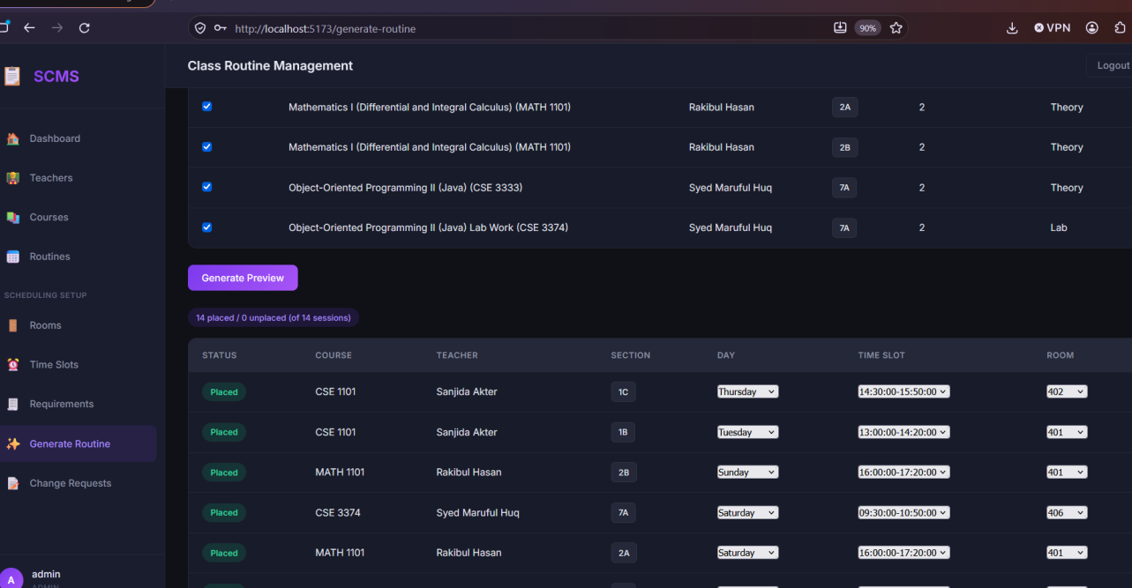
Figure 3.8: Screenshot of Generate Routine (Auto-Scheduling) 21

3.9 Change Requests Module
The Change Requests module lists requests submitted by teachers to modify a routine entry, showing the related routine, requester, reason, status, and date. The Administrator reviews and approves or rejects each request from this screen.
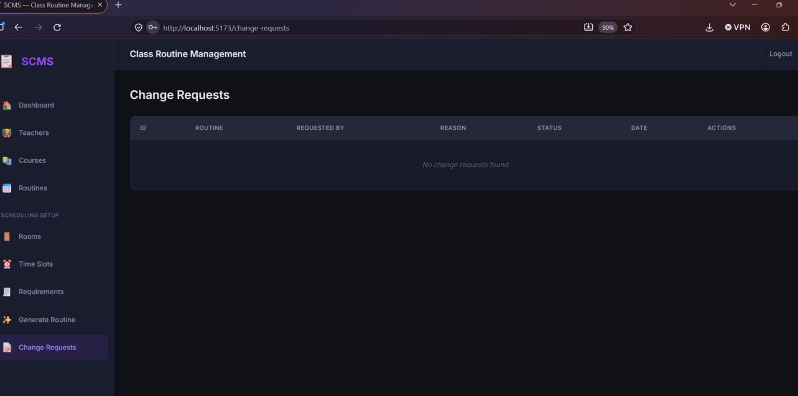
Figure 3.9: Screenshot of Change Requests Module 22

3.10 Teacher Dashboard
The Teacher Dashboard shows the logged-in teacher's assigned class routine and provides check-in / check-out controls for attendance, along with the option to submit a routine change request.
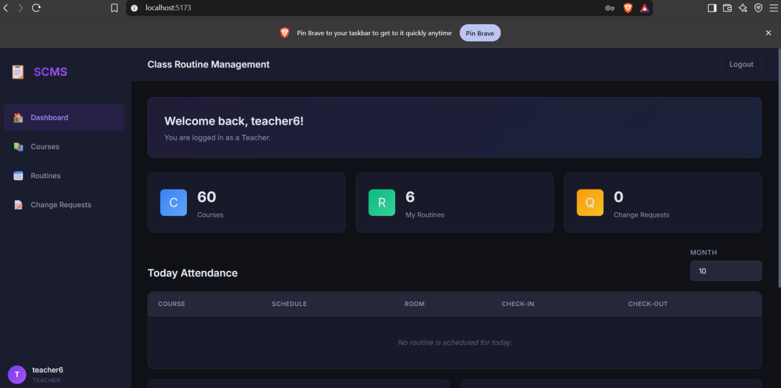
Figure 3.10: Screenshot of Teacher Dashboard

3.11 Student Dashboard
The Student Dashboard gives a simplified view for students, limited to Dashboard, Courses, and Routines in the sidebar. It shows the total number of courses and the number of routine entries relevant to the logged-in student.
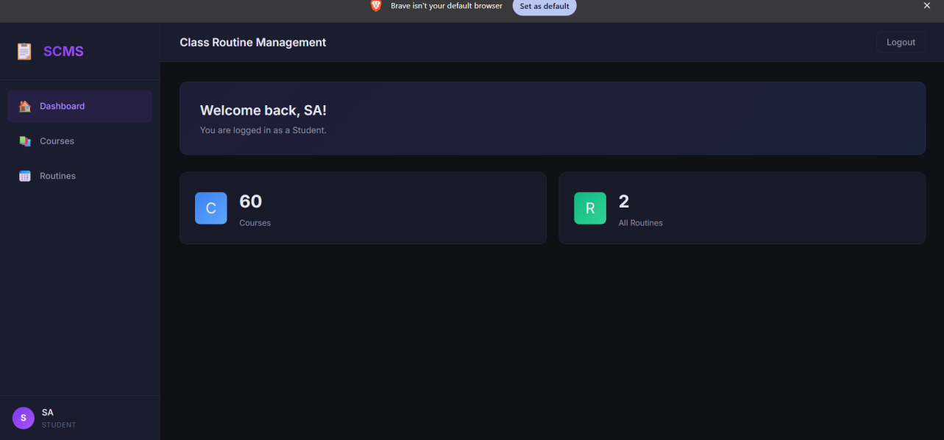
Figure 3.11: Screenshot of Student Dashboard 23
CHAPTER IV
SYSTEM TESTING & REPORTS

4.1 Report
The system generates the following categories of information for its users:
- Class Routine: the schedule of classes, including day, time slot, course, teacher, section, and room.
- Teacher Information: name, acronym, designation, department, mobile, and specializations.
- Attendance Report: each teacher's present and absent day counts, filterable by teacher, month, year, and day.
- Routine Generation Report: a Placed/Unplaced summary produced each time the auto-scheduling engine is run.
- Change Request Report: a log of submitted change requests along with their current status (pending, approved, or rejected).

4.2 Testing Overview
Testing was carried out to verify the correctness and reliability of the system's core features, in particular the routine auto-generation engine, CSV import/export tools, and role-based access control. Manual integration testing was performed across the Admin, Teacher, and Student interfaces to confirm that permissions and page navigation worked as intended.
Test Case | Input | Expected Output | Result
Admin login | Valid admin credentials | Redirect to Admin Dashboard | Pass
CSV import – Teachers | Valid filled-in teacher template | Multiple teacher records created | Pass
Define routine requirement | Course, teacher, section, sessions/week, room type | Requirement saved and listed | Pass
Auto-generate routine | Selected requirements, Generate Preview | Sessions placed into conflict-free day/time-slot/room | Pass
Export routine – PDF/Excel | Click Export PDF / Export Excel | Downloadable file with current routine | Pass
Teacher check-in | Teacher taps Check-In | Attendance recorded for current date | Pass
Student routine view | Student login | Only relevant routine displayed, read-only | Pass
Unauthorized access | Student attempts admin route | Access denied / redirected | Pass
Change request approval | Admin approves a pending request | Request status updated to Approved | Pass

Table 4.1: Test Cases and Results

4.3 Errors & Bugs
During testing, no critical or blocking bugs were identified in the core workflows described above, including the auto-generation engine's conflict-avoidance logic. Minor issues (such as CSV template formatting edge cases) were identified and resolved during development.

4.4 Solutions
Where minor issues were found, stricter template validation and clearer error messages were added to the CSV import tools. Should further issues arise after deployment, they can be resolved through the same iterative process of testing, bug-fixing, and re-validation.
CHAPTER V
CONCLUSION AND FUTURE SCOPE

5.1 Conclusion
SCMS successfully automates the process of creating and distributing class routines through a secure, role-based web application. Its automatic routine-generation engine – driven by configurable requirements for course, teacher, section, sessions per week, and room type – removes the most time-consuming part of manual scheduling, while still giving the Administrator full control to fine-tune and finalize the result. Bulk CSV import/export for teachers, courses, rooms, and time slots, PDF/Excel export of the routine, teacher attendance tracking, and a structured change-request workflow make the system practical for real institutional use. The project demonstrates the effective use of Django, Django REST Framework, React, and SQLite in building a complete full-stack web application.

5.2 Future Scope
The following enhancements are planned or recommended for future versions of the system:
- Email/SMS notifications for routine creation, updates, and cancellations.
- Further conflict-detection refinements in the auto-generation algorithm (e.g., teacher workload balancing).
- Migration to a more scalable database (e.g., PostgreSQL or MySQL) for larger deployments.

REFERENCES
[1] Django Software Foundation, Django Documentation, https://docs.djangoproject.com/
[2] Django REST Framework Documentation, https://www.django-rest-framework.org/
[3] React Documentation, https://react.dev/
[4] Vite Documentation, https://vitejs.dev/
[5] SQLite Documentation, https://www.sqlite.org/docs.html
[6] JSON Web Tokens (JWT) Introduction, https://jwt.io/introduction
[7] Stack Overflow, https://stackoverflow.com/

