**Computer Systems Technology**

British Columbia Institute of Technology

COMP 8005 - Assignment2- How-to

Albert Huang&

Aiyan Ma

Mar 5, 2018

Revision History

|  |  |  |  |  |
| --- | --- | --- | --- | --- |
| **No** | **Date** | **Version** | **Revised by** | **Remarks** |
| 1 | 2018-Feb-26 | V0.1 | Aiyan,Ma | The initial draft for Java version How-to |
| 2 | 2018-Mar-05 | V1.0 | Albert, H. | Combine python and java version to one |

# Table of Contents

Table of Contents 2

1. Python Mode 3

1.1 Running the Multi-Thread Server 3

1.2 Running the Epoll Server (Edge Trigger) 3

1.3 Running the Epoll Server (Level Trigger) 4

1.4 Running the General Client 4

2. Java Mode 5

2.1 EPoll Server 5

2.2 Poll Server 6

2.3 To start the MT Server 6

2.4 Start the SuperClient 7

# Python Mode

## 1.1 Running the Multi-Thread Server

1. Ensure you are running the terminal as root.
2. Ensure you have release enough file descriptors for your server to create connections:

**#ulimit -n 1000000**

**#python3 <script name> <port number>**

**Eg. #python3 multithread.py 10000**

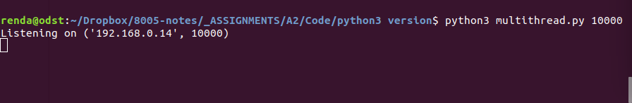

## 1.2 Running the Epoll Server (Edge Trigger)

1. Ensure you are running the terminal as root.
2. Ensure you have release enough file descriptors for your server to create connections:

**#ulimit -n 1000000**

**#python3 <script name> <port number>**

**Eg. #python3 epoll_ET.py 10000**

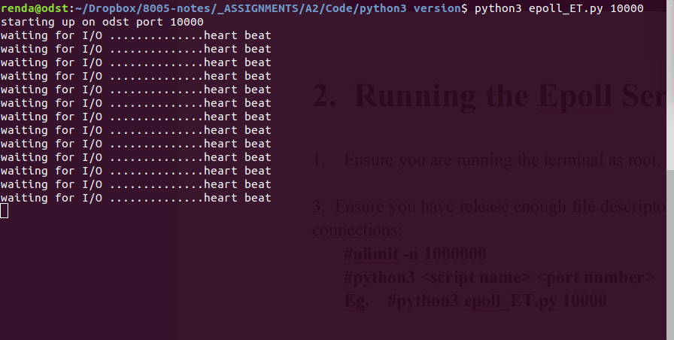

## 1.3 Running the Epoll Server (Level Trigger)

1. Ensure you are running the terminal as root.
2. Ensure you have release enough file descriptors for your server to create connections:

**#ulimit -n 1000000**

**#python3 <script name> <port number>**

**Eg. #python3 epoll_LT.py 10000**

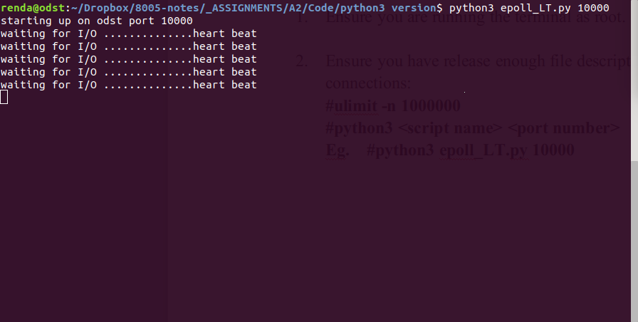

## 1.4 Running the General Client

1. Ensure you are running the terminal as root.
2. Ensure you have release enough file descriptors for your server to create connections:

**#ulimit -n 1000000**

1. Ensure you have enough ports to assign to connect to server side(option)

**#vim /etc/sysctl.conf**

**Then add a line like below:**

**Net.ipv4.ip_local_port_range = <min value> <max value>**

**Then save and exit;**

**Run : sysctl -p**

1. Run your client to start working:

**#python3 <script path> <ip address> <port number> <packets number> <sleepping duration> <threads per process>**

**Eg. #python3 select_client.py 192.168.0.14 10000 3 8 500**

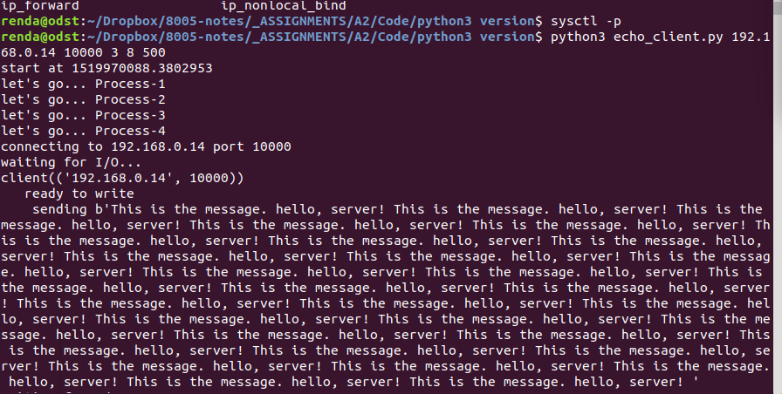

# Java Mode

There are four applications in java mode: i.e , three servers plus one client.

Server:The EPoll server, Poll server and Multi-Thread Server.

Client: the SuperClient.

Before running the command, execute the following as root:

1 increase the fd to 100K

#ulimit -n 100000

2 increase the heap memory

#java -Xss1024m -Xms4096m -Xmx5120m

## 2.1 EPoll Server

To Run it in java mode by default parameters:

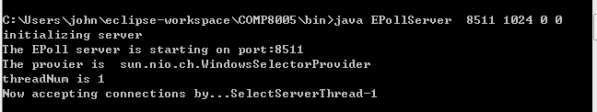

To show the usage, just using *-h*

Usage: {PORT} {BUFFER_SIZE(B)} {CPU (0|1)} {IO(0|1)}

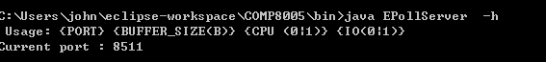

## 

## 2.2 Poll Server

#java -Djava.nio.channels.spi.SelectorProvider=sun.nio.ch.PollSelectorProvider PollServer

The parameters can be specified are:

Usage: {PORT} {BUFFER_SIZE(B)} {CPU (0|1)} {IO(0|1)}

Example:

java -Djava.nio.channels.spi.SelectorProvider=sun.nio.ch.PollSelectorProvider PollServer 8511 1024 0 0

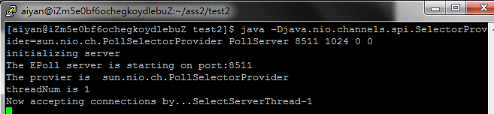

## 

## 2.3 To start the MT Server

By using the following command:

#java MTserver



## 2.4 Start the SuperClient

SuperClient is a test client designed to running tirelessly send payload to the target server.

To start the SuperClient, run the following command:

Java SuperClient {IP} {PORT} {INTERVAL(Nanos)} {PACKET_SIZE}

*$[aiyan@iZm5e0bf6ochegkoydlebuZ test]$ java SuperClient localhost 8099 1000 1024*

Example:

