Draft Letter

David Hood

3/14/24

Things David knows he still needs to do (that don’t alter overall content):

* more proofreading.
* standard citation format.
* clear links to source data.
* standard figure look
* Captions under graphs.

*The timetable is: I am welcoming changes up to Thursday 21st and regularly updating the draft here until then. On Thursday 21st I will make what I expect to be any final changes. On Friday 22nd I will be distribution the final draft to people who have expressed an interest in co-signing, with an aim to send it to the journal early in the week beginning Monday 25th.*

To the editor and editorial board,

I am formally writing to point out the significant errors in the paper from Gibson (2024)[1], published in your journal, as I feel both you and your readership should be aware of the problems before basing any decisions on the claims made. In particular, the paper asserts two claims:

* That claims of negative New Zealand mortality are underpinned by the “Our World In Data” projection graph using the method of Karlinsky & Kobak[2].
* That Gibson’s method, producing positive excess mortality, is more effective than Karlinsky & Kobak in determining mortality as it adjusts for population change due to immigration changes.

Neither of these claims are accurate.

# The underpinning of New Zealand’s mortality measurement

For centuries, it has been established practice among actuaries, demographers, and health researchers to measure mortality using death rates by age where such data is available[3]. This method superseded Crude Mortality Rates, where CMR takes into account total population change in comparisons by dividing the total number of deaths by the total number of people available to die, improving CMR by acknowledging that different ages have different risks of death, so comparing age-based risk of death on a uniform basis. In New Zealand, tutorials on making mortality comparisons by using death rates by age and standardising to a reference population have been published since the 1890s[4].

Age Standardised Mortality directly adjusts for both population growth and aging, as it is based on the number of deaths of the current resident population divided by the living current resident population, stratified by age group and time period. This directly measures the population change effects Gibson is trying to model.

While calculation of New Zealand’s cumulative excess mortality for 2020-2022 can vary by a couple of percentage points depending on the exact method, using a death rates by age (standardised) method the Institute of Actuaries finds New Zealand’s excess mortality from week 10 2020 to the end of 2022 to be -4% (that there are 4% fewer deaths than would be expected based on pre-COVID-19 trends)[5].

The Our World in Data graph, and the Karlinsky and Kobak method that underlies it, is an approximation (if it is a better or worse approximation to Gibson’s method will be discussed later). While recognising the Our World In Data graph is an approximation, there are still several practically useful implicit features about it:

* Being based on trends of deaths, it enables a common basis comparison with countries that lack age stratified current population information
* It makes weekly comparisons available.
* Able to be checked by any member of the public for the latest current worldwide information. This last is a function of Our World in Data presentation rather than the method, but it is still a practical benefit.

While the existence of centuries of mortality measurement (not mentioned in Gibson’s article) does not directly address if New Zealand medical professionals are aware that best practice mortality calculations recognise that people of different ages die at different rates when using the publicly available Our World in Data graphs in media pieces, it does establish that there is an established methodology, not mentioned in Gibson’s article, underpinning claims of New Zealand’s negative excess, and that method has been used for centuries, world-wide, across multiple disciplines. We can check if New Zealand medical professionals are aware of this by asking them: *“the key point being any comparisons both within country (over time) or between countries should be age standardised to provide the most accurate picture possible (and of course be based on high quality and complete underlying deaths data which we can say NZ’s are!)”*(Ashley Bloomfield) [6].

## Age Standardised Mortality Review

As Age Standardised Mortality is a standard across multiple disciplines, but is not raised in the Gibson paper, a brief review is in order.

Death rates for an age stratified group, for a time period in a given location, measure the rate at which that age group dies. These can be directly compared to death rates in other time periods and locations to measure if the group experience is more or less deadly. As it is a rate, it automatically adjusts for change in the population size of the age group.

While this enables direct comparisons of people of the same age, it does not enable total population comparisons (as total populations may have different age structures). Standardisation with a reference population addresses this by assessing the total population deaths on the basis of death rates by age if the places and times being compared had the same age structure.

*Figure 1*

|  |
| --- |
| ASMR steps |

Some variation in calculation results can be caused by the choice of standard population, due to the variation of young and old within a population. However, pragmatically, any population that can be argued to be analytically useful should produce similar results. Using single year ages groups by sex to 94 then 95+[7], and a linear baseline from 2013-2019, a standard reference population of 2023 gives a cumulative excess of -5% for 2020 to 2022. Using a standard reference population of 2021 when the borders were restricted gives a cumulative excess of -6%. Using a pre-COVID-19 standard population of 2019 gives a cumulative excess of -5%. Using the standard population of 1961, used by Stats NZ to maintain long-term continuity, cumulative excess is -5%.

### Baselines and excess mortality

Excess mortality is the difference to what is expected for mortality, so excess calculations using any method are sensitive what is considered normal: the baseline. For Age Standardised Mortality the regular process is to use a linear trend of preceding years, and in the case of a major multi-year event like a pandemic, the linear trend of pre-pandemic years.

As New Zealand, no different to most other advanced economies, has seen the rate of decrease in mortality slow over time, the length of the linear trend baseline period should be short enough not to be introducing error as a result of applying a straight line of best fit to curved data.

|  |
| --- |
| Figure 2: Structural error introduced by overly long baselines. Longterm (age) standardised death rates from https://infoshare.stats.govt.nz in Population : Death Rates - DMM : Standardised death rates (Maori and total population) (Annual-Dec) : Total Population |

Based on the influenza season patterns in recent pre-pandemic years, the Australian Bureau of Statistics (ABS) considers 2013-2019 to give the best baseline[8]. New Zealand has seen a very similar history in this period to Australia, with the added limitation that using 2011, the year of the Christchurch Earthquake and the residents of the second largest city living in broken housing through the following winter, is an extremely poor choice to include in baselines as an earthquake hitting the second largest city and people living in broken housing through the winter is not a reoccuring annual event.

While many international comparisons use a 5 year baseline range to increase the number of countries for which weekly level data is available, in practice the results for New Zealand do not differ substantively between a 5 (2015-2019) and 7 (2013-2019) year baseline period. A 5 year linear baseline and a 7 year baseline both give a cumulative excess for 2020-2022 of -5% when using a 2022 standard population.

## Comparison of Gibson and Karlinsky & Kobak

Starting from a commonly recognised best practice measure of mortality, age standised mortality, giving a cumulative excess mortality for 2020-2022 in the range of -4% to -6% depending on analytic assumptions, we can compare other methods to that.

The Our World in Data cumulative excess (Projection based on Karlinsky & Kobak) gives cumulative excess mortality for 2020-2022 as 0%.

Gibson’s Population adjusted for changes in growth rates model gives an excess mortality for 2020-2022 range of 1.7% to 5.3% with the central estimate rounding to 4%.

Though not mentioned in the paper, adding the Population as a model term to a death based model would normally be functionally equivalent to using the commonly known Crude Mortality Rate (deaths among the total population / total living population). A 2015-2019 linear regression of the annual CMR gives an excess of 1%.

Gibson’s method produces results further from actuarial standard methods than the Karlinsky & Kobak method. The reason for Gibson’s model performing so poorly compared to Karlinsky & Kobak lies in implicitly misapplying death rates by age. Young people frequently migrate and infrequently die. Old people infrequently migrate and frequently die. Applying a correction based on the amount of migration to the mortality of the total population (dominated by people not migrating) introduces unnecessary structural error.

|  |
| --- |
| Comparison of ages of migration and death |

Conversely, because the Karlinsky & Kobak method only uses death data, it implicitly limits itself to the population that dies. The population mainly dying are not migrating, so the model does not diverge as far from ASM as the Gibson method when border changes cause major fluctuations in migration.

Gibson asserted that it was not important to incorporate aging:

*If societal aging was a cause of the increased number of deaths, as Gabel and Knox (2023) put forward as a reason for the excess mortality in 2022, it should also show up prior to the COVID-19 era, given that societal aging is a long-term process.*

But, it does show up before COVID-19. If you do exactly the same type of analysis, but before covid and the arguments around closing the border, of comparing the crude death rate (which ignores aging but adjusts for total population size) of the 3 years (2017-2019) after the 5 year baseline (2012-2016) to the expected values of the baseline, then the most recent three years are a cumulative 10% above baseline.

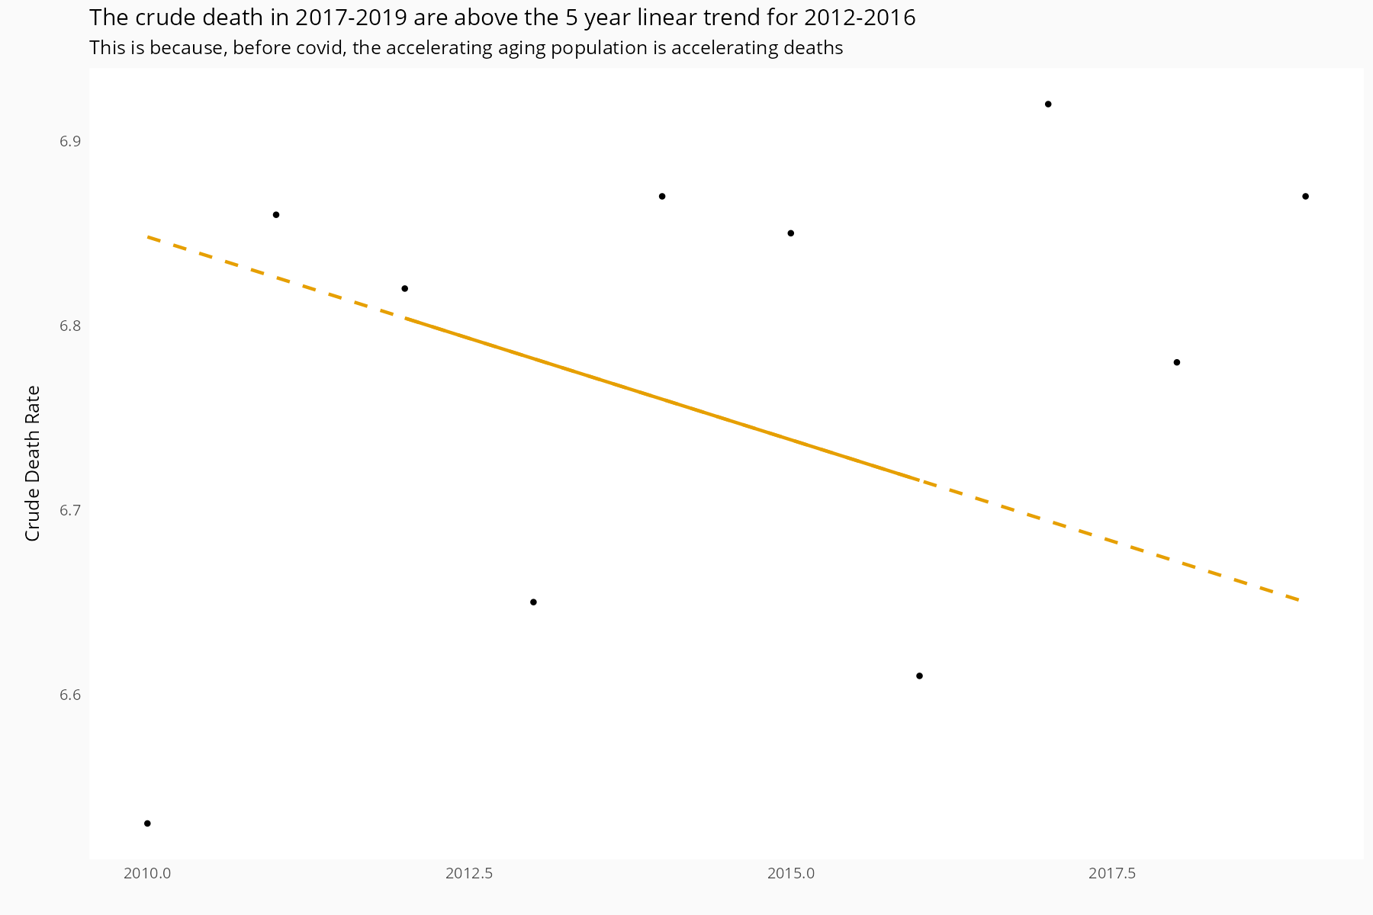 Of more surprise is that Gibson’s results for 2020-22 less well approximate the crude mortality rate than Karlinsky & Kobak, since the crude mortality rate is the accepted method of comparing death rates while ignoring the effects of age. While there is not enough information in the paper to exactly replicate Gibson’s method and achieve the same answers, part of the reason for the difference seems likely to be the unusual step of treating population as an additive contributor to deaths in his modification of the regression. But, compared to the differences with methods acknowledging age, such problems are minor.

I suggest anyone interested in this topic go explore population ages and death rates at Stats NZ themselves, and while there have a look at New Zealand death rates by age, or indeed the public, downloadable, standardised death rates. And then ask yourself, given the ready availability of high quality data, is the best default course of action to use the source that automatically compensates for the most confounders?

1. John Gibson (22 Feb 2024): Cumulative excess deaths in New Zealand in the COVID-19 era: biases from ignoring changes in population growth rates, New Zealand Economic Papers, DOI: 10.1080/00779954.2024.2314770
2. Ariel Karlinsky, Dmitry Kobak (2021) Tracking excess mortality across countries during the COVID-19 pandemic with the World Mortality Dataset eLife 10:e69336. Code available from https://github.com/dkobak/excess-mortality
3. Price, Richard (1773). Observations on Reversionary Payments. United Kingdom: (n.p.).
4. Report on the Statistics of New Zealand, 1890. Published by George Didsbury, Government Printer, Wellington., 1891. https://www3.stats.govt.nz/historic_publications/1890-official-handbook/1890-official-handbook.html Age standardised mortality is in the section “Adjusted death-rate a better means of comparison”.
5. Actuaries Institute: CMI Working Paper 180 https://www.actuaries.org.uk/learn-and-develop/continuous-mortality-investigation/cmi-working-papers/mortality-projections/cmi-working-paper-180
6. Ashley Bloomfield, 2024, personal communication
7. NZ annual deaths are available from <https://infoshare.stats.govt.nz> in Population : Deaths : Deaths by age and sex (Annual-Dec). NZ mean annual population is available from Population : Population Estimates - DPE : Estimated Resident Population by Age and Sex (1991+) (Annual-Dec) : Mean year ended.
8. Australian Bureau of Statistics. https://www.abs.gov.au/articles/measuring-australias-excess-mortality-during-covid-19-pandemic-until-first-quarter-2023#methodology