Some very brief notes:

- Aggregated constraint goal is evaluated, then post-evaluation a window pops up allowing for user-entry of values.
- Every attribute which we would like to interactively set, tag with: sfConsUser (for “User entry”), and tag with one of (for now): sfConsInteger, sfConsString, sfConsDouble to help the logic. This is inferable from the ranges but haven’t got round to it
- For each attribute tagged in this way, the attribute must have had a range set for it at some point in aggregated constraint goal (see example below)
- Undo allows you to undo choices
- Done is allowed when all sfConsUser tagged attributes have a value
- Ranges are updated dynamically through constraint propagation as in example below. This is the really neat feature.

Example SF description. Note no member(element, list) goal any more.

ListElement extends {
list theList;
[sfConsUser, sfConsString] element;
}

System extends {
x extends ListElement;
y extends ListElement;
z extends ListElement;
}#cons:1# lib(sd),
&::(sfget("x:element"), sfget(theList)),
&::(sfget("y:element"), sfget(theList)),
&::(sfget("z:element"), sfget(theList)),
alldifferent([sfget("x:element"),
sfget("y:element"),
sfget("z:element")])\#

sfConfig extends System {
theList ["one", VAR, "three", VAR];
aList [VAR, "two", VAR, "four"];
}#cons# sfattr(theList)=sfattr(aList)\#

This can be found at: core-branch-constraints/smartfrog/constraints/user.csf

Note that the unification occurs first, then the range constraints.

When running sfparse, a window will pop up, thus:

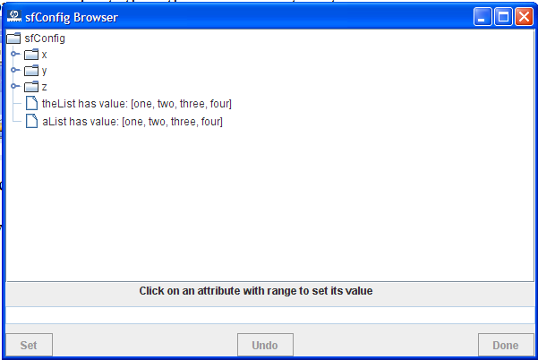

Expanding x, y, and z:

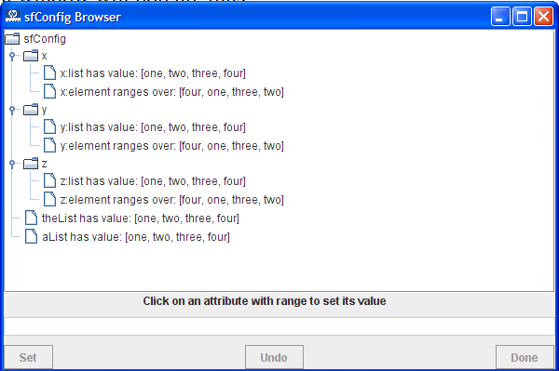

We see the attributes that may be set as they specify that they range over a domain, see x:element, etc.

Let’s click on x:element. We see that the Set button becomes enabled:
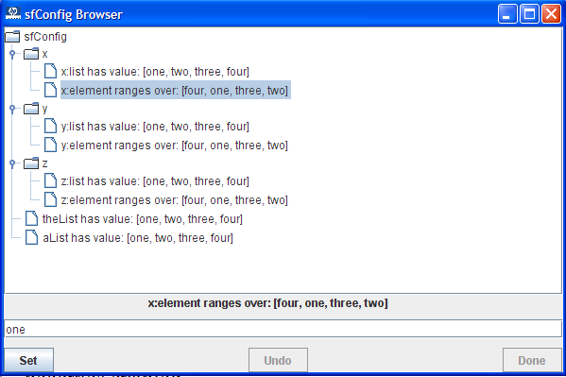

Let’s set the value to “one”. The ranges of y:element and z:element update automatically, and the Undo button (labelled 1 to indicate one undo possible) becomes enabled.

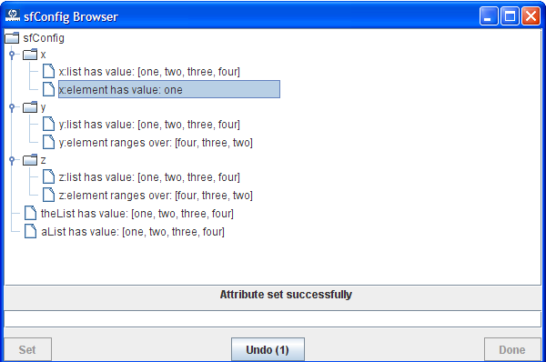

At this stage the user could undo this change, but we wont show that. Also if you incorrectly enter a value (ie not in range) it lets you know.
Let’s set y:element, and see that the range of z:element shrinks yet further.

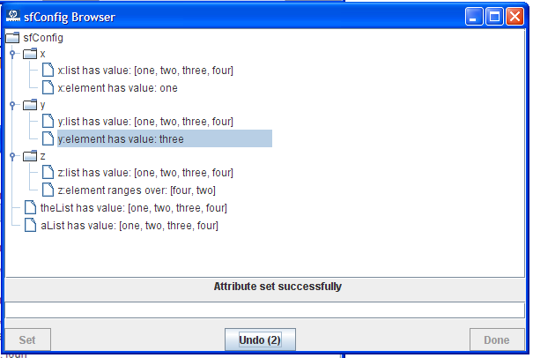

Finally, let’s set z:element. Notice that Done becomes enabled, as we may save these attribute settings and exit.

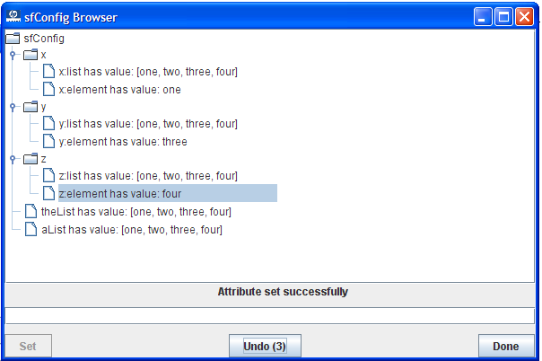

We may click Done or Undo. We’ll click Done. Look at the output sfparse (verbose):

x extends {
list [|"one", "two", "three", "four"|];
[ sfConsUser sfConsString ] element "one";
}
y extends {
list [|"one", "two", "three", "four"|];
[ sfConsUser sfConsString ] element "three";
}
z extends {
list [|"one", "two", "three", "four"|];
[ sfConsUser sfConsString ] element "four";
}
theList [|"one", "two", "three", "four"|];
aList [|"one", "two", "three", "four"|];

We see that the attributes we have set have been saved in the description hierarchy.

