**Sternberg Museum of Natural History**

Sample grant request form

|  |  |  |
| --- | --- | --- |
| **I. Requested materials:** | | |
| **Species** | **ID number** | **Other relevant**  **information** |
| Necturus maculosus | 13375 | 1 gram of tail tissue OR 5 ul DNA extract |
| Necturus maculosus | 17560 | 1 gram of tail tissue OR 5 ul DNA extract |
| Necturus maculosus | 17561 | 1 gram of tail tissue OR 5 ul DNA extract |
| Notophthalmus viridescens | 16623 | 1 gram of tail tissue OR 5 ul DNA extract |
| Notophthalmus viridescens | 12248 | 1 gram of tail tissue OR 5 ul DNA extract |
| Notophthalmus viridescens | 13291 | 1 gram of tail tissue OR 5 ul DNA extract |

**II. Project**

1. **Project title.**

A phylogenetic approach to understanding the evolutionary history of the threatened Cascade torrent salamander, *Rhyacotriton cascadae*

1. **List of personnel involved in project.**

**Lead Investigators**

Christopher Cousins: PhD Student at Oregon State University in the department of Fisheries, Wildlife, and Conservation Sciences (FWCS)* Responsible for requested materials

Dr. Brian Sidlauskas: Professor at Oregon State University in the FWCS department

Dr. Tiffany Garcia: Professor at Oregon State University in the FWCS department

**Collaborators**

Michael J. Adams: Scientist at the United States Geological Survey

Christopher Pearl: Scientist at the United States Geological Survey

1. **Project Description.**

The Cascade torrent salamander (*Rhyacotriton cascadae)* is one of four species within the monogeneric family of Rhyacotritonidae, endemic to the Pacific Northwest. Torrent salamanders are at risk from the impacts of climate change in their range, and as a result both *R. cascadae* and *R. kezeri* are currently candidate species for listing under the federal Endangered Species Act (ESA) by the United States Fish and Wildlife Service (USGS). To support conservation efforts for *R. cascadae*, we began a range wide population genomics study in 2022, to delineate genetically distinct populations within the species. As the species is patchily distributed across its’ range, and is thought to have limited dispersal potential, we expected to find genetic structure characterized by high differentiation between populations. We collected a total of 144 tail tips from individuals at 28 sites across the range of *R. cascadae,* using double digest restriction-site associated DNA sequencing (ddRADseq) to assemble markers across the genome, developing a panel of approximately 5000 SNPs.

Our preliminary results from 112 samples across twenty sites have putatively identified 4-5 distinct populations within the species, and evidence of little to no gene flow between populations. Surprisingly, we have found that one of these identified populations is genetically distinct from all other populations within the species. When we included two of the three congeners into the dataset and perform preliminary phylogenetic analyses, this unusual population is grouped with the congeners rather than the other populations of *R. cascadae.* However, all our data are from individuals within crown Rhyacotritonidae, making it difficult to root the resulting phylogenetic network. Access to the requested samples will provide us with key outgroups for better rooting the results, and thereby understanding the phylogeography and systematics of the radiation.

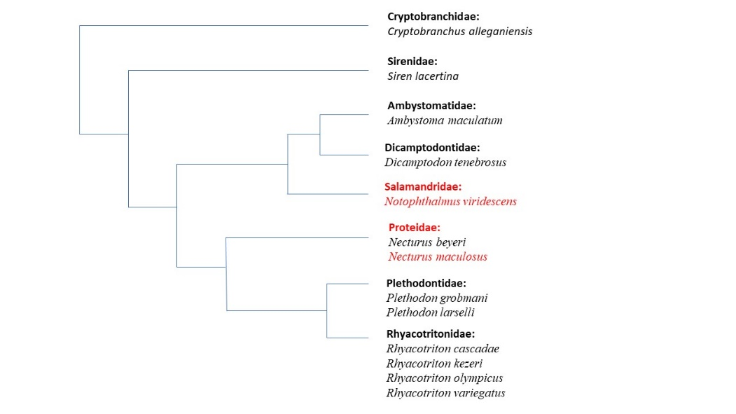Our preliminary results suggest that our current understanding of the evolutionary history of Rhyacotritonidae is incorrect, and if *R. cascadae* is listed by the USFWS under the ESA, an accurate knowledge of the species delineation will be critical for conservation efforts. To properly understand the evolutionary history of *R. cascadae*, we will assemble a dataset of tissue samples from all species of Rhyacotritonidae, in addition to seven of the ten currently recognized families within Caudata. The requested samples would help complete two lineages in our sampling design (fig. 1).

Figure - Planned phylogeny, samples requested from the SMNH are in red.

The phylogenetic analyses from this dataset will help improve our understanding of lineage diversification and speciation events within torrent salamanders, clarifying the systematics of a family that contains two ESA candidate species. This research will ensure that future conservation efforts protect unique evolutionary lineages. We expect to have sequencing of samples completed in the spring of 2023, and by early 2024 to have submitted a draft manuscript of our results describing the relevance of our findings to the evolutionary history within Rhyacotritonidae as well as its placement within the broader phylogenetics of Caudata.

1. **Techniques to be used.**

We are requesting 1 gram of tissue from each specimen. We will submit tissue samples to the Center for Quantitative Life Sciences (CQLS) at Oregon State University (OSU) for library preparation and sequencing on an Illumina NextSeq 2000 using a 150 base pair paired end P2 flow cell. As the genome size of salamanders is large, we will use a protocol that leverages higher starting quantities of extracted DNA with a narrow fragment size selection window to produce sufficient genetic markers for analyses. We will target nuclear DNA, using the PstI and MspI restriction enzymes. As no reference genome exists for any species of *Rhyacotriton,* the resulting fragments will be assembled de novo. These methods have proven to be successful with three species of *Rhyacotriton,* making the likelihood of successful data collection for this project high.

1. **Expected publications.**

We expect to publish one journal article from this study in 2024, which will use phylogenetic analyses to create estimates of divergences and speciation events within *R. cascadae*, and in the context of the phylogeny of Caudata. This manuscript will contribute to the understanding of the evolutionary history of *R. cascadae,* species delimitation within Rhyacotritonidae, and placement of Rhyacotritonidae within the order of Caudata.

1. **Estimated time of completion**

We estimate that library preparation and sequencing will be completed in the spring of 2023. Analysis will be completed by the end of summer, 2023. We will submit a draft manuscript to an academic journal in early 2024.

1. **Financial support.**

The estimated cost for library preparation and sequencing of the samples used in our study is ~$5500, which has been earmarked from an existing grant (Bullitt Environmental Fellowship) awarded to Christopher Cousins.