D2S Bharat
From Data-Science Job Demand to Skills, Success and Training Decisions
Analytics approach note — Round 2
SAS CU Hackathon · Build for Bharat
Team Code5urge
Shaman Sharma Anurag Prajapati Amrita Raman Rhydham Mittal
Data: SAS-provided Analytics Jobs, DataScience Jobs, JDS Skill Traits and SDS Personality Traits files. All code and outputs are reproducible from the project repository (Appendix A).

Contents
Right-click and choose “Update Field” to build the table of contents.

Executive Summary
Question. Institutions training data professionals must decide what to teach with limited money, trainers and seats. Using only the four SAS-provided datasets, we ask which skills the market demands and pays for (RQ1), which skills are associated with early-career salary hikes (RQ2), which personality traits are associated with senior success (RQ3), and what an institution should therefore teach first within its constraints (RQ4).
Data work. We removed 1,001 exact duplicate job postings (15,841 → 14,840), repaired 12,907 truncated skill tags, merged 814 spelling variants of job_type, parsed salary bands and experience ranges into numbers, and mapped every recruiter skill tag to a canonical skill (56.4% of tag uses to the ESCO/O*NET international taxonomies). A meaning-based text-matching step was tested, calibrated against recruiter tags, and rejected (best F1 6.8%) because the source descriptions are truncated at about 100 characters. In JDS and SDS, duplicate IDs (2 and 9) were investigated and kept as distinct people.
Key findings (associations, not causal effects):
- Market (RQ1). Each extra year of required experience multiplies the odds of a higher salary band by 1.66. Beyond experience, data-role postings asking for predictive modelling (OR 1.67), NLP (1.74), statistics (1.43), SAS (1.42) and Tableau/BI (1.41) sit in higher bands; MIS (0.25) and generic “communication” (0.70) mark lower-paid support roles.
- Juniors (RQ2, n = 139). Dashboards & storytelling (rank-biserial 0.59) and maths-stats (0.55) separate high- from low-hike juniors most strongly; a regularised logistic model reaches cross-validated AUC 0.90 against a 0.50 baseline (permutation p = 0.002).
- Seniors (RQ3, n = 161). Openness to experience (0.77) and conscientiousness (0.76) are by far the strongest correlates of success (AUC 0.96, p = 0.002), consistent with established personnel research [1].
- Triangulation. Maths & stats is the only skill area that is both paid more in the market and the strongest junior-hike signal. Dashboards & storytelling is rarely advertised and carries no clear market premium, yet it is the second-strongest junior-hike signal: a gap institutions can close.
Decision (RQ4). An integer optimisation model (OR-Tools CP-SAT) selects the plan that is mathematically optimal under the stated cost, coverage and capacity assumptions for an illustrative cohort with Rs 4 lakh and 200 trainer-hours: Statistics (60 seats), SAS on SAS Viya for Learners (60), Machine Learning Foundations (50), Python & SQL (35) and Data Storytelling with Tableau (58), costing Rs 3.53 lakh and closing 100% of the coding, maths and storytelling gaps. The four foundation courses are chosen with identical seat counts in all nine evidence scenarios. The binding constraint is trainer capacity, not money: extra budget alone adds nothing, while +40 trainer-hours (with about Rs 1.1 lakh) adds the Big-Data bundle (+10.2% impact) and +80 hours adds Deep Learning & NLP (+16.1%).

1 Problem Definition and Analytics Objective
Context. India’s analytics job market changes faster than curricula. Universities, skilling providers and CSR programmes must decide what to teach with limited budget, trainers and seats, but lack evidence on three questions: which skills the market demands and pays for, which skills are associated with early-career growth, and which personal traits are associated with success among senior data scientists. The SAS-provided data covers all three: job postings (Analytics Jobs), company-level openings and salaries (DataScience Jobs), and two outcome-labelled employee datasets (JDS Skill Traits for juniors, SDS Personality Traits for seniors).
Analytics objective. To identify the technical skills and personality traits most strongly associated with labour-market demand, pay and on-the-job success for data-science professionals, and to translate this evidence into a budget-constrained, explainable training plan that tells an institution what to teach first.
Table 1: Research questions, data and methods.
RQ | Question | Data | Methods
RQ1 Demand & pay | Which skills and roles are most demanded, and which are associated with higher salary bands, beyond experience? | Analytics Jobs (14,840 cleaned postings); DataScience Jobs (1,602 rows, 93,005 openings) | Cleaning, skill normalisation (ESCO/O*NET), Wilson CIs, ordinal logistic regression, FDR control, association rules
RQ2 Junior growth | Which of five measured skill areas are associated with a high vs. low salary hike? | JDS Skill Traits (139) | Mann–Whitney U, effect sizes, regularised logistic regression, shallow tree, repeated CV, permutation test
RQ3 Senior success | Which Big Five traits are associated with high vs. low success? | SDS Personality Traits (161) | As RQ2
RQ4 Decision | Given RQ1–RQ3, which training interventions should an institution prioritise under budget and capacity limits? | Evidence from RQ1–RQ3; documented cost assumptions | Integer optimisation (CP-SAT), sensitivity, Pareto frontier, robustness
Stakeholders. The primary decision-maker is a training institution (university, skilling provider or CSR programme). Secondary stakeholders are students choosing what to learn, employers and HR teams who write job descriptions and assess staff, and policy makers allocating skilling funds (Section 6).
Scope. Only the SAS-provided datasets are analysed; ESCO and O*NET [2], [3] serve solely as a skill vocabulary. Findings are associations, not causal effects. Analytics Jobs contains non-data roles too; we keep them for comparison and analyse the 5,138 data-role postings separately (Section 3.5).
Success criteria. Each RQ is answered with a quantified finding; predictive models are judged against a majority-class baseline with cross-validated accuracy and AUC; the RQ4 plan states which constraints bind and what extra resources would change.

2 Approach
The analysis moves from descriptive (what the market and employees look like) to diagnostic (which skills and traits are associated with pay and success) to prescriptive (what to teach first). Figure 1 shows the overall flow.
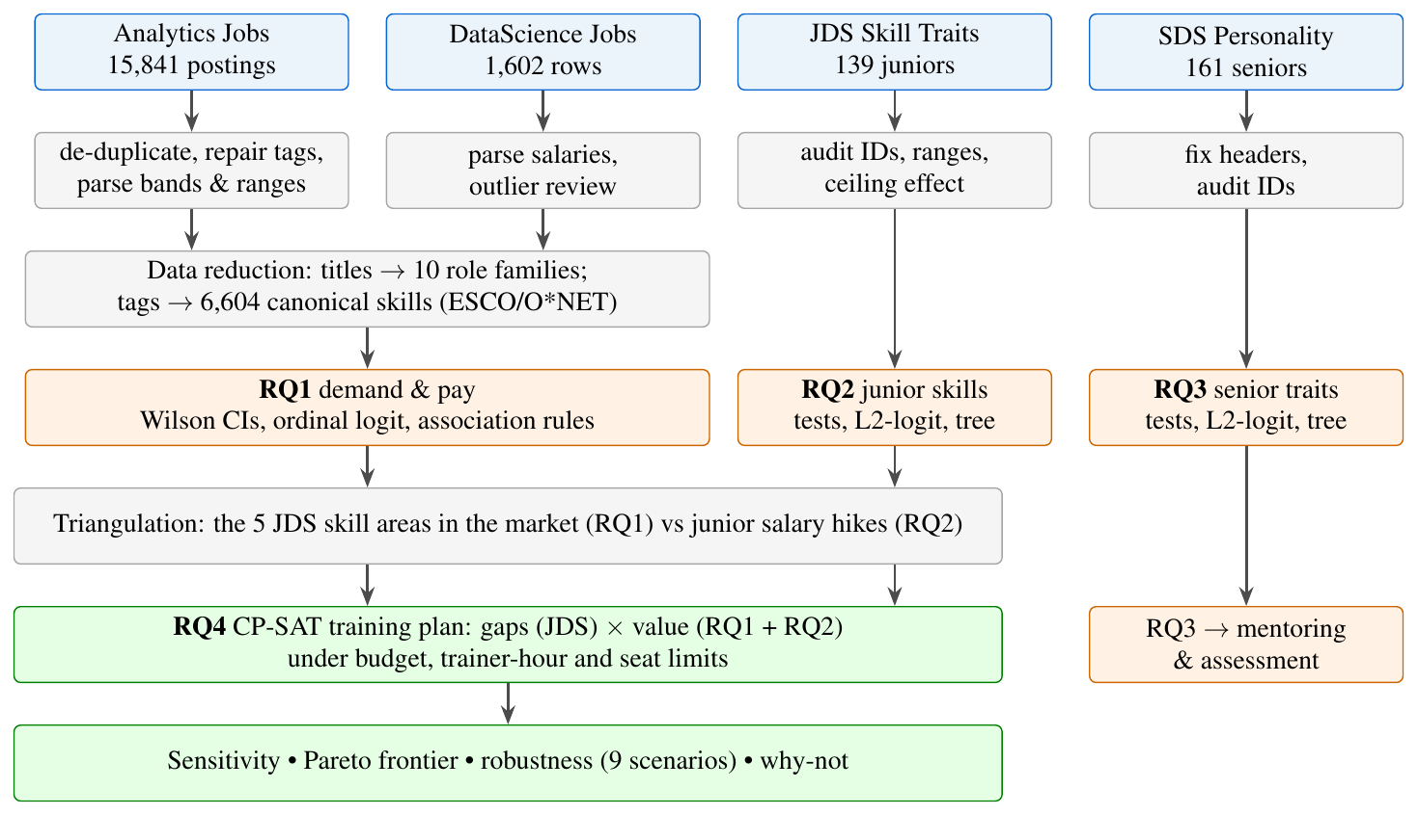
Figure 1: Analytical flow: four SAS datasets → cleaning and derivation → three diagnostic questions → one prescriptive decision.
Overall flow. The work proceeds in five stages, each feeding the next:
- Audit and prepare all four files (Section 3): repair, derive, de-duplicate and reduce until every variable needed by an RQ is clean and analysable.
- Describe the market (RQ1): what is demanded, and what is paid more once experience and role are held constant.
- Diagnose the employees (RQ2, RQ3): which measured skills and traits separate high from low outcomes, with tests, effect sizes and validated models.
- Triangulate: place the five JDS skill areas in the job market so that market and employer evidence can be compared on the same scale.
- Prescribe (RQ4): turn gaps and evidence weights into an optimal, budget-feasible training plan and test how robust it is.
Motivation and reasons for this approach.
- Decision first. The stakeholders (training institutions) need an action, not only a description, so the analysis is designed backwards from the RQ4 decision: every quantity the optimiser needs (gaps, value of a skill) is produced by an earlier stage.
- Triangulation over a single source. Job postings show what employers ask for; JDS shows what employers reward after hiring. Neither alone is reliable, so a skill is prioritised only when the sources agree, and disagreements (storytelling) are reported as findings.
- Methods matched to the data, not the other way round. Salary comes in ordered bands, JDS scores sit at a ceiling and JDS/SDS are small; the methods below were chosen for these properties. Complex models (gradient boosting, neural networks) were not used because with 139–161 people they would add variance without adding explanation.
- Transparency. Every step is scripted and every assumption (notably RQ4 course costs) is listed, so a jury or an institution can re-run the analysis with its own numbers.
Alternatives considered and rejected. Linear regression on salary midpoints (treats coarse bands as exact amounts); extracting skills from descriptions by meaning (tested, F1 6.8%, Section 3.5); deleting re-used JDS/SDS IDs (would lose 3–11% of people without evidence that they are duplicates); and a linear-programming plan (proposes fractional courses, Section 4.3).
Why these methods.
- Rank-based tests and effect sizes (Mann–Whitney U [4], rank-biserial correlation [5]) because the JDS 1–5 scores are bounded and heavily skewed towards the ceiling; Holm correction [6] controls the five tests per dataset. Bootstrap CIs [7] quantify uncertainty.
- L2-regularised logistic regression and depth-limited trees [8] for the small JDS/SDS samples. With five predictors the smaller class gives 13.2 (JDS) and 15.2 (SDS) events per predictor, a favourable ratio [9], [10]; complexity is still kept deliberately low and every model is scored by repeated stratified 5-fold cross-validation (20 repeats) against a majority-class baseline, with a label-permutation test of the AUC.
- Ordinal logistic regression [11] for pay, because salary is given in six ordered bands, not exact amounts; it lets us control for experience and role family. Benjamini–Hochberg FDR [12] controls the 30–40 skills tested.
- Association rules [13] reveal skill bundles that should be taught together.
- Integer optimisation (CP-SAT [14]) because courses are all-or-nothing, have batch sizes and prerequisites; a linear relaxation would propose fractional courses.
Tools. Python 3.13 with pandas, scikit-learn [15], statsmodels [16], sentence-transformers [17] (bge-small-en-v1.5 [18]) and OR-Tools; all steps are scripted and seeded (Appendix A). Equivalent SAS code for the core statistics is provided for SAS Viya for Learners [19] (Appendix E).

3 Data Exploration: Manipulation, Derivation, Consolidation and Preparation
This section follows the four preparation steps named in the brief: data modification (repairing and standardising values), data derivation (new variables from existing ones), data deduction (removing redundant records and inferring the right treatment of ambiguous ones) and data reduction (condensing high-cardinality text into analysable categories), followed by consolidation into one analysis-ready profile per dataset and the exploratory findings that shaped the analysis.

3.1 Consolidated data-quality audit
SAS describes the files as public, self-reported or masked sample data that may contain mistyped entries and outliers. We therefore audited every file before analysis (Table 2). The guiding rule was repair what is recoverable, flag what is uncertain, delete only what is provably redundant.
Table 2: Data-quality audit and actions for the four SAS files.
File | Raw | Used | Duplicates | Missing | Other issues and actions
Analytics Jobs | 15,841 | 14,840 | 1,001 exact duplicate rows removed | job_description 23%, job_type 78% | 12,907 truncated tags repaired; 814 job_type variants merged; 2,347 multi-city rows split; text descriptions truncated at source
DataScience Jobs | 1,602 | 1,602 | 0 duplicates | 0 missing | salaries stored as text (‘7.8L’) parsed to lakh; 39 high-salary outliers kept (senior roles)
JDS Skill Traits | 139 | 139 | 2 reused IDs kept (different people) | 0 missing | all scores within 1–5; ceiling: 58% at 5.0 (storytelling); column name fixed
SDS Personality Traits | 161 | 161 | 9 reused IDs kept (7 with different outcomes) | 0 missing | two malformed column names fixed (leading space, spaces in target name)

3.2 Data modification: repairing and standardising values
Missing and inconsistent values. job_type is 78% missing and, where present, spelt five ways (Analytics, analytics, ANALYTICS, analytic, Analytic). We merged the 814 variants but do not use the variable for segmentation. job_description is missing in 23% of rows, and 11,469 descriptions are cut off at about 100 characters and end in “…” (a property of the source, not of our processing). The recruiter-provided key_skills field is almost complete (one missing row), so it became the primary skill signal.
Skill tags. The 74,884 comma-separated tags contained 12,907 entries truncated by the export (“Rest…”, “Oracle Workflow…”), which we repaired by stripping the ellipsis rather than discarding them; 912 empty or “…”-only tags were dropped, and 28 case duplicates within a posting removed (Figure 2).
Headers and formats. SDS headers contained a leading space (“ extraversion”) and spaces inside the target name, and JDS used a hyphen (maths-stats_skills); all were normalised. DataScience Jobs salaries were stored as text (“7.8L”) and converted to lakh per year.
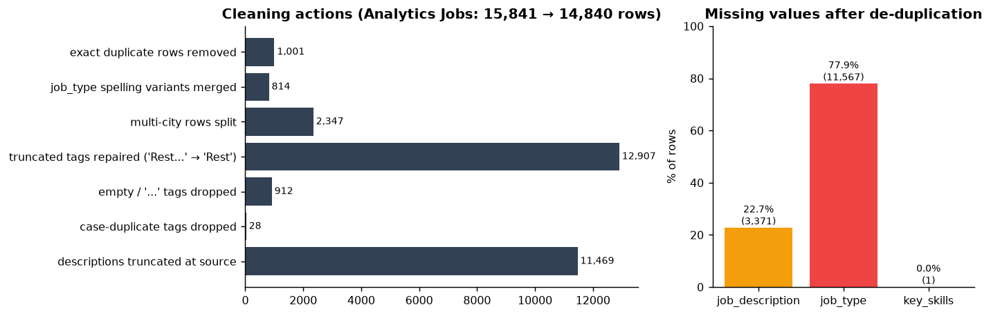
Figure 2: Modification and deduction actions on Analytics Jobs (left) and missing values after de-duplication (right).

3.3 Data derivation: new variables
Text ranges were converted to numbers so they can be modelled (Table 3). Salary is only available as six ordered bands, so it is analysed ordinally rather than as an exact amount (Table 4). The median posting asks for 3–7 years of experience, and 2,347 postings list several cities, which were split into a list.
Table 3: Variables derived during preparation.
Derived variable | From | Rule
exp_min, exp_max | experience (“5-10 yrs”) | numeric range bounds
salary band (ordinal), sal_mid_lakh | salary (“10to15”) | 6 ordered levels; midpoint for description only
locations, multi_city | location | split on commas; flag if >1 city
family | job_desig | 10 role families from ordered keyword rules (Section 3.5)
canonical skills | key_skills | ESCO/O*NET label or data-derived label (Section 3.5)
JDS skill-area flags | canonical skills | keyword patterns per JDS area (used for triangulation)
avg/min/max_lakh | DataScience Jobs salaries (“7.8L”) | numeric lakh per year

Table 4: Distribution of the salary band (Analytics Jobs, 14,840 postings).
Salary band (lakh/yr) | 0–3 | 3–6 | 6–10 | 10–15 | 15–25 | 25–50
Postings | 2,565 | 2,032 | 2,875 | 3,503 | 2,873 | 992
Share | 17.3% | 13.7% | 19.4% | 23.6% | 19.4% | 6.7%

3.4 Data deduction: redundant records and ambiguous cases
Exact duplicates. 1,001 Analytics Jobs rows were copies of another posting in every column except the row number. They were removed (15,841 → 14,840); keeping them would double-count demand. DataScience Jobs, JDS and SDS contain no fully identical rows.
Re-used IDs, inferred to be different people. JDS has 2 and SDS 9 IDs that appear twice. The paired rows have entirely different scores, and in SDS 7 of the 9 pairs have different outcomes. We deduce that these are masked or re-used IDs, not repeated people, and keep all rows; deleting them would discard 2.9% (JDS) and 11.2% (SDS) of the employee data.
Outliers, kept with reasons. 39 DataScience Jobs rows are high-salary outliers by the IQR rule (e.g. Senior Data Scientist at Flipkart, 82 lakh). They are plausible senior roles with few openings, so they are kept and salaries are summarised with medians and job-weighted averages. Low AI & ML scores (18 in JDS) and 5 agreeableness values (SDS) are valid scale values; rank-based methods are robust to them.
A method deduced to be unreliable. Meaning-based extraction of skills from the truncated descriptions was tested and rejected (Section 3.5).

3.5 Data reduction: from high-cardinality text to analysable categories
Two fields are far too fine-grained to analyse directly: 10,096 distinct job titles and 8,460 distinct skill tags. Table 5 summarises how each was reduced while keeping the information needed for the research questions.
Table 5: Data reduction steps.
Field | Before | After | Method
Job titles | 10,096 distinct | 10 role families | ordered keyword rules (Section 3.5)
Skill tags | 8,460 distinct (73,936 uses) | 6,604 canonical skills | taxonomy mapping + merging near-duplicate spellings (Section 3.5)
Canonical skills | 6,604 | top 30–40 per model | demand ranking; rarer skills kept for description only
Canonical skills | 6,604 | 5 JDS skill areas | keyword patterns aligned with the JDS definitions (triangulation, RQ4)
Salary | 6 text bands | 1 ordinal variable | ordered levels; midpoint used only for description
DataScience Jobs | 1,602 company × title rows | 10 titles | job-weighted aggregation

Skill normalisation: from 8,460 free-text tags to comparable skills
Recruiters write the same skill many ways (“Machine Learning”, “machine learning”, “ML”). To count and compare skills, the 8,460 distinct tags were mapped onto the international ESCO v1.2.1 and O*NET 30.3 taxonomies (22,758 skills) in a fixed order: exact name or acronym match; a known skill name contained in the tag (“Core Java” → Java); and finally the nearest skill by sentence-embedding similarity, accepted only above 0.85 (0.90 for one-word tags). A manual spot-check found and fixed systematic errors, for example “HTML” → PHP, “Core Java” → “core apples” and “Analytical” → analytical chemistry; four such mappings are corrected by an explicit, documented override list.
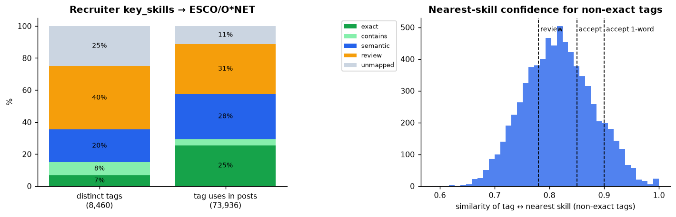
Figure 3: Mapping of recruiter tags to ESCO/O*NET (left) and similarity of non-exact tags to their nearest skill (right).
Tags that could not be mapped confidently (42.3% of tag uses) are not discarded. They become data-derived skills, and near-duplicate spellings are merged when two tags are ≥ 0.92 similar (1.3% of uses). As a result, every tag use resolves to a canonical skill (Figure 4), giving 6,604 distinct skills.
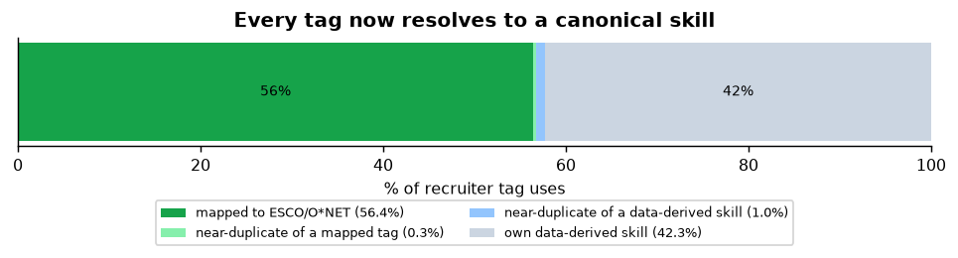
Figure 4: Every recruiter tag resolves to a canonical skill.
A method we tested and rejected. We also tried extracting skills by meaning from the job descriptions. Calibrated against the recruiters’ own tags, it reached at best F1 = 6.8% (precision 6.3%, recall 7.3%; Figure 5), and it produced matches such as “Hunting role” → animal hunting. Because the descriptions are truncated at the source, only exact skill names found in the text are used.
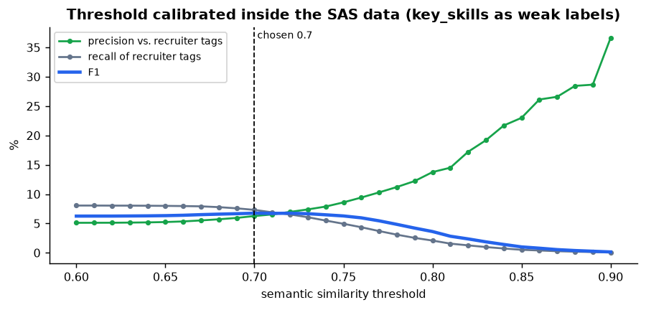
Figure 5: Calibrating meaning-based text matching against recruiter tags: agreement never exceeds F1 ≈ 7%, so it was excluded.

Role families
Job titles are highly varied (10,096 distinct titles, often padded with “Urgent”, “Walk-in” or city names). An ordered set of readable keyword rules assigns each title to one of ten families; generic “Analyst” falls back to Analytics/BI. Four families form the data roles (5,138 postings): Data Science/ML, Data Engineering, Analytics/BI and Business Analysis/Product. Only 9.4% of postings remain “Other” (Figure 6).
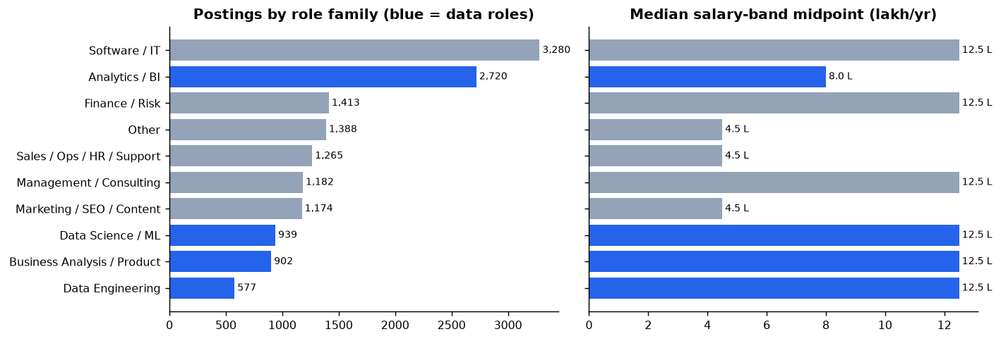
Figure 6: Postings and median salary band by role family; data roles in blue.

3.6 Consolidation: dataset profiles and exploratory findings
DataScience Jobs. The 1,602 rows aggregate 93,005 openings across 642 companies and 10 standard titles; the row median of the average salary is 11.9 lakh and the median minimum experience is 2 years.
JDS and SDS.
Both files are complete (no missing values), and both outcomes are balanced (JDS: 73 high / 66 low hike; SDS: 85 high / 76 low success), so the majority-class baseline accuracy is 52.5% and 52.8%. Table 6 summarises the variables.
(a) JDS Skill Traits (1–5 scale; outcome: salary hike).
Table 6: Descriptive statistics with group means by outcome.
Variable | Mean | SD | Min | Median | Max | Mean (high) | Mean (low)
Big data | 3.85 | 0.85 | 2.3 | 3.8 | 5 | 3.94 | 3.75
Maths & stats | 4.29 | 0.84 | 2.2 | 4.6 | 5 | 4.71 | 3.83
Coding | 4.27 | 0.89 | 2.2 | 4.6 | 5 | 4.64 | 3.85
AI & ML | 4.57 | 0.67 | 2.2 | 4.9 | 5 | 4.82 | 4.28
Dashboards & storytelling | 4.36 | 0.93 | 2.3 | 5 | 5 | 4.85 | 3.81
(b) SDS Personality Traits (normalised scores; outcome: success).
Table 6: Descriptive statistics with group means by outcome.
Variable | Mean | SD | Min | Median | Max | Mean (high) | Mean (low)
Neuroticism | 36.19 | 11.27 | 17 | 34 | 68 | 36.13 | 36.26
Extraversion | 43.20 | 12.13 | 17 | 45 | 67 | 48.86 | 36.88
Openness | 41.33 | 11.32 | 18 | 44 | 65 | 48.49 | 33.32
Agreeableness | 44.60 | 11.29 | 17 | 46 | 68 | 47.72 | 41.12
Conscientiousness | 45.21 | 13.21 | 18 | 49 | 66 | 53.68 | 35.74
Exploratory findings.
- Ceiling effect (JDS). 58% of juniors score the maximum 5.0 in dashboards & storytelling, 49% in AI & ML, 45% in coding and 41% in maths-stats (Figure 7). The scale cannot separate the strongest juniors, so effects are probably under-estimated.
- Group differences are visible before modelling: high-hike juniors score higher on four of five skills and high-success seniors on four of five traits (Table 6), motivating the formal tests in Section 4.2.
- Multicollinearity is low (maximum variance inflation factor 1.45 in JDS, 1.44 in SDS).
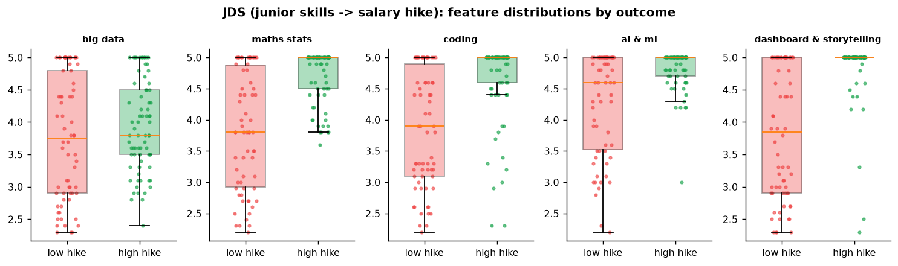
Figure 7: JDS: skill scores by salary-hike outcome. High-hike juniors cluster at the 5.0 ceiling.

4 Data Analysis
The analysis answers the four research questions in order of the analytics value chain (Figure 1): descriptive analysis of the job market (RQ1, Section 4.1), diagnostic statistical and machine-learning analysis of the two employee datasets (RQ2 and RQ3, Section 4.2) and a prescriptive optimisation that converts the evidence into a training decision (RQ4, Section 4.3). Each part ends with an explicit answer to its research question.

4.1 Market Demand and Pay (RQ1)

4.1.1 Demand
Within the 5,138 data-role postings, the most requested skills (with Wilson 95% intervals [20]) are data analytics (18.3% [17.3, 19.4]), SQL (16.5% [15.5, 17.5]), SAS (13.4%), Python (12.6%), business analysis (12.5%), machine learning (12.0%) and R (10.8%) (Figure 8). The market expects a toolkit: one statistical language (SAS, R or Python) plus SQL.
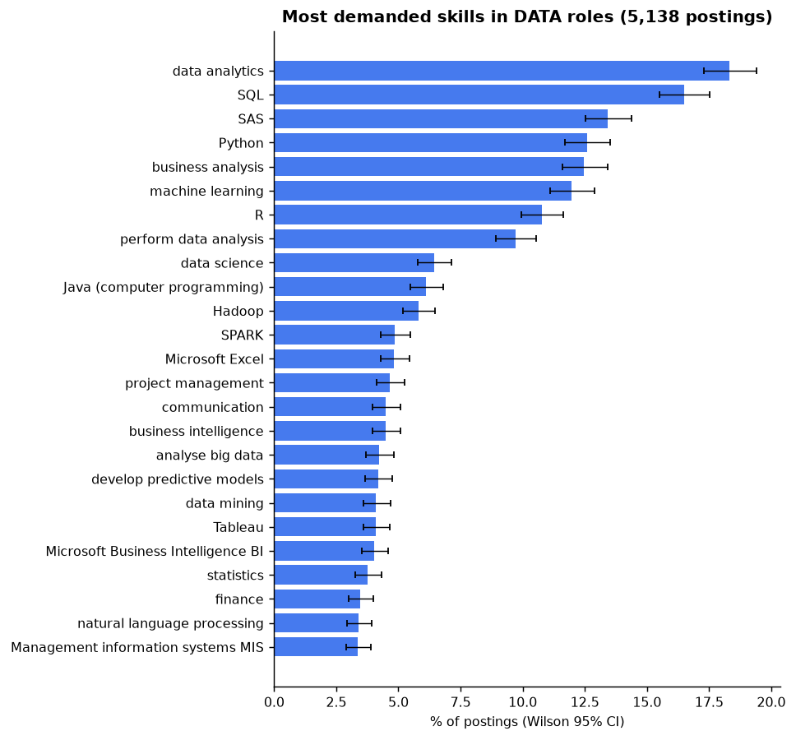
Figure 8: Most demanded skills in data-role postings (Wilson 95% CIs).

4.1.2 Pay, after accounting for experience
Raw salary comparisons are misleading because skills and seniority go together. We therefore fit an ordinal logistic regression of the six salary bands on indicators for the 30 most common skills, minimum experience, role family and a multi-city flag. The odds ratio (OR) of a skill is the multiplicative change in the odds of being in a higher band when a posting lists it, at the same experience and role family.
Experience dominates: each extra year of required experience multiplies the odds of a higher band by 1.66 (all postings) and 1.61 (data roles). Beyond experience, 13 skills remain significant at FDR q<0.05 in data roles (Table 7, Figure 9).
Table 7: Skills associated with salary band in data-role postings (ordinal logit, adjusted for experience, role family and multi-city; FDR q<0.05).
Higher-pay skill | OR [95% CI] |  | Lower-pay skill | OR [95% CI]
Product management | 2.95 [2.13, 4.07] |  | MIS | 0.25 [0.19, 0.34]
Natural language processing | 1.74 [1.25, 2.41] |  | Communication | 0.70 [0.55, 0.89]
Predictive modelling | 1.67 [1.28, 2.18]
Marketing analytics | 1.64 [1.20, 2.26]
Java | 1.51 [1.20, 1.90]
Statistics | 1.43 [1.09, 1.88]
SAS | 1.42 [1.20, 1.68]
Business intelligence | 1.41 [1.11, 1.80]
Tableau | 1.41 [1.09, 1.82]
Data mining | 1.40 [1.07, 1.83]
Data analytics | 1.25 [1.09, 1.42]
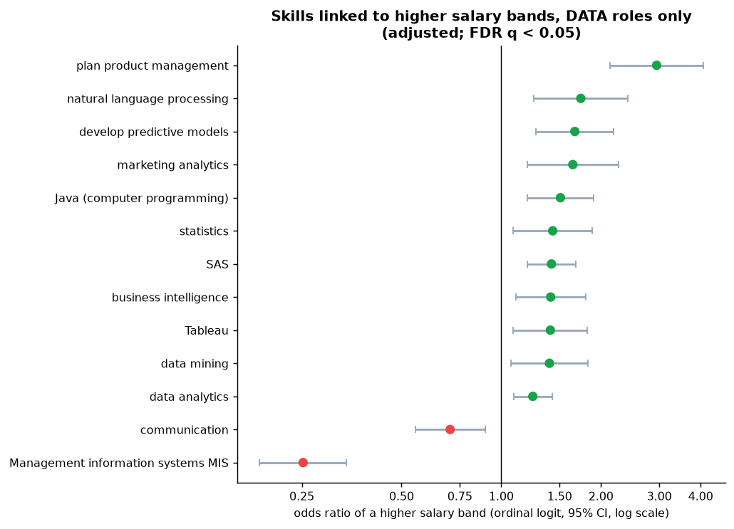
Figure 9: Adjusted pay association of skills in data roles (only skills with FDR q<0.05).
Interpretation. Advanced analytics (predictive modelling, NLP, statistics, data mining) and core tools (SAS, Java, BI/Tableau) are linked to higher bands beyond what experience explains; across all postings SQL (OR 1.23) and machine learning (1.34) are also significant. Postings emphasising MIS reporting or generic “communication” are lower-paid support roles; this does not mean communication is undervalued by employers, as RQ2 shows.

4.1.3 Skill bundles
Association rules show that the big-data stack is requested as a bundle: hive → Hadoop (confidence 75%, lift 13.1), Scala → Spark (72%, lift 15.2), hive → Spark (68%, lift 14.3); deep learning and NLP co-occur with lift 13.6 (Figure 10). These skills should be taught together, which is why the RQ4 catalogue contains a single Big-Data course.
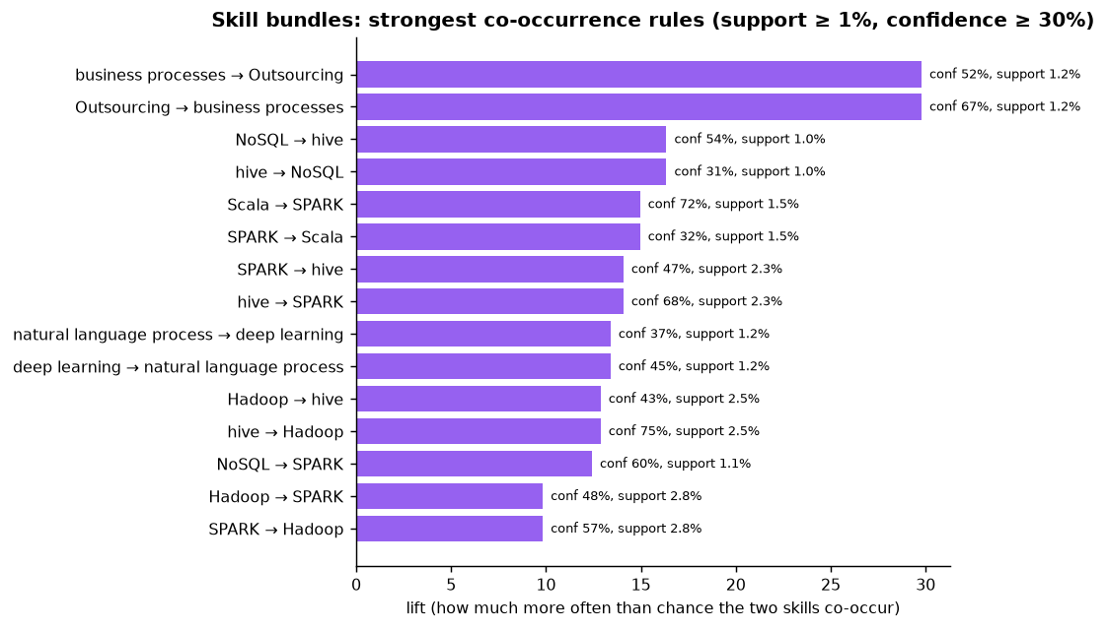
Figure 10: Strongest skill co-occurrence rules in data roles.

4.1.4 Company-level view (DataScience Jobs)
Average salary rises with minimum experience (Spearman ρ = 0.63, p<10⁻¹⁰⁰). Openings are spread across many employers (Herfindahl index 0.021), but the ten largest (TCS, Accenture, Cognizant, Wipro, IBM, Genpact, Capgemini, LTI, Tech Mahindra, HCL) offer 35% of all openings. The job-weighted average salary (9.7 lakh) is below the per-row median (11.9 lakh): most openings are at large IT-services firms that pay below the typical company (Figure 11).
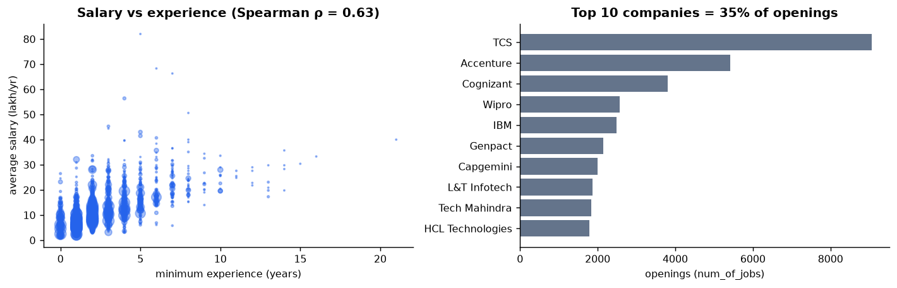
Figure 11: DataScience Jobs: salary vs experience (bubble size = openings) and the ten largest employers.

4.1.5 Triangulation: the five JDS skill areas in the market
To connect RQ1 with RQ2, each of the five JDS skill areas was measured in the job market (Table 8, Figure 12).
Table 8: The five JDS skill areas: market demand and pay (RQ1, data roles) vs junior salary-hike link (RQ2).
Skill area | Demand (%) | Market pay OR [95% CI] | RQ2 hike OR per SD [95% CI]
Coding | 40.7 | 1.50 [1.34, 1.68] | 1.67 [1.10, 2.79]
Maths & stats | 15.9 | 1.56 [1.35, 1.80] | 3.01 [1.99, 4.60]
AI & ML | 16.0 | 1.44 [1.23, 1.69] | 2.00 [1.23, 3.23]
Big data | 10.6 | 1.33 [1.10, 1.62] | 1.76 [1.18, 2.67]†
Dashboards & storytelling | 11.9 | 1.14 [0.98, 1.34] | 2.72 [1.77, 4.73]
† conditional (suppressor) effect; not significant on its own (Section 4.2).
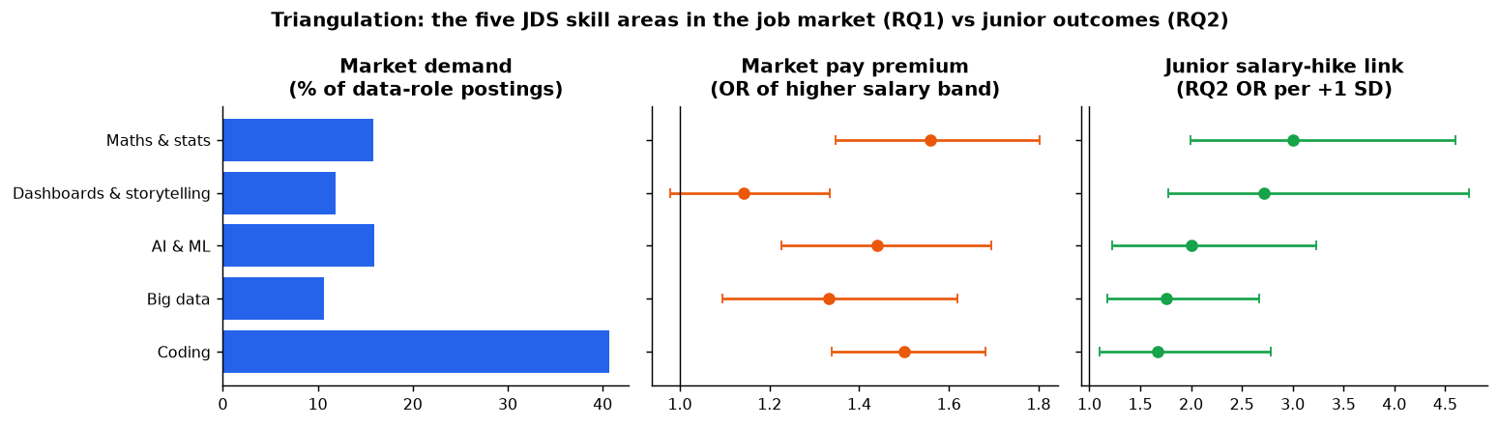
Figure 12: Triangulation of the five JDS skill areas across market demand, market pay and junior salary hikes.
Three messages follow. Maths & stats is the only area that is both paid more in the market and the strongest junior-hike signal. Coding is the baseline expectation (in 41% of data postings). Dashboards & storytelling is rarely advertised and carries no clear market premium, yet it is the second-strongest junior-hike signal: employers reward it after hiring more than they ask for it in postings.
Robustness check. The result for storytelling depends on its definition. If “reporting” and “MIS” are counted as storytelling (the literal JDS wording), its market OR becomes 0.79 [0.69, 0.90], because those terms mark clerical MIS jobs. We report the narrow definition (visualisation and BI tools, dashboards, storytelling) and disclose the alternative.

4.2 Junior Skills and Senior Traits (RQ2, RQ3)
Both questions use the same three-step design: (i) univariate comparison of high vs low outcome groups (Mann–Whitney U, rank-biserial effect size with 2,000-sample bootstrap CI, Holm correction); (ii) multivariable models (standardised L2-regularised logistic regression and a depth-≤ 3 decision tree with at least 10 people per leaf), scored by repeated stratified 5-fold cross-validation (100 folds in total); (iii) a permutation test (500 label shuffles) of the cross-validated AUC.
A methodological correction. The regularisation strength was first tuned on AUC. Because AUC ignores the size of coefficients, it selected very strong shrinkage, and the odds ratios collapsed towards 1 (e.g. SDS conscientiousness OR 1.26 despite Cohen’s d = 1.85). Tuning on log-loss fixed this and also improved cross-validated accuracy (JDS 0.817 → 0.864; SDS 0.901 → 0.924). All results below use log-loss tuning.

4.2.1 RQ2: which skills are associated with a high salary hike for juniors?
Table 9: RQ2 (JDS, n=139): group comparison and multivariable association.
Skill area | Mean high / low | Rank-biserial [95% CI] | Holm p | OR per +1 SD [95% CI]
Dashboards & storytelling | 4.85 / 3.81 | 0.59 [0.45, 0.72] | <0.001 | 2.72 [1.77, 4.73]
Maths & stats | 4.71 / 3.83 | 0.55 [0.40, 0.70] | <0.001 | 3.01 [1.99, 4.60]
Coding | 4.64 / 3.85 | 0.49 [0.31, 0.64] | <0.001 | 1.67 [1.10, 2.79]
AI & ML | 4.82 / 4.28 | 0.36 [0.19, 0.52] | <0.001 | 2.00 [1.23, 3.23]
Big data | 3.94 / 3.75 | 0.12 [−0.09, 0.32] | 0.217 | 1.76 [1.18, 2.67]†
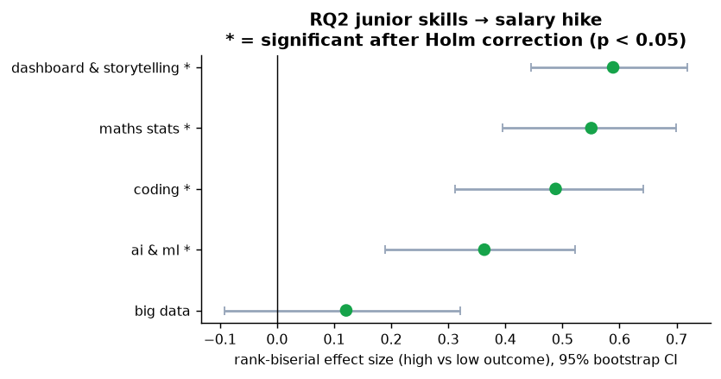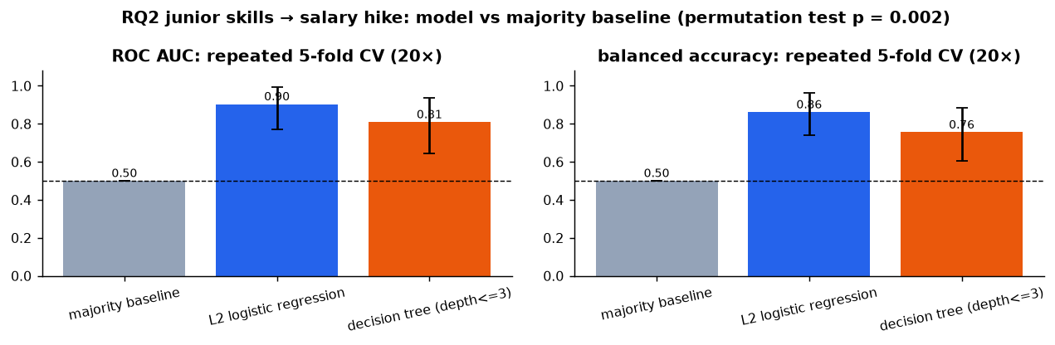
Figure 13: RQ2: effect sizes with bootstrap CIs (left) and cross-validated model performance (right).
Models. The L2 logistic regression reaches accuracy 0.864, balanced accuracy 0.861 and AUC 0.904 (fold range 0.77–0.99) against a 0.525 / 0.50 baseline; the tree reaches AUC 0.809. The permutation test gives AUC 0.903 vs a null mean of 0.494, p = 0.002.
Decision rule. The tree is easy to read: juniors with storytelling >4.15, maths-stats >3.70 and coding >4.65 received a high hike in 50 of 56 cases; those with storytelling ≤ 4.15 and maths-stats ≤ 4.60 received a low hike in 26 of 26 cases.
Answer to RQ2. High-hike juniors score higher on four of the five skill areas. The strongest signals are communicating results (dashboards & storytelling) and quantitative foundations (maths-stats). Big-data skill alone does not separate the groups.

4.2.2 RQ3: which traits are associated with senior success?
Table 10: RQ3 (SDS, n=161): group comparison and multivariable association.
Trait | Mean high / low | Rank-biserial [95% CI] | Holm p | OR per +1 SD [95% CI]
Openness to experience | 48.5 / 33.3 | 0.77 [0.65, 0.87] | <0.001 | 9.09 [4.65, 24.5]
Conscientiousness | 53.7 / 35.7 | 0.76 [0.62, 0.87] | <0.001 | 9.78 [5.59, 21.3]
Extraversion | 48.9 / 36.9 | 0.57 [0.42, 0.71] | <0.001 | 2.78 [1.28, 6.60]
Agreeableness | 47.7 / 41.1 | 0.30 [0.09, 0.50] | 0.002 | 1.96 [0.99, 4.40]
Neuroticism | 36.1 / 36.3 | 0.07 [−0.12, 0.26] | 0.454 | 2.44 [1.57, 4.69]†
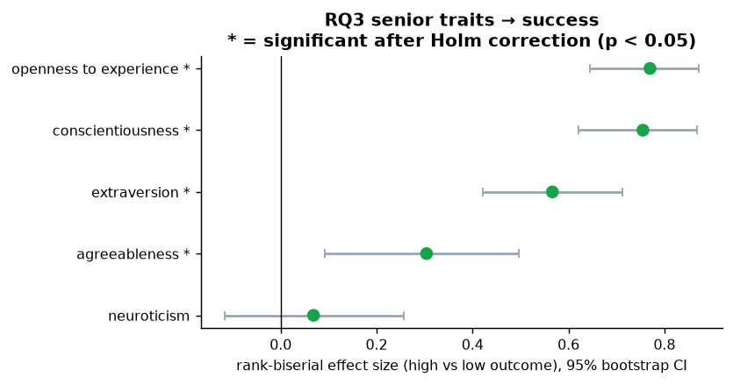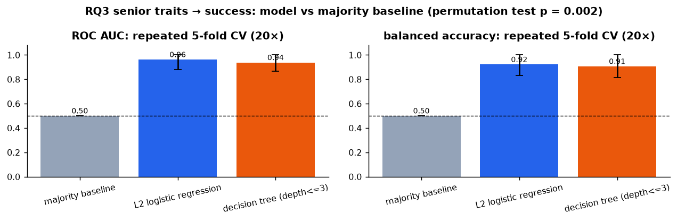
Figure 14: RQ3: effect sizes (left) and cross-validated model performance (right).
Models. L2 logistic regression: accuracy 0.924, balanced accuracy 0.922, AUC 0.963; tree: AUC 0.938. Permutation test: AUC 0.949 vs null 0.501, p = 0.002.
Decision rule. Every senior with openness ≤ 38.5 was low-success (52 of 52); openness >38.5, conscientiousness >36.5 and agreeableness >40.5 was high-success in 79 of 83 cases (Figure 15).
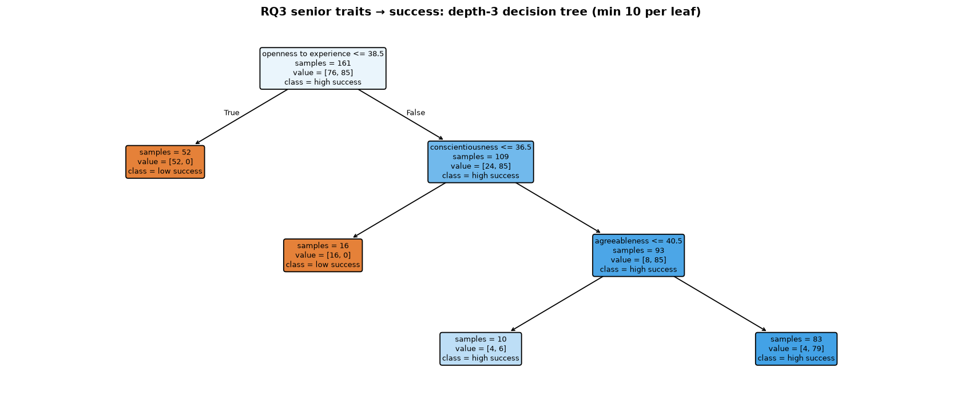
Figure 15: RQ3 depth-3 decision tree.
Answer to RQ3. Openness to experience and conscientiousness are by far the strongest correlates of senior success, followed by extraversion. This agrees with meta-analytic evidence that conscientiousness predicts job performance across occupations and that openness predicts training proficiency [1].

4.2.3 Suppressor effects and caution
†Big data (JDS) and neuroticism (SDS) show no difference on their own but a positive coefficient once the other variables are held constant. Each is mildly negatively correlated with the strong predictors (e.g. neuroticism vs extraversion −0.25). For neuroticism the logistic coefficient moves from −0.01 (p = 0.94) alone to 0.87 with conscientiousness and openness, and 1.37 (p = 0.001) with all five traits. These are conditional associations in a small sample; we report them but base no recommendation on them.
The SDS outcome separates unusually cleanly (52 of 52 below an openness threshold), which may indicate curated sample data; findings should be validated on another cohort before being used for policy. The very large SDS odds ratios partly reflect this separation, so effect sizes and decision rules are the more reliable summary.

4.3 What to Teach First (RQ4)

4.3.1 Model
RQ4 turns the evidence into a decision. For each candidate course c the model chooses whether to run it (r_{c} ∈ {0,1}) and how many seats to offer (s_{c}). For each skill area k it counts learners whose gap is closed, z_{k}:
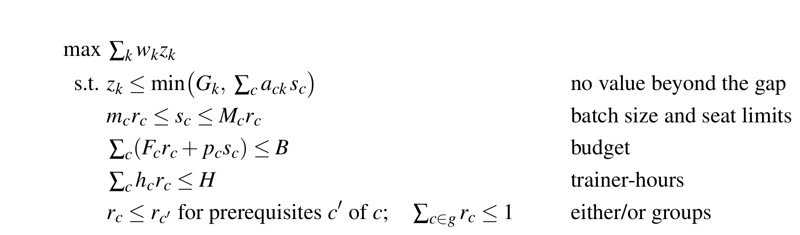
G_{k} (gap) and w_{k} (value) come from the data; course parameters F_{c}, p_{c}, h_{c}, M_{c}, a_{ck} are documented assumptions. The model is solved exactly with CP-SAT [14].
Table 11: RQ4 inputs: what is data and what is assumed.
Input | Source | Values
Gap G_{k} | Data (JDS): juniors below the high-hike group’s median | Maths 82 Coding 77 AI/ML 71 Big data 65 Storytelling 58
Value w_{k} | Data (RQ1+RQ2): equal mix of demand share, log market OR, log RQ2 OR, each scaled to its maximum | Maths 100 Coding 99.7 AI/ML 77.3 Storytelling 62.9 Big data 59.4
Uncertainty | Data: CI lower/upper bounds × 3 weighting schemes | 9 scenarios
Courses | Assumption, checked against public sources | 9 courses (Appendix C)
Budget, capacity | Assumption (scenario) | Rs 4 lakh, 200 trainer-hours
Cost assumptions: trainers at Rs 1,430–2,000 per hour, the upper-mid of the Rs 250–2,000 range reported for Indian data-science trainers [21] (deliberately conservative); SAS Viya for Learners [19], Tableau for students and Power BI Desktop are free, so per-seat costs are materials only; GPU time for deep learning at about Rs 100 per hour [22]. Personality (RQ3) is not modelled as a course, because traits are relatively stable; it informs mentoring and assessment instead (Section 6).

4.3.2 The optimal plan
Table 12: Optimal plan for Rs 4 lakh and 200 trainer-hours (solver-proven optimal for the model and assumptions in Table 11).
Course | Seats | Cost (Rs lakh) | Trainer-hours
Applied Statistics & Probability | 60 | 0.78 | 40
SAS Programming on SAS Viya for Learners | 60 | 0.45 | 30
Machine Learning Foundations | 50 | 0.97 | 48
Python & SQL for Analytics | 35 | 0.71 | 40
Data Storytelling with Tableau | 58 | 0.62 | 30
Total | 263 | 3.53 | 188
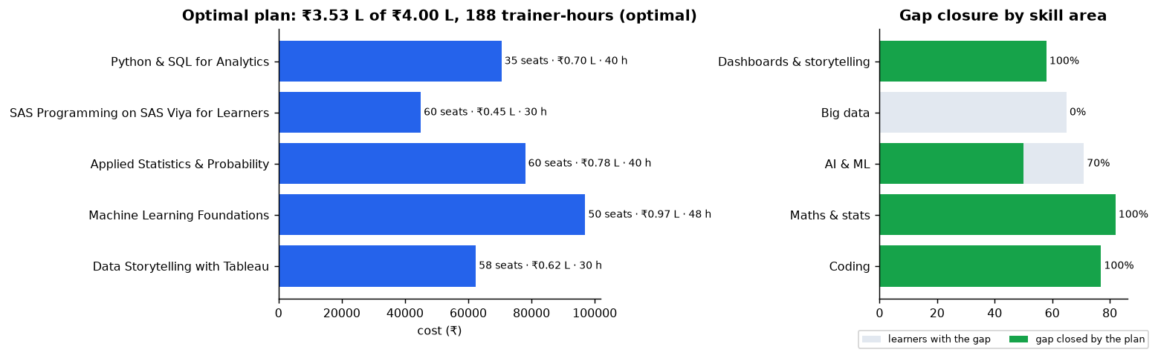
Figure 16: Optimal plan (left) and the share of each skill gap it closes (right).
The plan closes 100% of the coding, maths & stats and storytelling gaps and 70% of the AI & ML gap (ML Foundations is capped at 50 seats). It leaves the big-data gap open.
Why other courses were left out. Forcing each excluded course into the plan and re-solving shows its cost: Integrated Bootcamp −20.7% impact (high fixed cost, 90 trainer-hours, partial coverage), Deep Learning & NLP −12.8% (needs ML first and 40 more hours), Big-Data Stack −5.7% (lowest-valued area, does not fit the remaining hours), Power BI −1.1% (either/or with Tableau, which closes the full gap at the same per-seat cost).

4.3.3 Sensitivity: what would change the decision?
Money is not the constraint: Rs 0.47 lakh remains unspent, and an extra Rs 1 lakh adds no impact. Trainer capacity is, but in whole-course steps. The linear relaxation suggests each extra trainer-hour is worth 27.5 impact units, yet the exact integer re-solve with +40 hours adds nothing, because the next course (Big Data) needs 40 hours and Rs 1.1 lakh at the same time. This is precisely why integer optimisation, not a linear approximation, is needed. With a generous budget, extra trainer capacity buys:
Table 13: What additional trainer-hours buy (budget not limiting).
Trainer-hours | Added to the plan | Impact (change) | Gap closed
200 | base plan (5 courses) | 23,391 | AI/ML 70%, big data 0%
240 | + Big-Data stack | 25,767 (+10.2%) | big data 62%
280 | + Deep Learning & NLP | 27,158 (+16.1%) | AI/ML 96%
400 | + Bootcamp | 27,389 (+17.1%) | gains level off
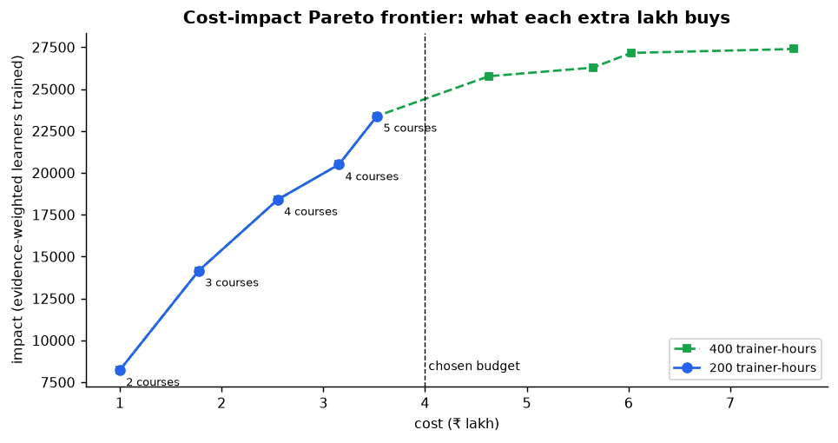
Figure 17: Cost–impact Pareto frontier with 200 and 400 trainer-hours.

4.3.4 Robustness
The plan was re-optimised under nine evidence scenarios: balanced, market-led and outcome-led weightings, each at the lower bound, point estimate and upper bound of every confidence interval (Figure 18). Statistics (60), SAS (60), ML Foundations (50) and Python & SQL (35) are chosen with identical seat counts in all nine scenarios, forming a safe core. Tableau storytelling is chosen in 7 of 9 and is replaced by the Big-Data stack only when the evidence is weighted purely by what job postings advertise.
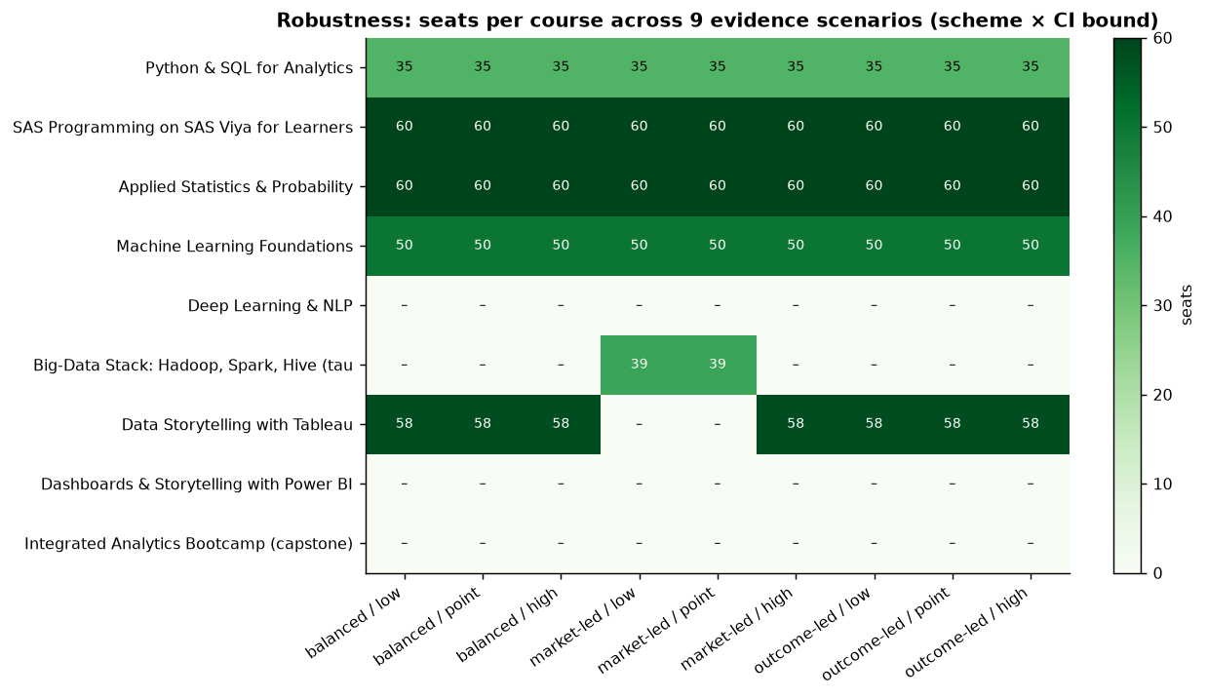
Figure 18: Seats per course across nine evidence scenarios.

5 Results and Conclusions
Table 14: Answers to the research questions.
RQ | Answer | Strength of evidence
RQ1 Demand & pay | Data roles ask for a toolkit (SQL 16.5%, SAS 13.4%, Python 12.6%, ML 12.0%). Beyond experience (OR 1.66 per year), predictive modelling, NLP, statistics, SAS and BI tools sit in higher salary bands; MIS and generic communication mark lower-paid support roles. | Strong: 14,840 postings, adjusted models, FDR control; salary only in bands.
RQ2 Junior growth | Storytelling (0.59) and maths-stats (0.55) separate high- from low-hike juniors most; model AUC 0.90 vs 0.50 baseline. | Strong but small sample (139); ceiling effect.
RQ3 Senior success | Openness (0.77) and conscientiousness (0.76) dominate; AUC 0.96. | Strong; unusually clean separation suggests sample data.
RQ4 Decision | Teach Statistics, SAS, ML Foundations, Python & SQL (robust in 9/9 scenarios) plus Tableau storytelling (7/9); expand trainer capacity before budget. | Optimal for the stated cost and coverage assumptions (not for real-world costs in general); robust to evidence uncertainty.
Overall conclusion. The evidence points in one direction from three independent angles: quantitative foundations (maths & stats) are valued by the market and by employers after hiring; coding is the entry ticket; and communicating results (dashboards & storytelling) is the skill employers reward internally but rarely advertise. For seniors, openness and conscientiousness, rather than any single technical skill, are associated with success. An institution can act on this immediately: a five-course plan closes most of an illustrative cohort’s gaps for Rs 3.53 lakh, and the next improvement depends on trainer capacity rather than money.
Link to the analytics objective. The objective (Section 1) asked for the skills and traits associated with demand, pay and success, and for an explainable training plan. Each success criterion is met: every RQ has a quantified answer (Table 14); both employee models beat the majority-class baseline under cross-validation (AUC 0.90 and 0.96 vs 0.50, permutation p = 0.002); and the RQ4 plan states its binding constraint (trainer-hours) and exactly what extra resources would buy (Table 13).
What we did not find. Big-data skill alone is not associated with junior hikes, and it has the weakest combined evidence of the five areas; it enters the plan only once extra trainer capacity is available. Meaning-based extraction from job descriptions did not work on this data and was excluded rather than reported.

6 Implications
Universities and skilling providers.
- Make statistics and probability and one statistical language plus SQL the non-negotiable core; SAS Viya for Learners removes the licence cost of the SAS track.
- Add a graded data storytelling module (dashboards, visual narrative, presenting to stakeholders). It is the most under-served skill: rewarded by employers, rarely taught or advertised.
- Teach the big-data stack (Hadoop, Spark, Hive, Scala) as one bundle, once trainer capacity allows.
- Plan trainer capacity before budget: sharing trainers across institutions unlocks the next courses more cheaply than extra money.
Students. Skills linked to pay and growth are concrete and learnable: statistics, a programming toolkit, and the ability to explain results. Postings that centre on MIS reporting sit in lower salary bands; building analysis and modelling skills moves candidates up.
Employers and HR. Storytelling and quantitative depth predict who earns high hikes, yet job postings rarely ask for storytelling. Writing it into job descriptions and assessments would align hiring with what employers already reward. For senior, customer-facing roles, structured assessment of conscientiousness and openness, alongside mentoring, is supported by both this data and prior research [1].
Policy and CSR programmes. The same model can be run for a district or a group of institutions to decide where shared trainers and seats create the most value, which suits CSR-funded skilling where budgets are fixed and capacity is scarce.

Limitations
- All results are associations from cross-sectional sample data, not causal effects.
- JDS and SDS are small (139 and 161); intervals are wide and SDS separates unusually cleanly. Validation on another cohort is needed before policy use.
- Salary is available only in bands; descriptions are truncated at source; 42% of tag uses are data-derived skills without an ESCO/O*NET code.
- RQ4 course costs, seats, hours and coverage are documented assumptions; with higher per-seat costs (our first draft, before the source check) budget rather than trainers became binding. The conclusion depends on cost levels, so they are stated explicitly and are easy to change.

References
[1] M. R. Barrick and M. K. Mount, “The big five personality dimensions and job performance: A meta-analysis,” Personnel Psychology, vol. 44, no. 1, pp. 1–26, 1991.
[2] European Commission, “ESCO: European skills, competences, qualifications and occupations, version 1.2.1.” 2025. Available: https://esco.ec.europa.eu
[3] National Center for O*NET Development, “O*NET 30.3 database.” 2026. Available: https://www.onetcenter.org/database.html
[4] H. B. Mann and D. R. Whitney, “On a test of whether one of two random variables is stochastically larger than the other,” Annals of Mathematical Statistics, vol. 18, no. 1, pp. 50–60, 1947.
[5] D. S. Kerby, “The simple difference formula: An approach to teaching nonparametric correlation,” Comprehensive Psychology, vol. 3, p. 11.IT.3.1, 2014.
[6] S. Holm, “A simple sequentially rejective multiple test procedure,” Scandinavian Journal of Statistics, vol. 6, no. 2, pp. 65–70, 1979.
[7] B. Efron and R. J. Tibshirani, An introduction to the bootstrap. New York: Chapman; Hall, 1993.
[8] L. Breiman, J. H. Friedman, R. A. Olshen, and C. J. Stone, Classification and regression trees. Belmont, CA: Wadsworth, 1984.
[9] P. Peduzzi, J. Concato, E. Kemper, T. R. Holford, and A. R. Feinstein, “A simulation study of the number of events per variable in logistic regression analysis,” Journal of Clinical Epidemiology, vol. 49, no. 12, pp. 1373–1379, 1996.
[10] E. Vittinghoff and C. E. McCulloch, “Relaxing the rule of ten events per variable in logistic and Cox regression,” American Journal of Epidemiology, vol. 165, no. 6, pp. 710–718, 2007.
[11] P. McCullagh, “Regression models for ordinal data,” Journal of the Royal Statistical Society: Series B, vol. 42, no. 2, pp. 109–142, 1980.
[12] Y. Benjamini and Y. Hochberg, “Controlling the false discovery rate: A practical and powerful approach to multiple testing,” Journal of the Royal Statistical Society: Series B, vol. 57, no. 1, pp. 289–300, 1995.
[13] R. Agrawal and R. Srikant, “Fast algorithms for mining association rules,” in Proceedings of the 20th international conference on very large data bases, 1994, pp. 487–499.
[14] L. Perron and F. Didier, “CP-SAT solver, Google OR-Tools v9.15.” https://developers.google.com/optimization/cp/cp_solver/, 2025.
[15] F. Pedregosa et al., “Scikit-learn: Machine learning in Python,” Journal of Machine Learning Research, vol. 12, pp. 2825–2830, 2011.
[16] S. Seabold and J. Perktold, “Statsmodels: Econometric and statistical modeling with Python,” in Proceedings of the 9th python in science conference, 2010, pp. 92–96.
[17] N. Reimers and I. Gurevych, “Sentence-BERT: Sentence embeddings using Siamese BERT-networks,” in Proceedings of EMNLP-IJCNLP 2019, 2019, pp. 3982–3992.
[18] S. Xiao, Z. Liu, P. Zhang, and N. Muennighoff, “C-Pack: Packaged resources to advance general Chinese embedding.” 2023.
[19] SAS Institute, “SAS viya for learners.” 2026. Available: https://www.sas.com/en_my/software/viya-for-learners.html
[20] E. B. Wilson, “Probable inference, the law of succession, and statistical inference,” Journal of the American Statistical Association, vol. 22, no. 158, pp. 209–212, 1927.
[21] KnowledgeHut, “How much does corporate training cost in india?” 2025. Available: https://www.knowledgehut.com/blog/enterprise/corporate-training-pricing-india
[22] TensorData, “GPU cloud pricing in india 2026: A100 and H100 costs compared.” 2026. Available: https://tensordata.com/blog/gpu-cloud-pricing-india-2026

Appendix A: Reproducibility
All analysis is scripted, seeded (seed 42) and re-runnable from the project repository (backend/). Run in this order (Python 3.13, uv):
Script | Produces
scripts/run_sas_ingestion.py | cleaned postings, tag mapping, text-calibration test
scripts/run_rq2_rq3.py | RQ2/RQ3 tests, models, odds ratios, trees
scripts/run_rq1.py | role families, canonical skills, demand, pay models, rules, triangulation
scripts/run_rq4.py | optimal plan, sensitivity, Pareto, robustness
scripts/make_report_assets.py | cleaned CSVs, LaTeX tables, figures for this report
Core modules: d2s/ingest/ (parsing, skill mapping), d2s/analysis/ (traits, jobs, plan), d2s/engine/ (CP-SAT model, sensitivity, Pareto, why-not). 49 automated tests check data handling, statistics and the optimiser (e.g. that every plan respects budget, prerequisites and either/or groups, and that the optimiser matches brute force on a small instance). Cleaned data: dataset/processed/clean/.

Appendix B: Role-family rules
Titles are lower-cased and matched against ordered keyword rules; the first match wins.
- Data Science / ML: data scien, machine learning, ML, deep learning, AI, NLP, computer vision, statistician, quant, predictive, modeller/modelling.
- Data Engineering: data engineer, big data, hadoop, spark, ETL, data architect, data warehouse, databricks, kafka, informatica, data platform, DBA, database, data model.
- Analytics / BI: data analy, analytics, BI, business intelligence, Power BI, Tableau, MIS, reporting, insight, SAS, statistic, research analyst.
- Business Analysis / Product: business analy, BA, product manager/owner/analyst, functional or business consultant.
- Marketing / SEO / Content, Finance / Risk, Software / IT, Sales / Ops / HR / Support, Management / Consulting (keyword lists in d2s/analysis/jobs.py); generic “Analyst” → Analytics / BI; else Other.

Appendix C: RQ4 course catalogue (assumptions)
Course | Fixed (Rs) | Per seat | Seats | Hours | Prereq. | Coverage (% of a learner’s gap per seat)
Python & SQL for Analytics | 60,000 | 300 | 15–60 | 40 | – | Coding 100
SAS Programming (SAS VFL) | 45,000 | 0 | 15–60 | 30 | – | Coding 70, Maths 20
Applied Statistics & Probability | 60,000 | 300 | 15–60 | 40 | – | Maths 100
Machine Learning Foundations | 72,000 | 500 | 15–50 | 48 | Py&SQL, Stats | AI/ML 100, Maths 20
Deep Learning & NLP | 80,000 | 2,000 | 10–30 | 40 | ML | AI/ML 60
Big-Data Stack (Hadoop, Spark, Hive) | 70,000 | 1,000 | 15–40 | 40 | Py&SQL | Big data 100
Data Storytelling with Tableau | 45,000 | 300 | 15–60 | 30 | – | Storytelling 100 (either/or)
Dashboards with Power BI | 40,000 | 300 | 15–60 | 28 | – | Storytelling 90 (either/or)
Integrated Analytics Bootcamp | 150,000 | 1,500 | 20–40 | 90 | – | Coding 40, Maths 40, AI/ML 30, Storytelling 40

Appendix D: Additional figures
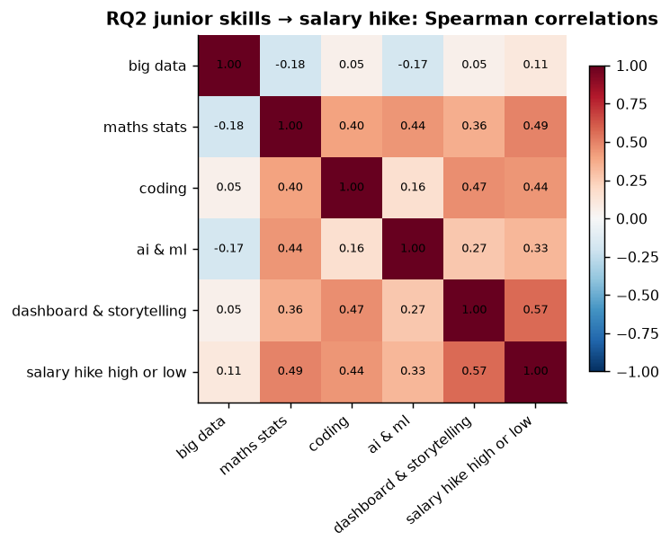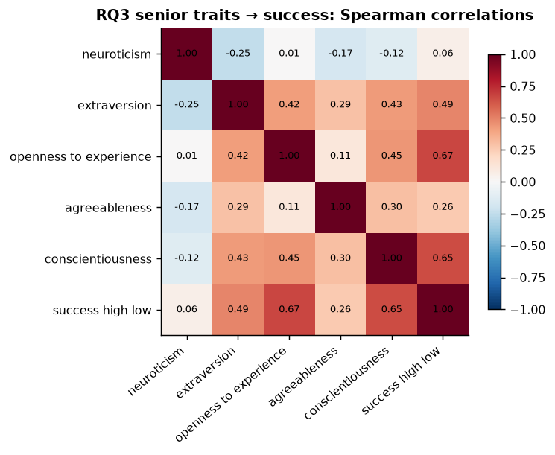
Figure 19: Spearman correlations, including the outcome (left: JDS; right: SDS).
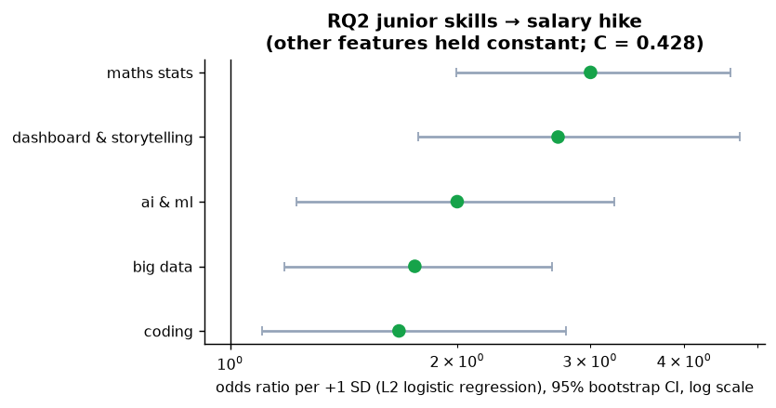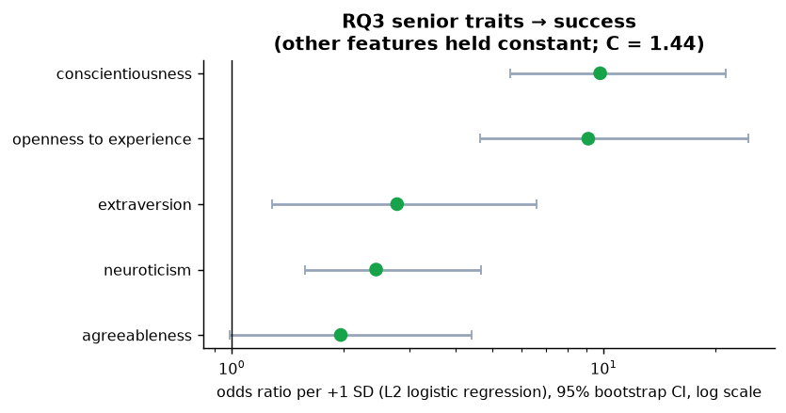
Figure 20: Odds ratios per +1 SD (L2 logistic regression, bootstrap 95% CI) (left: JDS; right: SDS).
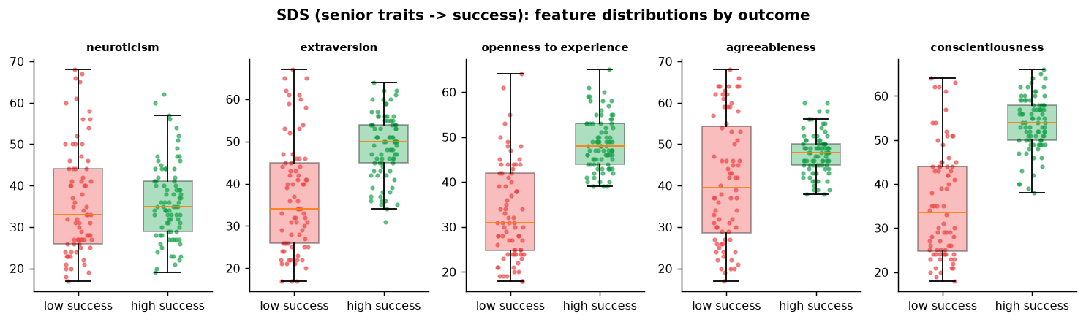
Figure 21: SDS: trait scores by success outcome.
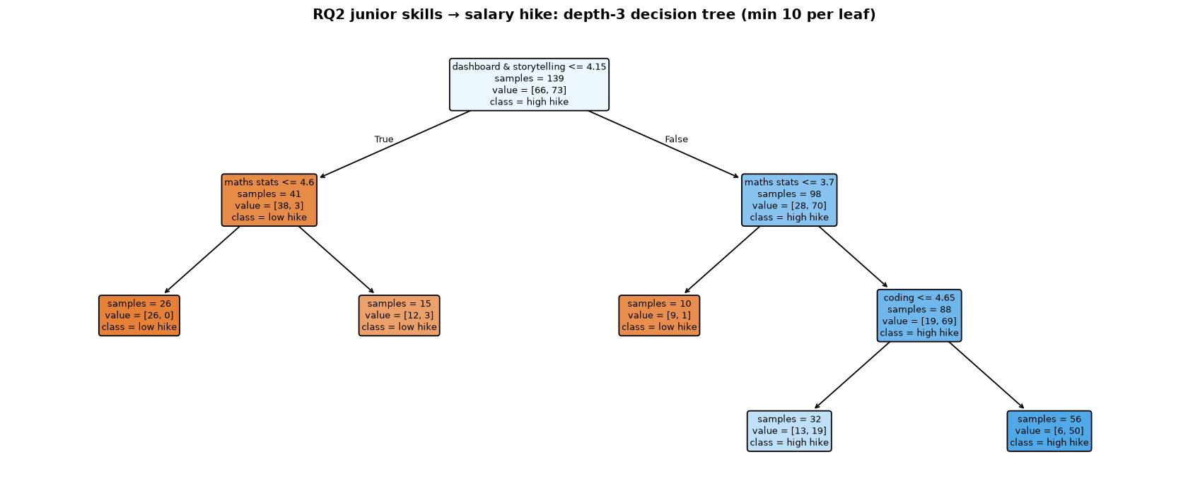
Figure 22: RQ2 depth-3 decision tree.
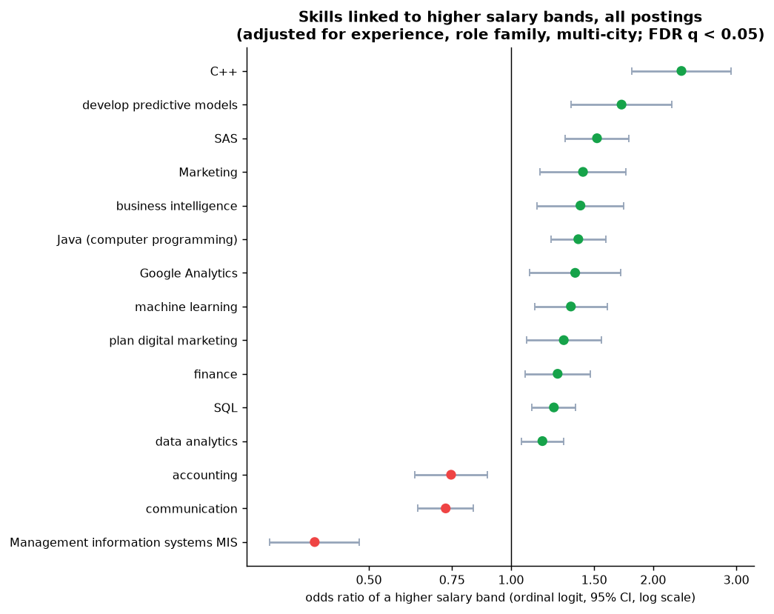
Figure 23: Adjusted pay association of skills, all postings.
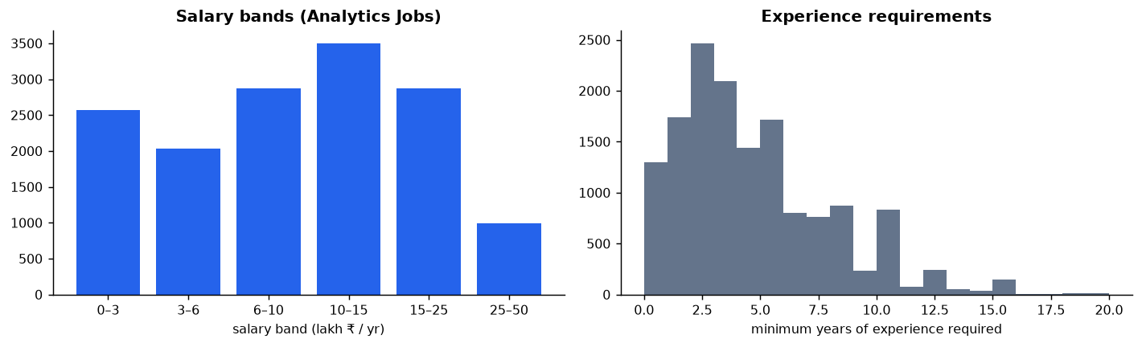
Figure 24: Analytics Jobs: salary bands and experience requirements.
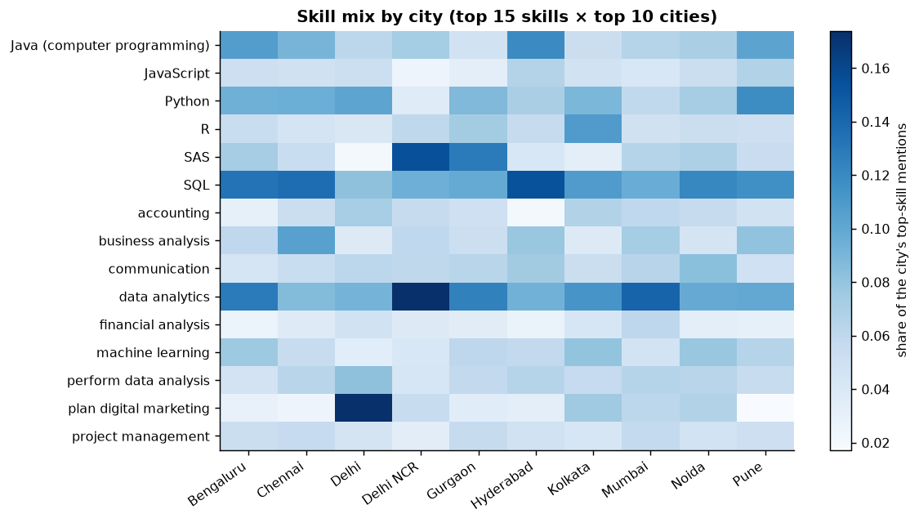
Figure 25: Skill mix by city (top 15 skills, top 10 cities).
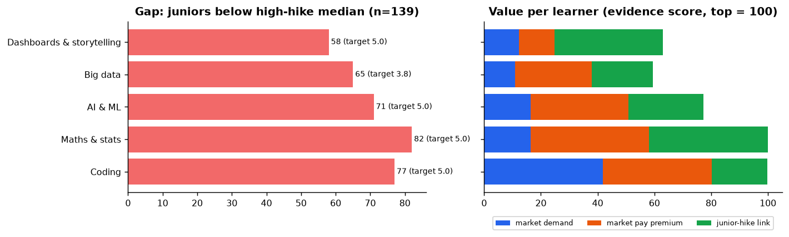
Figure 26: RQ4 inputs: gaps (left) and the value of closing them (right).

Appendix E: SAS code for the core analyses
The following program mirrors the core statistics in SAS (PROC MEANS, NPAR1WAY, LOGISTIC, HPSPLIT) for SAS Viya for Learners. It was written to match the Python analysis but has not yet been executed in SAS; results should be compared with Tables 9–10 before use.
/* D2S Bharat - core statistics in SAS (for SAS Viya for Learners / SAS Studio).
Reproduces the main RQ2/RQ3 analyses and key RQ1 preparation steps.
STATUS: written to mirror the Python analysis; not yet executed in SAS - run in VFL and
compare with the report tables before quoting.
Upload the four SAS files to your VFL home folder first and set &path. */
%let path=/home/&sysuserid/hackathon;
/* ---------- JDS: junior skills -> salary hike (RQ2) ---------- */
proc import datafile="&path/JDS Skill Traits.xlsx" out=jds dbms=xlsx replace;
getnames=yes;
run;
data jds;
set jds;
rename 'maths-stats_skills'n = maths_stats_skills;
run;
proc means data=jds n mean std min median max maxdec=2;
class salary_hike_high_or_low;
var big_data_skills maths_stats_skills coding_skills ai_and_ml_skills
dashboard_and_storytelling_skills;
run;
/* Mann-Whitney (Wilcoxon rank-sum) per skill */
proc npar1way data=jds wilcoxon;
class salary_hike_high_or_low;
var big_data_skills maths_stats_skills coding_skills ai_and_ml_skills
dashboard_and_storytelling_skills;
run;
/* Standardise, then logistic regression with odds ratios per +1 SD and ROC */
proc stdize data=jds out=jds_z method=std;
var big_data_skills maths_stats_skills coding_skills ai_and_ml_skills
dashboard_and_storytelling_skills;
run;
proc logistic data=jds_z plots(only)=roc;
model salary_hike_high_or_low(event='1') = big_data_skills maths_stats_skills coding_skills
ai_and_ml_skills dashboard_and_storytelling_skills / clodds=wald;
run;
/* Depth-3 decision tree */
proc hpsplit data=jds maxdepth=3 minleafsize=10 seed=42;
class salary_hike_high_or_low;
model salary_hike_high_or_low = big_data_skills maths_stats_skills coding_skills
ai_and_ml_skills dashboard_and_storytelling_skills;
partition fraction(validate=0.3 seed=42);
run;
/* ---------- SDS: senior traits -> success (RQ3) ---------- */
proc import datafile="&path/SDS Personality Traits.xlsx" out=sds dbms=xlsx replace;
getnames=yes;
run;
data sds;
set sds;
rename ' extraversion'n = extraversion
'success_ classification_ high_low'n = success_high_low;
run;
proc npar1way data=sds wilcoxon;
class success_high_low;
var neuroticism extraversion openness_to_experience agreeableness conscientiousness;
run;
proc stdize data=sds out=sds_z method=std;
var neuroticism extraversion openness_to_experience agreeableness conscientiousness;
run;
proc logistic data=sds_z plots(only)=roc;
model success_high_low(event='1') = neuroticism extraversion openness_to_experience
agreeableness conscientiousness / clodds=wald;
run;
proc hpsplit data=sds maxdepth=3 minleafsize=10 seed=42;
class success_high_low;
model success_high_low = neuroticism extraversion openness_to_experience agreeableness
conscientiousness;
run;
/* ---------- Analytics Jobs: de-duplication and derived variables (RQ1 prep) ---------- */
proc import datafile="&path/Analytics Jobs.csv" out=aj dbms=csv replace;
getnames=yes; guessingrows=max;
run;
/* exact duplicates ignoring the row id */
proc sort data=aj(drop=s_no) out=aj_dedup nodupkey dupout=aj_dups;
by _all_;
run;
data aj_clean;
set aj_dedup;
exp_min = input(scan(experience, 1, '-'), best.);
exp_max = input(scan(scan(experience, 2, '-'), 1, ' '), best.);
sal_min = input(scan(salary, 1, 't'), best.);
sal_max = input(scan(salary, 2, 'o'), best.);
length band $8;
band = salary;
band_rank = whichc(salary, '0to3', '3to6', '6to10', '10to15', '15to25', '25to50');
job_type_clean = lowcase(strip(job_type));
if job_type_clean = 'analytic' then job_type_clean = 'analytics';
has_sql = (index(lowcase(key_skills), 'sql') > 0);
has_sas = (prxmatch('/\bsas\b/i', key_skills) > 0);
run;
proc freq data=aj_clean;
tables band_rank job_type_clean / missing;
run;
/* ordinal (cumulative logit) model of salary band on experience + example skill flags */
proc logistic data=aj_clean;
model band_rank = exp_min has_sql has_sas / link=clogit clodds=wald;
run;

