Sales and Inventory Management System for Unison Auto Supply
Introduction
The Unison Auto Supply is a small shop that sells different parts of a car and its accessories. The shop still uses paper and receipts to record its daily sales and stocks. This old way of keeping records takes a lot of time and can cause mistakes or lost data. Because of this, the shop sometimes has trouble checking which car or motorcycle parts are sold or running out.
To help make their work easier, the study proposes a simple computer system that can record sales and track car or motorcycle parts automatically. This will make their business faster, more organized, and help them serve customers better.
Overview
The Unison Auto Supply is located in Sabayle, Iligan City. This shop sells different parts and accessories for the cars and motorcycle. This shop helps many car or motorcycle owners and mechanics find the parts they need. However, the store still uses the old way of managing their records. They write their sales, stocks, and orders on paper. Sometimes, it takes a long time to find old records or check which car or motorcycle parts are running out.
Because of this, our group decided to make a system proposal that can help the store improve their business process. The system will make recording, tracking, and updating their sales and stocks faster and easier. It will also help reduce mistakes and save time for the workers.

Statement of the Problem
The Unison Auto Supply still uses paper and receipts to record its daily sales and stocks. This manual way of managing their records causes problems such as slow recording, misplaced data, and difficulty in checking which car or motorcycle parts are running out. Sometimes, when customers ask for a certain part and it takes time for the workers to find the information. The manual process also increases the chance of mistakes and it takes a lot of time to write everything by a hand.
Because of these issues, there is a need to develop a simple computer-based Sales and Inventory Management System that can help Unison Auto Supply record sales, monitor stocks, and organize data faster and more accurately.
Objectives of the Study
- General Objective: The main goal of this study is to create a simple computer-based Sales and Inventory Management System that helps Unison Auto Supply record sales and track car or motorcycle parts easily and accurately.
- Specific Objectives: This study aims to reduce errors caused by writing records by a hand and to make it faster for the owner and staffs to record sales and check stocks and it also aims to help the shop to monitor which items are running out, keep records organized, and make them easier to search and update. And lastly the system will help save time and improve the daily work process of the shop.
Background of the Study
The Unison Auto Supply has been serving customers who need car and motorcycle parts for many years. This shop is known for selling different auto parts for cars, motorcycles, and other vehicles. Even though the shop is doing well they still use a manual way of writing their records using paper and pen.
Because of this, the workers sometimes have a hard time finding information especially when customers ask for certain items or when checking stocks. Writing and checking records by hand also takes time and can lead to mistakes.
That is why our group wants to recommend a simple computer-based system that will help Unison Auto Supply manage their sales and stocks more easily. The new system can help the store save time, reduce errors, and improve their daily business work.

Proposed System
A. System Description
The proposed system is a Sales and Inventory Management System that will help Unison Auto Supply record sales, track car and motorcycle parts and to check the available stocks using a computer. The system will replace the manual paper-based method with an easy to use digital process. And it will store all the records safely in one place and make it faster for the owner to view the sales, the update stocks, and to check the reports anytime.
B. How the System Works
The system will allow the owner or staff to log in and record each sale including the product name, quantity, and price. When an item is sold the system will automatically reduce its quantity in the stock. It will also show which items are running low so the owner can restock them easily. The main users of the system are the owner and staff, who will use it to record sales and manage inventory. This system fits the shop’s daily work because it makes recording, tracking, and checking stock levels faster and more organized.
C. System Functions and Features
a. User Login it allows the owner or staff to access the system securely.
b. Inventory Management it keeps track of the car and motorcycle parts including their stock quantity and availability.
c. Sales Recording it records each customer purchase including the item details and the total payment.

Appendix
Documentation
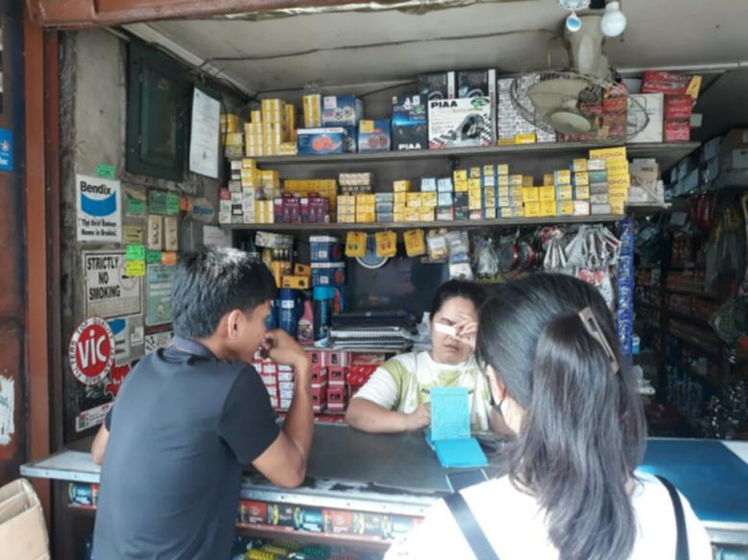


Interview Transcripts
1. Can you share how you usually handle your sales and records every day here in your store?
- Ilista ra sa mga resibo kung unsa ilang pangpaliton ug pila ilang mabayran sa ilang gipangpalit. Pero depende ra sad kay usaha'y mingaw man usaha'y dili.
2. When you check your stocks, how do you know which items are running out?
- Kung hapit na mahurot ang mga item parehas anang kani nga item kay isa nlang ang nabilin tapos kani nga item duha nlang nabilin.
3. Have you ever had a time when your sales or product records got mixed up or lost? What happened?
- Usaha'y kung ma misplaced lang.
4. Do you think it takes a lot of time to write and check everything by hand?
- Oo, madugay man gud mi ug sulat while naa'y mga customer.

5. If someone could make a simple system for your store, what do you want it to help you with?
- Kapoy kaayo e kuan sa computer kay dili man gud ingon nga fixed price dili parehas anang mga grocery kay fixed price na maglisod tag kuan kay usaha'y hangyo-hangyo.

