Johanna Rhyner
CS2810
15 December 2021

Final Project CS2810 Fall 2021

Algorithm:
I first implemented principle component analysis (PCA) to reduce the dimensionality of the datasets I was working with during the preprocessing step. I then implemented the k-means algorithm to cluster the data in the datasets.

Datasets:
I applied the k-means algorithm to two datasets. Links and descriptions are included below. Both were downloaded programmatically, so instructions for use are included in the “Code” section.
- gene expression cancer RNA-Seq Data Set
  - Link: https://archive.ics.uci.edu/ml/datasets/gene+expression+cancer+RNA-Seq#
  - Description: The dataset is comprised of a random extraction of gene expressions of patients with different types of tumors. The tumor types are: BRCA, KIRC, COAD, LUAD and PRAD. Each row represents a sample. RNA-Seq gene expression levels are represented as columns. A separate CSV file reveals the type of cancer associated with each sample.
  - Portion used: Due to the very high dimensionality of this dataset (20531 attributes), only the first 350 were included in testing.
- Answers to the Depression Anxiety Stress Scales
  - Link: https://openpsychometrics.org/_rawdata/
  - Description: This dataset is made up of answers to an online version of the Depression Anxiety Stress Scales (DASS). Answers are given as a numerical value indicating position on a subjective scale from 1 to 4. Time spent on the landing page, the DASS questions, and the other demographic/survey questions was also recorded. The following generic demographic survey information is also included: Ten Item Personality Inventory scores (scale of 1 to 7), English vocabulary (1 for yes or 0 for no to indicate whether participants knew the definition of a word), and numerical codes for education level, childhood environment (e.g. urban), gender, whether native language is English, age, handedness, religion, sexual orientation, race, voting habits, marital status, and family size. College major is included as a write-in option. Finally, technical information was used to determine country, screen size, uniqueness of location, and source.
  - Portion used: All data for DASS questions (question answer, time taken to answer the question, and question position in survey) was included. Non-DASS data was excluded due to lack of completeness.

Code:
The code can be run through the command line. Using argparse, the main function takes in three required arguments, in order: function to run ("elbow" or "cluster"), the name of the dataset to retrieve, and k (k represents the maximum k to try if the elbow function is being called or the k value to use in k-means if the cluster function is being called). The main function also takes in five optional arguments: number of principle components (default: 2), maximum times to loop in k-means (default: 100), x-axis label (default: x), y-axis label (default: y), and title (default: title). The number of principle components is only adjustable with the elbow function, while the axis and title labels are only used with the cluster function.
If the elbow function is called, input data is set to the specified dataset and the clean function is called. The cleaned_data function takes in a dataset name, and uses an if statement to call the retrieval function associated with that dataset. The retrieval function for each dataset downloads that dataset from its online location, extracts the files within, and reads the data file into an array. This file downloading portion was hard-coded for testing purposes, and unfortunately, I ran out of time to fix this, so the command-line arguments only works for the two datasets I worked with. To run the code with another dataset, the cleaned_data function could be updated with another if statement to retrieve data using custom clean functions to parse that data into a numpy array. The min-max scaling, PCA, and k-means portions of the code all accept numpy arrays, so the code should work as long as the data retrieval function reads the data into a numpy array.
In the cleaned_data function, the data is scaled using min-max scaling, and the specific number of principle components is chosen. Under the elbow cluster condition, preprocessed data is passed into elbow_plot function, which runs k-means on the data using k-values ranging from zero to the given maximum k-value. The inertia (SSE) for each value of k is determined (by creating a k-means instance, running the fit function on it, and extracting the SSE value) and k-values and inertias are then plotted on a line graph, which can be used to identify the optimal value of k.
Using this value of k, k-means clustering can then be visualized and assessed using the plot_clusters function. The plot_clusters function is called when “cluster” is passed into the command line. The plot_clusters function calls cleaned_data internally. This was intended to force the number of principle components selected to two so that the data points could be plotted, and I ran out of time to find a better way to do this. The plot_clusters function creates a k-means instance with the specified k and uses that to plot all data points colored by cluster (using a randomly generated unique color) and the centroids. The plot also displays the number of data points included in each cluster in the legend and the SSE at the bottom of the plot.
Due to time constraints, this is the only functionality I was able to successfully implement in the main function. However, the “Preprocessing” and “K-means” sections are very modular and can easily be run on any input data that has been formatted into a numpy array. These sections are further explained below:
Preprocessing:
This section includes the min_max_scale and pca functions. The min_max_scale function normalizes the given data using min-max scaling. It is modeled after MinMaxScaler() in sklearn. The pca function conducts PCA on the given data and returns the data reduced to the specific number of components.
K-means:
This section includes the k-means algorithm as a class. An instance of k-means is initialized with a specific k, and an optional maximum looping parameter. The default for max_loop is 100. Once a k-means instance has been created, the k-means algorithm is run be calling k-means.fit, which takes in data as a numpy array. It randomly selects k rows in the data array as initial centroids. It calculates the new centroids by calculating the distance from each data point to each centroid and storing that in an array, finding the minimums of that array, and the using those minimums to update each centroid to the mean of the data points assigned to its cluster. The cluster assignments and centroids are both stored as attributes of the k-means instance for later retrieval. Looping continues until the centroids at the start of the loop match the calculated mean centroids or the max number of loops is reached. Once the loop is finished, the inertia (SSE) is calculated and the cluster sizes are determined and both stored as k-means attributes.

Results:
DASS Dataset:
With two principle components, the optimal k for this dataset appears to be 3. With a k of two, the SSE was measured as less than 0.2:
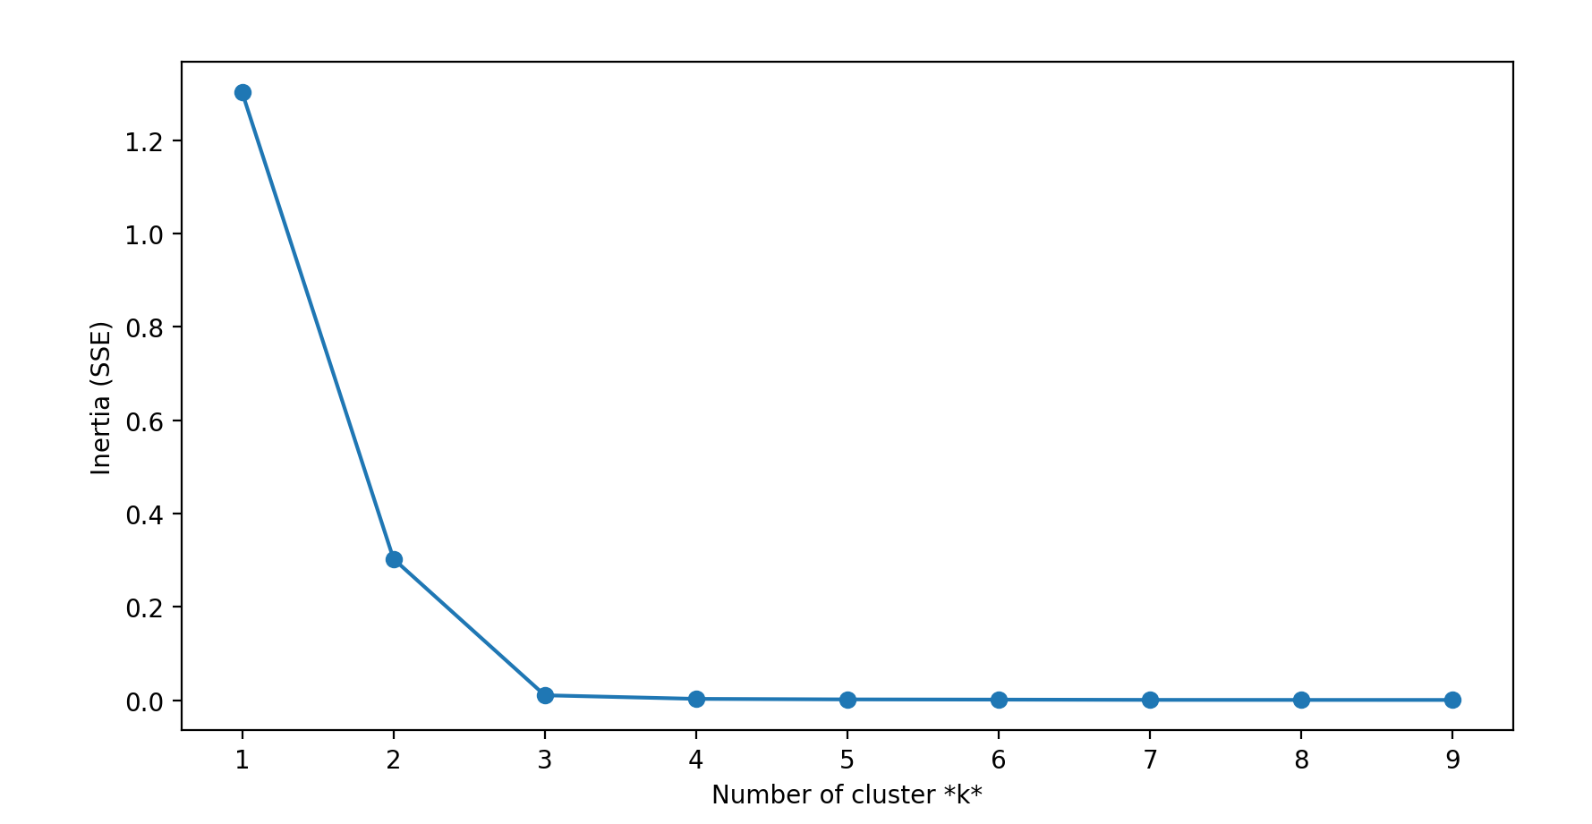
This dataset did not reduce well into two components. Running k-means on the reduced DASS dataset produced three very distinct clusters, but two of them contained only a single data point:
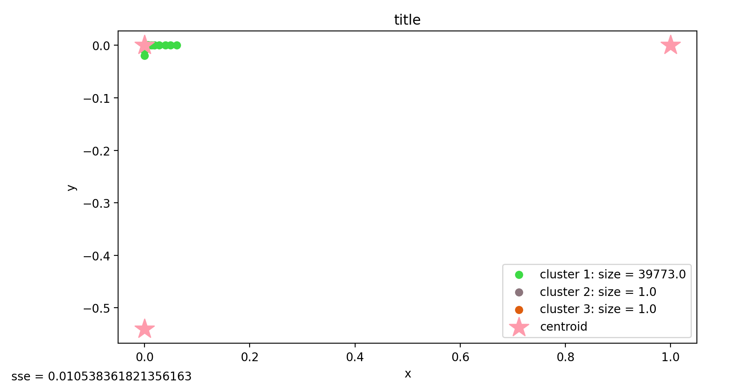

As can be seen above, the resulting SSE is low at about 0.01, but the cluster sizes range from 1 to 39,773. If I had more time, I would determine how the SSE changes with different numbers of principle components.
Gene Dataset:
For the gene dataset, the optimal k for the dataset reduced to two principle components is slightly higher at 4:
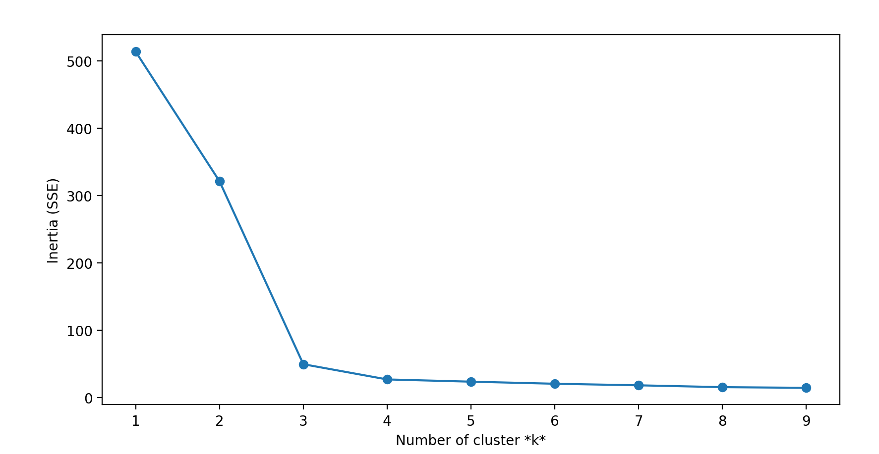
The inertia values in general are much higher for this dataset than the DASS dataset, indicating a larger data spread. This can be seen when the data is plotted:
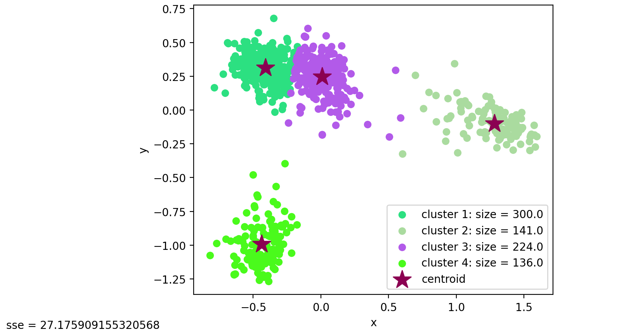
The data for this dataset is significantly more evenly distributed, with cluster sizes ranging from 136 to 300. The inertia, on the other hand, is higher than that of the DASS dataset: it is about 27.18. It appears that PCA was much more successful at retaining data integrity with the gene dataset than with the DASS dataset.

Conclusion:
K-means is very useful for clustering. However, due to runtime and memory limitations, it can often only be run when the dimensions of the data have been reduced, such as by using PCA. In this case, it was apparent that PCA is better at preserving some datasets than others, and that this affects the success of k-means.
The reduced DASS dataset exposed a common issue with k-means: namely, it struggles with outliers. Even less extreme cases, k-means is less successful when data is not more or less evenly and distinctly clumped. However, it can fairly successfully distinguish between two adjacent clusters. Oddly shaped datasets (especially circular datasets) are not well suited to k-means clustering, but for most datasets that form clump-like clusters, k-means is a relatively simple and effective way to divide data into clusters for analysis.

