**Q2 O.O.J C1821631**

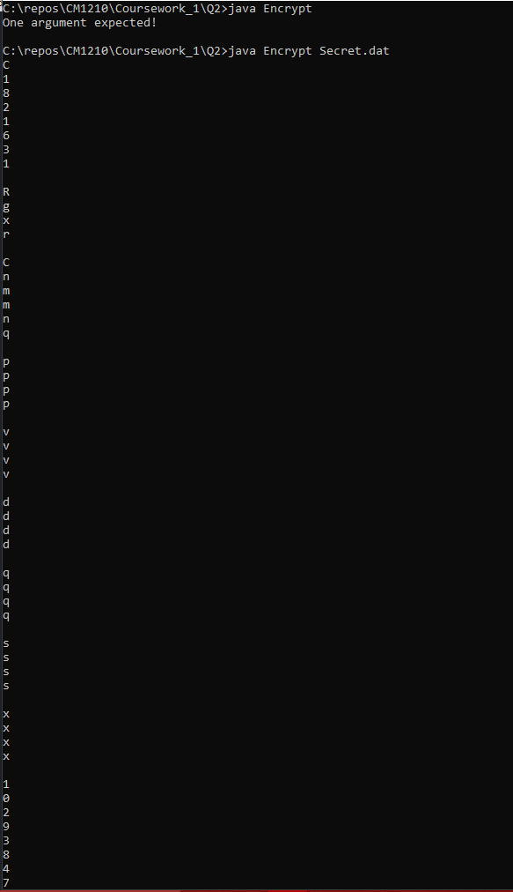

The secret.dat file contained the following

C1821631

Rhys Connor

qqqq

wwww

eeee

rrrr

tttt

yyyy

1029384756