Implementing and Comparing Real-Time Volumetric and Billboarded Clouds

1.0.0 Abstract
This paper analyses the performance and, by extension, viability of a voxel-based approach to representing cloudscapes in real-time simulation. This approach is compared against the use of billboards: a more traditional technique derived from instanced quad rendering. The study contrasts the performance characteristics between them.
To compare these techniques, a research artefact was created in the form of a Vulkan project that contained custom implementations of both techniques. The specifics of the implementations were informed by a previously conducted literature review which highlights the history of both techniques, the motivations for their use and development alongside the optimisations used in other implementations.
The research artefact was used to collect metrics regarding both techniques. A range of tests were conducted to determine certain aspects of the behaviours of each technique to deduce what their usefulness may be in contemporary games. The areas focussed on include overall frame time, frame variance and shader completion times compared to CPU function completion times.
As a result, it was found that volumetric rendering was more computationally expensive on the GPU, as expected was expected from information discovered in the literature review. Additionally, particular attention was paid to the variance in frame time present in each solution. The volumetric solution was found to have a greater variance in frame time depending on different circumstances. Due to these two factors, it was concluded that generally volumetric rendering is a useful approach when the desired fidelity and dynamism that the technique allows for are highly desirable for a given implementation because the lesser performance and unpredictable frame time variance makes it undesirable to be used elsewhere. On the other hand, billboards are more performant and are better suited for implementations where the skyscape is of lesser importance or is desired to behave in a more static manner.

2.0.0 Introduction
Videogames often strive to create the illusion of more detailed and complex behaviours than are at play. This is particularly true of graphics programming as the limitations imposed by hardware capabilities and frame time goals means that sometimes aesthetic goals are compromised in favour of performance. However, techniques that may once have been considered too computationally expensive for real-time simulations could now be viable. This is largely due to improvements in consumer GPU hardware allowing a greater number of complex simulations to take place. NVIDIA states in their article on the life of a triangle that, during the period of Direct3D9, the PS3 and Xbox 360, GPU architecture necessitated that rendering followed a fixed physical pipeline whereas they are now fully parallel. Due to this, primitives no longer run through pipeline stages sequentially, allowing for increased performance. Instead, different operations can be scheduled to occur at the same time which minimises idle waiting, henceforth maximising performance (NVIDIA, 2024).
One instance of this can be seen in the case of videogame skyscapes. Historically, cloud rendering has been approximated through other approaches to avoid much of the cost associated with accurately simulating participating mediums. These included techniques such as billboarding and use of static sky-domes and panoramic textures to create detailed skyscapes that achieve a desired artistic vision. Scheider states that traditional approaches such as these excel at keeping ram-usage and processing low, however they begin to become inadequate as more dynamic elements are desired. For example, if it was necessary that the camera pass through these clouds, the illusion would fall apart or if the game centres a dynamic weather system, a static pre-baked sky-dome would not suffice (Harris, 2002) (Schneider & Vos, The Real-time Volumetric Cloudscapes of Horizon - Zero Dawn - ARTR, 2024).
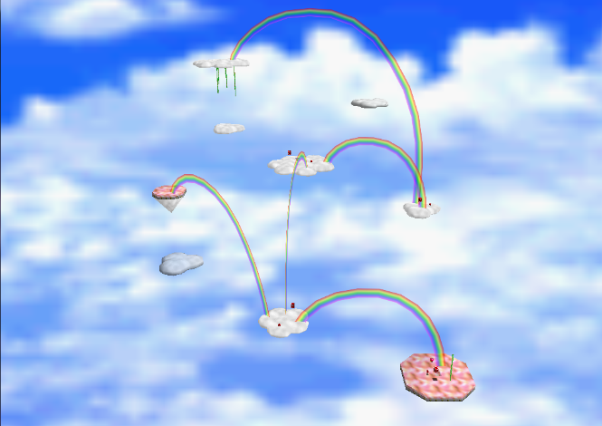
Figure 1 shows cloudscapes from Super Mario 64

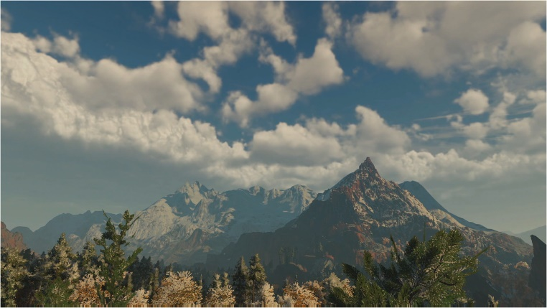
Figure 2 shows cloudscapes from Horizon: Zero Dawn

This paper examines volumetric cloud rendering which could now be considered a reasonable alternative to billboarded skyscapes, as they have seen use in titles such as Horizon: Zero Dawn. According to Fong and colleagues in a 2017 course regarding production volume rendering, this technique was considered only for production rendering needs a decade ago (Fong, Wrenninge, Kulla, & Habel, 2017). However, as production rendering has moved onto more advanced path-tracing techniques, this technique is now within the realm of possibility for real-time rendering, as evidenced by its use in Horizon: Zero Dawn. The primary reason it was once too expensive is due to plentiful texture reads, lengthy ray marches and nested loops. (Schneider & Vos, The Real-time Volumetric Cloudscapes of Horizon - Zero Dawn - ARTR, 2024). Haggstrom explains in ‘Real-Time Volumetric Rendering of Clouds’ that, the technique involves defining clouds by their density at given points and then raymarching through a voxel grid to sample its density and produce a result. He argues that they offer more potential for artistic expression as they can transition from low coverage to overcast, create different cloud types, handle different times of day and have clouds move across the sky (Haggstrom, 2018).
An important factor to consider when comparing these two approaches are player immersion and experience. If a skyscape is rendered non-volumetrically, the player may be left unsatisfied and have their immersion broken by the stilted nature of the clouds. In ’Real Time Cloud Rendering for Games’, Harris provides the example that a player may attempt to travel through them only to have the illusion broken or they may simply look at them from a distance and notice a repetition and a lack of dynamism (Harris, 2002). On the other hand, volumetric rendering is highly intensive. This could hinder a player’s enjoyment if the volumetrics are not performant enough to allow for a desired level of responsiveness in terms of frame times or perhaps the volumetrics must be rendered at an undesirable resolution.
Given how those in the production rendering space have reconsidered the standard approach to rendering clouds and volumes as a whole, this paper sets out to investigate a similar shift in real-time rendering. To do this, it compares an implementation of ray-marched volumetrics rendering to billboarded cloud rendering in the terms of performance to make inferences about each solutions potential use cases in a variety of game scenarios. As such, a conclusion will be reached that will decide upon the suitability of either technique for different requirements as well as to provide clarity on where the future of skyscape rendering may lie.

3.0.0 Aims and Objectives
The aim of this paper is to analyse volumetric and billboarded cloud rendering against one another as to infer the usefulness of the techniques in the context of contemporary real time graphics. To see this aim to completion, three primary objectives had to be met.
Conducting a survey on the state of both volumetric rendering as well as billboarded rendering. Gaining an understanding of the history of each technique and how to best implement them is highly important. This is because the methods discovered in this stage can be used to properly compare their performance in a fair and reasonable manner. A proper grounding in the foundational knowledge of either technique can intrinsically improve the analysis of said techniques as well as their implementations.
Additionally, a focus on developing an artefact which would enable a fair comparison between each focus to be conducted. Consideration had to be given as to how the implementations of each technique would behave and what approaches to take inspiration from that had been discovered during the survey to ensure that there was no great disparity between each of them performed.
Thirdly, performing tests on the artefact so that the resulting data can be analysed, and comparisons can be made. The methods of testing primarily focus on altering some factor to observe a change in frame time. Upon the completion of this then step, a valid statement based on evidence can be made as to the possible applications of these techniques in the realm of real-time rendering.

4.0.0 Literature Review
  - 4.1.0 Billboarding in Games
Microsoft defines ‘Billboarding’ in their D3D9 Documentation as a technique used to gain performance advantages by rendering 2D objects in a way that makes them appear to be 3D objects (Microsoft, 2024). This is done by orientating a textured rectangle based on the view direction of the camera (Akenine-Moller, et al., 2018). Billboards replace an object in the scene with a polygon that has a texture mapped to it consisting of an image that represents the object it replaces (Harris, 2002).
This technique is one of the cheapest ways to create somewhat convincing 3D graphics at a distance. Drawing many small triangles at a distance creates overdraw on the GPU, the simple shape of a billboard quad reduces the inherent overhead at a distance. Closely packed triangles are likely to emerge in small, dense objects or in objects seen from a far distance. Therefore, smaller triangles create increasingly higher performance costs, especially when those triangles are in the sub-texel range.

Figure 3 shows one triangle consumes one primitive


Figure 4 shows one triangle consisting of one texel consumes one primitive.


Figure 6 shows multiple triangles in one primitive consume a primitive each


Figure 5 shows two triangle consumes two primitives each.

The webpage G-TrucCreation tested the performance impact of such sub-texel triangles in their article ‘How bad are small triangles on GPU and why?’ by filling a 640x480 framebuffer with tiles, using a triangle pair to cover each tile. Figure 7 taken from the website clearly demonstrates an increase in performance impact as the size of a triangle is decreased. (G-TrucCreation, 2014).
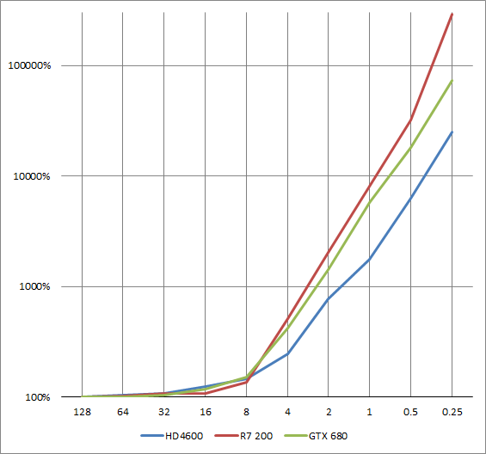
Figure 7 shows increase in performance overhead against size of triangle to be rasterised

Billboards are often integrated as part of many LOD systems as the lowest level of detail used at the furthest distance from the viewer partly due to the issue of sub-pixel triangles. However, billboards can also be used solely by themselves and are particularly common to see in foliage rendering, particle rendering and cloud rendering.
  - 4.1.1 Methods of Rendering Billboards and Imposters
A popular method to render many billboards is instanced rendering. This technique refers to drawing multiple objects using a single draw call. The GPU provides an instance index which can be used to access specific elements in arrays of data relevant to the billboards. This means that while more data is being pushed to the GPU for a singular draw call, there are less draw calls taking place, which is generally more efficient for many billboards.
Billboards are often used in situations where lots of similar objects must be rendered. As these objects are similar, they are likely to share the same data such as the same texture. To take foliage rendering as an example, if the renderer were to do a draw call for each blade of grass and individually push the texture needed for each billboard then the VRAM would be filled with identical textures and identical vertices, although the memory impact of these isn’t nearly as great as a texture. The combination of the overhead of a draw call alongside the unnecessary space taken up in VRAM by the same texture is unnecessary and it would be beneficial if these draw calls and repeated data could be removed. Therefore, rendering billboards is often achieved using instanced rendering.
However, even with instanced rendering, this method can still potentially use a lot of memory. Harris suggests in Real-Time Cloud Rendering for Games that, billboarded cloud rendering may make use of a type of billboard known as an imposter. This uses a multitude of cloud images, known as a texture index, that have been precomputed or computed dynamically at several different viewing angles that are then mapped onto the billboard to preserve the illusion that a skyscape contains realistic clouds (Harris, 2002). However, when discussing the use of volumetric clouds Haggstrom argues that these cloud images used for billboards could potentially be quite detailed, high resolution and in great quantity when attempting to achieve the most realism and dynamism from this approach and therefore take up more space. Therefore, as more realism is desired from this approach, the less of a performance advantage it holds (Haggstrom, 2018).
Akenine-Moller makes the case in In Real-Time Rendering Fourth Edition, that while a billboard’s transparent texels have no visual effect on the final image, they are discarded late into the rasterization stage. It follows that for each texel that goes unused, the relevant shader calculations are still taking place. Therefore, a rectangular mesh may not be the most useful for rendering some billboards but rather a tighter polygonal shape may more closely fit a specific image, reducing the amount of transparent texels and therefore reducing unnecessary shader work (Akenine-Moller, et al., 2018). This may be particularly useful for cloud rendering due to their large fringe where there are a great number of fully transparent texels.
  - 4.1.2 Billboarded Particle Systems
A particle system consists of separate small objects that are set into motion using some algorithm (Akenine-Moller, et al., 2018). These objects are referred to as particles. Many particle systems make use of billboarding, such as in Star Wars Battlefront 2 (Hillaire, 2016) and instanced rendering. It is also common for a particle system to be used to represent some form of volume such as smoke.
Particles take on their desired effect when there are multiples of them all acting in some desired simulated manner. It is generally not the case that the individual particle itself needs to represent a great level of detail and often it is desired that the individual particles are uniform in representation. For these reasons, billboards lend themselves well to being representations for individual particles.
It is common that some transparency is desired from particles in a system when trying to create the illusion of things such as smoke. Akenine-Moller et al state that, transparency creates many issues in graphics, especially when such transparent objects are near guaranteed to overlap one another. At a simplistic level, transparent objects must be drawn in sort order meaning that the furthest transparent object from the viewer is drawn first as to eliminate visual discrepancies when a later transparent object overlaps it. A more specific issue could arise with particles intersecting solid objects which could be combated by implementing ‘soft’ particles. These are particles that are tested against the depth buffer but do not write to it. If the underlying object is close to the particle billboard’s depth at that fragment, then it is made increasingly transparent (Akenine-Moller, et al., 2018).
  - 4.1.3 Billboarding’s Place in Skyscapes
Within the goal of rendering a skyscape, billboarding can be employed to render cloud textures in a way that simulates some realistic movement. This is not only because the billboards orientate themselves towards the camera but because the billboards might move along some path in a way that conveys the desired effect.
This technique is unlikely to create a satisfactory result on itself. Schneider & Vos of Guerilla Games used billboarded clouds alongside detailed pre-baked sky-domes in the KILLZONE series (Schneider & Vos, The Real-time Volumetric Cloudscapes of Horizon - Zero Dawn - ARTR, 2024). A sky-dome is an ellipsoid that surrounds a scene and is textured in such a way that creates the illusion of a grander environment, such as a sky (Luna, 2012). Said sky-dome mesh is generally centred around the viewer and moves with them, for this reason the mesh does not actually have to be large as it just changes its relative position (Akenine-Moller, et al., 2018). Schneider & Vos found this can produce some impressive results, especially if the texture that is applied to the sky-dome is highly detailed and is created by pre-baking lighting into the texture. (Schneider & Vos, The Real-time Volumetric Cloudscapes of Horizon - Zero Dawn - ARTR, 2024).
Akenine-Moller et al claim that a sky-dome works well in this situation because the sky is, generally, a great distance away from the viewer. If a group of objects, such as the sun or some clouds baked into the sky-dome or some far away buildings, are at a sufficient distance from the viewer then any parallax effect is barely perceivable when the viewer changes position. Any objects in the sky-dome must be placed deliberately to be viewed from such a great distance that any changes in the viewer are not intended to alter the view of the surroundings (Akenine-Moller, et al., 2018).
The sky-dome texture is large because of the detail required to look convincing. The resolution required depends on the field of view (FOV) of the viewer. A smaller FOV requires a larger resolution to achieve the same results as a larger FOV. Since at a small FOV a smaller portion of the mesh that makes up the sky-dome must take up the same screen space (Akenine-Moller, et al., 2018).
In the context of billboarded clouds specifically, it is desirable in some application, for the viewer to move through the false volumes. To alleviate the very apparent sudden disappearance that occurs when passing through said billboards, the transparency of the billboards could be reduced gradually as the viewer approaches them to a value of 0 (Akenine-Moller, et al., 2018).
Harris claims that, if the clouds are also only going to be viewed from a far distant in a certain application, a possible optimisation can be found in using lower resolution images. This is because clouds do not have high frequency edges like geometric models do so artifacts caused by said low resolution textures are less noticeable (Harris, 2002).
This combination of technologies can produce visually stunning results that are a suitable fit for game environments which are set at a singular point in time with static weather, such as in a more traditional third person game where the player goes from one level to another.
  - 4.2.0 What are Volumetrics
Symbol | Description | Unit
$$σ_{a}$$ | Absorption coefficient | $$m^{-1}$$
$$σ_{s}$$ | Scattering coefficient | $$m^{-1}$$
$$σ_{t}$$ | Extinction coefficient | $$m^{-1}$$
$$ρ$$ | Albedo | $$unitless$$
$$p$$ | Phase Function | $${sr}^{-1}$$
$$L$$ | Luminance | $${cd.m}^{-2}$$
$$T$$ | Internal Transmittance | $$unitless$$
(Hillaire, 2016)
Patapom defines a volume as referring to participating mediums where refraction, density and/or albedo change locally (Patapom, 2013), the most common examples of which being smoke, fire, dust and clouds; this paper will focus solely on clouds. Munoz demonstrates that as a photon travels through a volume, it may collide with the particles making up said volume and be altered in several ways at differential level (Munoz, 2014). Fong et al claim that for rendering applications, it is impractical to simulate collisions between each particle in the volume, they are treated as probability fields instead, represented using the absorption coefficient $σ_{a}$ (Fong, Wrenninge, Kulla, & Habel, 2017). A higher absorption coefficient increases the likelihood of photon-particle interactions.
The likely outcome for one of these collisions is absorption in which the energy from the photon is absorbed by the particle and for the simplicity of rendering purposes, has disappeared. Therefore, the more particles in the volume, the opaquer it becomes as more absorption occurs (Scratchapixel, 2024). Huber & Frost state, the alternate outcomes include the light beam being deflected from its path due to any change in the optical properties caused by an obstacle, known as scattering (Huber & Frost, 1998) or medium emission which will cause the photon’s power to increase. However, emission effects are outside the scope of this paper.
In-scattering is an event that adds photons and is a function of $σ_{s}$. Removing photons is a function of extinction $σ_{t}=σ_{a}+σ_{s}$ (Figure 8) representing absorption and out-scattering.
Munoz clarifies that these interactions happen at every differential point of the path of light (Munoz, 2014). According to him, physically rendering participating media involves solving or approximating the radiative transfer equation (Munoz, 2014). Due to the fixed time step nature of games, any equation that must is solved via integrating over a given time must be approximated. Haggstrom states, volumetric rendering generally refers to an algorithm that steps through a volume, samples the density and calculates the lighting (Haggstrom, 2018). This section will outline how games might create a representation of said volume, how they might step through said volume and how they may calculate lighting following this.
To summarise, lighting volumetrics is primarily concerned with determining the outgoing luminance $L$ of a medium by considering the events that occur inside the medium that alter the luminance when compared with the incoming luminance. These events include absorption, out-scattering and in-scattering.
  - 4.2.1 Absorption
Internal transmittance is the light being absorbed by the volume as it travels through it. This is governed by the Beer-Lambert Law: $T=e^{-\text{distance}×σ_{a}}$ (Figure 9)
Where distance refers to the distance from the point where the light ray enters the volume and the point where it exits it. The greater the absorption coefficient or the distance, the higher the optical depth and in turn the less light will travel through the medium section.
This models absorption but internal transmittance is influenced by both absorption and out-scattering. Albedo is a value representing the relative importance of scattering relatively to absorption in a medium where $ρ=\frac{σ_{S}}{σ_{t}}$ (Figure 10). This value lies within the [0,1] range. An albedo close to 1 indicates most light is being scattered instead of absorbed therefore creating a brighter volume. Such is the case with clouds.
  - 4.2.2 Single Scattering
It is likely that a photon will interact with a particle and be scattered and then interact with another particle and scatter again any number of times. This complexity known as multi-scattering was generally outside the scope of real-time volumetric rendering and is not modelled in more simple solutions. Instead, only the initial single-scattering was modelled.
  - 4.2.3 Multi-Scattering
Modelling realistic multi-scattering is too expensive for real-time applications but Schneider & Vos of Guerilla Games have suggested two different approximations. The first they refer to as the Beer’s-Powder approximation method which is a combination of Beer’s law and what they refer to as the Powder law where: $T=1.0-e^{-distance*2}$(Figure 11) (Schneider & Vos, The Real-time Volumetric Cloudscapes of Horizon - Zero Dawn - ARTR, 2024).
In-scattering brightens a certain region of a cloud. For this to occur, there needs to be an area where lots of rays are scattering into it. Scattering only occurs where there is cloud material, therefore the deeper into the cloud the viewer looks, the more scattering contributors there will be. The in-scattering at the edges of a cloud is also lower, making those edges appear darker. The Beer-Powder (Figure 11) approximation is useful because it approximates this effect (Schneider, Nubis: Authoring Real-Time Volumetric Cloudscapes with the Decima Engine, 2017).
The Beer-Powder approximation was the initial attempt but at a later date, in their 2017 SIGGRAPH talk regarding Nubis, they suggested an alternate method which is an improvement as the effect retains some directionality over the purely directional result achieved using the Powder function (Schneider, Nubis: Authoring Real-Time Volumetric Cloudscapes with the Decima Engine, 2017).
  - 4.2.4 Out-Scattering
The probability for in-scattering and out-scattering are the same and use the scattering coefficient $σ_{s}$. Despite a small chance that reflected photons could still contribute to the radiance ($L$) entering the camera, in the now standard model foundationally built by Schneider, these photons are disregarded as contributing to $L$. A phase function is used for modelling out-scattering (Schneider, Nubis: Authoring Real-Time Volumetric Cloudscapes with the Decima Engine, 2017).
Hillaire states phase function describes the probability distribution of how particles radii influence the distribution of light scattering direction at any point within participating media (Hillaire, 2016). They can be thought of similarly to BRDFs in physically based rendering. Different phase functions are used to approximate different types of scattering that can be identified from the size, radius and wavelength of a particle. The Henyey-Greenstein phase function is used for modelling cloud lighting and will be discussed later, the Reyleigh function is also commonly used for particles smaller than what would be found in a cloud (Hillaire, 2016).
  - 4.2.5 In-Scattering
Another contributing factor is in-scattering, wherein a photon travelling in a direction opposed to the direction of the camera is reflected and is aligned with the direction of the camera. This causes $L$ to be increased as photons are added.
This has been modelled by Guerilla Games based on Magnus Wrenninge’s Multiple Scattering approximation (Wrenninge, 2013). This involves combining two Henyey-Greenstein functions using a max operation. The attenuation value for the second function has been reduced to push light further into the cloud. This effect is only desired when the viewer looks away from the sun and as such the effect is reduced when the angle between the view ray and the light ray decrease. (Schneider, Nubis: Authoring Real-Time Volumetric Cloudscapes with the Decima Engine, 2017)
  - 4.3.0 Modelling Volumetric Clouds
Two factors are important when considering how to model volumes for games: how the volume data will be stored and how this data be generated. For representing the volume, it would be useful to have a single value to describe the ‘density’ at any point which will be used in future lighting calculations. To define these values this paper will examine techniques pioneered by Magnus Wrenninge and improved upon by Andrew Schneider and the Guerilla Games team (Schneider & Vos, The Real-time Volumetric Cloudscapes of Horizon - Zero Dawn - ARTR, 2024).
  - 4.3.1 Voxel Buffers
Wrenninge clarifies that in traditional surface rendering, there is a great distinction between geometry and shader. With regards to volume modelling, this isn’t the case as geometric primitives act more as a form of control for complex shaders which provide the final appearance. One common approach to model volumetrics involves voxel buffers (Wrenninge, 2013). Akenine-Moller states a voxel represents a volume of space, typically a cube, in a uniform three-dimensional grid. The most well-known voxel-based game is Minecraft in which the environment is modelled using voxels where each voxel stores an identifier and additional orientation or style data (Akenine-Moller, et al., 2018). To model clouds, each voxel will typically store only a value that represents the average density across the space contained within that specific voxel.
Storage of voxels has significant memory requirements as the storage requirement grows according to $O\left(n^{3}\right)$ with the voxel resolution. Akenine-Moller state Minecraft streams data in as 16x16x256 chunks for this very reason (Akenine-Moller, et al., 2018). This would not be practical for cloud representations as, generally, it is desired that the entire sky be filled with clouds instead of a portion. However, clouds generally require a lower resolution voxel grid than Minecraft due to being farther away from the viewer and bigger in nature than the cube voxels of Minecraft.
For a data point in a voxel grid, it is likely that neighbouring locations are likely to share the same data which is known as coherence whereas neighbouring locations with vastly different data means low or no coherence. It is also likely that a great portion of the voxel grid will contain empty values. If this is the case, then it is referred to as a sparse volume. Both lead to compact representations which means that an octree could be imposed as a supplemental representation upon the grid in order optimise it (Wrenninge, 2013).
  - 4.3.2 Weather Maps
It is the approach of Wrenninge and those who built from his foundational ideas that it is best to begin broadly in the sense that the initial values serve as an outline which are then ‘carved’ at to create more realistic and complex cloud shapes (Wrenninge, 2013) (Hillaire, 2016) (Schneider, Nubis: Authoring Real-Time Volumetric Cloudscapes with the Decima Engine, 2017). The initial stage of the approach begins by defining where clouds exist and what type of cloud they are. A possible way to do this, and the one Guerilla Games used, is with weather maps. In Guerilla Games’ approach, they assigned the red channel to cloud coverage, the green channel to precipitation and the blue to cloud type. (Schneider & Vos, The Real-time Volumetric Cloudscapes of Horizon - Zero Dawn - ARTR, 2024). While these weather maps can be created by hand, it is much more common to generate them using varieties of noise.
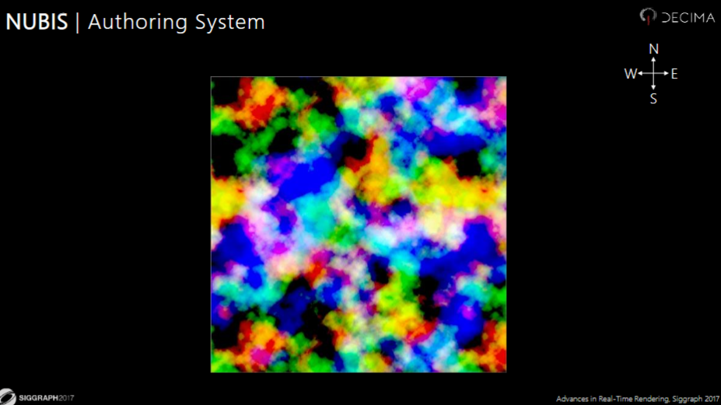
Figure 12 shows a weather map used in Horizon: Zero Dawn (Schneider, Nubis: Authoring Real-Time Volumetric Cloudscapes with the Decima Engine, 2017)

It is also stated that after the locations of where clouds can form has been determined, a shape-altering height-function is used to ensure that clouds are rounded at the bottom and top. A density-altering height function is then used to reflect that clouds are less dense at the top and bottom where the previous functions have created more inward shapes (Haggstrom, 2018).
There are many benefits to this approach with the three most apparent ones being that: since a weather map is only a texture, an artist can create unique skyscape formations for a specific event. For example, they may want to have the sun always poking through some pocket in the cloud, such was the case in the final boss battle of Horizon: Zero Dawn. A texture is also generally a very clear and concise visualisation of something that could otherwise be very abstract; it is also relatively easy to transition between two different skyscapes by linearly interpolating between two weather map textures (Schneider & Vos, The Real-time Volumetric Cloudscapes of Horizon - Zero Dawn - ARTR, 2024).
  - 4.3.3 Carving Volumetric Clouds using Noise
As previously stated, after broad density data has been created then it should be carved away at in some manner. The technique used widely across the games industry was introduced in the 2012 SIGGRAPH Production Volume Rendering Course and then expanded later in the book and later on in Guerilla Games’ approach makes use of noise textures for this (Schneider, Nubis: Authoring Real-Time Volumetric Cloudscapes with the Decima Engine, 2017).
Prior to Guerilla Games’ refinements, the approach involved drawing cloud volumes at a certain height zone above the viewer and using Fractal Brownian Motion (fBm) to ‘carve away’ the clouds. This involved layering different frequencies of Perlin noise atop each other to create detail. The noise is also combined with a gradient which defines the change in cloud density over height, as to model the different cloud types appropriately.
This technique was found to be too simplistic as the shapes it created did not reflect realistic cloud movement. As such, Guerilla Games further developed this approach by making use of alternate noise. They suggest using 2 3D textures and 1 2D texture containing a variety of noises.
One of the types of noise used was created by Guerilla Games for the explicit purpose of better modelling clouds. This being Perlin-Worley noise, a combination of the pre-existing Perlin and Worley noise where the Worley noise is used as an offset to dilate the Perlin noise (Schneider & Vos, The Real-time Volumetric Cloudscapes of Horizon - Zero Dawn - ARTR, 2024). There exists a noise generation project that can produce these noise textures developed by Sebastien Hillaire (Hillaire, 2016).

Figure 13 shows Perlin, Worley and Perlin-Worley noise.

The first 3D texture will be referred to as shape noise as it is responsible primarily for determining the shape of the cloud whereas the second will be referred to as detail noise. The single 2D texture will be referred to as curl noise. fBm is now used with these shape noise textures to combine them together. The curl noise does not require fBm and is sampled to distort the detail noise in order to fake fluid motion and add a sense of turbulence. Finally, combining the weather map, the values derived from fBm and the height-dependant functions creates cloud-like formation. The resulting cloud is then multiplied with a general density term.
Offsetting the weather-map allows for an entire cloud to move, offsetting the shape noise cause the clouds to change shape and offsetting the detail noise introduces turbulence without greatly altering them. Haggstrom claims these can be offset in conjunction to create believable dynamic results such as in cloud movement (Haggstrom, 2018).
Schneider & Vos found that great advantage of this approach is that the memory usage of this technique is limited to the cost of the textures used as opposed to, typically, dozens of billboard textures or sky domes (Schneider & Vos, The Real-time Volumetric Cloudscapes of Horizon - Zero Dawn - ARTR, 2024).
  - 4.4.0 Lighting Volumetric Clouds
Patapom states that clouds are a very thick participating medium consisting of microscopic water droplets which will either refract or reflect light that enters it but almost none of that light will be absorbed. This explains why clouds are a very bright volume (Patapom, 2013). It therefore makes sense why Hess, Kopke & Schult reported a single scattering albedo of 1 and a high extinction coefficient in the range of 0.04-0.06 in ‘Optical Properties of Aerosols and Clouds: The Software Package OPAC (Hess, Koepke, & Schult, 1998). It follows that approximating out-scattering is the most important part of modelling clouds.
Hillaire clarifies that in terms of water droplets, a wide and light density distribution volume could represent homogenous uniform fog whereas clouds are a locally dense heterogeneous volume (Hillaire, 2016) so modelling a fog would require differing values.
  - 4.4.1 Raymarching
As volumetric information is derived from a voxel grid instead of vertex data, raymarching is used to interpret the voxel data and produce a visual result. Munoz states that a light ray is continuous in nature however this is inherently incompatible with computer simulations, due to the fact that they are not capable of infinite precision. It follows that the path of light should be split into uniform segments that approximate all the differential interactions by a single sample (Munoz, 2014). This is the foundational idea behind raymarching. The bigger the size of the sample, often referred to as the step-size, the less representative it is and therefore the less accurate the simulation becomes although it will take less time overall. Haggstrom claims that to light volumetric clouds efficiently enough for real-time use, a careful balance must be struck when deciding on step-size and potential optimisations must be considered. However, taking too big steps may result in unwanted banding (Haggstrom, 2018).
In real terms, raymarching involves firing rays from the camera perspective into the scene. These rays advance forward at a rate defined by the step-size. At each point, the density value is accumulated until the ray ends. This resulting value is then used to for lighting calculations, specifically for being inserted into Beer’s law (Figure 9).
Haggstrom argues that optimisations could include making use of a dynamic step size. Meaning that a large step size is used before a non-zero density sample has been found. Yet when one is found, the ray returns one large step size backwards and continues sampling from that point using a smaller step size. Another optimisation involves ensuring that a ray stops sampling when the accumulated density reaches a value of 1 as any other samples would be superfluous (Haggstrom, 2018). These optimisations were used by Schneider & Vos in their solution and there is no particular downside to making use of them other than the chance that the large dynamic step size may skip over a small cluster of voxels with density values greater than zero which would result in visual artefacts and a potentially inconsistent image. (Schneider & Vos, The Real-time Volumetric Cloudscapes of Horizon - Zero Dawn - ARTR, 2024).
Once the raymarch has been completed and a density value has been derived, this value is then inserted into the Beer-Lambert (Figure 9) equation to model light absorption or, in the case of Horizon: Zero Dawn, the Beer-Powder equation. After absorption is modelled, scattering must be modelled using the same density value.
  - 4.4.2 Henyey-Greenstein Phase Function
Schneider & Vos clarify that in clouds, there is a higher probability of light scattering forward. This is known as anisotropic scattering. The Henyey-Greenstein function is used to reliably reproduce anisotropy in cloud lighting. Additionally, the amount of light scattering on the edges of clouds is lower which makes them appear darker (Schneider & Vos, The Real-time Volumetric Cloudscapes of Horizon - Zero Dawn - ARTR, 2024).
Despite using it for Horizon: Zero Dawn, when they began working on their Decima Engine, Guerilla Games found that the standard approach using the Henyey-Greenstein phase function produced inadequate highlights at sunset which was a goal of theirs in Horizon: Zero Dawn. To allow for more artistic malleability, they chose to alter the function using a variable that controls the intensity and spread of the effect so that the effect is artist friendly and can be adjusted dynamically to suit a variety of situations. Although, this is an area of continuing investigation as Schneider considers their current approach to not necessarily be based in the physical behaviours of light and volumes but rather as a workaround to approximate a solution for their specific use case. (Schneider, Nubis: Authoring Real-Time Volumetric Cloudscapes with the Decima Engine, 2017).
  - 4.4.3 Other Factors for Achieving Realistic Clouds
Haggstrom suggests that in the context of raymarching for clouds, at each sample where there is a non-zero density, a ray will also be fired towards the sun to accumulate density between said point and the sun. In this instance, the alpha is determined by the viewing ray density and the colour by the sun ray. He claims that the step size of the sun-ray raymarch should be significantly greater than that of the viewing ray however as a broader colour approximation is satisfactory (Haggstrom, 2018)
  - 4.4.4 Reprojection
Schneider & Vos found volumetric rendering as described above is still too costly to render on the PlayStation 4. (Schneider & Vos, The Real-time Volumetric Cloudscapes of Horizon - Zero Dawn - ARTR, 2024). The simplest way to reduce the cost this effect is to reduce the number of pixels being rendered each frame. However, Haggstrom claims that reducing the resolution and then upscaling would result in too poor of a picture quality. A differing approach allows for the benefits of a lower resolution to be maintained without sacrificing as much in quality. This is done by rendering one pixel in a 4x4 grid each frame and adjusting the positions of previously rendered pixels to move them to the appropriate place in order to avoid ghosting.
The process of adjusting the pixels positions is known as reprojection. Reprojection is done by recording how much a pixel has moved between frames across the screen, known as a motion-vector, and rendering this to a render-target where the red channel represents the X-axis and the green channel represents the Y-axis. The motion-vector is encoded into a separate texture. These motion vectors are used to move the pixels that are not raymarched on a given frame to the correct corresponding pixel. If no movement occurs, the motion vector texture is black (Haggstrom, 2018).

5.0.0 Research Methodologies
  - 5.1.0 Project Overview
To compare both the billboarded and volumetric cloud approaches, an artefact was created using the Vulkan SDK which contains an implementation of both solutions. The Vulkan project was built on the basis of blanco20-1’s Vulkan guide (vblanco20-1, 2025) which provides the basic features needed to render meshes in Vulkan. When running the artefact an image such as in Figure 14, Figure 15 and Figure 16 can be seen.
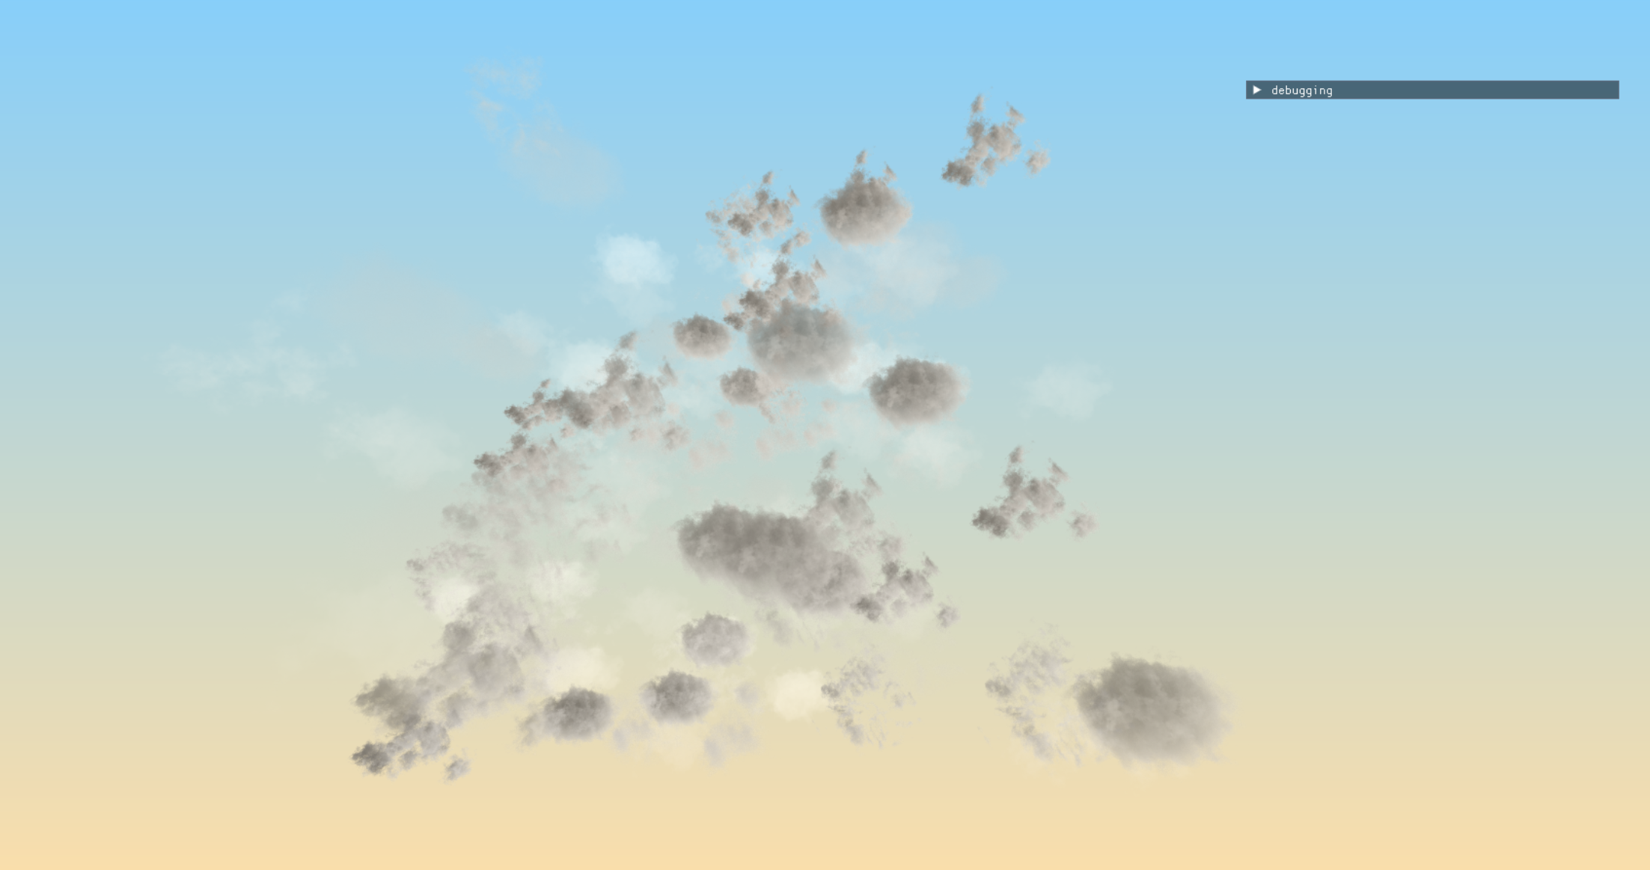
Figure 15 shows the billboarded solution more closely

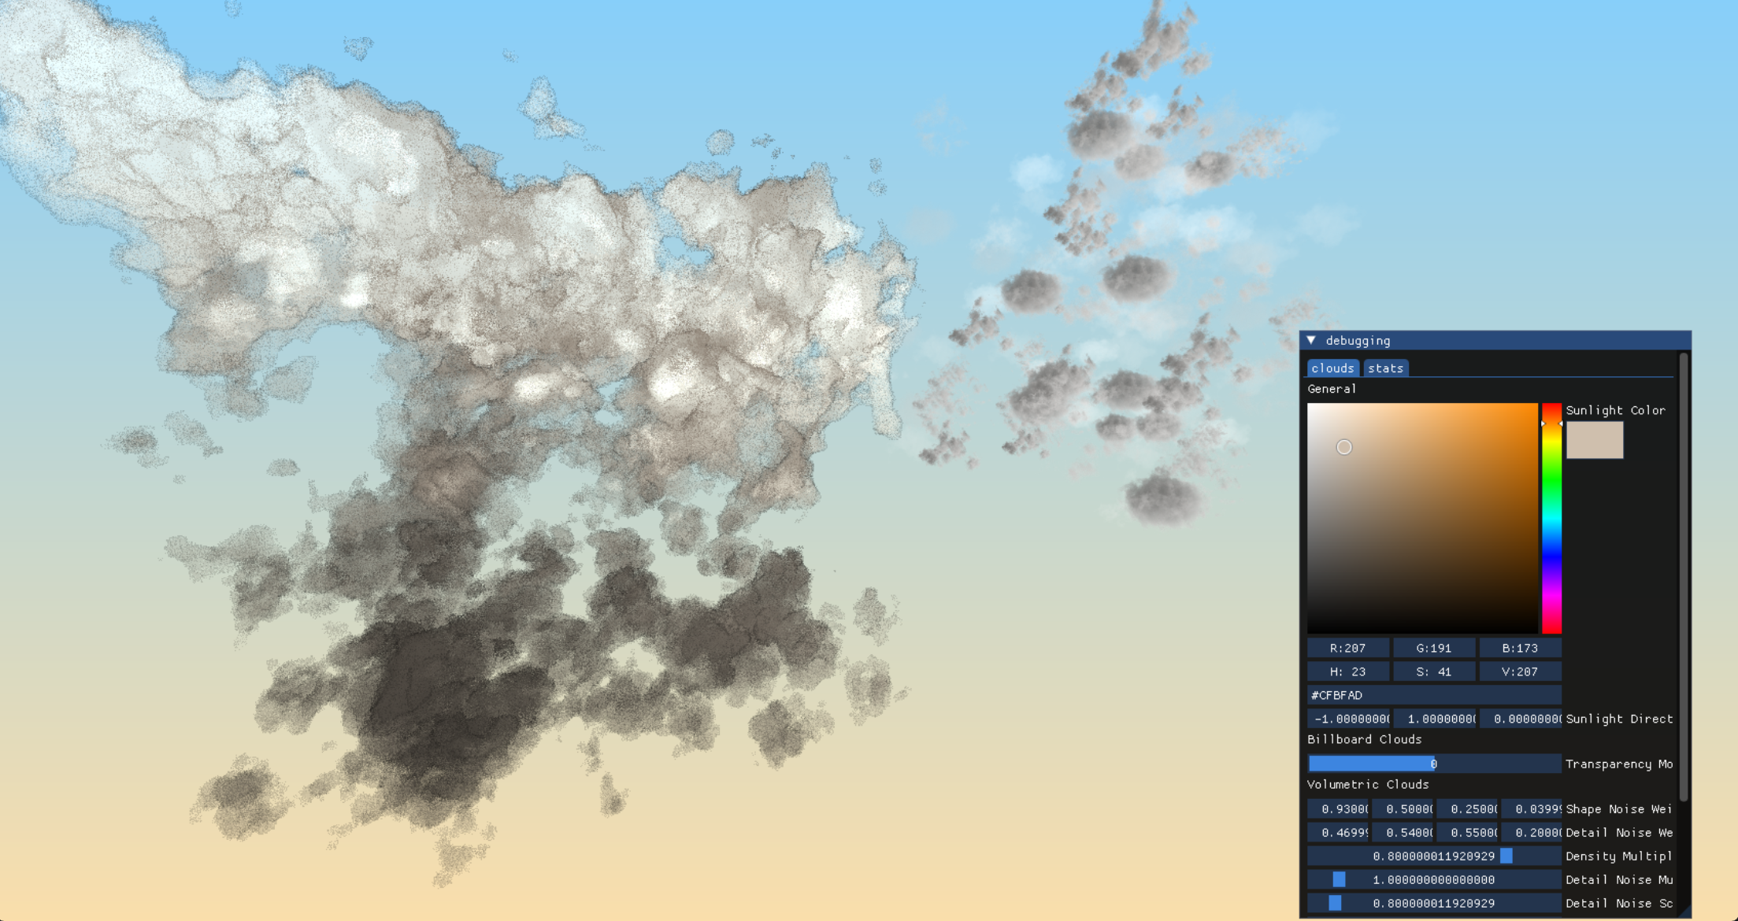
Figure 14 shows both the volumetric and billboarded solutions together

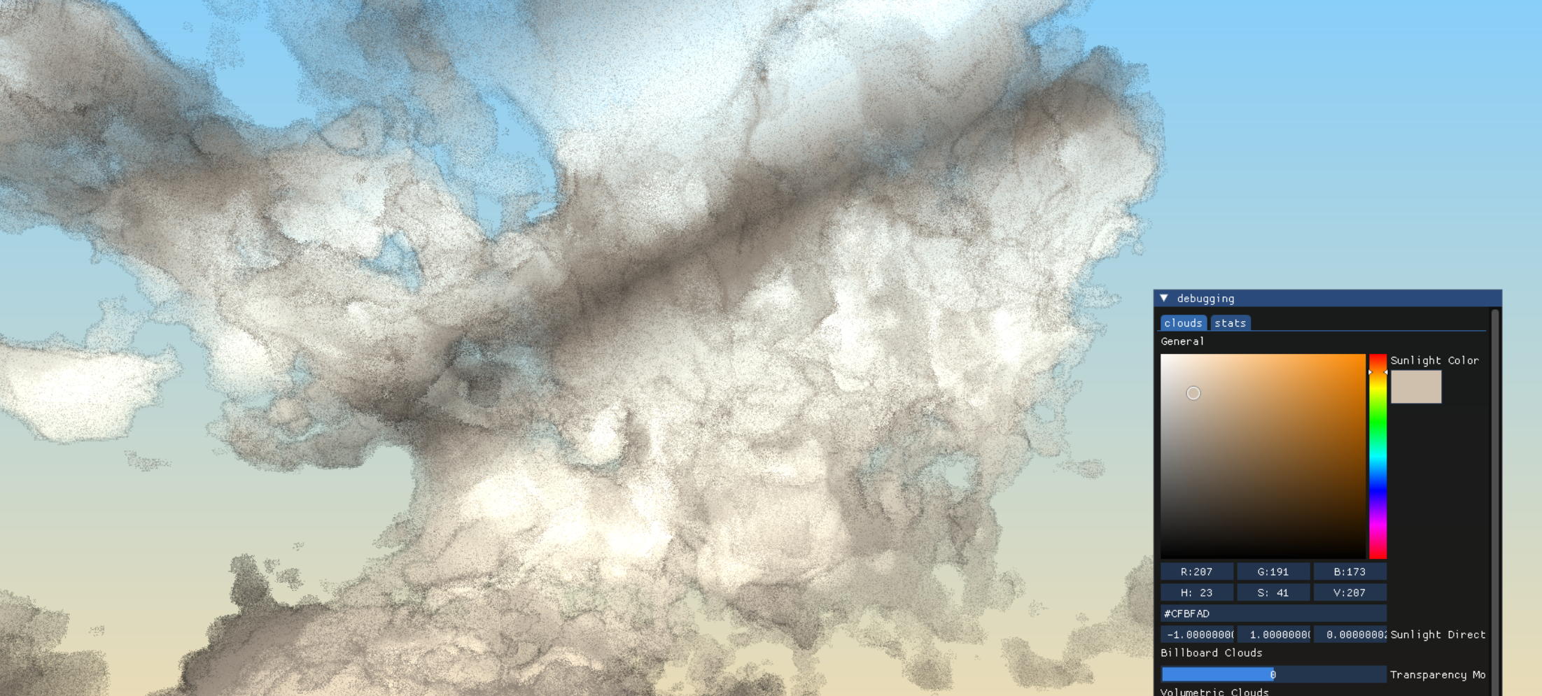
Figure 16 shows a closer view of the volumetric solution

  - 5.1.1 Billboarded Solution
Figure 19 shows how billboarded data is unpacked on the GPU

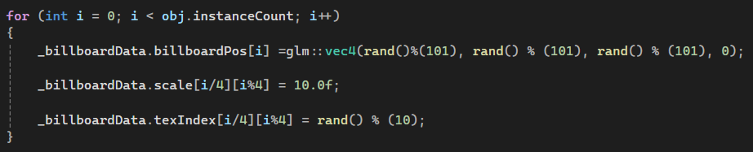
Figure 18 shows the way billboarded data is set

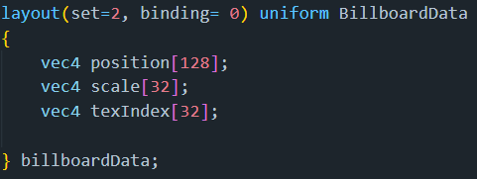
Figure 17 shows the buffer layout used for billboard data

The billboarded clouds make use of instanced rendering to reduce the number of draw calls that would have to take place otherwise. The billboards are regular quads made up of 4 vertices. The data pushed to the GPU includes the world position, the scale and the index of what texture to use as seen in Figure 17. For 128 billboards, an array of 128 vec4s is passed through for position values whereas only 32 vec4s are passed through for scale and texture index values. This is because only a single float value is needed to describe the scale and the texture index. As such, this data is packed into vec4s and must be unpacked when used as seen in figure 19. The decision was made to use arrays of float4s instead of arrays of floats because alignment can be maintained this way even with an amount of billboards that isn’t divisible by 4.
There are 9 2048x2048 textures which can be chosen from to be sampled in the pixel shader via the texture index. This index is currently randomised on the CPU; however, a more sophisticated system may alter the index based on factors such as height or other details regarding a particular solution to create more realistically transforming skyscapes. Regardless, as artistic fidelity is not a concern of this project, it was not pursued. The textures themselves can be found at: https://opengameart.org/content/clouds-with-transparency.
The billboards are also transparent in nature, with their transparency increasing the closer that the viewer gets to them. Due to their transparency, the order in which their drawn must be sorted. As instanced rendering is using, they cannot be sorted in the traditional sense. Instead, the values that are sent to the GPU such as position, scale and texture index are sorted in such a way that the clouds retain their appearance which can be seen in Figure 20.
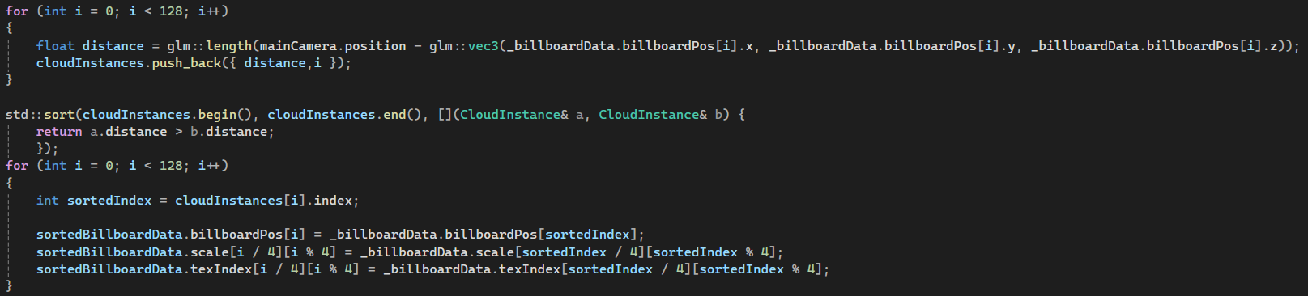
Figure 20 shows how billboarded data is sorted based on distance from the camera

  - 5.1.2 Volumetric Solution
The basic overview of the volumetric system is that on initialisation a 512x512x512 3D 1-channel 8-bit depth UNORM texture is created to contain the density information. This texture is then written to each frame by a compute shader. This compute shader has a local x, y and z size of 8. It takes in the 3D image for density, and two sampler3D images for noise. The shape noise is 128x128x128 and the detail noise is 32x32x32, however they are packed into a 2D representation, and were created using Sebastien Hillaire’s Tillable Noise Generator found at: https://github.com/sebh/TileableVolumeNoise. These noise textures are then used to generate density values. After the compute shader has finished a vertex shader runs which takes the input of a 36-vertex cube which it transforms into view space and simply passes on a few values to the corresponding pixel shader. This pixel shader is where the raymarch takes place that generates the visual representation of the voxel grid.
Looking at voxel generation in the compute shader more closely, a 3D value is derived from the global index of the work item being operated on by the compute shader. This position is normalised using the size of the voxel grid image. This normalised position is used to sample both noise textures. These noise textures can be scrolled using a time variable and a unique speed variable for each texture. The noise approach is inspired by the work done by the Guerilla Games’ team. Specifically, the fBm approach is used to generate a singular value from the noise. Guerilla Games’ approach also specifies the use of a density altering height-function which is used in the artefact.
As this project was built to be ran on an AMD GPU the local size of the compute shader is 4x4x4 as modern AMD GPUs contain 64 threads in each of their thread blocks. Therefore, on the CPU the group count sent via the command dispatch is equal to the width/height/depth value of the voxel image divided by 4. This allows for as much of the workload to be parallelised as possible.
The vertex shader transforms a cube into view space and calculates the ray origin to be passed onto the pixel shader. The cube serves as a sort of container for the voxel grid data in so far that a voxel grid image will be spread across the entirety of the cube. As such, a cube that is scaled smaller may not benefit from a larger voxel grid resolution as much as a large cube may. This is because with the large cube, a lower grid resolution may result in noticeable physical artifacts.
The pixel shader is responsible for generating the visual representation of the voxel grid. The colour value for an individual pixel is determined by raymarching through the voxel grid. There is an illumination value and a transmittance value which
Raymarching with larger step sizes can produce noticeable banding artefacts, as seen in Figure 21, which are particularly apparent when the viewer moves. To remove these artefacts, a random element is introduced when determining the sample position. This effectively disrupts the harsh lines that may be seen otherwise. However, this process introduces noise as a visual artefact instead which can be seen in Figure 22. This noise generally appears more natural than banding artefacts and as such is preferrable. In addition, the ‘jitter’ value chosen to offset the sample position is generated partly using a time value. This gives the effect of a non-static noise affecting the clouds. This further lessens how noticeable the artefact is as it can give the illusion of particles moving throughout the volume.
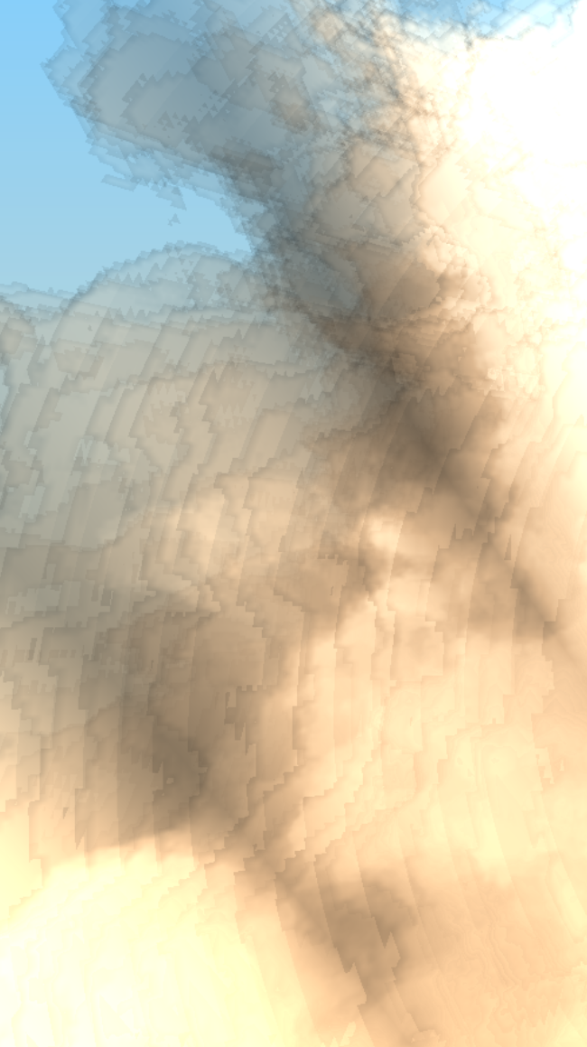
Figure 21 shows banding on the leftmost side of the image.

A few optimisations are made in the pixel shader. The raymarch ends early if the illumination value rises above 0.8. Similarly, if the transmit value also falls below 0.1 then the raymarch exits early. This optimisation is taken because the difference in appearance between a raymarch that ends early given these conditions and a fully finished raymarch is likely to be minimal. Even if these values were not chosen, the raymarch could exit early when the illumination rises above 1 or when the transmit lowers between 0 and there would be zero change to the final appearance.

Figure 22 shows noise artefacts throughout the cloud image.

The lighting calculations are primarily based on the work of Guerilla Games’ as presented in their Horizon: Zero Dawn talk and their NUBIS talk. From their first talk, the Powder equation is used to modify the traditional Beer-Lambert equation for accumulation. This is paired with alterations they presented in their second talk, namely the insertion of arbitrary values into the equation to produce what they considered to be more pleasant results. The Henyey-Greenstein function used is also as written in their secondary talk as seen in Figure 23.
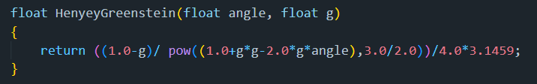
Figure 23 shows the Henyey-Greenstein function used inspired by Guerilla Games (Schneider, Nubis: Authoring Real-Time Volumetric Cloudscapes with the Decima Engine, 2017).

  - 5.2.0 Testing
The primary concern of this paper is regarding the matter of how either solution may perform. To ensure the results of this paper may be reproduced the following specifications about the device on which the artefact will be tested alongside some relevant details regarding the program itself.
  - 5.2.1 System and Project Configuration Details
All tests took place on an Omen 16-c0xxx which has an AMD Ryzen 7 5800H 8 core CPU, 16GBs of DDR4 RAM, an AMD Radeon RX 6600M GPU which has 7.98GBs of GDDR6 VRAM. The system runs Windows 11 23H2. The program was compiled with release flags enabled and Vulkan validation layers off. At the time of testing, the only programs running on the system were the artefact itself, Optick Profiler and NVIDIA Nsight Graphics.
  - 5.2.2 Testing Tools
Optick Profiler is a CPU profiler built specifically for profiling the performance of games which aims to be as lightweight as possible. The aspects of this tool which are particularly useful are its ability to distinguish between time spent doing useful work and time spent waiting. This is highly useful in highlighting bottlenecks in applications.
NVIDIA Nsight Graphics is a GPU debugger and profiler built to allow for the tacking of GPU performance and the analysis of GPU traces amongst other features. The use of this tool allows for frame times to be monitored. In addition, the ability to break down different shader stages allows for detailed analysis. As such, specific bottlenecks in the GPU pipeline itself can be located. The use of these tools in conjunction allows for a holistic approach to be taken with the analysis of both approaches.
  - 5.2.3 Primary Testing Aims
These tools have been chosen primarily for the fact that in combination they allow for great insight into the behaviour of both the CPU and the GPU. The primary goal of this paper is to establish under what circumstances either approach may be useful to a developer. As such, testing will aim to measure the performance of each approach in terms of frame times, frame variance, CPU vs GPU bottlenecks and memory usage. This should allow for a developer to gain a comprehensive understanding of the benefits and drawbacks of each approach.

6.0.0 Results and Findings
  - 6.1.0 Volumetric Testing
The research artefact used for all testing can be found at: https://github.com/rhysaelliott/FYP-Cloud-Rendering.
The research artefact uses a linear ray-marching algorithm in the implementation of volumetric rendering which can cause great frame time variances depending on specific factors. The primary factors are the distance of the camera from the voxel grid and the density makeup of the grid. As such, three types of volumetric render are be compared: a worst case, an average case and a best case. This will allow for the frame variances that can occur under regular use of this method be shown.
The first worst-case scenario is be referred to as the ‘Suboptimal Volumetric’. For this scenario, the density multiplier value is set to 0. This mimics the worst-case scenario where every raymarch must travel its full potential distance instead of exiting early. To examine volumetric rendering under assumed normal use, the default values as found in the repository will be used. This average case will be referred to as the ‘Standard Volumetric’. For the last scenario, the height map factor is set to 1. This creates a very dense voxel grid which means that all rays will exit early. This best-case is considered the ‘Optimal Volumetric’.
All volumetric settings are as found in the repo for the research artefact unless stated otherwise. In all tests the cloud speed and detail speed has been set to 0 to reduce randomness. In addition, for all volumetric tests the call to the draw_geometry function inside of the draw function has been commented out. Meaning that, for a volumetric test, the billboards will not be sorted or rendered. The default camera position was used in every test and the camera was never moved.
  - 6.1.1 Frame Time Volumetric Test
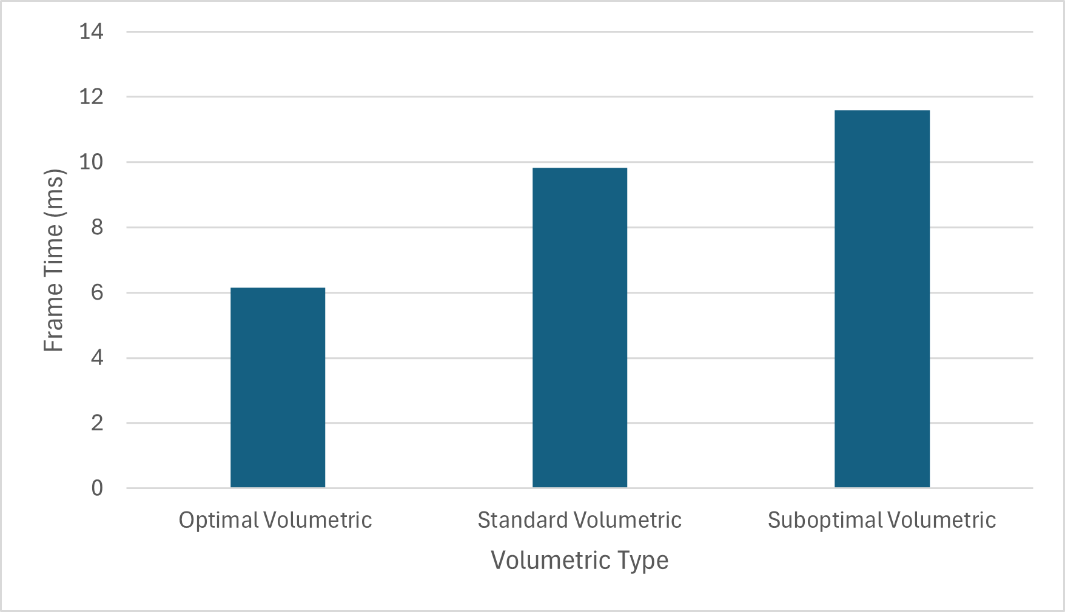
Figure 24

This test measures frame time. The values presented in Figure 24 were provided via the use of the Optick profiler. The frame time refers to the total amount of time taken to complete all instructions for one frame across both the CPU and GPU. The frame chosen was that which displayed median performance.
  - 6.1.2 Compute Shader Volumetric Test
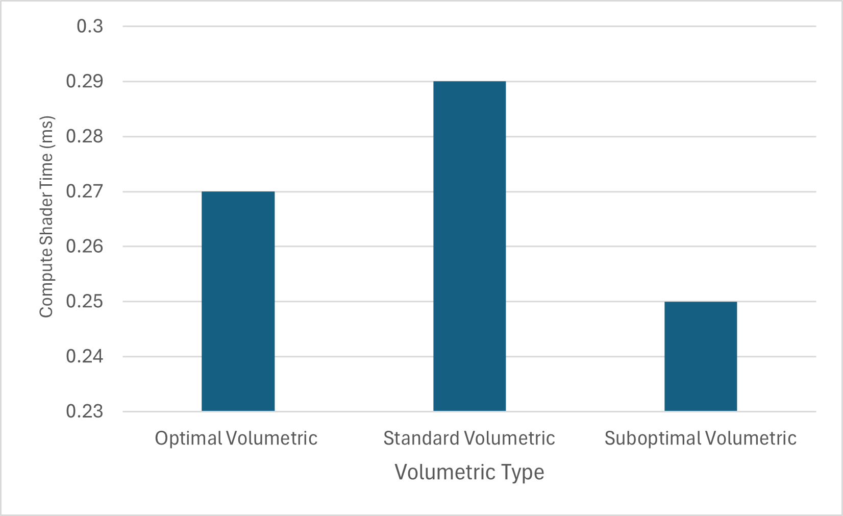
Figure 25

This test measures the time taken to complete the voxel generation shader. The values presented in Figure 25 were taken from a frame captured using NVIDIA Nsight.
  - 6.1.3 Raymarch Shader Time Volumetric Test
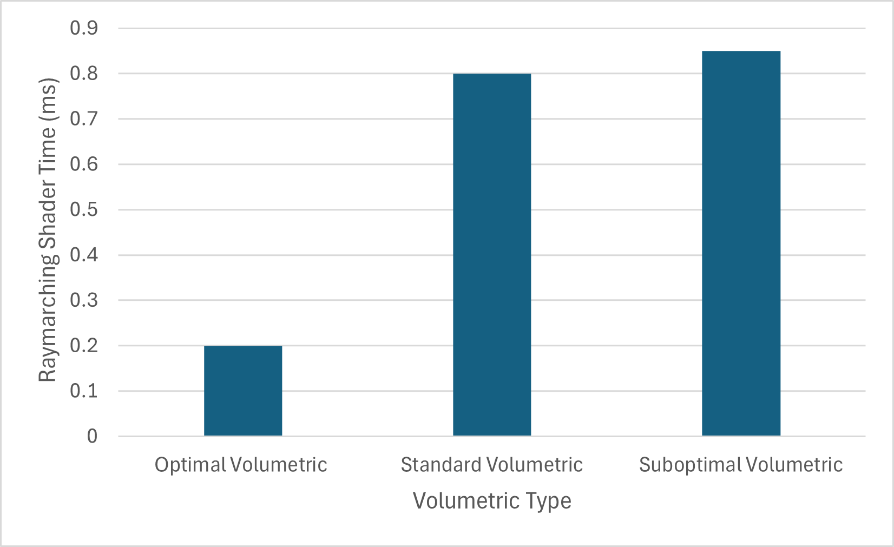
Figure 26

Similarly to the prior test, the values found in Figure 26 came from the same captured frame as the previous test and the frame was captured using NVIDIA Nsight. The value corresponds to the time taken for the vertex and pixel shader where raymarching takes place to complete.
  - 6.1.4 GPU Present Volumetric Tests
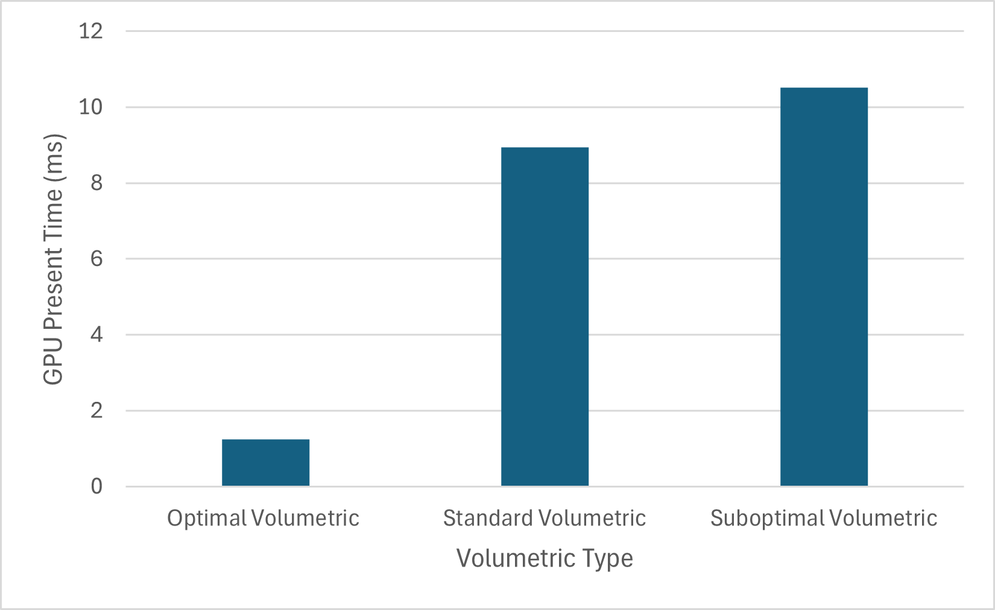
Figure 27

This graph shows a measure of how long the CPU was left waiting for the GPU to present. The value was gathered by using Optick and only measures the time it takes for vkQueuePresentKHR to complete.
  - 6.1.5 CPU Functions Volumetric Test
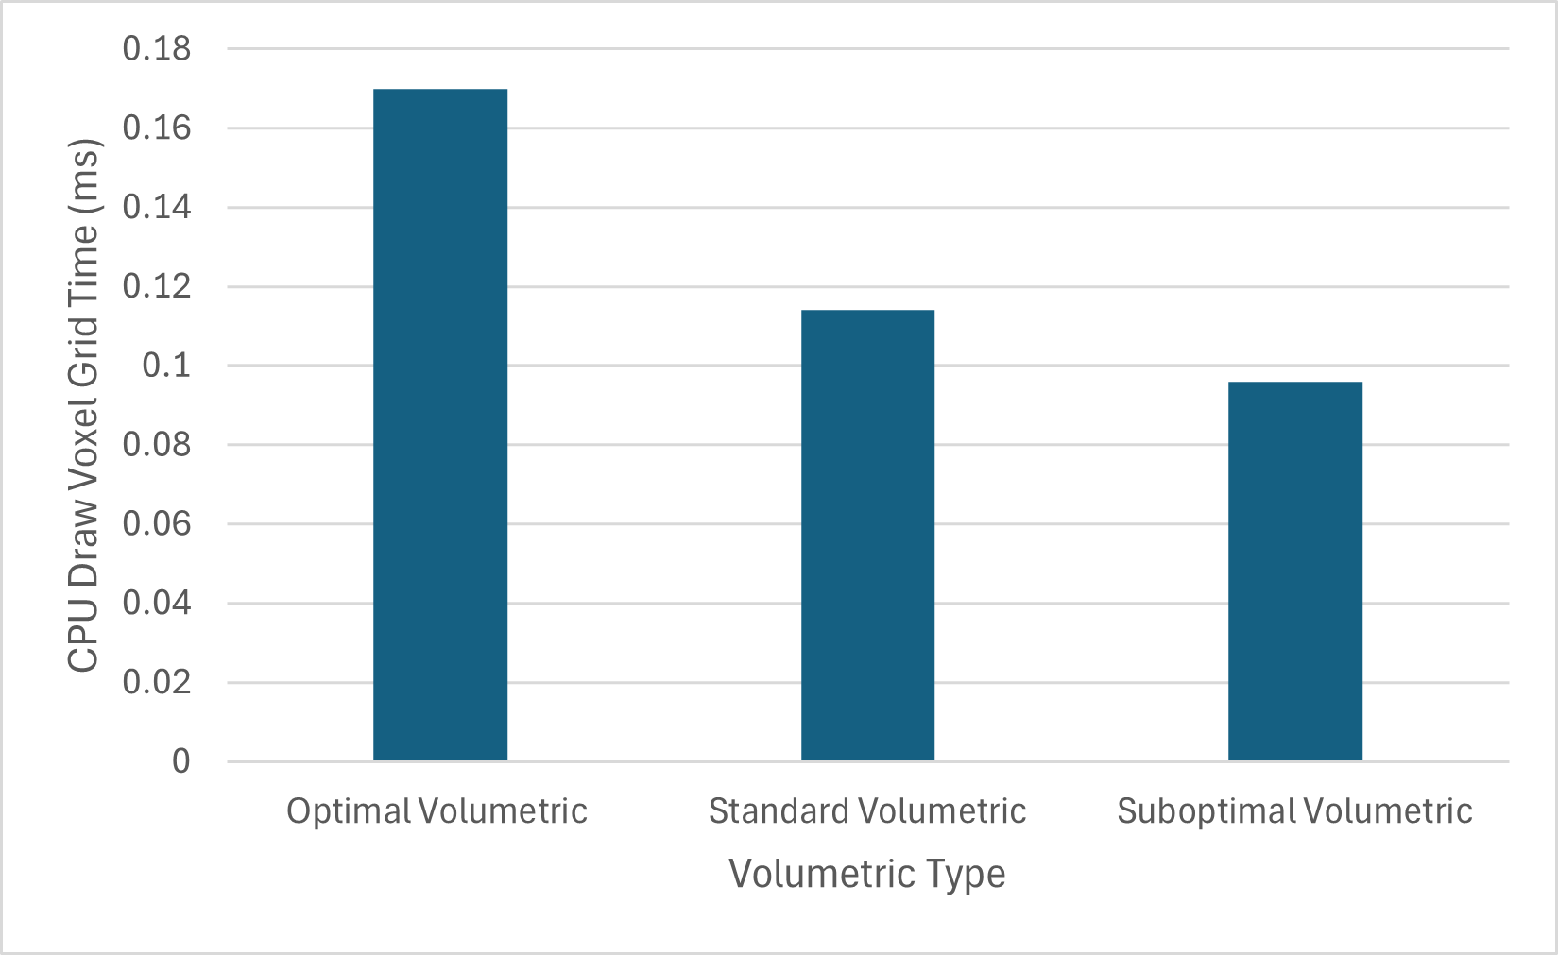
Figure 28

This test is a measure of how long it took for the draw_voxel_grid function to complete on the CPU, which is the function responsible for dispatching the compute shader. The values were collected from Optick Profiler. The function is responsible for dispatching the command to the compute shader.
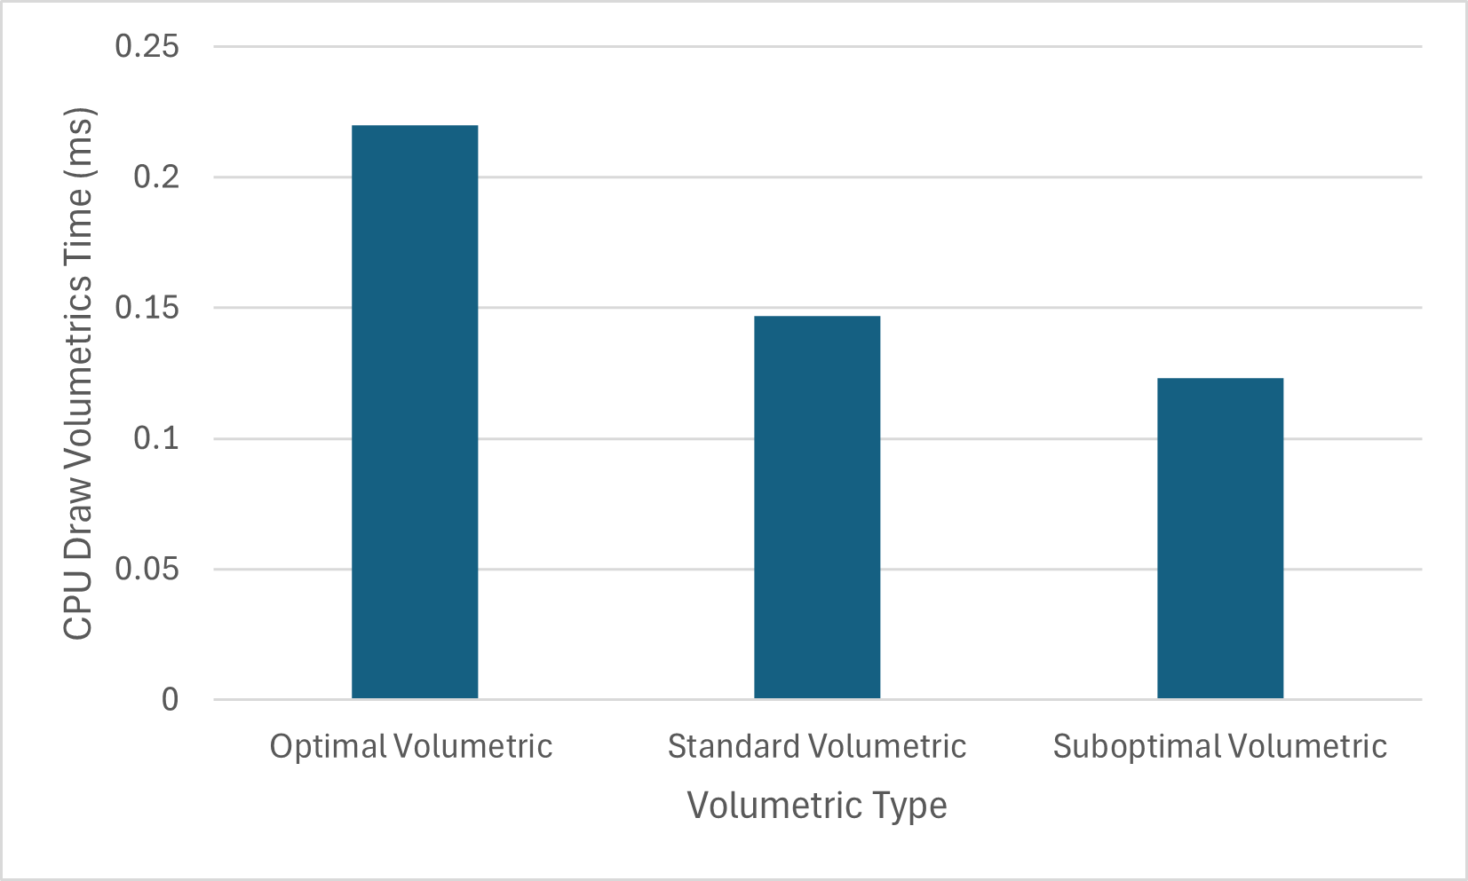
Figure 29

This test is a measure of how long it took for the draw_volumetrics function to complete on the CPU. The values were collected from Optick Profiler.
This graph shows the miscellaneous time taken on the CPU. This value was derived by taking the total frame time and subtracting the CPU draw_voxel_grid, draw_volumetrics and present time.
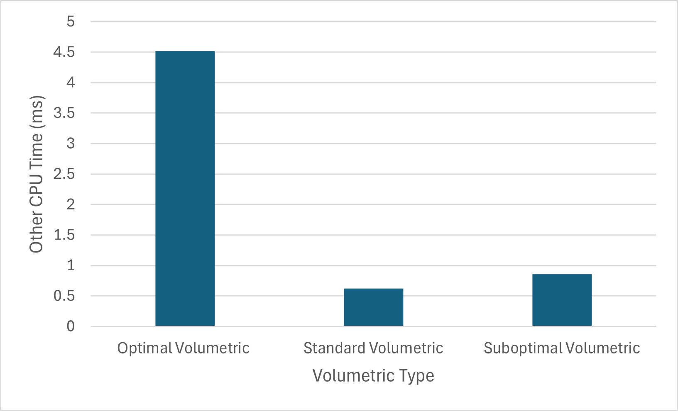
Figure 30

  - 6.1.6 Command Dispatch Influence on Volumetric Frame Times
The efficiency of the compute shader greatly depends on two factors: the resolution of the voxel grid and the specifics of the command dispatch. For the purposes of this test, only changes to the specifics of the command dispatch were measured.
 | Group Count | Local Size
Config 1 | (256, 256, 256) | (2, 2, 2)
Config 2 | (128, 128, 128) | (4, 4, 4)
Config 3 | (64, 64, 64) | (8, 8, 8)
Config 4 | (128, 128, 64) | (4, 4, 8)
Config 5 | (128, 64, 64) | (4, 8, 8)
Figure 31
To measure the effect of this, 5 configurations were created which can be seen in figure 32. All configurations ensure that the entire voxel grid is covered by the compute shader.
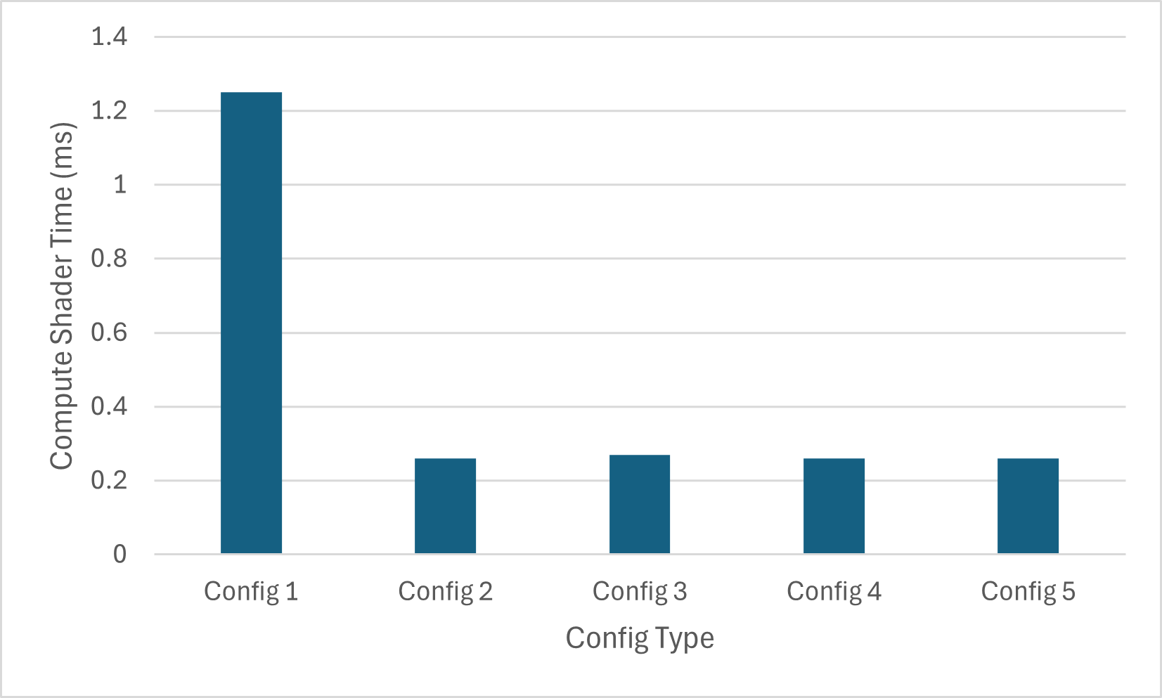
Figure 32

The graph measures the time it takes for the voxel generation shader to complete. The values were taken using NVIDIA Nsight.
  - 6.2.0 Billboard Testing
The primary factor affecting the performance of the billboards number of instances that are to be rendered. As such, the focus of the tests is on measuring the difference in performance between these varying number of instances. The number of instances can be decided by changing NUM_OF_BILLBOARDS value in vk_engine.h as well as in input_structure.glsl and then recompiling all shaders and the primary solution.
  - 6.2.1 Frame Time Billboard Test
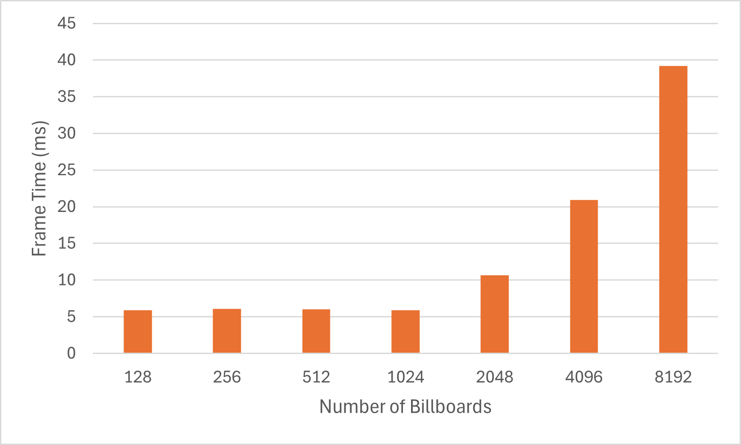
Figure 33

This test measures the total frame time as the number of billboard instances increases. The frame time value was taken from Optick Profiler.
  - 6.2.2 Billboard Shader Time Billboard Test
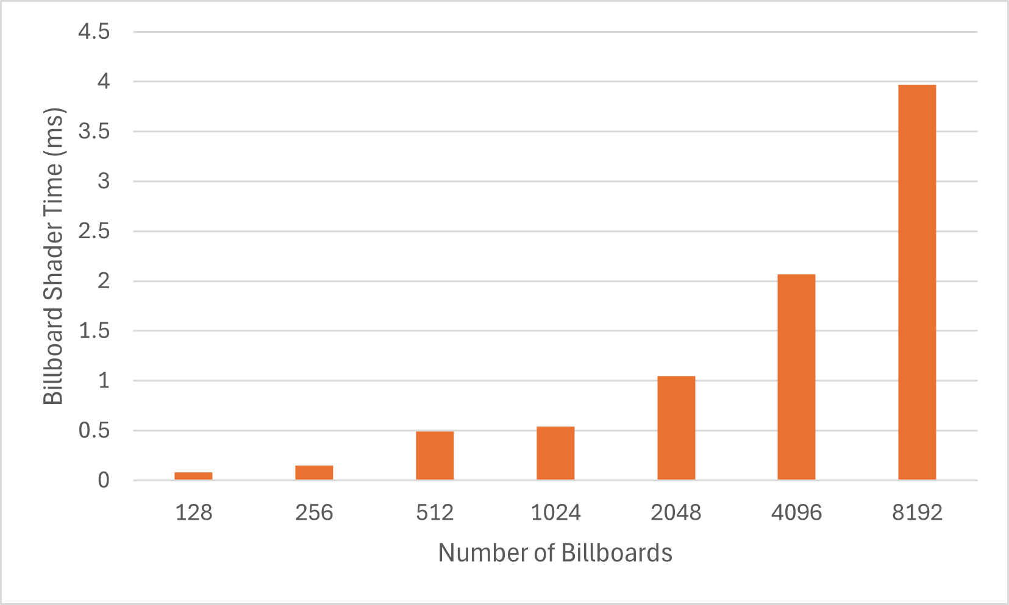
Figure 34

This graph measures the combined time it takes for the vertex and pixel shader responsible for altering the billboard rotations and lighting the billboards to take place. The values were taken from NVIDIA Nsight.
  - 6.2.3 CPU Billboard Sort Time Billboard Test
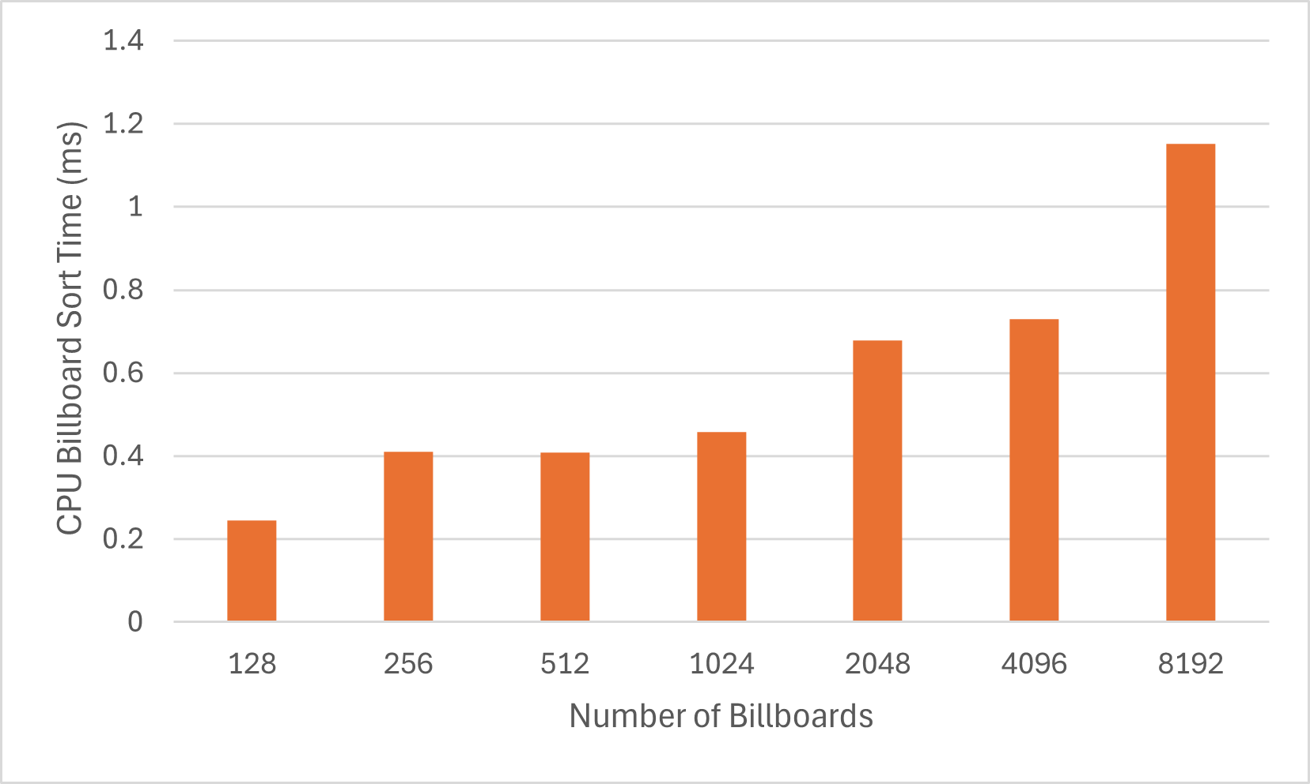
Figure 35

This graph shows the time taken for the draw_geometry function to complete, with the values taken from the Optick Profiler. This function gains most of its overhead from sorting the billboards for transparency.
  - 6.2.4 GPU Present Time Billboard Test
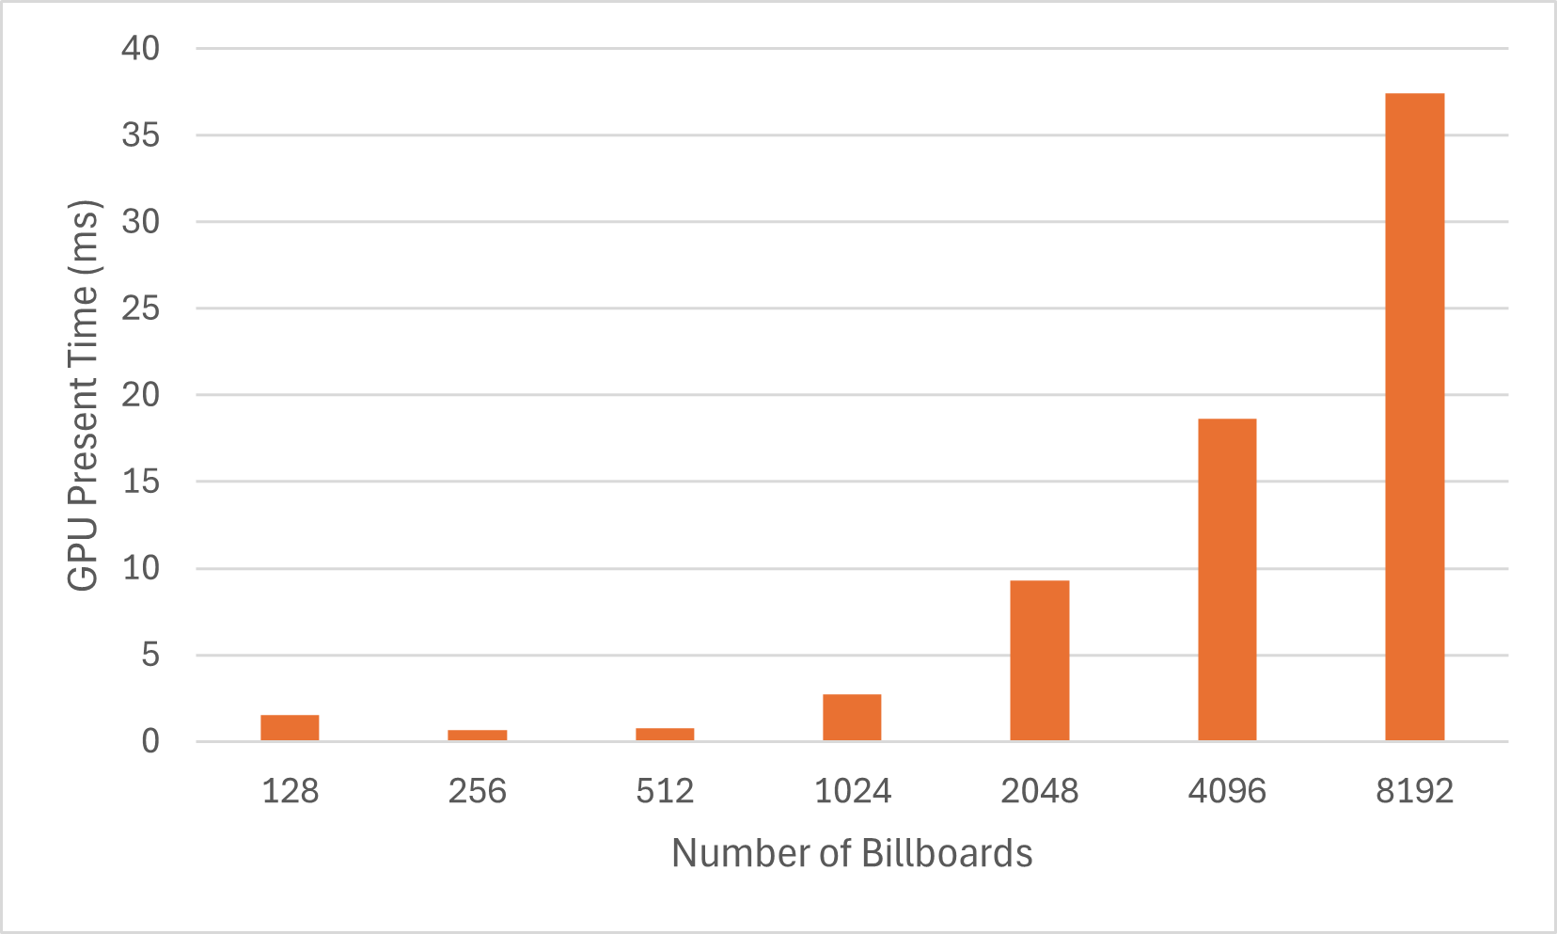
Figure 36

This graph shows a measure of how long the CPU was left waiting for the GPU to present. The value was gathered by using Optick and only measures the time it takes for vkQueuePresentKHR to complete.
  - 6.2.5 Other CPU Time Billboard Test
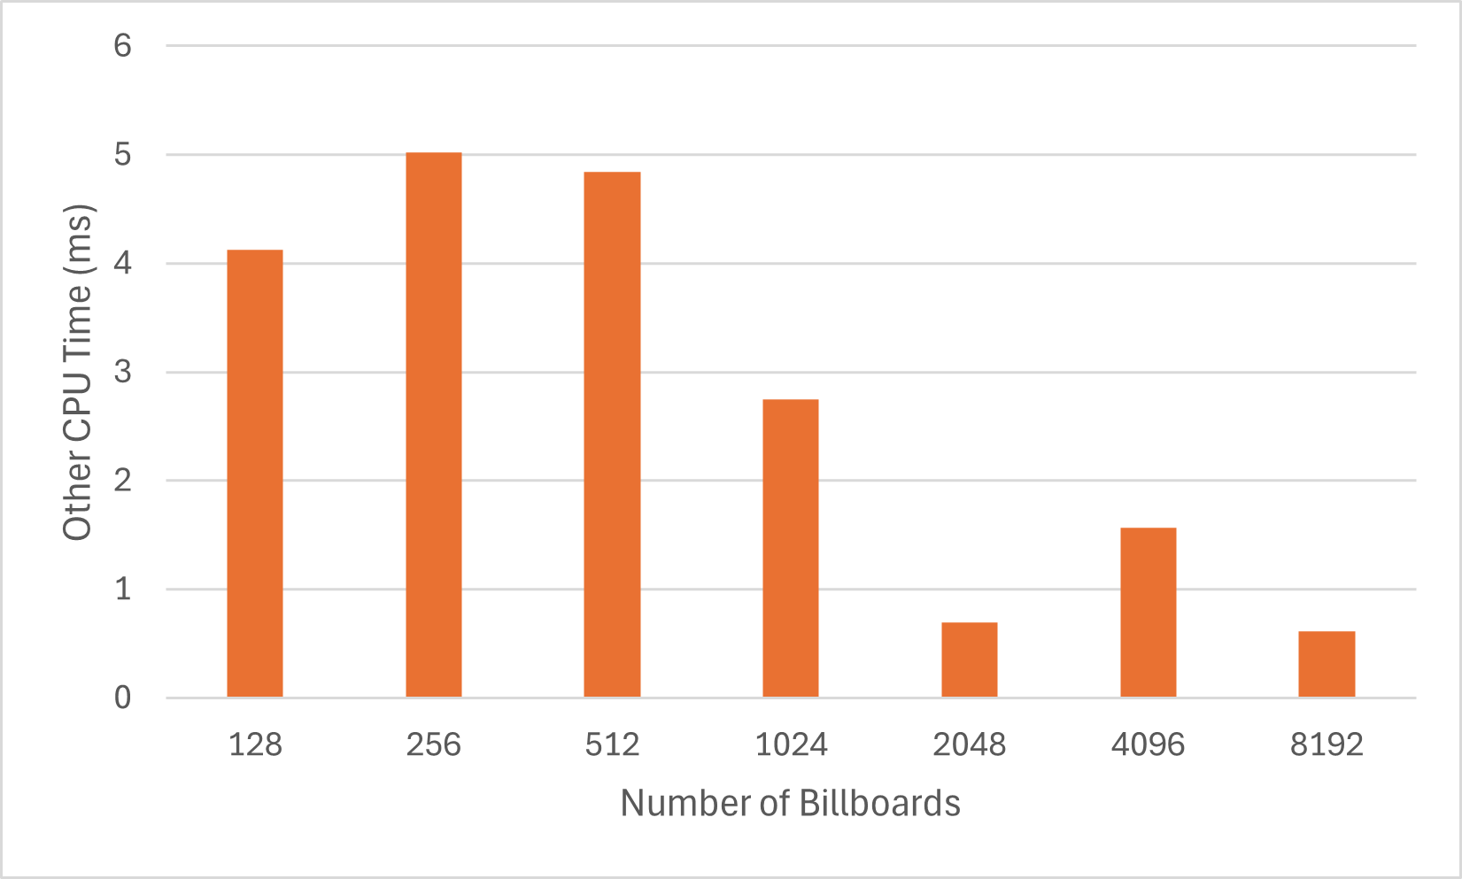
Figure 37

This graph shows the miscellaneous time taken on the CPU. This value was derived by taking the total frame time and subtracting the CPU draw_geometry and present time.
  - 6.3.0 Comparative Graphs
This section is dedicated to gathering the results from previous sections and collecting the data into useful graphs that will allow for proper conclusions to be made. The graphs that follow will compare the most optimal, least optimal and median implementations.
The least optimal implementation compares the ‘Suboptimal Volumetric’ and billboarded clouds with 2048 instances, instance counts higher than 2048 have been disregarded as outliers; it would not be useful to compare them here as it is unreasonable that they would be implemented. The most optimal solution compares the ‘Optimal Volumetric’ against billboarded clouds with 128 instances. The median solution compares the ‘Standard Volumetric’ against billboarded clouds with 1024 instances.
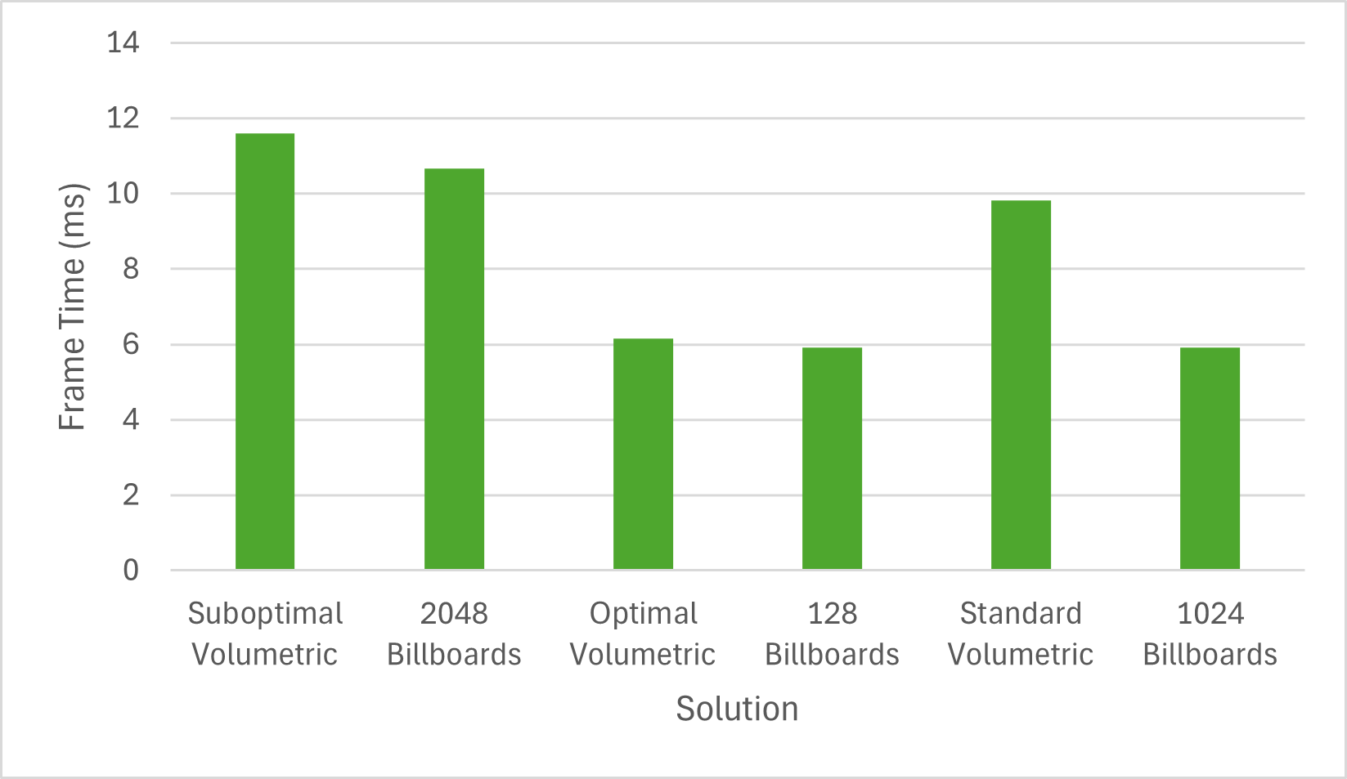
Figure 38

This graph compares the frame time of each of the specified solutions. The values are taken from the previous graphs.
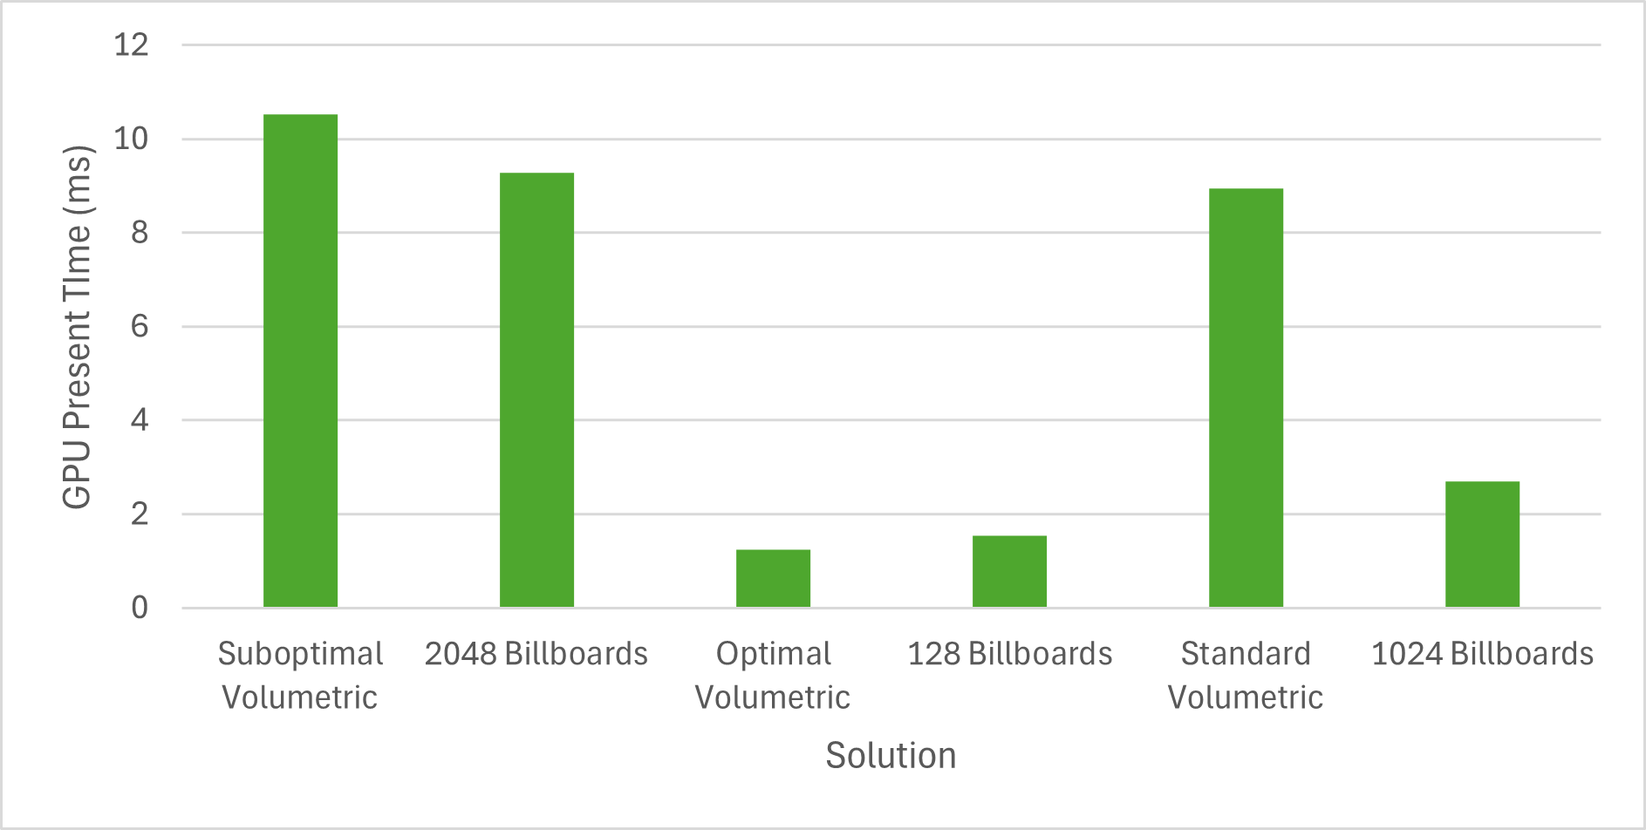
Figure 39

This graph compares the GPU present time of each of the specified solutions. The values are taken from the previous graphs.

7.0.0 Discussion and Analysis
Volumetric and billboarded rendering have different performance characteristics that may influence whether a solution is particularly desirable for a given contemporary videogame. The main influences that will be examined are overall frame time and frame time variance. Additionally, where it is applicable the CPU performance of each solution will also be analysed for the sake of comparison.
  - 7.1.0 Volumetric Analysis
It can be seen in Figure 24 that the difference in frame time between the optimal, suboptimal and standard cases is of a steady step in time complexity between them all. This frame variance can be observed in the regular use of the solution as the optimal scenario simulates a condition in which the viewer is travelling throughout a dense part of the volume. This causes the raymarch to exit early, which can be seen in Figure 26. Given no highly significant differences in performance can be observed in the other shader completion times which can be seen in Figure 25, it is evident that the variance in the performance of this solution is primarily due to the unpredictable nature of the raymarch.
The raymarch could be made less efficient by removing the early exits that exist in the main loop of the shader code. Though this may reduce the variance in frame time it would also mean that the GPU would be doing much more unnecessary work. The inherent variance in a raymarched approach per viewing angle means there will always be a degree of uncertainty in time complexity.
Additionally, it is evident from Figures 27 and 30 that there is a significant variance in the time that the CPU must wait on the GPU to present. If the time the CPU had to wait was more consistent, then this may be taken into consideration and some intensive CPU work could be done alongside rendering. Due to the significant variance however, it becomes much more difficult to create a layout of parallelised work that is meaningfully hides the CPU workload.
Figure 33 shows that there isn’t a significant difference in performance between the configurations defined in Figure 32, outside the outlier of Config 1. The possibility that significant performance gain could be found from altering the group count and group size of the command dispatch at this stage can therefore be disregarded.
However, it is clear that the area for significant performance increase in with regards to the raymarch. It is the most expensive shader stage and exhibits the greatest frame variance. This behaviour matches Guerilla Games’ original observations as Guerilla Games implemented reprojection in order to reduce the amount of raymarching that had to take place each frame (Schneider & Vos, The Real-time Volumetric Cloudscapes of Horizon - Zero Dawn - ARTR, 2024).
  - 7.2.0 Billboarded Analysis
Figure 34 shows that the billboarded solution varies much less in frame time up to a certain point. From 128 to 1024 instances, there is effectively no variance in the frame times observed. At 2048 instances, a near doubling in frame time from the prior tested instance count is present and this trend of greatly increasing frame times continues from this point onwards.
The most important distinction between instance counts is the size of the data that must be sent to the GPU, the data structure of which can be seen in Figure 17. As instance count increases, as does the size of the data that must be sent to the GPU. This is likely responsible for the increase in frame time. The size of the Local Data Share (LDS) per work group processor on the AMD Ryzen 7 5800H GPU that this test was conducted on is 128KB. When this data structure supports 8192 instances it is the size of 192KBs which exceeds the LDS size and therefore means that global memory will have to be accessed more often. This does not account for the additional space that the textures would take up. These data limitations were an initial motivation for the Guerilla Games team to explore volumetric approaches. Making use of a greater variety of billboard textures for the sake of imitating increased dynamic cloud behaviour would take up further space, limiting the quantity of instances that could be rendered.
This behaviour is predictable and as such it can be planned for reliably when building larger projects. The lack of significant differential in frame time between the 128 and 1024 instances may, for example, allow a developer to create a more dynamic weather system in the sense that a distinct visual difference with regards to the amount of cloud billboards in the sky can be seen between clear and cloudy conditions.
Figure 36 demonstrates also how an increased number of instances results in a gradual increase in time spent sorting the values sent to the GPU. This computation is done on the CPU and whilst a variance can be seen as the number of instances increases, it is nowhere as drastic as the increase in frame time as instance count increases. For example, the CPU time taken to sort 256 and 1024 instances is almost equal whilst there is only ~1ms difference between the time it takes to sort 128 and 8192 instances.
  - 7.3.0 Comparative Analysis
Taking Figure 39, the primary difference between the volumetric and billboarded solution is regarding the frame variance that each approach exhibits. Billboard rendering is more predictable and consistent under more grand changes to its visual appearance such as a significant increase in the number of billboards rendered. Whereas volumetric rendering may show greatly diverging frame time behaviour based on relatively little change to the solution, such as approaching the rendered volumetric or, alternatively, rotating the viewer in a direction that does not face the rendered volumetric.
Figure 40 can reconfirm that these solutions are indeed GPU bound. This once again highlights the importance of consistent frame times as a consistent GPU wait time can be used to influence the complexity of work done simultaneously on the CPU.
It is also clear that, from Figure 39, volumetric rendering is simply more expensive than billboard rendering. This result was to be expected as billboards and instanced rendering have long been used in videogames as performance efficient rendering methods.
For these reasons, volumetric rendering may only be worth implementing in circumstances where a great deal of focus in placed on a given skyscape, or a great deal of dynamism is required from the skyscape. This desire is what led the Guerilla Games to investigate and implement this technique in the first place (Schneider & Vos, The Real-time Volumetric Cloudscapes of Horizon - Zero Dawn - ARTR, 2024). The higher overall frame times alongside the unpredictable variance in frame time mean that it sacrifices a large portion of a given rendering budget and that greater CPU workloads cannot be ‘hidden’ by waiting on a reliable present time from the GPU.
In contrast, billboard rendering was found to be overall more performant and predictable with regards to frame time variance. This would make it more suited towards graphical projects that required less of the ‘frame budget’ to be spent on rendering a skyscape. This is a common circumstance with regards to videogames, it is commonplace for a games’ skyscape to not be the primary visual or gameplay focus. Therefore, for most consumer videogames it is likely that this technique will create adequate results in regards to fidelity and performance.
It is unlikely that volumetric cloud rendering will replace billboarded cloud rendering as the predominant method to render clouds. The difference in frame time for rendering each effect in a manner that achieves similar density is likely too significant for most use cases, from Figure 39 it is ~4ms. Additionally, volumetric rendering is not trivial to implement. Considering the types of games it has been used in so far, namely large open world games like Horizon: Zero Dawn, it is likely that this technique will be seen more frequently in large AAA titles in the context of a highly bespoke solution which features plentiful optimisations.
Ultimately, it can be said that the method used to generate the research artefact is flawed in nature. Reprojection was not implemented, which Guerilla Games stressed as being highly important to being able to make use of the volumetric technique in Horizon: Zero Dawn (Schneider & Vos, The Real-time Volumetric Cloudscapes of Horizon - Zero Dawn - ARTR, 2024). Additionally, the level of sophistication of the billboarded implementation is entirely arbitrary. It can be argued that neither are representative of a complex bespoke solution that may be used in a contemporary videogame; they are not the most optimised implementations.

8.0.0 Conclusion
  - 8.1.0 Discoveries
The primary discovery that had not become an expected outcome after conducting the literature survey was the significant variance in frame times seen under the volumetric solution as a result of the unreliability of the raymarching algorithm implemented. This metric is not as straightforward in analysing to arrive at useful conclusions since it is not as universally positive or negative in the same manner as total frame time is. It is a useful metric to measure but it’s influence on the techniques suitability in consumer videogames depends much more significantly on the specific nature of the videogame.
The variance could be mitigated by employing reprojection as this would reduce overall frame times, thereby decreasing the amount of variance seen. It is still likely the case that contemporary videogames should either implement some form of reprojection or should render their volumetric solution to an image that has a resolution either half or a quarter of the desired final resolution and then scale that image up for the final render.
  - 8.2.0 Reflection on Aims and Objectives
The aim of this paper this paper is to come to some meaningful conclusions as to the usefulness of volumetric and billboard cloud rendering in comparison to each other. To this extent, the paper is successful; It supports much of which was espoused by secondary resources in so far that it concludes volumetric rendering is less performant and better suited to specific uses cases whereas billboarded rendering has better performance and would be more suited to a wider range of general real-time use cases.
The literature review covers each technique in sufficient detail to inform the creation of research artefact. Billboarding is a trivial technique to implement and as such there is a lesser focus on research in that area as it is not necessarily relevant for furthering the overall aim of the paper, rather its use is as an alternate and popular baseline technique to compare against. Literature surrounding volumetric rendering is surveyed to a much greater extent as the implementation is of a more complex nature. It could be improved overall by expanding the focus into developing technologies in the respective areas. For example, as hardware accelerated raytracing has become increasingly commonplace in contemporary videogames, it may be useful to examine the emerging techniques that make use of this technological advance to render cloud volumetrics.
The research artefact is well-scoped for the nature of this paper; it allows for useful metrics to be uncovered and is a stable framework for studying the nature of the behaviour of these techniques. The fact that billboarded clouds are trivial to implement means that both techniques were reasonable to implement for the sake of comparison within the given time frame. If both techniques were equally as challenging as volumetric rendering to implement, then it is unlikely that the research artefact would have consisted of both implementations.
Additionally, if the research artefact was more complex in nature, then the work would be spread across multiple units of computation which would further increase the degree of uncertainty in isolated testing, henceforth making benchmarking more difficult and less reliable.
A differing approach to collecting results for this paper would have been to find secondary implementations of each technique from contemporary videogames. The results collected would have been significantly less reliable as there would be too many differing factors to truly generate meaningful analysis.
  - 8.3.0 Limitations
The primary limitation of this paper is the rudimentary and unsophisticated nature of the implementation of volumetric rendering in the research artefact. It is likely that had the research artefact implemented reprojection, that the performance metrics would have been closer to those of the billboarded solution given how Guerilla Games’ considered reprojection essential for volumetric rendering to be performant enough for their use case (Schneider & Vos, The Real-time Volumetric Cloudscapes of Horizon - Zero Dawn - ARTR, 2024).
The paper could have benefited from analysing the two techniques in a wider scope than simply performance. The fidelity of each approach is either inferred at many points or is supported with limited secondary sources. It may therefore have been beneficial to conduct a qualitative survey with a statistically significant sample size to gauge how most people regard the fidelity of each approach. Future work may cross-reference the qualitative analysis from end-users with the performance analysis from this paper in order to determine more succinctly whether the perceived graphical improvements are worth the cost.
Additionally, the paper could have examined how artists would approach each technique. A large focus of the primary inspiration for this paper, Guerilla Games’ implementation of volumetric clouds in Horizon: Zero Dawn, is on how this technique alters and, in their opinion, improves the artistic workflow within their studio with regards to skyscapes (Schneider & Vos, The Real-time Volumetric Cloudscapes of Horizon - Zero Dawn - ARTR, 2024). It may therefore have been beneficial to conduct a similar survey, perhaps with a more quantitative focus, with the sample size consisting of only artists. However, an investigation into this matter could easily be skewed by the robustness of the tooling created to interface with either technique.

9.0.0 Recommendation
There exist a number of possible approaches that could be used in the future of real-time videogames to render clouds. Some approaches build on existing billboard or volumetric rendering techniques as seen below.
In their article ‘Efficient Algorithms for Real-Time GPU Volumetric Cloud Rendering with Enhanced Geometry’ Parga & Palomo propose taking a two-pass approach to rendering volumetric clouds in order to reduce computing costs. This approach involves pre-computing the transmittance of each voxel given a number of light sources on the CPU in order to avoid what they refer to as ‘duplicate or void tracing’. The two-pass approach refers to the fact that illumination and projecting the cloud onto the frame buffer are done in two separate passes. This is done as it allows for the illumination calculations to only be done when a light source changes, hence reducing the computation time under static conditions. This approach is limited in the fact that this optimisation is not used when any dynamism takes effect. (Parga & Palomo, 2019)
Volumetric clouds are now also integrated into Unreal Engine 5 via the ‘Volumetric Cloud Component’. This allows for developers using the engine to trivially implement volumetric cloudscapes. The implementation makes use of many of the same techniques as the research artefact but also allows for much greater customisation with regards to fidelity and features. The implementation includes features such as cloud shadows and cloud ambient occlusion. Given the engines current popularity in contemporary videogame development, it can be expected that this component, and hence the volumetric cloud rendering technique, will see increasing use in more videogames (Epic Games, 2025).
With regards to billboarded rendering, Chapter 28 of Ray Tracing Gems II: Billboard Ray Tracing for Imposters and Volumetric Effects by Brüll, Diedrichs and Grosch focuses on how billboarding can be improved for use in ray tracing. Particularly, under a traditional billboarding approach the billboards do not appear to be properly orientated after reflection and refraction calculations take place. In the chapter, techniques are presented to try and mitigate this effect and improve the overall performance and fidelity of billboarded rendering in a ray-tracing context (Wald, 2021).
One of these are the use of spherical particles, interpretations of a billboard where each billboard is a sphere with a given radius r instead of a viewer-orientated quadrilateral. They found these produced results with less artefacts when intersecting other translucent objects, which is a situation they found to occur especially often when trying to create volumetric effects (Wald, 2021). They also recommend creating an additional ray-tracing acceleration structure that contains billboards in their triangle representation in order to increase performance as they found this method to result in a 40% increase in performance (Wald, 2021).

Bibliography
Akenine-Moller, T., Haines, E., Hoffman, N., Pesce, A., Iwanicki, M., & Hillaire, S. (2018). Real-Time Rendering Fourth Edition. Boca Raton: CRC Press.
Blom, S. (2021). A Comparison Between Rendering Techniques For Billboards In DirectX 11. Stockhom: KTH Royal Institute of Technology.
Cormack, J. (1997, December 23). DOOM. Retrieved from github: https://github.com/id-Software/DOOM
Epic Games. (2025, February 16). Volumetric Cloud Component. Retrieved from Unreal Engine Documentation: https://dev.epicgames.com/documentation/en-us/unreal-engine/volumetric-cloud-component-in-unreal-engine
Fong, J., Wrenninge, M., Kulla, C., & Habel, R. (2017). Production Volume Rendering SIGGRAPH 2017 Course. Disney.
G-TrucCreation. (2014, June 25). How bad are small triangles on GPU and why? Retrieved from G-Truc Creation: https://www.g-truc.net/post-0662.html
Haggstrom, F. (2018). Real-time Rendering of Volumetric Clouds. Umea: Umea University.
Harris, M. J. (2002). Real-Time Cloud Rendering for Games. Game Developers Conference 2002 Proceedings. San Jose: Miller Freeman Game Group.
Hess, M., Koepke, P., & Schult, I. (1998). Optical Properties of Aerosols and Clouds: The Software Package OPAC. Bulletin of the American Meteorological Society, 831-844.
Hillaire, S. (2016). Physically Based Sky, Atmosphere and Cloud Rendering in Frostbite. Physically Based Shading in Theory and Practice. Analheim: SIGGRAPH.
Huber, E., & Frost, M. (1998). Light scattering by small particles. J Water SRT - Aqua Vol. 47, 87-94.
Luna, F. D. (2012). Texturing a Sky. In F. D. Luna, Introduction to 3D Game Programming with DirectX11 (pp. 477-480). Dulles: Mercury Learning and Information.
Microsoft. (2024, 10 16). Billboarding. Retrieved from Direct3D 9 Graphics: https://learn.microsoft.com/en-us/windows/win32/direct3d9/billboarding
Munoz, A. (2014). Higher Order Ray Marching. Computer Graphics Forum Vol. 33, 167-176.
NVIDIA. (2024, November 08). Life of a triangle - NVIDIA's logical pipeline. Retrieved from NVIDIA DEVELOPER: https://developer.nvidia.com/content/life-triangle-nvidias-logical-pipeline
Parga, C. J., & Palomo, S. G. (2019). Efficient Algorithms for Real-Time GPU Volumetric Cloud Rendering. Symmetry, 10(4).
Patapom. (2013). Real-Time Volumetric Rendering. Bomb!
Schneider, A. (2017). Nubis: Authoring Real-Time Volumetric Cloudscapes with the Decima Engine. SIGGRAPH . Los Angeles: ACM Degital Library.
Schneider, A., & Vos, N. (2024, 10 16). The Real-time Volumetric Cloudscapes of Horizon - Zero Dawn - ARTR. Retrieved from Real-Time Rendering: https://advances.realtimerendering.com/s2015/The%20Real-time%20Volumetric%20Cloudscapes%20of%20Horizon%20-%20Zero%20Dawn%20-%20ARTR.pdf
Scratchapixel. (2024, 10 20). Volume Rendering. Retrieved from Scratchapixel: https://www.scratchapixel.com/lessons/3d-basic-rendering/volume-rendering-for-developers/intro-volume-rendering.html
vblanco20-1. (2025, January 23). vulkan-guide. Retrieved from GitHub: https://github.com/vblanco20-1/vulkan-guide/tree/starting-point-2
Wald, M. &. (2021). Ray Tracing Gems II. New York: Apress Media.
Wrenninge, M. (2013). Production Volume Rendering Design and Implementation. Boca Raton: CRC Press.

