Report: Vegan Restaurants in London

Coursera Project – Applied Data Science Capstone

By Rhys Davies

August 2019

Introduction

##### This is intended to help The Vegan Society understand the relationship between veganism and wealth. This information can help the Society in their outreach planning to cohorts of the population which are less likely to be aware of their values and what they can offer. Further this information can be distributed by The Vegan Society for other purposes including to support commerce (e.g. restaurants and estate agents).

##### Dr Marco Springmann of the Oxford Martin Programme on the Future of Food led the following study:

[Oxford Martin Report](https://www.oxfordmartin.ox.ac.uk/news/201603-plant-based-diets/)

##### This report makes powerful arguments, one particularly powerful claim highlighted by The Vegan Society is:

##### “If the world went vegan, it could save 8 million human lives by 2050, reduce greenhouse gas emissions by two thirds and lead to healthcare-related savings and avoided climate damages of $1.5 trillion.” The trend of increasing veganism supported by qualitative evidence of more vegan based foods both in supermarkets and also restaurants.

##### We wish to explore if there is a relationship between veganism and wealth. To begin this enquiry we will consider property price as a proxy for wealth. Although this assumption is qualitative, it remains reasonable, at least for the purposes of this exploratory project. The basis for this assumption is that people tend to purchase more expensive properties as their wealth increases. The rate of this change is not constant and indeed complex, but for our purposes it is enough to acknowledge a positive correlation.

##### We will consider London for a number of reasons. This is a large city with many neighbourhoods for which accurate house prices and also availability of vegan restaurants are available. It represents a homogenous testing area where we can test our hypothesis if house prices and veganism are somehow related.

##### The data available for London is available, internally consistent and of sufficient quantity to enable a meaningful analysis to be undertaken and offers the opportunity for a reliable conclusion.

##### London is widely considered to be amongst the leading cities in the world and consistently scores in the top 10 cities offering the best alternatives for vegans.

##### The London property market is one of the most studied and invested in the world. This offers an opportunity to identify any possible early trends as well as to offer useful information to people who may find the abundance and proximity of vegan restaurants a factor in their home buying decisions.

##### The relative cost of living a vegan lifestyle is complex. The costs of the raw materials are generally cheaper, although anecdotal evidence suggests that vegan products and vegan restaurants can and do charge a premium. However this is a crude generalization. There are multi-factors from fashion to the available economies of scale at play and this subject is itself a rabbit-hole of possibility and intrigue.[¶](https://eu-de.dataplatform.cloud.ibm.com/data/notebooks/converter/assets/66222575-d2ff-4f7e-9f67-b65da3efb0d8?project=9f48329d-0ef3-41f4-abe5-fc8da6a9bdf0#The-relative-cost-of-living-a-vegan-lifestyle-is-complex.-The-costs-of-the-raw-materials-are-generally-cheaper,-although-anecdotal-evidence-suggests-that-vegan-products-and-vegan-restaurants-can-and-do-charge-a-premium.-However-this-is-a-crude-generalization.-There-are-multi-factors-from-fashion-to-the-available-economies-of-scale-at-play-and-this-subject-is-itself-a-rabbit-hole-of-possibility-and-intrigue.)

Data

##### House price data can be obtained from the following location:

[UK Government data](https://www.gov.uk/government/statistical-data-sets/price-paid-data-downloads)

##### This contains HM Land Registry data under the Crown copyright and database right 2019. This data is also licensed under the Open Government Licence v3.0. Since house prices are not liquid, they are measured only occasionally when a transaction is made, then we do need to choose our method of measuring house price. General indices were considered, but for this analysis we consider the last paid price which represent the actual price paid for a unit within a particular postcode. This does mean however that the time of the transaction is not snapped at the same time and some transactions go back over the previous year. It also means that we are considering different unit sizes. Given our goal is to estimate the average in a region in order to rank by region, these effects will average themselves out.

##### Information pertaining to vegan restaurants will be obtained from Foursquare and their Products database. This will follow the requirements set out in the Developer section:

[Foursquare Developer site](https://developer.foursquare.com/)

##### This data is of high quality, and particularly so for London for which there is a deep data set. We know from experience that Foursquare data is sound and under constant scrutiny by the vast network of developers, users and contributors. It is this community to which we are happily rely for the quality of our data. The two data sets will be imported into a Python notebook and incorporated into a consistent dataframe where the data will be joined using postcode. This will then provide the ability to consider sold prices by postcode and also to consider the vegan restaurants per postcode. Given that many residential areas do not have high-streets or an abundance of commercial activity, we can ignore the postcodes which contain little or no commercial activity. Our goal is to consider the areas for which we do have an abundance of vegan restaurants and to view the house prices of these areas to the average.

Methodology

The Foursquare will be centred on a central London coordinate (51.50795322377849, -0.12432828429154276) and include a search radius of 5KM utilizing the ‘%vegan% search query in the venue/search URL.

Restaurants with missing post code data will be removed if postcode cannot be found by manual search.

UK house prices will be imported. This file is large with data spanning over two years which amounts to over 1 million rows of data. This is cleaned to remove entries with incomplete prices and postal codes. Duplicates may be present representing the same property being sold twice within the sample period. In this case each entry remains included.

The data will be grouped by the first three characters of the postal code. This reflects that there is not a large number of vegan restaurants and we need to expand the grouped area in order to create meaningful clusters.

Results

Following importing the data and cleaning of the data, the data sets were merged as shown below.

The most immediate point to note is that only a small set of vegan restaurants were found. The total number of vegan restaurants, sourced from the Foursquare database was 25. Note that 7 were eliminated since they had incomplete data or were dubious existence.

This small number of results has been checked and it does remain the case that there appears to be a very small number of restaurants spread across London.

The full list of these are shown in the table alongside their coordinates and the average house price within their respective shortened postcode.

|  |  |  |  |  |  |  |
| --- | --- | --- | --- | --- | --- | --- |
| Index | Short Postal Code | Average Price Paid (GBP) | Restaurant | Postal Code | Latitude | Longitude |
| 1 | E14 | 405,032 | Korean BBQ & Vegan Restaurant | E14TP | 51.519983 | -0.056017 |
| 2 | E16 | 368,627 | Vegan Yes | E16QL | 51.518734 | -0.071483 |
| 3 | E16 | 368,627 | Vegan Burgers by Mooshies | E16RL | 51.519731 | -0.071783 |
| 4 | E16 | 368,627 | The Little Vegan Pop Up Shop by Superdrug | E16GY | 51.523694 | -0.076749 |
| 5 | E16 | 368,627 | Vegan No Blood No Bones | E16GY | 51.523546 | -0.076607 |
| 6 | E16 | 368,627 | House Of Vegan | E16RU | 51.521744 | -0.071561 |
| 7 | E16 | 368,627 | Vida Vegan Bakery | E16SB | 51.523909 | -0.071618 |
| 8 | E16 | 368,627 | Shakey Shakey Vegan | E16RU | 51.521777 | -0.071564 |
| 9 | E16 | 368,627 | Jakes Vegan Steaks | E16RU | 51.521821 | -0.071393 |
| 10 | E16 | 368,627 | What The Pitta | E16GY | 51.523516 | -0.076104 |
| 11 | E16 | 368,627 | Dirty Vegans | E16RU | 51.521579 | -0.071556 |
| 12 | E27 | 308,492 | Essential Vegan | E27JP | 51.526287 | -0.077451 |
| 13 | E82 | 398,561 | All Nations Vegan House | E82LP | 51.549717 | -0.07429 |
| 14 | EC1 | 349,629 | Astro Vegan | EC1N | 51.519875 | -0.109297 |
| 15 | N16 | 345,502 | Vegan Veggie Love Cafe | N16DP | 51.527583 | -0.086871 |
| 16 | N16 | 345,502 | Vegan Tea Room | N16 | 51.552141 | -0.076193 |
| 17 | N19 | 354,045 | Vx [vee]{cross} | N19BT | 51.532929 | -0.119518 |
| 18 | N78 | 672,445 | Keren View Vegan Restaurant | N78DJ | 51.550766 | -0.109939 |
| 19 | NW1 | 483,962 | Rudy's Dirty Vegan Diner | NW18AH | 51.542488 | -0.148512 |
| 20 | NW1 | 483,962 | Young Vegans | NW1 | 51.541454 | -0.146686 |
| 21 | SE1 | 328,674 | Y Vegan | SE14JU | 51.501471 | -0.092695 |
| 22 | SE1 | 328,674 | London Vegetarian and Vegan School | SE14PA | 51.498461 | -0.083773 |
| 23 | SW9 | 358,691 | Pipoca Vegan | SW9 | 51.472065 | -0.112784 |
| 24 | W1D | 312,494 | Soho Vegan Market | W1D7PP | 51.512285 | -0.133766 |
| 25 | W1U | 408,478 | Vegan Crosstown Doughnuts | W1U1BW | 51.515354 | -0.151135 |

The number of restaurants per Short Postal Code were grouped together and the number of vegan restaurants counted as shown in the table below.

|  |  |  |  |
| --- | --- | --- | --- |
| Index | Short Postal Code | Number of Restaurants | Average House Price |
| 0 | E14 | 1 | 405,032 |
| 1 | E16 | 10 | 368,627 |
| 2 | E27 | 1 | 308,492 |
| 3 | E82 | 1 | 398,561 |
| 4 | EC1 | 1 | 349,629 |
| 5 | N16 | 2 | 345,502 |
| 6 | N19 | 1 | 354,045 |
| 7 | N78 | 1 | 672,445 |
| 8 | NW1 | 2 | 483,962 |
| 9 | SE1 | 2 | 328,674 |
| 10 | SW9 | 1 | 358,691 |
| 11 | W1D | 1 | 312,494 |
| 12 | W1U | 1 | 408,478 |

The data above was used to create a scatter plot showing the average house prices against the number of vegan restaurants in the vicinity. Here the vicinity is defined as the short post code. The index column shows that a total of thirteen vicinities are considered.

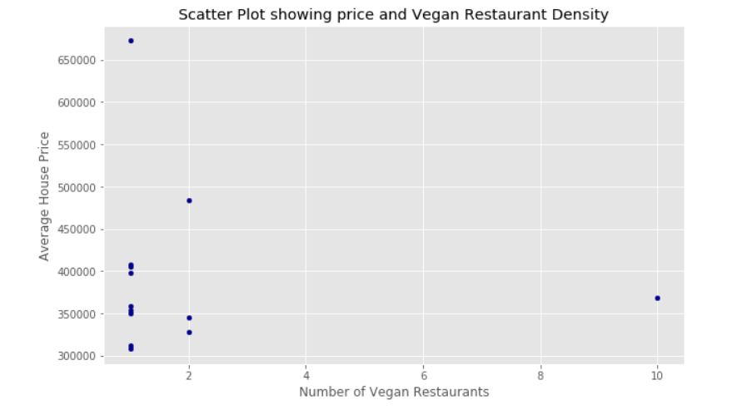

The graph shows that only in one area is there a significant clustering of vegan restaurants. Other vicinities have only a single vegan restaurant and the average house prices in these areas cover a wide range. A number of regions have 2 vegan restaurants and the average prices in these vicinities again looks widely dispersed. The single outlier (representing short postal code E16) has 10 vegan restaurants. This is indeed an outlier since no other vicinity contains more than 2 vegan restaurants. Note that our vicinity definition does not result in or imply that vicinities cover the same area or indeed have a comparable population.

Given this clustering, our analysis has calculated the mean position, given by the mean latitude and the mean longitude. This sits within the scatter of the restaurants and can be imagined as a centre of gravity type calculation.

Map showing the location of the vegan restaurants (blue) shown below and the centre of gravity (shown in red) illustrated below:

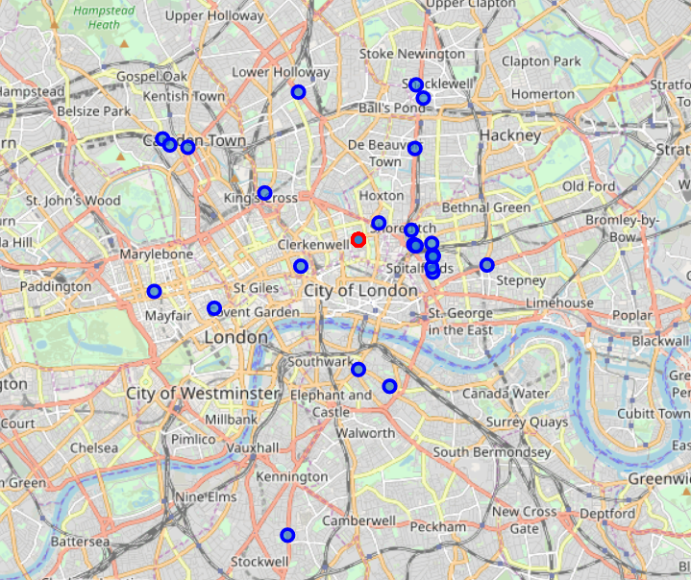

Discussion

The number of vegan restaurants found within Foursquare was far less than originally supposed. This perhaps is an interesting conclusion in itself. It suggests one or more of the following:

* Foursquare does not list many vegan restaurants
* There are not many vegan restaurants
* Restaurants serving vegan food are not uniquely vegan
* Vegan restaurants have not identified themselves as vegan for the purposes of Foursquare rankings

Each of these suggestions does would raise the question to The Vegan Society of if there is an under-representation of vegan restaurants. This would therefore lead to questions of a countrywide comparison of the proportion of veganism and the proportion of vegan restaurants. There would be a complication by the fact that some general restaurants also serve a vegan menu in conjunction with their non-vegan menu.

Our original question on a link between wealth and veganism has not resulted in a clear answer. The proxy by comparing to house prices has led to the suggestion that veganism is not directly linked to house prices. This would suggest that future studies consider a multi-factor model to investigate alternative linked and causal factors.

The results have however produced the unexpected result of the E16 cluster. Restaurant density and genre density is known to cluster, however the large cluster of 10 within E16 was surprising and hugely significant. This is a thread which if pulled and investigated could lead to some new insight and discovery. Why exactly is E16 such a hot-spot for vegan establishments? This is potentially of greater interest to The Vegan Society since identifies a geographical area in which there is clearly a significant interest in vegan dining. Future studies could address the question of the clientele of these restaurants, and in particular to determine if they are primarily local residents or commuters travelling to a known vegan vicinity – rather like people travel to out-of-town shopping parks.

The identification of this vegan hot-spot presents not only a research opportunity for The Vegan Society but also a marketing one too. Having such a focal area offers opportunities for news stories, promotional events (being a central point to attract others from the surrounding areas) as well as providing a competitive environment to nurture a high standard of products and cuisine.

Conclusion

The initial aim of this project was to investigate if wealth (proxied via house prices) was an indicator of veganism (proxied via the incidence of vegan restaurants). The analysis here has not found a direct relation between the two and finds no evidence to suggest a direct link between veganism and wealth.

However our analysis has identified a region with a significant density of vegan restaurants. This region is close to a ‘centre-of-gravity’ of the vegan restaurants in London. This region offers several interesting opportunities for The Vegan Society. These include an area offering research potential into vegan trends and dining, the opportunity for PR and marking, an epicentre with perhaps a critical mass of people to create innovation for the nascent vegan industry.

**-----**