Gener-AI-te study survey

Welcome! We are running this experiment to examine the impact of emerging technologies (namely, AI image generators) on the way in which art is created and received.
On the next page you will review an explanation of the research project, and then you will be asked to complete a set of preliminary surveys before reviewing a series of images and providing your critical feedback.
Your participation should require no more than 45-60 minutes. Thank you in advance for your time!

Please respond to the following demographic questions.
- Your age:
- Your sex assigned at birth:
- Education: The highest education level you have achieved (or equivalent):
- Your ethnicity:

Please indicate the degree to which you agree with each of the following statements. [source: Pelowski, M. (2015). Tears and transformation: feeling Like crying as an indicator ofinsightful or ‘aesthetic’ experience in empirical study of art. Front. Psychol. 6. 1–23. doi:10.3389/fpsyg.2015.01006]
- I am comfortable looking at and discussing art
- I am knowledgeable about art
- Art is important
- I enjoy being challenged by art
- I am interested in art

Please respond to the following regarding your art education background. [source: Chatterjee, A., Widick, P., Sternschein, R., Smith, W. B., and Bromberger, B. (2010). Theassessment of art attributes. Emp. Stud. Arts 28, 207–222. doi: 10.2190/EM.28.2.f]
- How many studio art classes have you taken at the high school level or above?
- How many art history classes have you taken at the high school level or above?
- How many art theory or aesthetics classes have you taken at the high school level or above?
- On average you visit art museums or galleries about once every:
- In the average week how many hours do you spend making visual art?
- In the average week how many hours do you spend reading a publication that is related to visual art?
- In the average week how many hours do you spend looking at visual art?

Please indicate whether you agree that you like or appreciate each of the following styles of art: [source: Pelowski, M., Gerger, G., Chetouani, Y., Markey, P. S., & Leder, H. (2017). But is it reallyart? The classification of images as “Art”/“Not Art” and correlation with appraisal and viewerinterpersonal differences. Frontiers in Psychology, 8, 1729.]
- Abstract
- Baroque
- Digital Art
- Realism
- AI Generated
- Impressionism

When you consider visiting an art exhibition, do you agree that you would like... [source: Tröndle, M., Kirchberg, V., and Tschacher, W. (2014). Is this art? an experimental studyon visitors' judgement of contemporary art. Cult. Sociol. 8, 310–332. doi:10.1177/1749975513507243]
- the exhibition to be thought provoking
- to improve your understanding of fine arts
- to experience a deep connection to the art
- to experience the beauty of the artworks
- to be entertained
- to be surprised

We are interested in your attitudes towards Artificial Intelligence. By Artificial Intelligence we mean devices that can perform tasks that would usually require human intelligence. Please note that these can be computers, robots or other hardware devices, possibly augmented with sensors or cameras, etc. Please complete the following scale, indicating your response to each item. Please answer the following questions by selecting your level of agreement with each statement. [source: Schepman, A., & Rodway, P. (2020). Initial validation of the general attitudes towards Artificial Intelligence Scale. Computers in human behavior reports, 1, 100014.]
- There are many beneficial applications of Artificial Intelligence
- I am impressed by what Artificial Intelligence can do
- Artificial Intelligence can have positive impacts on people's wellbeing
- Artificial Intelligence is exciting
- Artificial Intelligence can provide new economic opportunities
- Artificially intelligent systems can perform better than humans
- Much of society will benefit from a future full of Artificial Intelligence
- I am interested in using artificially intelligent systems in my daily life
- For routine transactions, I would rather interact with an artificially intelligent system than with other humans
- An artificially intelligent agent would be better than an employee at many routine jobs
- I would like to use Artificial Intelligence in my own job
- Artificially intelligent systems can help people feel happier
- Some complex decisions are best left to artificially intelligent systems
- I love everything about Artificial Intelligence
- I would entrust my life savings to an artificially intelligent investment system

Please view the image below and then respond to the questions before proceeding to the next page.
[Manipulation inserted here: attributional information regarding the origin of the image shown below describing that it was either 1) made by a human artist or 2) made by an artificial intelligence program]
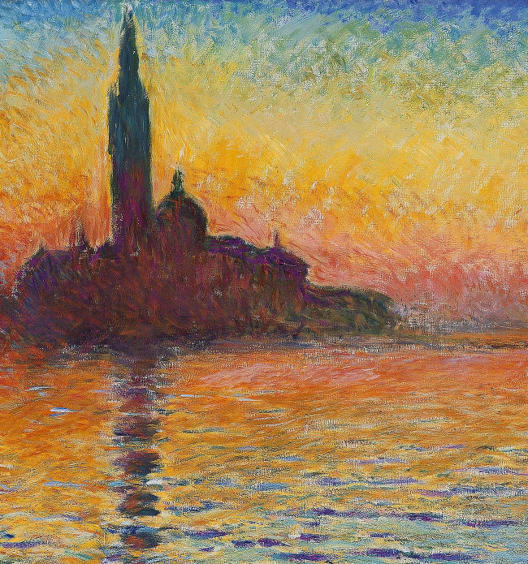
Please indicate the degree to which you agree that the image displays each of the features listed below. [source: Hagtvedt, H., Patrick, V. M., & Hagtvedt, R. (2008). The perception and evaluation of visual art.Empirical studies of the arts, 26(2), 197-218.]
- Imaginative
- Creative
- Inventive
- Innovative
- Original
- Novel
- Distinct
- Beautiful
- Aesthetically Pleasing
- Attractive
- Elegant
- Symmetrical
- Rhythmic
- Patterned
- Unified
- Balanced
- Thought Provoking
- Intellectually Stimulating
- Interesting

Please indicate the degree to which you agree that the image made you feel each of the emotions listed below. [source: Hagtvedt, H., Patrick, V. M., & Hagtvedt, R. (2008). The perception and evaluation of visual art.Empirical studies of the arts, 26(2), 197-218.]
- Agitation
- Stress
- Anxiety
- Tension
- Uncertainty
- Serenity
- Contentment
- Happiness
- Joy
- Stimulation
- Eagerness
- Enthusiasm
- Excitement
- Loneliness
- Melancholy
- Sadness
- Despair
Is the image displayed above a work of art? [source: Pelowski, M., Gerger, G., Chetouani, Y., Markey, P. S., & Leder, H. (2017). But is it really art? Theclassification of images as “Art”/“Not Art” and correlation with appraisal and viewer interpersonaldifferences. Frontiers in Psychology, 8, 1729.]
How much do you feel that the image above is a work of art? [source: Pelowski, M., Gerger, G., Chetouani, Y., Markey, P. S., & Leder, H. (2017). But is it really art? Theclassification of images as “Art”/“Not Art” and correlation with appraisal and viewer interpersonaldifferences. Frontiers in Psychology, 8, 1729.]
How much do you feel that you like or appreciate the image above? [source: Pelowski, M., Gerger, G., Chetouani, Y., Markey, P. S., & Leder, H. (2017). But is it really art? Theclassification of images as “Art”/“Not Art” and correlation with appraisal and viewer interpersonaldifferences. Frontiers in Psychology, 8, 1729.]

Please view the image below and then respond to the questions before proceeding to the next page.
[Manipulation inserted here: attributional information regarding the origin of the image shown below describing that it was either 1) made by a human artist or 2) made by an artificial intelligence program]

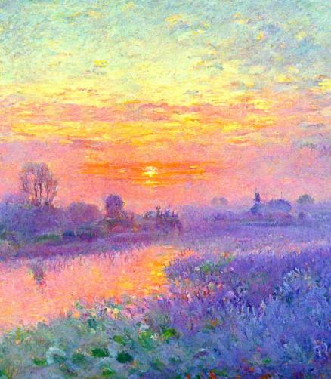
Please indicate the degree to which you agree that the image displays each of the features listed below. [source: Hagtvedt, H., Patrick, V. M., & Hagtvedt, R. (2008). The perception and evaluation of visual art.Empirical studies of the arts, 26(2), 197-218.]
- Imaginative
- Creative
- Inventive
- Innovative
- Original
- Novel
- Distinct
- Beautiful
- Aesthetically Pleasing
- Attractive
- Elegant
- Symmetrical
- Rhythmic
- Patterned
- Unified
- Balanced
- Thought Provoking
- Intellectually Stimulating
- Interesting

Please indicate the degree to which you agree that the image made you feel each of the emotions listed below. [source: Hagtvedt, H., Patrick, V. M., & Hagtvedt, R. (2008). The perception and evaluation of visual art.Empirical studies of the arts, 26(2), 197-218.]
- Agitation
- Stress
- Anxiety
- Tension
- Uncertainty
- Serenity
- Contentment
- Happiness
- Joy
- Stimulation
- Eagerness
- Enthusiasm
- Excitement
- Loneliness
- Melancholy
- Sadness
- Despair

Is the image displayed above a work of art? [source: Pelowski, M., Gerger, G., Chetouani, Y., Markey, P. S., & Leder, H. (2017). But is it really art? Theclassification of images as “Art”/“Not Art” and correlation with appraisal and viewer interpersonaldifferences. Frontiers in Psychology, 8, 1729.]
How much do you feel that the image above is a work of art? [source: Pelowski, M., Gerger, G., Chetouani, Y., Markey, P. S., & Leder, H. (2017). But is it really art? Theclassification of images as “Art”/“Not Art” and correlation with appraisal and viewer interpersonaldifferences. Frontiers in Psychology, 8, 1729.]
How much do you feel that you like or appreciate the image above? [source: Pelowski, M., Gerger, G., Chetouani, Y., Markey, P. S., & Leder, H. (2017). But is it really art? Theclassification of images as “Art”/“Not Art” and correlation with appraisal and viewer interpersonaldifferences. Frontiers in Psychology, 8, 1729.]

