|  |  |
| --- | --- |
|  |  |
| **Loch Lomond Rescue Boat (LLRB)**  **Data Analytics Report** |  |
|  |  |
|  | May 2024 By Rhys Wells |

### Overview

This report is the product of a project which aims to deliver analyses into the areas of preparedness, prediction, and public awareness. In this report we analyse incident data collected by the Loch Lomond Rescue Boat (LLRB) from 2021 to 2023, offering insights into incident trends and crew attendance. It provides actionable recommendations to enhance social media engagement, improve data collection, and optimise LLRB operations.

Key insights include:

* Incident trends by pager code and month.
* Analysis of response times and recommendations for improvement.
* Categorisation of common incident types and their frequencies.
* Analysis of incident geolocation data.
* Crew attendance patterns and strategies for enhancing crew training and attendance.
* Recommendations for improving social media outreach and data collection methods.

This report not only addresses the immediate goals set forth in the project proposal but also lays the groundwork for the use of ongoing improvements and planning for LLRB.

Table of Contents

Overview 2

Incident Analysis 3

Time Analysis 3

Shout Tags 5

Crew Analysis 7

Training 9

Geolocation on Map 10

Social Media 11

Data Collection 12

Further Lines of Enquiry 12

Conclusion 12

Table 13

### Incident Analysis

We analysed the distribution of incidents based on pager codes from August 2021 to December 2023.

The data reveals several important trends:

* Summer Peaks: Highest incident rates in May, June, and July, coinciding with increased activity on the loch.
* 999 Calls: Higher proportion of 999 calls outside summer months, with a notable uptick in February 2023.
* Questions: What caused the increase in 999 calls in February 2023? Why did 222 calls rise in 2023?

### Time Analysis

We now investigate time periods associated to each incident. The times that have been recorded are:

* Shout time: when the incident begun.
* Launch time: when the boat is launched.
* Return time: when the boat returns.

We identified and removed outliers from this analysis. As there were inconsistencies where the time of launch was recorded before the time of shout. For our analysis, we assumed that the time of shout precedes the time of boat launch.

Time analysis of incidents from 2021 to 2023 shows:

* Peak Times: Significant number of 999 incidents occur between 12 AM and 2 AM, with an afternoon/evening uptick between 3 PM and 9 PM.
* Incident Duration: The maximum duration for non-outlier incidents is approximately 250 minutes (4 hours).
* Response Times: The median time from shout to launch is 15 minutes, with 222-coded incidents resolved faster than 333 and 999 codes.

INSERT Linear regression (date/time)

### Shout Tags

To streamline incident categorisation, each incident is assigned one or more shout-tags based on its description. These tags help quickly understand the nature of the incident, facilitating analysis and response planning. These are:

* Mechanical: Issues involving mechanical failures or malfunctions.
* Rescue: Operations involving the rescue of individuals.
* Medical: Incidents requiring medical attention.
* Environmental: Events related to environmental factors or hazards.
* Mishap: General accidents or unexpected events.
* Assistance: Providing help or support in various situations.
* False Alarm: Incidents reported but found to be non-issues.
* Miscellaneous: Incidents that do not fit into other categories.
* Search: Operations involving searching for missing persons or items.
* Transport: Incidents related to the transportation of individuals or equipment.

Using historical data, we have identified trends in the frequency of different shout-tags. The graphs below illustrate the monthly distribution of incident tags, helping forecast which types of incidents are more likely to occur at different times of the year.

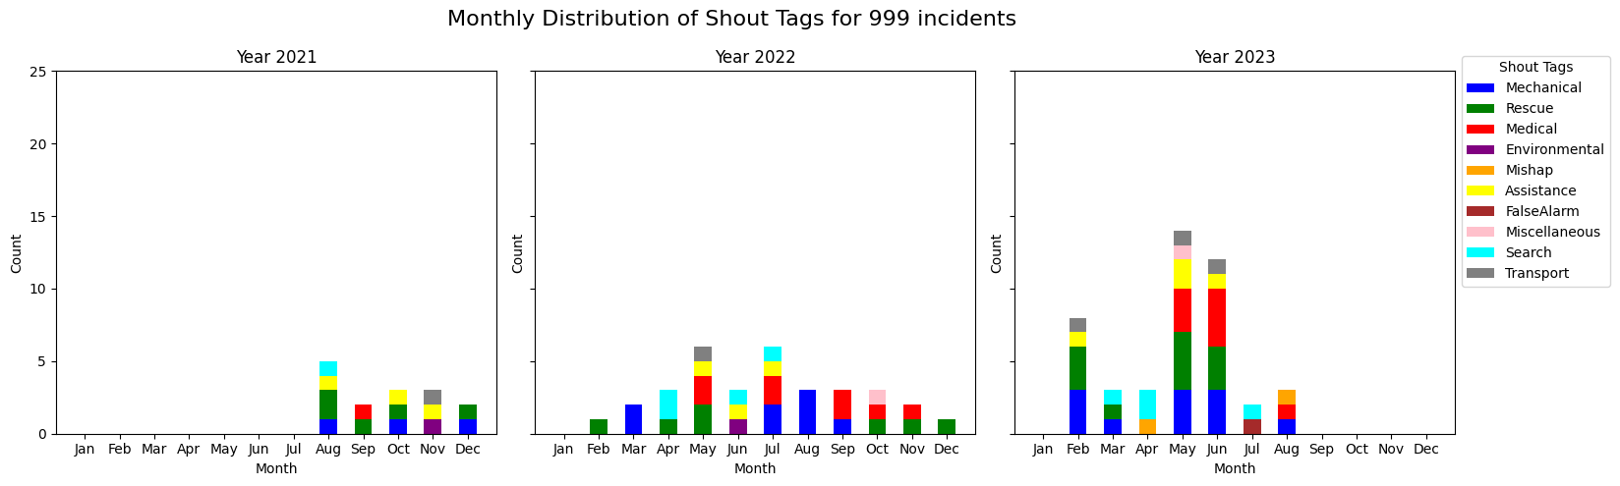

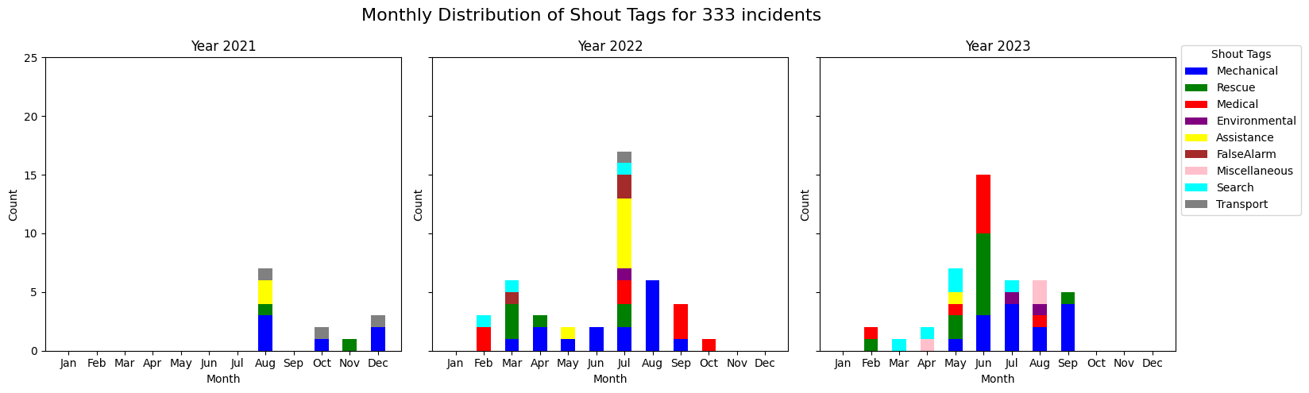

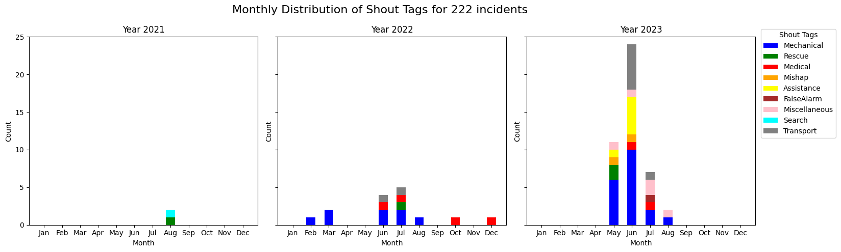

Key Insights:

* 999 Incidents: Predominantly involve Rescue, Medical, and Mechanical issues.
* 333 Incidents: Mostly Mechanical, followed by Rescue, Medical, and Search operations.
* 222 Incidents: Primarily Mechanical, Assistance, and Medical.

Additionally, we analysed the average response time for each tag, from shout to return:

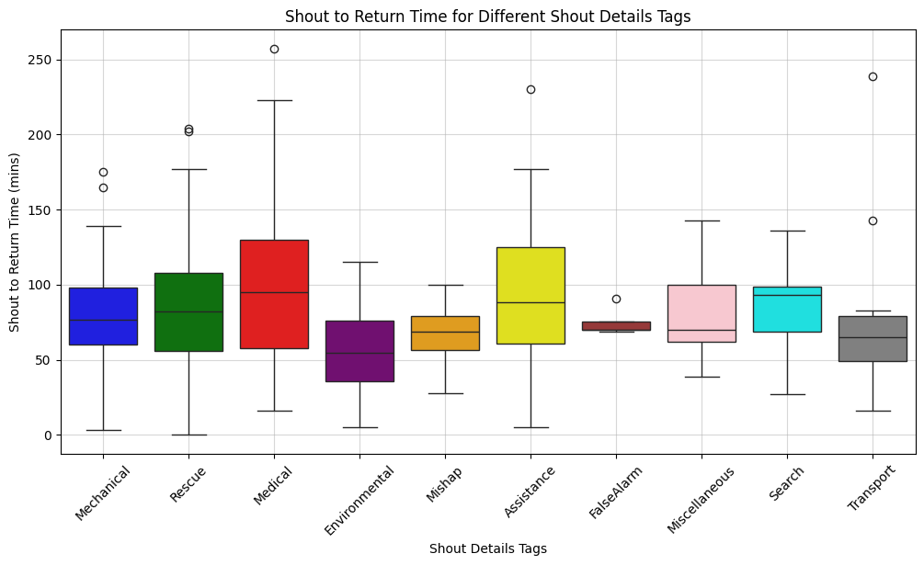

Insights:

* Mechanical & Transport: Quick resolution times due to well-defined procedures.
* Rescue: Longer durations reflecting the complexity and urgency.
* Medical: Variable times depending on the severity and conditions

Based on our analysis, we recommend the following steps to enhance incident response efficiency:

* Training for Common Tags: Focus on training for Medical incidents to improve response times and effectiveness.
* Suggest Maintenance: Prompt boat owners to do regular checks and maintenance to reduce the number of Mechanical incidents.
* Resource Allocation: Allocate resources based on the forecasted incident types and their peak times.

By implementing these recommendations, LLRB can enhance its preparedness and response efficiency, ensuring better outcomes for all incident types.

### Crew Analysis

This section aims to evaluate attendance patterns, identify gaps in crew participation, and suggest strategies for enhancing training and readiness. This will ensure LLRB maintains a highly skilled and prepared team for all incidents.

We begin by evaluate attendance of crew on board and shore from 2021-2023. We label coxswains with a (*) and safety advisors with a (+).

The above graphs show that a significant number of incidents are covered by a core group of members, while others have minimal or no participation.

Key members such as Coxswain (*) and Safety Advisors (+) have consistently high attendance, ensuring operational readiness. However, several members have not participated in any incidents. These are:

* Not on Board: GD, CC, JB, VM, JM, AC, FN, CA, TAM, GERARD, DAVY, LEE
* Not on Shore: IG, AJM, CMS, EM, KM, VM, JM, AC, FN, FR, CA, CS, JT, TAM, GERARD, DAVY, LEE

We now determine the range in times that regular members cover.

To mitigate the risk of lacking experienced members and ensure that training is effectively passed on to the next generation, we aim to identify the best candidates for training based on their activity levels and attendance patterns. By implementing a structured **mentorship program** and targeted training for coxswains and safety advisors, we can maintain and enhance the skills and readiness of our crew.

We have identified the following candidates for coxswain and safety advisor training based on their participation (regulars) and range of available:

* Coxswain Mentees (on board):
  1. ABJ
  2. DS
  3. TR
  4. JT
  5. GH
* Safety Advisor Mentees (on shore):
  1. RB
  2. TR
  3. GH
  4. RO

Next steps are to establish a mentorship program by pairing experienced coxswains and safety advisors with the identified mentees. By following these steps, we can ensure that the crew remains skilled and prepared.

### Training

It is necessary to record training data as it is essential for tracking progress and identifying knowledge gaps. Implementing a **standardised training log** will help record details of all training sessions, including participant names, training activities, and outcomes.

Recommendations:

* Regular Drills: Maintain a schedule of monthly drills to ensure continuous skill development and readiness for all crew members.
* General Training: Conduct monthly training sessions to ensure all crew members are regularly updated on essential skills and procedures.
* Targeted Training: Focus on areas with frequent incidents, such as Medical and Rescue operations, to improve response times and effectiveness in these critical areas.
* Specific Mentoring: Provide targeted mentoring for coxswains and safety advisors.
* Standardised Training Log: Implement a standardized log to document all training activities, participants, and outcomes. This will facilitate better tracking of individual and group progress.

By following these recommendations, we can ensure that training is comprehensive, well-documented, and tailored to meet the specific needs of the LLRB operations.

### Geolocation on Map

We have plotted the incidents on a map for better visualisation of their geographic distribution.

INSERT: docs\imgs\map.html

We plotted incidents on a map to visualise their geographic distribution:

* High-Risk Areas: Most incidents occur near the northern and central parts of the loch.
* Insights: Understanding these patterns can help in strategic planning and resource allocation.

### Social Media

Social media is a great tool for community engagement and preventing issues from turning into incidents. To increase outreach and engagement, we recommend the following strategies:

* Safety Tips: Regularly post safety tips and encourage community interaction.
* Showcase Operations: Use videos to highlight loch conditions, boat launches, and collaborations with emergency services.
* Content Calendar: Continue to highlight safety tips related to common incidents, such as injuries along the West Highland Way or boat breakdowns due to weather conditions. **These can be created ahead of time**.

For future work, we suggest **analyzing the impact of past posts** to see how they are received. We can then feedback community comments/themes to the crew and using metrics tailor posts for greater social media presence and engagement.

### Data Collection

To improve data collection accuracy and consistency:

* Document exact times for all incident phases, including shout, launch and return.
* Record the time when the shout is completed separately from the boat's return time.
* Use Google Maps to capture accurate location data in the form of latitude and longitude.
* Record crew members' initials to minimise misspellings.

Furthermore, in this data set, only two training shouts have been recorded. We recommend **recording all training sessions** and include details of the training activities. Additionally, some incidents were recorded simultaneously with training exercises. To improve accuracy, log the end of training and an incident as separate events.

We have provided a **standardised template** to ensure consistent data collection. This template includes reminders of the proper data collection format.

### Further Lines of Enquiry

Further research could focus on:

* Organisational Collaboration: Investigate cross-training and data sharing with organisations like SAS, LLTNP and DMMS.
* Pager Code Analysis: Understand additional pager codes (e.g., 9992167) to improve incident categorisation.

We would be interested in gathering feedback from stakeholders on this report (in a questionnaire). We hope to investigate further, lines of enquiry relevant to preparedness, prediction, and social media awareness.

### Conclusion

In conclusion, this report has examined incident data from the Loch Lomond Rescue Boat (LLRB) spanning 2021 to 2023. By being proactive on the recommendations provided in this report, LLRB can utilise proper data collection methods to monitor incident trends using data insights, thereby ensuring preparedness for future challenges. Furthermore, LLRB can optimize its operations, strengthen crew training, and foster greater community involvement. These efforts not only mitigate risks but also build trust among community members, ultimately contributing to a safer Loch Lomond for everyone.

### Table

|  |  |  |  |
| --- | --- | --- | --- |
| Initials | Name | Initials | Name |
| ABJ | Andy Biddulph Jnr | ABS | Andy Biddulph Snr |
| AC | Andy Connell | AJM | Angus John MacDonald |
| AM | Ally McLeod | CA | Christine Allan |
| CC | Craig Clancy | CMS | Callum MacKenzie Stevens |
| CS | Clinton Salter | DAVY | Davy |
| DS | David Stuart | DON | David O'Neil |
| EM | Euan MciIwraith | FN | Franny Nicol |
| FR | Frank Rogers | GD | Gemma Dorran |
| GH | Gerry Heaney | GERARD | Gerard |
| IG | Iain Gollan (Goz) | JB | Jenna Biddulph |
| JM | John Mason | JT | James Thomson |
| KM | Kevin McPartland | LEE | Lee |
| PD | Paul Dorrian | PBT | Phils Brooks-Taylor |
| RB | Ronnie Britton | RO | Rennie Oliver |
| TAM | Tam (Cox) | TR | Thomas Rogers |
| VM | Vicki Murphy |  |  |

|  |  |  |  |
| --- | --- | --- | --- |
|  |  |  |  |
| With data-driven insights, LLRB can optimise operations, ensuring safer waters for all. |  |
|  |  |