Natural and Manufactured Polymer Fibres

Fibres are the raw materials of all textiles. They are classified according to their original source. There are two forms of fibres natural and manufactured. Below is a chart explaining the different types of natural types of fibres:
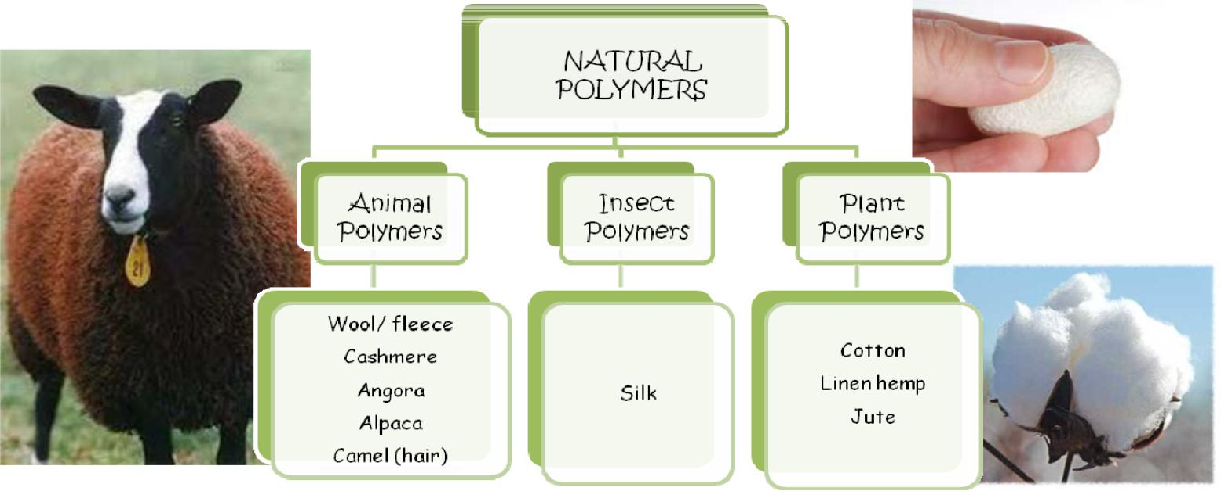

The second chart explains the different types of manufactured fibres:
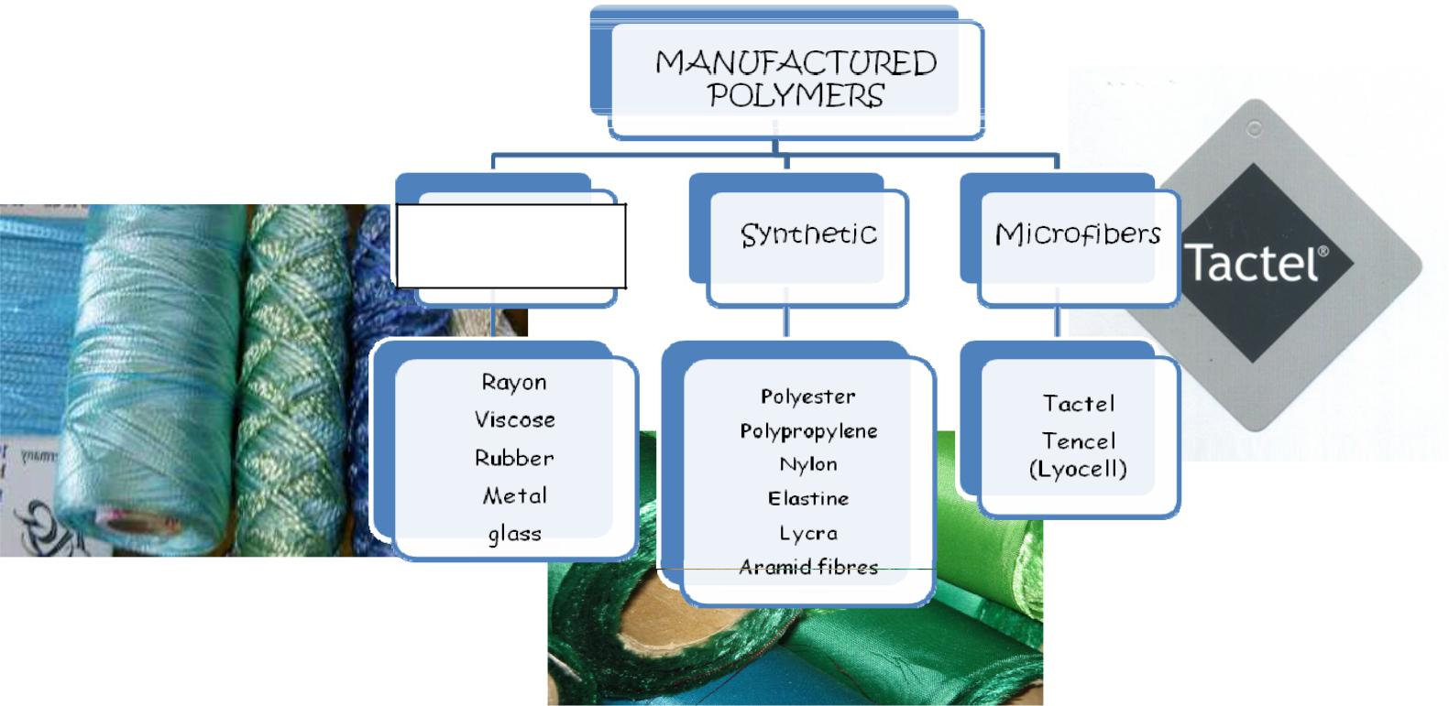

Regenerated

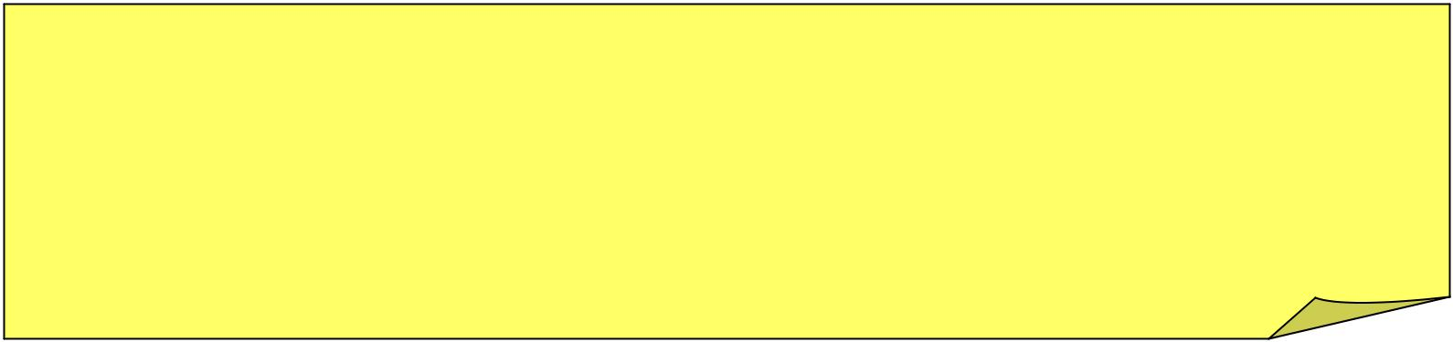

- Natural fibres derive from plants-cotton and linen or animals- wool and silk.
- Synthetic/man- made chemical fibres for example- acrylic, nylon and polyester are manufactured from minerals and materials such as oil and coal. Viscose is produced from Petrochemicals (derived from petroleum) or pine trees (wood pulp).

