📈 Business Intelligence Dashboard Project

**Author:** Rhythm Rahul Shankarwala  
**Role:** Data Analyst / Business Analyst  
**Tools & Technologies:** Microsoft Excel, Power Pivot, Data Modelling, Interactive Dashboards, Advanced Charting  
**Project Type:** End-to-End Data Analysis & Visualization  
**Industry Context:** Sales Performance & Logistics Optimisation

⭐ STAR Method Breakdown

**S: Situation**

In a cross-functional business environment, I identified an opportunity to enhance decision-making by transforming raw transactional data into a strategic reporting solution. The dataset included multi-dimensional sales records across regions, shipment modes, and product categories. The objective was to deliver a scalable, interactive dashboard that could support performance monitoring, profitability analysis, and operational efficiency.

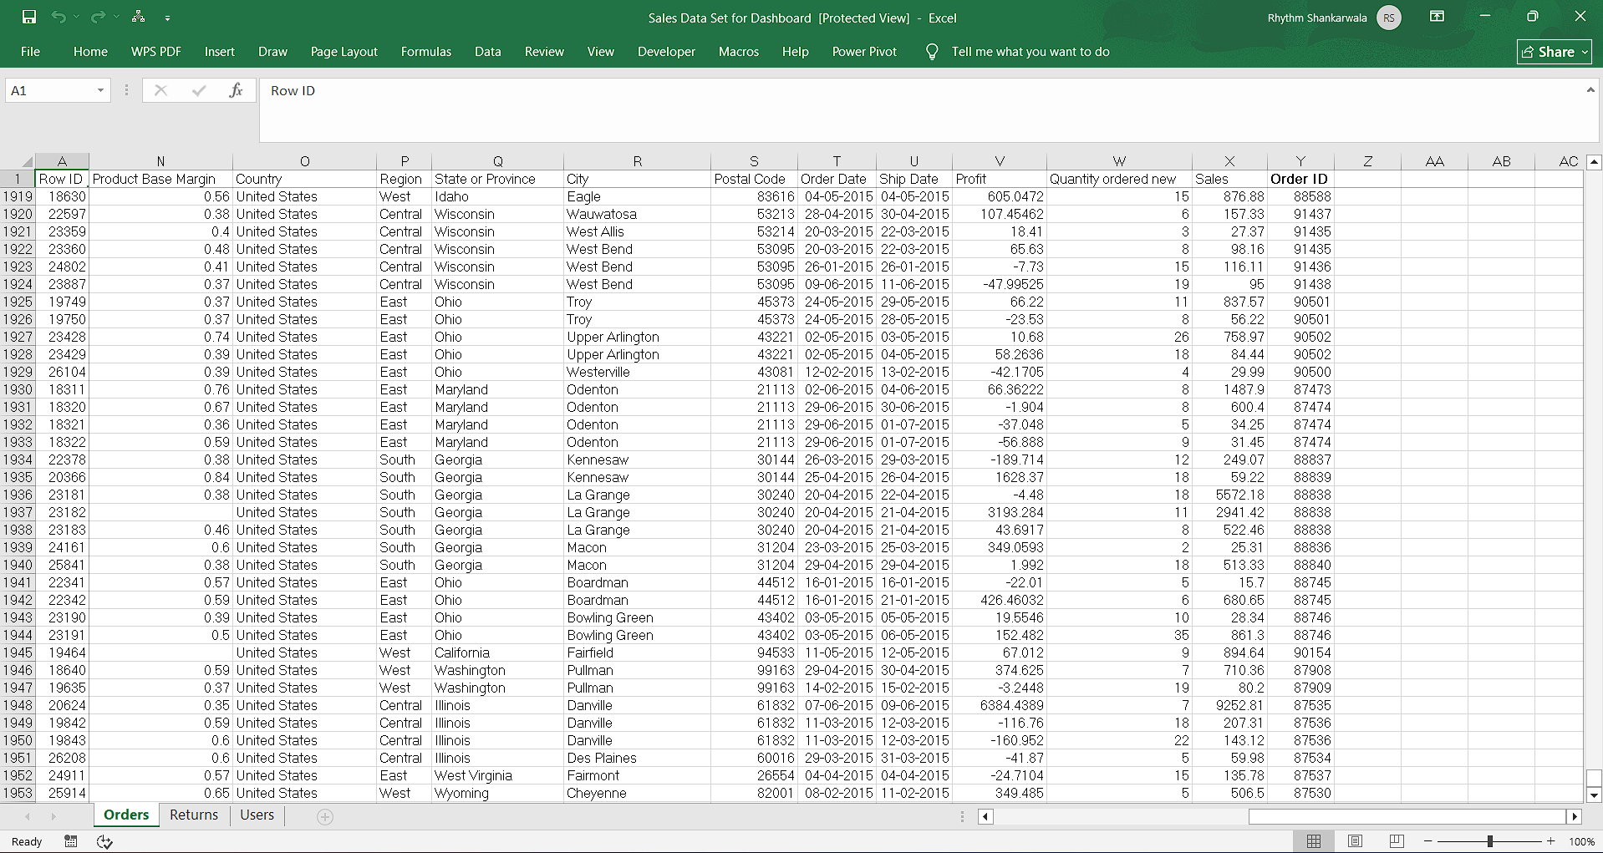  
*Caption: Source data used for ETL and dashboard development*

**T: Task**

My primary responsibilities included:

* Performing data extraction, transformation, and loading (ETL) using Excel.
* Designing a relational data model using Power Pivot to enable dynamic filtering and cross-table analysis.
* Developing a KPI-driven dashboard with slicers and visualizations to support business intelligence reporting.
* Aligning deliverables with stakeholder requirements for regional profitability, product performance, and logistics optimization.

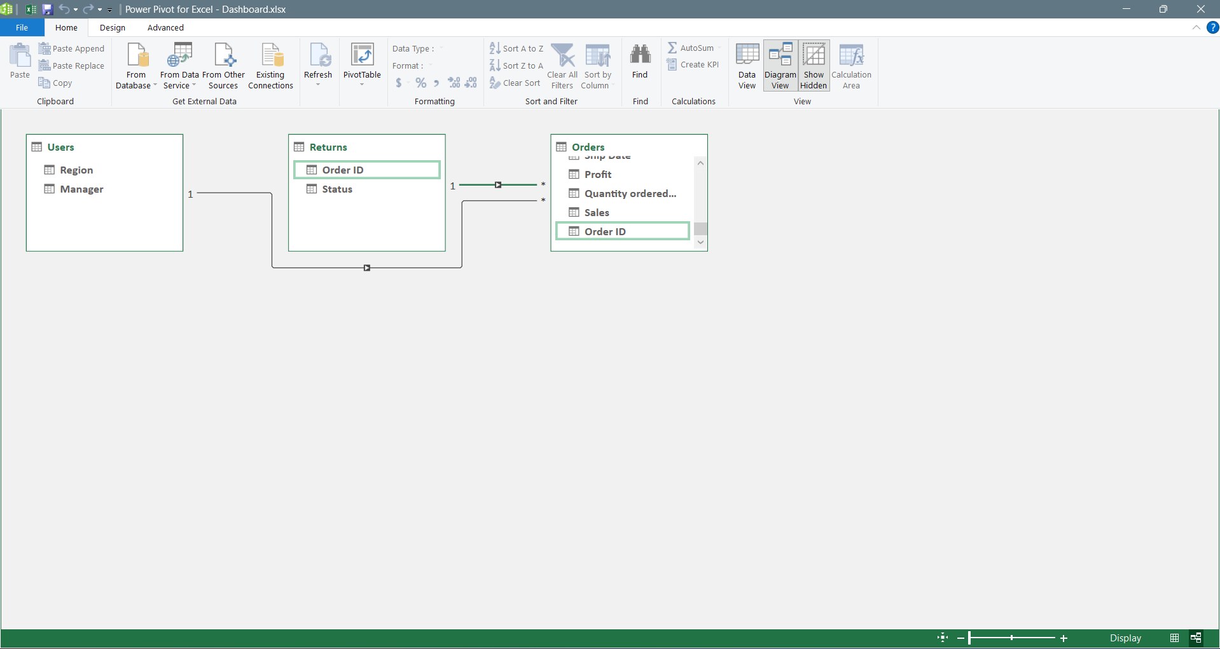  
*Caption: Data model architecture with defined relationships and lookup tables.*

**A: Action**

Key actions taken:

* Conducted data cleansing and normalization to ensure integrity across geographic, categorical, and financial fields.
* Established one-to-many relationships between Orders, Returns, and Users tables using Power Pivot for seamless data integration.
* Implemented interactive slicers for Customer Segment, Product Category, and Ship Mode to enhance user-driven analysis.
* Created data visualizations including:
* Shipment Mode Distribution (Pie Chart)
* Least Profitable Products (Bar Chart)
* Top Profitable States and Cities (Horizontal Bar Charts)

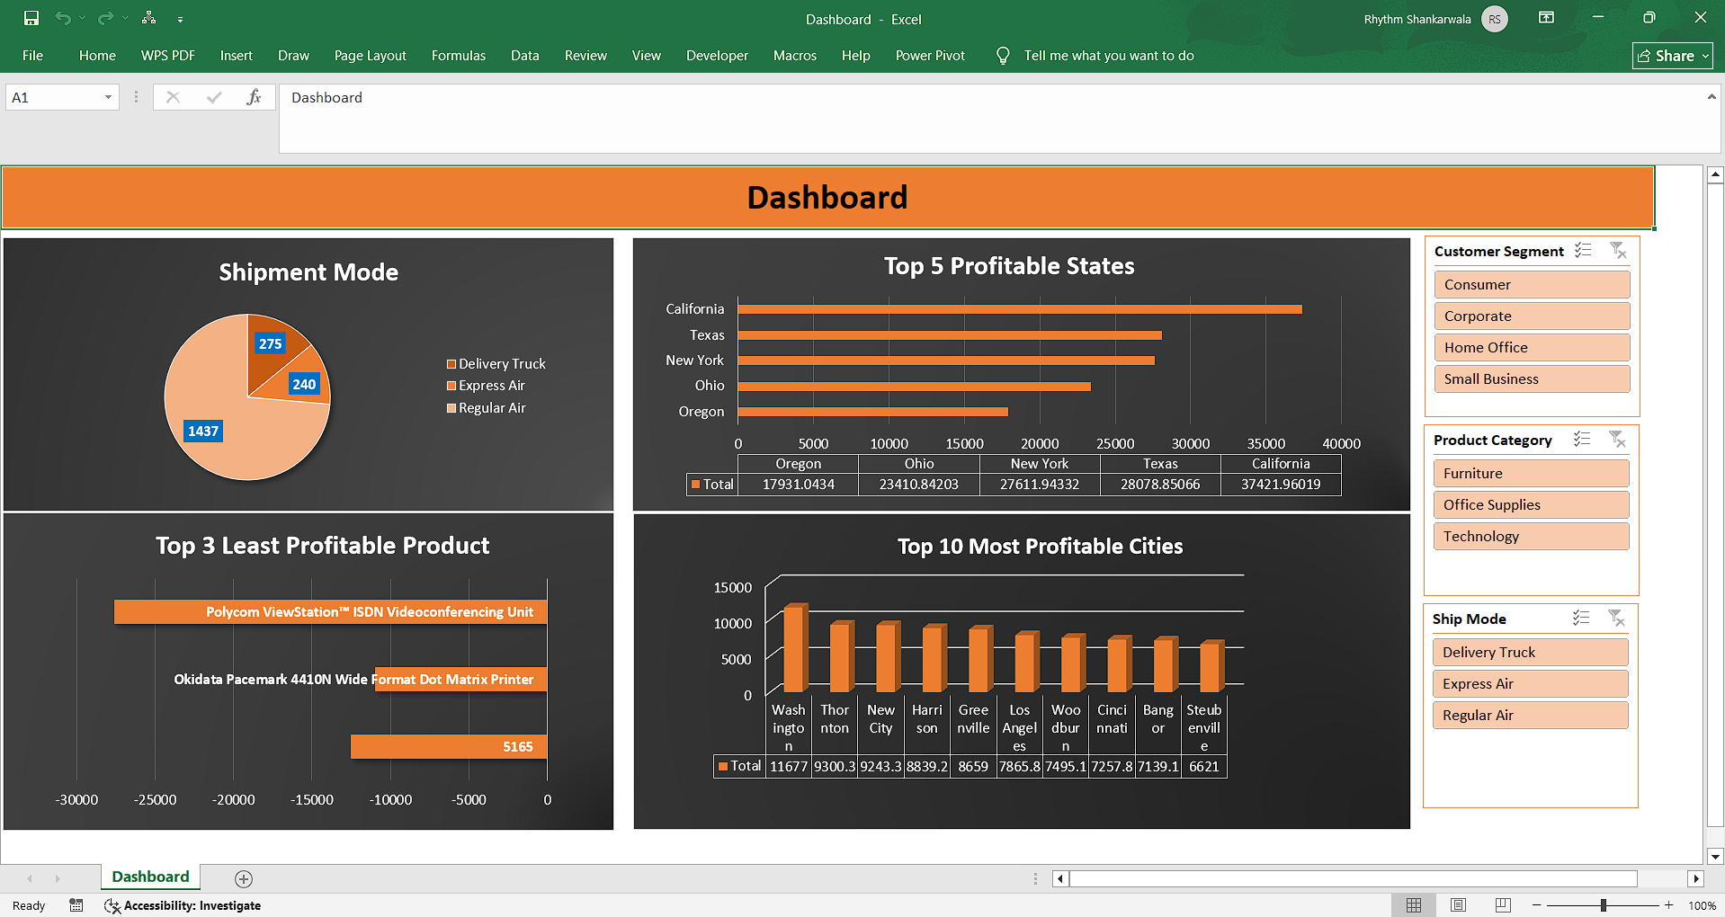  
*Caption: Final dashboard showcasing profitability metrics and shipment insights.*

**R: Result**

The dashboard enabled:

* Real-time insights into regional and product-level profitability.
* Identification of underperforming SKUs for strategic review.
* Enhanced visibility into shipment mode efficiency, supporting logistics cost optimization.
* Improved stakeholder engagement through intuitive, self-service analytics.

This project demonstrates my ability to:

* Translate complex datasets into actionable insights.
* Build scalable reporting solutions aligned with business goals.
* Apply data visualization best practices to drive strategic decision-making.