**Chapter 01 - Inception - Theory**

* What is Emmet?

Set of plugins in text editor that allows high speed coding

In Vs Code Emmet is internally installed

Emmet dynamically converts abbreviations into full code

Example: html:5 generates html5 boilerplate code

* Difference between a Library and Framework?

Framework -

collection of code libraries that provides pre-written code for everyday programming tasks to a web developer.

Provides a structure/pattern along with rules and guidelines which make sure architecture is in the right way.

Complex application development is faster and efficient

Library -

Collection of pre-written code snippets that can be reused to perform common functions.

Can be plugged into your project’s code on an as-needed basis.

Faster development and fewer vulnerabilities to have errors.

Main difference -

Inversion of control -

With a library one has complete control over the application flow. You get to decide when and where you want to call the library.

With a FrameWork the complete flow is controlled by the framework itself. Provides various place to plug in your code , but only call when its needed.

* What is CDN? Why do we use it?

CDN : Content delivery network

It is a network of servers that distributes content from an origin server throughout the world by caching content close to where each end user is accessing the internet via web-enabled device. The content they request for is first stored on the origin server and is then replicated and stored elsewhere as needed.  
We use CDN to reduce Latency. Latency is that annoying delay you experience when trying to access a web page or video stream before it fully loads on your device.

* Why is React known as React?

React was developed for applications that have constantly changing data like facebook. As react is a front end or View in MVC which means when user events(click/type/submit) changes the app’s data the view should react accordingly.

* What is crossorigin in script tag?

The crossorigin attribute sets the mode of the request to an HTTP CORS(cross origin resource sharing) Request. The purpose of the crossorigin attribute is used to share the resources from one domain to another domain. It is used to handle the CORS request that checks whether it is safe to allow for sharing the resources from other domains.

<script crossorigin="anonymous|use-credentials">

* What is difference between React and ReactDOM?

React:

It is a JavaScript library for building User Interfaces. The react package contains React.createElement(), React.Component, React.Children, and other helpers related to elements and component classes. It provides helpers that you need to build components.

ReactDOM:

It is the JavaScript library that allows React to interact with the DOM. The react-dom package contains ReactDOM.render(), and in react-dom/server we have server-side rendering support with ReactDOMServer.renderToString() and ReactDOMServer.renderToStaticMarkup().

* What is the difference between react.development.js and react.production.js files via CDN?

React.development.js: Used in the development environment when the code is in the development stage. This is less optimized and also provides debugging ability and hot load ability saving development time.

React.production.js: This is used in production environment when code is live on the internet for end user usage. This code is more optimized and is in min.js version.

* What is async and defer?

youtube.com/watch?v=IrHmpdORLu8

Normally JS pauses the html parsing as soon as the script tag is found, it will then fetch the script src and parse the fetched code after that it will resume the html parsing.

Async: when async attribute is added to Script tag - html parsing and script are also fetched asynchronously parallelly . As soon as scripts are fetched and are available in the browser the html parser will stop and scripts are executed then and there, once done html parsing will continue again.

Here the order of execution is not guaranteed.

Defer: when defer attribute is added to Script tag - html parsing and script are also fetched parallelly. Once complete html parsing is complete the scripts will be executed after that only.

* VS Code Extensions

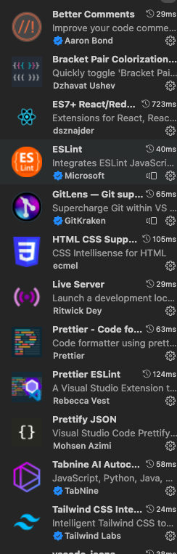

Chrome extensions :

