System High-Level Design Document

Exchange Network Phase 4 Project
(AQS)

QA Tools Application

Massachusetts Department of Environmental Protection

Version: 1.2

March 18, 2008

This Page Intentionally Left Blank

Revision History

Version | Date | Created By | Reviewed By
1.0
Description: | Draft SYSTEM HIGH-LEVEL DESIGN DOCUMENT
1.1 | 3/5/2008 |  | MassDEP
Description: | - Updated EPICS Database Expansion ER Diagram in “Appendix B – EPICS Expansion Draft Entity Relationship Diagrams” (Page 42) to display physical data type for each table column.  - Update Preliminary list of Automatic QA Tools Validation Checks in “Appendix A – Automated Validation Checks” (Page 38), based on feedback from Lawrence MassDEP.
1.2 | 3/18/2008 |  | MassDEP
Description: | - Updated the Manual Data Entry description to indicate that this is also where Forecast data could be entered into the system from inside the MassDEP State Network – (“Data Upload and Entry”, Page 29)  - Updated the description of the automated parsing of the hourly AIRNow OBS file to indicate that there will need to be two polling tasks and two files parsed in order to publish all required data to the Air Monitoring Public Website – (“Automated Data Parsing”, Page 29)  - Updated the Automated Validation Checks section to note the concept of Warning versus Error Validation Checks – (“Appendix A – Automated Validation Checks”, Page 38)

This Page Intentionally Left Blank
Table of Contents
1. Introduction 8
1.1 Purpose 8
1.2 Scope 8
1.3 Definitions, Acronyms, and Abbreviations 9
1.4 Document Overview 10
2. System High-Level Design Overview 12
2.1 System High-Level Design Goals, Scope, and Objectives 12
2.1.1  Data Polled and Maintained in E-DAS 13
2.1.2  Aggregate and Store Complete set of AQS Data in EPICS (ARA) 13
2.1.3  Capitalize on AIRNow FTP submission to Feed AQS Raw Data to EPICS 14
2.1.4  Full AQS Data Exchanged to EPICS 14
2.1.5  Parse Data to EPICS Oracle Database 14
2.1.6  QA Tools 15
2.1.7  Node Plug-in Submits AQS Data through MassDEP Network Node to EPA 15
2.1.8  Node Plug-in Submits Updated (QA) AQS Data to AIRNow (Optional) 15
2.1.9  Air Quality Data Reporting Public Website 16
2.1.10  Utilize Existing Exchange Network Technology to Support Public Data Download on the Air Monitoring Website 16
2.2 QA Tools High-Level Diagram 16
3. Detailed System Overview – QA Tools 18
3.1 System Design Considerations 19
3.1.1 Data Parsing Process 19
3.1.2 User Types and Security Roles 20
3.2 Detailed System Design 23
3.2.1 User Interface 23
3.2.2 Field Analyst Compliance 24
3.2.3 Data Comparison and Graphing 27
3.2.4 Minute Data Comparison 28
3.2.5 Data Upload and Entry 29
3.2.6 Automated Data Parsing 29
3.2.7 EPA AQS Submission 31
3.2.8 Administrator Tools 32
3.2.9 Air Monitoring Website Administration Module 32
3.3 EPICS AQS Database Expansion 34
4. Deployment 35
4.1 Overview 35
4.2 Web Server Recommended Requirements 35
4.3 Database Server Recommended Requirements 36
4.4 Application Server Recommended Requirements 36
Appendix A – Automated Validation Checks 38
Appendix B – EPICS Expansion Draft Entity Relationship Diagrams 42

Tables and Figures
Table 1: Definitions, Acronyms and Abbreviations 9
Table 2: QA Tools Security Roles and Privileges 20
Table 3: Web Server Hardware Requirements 35
Table 4: Database Server Hardware Requirement 36
Table 5: Application Server (Optional) Hardware Requirements 36

Figure 1: Overview of the AQS System Components 13
Figure 2: QA Tools High-Level Overview 17
Figure 3: Example MassDEP Web Application Template Left Navigation Panel Look and Feel 24
Figure 4: Field Analyst Compliance Sub-Modules Diagram 24
Figure 5: Flow Diagram for Automated Hourly Data File Parsing 30
Figure 6: Flow Diagram for Air Quality Data Files Uploaded through the QA Tools 31
Figure 7: AIRNow Data Quality Control Checks for Ozone 41
Figure 8: EPICS AQ Schema Entity Relationship Diagram (Visio 2002 Drawing) 42

Introduction

Purpose
This document provides a comprehensive architectural overview of the Massachusetts Department of Environmental Protection Exchange Network Node AQS/MassAir (AQS) for the Quality Assurance (QA) Tools portion. The document depicts the technical aspects of the AQS QA Tools System Components and is intended to capture and convey the significant architectural design decisions which have been made in preparation for the development of the QA Tools Intranet Web Application [herein referred to as ‘QA Tools’] – a Major Component to be developed under the AQS Project.

Scope
This document seeks to define the high-level functionalities of the AQS QA Tools System Components in as much detail as possible. This document merges knowledge from past meetings, from MassDEP experience, and from IT expertise to formulate a plan for developing the AQS QA Tools System Components.
Based on previous project team design discussions, first a Functional Requirements Specification Document was created under this project to identify the business process needs for all AQS System Components. After investigation of the defined Functional Requirements, consultation of standard design practices, and business process optimization, this document defines an application that will work in concert with all System Components of the AQS Project to allow MassDEP to do the following:
- Flow Air Quality System (AQS) Data to the EPA via the MassDEP Network Node as part of the National Environmental Information Exchange Network (NEIEN)*
- Streamline and Automate (where possible) the data gathering and data transfer for the AQS Data Flow using MassDEP Data Sources and Database(s) (existing and new)^{*1}
- Develop an Air Monitoring Public Website to enable the sharing of real-time Air Quality data and other Air Quality related information with the public.
  - The Website will also support the publishing of MassDEP Air Quality Data to the public via the MassDEP Node.
- Develop a set of Quality Assurance tools to streamline the process of Air Quality data review performed by state staff. ^{*1}

Definitions, Acronyms, and Abbreviations
This subsection provides the definitions of all unclear terms, acronyms, and abbreviations required to properly interpret the AQS System Design Document.

Table 1: Definitions, Acronyms and Abbreviations
Term | Definition
AIRNow | http://www.airnow.gov – The U.S. EPA, NOAA, NPS, tribal, state, and local agencies developed the AIRNow Web site to provide the public with easy access to national air quality information. The Web site offers daily AQI forecasts as well as real-time AQI conditions for over 300 cities across the US, and provides links to more detailed State and local air quality Web sites.
AQS | The Air Quality System (AQS) is EPA's repository of ambient air quality data. AQS stores data from over 10,000 monitors, 5000 of which are currently active. As discussed in more detail elsewhere, State, Local and Tribal agencies collect the data and submit it to AQS on a periodic basis.
AQS Data | For this document, three types of AQS Data have been defined for display on the Air Monitoring Data Website:  - AQS Data: AQS Data is Air Quality data (including Sites and Monitor Information, Monitoring Results, Parameter Information, etc.) that is also contained in the AQS Submission to the EPA. In order to make the website more Exchange Network centric, the website will be designed to be fed directly from data in an AQS version 2.0 XML Schema format for this type of data.  - AQS Related Data: AQS Related data is data that is calculated or determined based on the AQS Data. For example, Alert information is triggered when AQS results exceed a pre-defined threshold. Information, such as Alert information, will be published to the AQS website via a new schema block to be added to the AQS version 2.0 schema.  - Non-AQS Data: Non-AQS Data is the data on the website that is not contained in the AQS submission to the EPA. A new web page layout schema will be developed to transfer and publish this type of data to the website.
CSV | A file format (Comma Separated Value) for text files that is easily converted to and from Excel Worksheets via Microsoft Excel.
AQS | The project: Exchange Network Phase 4
FTP | FTP or File Transfer Protocol is used to transfer data from one computer to another over the Internet, or through a network.
GML | XML grammar defined by the Open Geospatial Consortium (OGC) to express geographical features.
HTML | Hypertext Markup Language is the predominant markup language for web pages. It provides a means to describe the structure of text-based information in a document – by denoting certain text as headings, paragraphs, lists, and so on.
Infragistics | A Third Party Web Toolkit that MassDEP recommends and has sufficient licenses for it to used in the development of the Air Monitoring Data Website and the QA Tools Web Applications. Please see http://www.infragistics.com/ for more information.
MassDEP | The Massachusetts Department of Environmental Protection
NAAS | EPA Network Authentication and Authorization Services: provides secure user authentication for Exchange Network Web Services.
OBS | The standard structure text file format used to FTP data to AIRNow automatically.
EPICS | MassDEP’s Enterprise-wide Oracle Database used for storing the State’s environmental information.
XML | A type of file (or language used when generating files) which allows for data and documents to be easily exchange over the web.

Document Overview
The AQS QA Tools System High-Level Design Document is arranged in the following format:

- Section 1: Introduction
  - A brief explanation of the purposes, goals, and format of this System Design Document.
- Section 2: System High-Level Design Overview
  - An overview of the goals and objectives for the AQS project. This section also provides a short explanation about each component and process to be developed/implemented under the AQS project, paying particular attention to the QA Tools.
- Section 3: Detailed System Functionality Explanations
  - This section documents the detailed design of all Modules within the QA Tools.
- Section 4: Deployment
  - This section lists the options for the areas of the MassDEP technical infrastructure where applications or processes should be setup in order to support the QA Tools.
- Appendix A
  - Appendix A contains the list of checks to be performed for the Automated Hourly Data Validation.

System High-Level Design Overview

System High-Level Design Goals, Scope, and Objectives
The Massachusetts Department of Environmental Protection (MassDEP) was awarded an Environmental Protection Agency (EPA) grant to implement a new air quality flow on the Exchange Network and develop a website to share real-time air-quality data with the public. The project consists of implementing automated cleansing of information, conversion of information to the Exchange Network format, delivery of information over the network in a secure and reliable fashion, and to the publicly accessible web interface.
As noted in the introduction, these technological advancements will be accomplished by developing the following major AQS System Functional Components:

- Flow Air Quality System (AQS) Data to the EPA via the MassDEP Network Node as part of the National Environmental Information Exchange Network (NEIEN)
- Streamline and Automate (where possible) the data gathering and data transfer for the AQS Data Flow using MassDEP Data Sources and Database(s) (existing and new)
- Develop an Air Monitoring Public Website to enable the sharing of real-time Air Quality data and other Air Quality related information with the public.
  - The Website will also support the publishing of MassDEP Air Quality Data to the public via the MassDEP Node.
- Develop a set of Quality Assurance tools to streamline the process of Air Quality data review performed by state staff.

The following diagram outlines the high level major components of the AQS System; each component is described in the numbered sections below the diagram.
Figure 1: Overview of the AQS System Components

Data Polled and Maintained in E-DAS
The existing business process will continue to retrieve data from the Air Quality monitoring stations and populate this information into E-DAS, located at the Lawrence facility, on an hourly basis.
Although the E-DAS system will continue to serve as the primary data management tool at the Lawrence AAB facility, a separate data store will be established at Boston.

Aggregate and Store Complete set of AQS Data in EPICS (ARA)
Because the Air Quality data maintained in E-DAS is stored in a proprietary format, IT proposes to create a separate storage of AQS data in a new EPICS (ARA) database module to be created under this project. The EPICS storage of AQS data will store a complete set of AQS data to allow review and to aggregate separate AQS data sources if necessary. The EPICS AQS Data will support the following data sharing applications to be developed under this project, at a minimum:
- AQS-XML Submissions
- MassDEP Air Monitoring Website
- Ad hoc Data Downloads
Because there are a variety of data sharing needs, the data at Boston will need to include a full set of information, including:
- Latest hourly raw data
- Site, monitor, protocol, precision/accuracy, and QA’d raw data that will support a complete AQS submission (and provide necessary supporting information on the website).

Capitalize on AIRNow FTP submission to Feed AQS Raw Data to EPICS
In order to allow the latest set of hourly data to be displayed on the MassDEP website, an automated mechanism will need to be established to transfer this data from Lawrence to Boston. Please see the Automated Data Parsing Section (3.2.6) for more information on the Data Transfer, Parsing/Upload process.

Full AQS Data Exchanged to EPICS
While the previous section would accomplish the transmittal of Raw Data to EPICS, additional data would need to be maintained in EPICS that includes all information needed to support a complete AQS submission. Based on Design Discussions with MassDEP Staff, the initial design is to load this data into EPICS with a one-time migration. MassDEP Staff will then be responsible for maintaining the Full AQS Data (e.g. Monitor Details, Basic Site Info, etc.) within EPICS via the QA Tools (similar to how it is done via AQS and AIRNow currently). We will use the Raw AQS Data together with the Full AQS Data to submit AQS Raw Data electronically to the EPA.
Please see the “MassDEP_AQS_FlowConfigurationDocument_v2.1.doc” for more information on the AQS Node Submission to the EPA.

Parse Data to EPICS Oracle Database
As noted above, the ideal solution would be to utilize the existing AIRNow FTP process to transfer real-time Raw Air Quality Data to be displayed on the Air Monitoring Data Website. In order to do this, the “OBS” file FTP’d to AIRNow would need to be parsed to the EPICS database once it was transferred to the MassDEP environment at Boston. A process will be built to do this.
Please see the Automated Data Parsing Section (3.2.6) for more information on the Data Transfer, Parsing/Upload process.

QA Tools
A comprehensive Web-based QA Toolset will be developed that will allow Lawrence staff to manage their quality assurance tasks and quickly identify potentially erroneous air quality data. In order to provide a comprehensive, solution, IT recommends that the different QA Tools be combined into one solution. This will enable Lawrence staff to complete a variety of QA tasks within one application. The major components included in this Toolset are:
- Data Upload Module
- Field Analyst Compliance Module
- Data Comparison and Graphing Module
- Speciation Analysis Module

The QA Tools functional design is the main topic of this document. A high-level overview of the QA Tools is provided in the next document section.

Node Plug-in Submits AQS Data through MassDEP Network Node to EPA
A Node Plug-in will be developed to plug into the existing MassDEP Node which will generate the AQS XML file and submit to the EPA on an on demand basis formatted according to the AQS v2.0 schema.

Please see the “MassDEP_AQS_FlowConfigurationDocument_v2.1.doc” for more information on the AQS Node Submission to the EPA.

Node Plug-in Submits Updated (QA) AQS Data to AIRNow (Optional)
The same Node plug-in described in the section above used to submit AQS Data to the EPA can also be used to feed data to AIRNow.
The advantages of implementing an XML-based AIRNow data flow are:
- The traditional flat (OBS) files to AIRNow do not allow data to be updated. But the XML data transmission to AIRNow does allow updates to be automatically made. This is especially important in allowing users of the AIRNow Tech application to see QA’d information.
- Ensures data is consistent, regardless of the exchange partner.
- Ultimately reduces the number of different exchange mechanisms, thus reducing long-term support costs.

Air Quality Data Reporting Public Website
The Air Quality Data Monitoring Website will relay live, near real-time data to the Commonwealth, while engaging public interest in and knowledge of air quality.
Please see the “MassDEPAQS_SDD_Website_v.1.2.doc” for more information on the Air Monitoring Data Website functional design.

Utilize Existing Exchange Network Technology to Support Public Data Download on the Air Monitoring Website
A module of the Website will allow Public User’s to query and download Real Time as well as Historical Massachusetts Air Quality Data from the MassDEP in multiple file formats, including, HTML, XML, GML, and CSV. This function may potentially be built by integrating with the MassDEP AQS Node Web Service to also be developed under this process.
Please see the “MassDEP_AQS _SDD_Website_v.1.2.doc” for more information on the Air Monitoring Data Website – Data Download functional design.

QA Tools High-Level Diagram
Component 6 from the AQS High-Level overview above is the QA Tools; this section contains a High-Level Diagram of the QA Tools.

The diagram below outlines each of the Application Components of the QA Tools that will have a User Interface. For each of the 7 Components with a User Interface, the major modules are listed in the diagram along with high-level steps for interacting with the Component or sub-Module. The background color for each Component, Sub-Module, or Step indicates the lowest Security level that will be allowed access according to the included Legend. Please see the “User Types and Security Roles” Section (3.1.2) below for detailed information on which User Security Role may access which QA Tools functions.

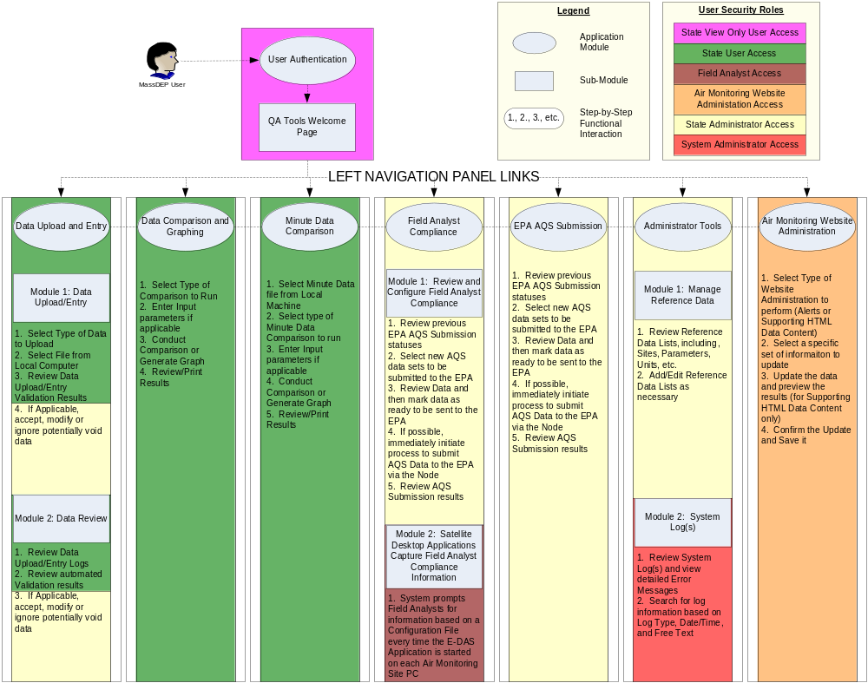
Figure 2: QA Tools High-Level Overview

Detailed System Overview – QA Tools
Data collected from the remote MassDEP Air Monitoring Sensors, once aggregated in E-DAS, undergoes a rigorous QA process. It is highly labor intensive and manual, yet is repetitive – which indicates that automation can create greater efficiency. For this reason, the AQS Project Team is designing and developing the QA Tools to streamline the MassDEP Lawrence Staff QA process. There are three main areas where automated, web-based QA Tools will be helpful:

- Field Analyst Compliance: This component of the QA Tools will include a satellite application to be deployed on the computers at each Air Monitoring Site to assist with Field Analyst Compliance. Lawrence MassDEP Staff will maintain the configuration of the satellite applications which will be used to ensure that Field Analysts accurately and completely execute and document all necessary site maintenance tasks.

- Data Comparison and Graphing: This component of the QA Tools will have two parts as described later in the document: Automated Validation and Graphical Display. This component will enable MassDEP Lawrence Staff to concentrate on investigating potential Data Issues instead of identifying them.

- Minute Data Comparison: Speciation Analysis. All web applications developed must conform to web accessibility standards, as discussed in section 2.9 of this RFQ.

The Project Team has also identified other areas of the AQS project where an internal Web Application would be useful for supporting related components of the AQS Project. The following areas of the QA Tools will be developed to this end:

- Data Upload and Entry: To allow for upload of edited E-DAS data or other third party Air Quality data, the QA Tools will have a comprehensive submission module that will allow data to be uploaded according to the following file formats: .AIR, .R2, .OBS (.MA1). The QA Tools will also allow a simple data entry interface to manually enter in small data sets.

- Automated Data Parsing: This component is not part of the QA Tools Web portion; however it is required to support the entire AQS Project. The component is documented here because it will be used by the QA Tools within the ‘Data Upload and Entry’ and ‘Data Comparison and Graphing – Automated Validation’ Modules.

- EPA AQS Submission: MassDEP wishes to be able to review and control the sets of data to be uploaded to the EPA via the AQS Node Submission. To support this, the QA Tools will have an AQS Submission area for MassDEP Staff to review and select data sets to be uploaded to the EPA.

- Administrator Tools: This module would be used to allow MassDEP Staff to maintain reference data and to view System log(s).

- Air Monitoring Website Administration: As noted in the Air Monitoring Data Website System Design Document, many of the supporting web content will be updatable by MassDEP staff. This module will allow MassDEP staff to review and edit the supporting data content for the Air Monitoring Data Website.

The following sections below are provided in this document to outline the 8 Modules of the QA Tools as discussed above:

- Section 3.1: System Design Considerations – This section defines in more detail the relevant design considerations taken into account while determining how best to make the QA Tools a reality.

- Section 3.2: Detailed System Design – This section attempts to define the design of the separate QA Tools components in as much detail as possible.

System Design Considerations
The following sections document important design considerations investigated during the QA Tools design process, which may not have a place to be duly noted in the rest of the System Design document.

Data Parsing Process
The Team investigated a few different options initially for the parsing of Air Quality Data from standardized text file formats to the EPICS Air Quality Data Storage tables. At the time that this document was last updated, the team has chosen to create a parsing tool written in VB.Net code to be utilized during the Automated Data Parsing process and QA Tools Upload Data Parsing Process.

The team investigated using LimsLink, a third party tool licensed for use under other projects by MassDEP, to handle strictly the parsing from file to database, but found that the solution was not able to be integrated fully with the QA Tools. The team felt that this would result in a more complicated Data Parsing process and add potential points of failure and extra processing time that would need to be accounted for during the transfer of Real-Time Air Quality Data from E-DAS for display on the Air Monitoring Public Website.

Please see the Automated Data Parsing Section (3.2.6) for more information on the Data Flow for the Parsing of the different Data Types.

User Types and Security Roles
The QA Tools will interface with the MassDEP Enterprise Security Web Services application to manage User Security. Before the QA Tools can be accessed by any User, the User’s Account Name must be associated to the QA Tools with a specific Security Role in the MassDEP Enterprise Security Web Services application. The following logic will be used to control Security:

- MassDEP User Navigates Internet Explorer 6.0 or higher Web Browser to the QA Tools URL
- The QA Tools will capture the User’s MassDEP Windows Login Account Name
- The QA Tools will invoke the MassDEP Enterprise Security Web Services Application passing the User’s Login Name and the QA Tools Application Name
- If a Role exists, the Enterprise Security Web Application will return the Role Name associated with the User for the QA Tools
- The QA Tools will allow the User the level of access pre-defined for the specific Role that the User is associated with. If there is no Role associated with the User, the User will not be permitted to access the QA Tools.

The following Roles will be available within the MassDEP Air Quality QA Tools:

Table 2: QA Tools Security Roles and Privileges
Security Roles | Privileges
State View Only | - Will have VIEW ONLY Access to:  - Data Comparison and Graphing  - Minute Data Comparison  - Data Upload and Entry  - Will NOT have Access to:  - Field Analyst Compliance  - EPA AQS Submission  - Administrator Tools  - Air Monitoring Website Administration  - WILL NOT have the ability to override Potentially Invalid data
State User | - Will have Access to:  - Data Comparison and Graphing  - Minute Data Comparison  - Data Upload and Entry  - Will NOT have Access to:  - Field Analyst Compliance  - EPA AQS Submission  - Administrator Tools  - Air Monitoring Website Administration  - WILL NOT have the ability to override Potentially Invalid data
Field Analyst State User | - Will have Access to:  - Field Analyst Compliance – Satellite Application  - Will NOT have Access to:  - Field Analyst Compliance – Configuration Module  - Data Comparison and Graphing  - Minute Data Comparison  - Data Upload and Entry  - EPA AQS Submission  - Administrator Tools  - WILL NOT have the ability to override Potentially Invalid data
Air Monitoring Data Website Administrator | - Will have Access to:  - Air Monitoring Website Administration  - Will NOT have Access to:  - Field Analyst Compliance  - Data Comparison and Graphing  - Minute Data Comparison  - Data Upload and Entry  - EPA AQS Submission  - Administrator Tools  - WILL NOT have the ability to override Potentially Invalid data
State Administrator | - Will have Access to:  - Field Analyst Compliance  - Data Comparison and Graphing  - Minute Data Comparison  - Data Upload and Entry  - EPA AQS Submission  - Will NOT have Access to:  - Administrator Tools  - Air Monitoring Website Administration  - WILL have the ability to override Potentially Invalid data
System Administrator | - Will have Access to:  - Field Analyst Compliance  - Data Comparison and Graphing  - Minute Data Comparison  - Data Upload and Entry  - EPA AQS Submission  - Administrator Tools  - Will NOT have Access to:  - Air Monitoring Website Administration  - WILL have the ability to override Potentially Invalid data

Detailed System Design
The following sections attempt to delineate the design of the corresponding QA Tools Module in as much detail as possible. Where applicable, diagrams, footnotes, and cross-references are included to make the design documentation more clear.

Please note that the final implementation of the QA Tools will be reached via an Iterative review process with IT and MassDEP. Development QA Tools Screens will be shared and reviewed with MassDEP at critical points throughout the Development Process. During these review sessions the Project Team will work together to identify QA Tools Modifications if necessary. IT will document the review meetings for historical purposes and make any agreed upon changes. The newly updated QA Tools Screens will be reviewed again with MassDEP and the process as just described will be repeated. In this way, the QA Tools will eventually reach the QA and ultimately Production versions when the functionalities sufficiently meet or exceed the Functional Requirements documented in the Overall AQS Functional Requirement Specifications document.

User Interface
The User Interface of the QA Tools will be governed by the Internal MassDEP Web Application Template. The Template utilizes a ‘Left Navigation Panel’ concept to allow direct access to all parts of the Web Application from any page within the Web Application. The AQS QA Tools ‘Left Navigation Panel’ will have the following Links (grouped under the corresponding Headers if possible) based on the QA Tools components identified above:

- QA Tools
  - Data Upload and Entry
  - Data Comparison and Graphing
  - Minute Data Comparison

- Admin Tools
  - Field Analyst Compliance
  - EPA AQS Submission
  - Administrator Tools
  - Air Monitoring Website Administration

The screenshot below is an example of the ‘Left Navigation Panel’ Look and Feel from an existing MassDEP Internal Web Application:

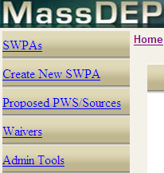
Figure 3: Example MassDEP Web Application Template Left Navigation Panel Look and Feel

Field Analyst Compliance
As noted above, the Field Analyst Compliance Module will include a Satellite desktop application to be installed on each of the Air Monitoring Site computers. It will also include a management Sub-Module within the QA Tools core Application. The diagram below depicts how the two Sub-Modules of the Field Analyst Compliance will work together. The numbered sections of the diagram are explained below the diagram.

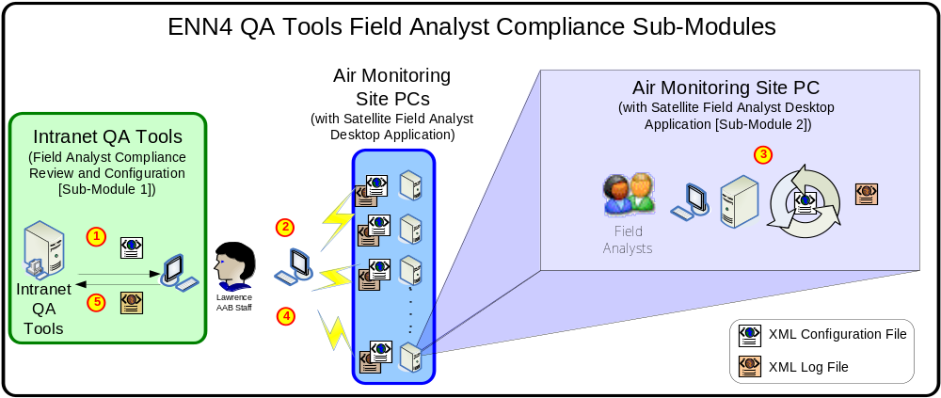
Figure 4: Field Analyst Compliance Sub-Modules Diagram

-  Review/Configure Field Analyst Compliance: Lawrence AAB Staff with appropriate rights can review the complete Field Analyst log from within the QA Tools. Staff will also be able to modify the settings for the Field Analyst Desktop Application within the QA Tools. After modifying the settings, the Staff can generate an XML Configuration file ( ) which will be used by the Field Analyst Desktop Application.

-  Manually Transfer Configuration File: Lawrence AAB Staff must take each generated XML Configuration File ( )from the QA Tools and transfer it manually via PC Anywhere to each Air Monitoring Site PC anytime a configuration change is made to the Field Analyst Compliance settings.

-  Field Analysts are Prompted to Log Information: When a Field Analyst starts the E-DAS application on an Air Monitoring Site PC, the Field Analyst Compliance Desktop Application will also start. The Desktop Application will prompt the Field Analyst to log information according to the pre-determined settings stored within the XML Configuration File ( ). The logs entered by the Field Analyst will be captured and stored locally within an XML Log File ( ).

-  Manually Retrieve Log File: Lawrence MassDEP Staff will manually retrieve the XML Log File ( ) from each Air Monitoring Site PC via PC Anywhere. By deleting the file stored locally on the Air Monitoring PC, the Field Analyst Desktop Application will create a new XML Log File. In this way, Lawrence MassDEP Staff can determine when the XML Log Files are getting too big and need to be shrunk.

-  Upload Log File to QA Tools: After retrieving the files, Lawrence MassDEP Staff can upload the XML Log Files ( ) to the QA Tools. By doing so, the Logs will be added to the QA Tools Master Field Analyst Compliance Log. Lawrence MassDEP Staff can then review the log information via the QA Tools (as noted in Step ).

Each Field Analyst Compliance Sub-Module is defined in detail in the sections that follow.

Field Analyst Review and Configuration Module
The Field Analyst Review and Configuration Module will be contained within the QA Tools. It will only be accessible to User Accounts with ‘State Administrator’ or ‘System Administrator’ privileges. The following three main functions will be available from this module:

- Upload XML Log Files from Air monitoring Sites:
  - Users with appropriate rights can upload the XML Log files from the Air Monitoring Site Satellite Applications. This will allow the Logs from the Satellite Application to be reviewed from within the QA Tools.
  - If a duplicate Date/Time, Site, and Log Category record is included in the XML Log File, the Log Data should overwrite the existing log in the System.

- Review Logs:
  - Users with appropriate rights can filter and review Logs from all the Satellite Applications provided that the corresponding XML Log files were uploaded to the QA Tools.
  - At a minimum, Users should be able to filter by the following criteria:
    - Site
    - Log Category
    - Field Analyst
    - Date Range

- Configure Satellite Applications:
  - Users with the appropriate rights can configure the Satellite Application Prompts.
  - By default the Satellite Applications will capture or require the following information on Login of the E-DAS Application at each Air Monitoring Site PC:
    - Field Analyst Username
    - Purpose of Visit
    - Air Monitoring Site Number [or Logger ID] (System Capture)
    - Entry Date/Time (System Capture)
  - Users with the appropriate administrator rights will be able to configure the available prompts to users, including
    - Text to prompt Field analyst with
    - Schedule and Occurrence – the number of times and frequency for which this Log must be entered at the Site (could be set to every time a User Logs into E-DAS)
    - Pre-Filled Data Entry Template
    - Monthly Reminder Indicator – Within One Week of the end of the month, a list of reminders will be presented to the Field Analyst at each site. It will list the Logs that are required to be filled in for that month according to their schedule that have not been filled in yet (if the Monthly Reminder Indicator is set to Yes for the Log)
    - Log Type to follow – If a Field Analyst enters one Log, the Administrator could require that they continue to enter this Log

Field Analyst Desktop Application
The Field Analyst Desktop Application will be deployed at each site. The Application will be designed to be opened whenever a User starts the E-DAS Application at each Air Monitoring Site PC. The Field Analyst Desktop Application will follow this behavior:
- Starts when E-DAS Opened
- Requires Username and Visit Purpose every time it is opened (captures Date/Time and Site); it will save this information and all logs entered to a local XML Log file.
- By default the Field Analyst can select to enter any available Log Type.
  - When entering a Log, the default text entry template will appear as configured by the MassDEP Lawrence Administrators.
  - Users will be able to enter a Log Date/Time which indicates the Date/Time that the Log Item corresponds to, as opposed to the time that the Log was physically entered into the system, for cases when the Field Analyst is logging an issue that occurred in the past.
- Field Analysts could also search any past Log entries.
- If any Logs are Scheduled to be entered they will show up as Current Scheduled entry options to the Field Analyst
- Within one week of the end of each month, for any Logs are Scheduled to be completed at the end of that month that have not been completed yet, a reminder will be presented to the Field Analyst listing each Log that is coming due.

Data Comparison and Graphing
The Data Comparison and Graphing Module will contain two main parts:

- Automated Data Validation:
  - Data that is uploaded through the QA Tools or transferred automatically will be QA’d automatically. Potentially Invalid data will be flagged immediately and will not be displayed on the Air Monitoring Public Website until the data has been reviewed by MassDEP Lawrence Administrators. Please see “Appendix A – Automated Validation Checks” for more information on the Automated Validation to be performed.
  - The Potentially Invalid data will be listed in a table for State Administrators to review.
    - The Potentially Invalid data should be able to be exported to an AQS compliant format
    - During review of the Potentially Invalid data, State Administrators can decide how to handle the data with respect to its availability on the Public Website. They must select one of the following options for each Potentially Invalid data record:
      - Accept Record as Is
      - Add a Flag
      - Ignore Record
- Data Graphing:
  - The QA Tools will interface with Active Reports to allow Users to graph pre-determined Data Comparisons.

  - Active Reports will be developed for the following Data Comparisons:
    - Generic
      - User can select Site, Parameter, and Date Range and View the corresponding Hourly Concentration Graph with supporting text results.
    - “Buddy Site” Comparison
      - Users can select a “Buddy Site” configuration and a Date Range and generate a graph showing the correlation with supporting text results.
    - Meteorological Graph
      - User could select a Site and/or a Parameter, a Date Range, and one or more Meteorological Parameters to view the Air Quality Data results in comparison to the selected Meteorological parameters with supporting text results.
    - Scan Report
      - A report that will take data from a File (or other defined subset) and compare it to historical Data and report on the comparison (similar to the EPA AQS Scan Report).

  - NOTE: For Potentially Invalid Data that results from “Buddy Site” Comparisons, a function will be included to allow MassDEP Administrators to directly graph the Buddy Site Comparison that resulted in the Potentially Invalid Data.

Minute Data Comparison
The Minute Data Comparison Module will function similar to the Automated Data Comparison except that it is for Minute Data, as opposed to Hourly Averages, and the Comparison will be run as an on-demand process. This process depends on the capability of MassDEP being able to obtain the Minute Data File in a standardized file format export from E-DAS. If the data cannot be exported to a readable standardized format, than this QA Tools module will not be possible.

Data Upload and Entry
The Data Upload and Entry module will allow data to be uploaded according to the following text formats at a minimum:
- AIRNow Text File Format (.OBS, .MA1)
- AIRS Text File Format (*.AIR)
- AQS R2 Text File Format (*.R2)

The Module will also allow users to enter Data manually for smaller data subsets. This manual entry area would allow MassDEP Users on the internal network to also input Forecast data to the EPICS Data Storage in Boston via the QA Tools for display on the Air Monitoring Public Website; the team is still investigating options for allowing Forecast data to be input in the system from outside the MassDEP State Network. The fields to be included for manual entry are:

Note: Fields that will be required for a manual entry record are denoted by asterisks (*) below

- Data Type*: From a Reference List maintained by MassDEP Administrators via QA Tools
- Date*: Select from Calendar Pick-list or type date (MM/DD/YYYY)
- Time: Select from Pick-list or type time (12AM, 1AM . . . . . 10PM, 11PM)
- Parameter*: From a Reference List maintained by MassDEP Administrators via QA Tools
- Unit*: Defaulted based on Reference Parameter List
- Value*: Free text

Automated Data Parsing
At the time that this document was last updated, the following Design is being implemented for the Automated Data Parsing. Each diagram below depicts the flow of the Air Quality data as it parsed into EPICS. There are two types of Data being parsed to EPICS; the following diagram illustrates the Data Flow for the Parsing of the Automatic Hourly Air Quality Data that is FTP’d to AIRNow.

After follow-up discussions with MassDEP, it was identified that the data FTP’d to AIRNow is not sufficient to support all the data required to be published to the Air Monitoring Public Website. Therefore, a second polling task will be setup in the Lawrence E-DAS Application which will retrieve data not retrieved by the AIRNow polling task, and aggregate it in an OBS file with the data that is retrieved by the AIRNow polling task, but not included in the OBS file FTP’d to AIRNow.

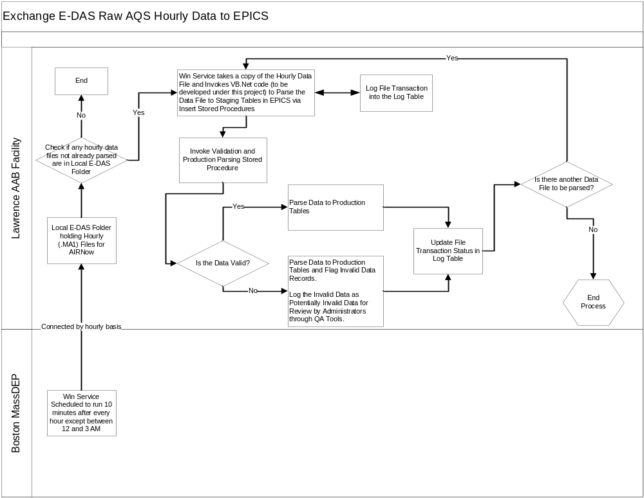
Figure 5: Flow Diagram for Automated Hourly Data File Parsing

The following diagram illustrates the Data Flow for the Parsing of the Air Quality Data Files that are uploaded through the QA Tools.

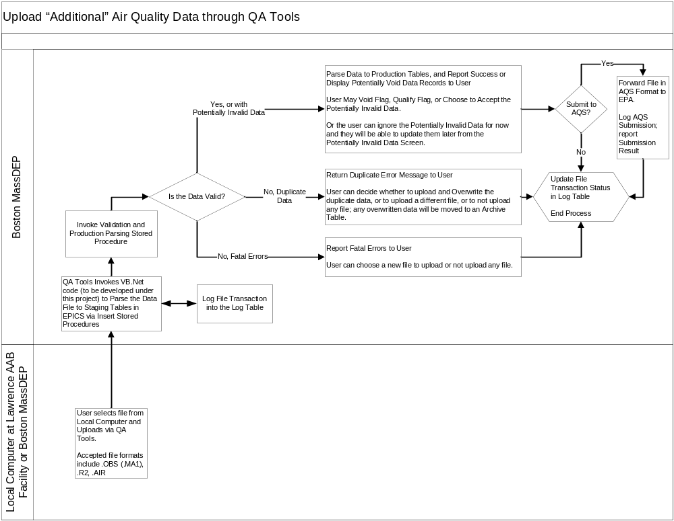
Figure 6: Flow Diagram for Air Quality Data Files Uploaded through the QA Tools

EPA AQS Submission
This module will be directly defined by the design of the AQS Data Flow to the EPA found in the AQS Data Flow Configuration Document to be completed after the design of the QA Tools is finalized. Please refer to the AQS FCD when it becomes available for detailed design on the QA Tools EPA AQS Submission Module.

At this point, it is important to note that the QA Tools EPA AQS Submission Module will permit the following functionalities:
- MassDEP Administrators with appropriate rights may select data based on the criteria to be defined in the AQS FCD.
- The selected AQS Data Subset will be pre-validated by the QA Tools based on the checks defined in the AQS FCD.
- MassDEP Administrators can review the pre-validated Data and override it if necessary as defined in the AQS FCD.
- MassDEP Administrators can initiate the AQS Submission from the QA Tools application according to the process defined in the AQS FCD.

Administrator Tools
The Administrator Tools Module has two sub-modules, Updating Reference Data and System Logs, as described in further detail below:

- Updating Reference Data
  - System Administrator Users can update Reference Data through the Administrator Tools Module, including:
    - Reference Code Pick-lists
    - Parameter List
    - Site List
    - Monitor List
    - “Buddy Site” List
      - User selects two or more sites
      - User selects one or more parameters
      - User enters range
      - The “Buddy Site” configurations will be used by the system during automated validation and for generating “Buddy Site” graphs, as noted in the Data Comparison and Graphing Section (3.2.3).

Air Monitoring Website Administration Module
As noted in the Air Monitoring Data Website System design Module, the QA Tools will include a module for Air Monitoring Website Administrators to edit “Non-AQS” Data Content. The QA Tools will have two distinct types of data available for update:

- Alerts: Alerts are setup to display information to public users when a certain Air Quality Threshold is met or exceeded. The following information about each Alert can be configured by the Air Monitoring Website Administrator:
  - Parameter for Alert
  - Threshold for Alert
  - Threshold Calculation Basis: One Time Value, 8-Hour Rolling Average, etc.
  - Length of Alert: How long the Alert should be visible on the Website
  - Alert Text
  - Alert Link: Administrator can choose to Include Default Link to “How can I protect my health today?”, to include a different Link (User defines Link URL and Link Text), or to include no link.

- HTML Blocks: Multiple HTML Blocks are located on each page of the Air Monitoring Data Website. They are used to display information for any “Non-AQS” Data Content NOT part of the Google Maps, Two-Dimensional Graphs, or AQS Tables. Air Monitoring Website Administrators will be able to update each of the HTML blocks via the QA Tools HTML editor interface.
  - User would select an Air Monitoring Website Tab, then select an Air Monitoring Website Second Level Navigation Page, and then select one of the HTML blocks on the page (if more than one).
  - User can then edit the HTML blocks via the HTML QA Tools.
  - User can preview the HTML as it should look on the Air Monitoring Website
  - User can then click to Save the changes, or click Cancel to return to the previous page without any uncommitted changes being saved.

EPICS AQS Database Expansion
The EPICS AQS Database Expansion is documented in the Air Monitoring Data Website System Design Document (“MassDEP_AQS _SDD_Website_v.1.2.doc”). The same EPICS AQS Database Expansion will be used to support the Air Monitoring Data Website and the QA Tools.

An updated version of the EPICS Database Expansion ER Diagram including objects to support the QA Tools and the Node Submission to AQS is included in this document in “Appendix B – EPICS Expansion Draft Entity Relationship Diagrams”.

Deployment
This section identifies the different options for areas requiring installation and configuration in order to support the QA Tools.

Overview
The following Servers are proposed to be used at MassDEP Boston to support the QA Tools:

  - Internal Web Server to be Specified
    - Hosts the Intranet QA Tools Web Application

  - Internal Application Server to be Specified
    - Hosts the Automated Win Service for Automated Data Transfer Parsing

  - EPICS Database Server
    - Hosts the Air Quality Data Storage Objects in the EPICS Oracle Database

Web Server Recommended Requirements
  - Software:
    - Windows Server 2003 with latest updates
    - .NET Framework 2.0 with latest updates
    - WSE 3.0 with latest updates
    - IIS 6.0 with latest updates
  - Hardware:
Table 3: Web Server Hardware Requirements
Web Server | Minimum Requirements | Recommended System
Load Balancing | Not Required | Network Load Balancing Recommended
Processor | Pentium IV 2.4 GHz or higher | Pentium IV 2.8 GHz or higher
Memory | 2 GB of RAM | 4 GB of RAM or higher
Disk Space | 20 GB free hard disk space | 40 GB free hard disk space or higher

Database Server Recommended Requirements
  - Software:
    - Windows Server 2003 with latest updates
    - Oracle 9i with latest updates
  - Hardware:
Table 4: Database Server Hardware Requirement
Web Server | Minimum Requirements | Recommended System
Load Balancing | Not Required | Cluster Server with RAID 5 Storage Array
Processor | Pentium IV 2.4 GHz or higher | Pentium IV 2.8 GHz or higher
Memory | 2 GB of RAM | 4 GB of RAM or higher
Disk Space | 40 GB free hard disk space | 80 GB free hard disk space or higher

Application Server Recommended Requirements
  - Software:
    - Windows Server 2003 with latest updates
    - .NET Framework 2.0 with latest updates
    - WSE 3.0 with latest updates
  - Hardware:
Table 5: Application Server (Optional) Hardware Requirements
Web Server | Minimum Requirements | Recommended System
Load Balancing | Not Required | Network Load Balancing Recommended
Processor | Pentium IV 2.4 GHz or higher | Pentium IV 2.8 GHz or higher
Memory | 2 GB of RAM | 4 GB of RAM or higher
Disk Space | 20 GB free hard disk space | 40 GB free hard disk space or higher

Appendix A – Automated Validation Checks
The following checks will be built into the QA Tools Data Parsing process. Where noted, the checks depend on reference data that may be updated by MassDEP Administrators.

Please note: The Automated Validation Checks will fall under two categories: Warnings and Errors. The category will be able to be configured by MassDEP Staff with the appropriate rights.

- Warnings will indicate that Data is potentially void, but the QA Tools Application will only notify MassDEP Staff that data triggered a Warning message. The Data will still be allowed to be displayed on the Air Monitoring Public Website.
- Errors will indicate that Data is Potentially Void and the Data will not be displayed on the Air Monitoring Public Website until signed off on by Lawrence Staff (The Lawrence Staff could also choose to never allow the bad data to appear on the site).

Initially, all Automated Validation Checks will be implemented as Errors, and MassDEP Staff may phase in configuring some of the checks to warnings after they become more familiar with the functionality of the QA Tools Application.

Please Note: The following list is as exhaustive as reasonably possible at this point of the Project. IT fully expects that the Validation Checks will be added to throughout the development and testing phases of this project. It is felt at this time that it is not beneficial to further investigate Validation Checks until MassDEP Staff have a prototype version of the QA Tools to consider for reference as to how these Validation Checks will be executed and how the results of the checks will be recorded and presented. For this reason, the QA Tools have been designed in such a way that the Validation Checks and Potentially Void Data review process is easily updatable via Stored Procedures in the EPICS Air Quality Data Storage.

    - Solar Radiation
      - No values overnight (< 10, > -20)
        - Overnight is 5pm – 6am in Winter; 9pm – 4am in the Summer
      - A 0 value during the day is invalid

    - Wind Speed
      - Same values for more than 3 consecutive hours is potentially invalid
      - Wind Speed greater than 30 mph for an hourly average is potentially invalid

    - Wind Direction
      - Duplicate values for more than 3 consecutive hours is potentially invalid

    - NO, NO₂, NO_{X}
      - NO + NO₂ = NO_{X} (within a .02 - .03 range)

    - Log Book
      - Make sure Field Analysts track tank changes
      - There should be a log entry corresponding to the Date/Time of all missing data values

    - Overall
      - NEW Automated Check: For each parameter a percent change maximum will be configurable by MassDEP Administrators. If adjacent hourly averages differ by more than the percent change maximum, the data is potentially void.
      - For each parameter a maximum value will be configurable by MassDEP Administrators. If a value exceeds the corresponding maximum value, the data point is potentially void.
      - For each parameter a minimum value will be configurable by MassDEP Administrators. If a value is below the corresponding minimum value, the data point is potentially void.
      - All missing data will be flagged for review from Lawrence Staff. Staff must add a Void or Qualifier Flag to the missing Data point before the Data is acceptable for submission to AQS. (Data could have multiple flags)

    - SO₂
      - Values over 0.80 are Potentially Invalid

    - PM2.5 BAMS:
      - Values greater than 100 for more than 3 hours are potentially invalid
      - Duplicate values for more than 3 consecutive values are potentially invalid

    - CO
      - Values > 3.0 are Potentially Invalid
      - Values < -.4 are Potentially Invalid

    - O-Zone:
      - If we can get minute data into the QA Tools, we will check for a noise difference: Consecutive Minute data points with a difference of 25 ppb for O₃ should be flagged as potentially void data
      - Data below 0 is Potentially Invalid data
      - During Non-Ozone season, should be < 0.080 (Ozone season is November to March)

    - Calibration Reports (This set of checks is dependent upon being able to automatically transfer or upload the Calibration Data to the QA Tools Application).
      - Zero Values over .4 or less than -.4 require Field Analyst Notification to be adjusted.
      - Expected values should be within a 10% difference from Real values
      - Data is void if the Expected values are 15.5% different or higher from Real values
      - Auto level 1 points run on the same schedule (not every day except CO zero) at each site.
        - O3 level 1 points run every other day
        - CO, SO2, NO/NO2/NOX, SO2T level 1 points run every third day
      - With the exception of CO which runs a zero every night, all other zeros run with the level 1 point.
      - The time schedule for these points varies at each site, although O3 (2300) and CO (zero 2200, level 1 2300) have consistent schedules.

    - Black Carbon
      - Internal Black Carbon Data gets emailed to Leslie from Tom
      - It gets run through the Data Masher
      - Take Data masher files and calculate 60 minute averages based on compiling
      - Black Carbon comes into E-DAS but is not reported to the EPA
      - The Data Masher Black Carbon Data is sent to the EPA
      - If Hourly data is blank, the data is Potentially Invalid; if there is >30 minutes of data for the hour, it is averaged and hand entered. If the data is invalid, codes have to be added as AQS does not accept blank fields.

    - Hi/Low Checks on a Monthly Basis
      - It is undetermined at this point if this type of check will be necessary considering the real-time Hi/Low upload checks, but currently a comparison of max/min Hi/Low values are compared against norms for a Monthly set of E-DAS Data.

    - Companion “Buddy” Sites
      - Compare data value to average value of surrounding stations with similar monitoring environment (urban, rural, etc.). To help improve reliability, ensure that Buddy sites are from the same agency. The number of Buddy site can range from 0 to 5. If the value being checked in not within the user-specified range (typically 20-40 ppb) of the Buddy value average, the data are flagged as bad. A minimum number of Buddy sites (typically three if five are defined) are necessary for the check to be done.
      - To setup a “Buddy” Site Validation Check through QA Tools the following steps will be able to be performed by Lawrence MassDEP staff:
        - Pick the Sites
        - Pick the Parameters
        - Define the acceptable range for each selected Parameter

    - BAMS Data: Has a Specific Excel Data Format
      - If possible to load in the BAMS Flow Data, the following Data Checks would be automatable:
        - Check Flow Range based on configurable reference data for potentially void data.
          - The valid Flow range is 751 – 917, with a constant 834 being optimal.
        - BAMS Data Values above 100 are Potentially Invalid
        - BAMS Data Values that stay the same for more than 3 consecutive hours are Potentially Invalid
        - Flows with the same value for more than 3 consecutive hours is potentially void data
        - The BAMS Temperature should match the Site Temperature monitor
        - BAMS has internal flags that should be translated

The following file is a representation of the automated data checks for Ozone data as documented and used by AIRNow. Unless specifically declined by MassDEP, the data checks in this file that are not already addressed in the list above, will also be implemented as Automated Validation Checks in the QA Tools for all possibly applicable Parameters:

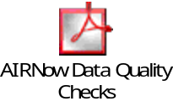
Figure 7: AIRNow Data Quality Control Checks for Ozone

Appendix B – EPICS Expansion Draft Entity Relationship Diagrams

Figure 8: EPICS AQ Schema Entity Relationship Diagram (Visio 2002 Drawing)

*? The MassDEP AQS QA Tools Application will be integral in fulfilling these 3 AQS Project Requirements. The Air Monitoring Public Website will also be impacted by the QA Tools for “Non-AQS Data” content configuration. Please see the latest version of the Air Monitoring Public Website System Design Document for more information on the Air Monitoring Public Website and its design.
The AQS 2.0 schema will be used to populate the website with all the data that would be reported to the EPA via the AQS Submission. A separate business XML schema will be developed to transfer and populate the non-AQS data on the website, such as
MassDEP has previously implemented projects that integrate with the new ARA Data Management Model which will eventually incorporate the entire EPICS data repository. In this project, the Air Quality Data Storage will provide for an option to integrate with the ARA Data Model for Air Monitor Site Location Data. Please see the “EPICS AQS Database Expansion” Section (3.3) for more information on the EPICS Database.
Initially (see Overall AQS Functional Requirements Specification Document) the third QA Tool area was “Speciation Analysis”. After further review and design discussion, the MassDEP team has decided that support for Minute Data QA Validation would be more beneficial. Provided the Speciation Analysis Data can be provided to MassDEP in the AQS Text File Format, the team has decided that it would still be helpful to have a Graph devoted to Speciation Analysis in the ‘Data Comparison and Graphing’ Module.
The Google Maps (and Section 508 support Tables), Two Dimensional Graphs (and Section 508 support Tables), Two-Level Navigation Tabs, Physical Web Page Layout, and Physical Web Page Count will not be able to be modified via this module.
This document considers the Parsing of two different Data Types: the Automatic Hourly .MA1 files that are FTP’d to AIRNow from out of E-DAS; and additional standardized Air Quality Formats that are obtained from outside of E-DAS and need to be uploaded to EPICS via the QA Tools.
The MassDEP Intranet Web Application Template already handles this interface. We will use the methods within the Template to make this functionality possible.
The QA Tools Application Name will be configurable within the QA Tools web.config file. The name should be pre-determined by the MassDEP Enterprise Security Application Administrator(s).
This is the current Third Party tool used by MassDEP to access Air Monitoring Site PCs via a dial-up connection.
Please see the User Types and Security Roles Section (3.1.2) for more information on User Account Security and Privileges.
The past log entries will not be able to be updated, though Field Analysts can add addendums to past Logs. In addition, the Satellite Desktop Application will be developed to minimize the impact on searching historical logs by implementing an archival process.
Please see “Appendix A – Automated Validation Checks” for more information on the types of Automated Data Checks that could produce Potentially Invalid data.
The Project Team is also investigating possibly using a Third-Party Tool called LimsLink for the Data Parsing. MassDEP already has licenses to use LimsLink. The drawback with the third party software is that it is believed that LimsLink could not be fully integrated with the QA Tools Application. Therefore the Data Parsing would be an asynchronous process which would add complexity to the Data Parsing. Labtronics (the vendor that owns the LimsLink software) has confirmed that there is no external API or option that would make it possible for the QA Tools or Automated Data Parsing process to fully integrate with LimsLink. An additional concern raised was that the LimsLink software requires one License per Data Tool that captures data parsed by LimsLink. Under this project, that means that MassDEP would need to purchase licenses for each Air Monitor in use by the State (currently priced at $1700 per license, or $1300 per license if purchasing 50 or more licenses).
Please note that this process depends on the naming the convention of the Hourly Air Quality Files. The Hourly OBS Files are named “MMDDHH.MA1”, where MM is the 2-Digit Month and DD is the 2-Digit Year and HH is the 2-Digit Hour. The Win Service will use this naming convention to track Hourly Data Files that have been Parsed or need to be parsed.
IT is not responsible for the content displayed on the Air Monitoring Website or problems that may occur while rendering the Air Monitoring Website pages if incorrect or invalid HTML code is updated by MassDEP Administrators for one or more of the HTML Blocks.
It will also be used to support the AQS Submission to the EPA.

