ANALYSING MENTAL HEALTH
IN STUDENT ECOSYSTEM
Tableau Project Report
Summer Internship Programme
Student Name: RHYTHM VERM
Course / Section: B.COM(HONS.)
College: IITM,JANAKPURI
Academic Year: 2026

1. Introduction
This project uses Tableau to study different factors related to the mental health of students. The dashboard brings together information such as stress, sleep, study hours, academic performance, depression and mental-health risk. The main aim is to present the available data in a simple visual form so that the patterns can be understood more easily.

2. Problem Statement
Student-related data contains many records and different variables. Looking at the data in a normal table can make it difficult to understand the overall picture. A Tableau dashboard helps present the same information through charts and summary figures, making comparison and exploration easier.

3. Objectives
- To study selected mental-health related indicators in the student dataset.
- To show important summary values using Tableau.
- To compare the displayed stress-related information across gender categories.
- To view the distribution of mental-health risk.
- To examine study hours and academic performance through visualization.
- To present the findings in one easy-to-use dashboard.

4. Dataset Overview
The dashboard contains 1,000 student records. The fields visible in the dashboard include gender, stress level, sleep distribution, study hours, academic performance, depression-related information, heart rate variability and mental-health risk. The gender categories shown are Female, Male and Other.
Measure / Category | Value shown in dashboard
Total students | 1,000
Average stress level | 5.452
Average sleep distribution | 6.487
Mental-health risk count – Female | 331
Mental-health risk count – Male | 341
Mental-health risk count – Other | 328
The values in this table are taken from the supplied Tableau dashboard.

5. Data Preparation and Analysis
The dataset was connected to Tableau and the required fields were used to create different worksheets. The worksheets were then arranged together to form the dashboard. The analysis is mainly descriptive, meaning that the dashboard shows patterns and counts in the available data rather than proving cause-and-effect relationships.
- Summary values were used to give an overall view of the data.
- Gender was used for group-wise comparison.
- Study hours and academic performance were shown together in a chart.
- Mental-health risk was shown using category-wise counts.
- Depression-related values were presented through a gender-wise pie chart.

6. Dashboard and Visualizations

6.1 Summary Cards
The top of the dashboard shows three main values: 1,000 total students, an average stress level of 5.452 and an average sleep distribution of 6.487.

6.2 Study Hours and Academic Performance
This chart compares Study Hours Per Day with the Academic Performance Index. It helps the user see how performance values are spread across different study-hour values. It should be treated as a visual comparison and not as proof of causation.

6.3 Stress Level by Gender
The dashboard includes a gender-wise visualization for the displayed stress-related measure. Female, Male and Other categories can be compared using the visual encoding and legend.

6.4 Mental Health Risk Distribution
The mental-health risk section shows 331 records for Female, 341 for Male and 328 for Other. These are dashboard counts and should not be treated as percentages or clinical prevalence rates.

6.5 Heart Rate Variability
The dashboard includes a bar chart for Heart Rate Variability by gender. The visible vertical axis is count-based, so it represents the displayed number of records rather than a direct average HRV comparison.

6.6 Gender vs Depression Level
The pie chart shows displayed depression-related counts by gender: 1,818 for Female, 1,825 for Male and 1,860 for Other.

7. Dashboard Screenshot
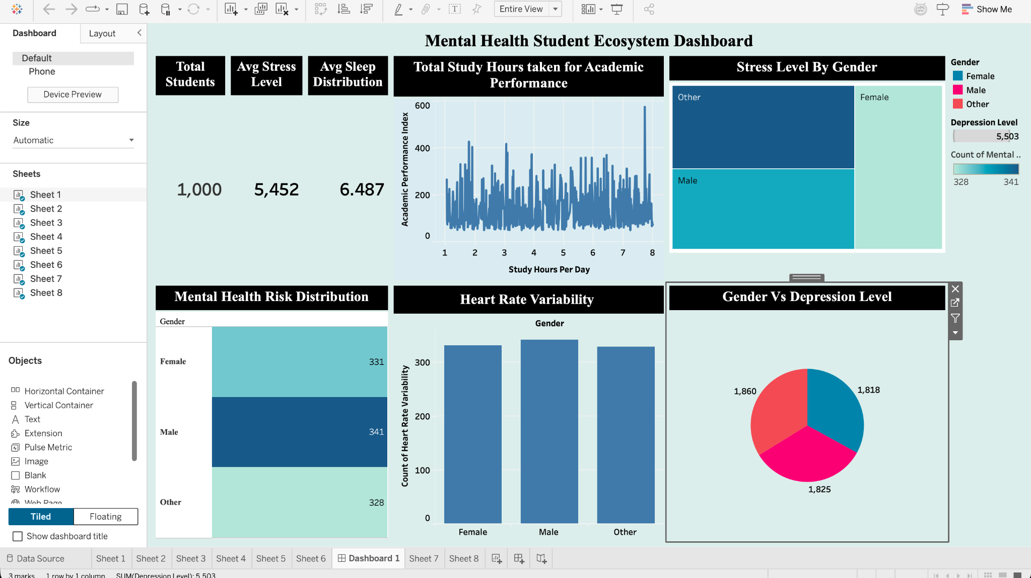
Figure 1: Tableau dashboard for the project.

8. Key Findings / Observations
- The dashboard contains 1,000 student records.
- The displayed average stress level is 5.452 and the displayed average sleep distribution is 6.487.
- The dashboard includes Female, Male and Other gender categories.
- The displayed mental-health risk counts are fairly close across the three gender categories.
- The study-hours and academic-performance chart shows a wide range of performance values.
- The dashboard brings academic, lifestyle and mental-health related information together in one place.

9. Limitations
- The dashboard is based on the available dataset and does not establish cause-and-effect relationships.
- The original data collection method and sampling method are not shown in the dashboard.
- Some charts show counts, so they should not automatically be interpreted as averages or percentages.
- No statistical significance test is included in the current dashboard.
- Mental-health information shown in the dashboard should not be considered a medical diagnosis.

10. Performance Testing
The dashboard was reviewed from a usability point of view by checking the arrangement of the charts, summary cards and available interactive elements. For final publication, filters and dashboard interactions should also be checked for proper response.

11. Web Integration
The dashboard can be published through Tableau Public or another approved Tableau environment. After publishing, the generated web link can be used for the internship submission and demonstration if required by the college.

12. Tableau Story
The current dashboard can be used as the base for a Tableau Story. A simple story can be organised into four points: overall student mental-health overview, academic and lifestyle factors, gender-wise comparisons, and final observations.

13. Conclusion
The project shows how Tableau can be used to convert student-related data into a visual dashboard. The dashboard combines summary figures with charts related to stress, sleep, study hours, academic performance, depression, gender and mental-health risk.

14. Future Scope
- More detailed analysis can be added if additional student data is available.
- Correlation or statistical analysis can be used for selected relationships.
- Attendance, social interaction, sleep and intervention-related fields can be explored further.
- Tooltips and filters can be improved to make the dashboard easier to use.
- A Tableau Story can be added for a more structured presentation.

15. Project Deliverables
- Tableau workbook (.twbx)
- Tableau dashboard
- Tableau Story, if required by the project checklist
- Tableau Public / web link, if required
- GitHub repository link
- Project report
- Project demonstration video

