Neville’s Interpolation Example

Find f(x) at x0=8.8 from following data:

x: 7.7, 8.0, 8.3, 8.6, 8.9, 9.2, 9.5, 9.8, 10.1

f(x): 12.82, 15.94, 17.56, 18.21, 18.52, 18.64, 18.76, 18.81, 18.84

Neville’s iterations table:

|  |  |  |  |  |  |  |  |  |  |
| --- | --- | --- | --- | --- | --- | --- | --- | --- | --- |
| $$x$$ | $$f(x)$$ | $$Linear$$ | $$Quadratic$$ | $$Cubic$$ | $$Quartic$$ | $$Quintic$$ | $$Sextic$$ | $$Septic$$ | $$Octic$$ |
| $$7.7$$ | $$12.82$$ |  |  |  |  |  |  |  |  |
| $$8.0$$ | $$15.94$$ | $$24.26$$ |  |  |  |  |  |  |  |
| $$8.3$$ | $$17.56$$ | $$20.26$$ | $$16.93$$ |  |  |  |  |  |  |
| $$8.6$$ | $$18.21$$ | $$18.64$$ | $$18.10$$ | $$18.37$$ |  |  |  |  |  |
| $$8.9$$ | $$18.52$$ | $$18.41$$ | $$18.45$$ | $$18.42$$ | $$18.41$$ |  |  |  |  |
| $$9.2$$ | $$18.64$$ | $$18.48$$ | $$18.44$$ | $$18.45$$ | $$18.44$$ | $$18.43$$ |  |  |  |
| $$9.5$$ | $$18.76$$ | $$18.48$$ | $$18.48$$ | $$18.45$$ | $$18.45$$ | $$18.44$$ | $$18.44$$ |  |  |
| $$9.8$$ | $$18.81$$ | $$18.64$$ | $$18.37$$ | $$18.49$$ | $$18.45$$ | $$18.45$$ | $$18.44$$ | $$18.44$$ |  |
| $$10.1$$ | $$18.84$$ | $$18.71$$ | $$18.56$$ | $$18.28$$ | $$18.51$$ | $$18.46$$ | $$18.45$$ | $$18.45$$ | $$18.44$$ |

Neville’s formula:

$$P\left(x\right)=\frac{\left(x-x_{j}\right)P_{0,1,…,j-1,j+1,…,k}\left(x\right)-\left(x-x_{i}\right)P_{0,1,…,i-1,i+1,…,k}\left(x\right)}{(x_{i}-x_{j})}$$

Where:

$P_{0,1,…,j-1,j+1,…,k}$ and $P_{0,1,…,i-1,i+1,…,k}$ are often denoted $\hat{Q}$ and $Q$

$$P\left(x\right)=\frac{\left(x-x_{j}\right)\hat{Q}\left(x\right)-\left(x-x_{i}\right) Q\left(x\right)}{(x_{i}-x_{j})}$$

Solution:

$$Q_{1,1}=\frac{\left(8.8-x_{0}\right)Q_{1,0}-\left(8.8-x_{1}\right)Q_{0,0}}{(x_{1}-x_{0})}=\frac{\left(8.8-7.7\right)15.94-\left(8.8-8.0\right)12.82}{(8.0-7.7)}=24.26$$

…

$$Q_{8,8}=\frac{\left(8.8-x_{7}\right)Q_{8,7}-\left(8.8-x_{8}\right)Q_{7,7}}{(x_{8}-x_{7})}=\frac{\left(8.8-9.8\right)18.45-\left(8.8-10.1\right)18.44}{(10.1-9.8)}=18.44$$

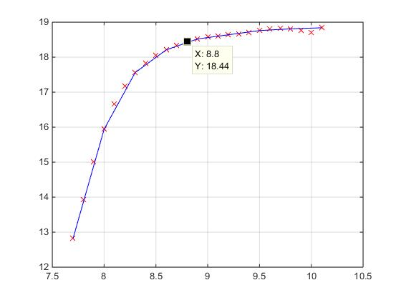

Notes:

* Neville's algorithm is based on the Newton form of the interpolating polynomial and the recursion relation for the divided differences.
* The interval gap does not have to be fixed.
* Can be applied for situation with increasingly higher order Lagrange interpolation polynomials.