**Implementing Associative Memory on a Quantum** **Computer Simulator**

William Bernoudy

**Abstract**

This paper presents an implementation of associative memory on a quantum computer down to the gate level, using an algorithm by Ventura and Matinez (2000). It gives an overview of the original algorithm as well as explains how the different components of the algorithm were accomplished using simple quantum gates. To illustrate this, the new algorithm is demonstrated by writing computer code for a quantum computer simulator.

**Introduction**

Associative memory deals with the problem of “learning” a set of patterns, and then being able to “recall” a certain pattern when presented with a part of the pattern. There are many simple classical algorithms that can achieve this task, such as storing the patterns in a database and then searching over the database (and each pattern) to find the one that matches. However, these can be slow and require lots of storage space. Another classical solution to this problem is using a Hopfield network, a type of neural network which can be trained with a set of patterns and then used to produce patterns when presented with a part of one. However, if the patterns are of length $n$, the neural network requires $n$ neurons, and is then limited in how many patterns it can store (usually less than half of $n$).

Quantum computing allows a significant improvement over neural network techniques. Dan Ventura and Tony Martinez, in a paper titled *Quantum Associative Memory*, present two algorithms that achieve associative memory that allow up to $m = 2^{n}$ patterns to be stored on $n$ qubits, with a training complexity of $O(mn)$ and a recall complexity of $O\left(\sqrt{n}\right)$.

In order to show how this algorithm might actually be implemented on a universal quantum computer, each stage of Ventura’s and Martinez’s (V&M) was achieved and simulated using only common quantum gates. Unless noted, all parts of the algorithms are taken directly from their paper.

**Explanation of Algorithms**

**Overview**

Given a set $P$ of patterns to be learned, each pattern is loaded one at a time onto the $n$ qubits until we have achieved an equal distribution of all the patterns. A slightly modified Grover’s algorithm can then be used to retrieve a pattern based on a known portion of it.

**Learning Stage**

For patterns of length $n$, $n$ qubits are needed to store the pattern (called the storage qubits). However, during the learning stage, three extra qubits are necessary: one as an intermediate qubit which is always returned to $|0⟩$ ($g$), and two as control bits ( $c_{1}$ and $c_{2}$). Note that this is a slight modification of V&M’s algorithm, which required $2n + 2$ qubits. This is because I used a Z-gate with controls on every one of the storage bits for the sake of much shorter simulation times.[1] For the algorithm, we require two special gates:

$$C0NOT=\left(\begin{matrix}0 & 1 & 0 & 0 \\ 1 & 0 & 0 & 0 \\ 0 & 0 & 1 & 0 \\ 0 & 0 & 0 & 1\end{matrix}\right)$$

$$CS_{p}=\left(\begin{matrix}1 & 0 & 0 & 0 \\ 0 & 1 & 0 & 0 \\ 0 & 0 & \sqrt{\frac{p-1}{p}} & \frac{-1}{\sqrt{p}} \\ 0 & 0 & \frac{1}{\sqrt{p}} & \sqrt{\frac{p-1}{p}}\end{matrix}\right)$$

$C0NOT$ is simply a controlled-not gate that flips the second bit if the first is zero, instead of one. It can be constructed by doing a NOT on the first qubit, a CNOT, and then another NOT on the first. $CS_{p}$ allows us to slice the state with the control bit as a one into two states, one being $\frac{1}{n}$ of the superposition, and the other being $\frac{p}{n}$ of the superposition.[2]

Here are the steps of the algorithm for each pattern in *P*:

**Learning a single pattern on** *n* **qubits:**

1. Apply $C0NOT$ gates with control on $c_{2}$ to storage qubit if the corresponding bit in the pattern is a 1.
2. Apply $C0NOT$ gate with control on $c_{2}$ to $c_{1}$.
3. Apply $CS_{p}$ with control on $c_{1}$ onto $c_{2}$, where $p$ is the number of patterns left including the pattern being learned.
4. Apply NOT gates to every qubit where the corresponding bit in the pattern is a 0.
5. Apply controlled NOT gate with controls on every storage qubit to $g$.
6. Apply CNOT gate with control on $g$ to $c_{1}$.
7. Repeat step 5.
8. Repeat step 4.

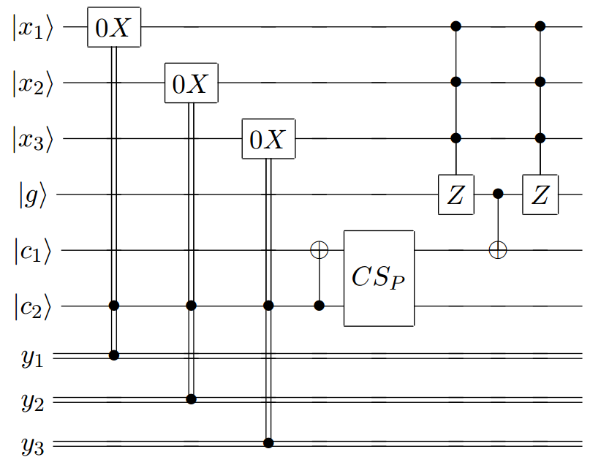We can repeat this algorithm for every pattern until $P$ has been “learned” by the quantum computer. By the end of the algorithm, all three extra qubits, $g$, $c_{1}$ and $c_{2}$, will be unentangled from the rest of the system so we can safely discard them. Note that is single pattern learning algorithm is $O(n)$, and as we must apply it for $m$ patterns, the entire learning algorithm is $O(mn)$.

**Figure 1** This example is for loading patterns with a length of 3. The pattern would come in loaded on the classical bits, $y_{1}$, $y_{2}$ and $y_{3}$. The $0X$ gate represents a controlled NOT except that the control looks for a zero on $c_{2}$.

**Recall algorithm**

As previously stated, the recall algorithm uses a modified Grover search to find the correct learned pattern. The first difference is that we do not prepare the system in any way by applying Hadamard gates at the beginning, as we already have the superposition we want. The second is that at the beginning, since the Grover diffusion operator will also flip the phases of all the states representing the patterns (instead of just the desired pattern), we need another operator that flips all the phases of the patterns back. We call this operator $I_{P}$. In terms of its matrix, it can be represented as an identity matrix where the $i$ th 1 is changed to a *−*1 if $i$ is the decimal representation of one of the patterns. We can construct it with gates by going through every pattern, applying a NOT gate on the qubits that correspond to zeros in the pattern, applying a controlled Z with controls on every qubit (except the one with the Z-gate, which can be any of them), and then re-applying the same NOT gates. This method can be seen in the function 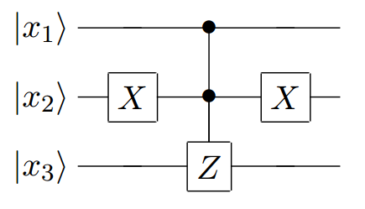*constr-patterns-phaser* in my code (Appendix A). We will notate the normal Grover diffusion operator with $G$.

**Figure 2** This example represents one pattern for $I_{P}$. The pattern would be (1 0 1), so we need to apply the NOT gate to the second qubit because it is a zero.

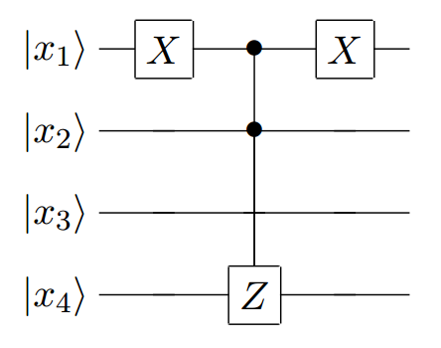We want the oracle for Grover’s algorithm to be a quantum circuit which flips the phase of the system if it is in the correct pattern. Thus, we can construct it simply by applying NOT gates to all qubits that correspond to zeros in the part of the pattern we know, applying a controlled Z gate with controls on all the qubits corresponding to bits we know onto one of the qubits corresponding to the qubits we don’t know, and then applying the same NOT gates again. This method can be seen in the function *constr-search-phaser* in my code (Appendix A). We will notate this oracle function with $I_{s}$.

**Figure 3** This example would correspond to the partial sequence (0 1 ? ?). We apply a NOT gate to the first qubit because we know it is a zero, then a Z with controls on the known qubits with a target on one of the unknowns, and then re-apply the NOT.

**Recalling pattern given partial sequence**

1. Apply $I_{s}GI_{PG}$ to the qubits.
2. Repeat $T$ times:
   1. Apply $I_{s}G$ to the qubits.
3. Measure register.

Where

$$T=\frac{\frac{π}{2}-arctan⁡(\frac{k}{l}\sqrt{\frac{r_{0}+r_{1}}{N-r_{0}-r_{1}}})}{\arccos{(1-2\frac{r_{0}+r_{1}}{N})}}$$

and

$$k=4a-ab+\frac{r_{1}}{r_{0}+r_{1}}$$

$$l=-ab+\frac{2a(N+p-r_{0}-2r_{1})}{N-r_{0}-r_{1}}-\frac{p-r_{1}}{N-r_{0}-r_{1}}$$

$$a=\frac{2(p-2r_{1})}{N}$$

$$b=\frac{4(p+r_{0})}{N}$$

and where $p$ is the number of patterns, $r_{0}$ is the number of marked states (states involving the unknown qubits that the controlled Z gates in $I_{P}$ did not act on, or, in the matrix representation, all the states corresponding to the *−*1s in the matrix) that do not correspond to learned patterns, and $r_{1}$ all the marked states that do correspond to learned states. In my code, I assumed that there was only one learned state that the recall should return, so I assumed $r_{1}$ is 1 and $r_{0}$ is equal to $2^{u}-1$ where $u$ is the number of unknowns in the partial sequence.[3]

Though I have no understanding of $T$, V&M assert that the second algorithm is still $O\left(\sqrt{n}\right)$ and the same as Grover’s algorithm. This makes sense in that though it was modified slightly, the algorithm remains essentially the same.

**Usage of Code**

The code that I wrote to implement these algorithms has been included in Appendix A. It is written in Scheme and uses quetzal.rkt, a quantum computer simulator also written Scheme (Bernoudy, 2015). The learning algorithm is called *learn*, and the recall algorithm is called *Grover-part*. You can use them like so:

> (**define** P ’((0 0 0 0) (0 0 1 1) (0 1 1 0) (1 0 0 1) (1 1 0 0) (1 1 1 1)))

> (**learn** P)

> (**Grover-part** ’(0 1 1 ?) P)

> (**measure-register**)

The most likely result is |0110> with a probability of 0.8437500000000002

**Discussion and Conclusion**

Though in general I was able to successfully implement most parts of the algorithms outlined by V&M, there was one notable issue that I had: The calculation of $T$ often gave me the wrong value. As a result, the code would often apply the oracle and Grover diffusion operator too many times and thus the final superposition was not likely to return the correct value. For example, when 6 patterns of length 4 are learned, and a partial sequence with two unknowns is used to recall, V&M’s definition of $T$ gives $T=3$. However, repeating the Grover step results in a final superposition with $≈26\%$ chance of returning the wrong pattern, and only a $≈9\%$ chance of retrieving the correct pattern. If we set $T=0$, however, the final system state has a $≈84\%$ chance of returning the correct pattern. While this may be due to a mistake in my code or in my implementation of it, I have always been able to achieve a high rate of getting back the correct pattern using different values of $T$, which suggests there is an issue with my (or V&M’s) calculation of $T$.

**Appendix A**

#lang racket

(**require** math)

(**require** racket/vector)

(**require** 2htdp/batch-io)

(**define-namespace-anchor** a)

(**define** ns (**namespace-anchor->namespace** a))

(**require** "quetzal.rkt") ; note that quetzal.rkt must be present in current directory

;-----------------Start qassoc.rkt--------------------;

(**define** (**S-con** p)

(**matrix** [

[1 0 0 0]

[0 1 0 0]

[0 0 (**sqrt** (**/** (**sub1** p) p)) (**/** 1 (**sqrt** p))]

[0 0 (**/** 1 (**sqrt** p)) (**sqrt** (**/** (**sub1** p) p))]

]))

(**define** (**learn** patterns)

(**letrec** (**[bits** (**length** (**car** patterns))]

[qubits (**+** (**length** (**car** patterns)) 3)] ; n qubits for storage, 1 intermediate qubit, 2 control qubits

[C0NOT (**matrix\*** (**G-nqubit-constructor** 4 '(**0**) Pauli-X-gate) ; C0NOT is the same as CNOT surrounded by nots on the control qubit

CNOT-gate

(**G-nqubit-constructor** 4 '(**0**) Pauli-X-gate))]

[big-control-X (**matrix-stack** (**list** (**submatrix** (**identity-matrix** (**expt** 2 (**+** 1 bits))) (**-** (**expt** 2 (**+** 1 bits)) 2) (**expt** 2 (**+** 1 bits)))

(**matrix-row** (**identity-matrix** (**expt** 2 (**+** 1 bits))) (**-** (**expt** 2 (**+** 1 bits)) 1))

(**matrix-row** (**identity-matrix** (**expt** 2 (**+** 1 bits))) (**-** (**expt** 2 (**+** 1 bits)) 2))))])

(**initialize-register** (**build-list** qubits (**lambda** (**x**) 0))) ; Initialize all qubits to |0>

(**for** (**[pattern** patterns] [p-index (**length** patterns)])

(**for** (**[bit** pattern] [b-index bits])

(**if** (**=** bit 1)

(**apply-gate** register (**list** (**sub1** qubits) b-index) C0NOT) ; flip the corresponding qubit if the bit in the pattern is a 1

(**void**)))

(**apply-gate** register (**list** (**-** qubits 1) (**-** qubits 2)) C0NOT) ; flip the c1 control qubit

(**apply-gate** register (**list** (**-** qubits 2) (**-** qubits 1)) (**S-con** (**-** (**length** patterns) p-index))) ; apply the "save" gate to control qubits

(**for** (**[bit** pattern] [b-index bits])

(**if** (**=** bit 0)

(**apply-gate** register (**list** b-index) Pauli-X-gate) ; apply not gates on all qubits whose corresponding bit is 0

(**void**)))

(**apply-gate** register (**build-list** (**-** qubits 2) values) big-control-X) ; apply not gate with controls on all storage qubits on intermediate bit

(**apply-gate** register (**list** (**-** qubits 3) (**-** qubits 2)) CNOT-gate) ; CNOT with control on intermediate qubit, target on c1

(**apply-gate** register (**build-list** (**-** qubits 2) values) big-control-X) ; reverse the controlled not

(**for** (**[bit** pattern] [b-index bits]) ; reverse all the not gates to the storage qubits

(**if** (**=** bit 0)

(**apply-gate** register (**list** b-index) Pauli-X-gate)

(**apply-gate** register (**list** (**sub1** qubits) b-index) C0NOT))))

(**apply-gate** register (**list** (**-** qubits 1)) Pauli-X-gate) ; the algorithm will leave all states with the c2 bit as |1>, so not all these

(**remove-unentangled-qubit** register) ; We can now ignore the last three qubits as they are not entangled

(**remove-unentangled-qubit** register)

(**remove-unentangled-qubit** register)))

(**define** (**remove-unentangled-qubit** reg) ; removes the last qubit from the system (assumes it is unentangled)

(**let** [(**new-reg** (**submatrix** reg 1 (**build-list** (**/** (**matrix-num-cols** reg) 2) (**lambda** (**x**) (**\*** x 2)))))]

(**set-register** new-reg)

new-reg))

(**define** (**constr-big-control-Z** N)

(**diagonal-matrix** (**build-list** N (**lambda** (**x**) (**if** (**=** x (**-** N 1)) -1 1)))))

(**define** (**get-not-qubits** qubits mtau) ; gets all the qubits which we know should be flipped

(**cond** [(**null?** mtau) '()]

[(**eq?** (**car** mtau) 0) (**cons** (**-** qubits (**length** mtau)) (**get-not-qubits** qubits (**cdr** mtau)))]

[else (**get-not-qubits** qubits (**cdr** mtau))]))

(**define** (**constr-search-phaser** tau)

(**letrec** (**[qubits** (**length** tau)]

[N (**expt** 2 qubits)]

[find-unknown (**lambda** (**mtau**) ; get an unknown to apply a controlled Z gate to

(**if** (**eq?** (**car** mtau) '?) (**-** qubits (**length** mtau))

(**find-unknown** (**cdr** mtau))))]

[known-bits (**filter** (**lambda** (**x**) (**not** (**eq?** (**list-ref** tau x) '?))) (**build-list** qubits values))]

[big-control-Z (**constr-big-control-Z** (**expt** 2 (**+** (**length** known-bits) 1)))]

[to-not-gate (**lambda** (**q**) ; applies an X gate

(**G-nqubit-constructor** N (**list** q) Pauli-X-gate))]

[to-Z-gate (**lambda** (**q**) ; applies the Z gate to the two possible states of the unknown qubit

(**matrix\*** (**G-nqubit-constructor** N (**append** known-bits (**list** q)) big-control-Z) ; first a Z on the unknown

(**to-not-gate** q) ; flip the unknown

(**G-nqubit-constructor** N (**append** known-bits (**list** q)) big-control-Z) ; another Z

(**to-not-gate** q) ; flip it back to preserve the state

))])

(**eval** (**cons** matrix* (**append**

(**map** to-not-gate (**get-not-qubits** qubits tau)) ; first apply X to all the qubits that should be flipped (so that if we have the right pattern, all qubits are 1)

(**list** (**to-Z-gate** (**find-unknown** tau))) ; controlled Z gate on on of the unknowns

(**map** to-not-gate (**reverse** (**get-not-qubits** qubits tau))))) ns) ; apply the same Xs in reverse order to preserve state

))

(**define** (**constr-patterns-phaser** patterns)

(**letrec** (**[qubits** (**length** (**car** patterns))]

[N (**expt** 2 qubits)]

[big-control-Z (**constr-big-control-Z** N)]

[to-not-gate (**lambda** (**q**) ; applies an X gate

(**G-nqubit-constructor** N (**list** q) Pauli-X-gate))]

[constr-helper (**lambda** (**pats**)

(**cond** [(**null?** pats) (**list** (**identity-matrix** N))]

[else (**append** (**map** to-not-gate (**get-not-qubits** qubits (**car** pats)))

(**list** big-control-Z)

(**map** to-not-gate (**get-not-qubits** qubits (**car** pats)))

(**constr-helper** (**cdr** pats)))]))])

(**eval** (**cons** matrix* (**constr-helper** patterns)) ns)

))

(**define** make-Hadamard (**lambda** (**N**)

(**let** (**[constant** (**exact->inexact** (**/** 1 (**expt** 2 (**/** (**/** (**log** N) (**log** 2)) 2))))])

(**build-matrix** N N (**lambda** (**i** j)

(**\*** constant (**expt** -1 (**matrix-dot** (**bits->row-matrix** (**bits** i N)) (**bits->row-matrix** (**bits** j N))))))))))

(**define** (**calc-T** p r0 r1 N) ; p: total patterns, r0: # of states that don't correspond to patterns, r1: # that do

(**letrec** (**[a** (**/** (**\*** 2 (**-** p (**\*** 2 r1))) N)]

[b (**/** (**\*** 4 (**+** p r0)) N)]

[k (**+** (**-** (**\*** 4 a) (**\*** a b)) (**/** r1 (**+** r0 r1)))]

[l (**-** (**/** (**\*** 2 a (**+** N (**-** p r0 (**\*** 2 r1)))) (**-** N r0 r1)) (**\*** a b) (**/** (**-** p r1) (**-** N r0 r1)))])

(**exact-round** (**/** (**-** (**/** pi 2) (**atan** (**/** (**\*** k (**sqrt** (**/** (**+** r0 r1) (**-** N r0 r1)))) l))) (**acos** (**-** 1 (**/** (**\*** 2 (**+** r1 r0)) N)))))))

(**define** (**Grover-part** tau patterns)

(**letrec** (**[qubits** (**length** tau)]

[N (**expt** 2 qubits)]

[all-qubits (**build-list** qubits values)]

[full-Hadamard (**make-Hadamard** N)]

[Hadamard (**lambda** (**reg**)

(**apply-gate** register all-qubits full-Hadamard))]

[search-phase-flip-gates (**constr-search-phaser** tau)]

[patterns-phase-flip-gates (**constr-patterns-phaser** patterns)]

[T (**calc-T** (**length** patterns) (**-** (**expt** 2 (**count** (**lambda** (**x**) (**eq?** x '?)) tau)) 1) 1 N)] ; Assume that there is only one match in the learned patterns

[big-control-Z (**constr-big-control-Z** N)])

(**apply-gate** register all-qubits search-phase-flip-gates) ; Apply the phase flip for the one we're searching for

(**Hadamard** (**apply-gate** (**Hadamard** register) (**reverse** all-qubits) big-control-Z)) ; One Grover diffusion

(**apply-gate** register all-qubits patterns-phase-flip-gates) ; Apply gate that flips the phase of all patterns

(**Hadamard** (**apply-gate** (**Hadamard** register) (**reverse** all-qubits) big-control-Z)) ; A second Grover diffusion

(**for** (**[i** T]) ; We apply the search phase flipper and the Gover diffusion T times

(**apply-gate** register all-qubits search-phase-flip-gates) ; Apply the phase flip for the one we're searching for

(**Hadamard** (**apply-gate** (**Hadamard** register) (**reverse** all-qubits) big-control-Z)) ; Apply a Grover diffusion

)))

**References**

Bernoudy, W. (2015, October 16). Quetzal. Retrieved January 31, 2016, from https://github.com/rhyzomatic/quetzal

Ventura, D., & Martinez, T. (2000). Quantum associative memory. *Information Sciences*, 124(1), 273-296.

1. Any single qubit gate U with an arbitrary number of controls can be achieved by using a series of CNOT gates and twice the qubits.
2. A better and more in depth explanation of how this gate works can be found in V&M’s paper.
3. If you play around with a few more examples, you might notice that the code will not always produce the correctly matched string. This is covered in the conclusion.