

GERTICO
NameService
Architekturbeschreibung des GERTICO Moduls NameService
„White Paper“

Bearbeitet von:

Reinhard Herzog
Version 0.3
13. August 2002
Inhalt
1 Dienstbeschreibung 4
1.1 Übersicht 4
1.2 Abbildung des HLA Federation Management auf den NameService 4
2 Struktur des GERTICO Namensraumes 6
3 Module und Schnittstellen 8
Abbildungen
Abbildung 1: Objektreferenzauflösung über den Namensdienst 4
Abbildung 2: Create Federation Execution 5
Abbildung 3: Join Federation Execution 6
Abbildung 4: Namensbaum Struktur 7

Dienstbeschreibung

Übersicht
Für die Beschreibung des Namesdienstes sei an dieser Stelle auf die CORBA Dienste Beschreibung verwiesen (http://www.omg.org). Dieser Dienst wird unverändert genutzt, um Objektreferenzen zwischen den verteilten Prozessen auszutauschen.
Abbildung 1: Objektreferenzauflösung über den Namensdienst | 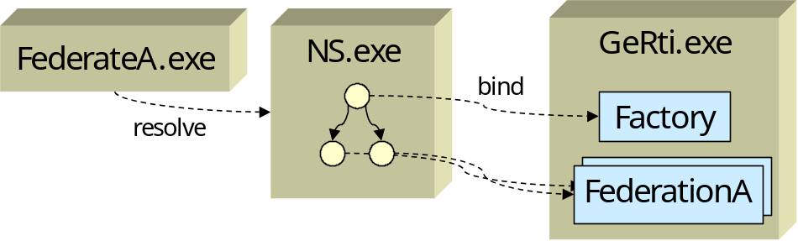
In Abbildung 1 ist ein Beispiel für einen Namensbaum dargestellt. Eine CORBA Anwendung ,die Objektreferenzen benötigt, (Im Bild als "FederateA.exe" dargestellt) erreicht über einen Standard CORBA Aufruf (resolev_Initial_references ("NameService")) die CORBA Objektreferenz des Namensdienstes. Dieser Dienst (im Bild NS.exe) muss zuvor gestartet sein. In TAO ist dieser Dienst als eigenständiges Programm verfügbar.
Im Namensdienst wird über den Wurzeleinstieg (root) der Namensraum (NamingContext) von GERTICO gefunden. In diesem Namensraum trägt sich der GERTICO Server mit seinem Factory Objekt ein. Ein Federate findet dieses Factory Objekt und kann darüber Federations starten, oder sich in bereits laufende einbringen. Eine gestartete Federation wird ebenfalls durch einen eigenen Namensraum dargestellt, in dem ein FederationManagement Objekt angemeldet ist (im Bild als FederationA gezeigt). Diese Dienste sind in der GeRtiFactory beschrieben.

Abbildung des HLA Federation Management auf den NameService
Wird in wesentlichen Teilen auf den Namensdienst abgebildet. Einträge erfolgen durch Dienste der GeRtiFactory.
Abbildung 2: Create Federation Execution | 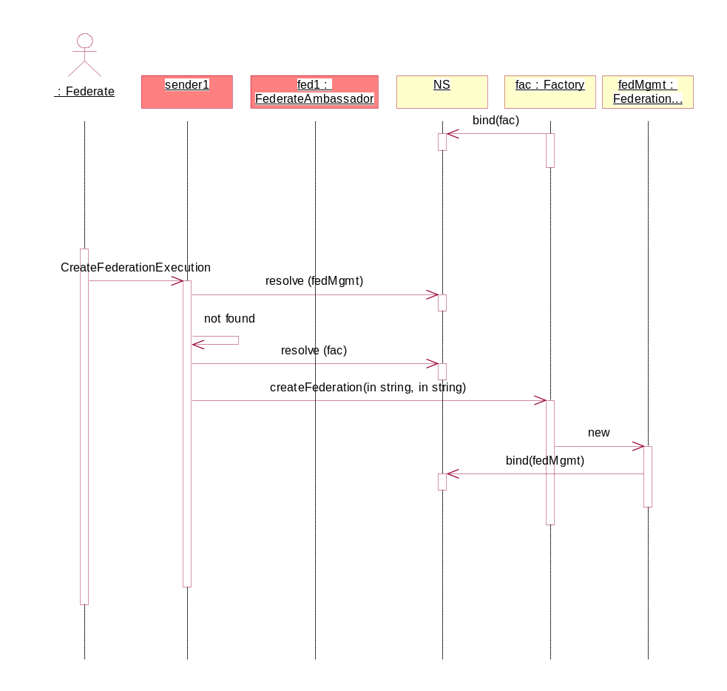

Eine Vorbedingung für die Methode JoinFederationExecution ist, dass sich die Federation besteht, und sich der FederationManagement Server im NameService eingetragen hat.
Abbildung 3: Join Federation Execution | 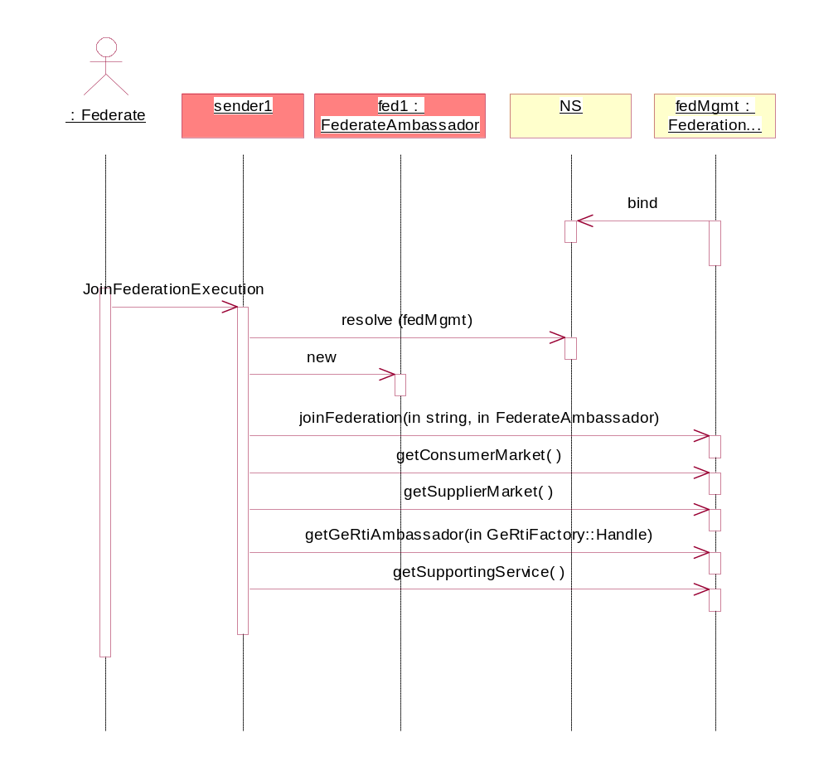

Struktur des GERTICO Namensraumes
Der Namensraum des NameService ist als Baum strukturiert. Der Einstieg in den GERTICO Namensraum soll unmittelbar unterhalb der Wurzel (als root bezeichnet) dieses Namensbaumes liegen. Derzeit wird die folgende Struktur verwendet:
- root
  - „GeRTI“
    - Object Reference „Factory“
→ Factory
    - <Federation 1>
      - FederationManagement
      - „TimeService“
        - Object Reference “tm1”
→ TimeMaster
        - …
        - Object Reference “tm”<m>
→ TimeMaster
    - ...
    - <Federation n>
  - ...
In einer späteren Version könnten die Administrations-Interfaces der EventChannel ebenfalls eingetragen sein.

Abbildung 4: Namensbaum Struktur | 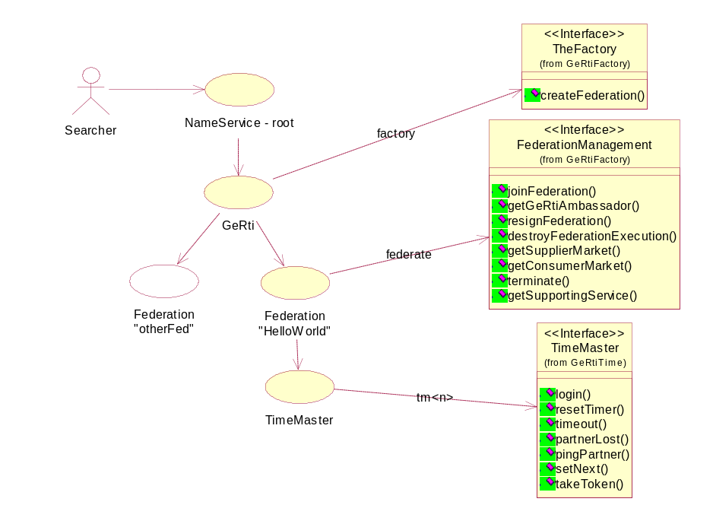

Module und Schnittstellen
Das Modul CosNaming wird unverändert verwendet [refOMG].
module CosNaming
{
// = TITLE
// This module provides interface for using COS Naming Service.

typedef string Istring;
// Define a typedef for String. Maybe at some point, <Istring> will
// be different to support Internationalization.

NameComponent | struct NameComponent  {  // = TITLE  // This is a 'simple' name.  //  // = DESCRIPTION  // Both id and kind fields are used in resolving names.  Istring id;  // This is the name that is used to identify object references.  Istring kind;  // Stores any addtional info about the object reference.  };  typedef sequence <NameComponent> Name;  // This is a compound name: <c1; c2; c3; cn> where c1 to cn-1 are  // the names of the nested contexts, and cn is the name of the  // object bound in cn-1.  enum BindingType  {  nobject,  // object binding.  ncontext  // Naming context binding.  };  struct Binding  {  Name binding_name;  // Simple name, under which an object is bound in a given context.  BindingType binding_type;  // Indicates whether the binding_name identifies a context, and, therefore, can  // participate in name resolution.  };  typedef sequence <Binding> BindingList;  interface BindingIterator;  // Forward declaration.
NamingContext | interface NamingContext  {  // = TITLE  // Interface for managing name bindings and naming contexts.  // = Exceptions.  enum NotFoundReason  {  missing_node,  not_context,  not_object  };  exception NotFound  {  // = TITLE  // Indicates that the name does not identify a binding.  NotFoundReason why;  Name rest_of_name;  };  exception CannotProceed  {  // = TITLE  // Implementation may throw this exception if some reason it cannot  // complete the operation. This is currently not used in TAO.  NamingContext cxt;  Name rest_of_name;  };  exception InvalidName  {  // = TITLE  // A name of length 0 is invalid. Implementations may place  // further restrictions.  Name reason;  };  exception AlreadyBound  {  // = TITLE  // Indicates that the specified name is already bound to  // some object. Only one object can be bound to a  // particular name in an context. To change the binding,  // <rebind> and <rebind_context> can be used.  Name reason;  };  exception NotEmpty  {  // = TITLE  // Indicates that the context is not empty.  Name reason;  };  // = Binding operations.  void bind (in Name n, in Object obj)  raises(NotFound, CannotProceed, InvalidName, AlreadyBound);  // Create a binding for name <n> and object <obj> in the naming  // context. Compound names are treated as follows: ctx->bind  // (<c1; c2; c3; cn>, obj) = (ctx->resolve (<c1; c2;  // cn-1>))->bind (<cn>, obj) if the there already exists a  // binding for the specified name, <AlreadyBound> exception is  // thrown. Naming contexts should be bound using <bind_context>  // and <rebind_context> in order to participate in name  // resolution later.  void rebind (in Name n, in Object obj)  raises(NotFound, CannotProceed, InvalidName);  // This is similar to <bind> operation above, except for when  // the binding for the specified name already exists in the  // specified context. In that case, the existing binding is  // replaced with the new one.  void bind_context (in Name n, in NamingContext nc)  raises(NotFound, CannotProceed, InvalidName, AlreadyBound);  // This is the version of <bind> specifically for binding naming  // contexts, so that they will participate in name resolution  // when compound names are passed to be resolved.  void rebind_context (in Name n, in NamingContext nc)  raises(NotFound, CannotProceed, InvalidName);  // This is a version of <rebind> specifically for naming  // contexts, so that they can participate in name resolution  // when compound names are passed.  // = Resolving names.  Object resolve (in Name n)  raises(NotFound, CannotProceed, InvalidName);  // Return object reference that is bound to the name. Compound  // name resolve is defined as follows: ctx->resolve (<c1; c2;  // cn>) = ctx->resolve (<c1; c2 cn-1>)->resolve (<cn>) The  // naming service does not return the type of the object.  // Clients are responsible for "narrowing" the object to the  // appropriate type.  // = Unbinding names.  void unbind (in Name n)  raises(NotFound, CannotProceed, InvalidName);  // Remove the name binding from the context. When compound  // names are used, unbind is defined as follows: ctx->unbind  // (<c1; c2; cn>) = (ctx->resolve (<c1; c2; cn-1>))->unbind  // (<cn>)  // = Creating Naming Contexts.  NamingContext new_context ();  // This operation returns a new naming context implemented by  // the same naming server in which the operation was invoked.  // The context is not bound.  NamingContext bind_new_context (in Name n)  raises(NotFound, AlreadyBound, CannotProceed, InvalidName);  // This operation creates a new context and binds it to the name  // supplied as an argument. The newly-created context is  // implemented by the same server as the context in which it was  // bound (the name argument excluding the last component).  // = Deleting contexts.  void destroy ()  raises (NotEmpty);  // Delete the naming context. NOTE: the user should <unbind>  // any bindings in which the given context is bound to some  // names before invoking <destroy> operation on it.  // = Listing the naming context.  void list (in unsigned long how_many,  out BindingList bl,  out BindingIterator bi);  // Returns at most the requested number of bindings <how_many>  // in <bl>. If the naming context contains additional bindings,  // they are returned with a BindingIterator. In the naming  // context does not contain any additional bindings <bi>  // returned as null.  };
BindingIterator | interface BindingIterator  {  // = TITLE  // Interface for iterating over Bindings returned with the  // <list> operation.  boolean next_one (out Binding b);  // This operation returns the next binding. If there are no  // more bindings false is returned.  boolean next_n (in unsigned long how_many,  out BindingList bl);  // This operation returns at most the requested number of  // bindings.  void destroy ();  // This operation destroys the iterator.  };  };

In anderen Produkten kann dies anders gelöst sein. Bei der RTI-NG ist der CORBA Dienst Bestanteil des rtiexec Prozesses.

