HOSPITAL MANAGEMENT
My First Screen shows Submission detailsare as follows:-
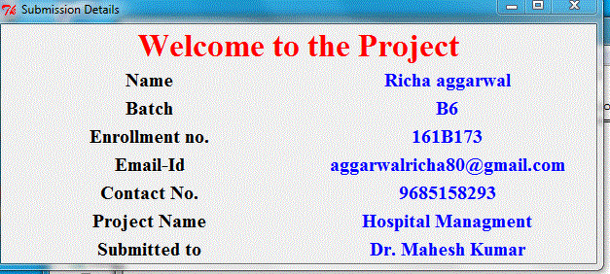
This Screen will appear only for 5 seconds and after that the second sereen will appear automatically:-
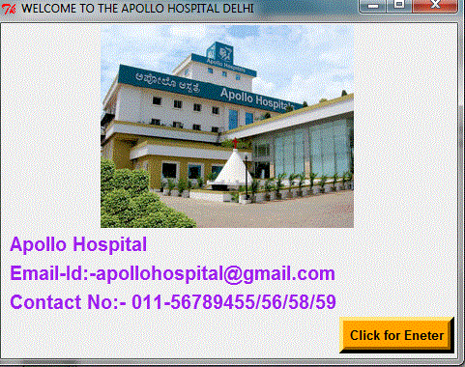

In this Screen image of hospital will appear and information of hospital will also show and by clicking of button “click to Enter” will forward to the next Screen and my next screen show the information of patient which are suffering from diseases.
CLICK FOR ENTER(Button)
And my third Scrren are:-
This is my Third Screen . In this patient Details will be filling. In first row we will write patient id (in integer) and in second row we will write Full name (varchar)of Patient. In third row row will write age (integer)of patient. In third row we will select gender of patient by option menu.
In fourth row we will write contact no (integer)of patient . And in fifth row we will select the type of profession whom patient want to meet by option menu.

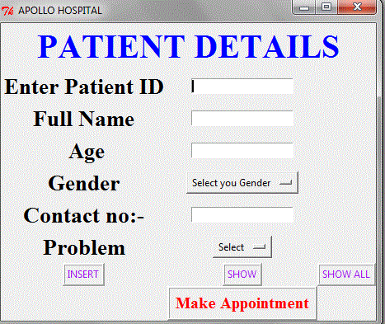
By entering all the information o0f patientL:-
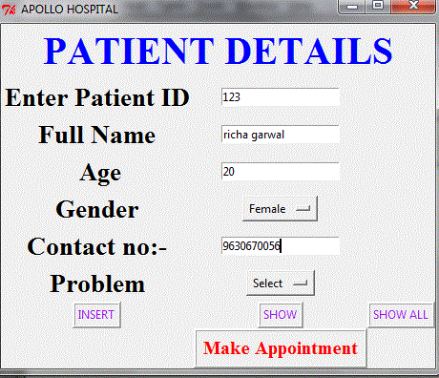
INSERT BUTTON:-
By clicking on insert Button the message box will appear and show that “Sucessfully inserted”. And one label record created will also appear.
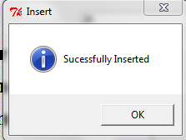

SHOW BUTTON:-
By clicking on show Button the message box will appear and show the information which we have been enter .
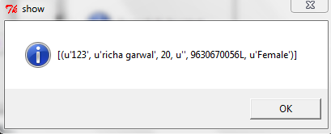
SHOW ALL BUTTON:-
By clicking on show all Button the message box will appear and show the all the information of patients which we have been enter .
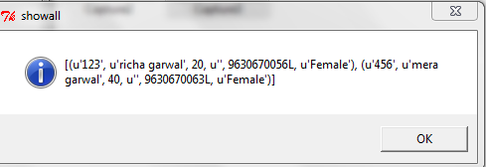
MAKE APPOINTMENT:-
By clicking this button the next window will open and in the next window show the information of doctor which we want to consult by select the problem by option menu.
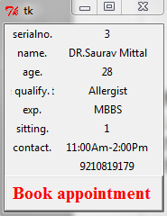
BOOK APPOINTMENT:-
by click this button uour appointment will be booked and the message box will apear.
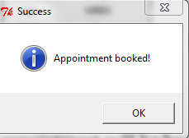
Now that is all for my project
GET WELL SOON.......
Thank you....

