Visualization Library Documentation

Library Overview

Matplotlib
Matplotlib is a foundational Python plotting library known for its flexibility and extensive customization options. It is widely used for creating static, publication-quality visualizations.
- Key Features: Supports a wide range of plots, from basic bar charts to complex 3D visualizations, with granular control over plot elements like axes, labels, and colors.
- Use Cases: Ideal for academic research, reports, and scenarios requiring precise control over plot aesthetics, such as when presenting tipping trends in a formal report.

Seaborn
Seaborn is a high-level library built on top of Matplotlib, designed for statistical data visualization. It simplifies the creation of aesthetically pleasing plots with less code.

- Key Features: Provides intuitive functions for complex statistical plots like boxplots and scatterplots, with built-in attractive styles and color palettes.
- Use Cases: Best for exploratory data analysis (EDA), such as understanding the distribution of tips across days or the relationship between bill amounts and tips.

CODE SNIPPET
The code in tips_visualization.py uses Matplotlib and Seaborn to analyze the tips dataset, which contains restaurant tipping data with columns like tip, total_bill, day, and sex. It starts by importing these libraries and loading the dataset, setting the stage for four visualizations. The first visualization, a Matplotlib bar chart, calculates the average tip for each day (Thursday to Sunday) and displays it, revealing that Sunday has the highest average tip (around 3.2) while Friday has the lowest (around 2.7). This helps identify trends in tipping behavior across days, possibly due to varying customer patterns.

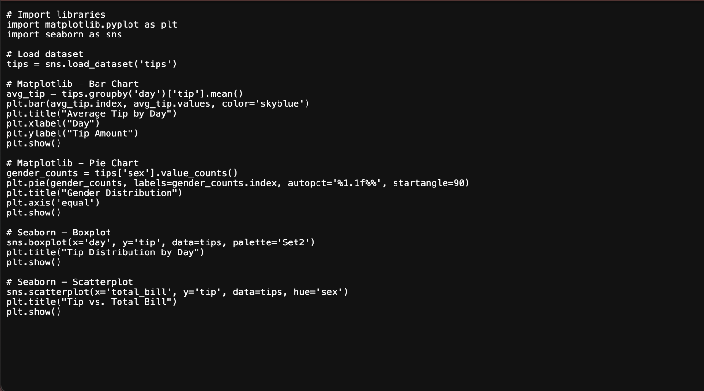
Next, a Matplotlib pie chart shows the gender distribution, indicating 64.3% male and 35.7% female customers, providing a demographic overview for further analysis. Seaborn is then used to create a boxplot, which displays the distribution
of tips by day, highlighting that Sunday has a higher median and outliers above 8, while Thursday and Friday show more consistent tipping with fewer outliers. Finally, a Seaborn scatterplot examines the relationship between total bill and tip, with points colored by gender, showing a trend where higher bills lead to higher tips (mostly between 2 and 6 for bills under 30), with males more frequent at higher bills (above 40). These visualizations collectively offer insights into tipping patterns, variability, and correlations, aiding in understanding customer behavior in a restaurant setting.

Graph Types
1. Bar Chart (Matplotlib)
- Description: A bar chart displays categorical data with rectangular bars, where the height represents the value.
- Use Case: Useful for comparing the average tip amount across different days of the week in the tips dataset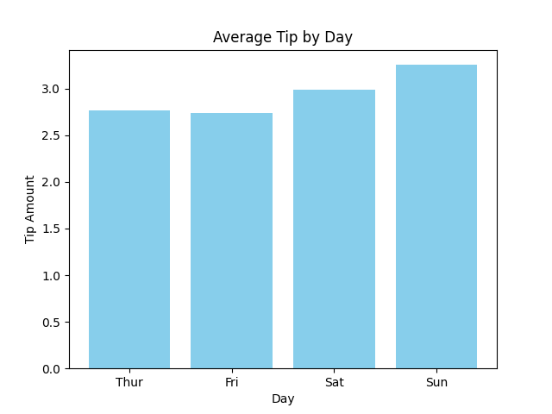
- Explanation: This bar chart shows the average tip amount for each day (Thursday to Sunday). Sunday has the highest average tip (around 3.2), while Friday has the lowest (around 2.7). This suggests tipping behavior varies by day, possibly due to differences in customer demographics or dining patterns on weekends versus weekdays

2. Pie Chart (Matplotlib)
- Description: A pie chart is a circular chart divided into slices to show the proportion of categories.
- Use Case: Useful for visualizing the gender distribution of customers in the tips dataset.
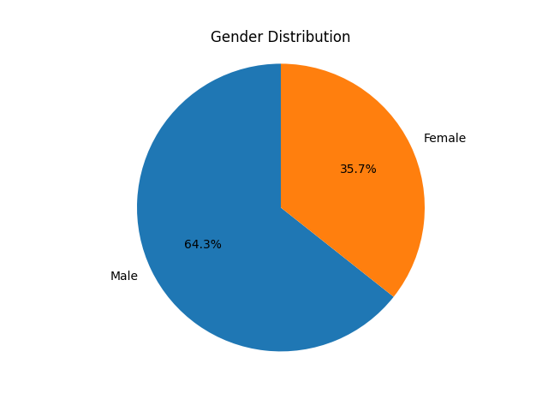
- Explanation: The pie chart reveals that 64.3% of customers are male, while 35.7% are female. This insight helps understand the demographic composition of the dataset, which can be useful for further analysis, such as checking if gender influences tipping behavior.

3. Boxplot (Seaborn)
- Description: A boxplot displays the distribution of data through quartiles, highlighting the median, spread, and outliers.
- Use Case: Useful for analyzing the spread and variability of tips across different days in the tips dataset.
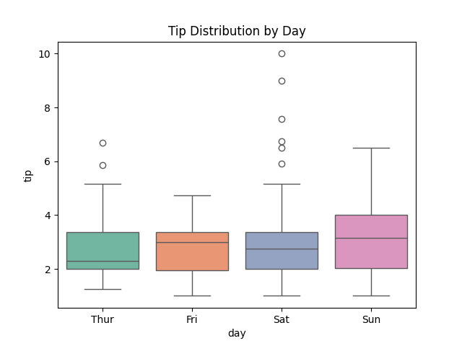
- Explanation: The boxplot shows the distribution of tips for each day. Sunday has the highest median tip and several outliers above 8, indicating some customers tipped exceptionally high. Thursday and Friday show lower medians and fewer outliers, suggesting more consistent tipping
behavior on those days. This helps identify days with higher variability in tipping.
4. Scatterplot (Seaborn)
- Description: A scatterplot plots individual data points to show the relationship between two continuous variables.
- Use Case: Useful for exploring the relationship between total bill amount and tip, with a breakdown by gender in the tips dataset.
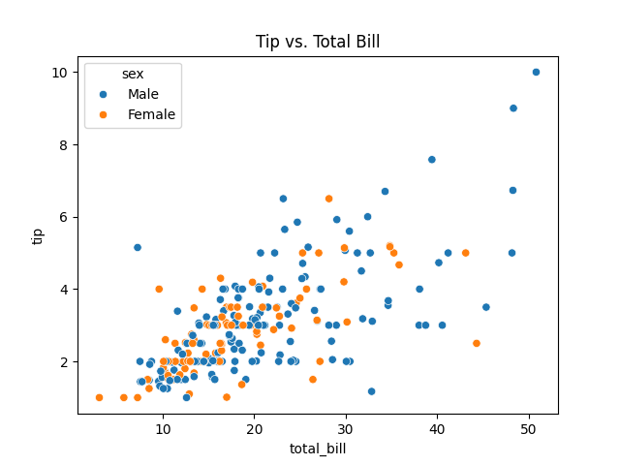
- Explanation: The scatterplot shows a general trend where higher total bills correspond to higher tips, with most tips falling between 2 and 6 for bills under 30. The breakdown by gender reveals that both male and female customers follow this trend similarly, though males appear more frequently at higher bill amounts (above 40). This suggests a potential correlation between bill amount and tip, with no significant gender-based difference in tipping patterns.

Comparison of Matplotlib and Seaborn
- Ease of Use: Seaborn is easier to use for statistical visualizations, requiring fewer lines of code for complex plots like boxplots and scatterplots. Matplotlib, while more verbose, offers greater control over plot details.
- Customization: Matplotlib excels in customization, allowing fine-tuned adjustments to every plot element. Seaborn provides less control but defaults to visually appealing styles.
- Interactivity: Neither library is inherently interactive (unlike Plotly or Bokeh). However, Matplotlib can be extended with interactive features using additional tools, while Seaborn focuses on static plots.
- Performance with Large Datasets: Matplotlib handles large datasets slightly better due to its lower-level nature, but both libraries may slow down with very large data. Seaborn’s reliance on Matplotlib means its performance is similar, though its statistical computations can add overhead.
- Recommendation: Use Matplotlib for precise, custom visualizations (e.g., publication-quality bar charts). Use Seaborn for quick, aesthetically pleasing statistical plots during EDA (e.g., boxplots for tip distributions).

Conclusion
This guide demonstrates how Matplotlib and Seaborn can be used to visualize the tips dataset, offering insights into tipping behavior. Matplotlib’s bar and pie charts helped compare averages and proportions, while Seaborn’s boxplot and scatterplot revealed distributions and relationships. By understanding the strengths of each library, users can choose the right tool for their data visualization needs, whether for detailed customization or rapid exploratory analysis.

