TITLE OF THE PROJECT

HOTEL MANAGEMENT SYSTEM

Submitted To:
Submitted By:Salman Beg

Table of Contents
Title of the project.

Introduction and objectives of the Project.

Project category.

Analysis (DFDs, ER Diagrams, Class Diagrams etc.)

A complete structure Which includes :
(i) Number of modules and their description to provide an estimation of the
student’s effort on the project.

(ii) Data Structures as per the project requirements for all the modules.

(iii) Process Logic of each module.

(iv) Report generation.

Tools / Platform, Hardware and Software Requirement specification

Security and Validation Checks.

Scope of future application.

Conclusions

Bibliography

Title of the Project

HOTEL
MANAGEMENT SYSTEM

INTRODUCTION

My project title is Hotel Management System.I have tried my best to make the complicated process of Hotel Management System as simple as possible using Structured & Modular technique & Menu oriented interface. I have tried to design the Project in such a way that user may not have any difficulty in using this package & further expansion is possible without much effort. Even though I cannot claim that this work to be entirely exhaustive, the main purpose of my exercise is perform each Employee’s activity in computerized way rather than manually which is time consuming.

I am confident that this software package can be readily used by non-programming personal avoiding human handled chance of error. This project is used by two types of users

i. Online Users.
ii. Administrator (management of the Hotel).

Online users can see the required articles or news
Administrator can maintain daily updates in the hotel records. Administrator is must be an authorized user. He can further change the password. There is the facility for password recovery, logout etc.

The main aim of the entire activity is to automate the process of day to day activities of Hotel like Room activities, Admission of a New Customer, Assign a room according to customer’s demand, checkout of a computer and releasing the room and finally compute the bill etc.

The limited time and resources have restricted us to incorporate, in this project, only a main activities that are performed in a HOTEL Management System, but utmost care has been taken to make the system efficient and user friendly.

“HOTEL Management System” has been designed to computerized the following functions that are performed by the system:

Room Detail Functions
Opening a New Room
Modification to room assigned
Check-in and check-out Detail Functions
Admission of New customer
Check-out of customer
Room assigning related to customer’s need.
Statement of Customer Details
Check-in customer
Check-out customer
Room Details
Total number of Customers in the Hotel
Individual customer Report

OBJECTIVE

During the past several decades personnel function has been transformed from a
relatively obscure record keeping staff to central and top level management function. There are many factors that have influenced this transformation like technological advances, professionalism, and general recognition of human beings as most important resources.

- A computer based management system is designed to handle all the primary information required to calculate monthly statements. Separate database is
- maintained to handle all the details required for the correct statement calculation and generation.

- This project intends to introduce more user friendliness in the various activities such as record updation, maintenance, and searching.

- The searching of record has been made quite simple as all the details of the customer can be obtained by simply keying in the identification of that customer.

- Similarly, record maintenance and updation can also be accomplished by using the identification of the customer with all the details being automatically generated. These details are also being promptly automatically updated in the master file thus keeping the record absolutely up-to-date.

- The entire information has maintained in the database or Files and whoever wants to retrieve can’t retrieve, only authorization user can retrieve the necessary information which can be easily be accessible from the file.

The main objective of the entire activity is to automate the process of day to day.

activities of Hotel like:

- Room activities,
- Admission of a New Customer,
- Assign a room according to customer’s demand,
- Checkout of a computer and releasing the room
- Finally compute the bill etc.
- Packages available.
- Advance online bookings.
- Online Cancellation.
- List of Regular customers.
- Email facility.
- Feedbacks

Frontend

VISUAL BASIC is a high level programming language which evolved from the earlier DOS version called BASIC. BASIC means Beginners' All-purpose Symbolic Instruction Code. It is a very easy programming language to learn. The code look a lot like English Language. Different software companies produced different versions of BASIC, such as Microsoft QBASIC, QUICKBASIC, GWBASIC ,IBM BASICA and so on. However, people prefer to use Microsoft Visual Basic today, as it is a well developed programming language and supporting resources are available everywhere. Now, there are many versions of VB exist in the market, the most popular one and still widely used by many VB programmers is none other than Visual Basic 6. We also have VB.net, VB2005, VB2008 and the latest VB2010. Both Vb2008 and VB2010 are fully object oriented programming (OOP) language.
VISUAL BASIC is a VISUAL and events driven Programming Language. These are the main divergence from the old BASIC. In BASIC, programming is done in a text-only environment and the program is executed sequentially. In VB, programming is done in a graphical environment. In the old BASIC, you have to write program code for each graphical object you wish to display it on screen, including its position and its color. However, In VB , you just need to drag and drop any graphical object anywhere on the form, and you can change its color any time using the properties windows.
On the other hand, because the user may click on a certain object randomly, so each object has to be programmed independently to be able to response to those actions (events). Therefore, a VB Program is made up of many subprograms, each has its own program code, and each can be executed independently and at the same time each can be linked together in one way or another.

The Development Environment
. 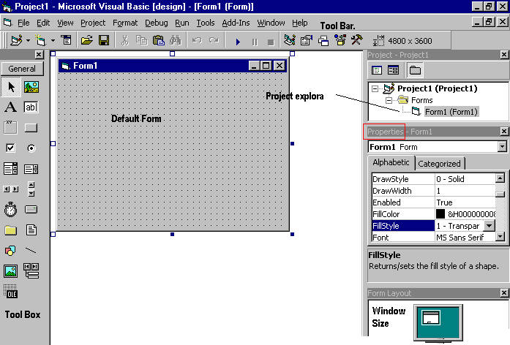

Properties Window
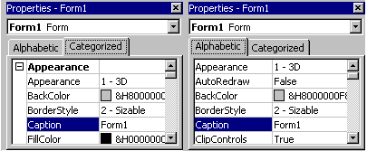

Understanding the tool box

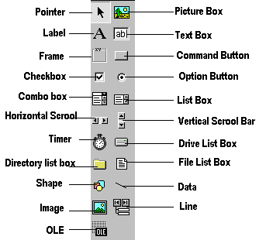

You may have noticed that when you click on different controls the Properties Window changes slightly this is due to different controls having different functions. Therefore more options are needed for example if you had a picture then you want to show an image. But if you wanted to open a internet connection you would have to fill in the remote host and other such settings. When you use the command () you will find that a new set of properties come up the following will provide a description and a property.

Backend

A Basic introduction to Microsoft Access

Ms Access is a database management tool that enables one to have good command of data collected. The programme enables one to retrieve, sort, summarize and report results speedily and effectively. It can combine data from various files through creating relationships, and can make data entry more efficient and accurate.

Microsoft Access (MS Access) enables one to manage all important information from a single database file. Within the file, one can use:

• Tables to store your data.
• Queries to find and retrieve specific data of interest.
• Forms to view, add, and update data in tables.
• Reports to analyze or print data in a specific layout.
• Data access pages to view or update, the data.

In MS Access, data is stored once in one table, but can be viewed from multiple locations.When the data is updated in a Table, Query or Form, it is automatically updated everywhere it
Appears.

Establishment of Ms Access database

All Ms Access databases files are saved with extension .mdb
A database should have a separate table for every major subject, such as pedigree records, Production data or Treatment information.
Data should not be duplicated in multiple tables.

Microsoft Access provides three methods to create a database
- Database Wizard (though easy, the wizard offers limited options to customize the database)

- Using a template (This method works best if one can find and use a template that closely matches the specific requirements)

- Creating a database directly (This is the most flexible method, but it requires one to define each database element separately).

Relational Databases
A relational database is one whose components (tables, forms, queries etc) are related (linked). The linkages between database components are created by making relationship links between them. The relationship can be between:

- One component and another (one-to-one relationship),

- One component related to several other components (one-to-many)

- Several database components (many-to-many).

Creation of relationships between database components reduces data redundancy and
enhances ease of access of the information.

ADVANTAGE
I have designed the given proposed system in the VB to automate the process of Hotels.This project is useful for the authorities which keep track of all the users registered in a particular state .The authority can add hotel packages, room details, availability of rooms, booking etc.

The following steps that give the detailed information of the need of proposed system are:

Performance: During past several decades, the records are supposed to be manually handled for all activities. The manual handling of the record is time consuming and highly prone to error.

To improve the performance of the Hotel Management System, the computerized system is to be undertaken. This project is fully computerized and user friendly even that any of the members can see the report and status of the company.

Efficiency: The basic need of this website is efficiency. The website should be efficient so that whenever a new user submits his/her details the website is updated automatically. This record will be useful for other users instantly.

Control: The complete control of the project is under the hands of authorized person who has the password to access this project and illegal access is not supposed to deal with. All the control is under the administrator and the other members have the rights to just see the records not to change any transaction or entry.

Security: Security is the main criteria for the proposed system. Since illegal access may corrupt the database. So security has to be given in this project.

PROJECT CATEGORY
This Project is coupled with material on how to use the various tool, sub sets available in
VB AND MS-Access.

System Study & Analysis
PRINCIPLES OF SYSTEM ANALYSIS
1. Understand the problem before you begin to create the analysis model.
2. Develop prototypes that enable a user to understand how human machine interaction will occur.
3. Record the origin of and the reason for every requirement.
4. Use multiple views of requirements like building data, function and behavioral
models.
5. Work to eliminate ambiguity.
ENTITY RELATIONSHIP DIAGRAM (ERD)

Entity – Relationship Diagram: This depicts relationship between data objects. The attribute of each data objects noted in the entity- relationship diagram can be described using a data object description. Data flow diagram serves two purposes:

1. To provide an indication of how data are transformed as they move through
the system.

2. To depict the functions that transformation the data flow.

Data Objects: A data object is a representation of almost any composite information that must be understood by the software. By composite information, we mean something that has a number of different properties or attributes. A data object encapsulates data only there is no reference within a data object to
operations that act on the data.

Attributes: Attributes define the properties of a data object and take on one of three different characteristics.

They can be used to:

Name an instance of data object.
Describe the instance.
Make reference to another instance in other table.

Relationships: Data objects are connected to one another in a variety of different ways. We can define a set of object relationship pairs that define the relevant relationships.

CARDINALITY AND MODALITY:
Cardinality:
The data model must be capable of representing the number of
occurrences of objects in a given relationship. The cardinality of an object relationship pair is

♦ One-T0-One (1:1): An occurrence of object ‘A’ can relate to
one and only one occurrence of object ‘B’ and vice versa.

♦ One-To-Many (1:N): One occurrence of object ‘A’ can relate
to one or may occurrences of object ‘B’ but an occurrence
of object ‘B’ can relate to only one occurrence of object ‘A’.

♦ Many-To-Many (M: N): An occurrences of ‘B’ and an
occurrence of ‘B’ can relate to one or many occurrence of
‘A’.

Modality:
The modality of a relationship is zero if there is no explicit need for
the relationship to occur or the relationship is optional. The Modality
is one if the occurrence of the relationship is mandatory.
The object relationship pair can be represented graphically using the
Entity Relationship Diagrams.
A set of primary components are identified for the Entity Relationship Diagram,
1. Attributes,
2. Relationships and
3. Various Type Indicators.
The primary purpose of the Entity Relationship Diagram is to represent data objects and their relationships.
E-R DIAGRAM

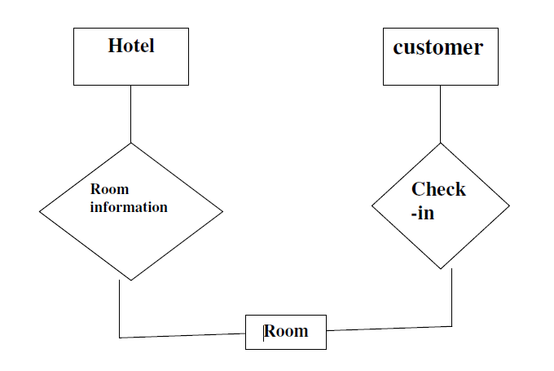

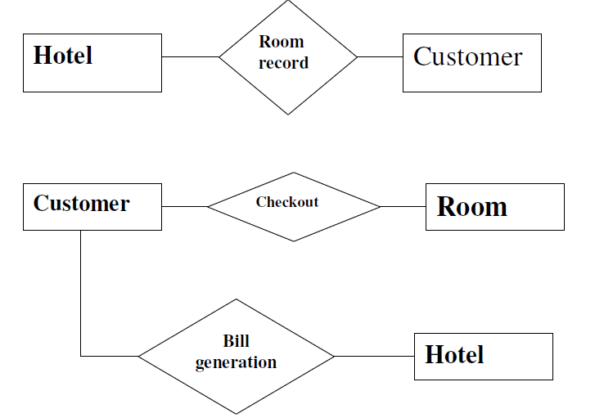

CONTEXT LEVEL DFD
HOTEL MANAGEMENT SYSTEM

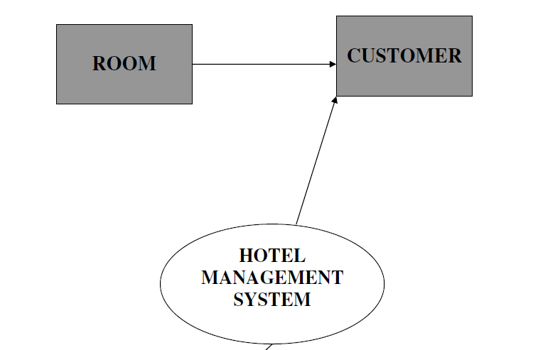

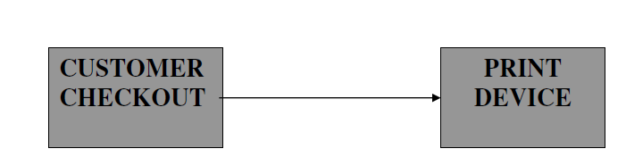

DATA FLOW DIAGRAM
OPENING A NEW ROOM

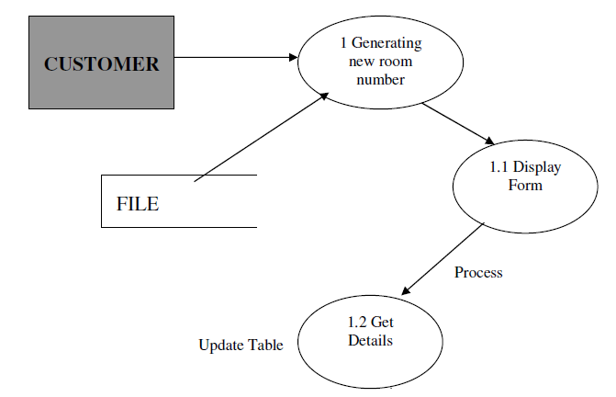

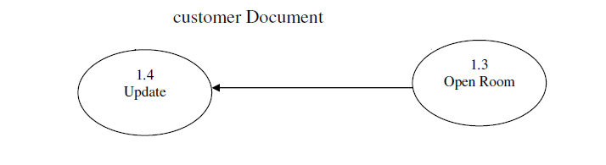

DATA FLOW DIAGRAM
CHECK-IN OF A NEW CUSTOMER

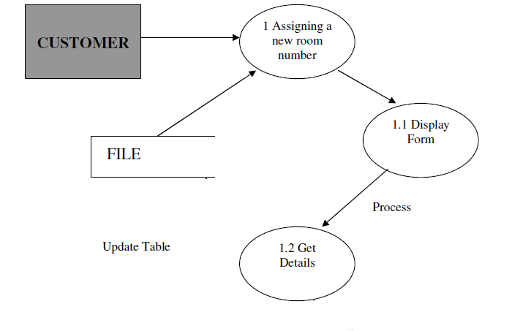

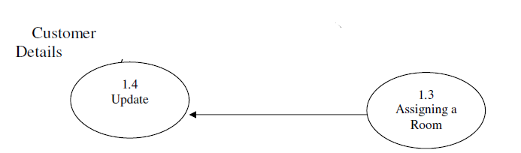

DATA FLOW DIAGRAM
RECORD MODIFICATION

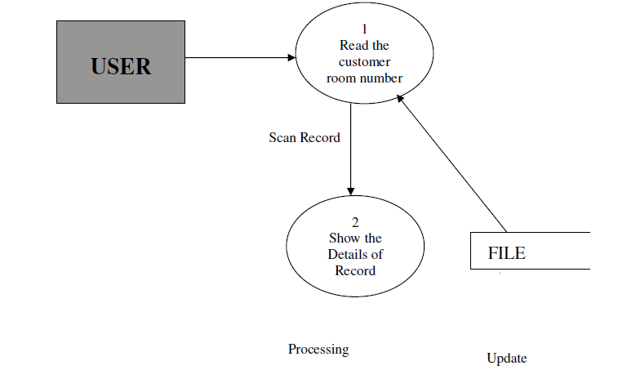

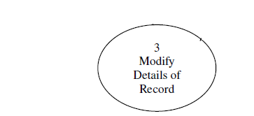

DATA FLOW DIAGRAM
CHECK-OUT OF CUSTOMER

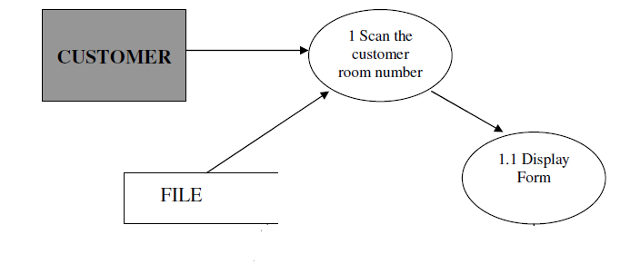
Update Table
process

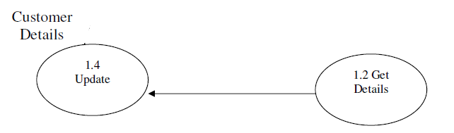
DATA FLOW DIAGRAM
LISTING OF CUSTOMERS

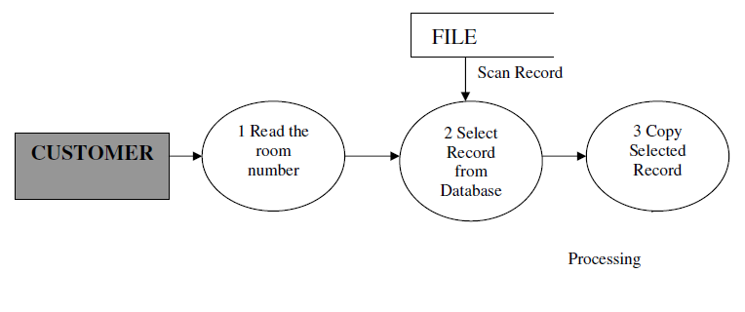

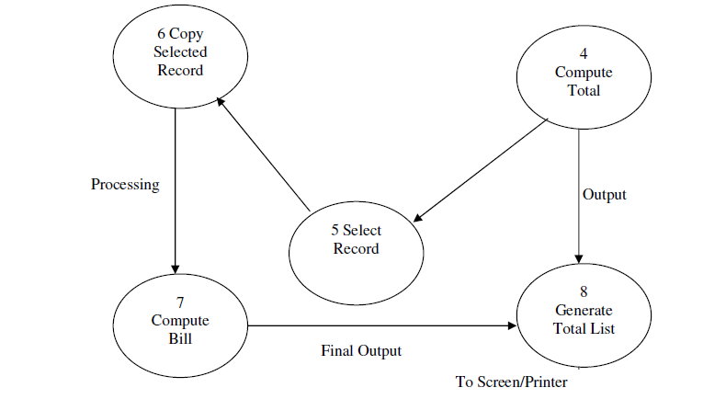

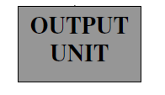
DATA FLOW DIAGRAM
GENERATING BILL OF CUSTOMER

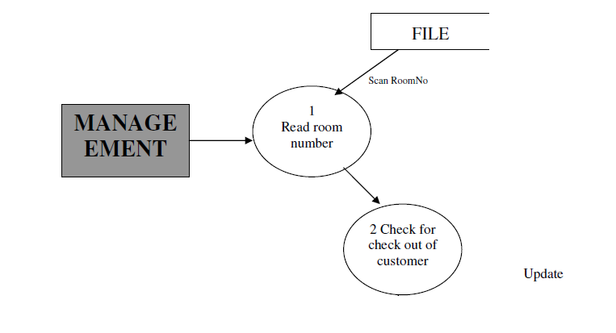 Processing
4
Close Database

3
Computer Bills

CUSTOMER

Cash

DATA FLOW DIAGRAM
LIST OF ALL RECORDS

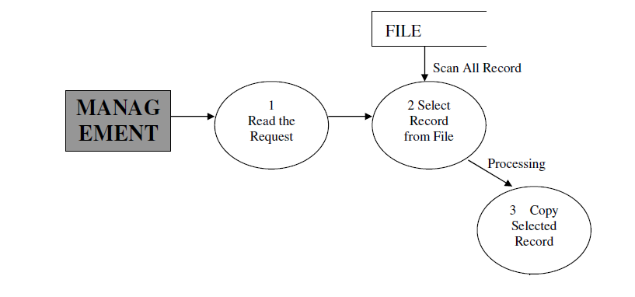

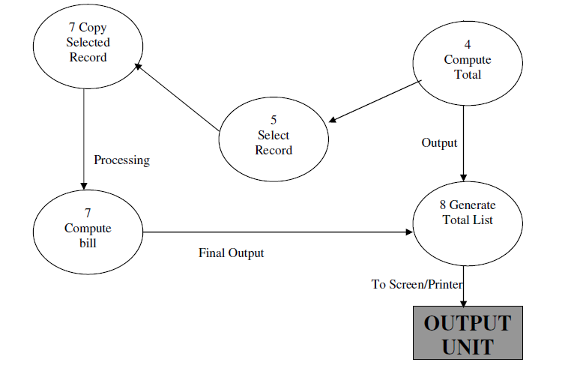
CONCLUSION

This project is designed to meet the requirements of Online Hotel Management. It has been developed in VB & Mas-Access keeping in mind the specifications of the system.

For designing the system we have used simple data flow diagrams.

Overall the project teaches us the essential skills like:

- Using system analysis and design techniques like data flow diagram in designing the system.

- Understanding the database handling and query processing.

