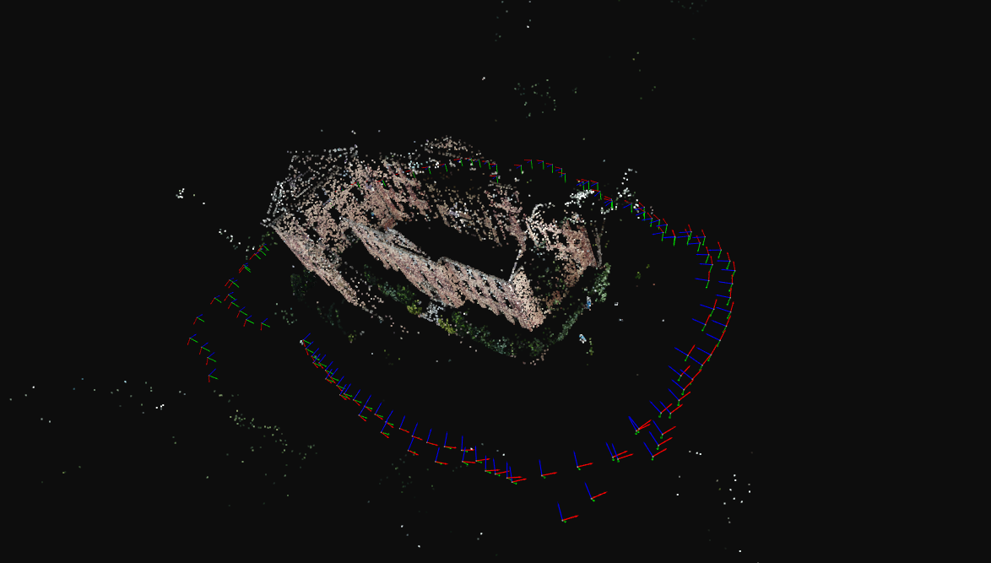
MST = 30%
==============================================================================
Model Images Points Mean track
------------------------------------------------------------------------------
...n\outputs\South_building\MST\30_MST\0 121 30906 4.70
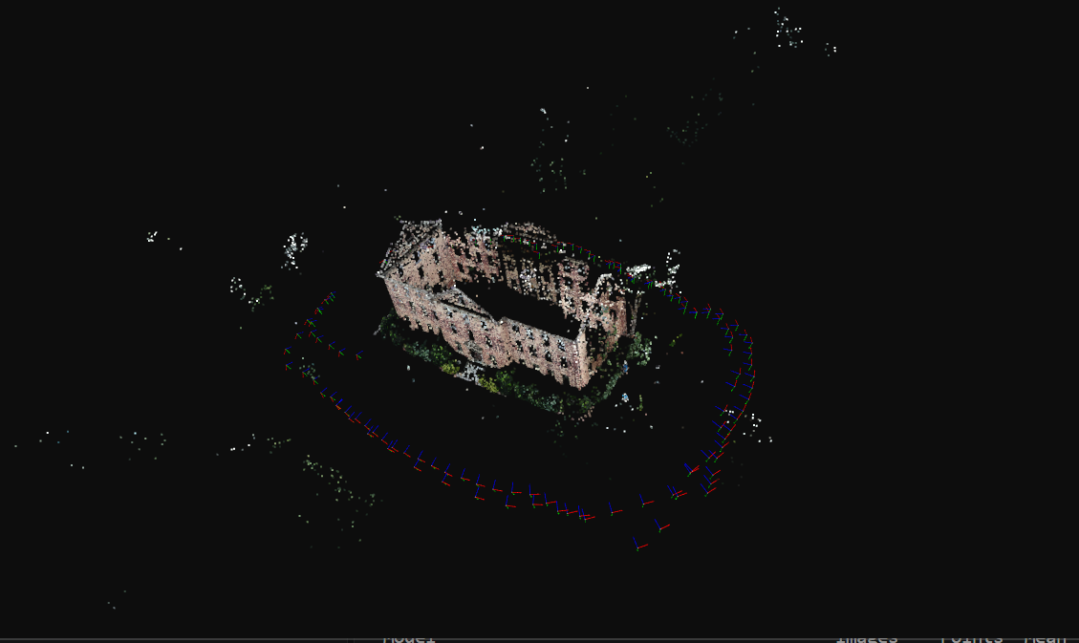
MST -50%
==============================================================================
Model Images Points Mean track
------------------------------------------------------------------------------
...n\outputs\South_building\MST\50_MST\0 123 32396 5.15
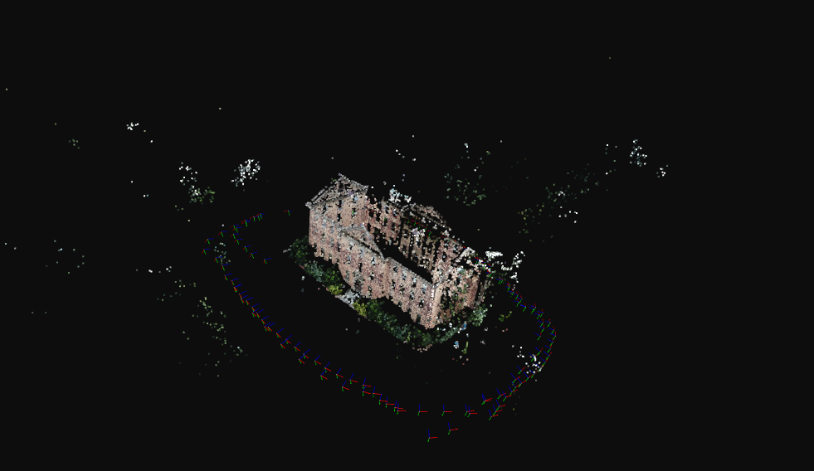
MST =100%

Odom 30% -good results
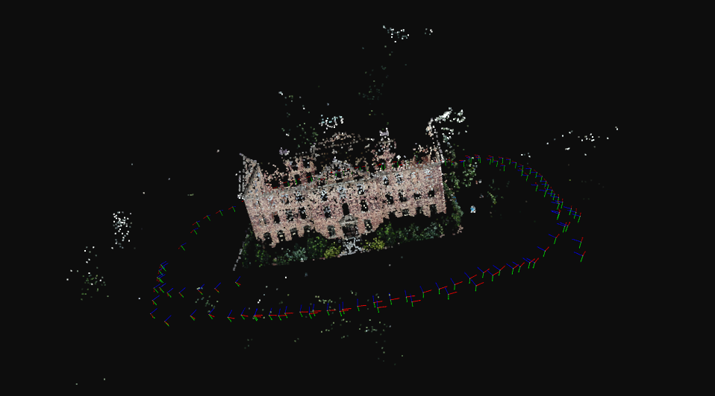
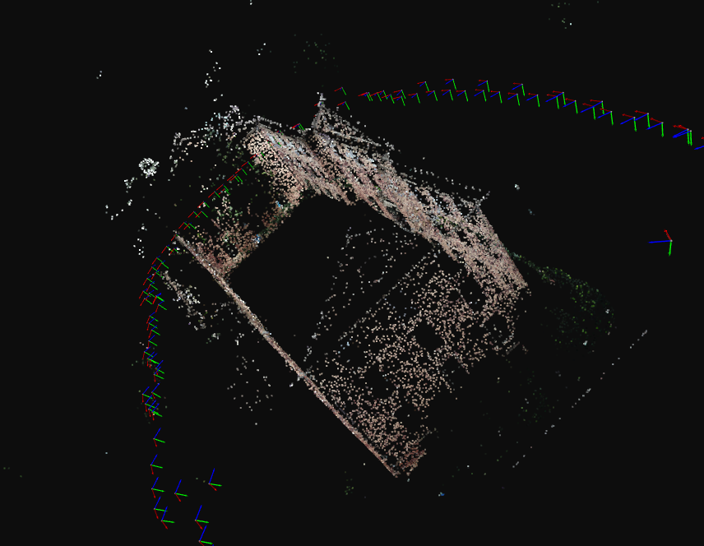
The wall is missing though
Odometric backbone at 50% budget
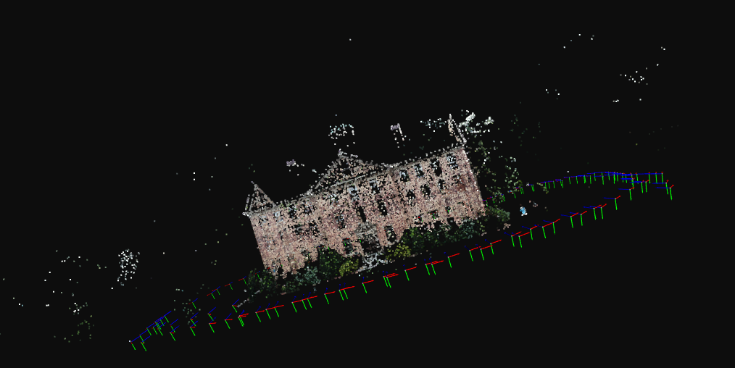
Odometric backbone at 100% budget. The wall not generated at 30% budget seems to be missing overall
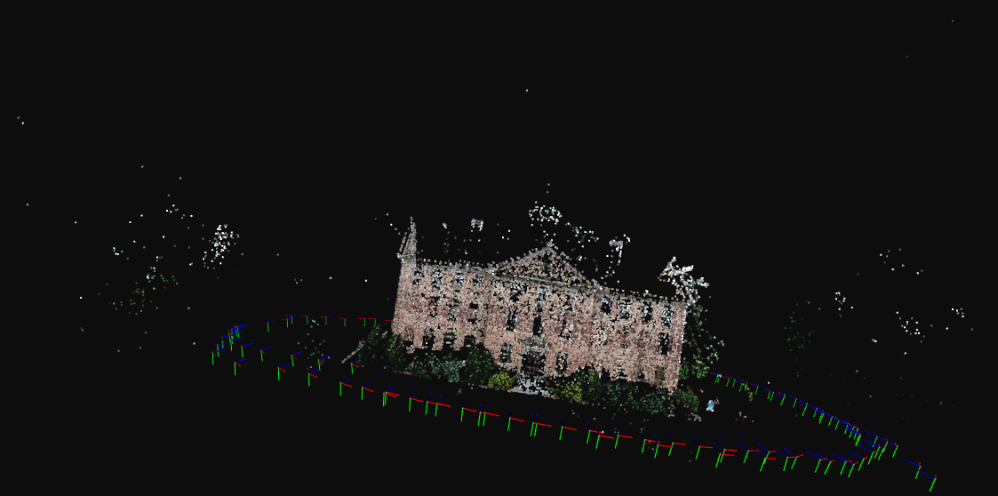

MST 30%
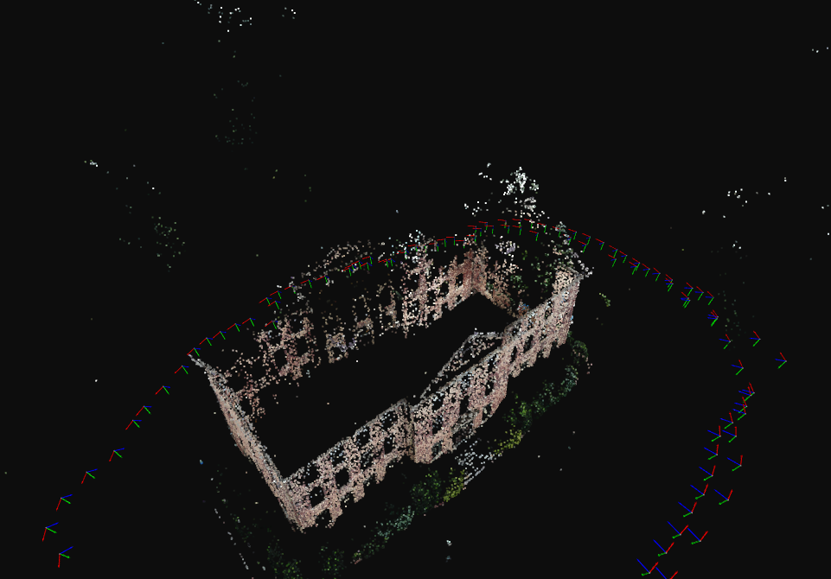
50% MSt
