**1) A speed control and reporting system has the following characteristics: If you drive 50 km/h or less, nothing will happen. If you drive faster than 50 km/h, but no more than 55 km/h, you will be warned. If you drive faster than 55 km/h but not more than 60 km/h, you will be fined. If you drive faster than 60 km/h, your driving license will be suspended. The speed in km/h is available to the system as an integer value. Which would be the most likely set of values (km/h) identified by applying the boundary value analysis, where only the boundary values on the boundaries of the equivalence classes are relevant?**

a) 0, 49, 50, 54, 59, 60.

b) 50, 55, 60.

c) 49, 50, 54, 55, 60, 62.

d) 50, 51, 55, 56, 60, 61.

**2) You are testing an e-commerce system that sells cooking supplies such as spices, flour, and other items in bulk. The units in which the items are sold are either grams (for spices and other expensive items) or kilograms (for flour and other inexpensive items). Regardless of the units, the smallest valid order amount is 0.5 units (e.g., half a gram of cardamom pods) and the largest valid order amount is 25.0 units (e.g., 25 kilograms of sugar). The precision of the units field is 0.1 units. Which of the following is a set of input values that cover the boundary values with two-point boundary values for this field?**

a) 0.3, 10.0, 28.0

b) 0.4, 0.5, 0.6, 24,9,25,0, 25.1

c) 0.4, 0.5, 25.0 25.1

d) 0.5, 0.6, 24.9, 25.0

**3) You are testing an e-commerce system that sells cooking supplies such as spices, flour, and other items in bulk. The units in which the items are sold are either grams (for spices and other expensive items) or kilograms (for flour and other inexpensive items). Regardless of the units, the smallest valid order amount is 0.5 units (e.g., half a gram of cardamom pods) and the largest valid order amount is 25.0 units (e.g., 25 kilograms of sugar). The precision of the units field is 0.1 units. Which of the following is a MINIMAL set of input values that cover the equivalence partitions for this field?**

a) 10.0, 28.0

b) 0.4, 0.5, 25.0, 25.1

c) 0.2, 0.9, 29.5

d) 12.3

**4) In a system designed to work out the tax to be paid:**

**An employee has 4000 of salary tax free. The next 1500 is taxed at 10% The next 28000 is taxed at 22%**

**Any further amount is taxed at 40%**

**To the nearest whole pound, which of these is a valid Boundary Value Analysis test case?**

A. 1500  
B. 32001  
C. 33501  
D. 28000

**5) Given the following specification, which of the following values for age are in the SAME equivalence partition?**

**If you are less than 18, you are too young to be insured. Between 18 and 30 inclusive, you will receive a 20% discount. Anyone over 30 is not eligible for a discount.**>18 нет страховки

18-30 - 20%

30+ - нет скидки

A. 17, 18, 19.  
B. 29, 30, 31.  
C. 18, 29, 30.  
D. 17, 29, 31.

**6) If the temperature falls below 18 degrees, the heating is switched on. When the temperature reaches 21 degrees, the heating is switched** **off. What is the minimum set of test input values to cover all valid equivalence partitions?**<18 - обогрев

21 - отключается

A. 15, 19 and 25 degrees  
B. 17, 18, 20 and 21 degrees  
C. 18, 20 and 22 degrees  
D. 16 and 26 degrees

**7) Assume postal rates for ‘light letters’ are:**

**$0.25 up to 10 grams;**  
**$0.35 up to 50 grams;**  
**$0.45 up to 75 grams;**  
**$0.55 up to 100 grams.**

**Which test inputs (in grams) would be selected using boundary value analysis?**

A. 0, 9,19, 49, 50, 74, 75, 99,100  
B. 10, 50, 75,100, 250, 1000  
C. 0, 1,10,11, 50, 51, 75, 76,100,101  
D. 25, 26, 35, 36, 45, 46, 55, 56

**8)Given the following decision table:**

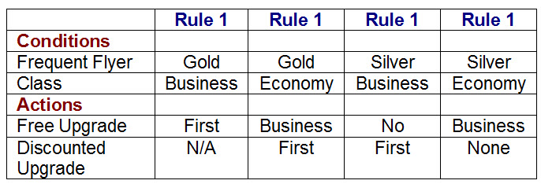

**What is the expected result for each of the following test cases?**

**P. Gold frequent flyer, travelling in Economy class.**

**Q. Silver frequent flyer, travelling in Business class.**

A. P. Offer free upgrade to Business and discounted upgrade to First. Q. Offer discounted upgrade to First

B. P. Offer free upgrade to Business but cannot upgrade to First. Q. Offer discounted upgrade to First

C. P. Offer free upgrade to First. Q. Cannot upgrade to First

D. P. Offer discounted upgrade to First. Q. Offer free upgrade to First

**9) A company is going to provide their employees with the company for less than two years, 10% of their salary for more than two but less than five years, and 25% for five to ten years, 35% for ten years or more. The interface will not allow a negative value to be input, but it will allow a zero to be input.**

**How many equivalence partitions are needed to test the calculation of the bonus?**

A. Two equivalence partitions.

B. Three equivalence partitions.

C. Four equivalence partitions.

D. Five equivalence partitions.

**10) An automated air-conditioner is programmed to turn its heating unit on when the temperature falls below 17 Deg. C and to turn its refrigeration unit on when the temperature exceeds 26 Deg. C. The air-conditioner is designed to operate at temperatures between -10 Deg. C and +40 Deg. C. Given the above specification, which of the following sets of values shows that the equivalence partition test design technique has been used correctly?**

A. -11 Deg. C, -1 Deg. C, 18 Deg. C, 27 Deg. C, 51 Deg. C

B. -11 Deg. C, -1 Deg. C, 12 Deg. C, 18 Deg. C, 27 Deg. C, 51 Deg. C

C. -11 Deg. C, 18 Deg. C, 51 Deg. C

D. -1 Deg. C, 12 Deg. C, 18 Deg. C, 27 Deg. C

**11) Given the following decision table:**

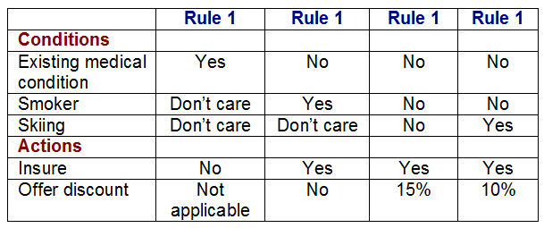

**What is the expected action for each of the following test cases?**

**Joe is a smoker who will be skiing and has an existing medical condition.**

**Sue is a non-smoker who does not ski and does not have an existing medical condition.**

A. Insure Joe offering no discount, insure Sue offering no discount

B. Insure Joe, offering a 10% discount and insure Sue offering a 10% discount

C. Do not insure Joe and insure Sue offering no discount

D. Do not insure Joe and insure Sue offering a 15% discount

**12) Arrive-and-Go airline wants to clarify its baggage handling policy, whilst maximizing revenues, and will introduce the following tariffs for all baggage per individual customer (weights are rounded up to the nearest 0.1Kg):**

**The first 2Kg will be carried free of charge.**

**The next 10 Kg will be carried for a flat charge of $10.**

**An additional 15Kg will be charged a total charge of $17.**

**Luggage over this amount will be charged at $5 per Kg, up to a maximum of 150Kg per person.**

**No passenger may take more that 150Kg with them.**

**Which of the following would constitute boundary values for baggage weights in the price calculation?**

A. 0, 5.0, 10.0, 17.0

B. 2.0, 9.9, 15.0, 26.9

C. 1.9, 12.0, 14.9, 150.0

D. 2.0, 12.1, 27.0, 150.1

**13). Which of the following is a valid collection of equivalence classes for the following problem: An integer field shall contain values from and including 1 to and including 15**

A. Less than 1, 1 through 15, more than 15  
B. Negative numbers, 1 through 15, above 15  
C. Less than 1, 1 through 14, more than 15  
D. Less than 0, 1 through 14, 15 and more

**14) A video application has the following requirement: The application shall allow playing a video on the following display resolution:**

**1. 640x480.**

**2. 1280x720.**

**3. 1600x1200.**

**4. 1920x1080.**

**Which of the following list of test cases is a result of applying the equivalence partitioning test technique to test this requirement?**

1. a) Verify that the application can play a video on a display of size 1920x1080 (1 test case).
2. b) Verify that the application can play a video on a display of size 640x480 and 1920x1080 (2 test cases).
3. c) Verify that the application can play a video on each of the display sizes in the requirement (4 test cases).
4. d) Verify that the application can play a video on any one of the display sizes in the requirement (1 test case).

**15) An employee’s bonus is to be calculated. It cannot become negative, but it can be calculated to zero. The bonus is based on the duration of the employment. An employee can be employed for less than or equal to 2 years, more than 2 years but less than 5 years, 5 to 10 years, or longer than 10 years. Depending on this period of employment, an employee will get either no bonus or a bonus of 10%, 25% or 35%. How many equivalence partitions are needed to test the calculation of the bonus?**

A 3

B 5

C 2

D 4