**Block Diagram:**

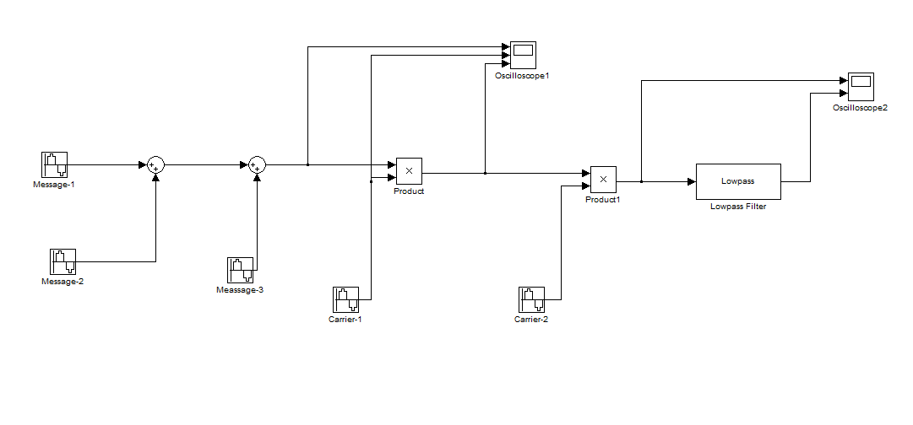

**Figure No.-01:** Simulink Block Diagram of Modulation & Demodulation

**Output:**

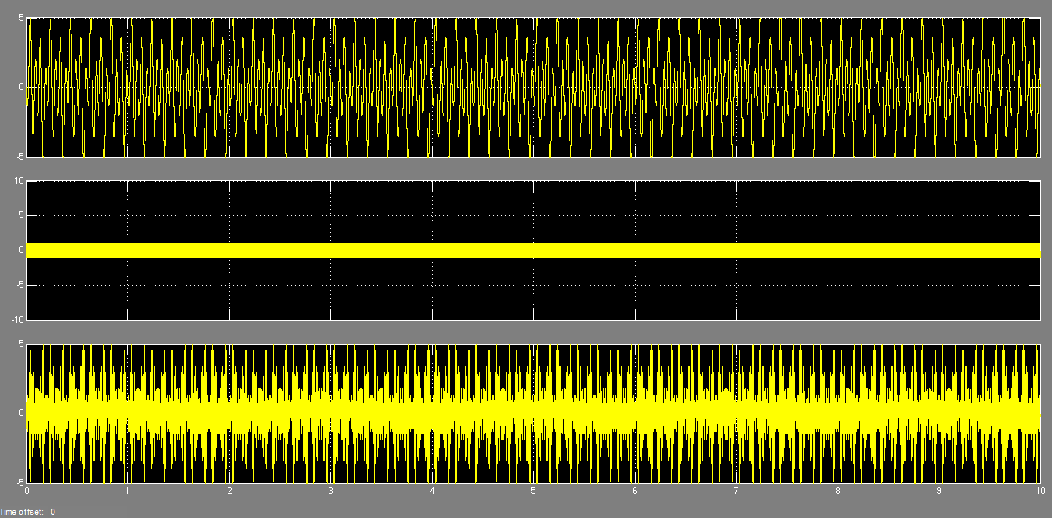

**Figure No.-02:** Modulation Output Signal

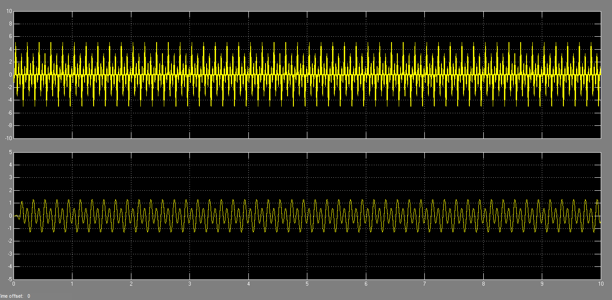

**Figure No.-03:** Demodulation Output Signal