**Introduction:**

The OQPSK modulation is a PSK modulation, using 2 bits per symbol & a delay of one bit in the in quadrature signal (refer to OptiSystem component library, **OQPSK Pulse Generator**). TheOQPSK Modulator Baseband block modulates the input signal using the offset quadrature phase shift keying (OQPSK) method & applies pulse shape filtering to the waveform. For information about delays incurred by modulator-demodulator pair processing, se modulation delays. A simple method to avoid deep fades is Offset-QPSK. In Offset-QPSK, the quadrature component of a signal is delayed by T/2 with respect to the in-phase component. Hence, the in-phase & the quadrature components cannot change simultaneously anymore, & diagonal transitions of the trajectory are avoided.

**Schematics Block Diagram:**

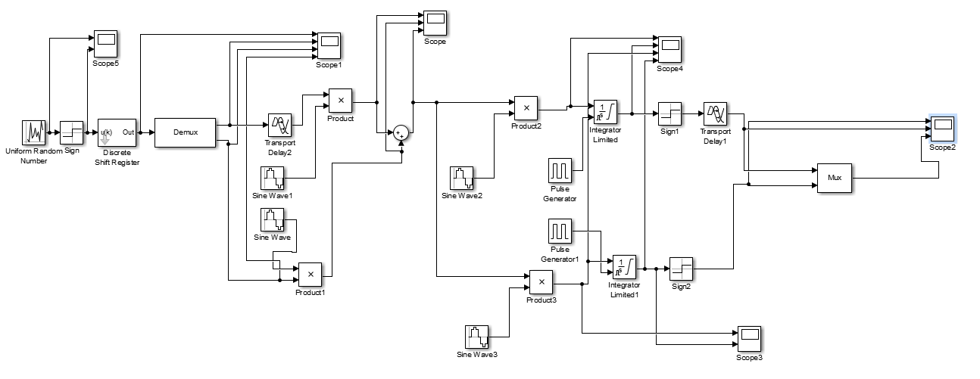

**Figure 01:** Simulink Block Diagram for OQPSK Modulator & Demodulator

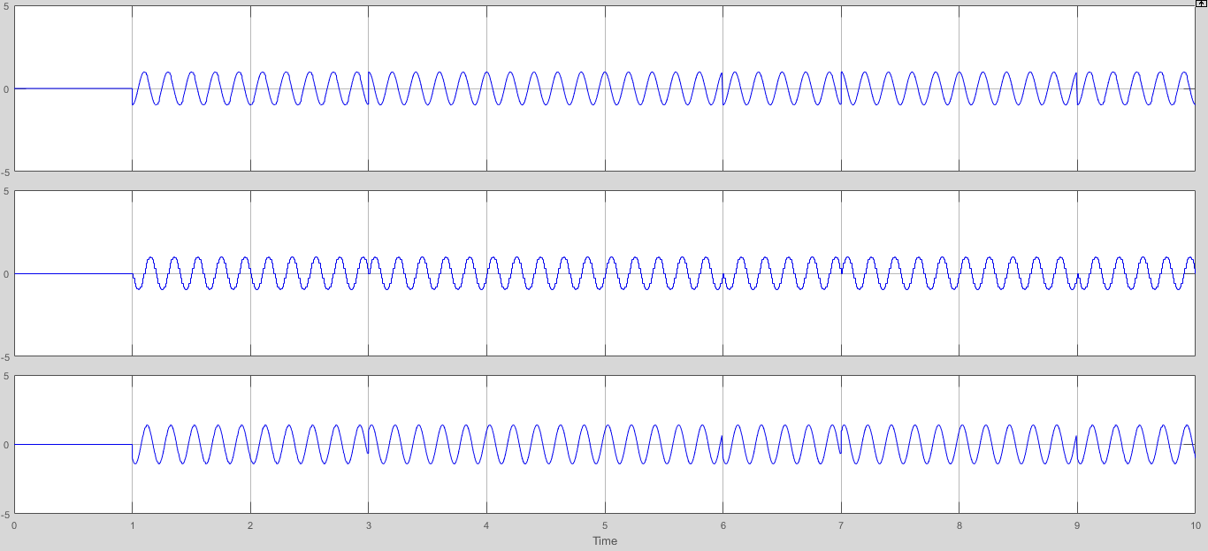

**Figure 02:** Modulation Waveform of OQPSK

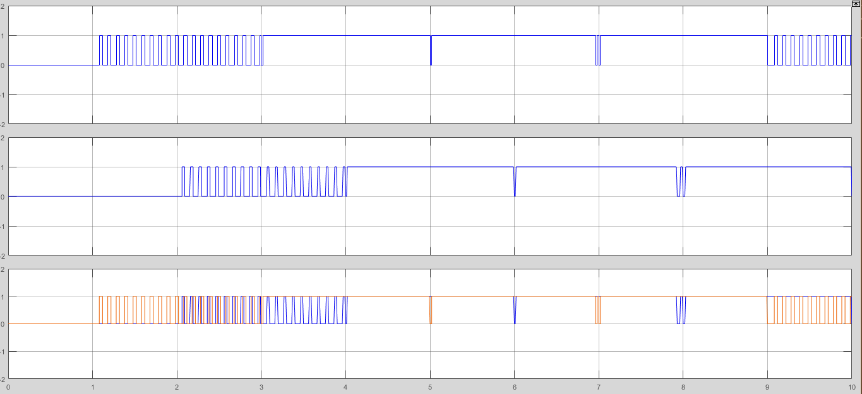

**Figure 03:** Demodulation Waveform of OQPSK

**MATLAB Code To Generate OQPSK Modulation & Demodulation:**

clc;

clear all;

close all;

n=10;

Tb=1;

fc=1;

t=(0:Tb/100:2*Tb);

m=round(rand(1,n));

c1=(sqrt(2/Tb))*cos(2*pi*fc*t);

c2=(sqrt(2/Tb))*sin(2*pi*fc*t);

subplot(5,2,1);

stem(m);

title('Binary data bits');xlabel('n---->');ylabel('b(n)---->');grid on;

subplot(5,2,2);

plot(t,c1);

title('Carrier Signal-1');xlabel('t---->');ylabel('c1(t)');grid on;

subplot(5,2,3);

plot(t,c2);

title('Carrier Signal-2');xlabel('t---->');ylabel('c2(t)');grid on;

p1=-Tb; p2=Tb; p3=0; p4=2*Tb;

for i=1:2:n

r1=(p1:Tb/100:p2);

if m(i)==1

m_s(i,:)=ones(1,length(r1))

else

m_s(i,:)=-1*ones(1,length(r1))

end

subplot(5,2,5);

plot(r1,m_s(i,:));

axis([-2 n -2 2]);

title('Odd Bits');

grid on

hold on

odd_sig(i,:)=c1.*m_s(i,:)

subplot(5,2,6);

plot(r1,odd_sig(i,:));

axis([-2 n -2 2]);

title('Odd Signal');

grid on

hold on

r2=(p3:Tb/100:p4);

if m(i+1)==1

m_s(i,:)=ones(1,length(r2))

else

m_s(i,:)=-1*ones(1,length(r2))

end

subplot(5,2,7);

plot(r2,m_s(i,:));

axis([-2 n -2 2]);

title('Even Bits');

grid on

hold on

even_sig(i,:)=c2.*m_s(i,:)

subplot(5,2,8);

plot(r2,even_sig(i,:));

axis([-2 n -2 2]);

title('Even Signal');

grid on

hold on

oqpsk(i,:)=(odd_sig(i,:))+(even_sig(i,:))

zq=p3:Tb/100:p4;

subplot(5,2,9);

plot(zq,oqpsk(i,:));

axis([-2 n -2 2]);

title('OQPSK Modulated Signal');

grid on

hold on

p1=p1+(2*Tb); p2=p2+(2*Tb); p3=p3+(2*Tb); p4=p4+(2*Tb);

end

kd1=0;kd2=Tb

for i=1:n-1

x1=sum(c1.*oqpsk(i,:));

x2=sum(c2.*oqpsk(i,:));

if (x1>0&&x2>0)

demod(i)=1;

demod(i+1)=1;

elseif (x1>0&&x2<0)

demod(i)=1;

demod(i+1)=0;

elseif (x1<0&&x2<0)

demod(i)=0;

demod(i+1)=0;

elseif (x1<0&&x2>0)

demod(i)=0;

demod(i+1)=1;

end

subplot(5,2,10);

stem(i,demod(i));

title('Demodulated Signal');

kd1=kd1+(2*Tb+.01); kd2=kd2+(2*Tb+.01);

end

**Output Waveforms:**

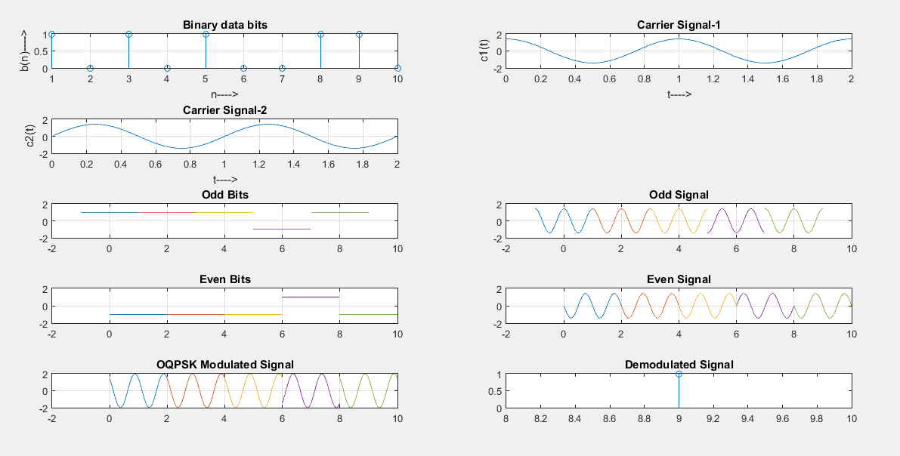

**Figure No.-04:** Modulated & Demodulated Signal ofOffset Quaternary Phase Shift keying

(OQPSK)

**Conclusion:**

In this project, our task was to generate OQPSK modulator & demodulator using Simulink & MATLAB. The main purpose of OQPSK is to limit maximum phase change possible in QPSK. In QPSK, each pulse represents two bits. The main advantage of phase & frequency modulation systems over amplitude modulations systems, is that it has a constant envelope. The advantages of offset Quadrature Phase shift Keying or OQPSK over QPSK is that due to the offset where the change in the I channel there is never more than 90 degrees of phase shift in the output phase of the system unlike in the ordinary QPSK where there is a possibility of error. So we can conclude that, OQPSK is far better than QPSK in telecommunication engineering.