**Overview**

The purpose of this assignment is to create a binary classifier that can predict whether applicants will be successful, who are funded by Alphabet Soup using machine learning and neural network techniques on the provided dataset.

**Results**:

**Data Preprocessing**

* What variable(s) are the target(s) for your model?
  + The variable of targets was the “IS_SUCCESFUL” variable in the dataframe

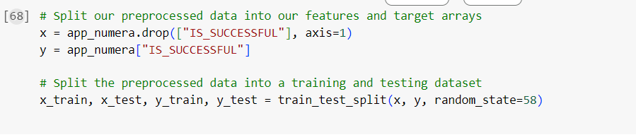

* What variable(s) are the features for your model?
  + features of the model include all other variables that were complementary to and except for “IS_SUCCESFUL”.
* What variable(s) should be removed from the input data because they are neither targets nor features?
  + The variable removed from the dataframe was “EIN” and “NAME” as they were not targets or features.

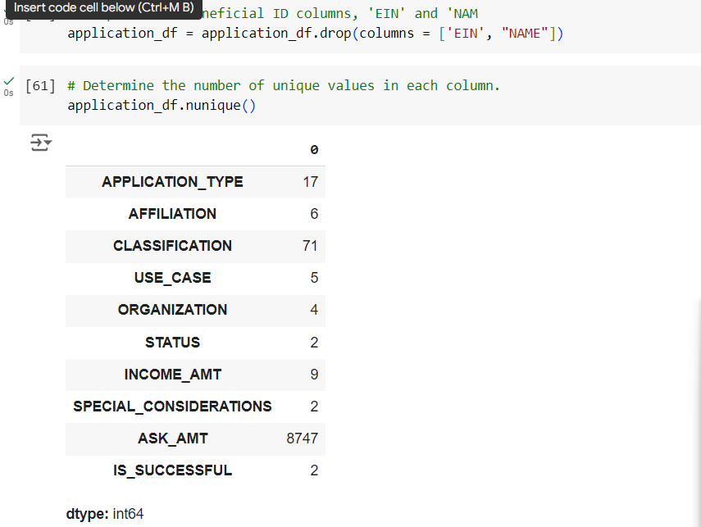

**Compiling, Training, and Evaluating the Model**

* How many neurons, layers, and activation functions did you select for your neural network model, and why?
  + The first attempt contains 10 hidden node layers and 8 hidden node layers.
* Were you able to achieve the target model performance?
  + No, I was not able to achieve the target model performance.
  + Before trying to clean the model, the original deep learning model has an accuracy rate of 72.4% and was only able to increase it to 72.56%.
* What steps did you take in your attempts to increase model performance?
  + In order to increase the model accuracy by adding more nodes by setting the first layer to 10 and
    - Added 1 more hidden layers with a total of 3 hidden layers
    - Added more more neurons to each hidden layer and randomly iterating through 10 in the first layer, 8 in the second layer and 5 in the third layer
    - Different activation methods were applied as well including Relu for the hidden layers and Sigmoid for the outer layer
    - In addition to this, i created 200 number of epochs instead of 100 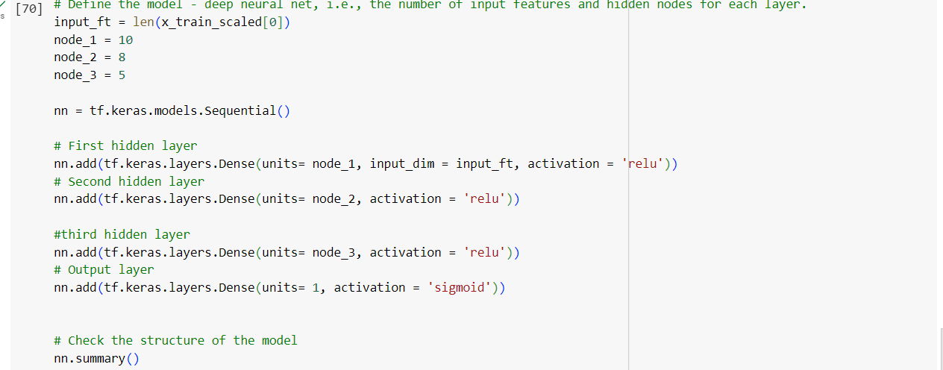epochs as shown in the initial notebook

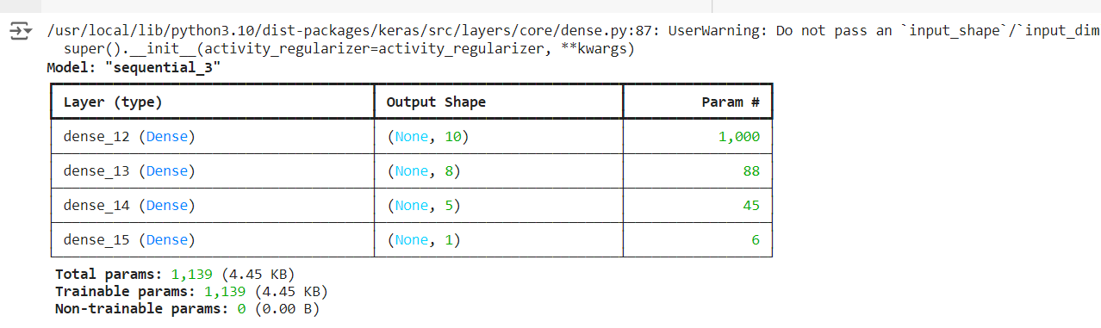

* This yielded the following model accuracy result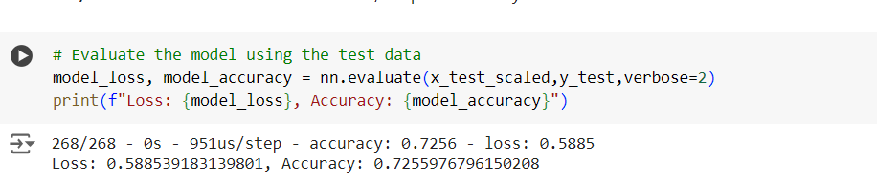

**Summary**

In conclusion the new model shows that there is a 72.56% to about 75% accuracy for the model's results. Since the model did not achieve a 75% accuracy, it would be ideal to drop certain variables in the dataset, to adjust the size of each bin as well as its value to achieve greater accuracy results. In addition to this a random forest model can be applied to solve this classification problem.