Case Study

DBAS17370
Database Implementations and Management

Kai-Ann Parsons 991731084
Hanna Mathew 991622474
Riaa Sehgal 991723834

Gurdeep Gill
26th March, 2025

Part A: Anonymous Blocks

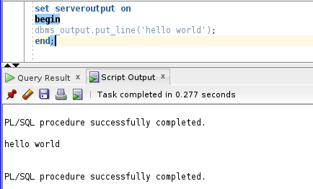

- Modify the existing anonymous block which you have created in Q1 with the following changes:

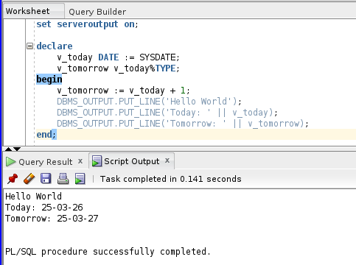

- Edit the script created in the last question with the following changes:
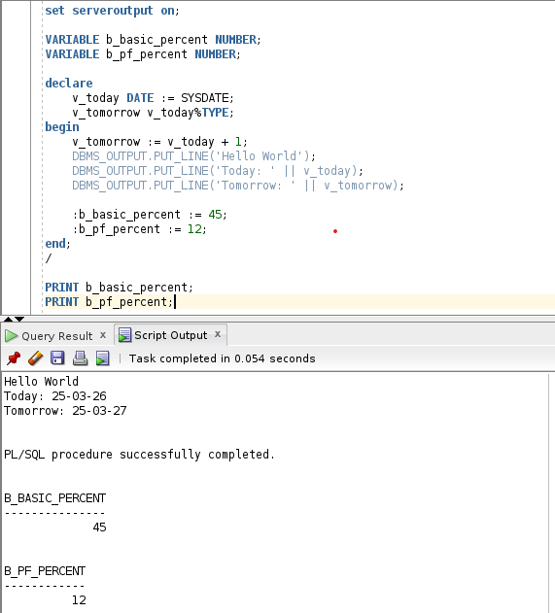

- Execute the following PL/SQL block to declare variables in a PL/SQL anonymous block:
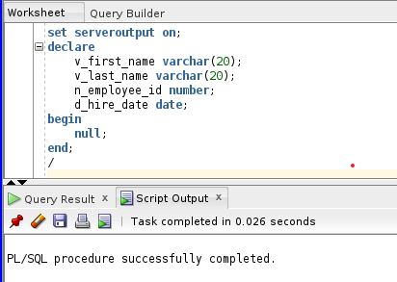

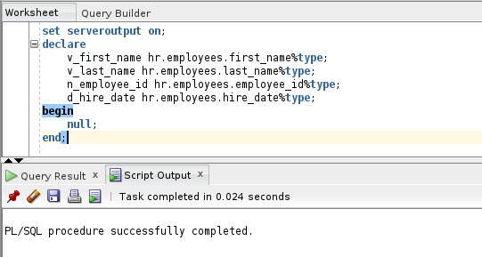

- Let us assign the values to the variables defined in the previous block.

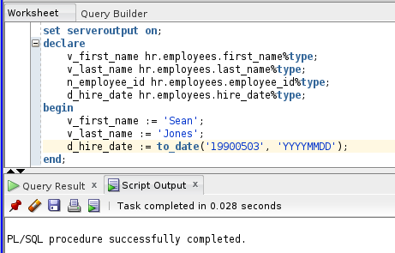

- Let us use INTO of the SELECT statement to assign a value to a variable. The INTO clause moves the values from the SELECT query’s column list into corresponding PL/SQL variables.

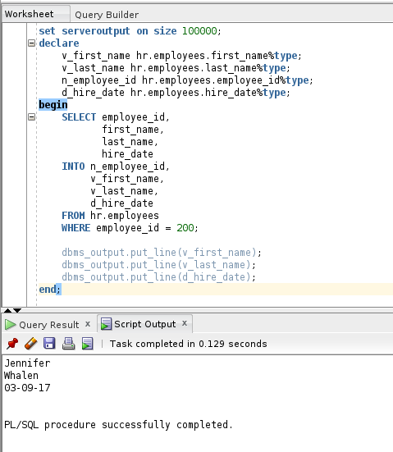

Part B: Procedures
1.
a)
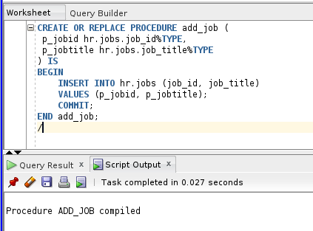

b)
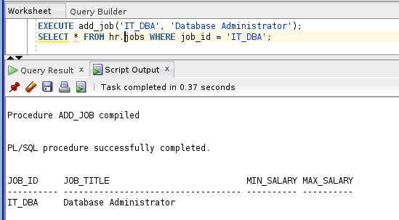

c)
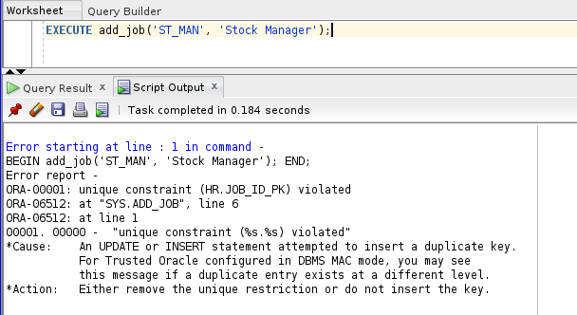

Part C: User Authentication

- Creating Password Authenticated Users:
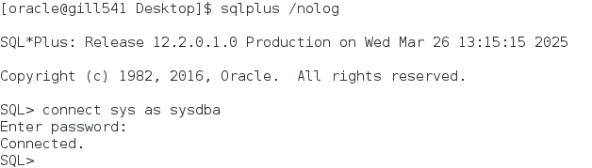
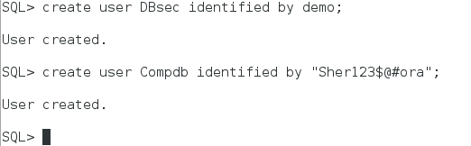

- Creating a User Profile
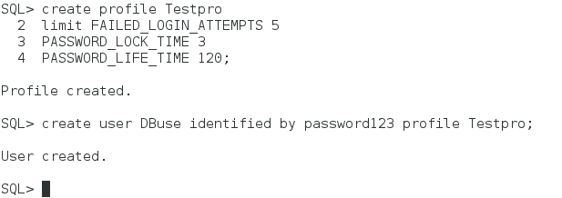

- Password Management
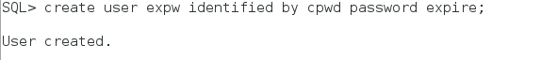
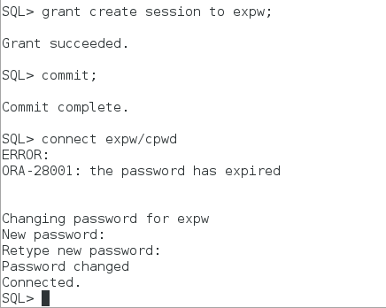
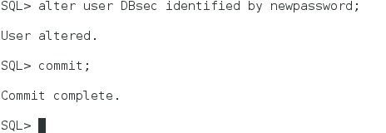

- Locking The User Account
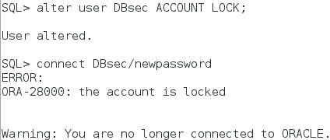

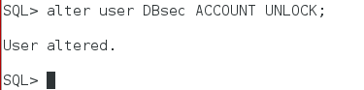

- Assigning Disk Quota to a New User

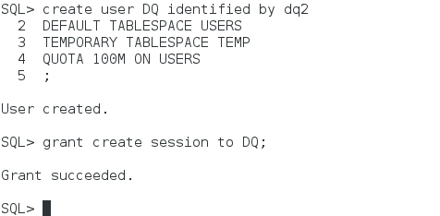
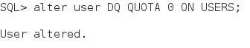
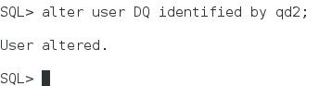

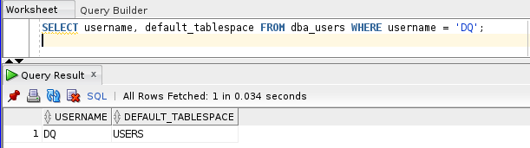

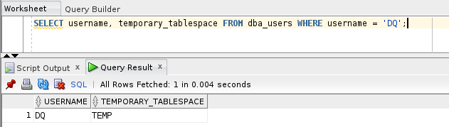

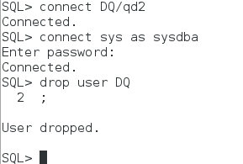

Part D: Triggers
1. a)

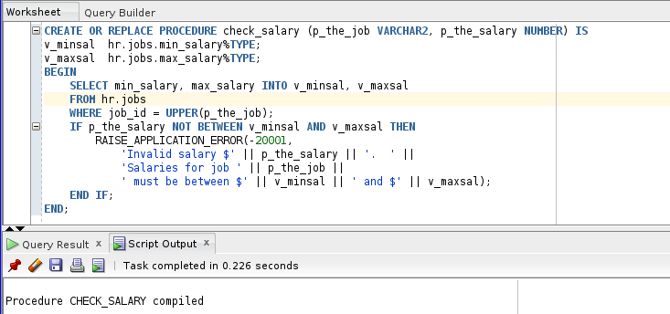

b)

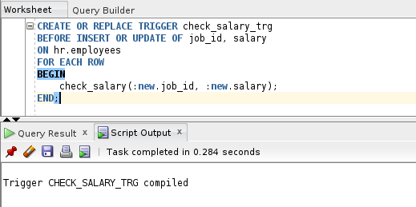
2. a)
The procedure call failed and raised the following error:
ORA-20100: Invalid salary $1000. Salaries for job SA_REP must be between $6000 and $12000
Why did this happen?
- The CHECK_SAL_TRG trigger enforces salary constraints based on job role.
- In this case, the default job assigned to Eleanor by the ADD_EMPLOYEE procedure is likely SA_REP.
- The salary internally assigned by the procedure was $1000, which is below the allowed range for SA_REP ($6000–$12000).
- The CHECK_SAL_TRG trigger detected this invalid salary and raised a custom exception using:
RAISE_APPLICATION_ERROR(-20100, 'Invalid salary $1000. Salaries for job SA_REP must be between $6000 and $12000');

b)
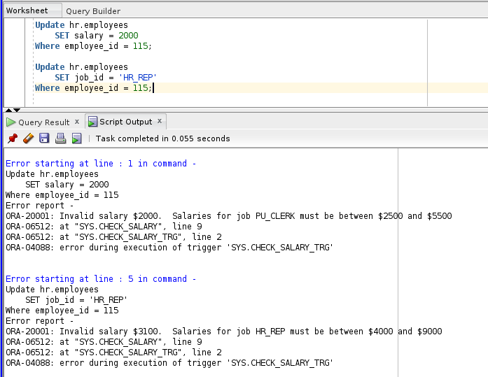

c)
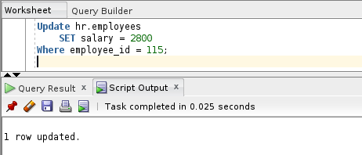

Part E: Profiles, Users, Privileges, and Roles

- Creating LabAC User
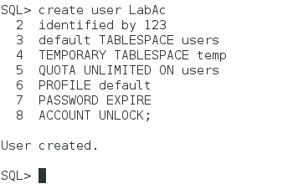
- Query V$DATABASE_PROPERTIES

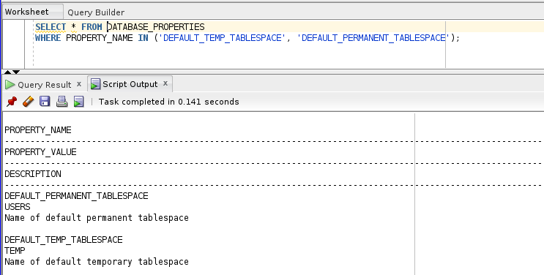
This view shows the default tablespace assignments of the database. It's useful to confirm whether users will inherit correct tablespace settings if not explicitly defined during user creation.
- Granting privileges to LabAc
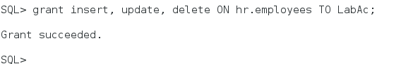
- Granting SELECT to PUBLIC
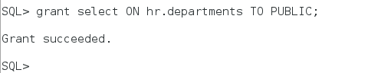
- Granting SELECT with GRANT OPTION
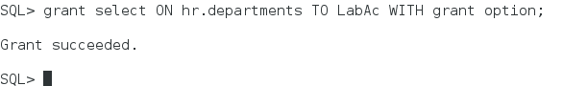
- Creating Demo User
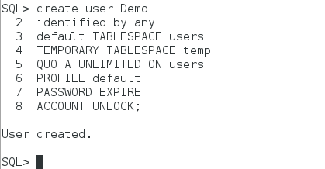
- Re-running V$DATABASE_PROPERTIES query

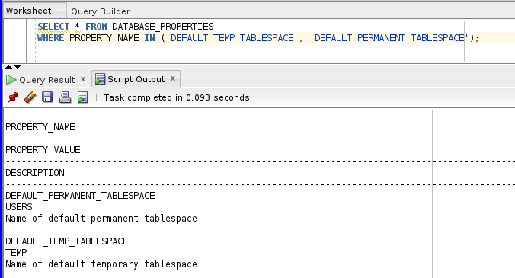
Same as step 2. This reconfirms that both LabAc and Demo users are aligned with system defaults unless otherwise changed.

- Granting SELECT to Demo on hr.employees
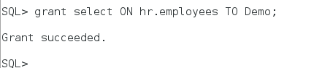
- Granting update on specific columns
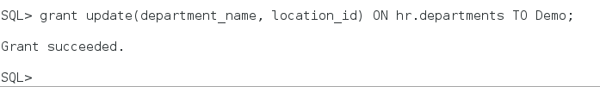
- Granting SELECT and INSERT with grant option
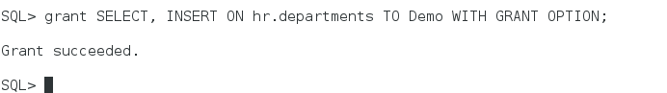
- Granting system privileges
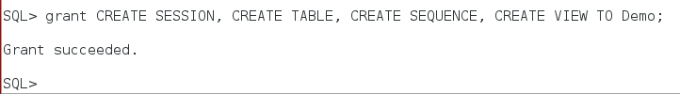
- Revoke table privileges from Demo
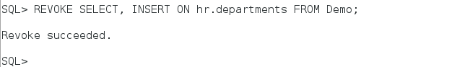
- Revoke system privileges from Demo
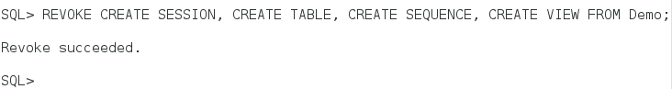
- Creating a role
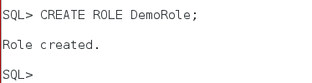
- Granting object privileges to role
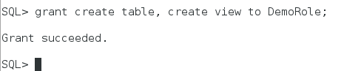
- Grant role to LabAc and Demo
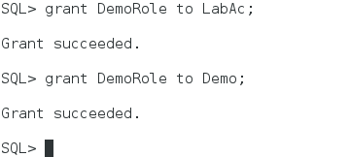
- Change Demo’s password
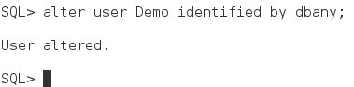
- Create a custom password profile
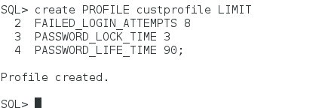
- Assigning customprofile to Demo
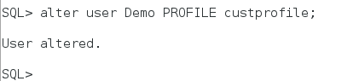
- Trying to connect as Demo

