NITTE MEENAKSHI INSTITUTE OF TECHNOLOGY
Department of Electronics and Communication Engineering
OBJECT-ORIENTED PROGRAMMING USING C++ LAB
TASK 1 REPORT (WEEKS 1–6)
Submission deadline: 16 October 2026
Student Name | Ria Jirankali
USN | NB25ECE149
Section / Batch | C1
Task Title / Problem Statement | Implementation of Student Class Using Object-Oriented Programming Concepts in C++
GitHub Repository URL | https://github.com/riajirankali-a11y?tab=repositories

1. Aim / Objective
To implement a Student class using encapsulation and a parameterized constructor, overloaded display functions, a static student counter, a friend function, dynamic memory allocation, and an overloaded > operator to compare students' marks.

2. Problem Statement
Create a Student class with private data members for roll number, name, and marks. Initialize student objects using a parameterized constructor. Demonstrate function overloading, count created students using a static data member, use a friend function to compare two students, and overload the > operator to compare students based on marks. Allocate the objects dynamically and release the memory after use.

3. Concepts Used
• Classes and objects
• Encapsulation (private data members)
• Parameterized constructor
• Function overloading
• Static data member and static member function
• Friend function
• Operator overloading (>)
• Dynamic memory management using new and delete
• Pointers and member access using ->

4. Algorithm / Steps
1. Start the program and define the Student class.
2. Declare roll number, name, and marks as private members and declare a static student counter.
3. Use a parameterized constructor to initialize each object and increment the counter.
4. Overload display() to print student details, with and without a heading.
5. Define a friend function to compare the private marks and names of two students.
6. Overload the > operator to compare two students by marks.
7. Dynamically create three Student objects using new.
8. Display student details and the total number of students created.
9. Demonstrate the friend function and > operator.
10. Delete all dynamically allocated objects and stop.

5. Source Code

#include <iostream>
#include <string>
using namespace std;

class Student {
private:
int rollNo;
string name;
double marks;
static int studentCount;

public:
Student(int r, const string& n, double m)
: rollNo(r), name(n), marks(m) {
++studentCount;
}

void display() const {
cout << "Roll No: " << rollNo
<< ", Name: " << name
<< ", Marks: " << marks << "/100" << '\n';
}

void display(const string& heading) const {
cout << heading << '\n';
display();
}

double getMarks() const {
return marks;
}

static int getStudentCount() {
return studentCount;
}

friend void compareStudents(const Student& s1, const Student& s2);

bool operator>(const Student& other) const {
return marks > other.marks;
}
};

int Student::studentCount = 0;

void compareStudents(const Student& s1, const Student& s2) {
cout << "\nFriend function comparison:\n";
if (s1.marks > s2.marks) {
cout << s1.name << " scored more than " << s2.name << ".\n";
} else if (s2.marks > s1.marks) {
cout << s2.name << " scored more than " << s1.name << ".\n";
} else {
cout << s1.name << " and " << s2.name << " scored equal marks.\n";
}
}

int main()

Student* s1 = new Student(101, "Aarav", 86.5);
Student* s2 = new Student(102, "Diya", 92.0);
Student* s3 = new Student(103, "Kiran", 78.0);

cout << "STUDENT DETAILS\n";
s1->display();
s2->display("Student 2 details:");
s3->display();

cout << "\nTotal students created: "
<< Student::getStudentCount() << '\n';

compareStudents(*s1, *s2);

cout << "\nOperator > comparison:\n";
if (*s2 > *s1) {
cout << s2->getMarks() << " marks are greater than "
<< s1->getMarks() << " marks.\n";
} else {
cout << s1->getMarks() << " marks are greater than or equal to "
<< s2->getMarks() << " marks.\n";
}

delete s1;
delete s2;
delete s3;

return 0;
}

6. Compilation and Execution
Compiler / IDE used: GCC (g++) with C++17; source can also be opened in VS Code.
Compilation status: ☒ Successful ☐ Errors encountered and corrected
Execution status: ☒ Successful ☐ Not successful

7. Output Screenshot(s)
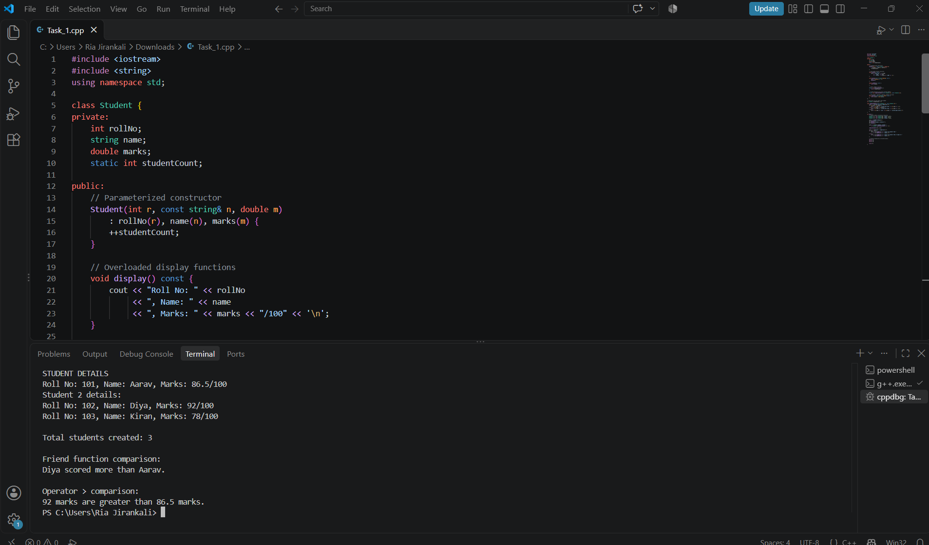

8. Result
The program compiled successfully and executed successfully. It displayed three student records, counted the students, compared two students through a friend function, and demonstrated the overloaded > operator.

9. Learning Outcome / Reflection
I learned how encapsulation protects class data, how constructors initialize objects, and how function and operator overloading provide multiple ways to use class operations. I also practiced static members, friend functions, and dynamic memory management using new and delete.

10. GitHub Submission Checklist
- Report prepared using this template
- Source code (.cpp) uploaded
- Output screenshot(s) uploaded
- Program compiled and executed successfully
- Files organized in the correct weekly/task repository
- GitHub repository URL included above
Student Declaration: I confirm that this report and program represent my own work.
Student Signature: Ria Jirankali Date: 16/10/2026

