**PYTHON - MINI PROJECT**

**PROJECT TITLE:** Personal Assistant

**DESCRIPTION**: In this project we will be able to chat with, ask questions to our Personal Assistant which is created using AI.

An AI virtual assistant, also called AI assistant or digital assistant, is **an application program that understands natural language voice commands and completes tasks for the user**.

The **Artificial Intelligence-Powered Personal Assistant** uses Artificial Intelligence (AI), natural language processing to extract information and complex data from conversations to understand them and process them accordingly.

**PROGRAM FLOW:**

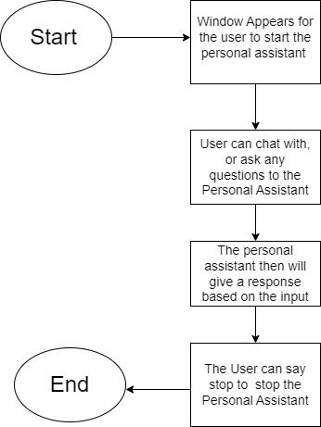

**PACKAGES USED ARE:**

1. Tkinter - To create the interface of the project.

2.speech_recognition as sr- to identify spoken words and converts them into text. It allows computers to understand human language.

3. pyttsx3- it is a text-to-speech conversion library in Python

4.openai- it provides convenient access to the OpenAI API from applications written in the Python language.

**PROGRAM:**

https://github.com/riakhetani/PythonMiniProject.git

**OUTPUT:**

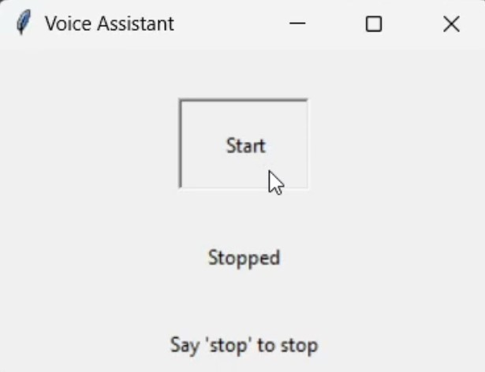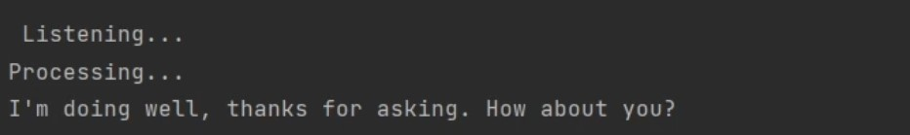

**CONCLUSION:**

1.The project creates a very good interface for people to get information without using browser.

2.It provides a large range of answers, responses based upon the type of input using openai.api_key package of python.

3.It can give information about any question asked.

4.It can also be a fun Virtual AI Based Personal Assistant to chat with.