Modes of knowing:   
resources from the baroque[1]

## John Law

ESRC Centre for Research on Socio-Cultural Change (CRESC),

Department of Sociology, Faculty of Social Sciences,  
The Open University, Walton Hall,

Milton Keynes MK7 6AA

(4th December 2012; EmpiricalBaroqueIntroductionNew1.docx)

‘By dint of quartering the subjective, the cognitive, the objective and the collective, how can we say the right word and live a happy life? The analysis that unties these four components comes from the hate that divides. What love will reunite them? What’s the project of a thought, the program of a language, the hope of a life.’ (Michel Serres, 2012, 75)

‘I do not want to fix or represent the self as self, but to recognize the existence of the self in relationship with otherness and perceive the world in a place where such a relationship exists.’ (Lee Ufan, 121-122)

‘The Two Boys began playing at the Kantju waterhole, mixing the water with the surrounding earth. They piled the mud up, getting bigger and bigger, until it was the size that Uluru is now. Then they started playing on it. They sat on the top, and slid down the south side of their mud pile on their bellies, dragging their fingers through the mud in long channels. The channels hardened into stone and now form the many gullies on the southern side of Uluru.’ (Tommy Manta, reprinted in Anne Kerle, 1995, 18).

‘The soul is suspended in such a way that it seems to be completely outside itself. The will loves; the memory, I think, is almost lost; while the understanding, I believe, though it is not lost, does not reason – I mean that it does not work, but is amazed at the extent of all it can understand; for God wills it to realize that it understands nothing of what His Majesty represents to it.’ (Teresa of Àvila, 1964, 68)

There are many ways of knowing, but only a few of them make it into social science. The starting point of this book is that the *modes of knowing* in social science are very particular; that they render very specific and limited versions of the world; that while no doubt in some ways they know well, they are also inhibiting and indeed restrictive. So this is the core question of the book. Do we want to find new ways of recognising and responding to other versions of reality? Do we want to learn to attune to ourselves to other kinds of realities? And if so, then where might we look and how might we do this?

So what is the mode of knowing of social science? Let me gesture.

In social science we work mostly through *texts*. We work, mostly, by *describing* bits and pieces of the world (or perhaps, as an alternative we do ‘theory’.) We typically write in ways that are more or less sober or *austere*. Neither *emotions* nor *bodies* get much of a look in. Instead we follow more or less prescribed sets of *methods*. We use these methods to *purify* the world, to render it *tractable* and textual. We also tend to think that methods are techniques that will guarantee that what we have learned about the world is reliable. As a part of this we attend to whatever can be made *visible* or reported on. We also work more or less *analytically*, trying to make *separations* and drawing patterns out of complexity. Then we try to pin those patterns down, looking for correlates, causes and effects, or their equivalents. And we usually think that we have succeeded if we have pulled everything that is relevant *together* into a single explanatory pattern, a single story, or a single graph.

All this is too simple. As is obvious, social science is far more varied than this suggests. But look now at the quotations above. I’ve chosen them because none of them fit within contemporary social science, but also because they are interesting if we want to think about knowing. Thus, despite the fact that they are texts (they wouldn’t be printed on the page if they were not) they also take us to quite other modes of knowing.

Michel Serres, philosopher and historian of science, is a wordsmith. But he’s writing in a way that isn’t really philosophy any more. Or if it is, then philosophy is on the move. The citation comes from a book that reveals its learning, but is personal and poetic too.[2] It is also excessive to analysis. Indeed explicitly so: he tells us that he’s resisting what he calls ‘quartering’. Then again, whatever else it is, neither is it austere. He’s telling us that we need to love the world, Biogea, if we are to stop destroying it. As a part of this we are going to need to learn to give up on control. And to do this, to work his knowledge effects, Serres is telling stories that move on and with emotions to avoid the divisions set up in Western ways of knowing. The object, I think this is implied, is to use philosophy but transcend it too. For the book is a declaration of love for a world that is on the verge of destruction. A world in need of love. This really doesn’t fit.

Lee Ufan, a Korean philosopher who lives in Japan, is also an artist. It would be better to call him an artist-philosopher. So he writes, but he also paints and sculpts. He uses texts but he also extracts himself from them in his minimalist artworks.[3] Like Serres, he’s interested in relations. Again like Serres he is critical of Western boundedness and separation, but he is pushing the thought in a different direction. So we learn as we read him, but more especially as we absorb ourselves in his artworks, that selves are in relations. Then we learn that those patterns of relations extend out ever so far. And finally we learn that those relations come in many different material forms. Iron, boulders, or canvas, his arrangements work to include the viewer but then to move her one. They are materially heterogeneous. They absorb her into a field. And as a part of this they work to cultivate a sense of otherness; an apprehension of that which is not present; of incompleteness. Bodies, then, and sensibilities to absence and relationality – these are crucial to the mode of knowing being cultivated here. Neither the modality, the materials, nor the apprehension, otherness, fit. This is a different mode of knowing.

Let me make an abrupt shift. Citation number three. Tommy Manta was from the Pitjantjatjara nation of Central Australia. His story, recorded and transcribed in 1994, is reprinted in a tourist guidebook for Uluru published in 1995.[4] The citation is a small excerpt from a longer ‘dreamtime’ story about ancestral beings and the creation of the world. But, this is crucial, the ‘dreamtime’ that he is telling didn’t happen a long time ago. Yes, it happened in the past, but it is also being done, and redone, in continuing narratives, stories, rituals and re-enactments by particular guardians at particular sites. Now. Here we are thrust into a world of radical performativity. It’s like this: if the rituals stop, then the world gets hollowed out. It stops being realised. It empties. Nothing carries on by itself. And here is another difference: the stories and the rituals are site specific. Only those who are initiated can know or practice them. In this mode of knowing (if that is what we want to call it) there is no general world, general reality, out there all by itself. Realities are done provisionally and locally (except that there is no ‘global’). And they belong to particular groups. So, to return to the story, this isn’t just ‘a story’. At least in the right context, it isn’t so much a description but rather the re-doing of events that materialise the world, its geographical features, its animals and plants, its weather, and the people who live in it. Except that to say that people ‘live in’ the world makes little sense. Whatever this is, it’s a mode of knowing far removed from social science. Indeed far removed from Western common sense.

And the final citation? This comes from the memoirs of the sixteenth century Spanish Carmelite nun and mystic, Santa Teresa d’Ávila.[5] I will return to her shortly, but here let me say that her memoirs were hugely important in seventeenth century Catholic Roman Europe as a source of spiritual inspiration. The memoirs are, of course, textual. They come in the form of words. But what’s important is what they do. And what they do is offer techniques for dissolving the self and embracing – being embraced by – the grace of God. For Santa Teresa, to enter into communion with God is to submit the body to the disciplines of prayer and penitence. It is utterly corporeal. Knowing cannot be separated from the body. The division makes no sense. And then again, at times, it is to achieve a state of ecstasy. There is nothing sober about communion with God. Indeed, as the citation reveals, neither is there anything analytical. This is a mode of knowing that is corporeal, and it is a mode of knowing that goes out to seek and to experience that which is invisible – the fire of the Holy Spirit. And to be swallowed up in it.

So we have four different modes of knowing. They do not belong together. But I juxtapose them because they don’t fit the most obvious versions of social science. My hope is that this means that they help us to throw our assumptions about what it is to know and know well into relief. It is also that they also help us to start out on a related quest: that of sensitising ourselves to some of the things that we *don’t* know well. Or at all. So what do we learn?

Here’s a provisional list.

1. In social science there are some things we simply do not ***see or feel***. They mostly get blanked out. We don’t apprehend or *know* love. Neither do we know *through* love (Michel Serres). We do not come to know through spiritual experience (Santa Teresa). If we experience communion then this has nothing to do with social science modes of knowing. This is the first form of exclusion.
2. Then we are wary of what we might code up as ***excess***. Ecstasy, including eroticism and religious enthusiasm (Santa Teresa), these don’t fit. And neither does ritual (Tommy Manta). I think we’re learning that for social science reality itself is, as it were, austere. The parts of the world that are relevant to social science work are taken to work in matter-of-fact ways. They aren’t lively. Yes, it may be a large technical task to learn about them, but in principle there is no problem: they simply need to be tamed and told.
3. We are sceptical of ***formlessness***. Instead we assume that the world is ***structured***. We probably don’t actually know how it is divided up, this is usually work in progress. Indeed this work in progress is what keeps us busy. But nevertheless we mostly work secure in the idea that it is shaped and orderly. The idea that it might be boundless – or indeed that it might fold back on itself – doesn’t fit either. There is no space for anything like the grace of the Christian God (Santa Teresa); or the formlessness that exists outside the rituals of the ‘dreamtime’ (Tommy Manta).
4. Neither is there much space for the idea that knowing needs to be ***materially heterogeneous***. Again similarly, we work on the assumption that the world is tractable in the specific sense that whatever form it may take, the latter can be rendered ***symbolically***. The text and other forms of symbolic representation, these are the gold standard. You don’t need sculpture (Lee Ufan), ritual (Tommy Manta), the stations of the Cross (Santa Teresa) or indeed love (Michel Serres). You don’t need to be there, as it were, in the body, linked to or part of the apparatus in order to know. You can sit and read.
5. The idea that knowing might mean that we need to ***move around*** also seems strange. Yes, of course we move around as we learn. And yes, we are limited, practically, in how much we can take on board and assimilate. But the assumption is that as we learn we are *collecting* knowing. So the idea that in principle only a little can be known in any particular place is strange. Instead we work analytically, and without thinking much about it, we also work on the assumption that our job is to pull whatever we have learned into an overview. The notion that knowing might a journey (Santa Teresa), a matter of being included in a spatial arrangement at a particular location (Lee Ufan), or be both site and person-specific (Tommy Manta) and therefore untransmissible, doesn’t make much sense.
6. The idea that knowing might attend to that which is ***radically absent*** doesn’t fit very well either. Of course we need to go looking for empirical materials. In parts of social science our data is pretty esoteric and it takes some effort to create it. That is a given. But if we get it right then the data we collect is always about the world as it is: it reflects or represents the form of the world. The idea that we might need to open ourselves up to that which cannot be caught in the net of description, that which is necessarily absent, that which is Other (Lee Ufan, Santa Teresa) doesn’t fit.
7. Finally, there’s the issue of **performativity**. When we know, do we also assume that the practices of knowing have also created whatever it they are telling about? The standard answer is no. This goes back to the business of form and structure. They are out there, the form and the structure, waiting to be revealed. But the Tommy Manta story tells us something different. It’s not that people create the world. It’s that *practices* do the world – including the people caught up in them. And though there are signs that this is shifting, this too is fairly unthinkable to the standard modes of knowing in social science.

So if we go looking for other ways of knowing we learn something about our own. We learn that they are specific. We learn that they are restrictive. And we learn that it is possible to know differently. And then, of course, we need to debate. Perhaps this list of restrictions is okay. Perhaps we neither need nor want to attune to the world in the kinds of ways being listed here. Perhaps we simply don’t need them in social science. Such, I guess, is what most social scientists would think.

But then again, perhaps we do. Perhaps our current repertoires are too narrow. Perhaps there are other versions of the world that it would be good to know, even if this meant that we had to shift what counts as knowing. Perhaps we should be experimenting with these. And such is purpose of the present book. The authors have come together to experiment with non-standard ways of knowing. They have come together because they are more or less uneasy with the ways in which we know in standard social science. And they have come together because they want to play off one particular and different way of knowing, that of *the baroque*.

Why the baroque? The answer is that (what later came to be called the baroque) it is only three hundred and fifty years old, but it is also a foreign country. It *knew* things differently. It knew *about* different things. It knew extravagantly and excessively, it knew in material heterogeneous ways; it apprehended that which is other and could not be caught in a cognitive or symbolic net; it knew in ways that did not gather to a single point; and it knew itself to be performative. Hence the interest in the baroque in its many varieties (for there were many baroques). It’s a possible *resource* for knowing differently. It’s a possible resource for making a difference in contemporary social science, know dong this differently; it’s a storehouse of possible techniques. Which is not to say that it is the right way of knowing. For this book does not seek to create a ‘baroque social science’ whatever that might be. And its contributors in any case work in very different ways. Some explore and describe alternative ways of knowing. Some work out, and engage in, novel ways of knowing. Some are much more taken by the baroque than others. But all share the view that the current ways of knowing in social science are particular and – more important – restrictive. And all are using the possibilities raised by the baroque to think and work differently.

# Otherness and the baroque

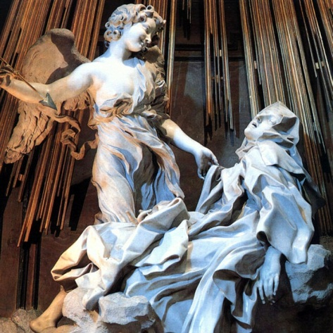

I have just said that the baroque was many things. It is an archipelago rather than an island. But I start in a specific place with a particular work of art in Rome in the church of *Santa Maria della Vittoria*. This is a sculpture by Gian Lorenzo Bernini created around 1647. It’s the Ecstasy of Santa Teresa d’Ávila. Santa Teresa was a Spanish Carmelite and a visionary mystic. Canonised in 1622, she was an inspirational figure for the Catholic Counter Reformation. Highly literate, in the memoirs that I have cited above she famously describes how she was visited by an angel.

‘He was not tall, but short, and very beautiful’, and added that his face was ‘all afire’.

[6]

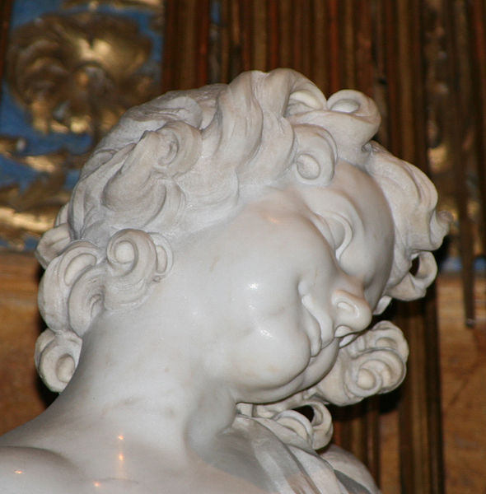

‘In his hands’, she continued, ‘I saw a long golden spear and at the end of the iron tip I seemed to see a point of fire.’

[7]

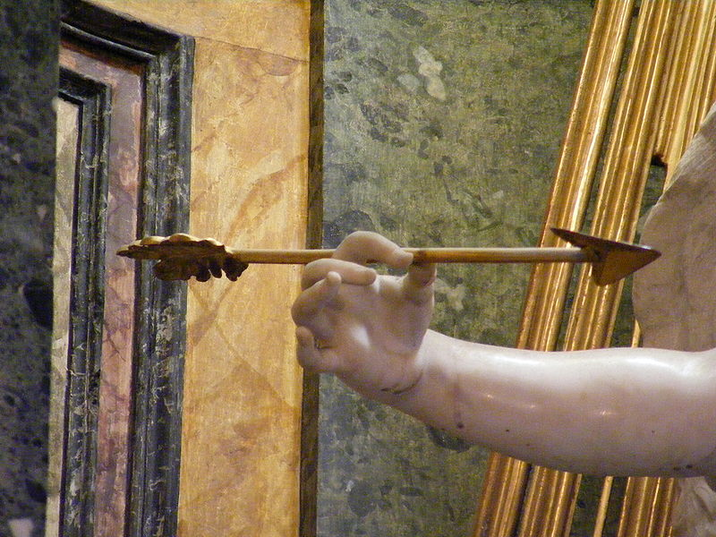

‘With this he seemed to pierce my heart several times so that it penetrated to my entrails. When he drew it out, I thought he was drawing them out with it and he left me completely afire with a great love for God.’[8]

‘The pain [from the angel’s spear] was so sharp that it made me utter several moans; and so excessive was the sweetness caused me by this intense pain that one can never wish to lose it, nor will one's soul be content with anything less than God.’

In the sculpture the angel has just withdrawn his spear. He is looking down on Santa Teresa with the love and affection that a parent might show for a child or the Christian God might feel for his children. At the same time she is in a place of ecstasy and pain, ‘afire’ as she puts it with his love.

With this time travel we have entered the archipelago of the baroque. Bernini’s Ecstasy of Santa Teresa was created in Rome in the middle years of the seventeenth century, which is certainly one of the larger islands that we need to visit. We need to know that the term, ‘the baroque’, was a label pinned onto artworks a long time after they were created. The label is iffy because it implies a chronology and teleology, but it has been conventional in art history to talk of work in Rome at this time as the ‘High Baroque’. The sculpture itself is canonical. It exemplifies a style of Italian art which flowered with extraordinary energy under the patronage of Popes, princes and Cardinals in Italy in the middle fifty years of the seventeenth century. But if we’re interested in what we might learn from it as a way of understanding then we’ll need to ask: what is a statue like this *doing*? how does it enter into *experience*? how does it *differ* from the ways in which we now go about *knowing*? and most important, what do we want to *learn* and *take* from it – or not – as we think about bodies, affects, non-coherence and the elusive. As we think about the modes of knowing in social science. So let me start with three preliminary reflections[9].

First there is the issue of *subject matter*. In Western twenty-first century social sciences we might be interested in analysing the techniques for *representing* religious ecstasy, but we rarely set out to write texts intended to induce this in the reader. This extends to loss of self in any other form. Academic knowing does not have much to do with unbounding the person, spiritually or otherwise. In this respect it is far removed from many artworks from the baroque – though the latter wasn’t necessarily spiritual. Bernini worked with classical mythological subjects too and, differently again, here is his bust of Louis XIV.

[10]

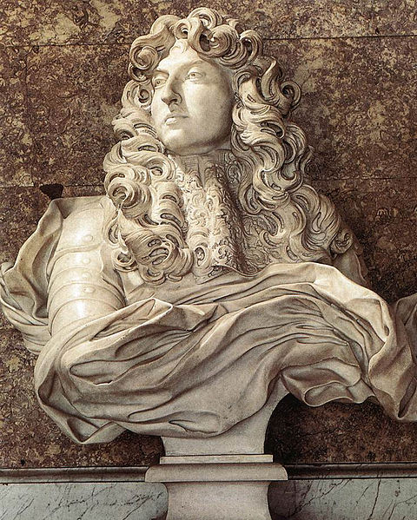

But that said, in one way or another, baroque styles were very often about transcending the person. So there are several points here.

* First, and straightforwardly, the baroque recognised *different kinds of realities*.
* Second, those realities often had to do with the *spiritual* life.
* And, third, they belonged to a world that was *extra-ordinary* and only partially fitted with mundanity.

So there is an argument for saying (I have already foreshadowed the argument above) that the baroque offers a way of acknowledging *Otherness* – or at least *absences and gaps*.

If the first point has to do with absence or Otherness this also tells us that to work in the baroque is to mobilise particular kinds of *subjectivities*. And this is the second point. The *argument* of the Santa Teresa sculpture is *emotional*, not reasonable. Here’s another Bernini sculpture, also from Rome:

[11]

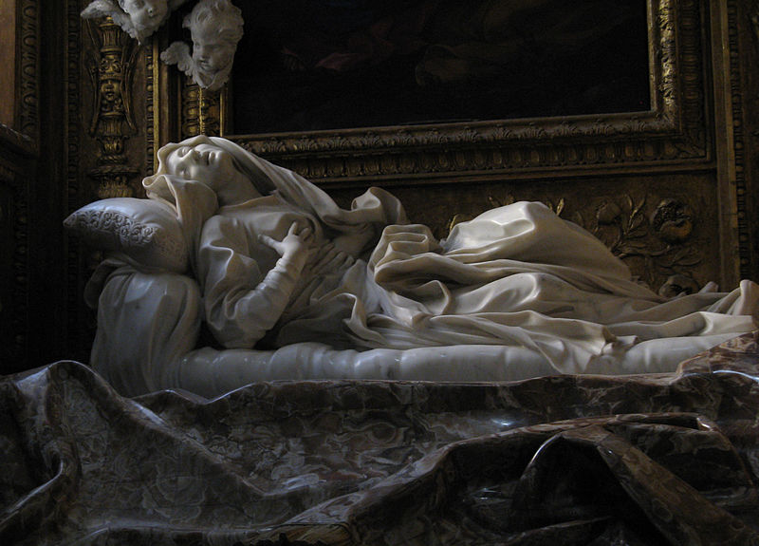

This is of the nun Ludovica Albertoni, on her deathbed in pain and in ecstasy. Is the latter sexual? Many say so. Do we share whatever it is she is depicted as feeling? Or at least resonate with it? Is it idolatrous? Again, many say so. But how we respond to these questions doesn’t really matter, for whatever our response we’re in part reacting *emotionally*. So here’s a second possibility. The baroque might be a resource for reflecting on *emotional* modes of knowing and learning.

One: otherness. Two: emotions. And three? Straightaway, we are moved to questions of *embodiment*. Baroque ways of knowing or experiencing have to do with pleasure, and pain, and the flesh. Sometimes, indeed often, in ways that are transgressive.

[12]

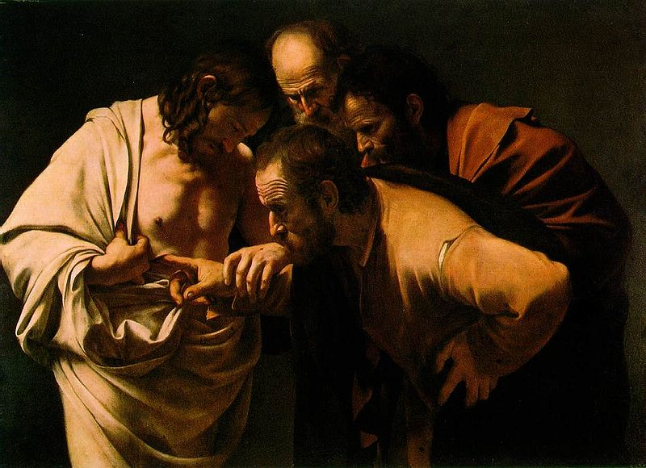

Look, for instance, at Caravaggio’s *Doubting Thomas*. Here Thomas doesn’t just doubt. He doubts so much that (and seemingly at Christ’s invitation) he presses his finger into the gaping wound left by the centurion’s lance. The picture has been understood in many ways, for instance as an expression of homoeroticism, but a more straightforward reading is that it is the flesh and only the flesh, that can vanquish Thomas’s doubts. Our doubts too.

So what’s at issue is ***sensuousness***, *bodily* but also and more generally ***materially***. For if baroque forms of experience are about bodies they are also about textures in other material forms as well. They are all about ***stuff***. In the archipelago of the baroque that’s what experience is: it is about inducing specific forms of bodily sensibility far removed from those of protestant asceticism. It is a place where mind-body dualisms don’t work, or they work differently. ***Cogito, ergo sum***? No thank you! There are no seats of consciousness removed from the flesh. So that’s the third issue: how to put body and knowing together. Or materials and knowing.

All three issues interfere with social science modes of knowing. The question is: do they do so usefully? And, more generally, if we want to cultivate our sensibilities to other forms of knowing, is there anything here that can we borrow from baroque? To think about this I draw on art history and treat the latter as a set of techniques.

# Six Techniques of the Baroque

## Theatricality

The baroque works as *theatre*.

[13]

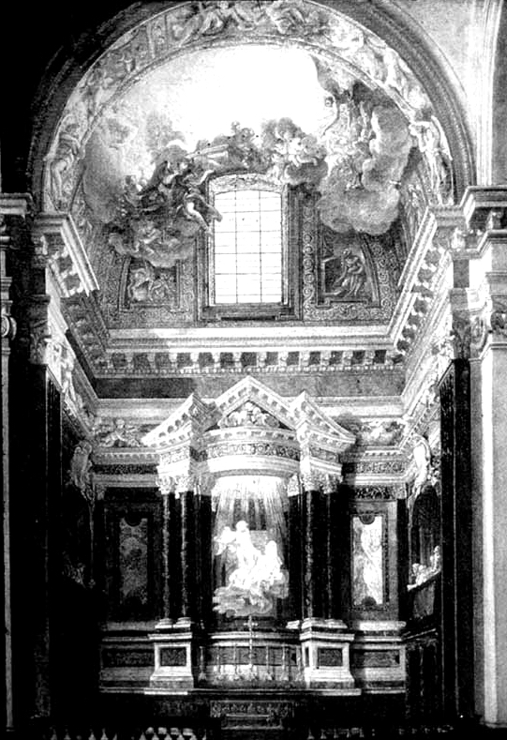

Look at this eighteenth century painting. This, which shows us the whole chapel around the sculpture of Santa Teresa, reveals that this is a space that has been set out like a stage[14]. In the middle you can see the saint and the angel. They are being brightly lit from above by a hidden source of light. They’re inside a pediment with columns on either side set at the back of a shallow chapel. In front there is an altar and a low balustrade. And then on either side of the chapel there are onlookers in *prie dieux* that look uncannily like theatre boxes. All in all it’s like a stage in a theatre. So this is the first and perhaps the most fundamental point about Bernini’s baroque technique – and the baroque more generally. It is about the *theatrical*, its effects, its dialogues, its scenery and the multiplication of its artifices.

## Boundlessness

Second, and as a part of this, baroque art-works *undo boundaries* – for instance between inside and outside. The painting above appears in most of the commentaries on the sculpture precisely because it’s more or less impossible to get a photographic overview of the chapel: you can’t get far enough away to see it as a whole or photograph it.[15] In practice, then, to see it at all, you are already being forced to step inside the theatre. But then the question is: where does the spectacle end? Who or what is inside, and who or what isn’t? The answer is that it isn’t clear, or perhaps it doesn’t end at all. Rudolf Wittkower, historian of Italian baroque art and architecture, argued what is happening is far removed from the Renaissance appreciation of art. Rather the baroque is about ‘the *elimination* of different spheres for statue and spectator’.[16] So it is with Bernini’s chapel where we can also see overflow in multiple and material forms.

First Santa Teresa’s bare foot hangs below the marble clouds on which she is lying[17]. It escapes the frame.

[18]

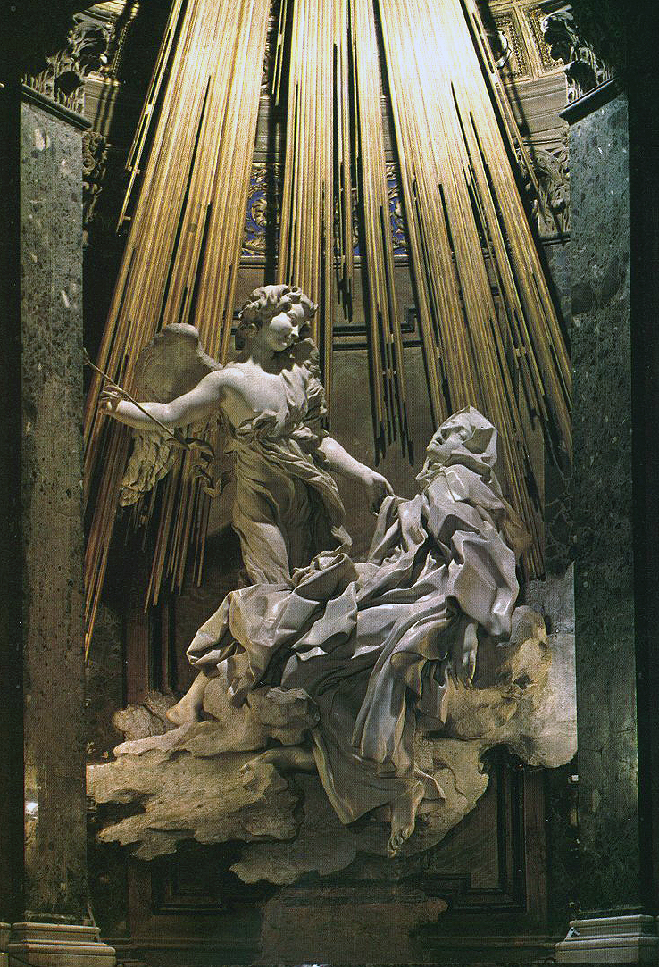

Second, the golden rays of light behind her burst out from heaven above to illuminate the divine grace being endowed on the saint in her moment of holy but transient irradiation[19]. Third, the pillars and pediment framing the sculpture look as if they are in the process of being blown open by the force of that grace. Look at the ceiling, number four, and the illusion is extended. Up above, and reaching down in a *trompe l’oeil* from far beyond the roof of the chapel, the Christian dove – the Holy Spirit – bursts through billowing clouds that are being blown aside by angels and (another artifice of boundlessness) those clouds also extend beyond the vault into the nave of the church. And, number five (more boundlessness), the marble spectators in the *prie dieux* are looking in different directions. On the one hand they are part of the spectacle and on the other hand they are not, since they also seem to be looking *at* it.

[20]

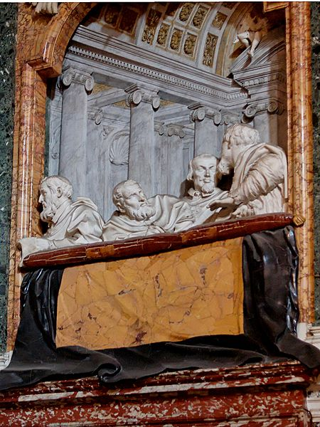

And then, six, since one of these spectators is looking out at the visitor, she, the visitor, isn’t just looking on from outside either. She’s part of the spectacle, too close to detach herself, and is being included in the exchange of gazes afforded by the spectacle. And finally, seventh, in the floor of the chapel the skeletons of the dead are looking up and gesticulating in hope of the Resurrection. The theatre of the chapel overflows into the groundlings of the underworld as well.

So this is a second stylistic technique of baroque artwork. This works its artifices to *elide the division between inside and outside*. It resists the perspectival picture framings of the Renaissance and *includes* the subject. You never stand outside and watch. If you engage with it at all, you are drawn inside. You can’t do what feminist Donna Haraway calls ‘the God trick’ of pretending that you can see it all from nowhere in particular. Instead you’re entangled. You’re *asked to*, you’re *required*,to submit and to participate.[21]

## Heterogeneity

Baroque artworks are *heterogeneous* too. They multiply their media. Bernini, we are told ‘… gave a public opera wherein he painted the scenes, cut the statues, invented the engines, composed the music, writ the comedy, and built the theatre.’[22] In other contexts Bernini also organised fireworks, and designed carnival floats, squares and fountains such as the Fontana dei Quttro Fiumi in the Piaza Navona, again in Rome.

[23]

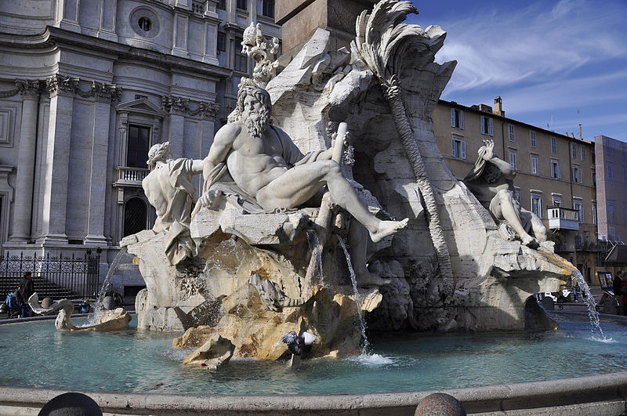

No doubt he was exceptional, but the baroque pushes towards overlapping art-media – and indeed towards universal art[24]. These media do not collapse into a single art-form, but architecture, sculpture, painting, and urban design, all are chained together. ‘What is the group,’ asked Wittkower, ‘of *St Teresa and the Angel*? Is it sculpture in the round or is it a relief?’[25]His point was that the question cannot be answered in that form.

This expresses itself in material practice in the Santa Teresa chapel. The pillars and the walls are made of rich marbles of different colours. Then there is the highly polished white marble of the statue itself. The ceiling is made of stucco, and is painted, as we’ve seen, as a *trompe l’oeil*. There are flat reliefs, again made of stucco, at the back of the *prie dieux*, perspectival renderings that meld into and appear to extend the architecture of the church itself.[26] The frame for the sculpture is architectural in form. So three-dimensional sculptural work (the statue itself) melds into bas relief, which in turn melds into two-dimensional perspectivalism, which is then interwoven with architecture. This isn’t opera. Music and the spoken word don’t last for long but, within the limits set by the ephemeral qualities of certain kinds of materials, this is a world of materially heterogeneous artifice that also combines different art forms which work in terms of more or less dissimilar conventions. If we were to go hunting for a contemporary analogue we might think of museums, or *son et lumière*, or the digital, or clubbing. We wouldn’t be thinking of more or less homogeneous texts such as the one you’re reading now. The challenge, then, is whether we need to shift our academic media if we want to know and to handle the excessive and the non-coherent.

## Folding: both one and two

But how to think about unboundedness? This question leads us to a fourth baroque technique: that of the *fold*. For the unboundedness of baroque art-work isn’t just about the absence of boundaries. Rather it works by pleating insides and outsides together. On the one hand they’re still separate, the insides and the outsides, but on the other hand they aren’t separate at all[27]. We’re in the world of the Mobius strip. The inside becomes the outside, and the outside becomes the inside. Or they are the same.

[28]

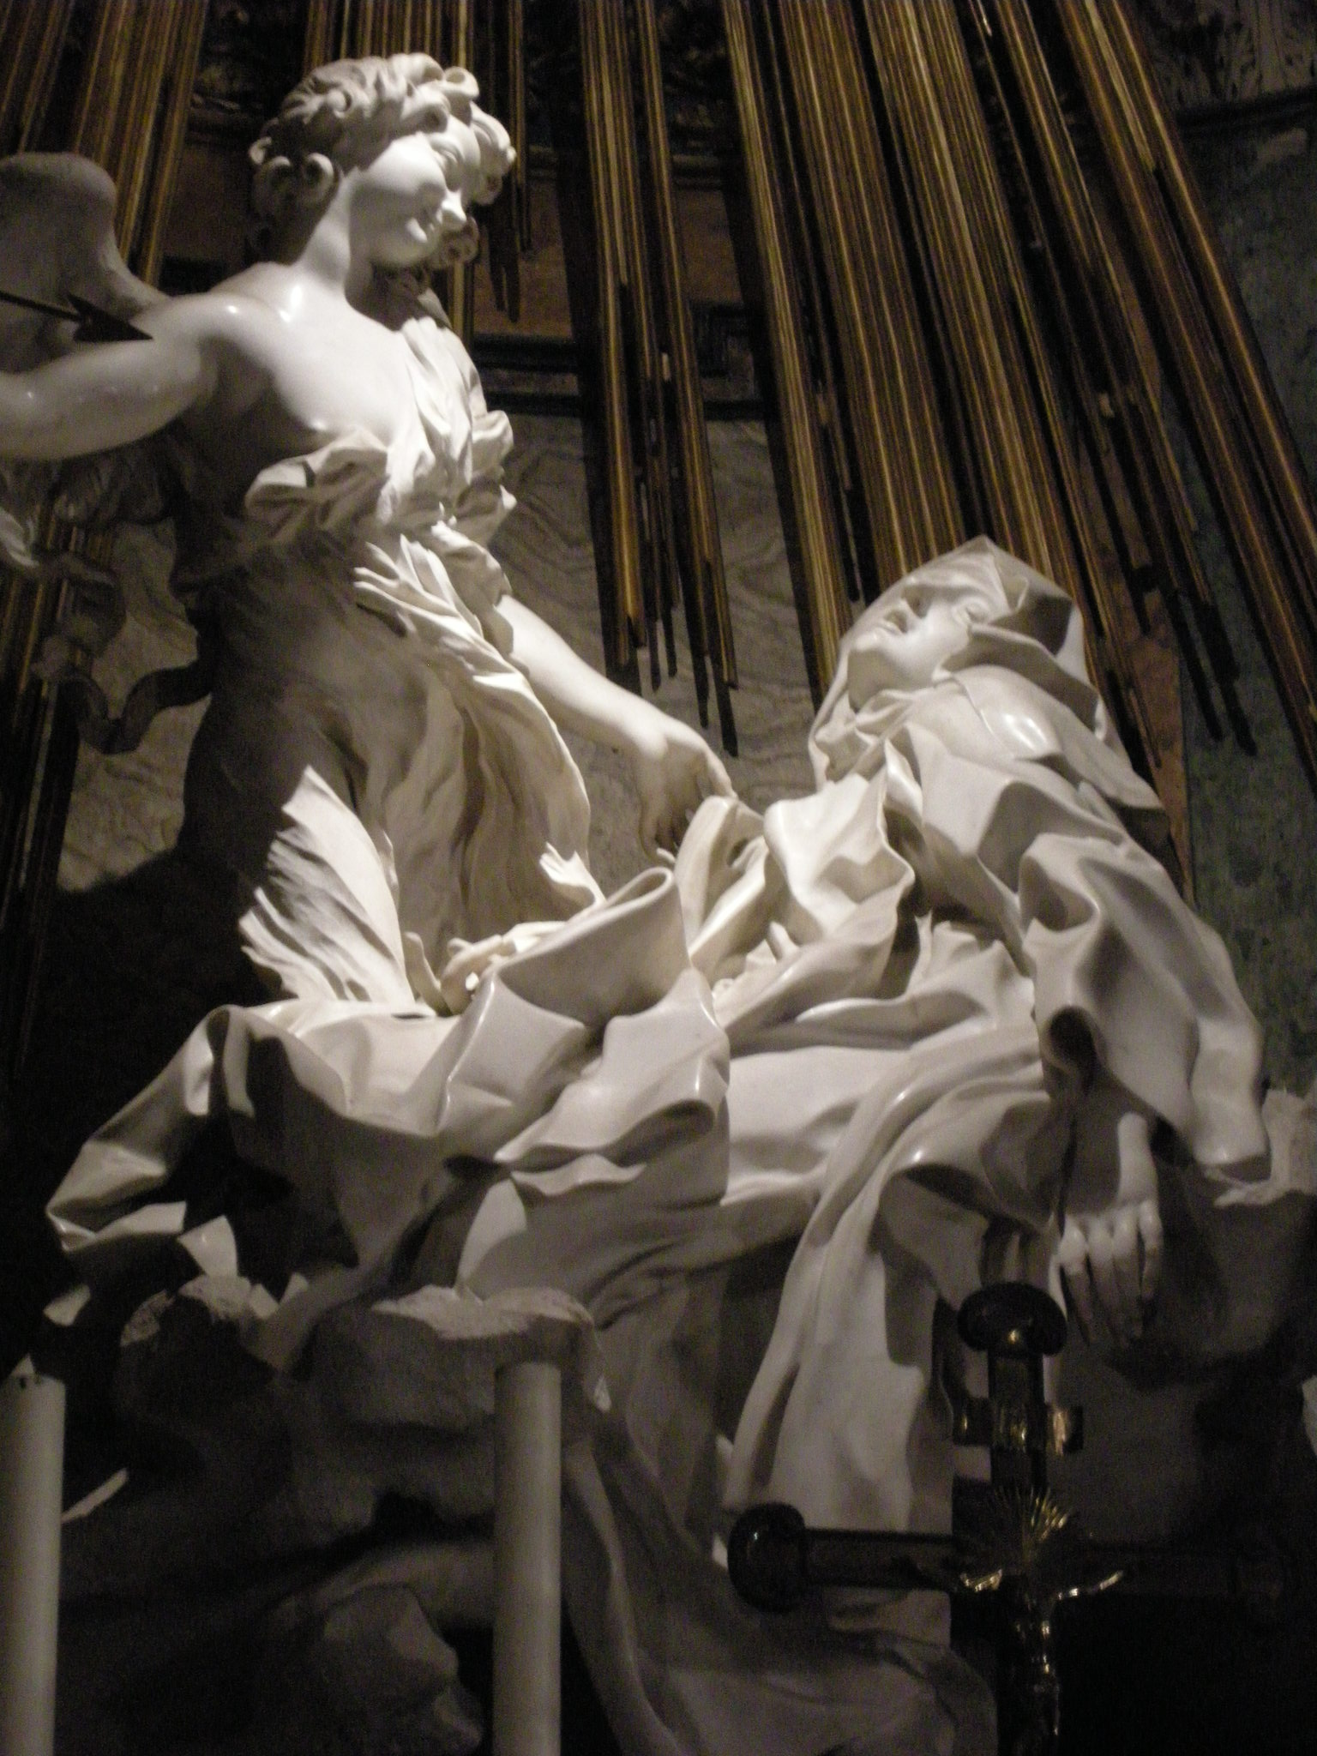

Look at the folds of Santa Teresa’s gown. Yes, in the most obvious way it covers her. We cannot see her body. There is scarcely a hint of its shape. But in another and more important respect it doesn’t cover her at all, for the grace of the Christian God stands outside her in angelic form but it is also within her, in the form of her ecstasy. We’re witnessing spiritual transcendence *and* immanence, two aspects of the same overwhelming force. But, here’s the question, how does Bernini *represent* that simultaneous separation and unity? One answer – it comes from Deleuze – is that he does this in the folds of her gown. It’s like a Mobius band. The gown has two sides, but at the same time only one. The fold expresses the single and double grace of the Holy Spirit[29].

Similar artifices are at work elsewhere. Consider again the figures in the boxes. Are they outside? The answer is yes. After all, they are (or perhaps are not) looking on. At any rate they are apart from Santa Teresa and the angel. But at the same time they are not separate, for they are also a *part* of the theatre. And we, the spectators, are in a similar position. We’re looking on so we’re outside. At the same time we are also being folded in. Such, at any rate, is the conclusion we might draw if we attend to the figure lurking at the back of the *prie dieu* on the right who is watching not only the figure turned away from us (who seems to be talking to him) but is also (as we’ve seen) looking at us as well. So we’re being included too, pleated into the mixture.

This is the fourth part of Bernini’s techniques. The artifice of the fold separates inside and outside, but undoes that separation too. It’s like a screen, a fabric with two sides that are only one side[30]. To put it differently, it is also an artifice that works through endless tension or, perhaps better, displacement, between within and without. *Within baroque art-work, to experience is to be outside and to be inside at the same time*. It is to accept and appreciate this as a condition of understanding.[31]

How to apply this thought to contemporary forms of knowing? Any answer is likely to be complicated, for in this way of thinking any form of knowing folds the outside inside itself anyway. So, for instance as I write this introduction I’m folding in: artwork from Rome; commentaries on that artwork from a range of art historians; plus a dose of social theory. The issue, then, is not so much about the *need* to fold inside but rather with *what we make of the continuity between inside and outside* once we start to acknowledge it.

## Distribution, Movement and Self-Consciousness

And this moves us a fifth set of artifices to do with *distribution* and *movement*. In the artworks of the baroque in Rome understanding is spread around. It is located in different places. Knowing is a matter of *moving*. So the sculpture of the saint and the angel lie in the spatial centre of the chapel, but for the onlookers it is more complicated. In the *prie dieux* there are conversations. Someone is reading a text (no doubt Santa Teresa’s *Life*) and even those who seem to be looking at her can’t really see her because Teresa is invisible from where these sculptured viewers stand. What’s happening is a *multiplication of viewpoints*. So what to make of this?

[32]

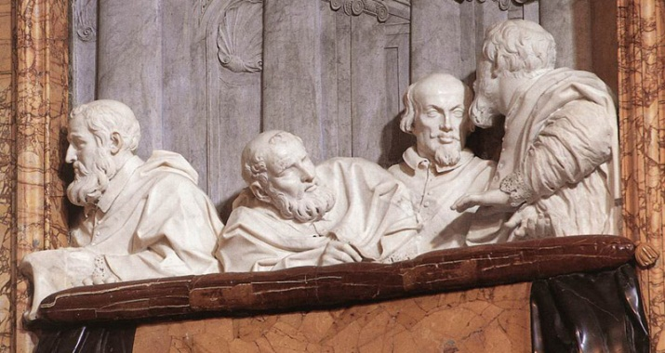

One message is that there is no one way of knowing the grace of God or the ecstasy of Santa Teresa. It arises out of *vision*. It arises out of *visions* in the plural. It grows out of the study of *texts*. It is achieved through *piety and prayer*. We can see that it arises in *discussion*. It may come in the form of *sculpture and art work*. The assumption is that human beings are limited. Only God can see the whole truth, while how human beings know is limited, more or less confused.[33] The lesson is that experience is *distributed*, but also that it is important to work at different ways of appreciating or understanding, and to try to hold onto them at the same time. Necessarily what we know is partial, but it is also multiple, allegorical, and mediated. In rejecting the humanist optimism of the Renaissance the baroque knows in ways that rest upon *multiplication*. To experience as best we can is to proliferate media, perspectives, and processes, it is to juxtapose these, and then it is to acknowledge that they cannot be pulled into a humanly coherent whole; to recognise that there is, as it were, an unknowable hole in the middle.[34]

This tells us that baroque art-works are also about *movement*, to be understood as a *process*. As I earlier hinted, the artifices of the baroque are like literal or metaphorical Stations of the Cross; or like Teresa’s four stages in the ascent of the soul[35]; or indeed like the Spiritual Exercises of St Ignatius Loyola[36]. But as we’ve just seen, we are being moved between modes of sensing and experience within the Cornaro chapel too. So, here’s a final twist: baroque artifices are also a matter of *self-consciousness*. They know that they are just *another* form of recognising – though there is nothing ironic or post-modern going on here. It is just that that any particular form of experience appreciates that since it is limited it will always be important to move on to another; and then another. All within a particular spiritual or theological hierarchy, a hierarchy exemplified, for instance, by the ceiling by Andra Pozzo in the Jesuit Sant'Ignazio church in Rome, with St Ignatius in the middle on the left, receiving the light from Jesus and from God the Father in the middle.[37]

[38]

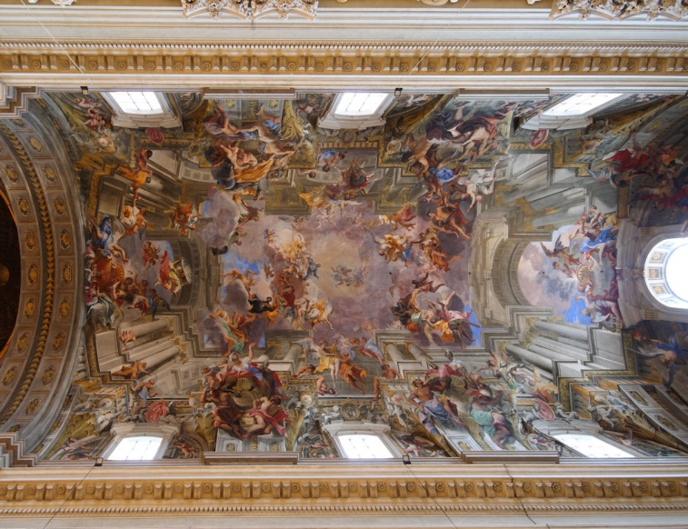

These baroque art-works thus cultivate a form of self-consciousness that is also modest in a very particular way by being located within a very particular spiritual hierarchy.[39] So it is contexted – this is the modesty part – but at the same time it is also about the possibility of moving through or rising in that hierarchy. Modesty and a kind of grand ambition are combined together in a recognition that the journey to the next Station of the Cross is beckoning and that it may lead to somewhere better through the various worldly intermediaries offered by prayer, study and devotion. So there is one way in which what is known is almost less important than the *processes of knowing itself*. Understanding cannot be detached from sensuous materiality for, as intellectual historian Chunglin Kwa observes, abstraction is foreign to the baroque.[40]

## Otherness and absence

Finally, I want to say that baroque art-works are sensible to *Otherness* – or perhaps, more modestly, to *absence –* substantially though not entirely, in the form of spiritual experience.[41] For as we have seen, understanding is about being seized and transported somewhere else passionately, sentimentally, ecstatically, and/or fearfully. This is the work that Bernini’s Santa Teresa is doing, for this is the materialisation of a story that would have been entirely familiar to its seventeenth century viewers. It is the rendition of a powerful *upward movement* from mundanity to spiritual mystery. Wittkower proposes three levels. There’s the human: you, me and the Cornaros in their boxes. Here we are more or less in the dark, both literally and figuratively. We are looking on, we are trying, we are praying or reading, we are hoping that we will be swept up, but we are also thoroughly *mundane*. Then there’s Santa Teresa, in her ecstasy, pierced by the love of God. She is the brilliantly lit *intermediary*, human but transported beyond the human. So she is the second level. Then, third, and high above us there is the *transcendent God* in the form of the *trompe l’oeil* ceiling, for if we enter the illusion properly there is no ceiling. Instead we are gazing up, as Wittkower puts it, at ‘the unfathomable infinity of the empyrean’[42]. Such is the spiritual hierarchy being engineered here, a move from the dark below to the limitless light of the Holy Spirit.

So the message is Catholic. But, like Wittkower, we may also make the argument in more secular terms. ‘If’, he writes, ‘[the viewer] yields entirely to the ingenious and elaborate directions given by the artist, he will step beyond the narrow limits of his own existence and be entranced within the causality of an enchanted world.’[43] His point has in part to do with irreducible *difference*. The divine cannot be contained within the mundane, and the challenge is: how do we go about trying to apprehend it? But this is what is being attempted. These art-works are a set of artifices for recognising, acknowledging, and embracing the otherworldly; for experiencing the work of the Holy Spirit. Push the thought into the realm of the secular, and they become techniques for recognising and relating to absence or Otherness. And once again they pose the question: is there something here that might be borrowed from the baroque if we are interested in ways of knowing excess within the contemporary academy? Of recognising the whole that is, at the same time, a hole in our artefacts of knowing or experiencing?[44]

# The Performativity of Baroque-works

The styles that we discover when we visit the baroque may be imagined as a possible set of more or less experimental resources for playing with sensibilities to the peripheral. But what of the fact that it has often been the object of a bad press? The word ‘baroque’ started life in the eighteenth century as a pejorative term to describe the supposedly misshapen and inappropriate exuberance of art of the Catholic Counter Reformation.[45] And its politics have always been controversial, for, as Protestants well-recognised, it was part of an elaborate and well-developed *strategy of power*. To engage with its art-works (for instance Santa Teresa) was to engage spiritually, emotionally and physically with a Roman Catholic version of the Christian God, and to be embedded in the set of intermediaries – the papacy, including the worldly power and wealth of popes – that went with Roman Catholicism[46]. So there is a power strategy embedded in the chapel and more generally in the baroque. It is to *shock*, *to awe*, *to move*, to *demand participation*, and to *dominate*.

Perhaps, then, to be interpolated is to collude. José Antonio Maravall shows how the Spanish seventeenth century baroque was as an absolutist response to the multiplication of the crises, economic, social and military of that century. The issue was how control might be maintained in a precarious urban world of embryonic mass culture in which the material certainties were under threat, but the nascent inquiring individualism and freedoms of the Renaissance could not be pushed back into their box. The answer was the creation of what he calls the ‘guided culture’ of the baroque: ‘[i]t was not a question of merely imposing silence but also of guiding.’[47] He argues (we’ve seen this in the Cornaro chapel) that it worked by turning spectators into accomplices by incorporating them into unfinished scenes and working on their emotions. So the lesson here is clear: unless we’re committed to versions of hierarchical social control appropriate to mass culture then we need to be cautious.

But sometimes the baroque is not authoritarian. Yes, in many Latin American historical contexts baroque architecture and art were part of the colonising Spanish culture. Alongside military and political repression, the monarchy and Catholicism moved to metaphorical seduction in the form of elaborate ceremonies, expansive town squares and ornate baroque churches.[48] But the styles imported by the Spanish also turned themselves into modes of resistance. The demands for conformity were converted into a resource for other exuberant and non-conformist but equally baroque agendas. Bolivar Echeverria draws on Georges Bataille to argue that it was the repression in Latin America that made transgression possible.

‘[I]n its theatrical use of the indisputable formal canon, baroque art found the opportunity to animate all its petrified gestures and to revitalize the situation in which it was constituted as a negation and sacrifice of the Other.’[49]

In this reading, division and resistance turned around an opposition between formal and informal, and in particular between the rational calculations of the quantitative and the vital energy of the qualitative. To put it simply, the baroque was a culture in tension. It was indeed repressive but it was also (and therefore) about the *transgressions* of lively excess, about ‘obeying without fulfilling’.[50]

So it isn’t necessarily conservative, and Walter Benjamin knew this too. His rejected *Habilitation* thesis on German tragic drama[51] foreshadows his later concern with the possibility of redemption through attention to fragmentation. The simple stories of history and necessity, myths he called them, are broken up in the desolation and hopelessness of seventeenth century tragic baroque drama. And the tool is allegory. ‘Allegories are,’ he famously insisted, ‘in the realm of thought what ruins are in the realm of things.’[52] Broken and incomplete, set alongside one another they don’t hold together, and offer the basis for resisting the smoothing stories of history that otherwise work to paper over the cracks. They work as mute witnesses to the alternatives that have been written out of the record. So the task of the baroque scholar is to find ways of giving them voice.[53]His fragmented albeit ambitious story is thus a parable about the importance of cultivating a baroque sensibility to the alternatives, indeed the ruins, and to the Others that have been lost[54]. Allegory becomes a tool for arresting history and recuperating that which has been erased by the storm of progress[55]. And, indeed, this is a sensibility integral to the modern world in its earliest manifestation – the baroque.

These two brief detours tell us that to experiment with the artifices of the baroque is not necessarily to be conservative. But the larger lesson is that baroque techniques that are deliberately *interventionary*. They describe or represent the world – for instance the ecstasy of the Saint – but they do not just describe, for as they describe they also seek to make a difference. Representation and intervention are knowingly bound together. To put it differently, *baroque artifices are explicit about the fact of their own performativity*. They are about shaping the world, operating upon it, and formatting it one way or another. Descriptions are never idle.[56]

But what should we make of the *elasticity* of the category? The fact that the baroque is an archipelago rather than a single historical reality? As I have noted, art historians remind us that ‘the baroque’ appears in different modes in different parts of the world at different times[57], and that the label was pasted onto what it describes long after the event. They add that this labelling may itself have had performative effects[58]. And indeed the commonalities between (say) Bernini, Caravaggio, Rembrandt and Rubens, not to mention the eighteenth century baroque architecture of Latin America become hard to discern.[59]

But then the meaning of the term has shifted too[60]. As I have just noted, the term started out as a term of *retrospective disapprobation*, pinned to artwork that was taken to be misshapen, excessive and exuberant. Then it got turned into a *period of artistic production*, one that supposedly followed the Renaissance (perhaps as the Renaissance ‘gone wrong’) but preceded the constraints of Neo-Classicism. And then it appeared in a third incarnation as an *artistic style*. So Wölfflin treated the baroque as a ‘complex of symptoms’[61]: first it was ‘painterly’, suggesting displacement and movement by attending to vague forms, for instance in the form of light and shadow; second it was massive, amorphous and intimidating, rendering matter supple and turning corners into curves; and then, third, it worked through movements – especially upward movements – of curves, rhythmic sequences, dissonances, and incompletenesses in which form dissolved fleetingly into light[62].

So its history covers denunciation, period, and style. But the term is still on the move. More recently still it has transformed itself into identifiable *operating principles*, though the character of these principles depends upon who you choose to read. Indeed we’ve come across such principles in two versions already. Benjamin’s move to freeze allegorical ruins and their redemptive juxtapositions is the first. And Deleuze’s quite different insistence on folds and pleats is the second. ‘[W]e all’, concludes the latter in *Le Pli*, ‘remain Leibnizian because what always matters is folding, unfolding, refolding’[63]. And if we’re listing operating principles, we would need to add Foucault’s archaeological analysis of the classical episteme. Here the baroque becomes a table of representations, a linguistic grid preoccupied with the endlessly uncertain classifications and taxonomic orderings of signs, a grid with an absence at its centre.[64]

No doubt the list might be further extended. But its variety and the way it has recently shifted to attend to operating principles and functions suggest not only that it is not just politically conservative. It also reveals an increasing propensity to think of ‘the baroque’ as a set of *tools for formatting experience, forms of understanding and realities* as a response to contemporary questions. The focus, as I noted above, is on the *performativity* of the baroque. In this way of thinking it becomes a set of techniques for interfering with some, at least, of the binaries that have shaped and been reproduced in our modes of knowing in the sciences and the social sciences. A possible set of tools for sensitising ourselves to what lies at the peripheries of social science knowing rather than in the centre of our focus. Tools which we may set alongside others.

# Visions of the Empirical Baroque

Disciplinary knowing is necessarily specialist knowing. But in an era when the material forms of knowing are changing, academic structures are under pressure, there are calls for impact and applicability, and the contexts for lay knowledge are evolving (most notably with the creation of electronic media and communities), academic social science is under pressure. Sometimes that pressure turns into crisis, and it becomes clear that our modes of knowing are serving us badly. Then it becomes important to look for resources that interfere with those repressions. And, as I have just said, the baroque becomes an interesting candidate. Not the answer. But something we can play with, safely removed, as we are, from many of its more sinister consequences.

There is much writing in the social sciences about ‘the baroque’. Most of it is either historical or seeks to explore the ‘neo’ or the ‘contemporary’ baroque[65], but much takes the form of exegeses and commentaries on authors such as Benjamin, Deleuze and Foucault. This book draws on these resources but its focus is predominantly empirical. We don’t want to contribute to the already large theoretical literatures on the baroque. Even less do we want to create a new ‘baroque moment’. Rather the book seeks to explore a much more specific set of questions: what borrowings from the baroque archipelago and its various histories, practices, artifices, philosophies and politics, might do in particular ways for *empirical* research in the social sciences and the humanities. To be sure, the divide between theory and the empirical is both arbitrary and conventional. It is, in any case, a division that makes little sense from the standpoint of a baroque sensibility – the latter mostly didn’t theorise itself, and it certainly had no notion of theorising as abstraction[66].

Unsurprisingly, given both the heterogeneity of the baroque and the diversity of their concerns, the contributors experiment with or react to versions of the ‘empirical baroque’ in very different ways. But overall they work in one of two ways. On the one hand, some describe and explore alternative modes of knowing in ways that are influenced by a dialogue with the concerns of the baroque. On the other hand, and again in dialogue with the baroque, some seek to experiment directly with other ways of knowing and other kinds of knowledge practices. The overall result is, indeed, experimental and sometimes it is provocative too, but we also hope that it will help to lever open some of the more restrictive assumptions about what it is to know in social science.

## Mattijs van de Port

Our experience is disorderly and excessive. But so too is the baroque. So there’s an opportunity here, if we want to know excess, but there is also a danger. If we subject the baroque to the orderly aesthetics of academia then this may threaten its powers of disruption, which would make the whole project of exploring baroque ways of writing kind of redundant. Perhaps if we ask, instead, what a baroque register *does* (rather than what it *is*) this might help us out of this problem. Taking the baroque that I am most familiar with – the baroque that I encountered in Salvador da Bahia, Brazil – as an empirical starting point for my explorations, I discuss how this aesthetic enters into *experience*; how it differs from the ways in which we now go about knowing.

## Hugh Raffles

What can a stone do? What can a *baroque* stone do? What can a stone do *baroquely*? In this essay, I try to take seriously the ethnographic-empirical ideal of staying close to a research object and, as a corollary, rather than following the object, I surrender to its lead. This experiment responds to the present volume’s elaboration of the baroque in two ways: 1. It enacts the possibility of a radically open empirical sensibility in which outcomes are driven by the object’s life and propensities; and 2. It attempts to distort and displace the site of articulation of empirical investigation, ceding empirical jurisdiction to the object.

## Ingunn Moser

Alzheimer’s: How can the present be non-coherent, old together all sorts of pasts, and presents. How can there be apple juice and going home where you expect your mother to look after you, and all sorts of other events. (Learning about time from Alzheimer’s, but appreciating that all of us play with the complexity of times, which suggests it might be useful to bring in examples that don’t have to do with Alzheimer’s.

## Annemarie Mol

Annemarie Mol moves us to the kitchen to explore the issue of coherence. How, she asks, does a clafoutis hold together sufficiently to be created and eaten? She notes that if it is to be successful, the dish needs, like the baroque, to hold a series of quite different worlds together – in this case these include versions of agriculture, cuisine, nutrition, and versions of pleasure or taste. That these cohere in the form of this dish is an achievement, and it isn’t obvious. And the problem is compounded by the material form of the dessert. Unlike a Bernini statue or the London Stone which may last for centuries if the conditions are right, a clafoutis has to be recreated every few days: what she calls the ‘clafoutis-assemblage’ has to be done again and again. But the uncertainty of its coherence is reduced by the fact that it may be done in different ways. Mol’s point is that coherence is complex: indeed, that it is mysterious. It is also experimental: perhaps we should take seriously the idea that cooking is a mode of knowing.

## Antoine Hennion

Antoine Hennion revisits the baroque revival in ancient music of the 1980s and the 1990s and argues that the notion of the baroque was itself performative, enacting new modes of empirical sensibility in ways that were relatively pluralistic. When the revival movement insisted that ‘music should be played differently’ this was a way of opening up questions that had been effaced in music history, and hearing the past as indeed being past, different, or other. The shift, then, was from seeing music as being fixed in a score to a matter of bodily performance. But, continues Hennion, how can we learn from or know this? It isn’t good enough to depend on text, and simply write an academic paper. We also need to experiment with music and musical performance. Obviously this experiment cannot itself take place between the covers of a book. We are constrained in the ways I rehearsed earlier, by our media and materials. But the chapter describes workshop experiments undertaken by Hennion in which the audiences became part of the experiment.

## Matei Candea

The section opens with reflections on ethnographic fieldwork. Candea takes us to Southern Africa where, as he puts it, ‘I follow scientists who follow meerkats around the Kalahari desert’. He notes that there are two somewhat related empirical observational sensibilities – biological and anthropological – at work here. Candea explores their similarities and dissimilarities by playing the Deleuzian fold up against what he refers to as the Renaissance cut with its concern with clarity in the form of distinction. The play between cut and fold runs through many contemporary academic contexts including anthropology. In his paper Candea side-steps the division by invoking Impressionist experiments in art in which the two – the classical and the baroque, or the cut and the fold – are held together experimentally.

## Helen Verran

Whole and parts in different variants are also the focus of this chapter. Her particular concern is with the character of generalising. Working in a way that resonates with contributions by Law and de Port, she argues that generalising takes two forms. In a romantic version, and here she talks about *one-many* generalising, units or elements are precisely defined. It is their similarities which allow them to be aggregated together to produce a collectivity, and the character of that aggregated collectivity is also clear. Baroque generalising works the tension of vagueness and precision differently. Strategic vagueness of a whole allows multiple, distinct parts to be articulated. She shows how these two forms of generalising are often combined and wonders about the usefulness of making the contrast and naming it as one which sets the romantic against the baroque.

## John Law

In this chapter John Law takes us to a messy and overwhelming ethnographic field site: the fish farm. Here, all juxtaposed together, there are people, technologies, fish, feedstuffs, and naturally occurring elements such as air, water and birds. It’s possible to describe and analyse this in all sorts of ways, but the paper works by mimicking the analysis of Bernini’s Santa Teresa status and its setting outlined in the introduction. The aim is to show how an object (in this case a baroque sculpture in its architectural setting) may evoke or suggest a method of analysis that is quite unlike those of standard social science.

## Mario Blaser & Marisol de la Cadena

[A material post-colonial way of knowing]

## Evelyn Ruppert

Information is Beautiful. Ruppert investigates contemporary practices of visualising large arrays of digital data to know collectives. Ostensibly generated by an empirical and technical data science, she explores how visualisations involve a sensory experience of the social and make what is ineffable ‘experientially real’ (as van de Port puts it). Visualisations she argues provoke an exuberant sense of the social that do not 'undo its mystery' but enhance its Otherness as an excess beyond representation.

## Adrian Mackenzie

[For discussion]

# References

Alpers, Svetlana (1988), Rembrandt’s Enterprise: the Studio and the Market, Chicago: Chicago University Press.

Alpers, Svetlana (1989), The Art of Describing: Dutch Art in the Seventeenth Century, London: Penguin.

Avery, Charles (1997), Bernini: Genius of the Baroque, London: Thames and Hudson.

Bal, Mieke (1999), Quoting Caravaggio: Contemporary Art, Preposterous History, Chicago and London: Chicago University Press.

Benjamin, Walter (1985a), One Way Street and Other Writings, London: Verso.

Benjamin, Walter (1985b), The Origin of German Tragic Drama, translated by John Osborne, London: Verso.

Benjamin, Walter (1992), 'Theses on the Philosophy of History', pages 245-255 in Illuminations, London.

Benjamin, Walter (1999), The Arcades Project, translated by Harry Zohn, Cambridge, Mass., and London: Harvard University Press.

Buci-Glucksmann, Christine (1994), Baroque Reason: the Aesthetics of Modernity, translated by Patrick Camiller, Theory, Culture and Society, London, Thousand Oaks and New Delhi: Sage.

Buck-Morss, Susan (1989), The Dialectics of Seeing: Walter Benjamin and the Arcades Project, Cambridge Mass.: MIT.

Callon, Michel, and Bruno Latour (1981), 'Unscrewing the Big Leviathan: how actors macrostructure reality and how sociologists help them to do so', pages 277-303 in Karin D. Knorr-Cetina and Aaron V. Cicourel (eds), Advances in Social Theory and Methodology: Toward an Integration of Micro- and Macro-Sociologies, Boston, Mass: Routledge and Kegan Paul.

Caygill, Howard (2011), 'Ottomen Baroque: the Limits of Style', pages 65-79 in Helen Hills (ed.), Rethinking the Baroque, Farnham, UK, and Burlington, Vermont: Ashgate.

Chakrabarty, Dipesh (2000), Provincializing Europe: Postcolonial Thought and Historical Difference, Princeton and Oxford: Princeton University Press.

DaCosta Kaufmann, Thomas (2011), 'Discomfited by the Baroque: a Personal Journey', pages 84-98 in Helen Hills (ed.), Rethinking the Baroque, Farnham, UK, and Burlington, Vermont: Ashgate.

Deleuze, Gilles (1993), The Fold: Leibniz and the Baroque, London: The Athlone Press.

Echeverria, Bolivar (2005), 'Modernity and Capitalism (15 Theses)', in Revista Theomai / Theomai Journal; Estudios sobre Sociedad, Naturaleza y Desarrollo / Society, Nature and Development Studies, 11 also available at <http://revista-theomai.unq.edu.ar/numero11/artbolivarecheverria11.htm>.

Escobar, Arturo (2008), Territories of Difference: Place, Movements, Life, *Redes*, Durham and London: Duke University Press.

Foucault, Michel (1972), The Archaeology of Knowledge, London: Tavistock.

Gandolfo, Daniella (2009), The City at its Limits: Taboo, Transgression, and Urban Renewal in Lima, Chicago and London: The University of Chicago Press.

Gouldner, Alvin (1973), 'Romanticism and Classicism: Deep Structures in Social Science', Diogenes, 21: (82), 88-107.

Hall, David L., and Roger T. Ames (1995), Anticipating China: Thinking Through the Narratives of Chinese and Western Culture, Albany: State University of New York.

Haraway, Donna J. (1989), Primate Visions: Gender, Race and Nature in the World of Modern Science, London: Routledge and Chapman Hall.

Haraway, Donna J. (1991), 'Situated Knowledges: the Science Question in Feminism and the Privilege of Partial Perspective', pages 183-201 in Donna Haraway (ed.), Simians, Cyborgs and Women: the Reinvention of Nature, London: Free Association Books, also available at <http://www.staff.amu.edu.pl/~ewa/Haraway,%20Situated%20Knowledges.pdf>.

Haraway, Donna J. (1997), Modest_Witness@Second_Millennium.Female_Man©_Meets_Oncomouse™: Feminism and Technoscience,, New York and London: Routledge.

Hibbard, Howard (1990), Bernini, London: Penguin.

Hills, Helen (2007), 'The Baroque: Beads in a Rosary or Folds in Time', Fabrications: The Journal of the Society of Architectural Historians, Australia and New Zealand, 17: (2), 48-71.

Hills, Helen (2011a), 'The Baroque: Grit in the Oyster of Art History', pages 11-36 in Helen Hills (ed.), Rethinking the Baroque, Farnham, UK, and Burlington, Vermont: Ashgate.

Hills, Helen (ed.) (2011b), Rethinking the Baroque, Farnham, UK, and Burlington, Vermont: Ashgate.

Kuhn, Thomas S. (1970), The Structure of Scientific Revolutions, Chicago: Chicago University Press.

Kwa, Chunglin (2002), 'Romantic and Baroque Conceptions of Complex Wholes in the Sciences', pages 23-52 in John Law and Annemarie Mol (eds), Complexities: Social Studies of Knowledge Practices, Durham, N.Ca and London: Duke University Press.

Lambert, Gregg (2004), Return of the Baroque: Art, Theory and Culture in the Modern Age, London: Continuum.

Latour, Bruno (1993), We Have Never Been Modern, Brighton: Harvester Wheatsheaf.

Latour, Bruno (2001), 'Gabriel Tarde and the End of the Social', pages 117-132 in Patrick Joyce (ed.), The Social in Question. New Bearings in History and the Social Sciences, London . Routledge, also available at <http://www.ensmp.fr/~latour/articles/article/082.html>.

Latour, Bruno (2010), '"Thou Shalt Not Freeze Frame," Or How Not to Misunderstand the Science and Religion Debate', pages 99-123 in On the Modern Cult of the Factish Gods, Durham and London: Duke.

Latour, Bruno, and Steve Woolgar (1986), Laboratory Life: the Construction of Scientific Facts, Second Edition, Princeton, New Jersey: Princeton University Press.

Law, John (2002), Aircraft Stories: Decentering the Object in Technoscience, Durham, N.Ca.: Duke University Press.

Law, John (2004), After Method: Mess in Social Science Research, London: Routledge.

Leibniz, Gottfried Wilhelm (1998), 'Monadology', pages 268-281 in R.S.Woodhouse and Richard Franks (eds), G.W. Leibniz: Philosophical Texts, Oxford and New York: Oxford.

Mannheim, Karl (1953), 'Conservative Thought', pages 74-164 in Karl Mannheim (ed.), Essays on Sociology and Social Psychology, London: Routledge and Kegan Paul.

Maravall, José Antonio (1986), Culture of the Baroque: Analysis of a Historical Structure Manchester: Manchester Univerisity Press.

Mol, Annemarie (2002), The Body Multiple: Ontology in Medical Practice, Durham, N. Ca., and London: Duke University Press.

Popper, Karl R. (1959), The Logic of Scientific Discovery, London: Hutchinson.

Shapin, Steven (1984), 'Pump and Circumstance: Robert Boyle's Literary Technology', Social Studies of Science, 14, 481-520.

Shapin, Steven, and Simon Schaffer (1985), Leviathan and the Air Pump: Hobbes, Boyle and the Experimental Life, Princeton: Princeton University Press.

Stengers, Isabelle (2008), 'Experimenting with Refrains: Subjectivity and the Challenge of Escaping Modern Dualism', Subjectivity, 22, 38-59.

Teresa of Àvila (1964), The Life of Teresa of Jesus: Image Books.

Toman, Rolf (ed.) (1998), Baroque: Architecture, Scultpure, Painting, Köln: Könemann Verlagsgesellschaft mbH.

van de Port, Mattijs (2011), Ecstatic Encounters: Bahian Condomblé and the Quest for the Really Real, Amsterdam: Amsterdam University Press.

Verran, Helen (2001), Science and an African Logic, Chicago and London: Chicago University Press.

Wittkower, Rudolf (1997 [1955]), Bernini: the Sculptor of the Roman Baroque, London and New York: Phaidon.

Wittkower, Rudolf (1999 [1958]), Art and Architecture in Italy 1600-1750: II High Baroque, revised by Joseph Connors and Jennifer Montague, New Haven and London: Yale University Press.

Wölfflin, Heinrich (1984), Renaissance and Baroque, London: Collins.

1. I am grateful to the participants at the workshop on ‘The Baroque as Empirical Sensibility’ June 11th-13th 2011 at the Manchester Museum in the University of Manchester who brought the topic of the baroque in the contemporary humanities and social science to life. This introduction reflects many themes raised in that meeting. The workshop was sponsored by the UK’s Economic and Social Research Council (ESRC) Centre for Research in Socio-Cultural Change (CRESC), and I am grateful to CRESC and the ESRC for financial support for the event. I am particularly grateful to Antoine Hennion, Helen Hills, Annemarie Mol, Hugh Raffles and Evelyn Ruppert who commented on earlier drafts of this piece.
2. Serres {, 2012 #3755}.
3. Ufan {, 2011 #3756}.
4. Kerle {, 1995 #798}.
5. Teresa of Àvila {, 1964 #3542}.
6. <http://commons.wikimedia.org/wiki/File:Santa_Maria_della_Vittoria_-_7.jpg>
7. <http://upload.wikimedia.org/wikipedia/commons/3/3a/Ecstasy_of_St_Theresa_-_arrow.jpg>
8. Teresa of Ávila (1964, 164).
9. In what follows I draw on Wittkower (1997 [1955]; Wittkower: ), Hibbard (1990), Avery (1997), Toman (1998) and Hills (2007).
10. <http://en.wikipedia.org/wiki/File:LouisXIV-Bernini.jpg>
11. <http://en.wikipedia.org/wiki/File:Giovanni_Lorenzo_Bernini-Blessed_Ludovica_Albertoni-Basilica_of_San_Francesco_a_Ripa.jpg>
12. <http://commons.wikimedia.org/wiki/File:The_Incredulity_of_Saint_Thomas_by_Caravaggio.jpg>
13. From <http://commons.wikimedia.org/wiki/File:Cappella_Cornaro.jpg>.
14. See, for instance, Avery (1997, 144).
15. Wittkower (1997 [1955], 158).
16. Wittkower (1997 [1955], 15). My emphasis.
17. It’s important that her foot is bare: she was the founder of the discalced – the shoeless – Carmelites.
18. <http://upload.wikimedia.org/wikipedia/commons/thumb/3/3e/Estasi_di_Santa_Teresa.jpg/512px-Estasi_di_Santa_Teresa.jpg>
19. ‘By contrast to the calm, diffused light of the Renaissance, this directed light [of the baroque] seems fleeting, transient, impermanent.’ Wittkower (1999 [1958], 14).
20. <http://commons.wikimedia.org/wiki/File:Cornaro_SM_della_Vittoria.jpg>
21. This is the topic of considerable discussion in science and technology studies. See Haraway (1991) and Shapin (1984).
22. John Evelyn, quoted by Wittkower (1997 [1955], 13).
23. <http://en.wikipedia.org/wiki/File:Rome_Fontana_dei_Quattro_Fiume_10-01-2011_11-54-14.JPG>
24. Deleuze, 1993 #884, 123}.
25. Wittkower (1999 [1958], 14).
26. Wittkower, 1997 [1955] #3546, 158}.
27. The argument comes from Deleuze (1993); see also Hills (2007) who explores Deleuze’ argument in part with an account of Bernini’s Santa Teresa.
28. <http://upload.wikimedia.org/wikipedia/commons/5/5b/Santa_teresa_di_bernini_03.JPG>
29. The argument comes from Deleuze. ‘And when the folds of clothing spill out of painting, it is Bernini who endows them with sublime form in sculpture, when marble seizes and bears to infinity folds that cannot be explained by the body, but a spiritual adventure that can set the body ablaze.’ (1993, 121-122). Though Hibbard (1990, 140) offers an alternative reading that deserves serious attention. His suggestion is that it is the angel who is partially clothed in fire, ‘a clinging, flame-like drapery’. By contrast, the saint is clothed (he suggests) in a ‘coarse cloth’ and seems ‘almost earthbound, as if dragged down by the weight of material that seems to suffocate her.’ The effect, he adds, is a ‘poignant contrast between spirit made flesh and flesh made spirit’. Perhaps, then, we need to see the folds of the two gowns themselves as folded. For further commentary see Hills (2011a, 28).
30. I am misquoting Leibniz here. See Leibniz (1998), but of course the point is Deleuze’s.
31. There are some responses to this question. Kwa (2002) argues that there is a subordinate but long-term baroque tradition at work in parts of the natural sciences, including meteorology and environmental science, where outsides are found within. Arguably so called ‘actor-network’ theory also works in terms of a similar – and monadological – sensibility folding insides and outsides together. See, for instance, Callon and Latour (1981) and Latour (2001). For further commentary see Law (2004).
32. This picture comes from Wikimedia Commons at <http://upload.wikimedia.org/wikipedia/commons/a/a0/Cornaro_SM_della_Vittoria.jpg>
33. I borrow from Leibniz (1998).
34. The incapacity to step outside is also reflected in seventeenth century Netherlandish artistic practice, with rather different social, religious and economic effects. See Alpers (1989).
35. These moved through different versions of contemplation, prayer, and ecstatic union with God.
36. These exercises that that were practised by the devout Bernini for the larger part of his life. Bernini also went to mass daily for forty years Wittkower, 1997 [1955] #3546, 56, 196}.
37. I thank Hugh Raffles for discussion on this point.
38. <http://upload.wikimedia.org/wikipedia/commons/3/30/Sant_ignazio_ceiling.jpg>
39. I thank Hugh Raffles for discussion on this point.
40. Kwa (2002).
41. For the argument that the baroque as understood by Walter Benjamin, can be understood as an aesthetics of Otherness, see Buci-Glucksmann (1994).
42. Wittkower (1997 [1955], 158).
43. Wittkower (1997 [1955], 158).
44. I am grateful to Antoine Hennion for discussion on this point, and I am grateful, also the Mattijs van de Port for the inspiration of his work on Bahian condomblé. See van de Port (2011).
45. Maravall (1986, 208).
46. Include in this pantheon the rich and powerful Cornaro clan, for as we gaze at Santa Teresa the person looking at us is none other than Cardinal Frederico Baldissera Bartolomeo Cornaro, son of one Venetian Doge and brother of another. So the question is: what are we doing in his family chapel which is, let’s remember, also his sepulchre? The answer is that alongside everything else, we’re subjecting ourselves to his scrutiny in addition to that of God.
47. Maravall (1986, 73).
48. Though he feels uneasy with the term baroque, see DaCosta Kaufmann (2011).
49. Echeverria (2005), in somewhat shaky translation. Echeverria’s argument is picked up and explored by Gandolfo (2009).
50. Echeverria (2005).
51. Benjamin (1985b).
52. Benjamin (1985b).
53. For Benjamin in the form of the card index and the juxtaposed notes that make up the ruins of his unfinished *Arcades Project* . Benjamin (1999). He writes about the card index as ‘the conquest of three-dimensional writing’ in *One Way Street* (Benjamin: 1985a, 62). For commentary see Buck-Morss (1989).
54. Buci-Glucksmann (1994).
55. A misquote from the ninth of Benjamin’s *Theses on the Philosophy of History* with its commentary on Paul Klee’s *Angelus Novus*. ‘[The angel’s] face is turned towards the past. Where we perceive a chain of events, he sees one single catastrophe which keeps piling wreckage upon wreckage and hurls it in front of his feet. The angel would like to stay, awaken the dead, and make whole what has been smashed. But a storm is blowing from Paradise …’ Benjamin (1992, 249).
56. For this argument applied to the conditions for felicitous speech in religion and developed in a different direction see Latour (2010). The argument about performativity has been widely extended to other contemporary forms of knowing including those of technoscience. See, for instance Latour and Woolgar (1986).
57. See the essays collected in Hills (2011b) and Hills’ introductory essay to this volume (see Hills (2011a)), but also Lambert (2004). On art markets and the conditions of art production in the Netherlands in its seventeenth century ‘Golden Age’ see Alpers (1988).
58. Caygill (2011).
59. DaCosta Kaufmann (2011).
60. For accounts of this shift, see Lambert (2004) and Hills (2011a).
61. Wölfflin (1984, 17).
62. ‘The baroque’, wrote Wölfflin, ‘never offers us perfection and fulfilment, or the static calm of ‘being’, only the unrest of change and the tension of transience.’ Wölfflin (1984, 62); and Wölfflin (1984, 64).
63. Deleuze (1993, 137).
64. Foucault (1972). There’s a hole in the middle, a gap, which is the invisible absence of the capacity to represent representation. Such is the point of his deconstruction of Velasquez’ Las Meninas.
65. Bal (1999).
66. ‘How much Leibniz is part of this world, for which he provides the philosophy it lacks!’ Deleuze (1993, 126).