Document overview

Table of Contents

Anthropology of imaginaries 1
Literature technologies of 'the imaginary/imaginaries' 3
Approach 3
The differences between imagination and imaginary 3
References 6

Anthropology of imaginaries
If we think that imaginaries matter, then we might be interested in how they are made, and how they could be made differently. The two articles under discussion here – 'Cultures of Circulation: The Imaginations of Modernity' (Lee & LiPuma 2002) and 'Imagined collectivities and multiple authorship' (Strathern 2006) – lay down some interesting challenges. Both articles are written by anthropologists focusing on contemporary media and public cultures, albeit from very different angles. Lee and LiPuma present imaginaries as forms of collective agency paradigmatically embodied in publics, in citizen-states or in markets (Lee & LiPuma 2002, p.194) They draw on the work of Marx, Anderson and Appadurai, as well as a range of cultural anthropology (Malinowski, Mauss, etc.) in order to analyse contemporary capitalism and financial markets in particular. They suggest that the processes of exchange and circulation found there constitute a new kind of imaginary that we are just beginning to inhabit. Marilyn Strathern's article also has a contemporary focus: shifts in the notions of creativity and property associated with open source software, but her emphasis is very different. She argues that collectives themselves can only be imagined: the very title of her article 'imagined collectivities' suggest that the mode of existence of collectives is imagined. Both articles converge in several basic concerns (for instance, the idea that the very existence of collectives depend on imaginaries), but differ on how they analyse this dependence.
For Lee and LiPuma, the three principal imaginary components of Western modernity (as per Charles Taylor) of market, state and publics all derive from processes of circulation. For them, the key problem is to understand how imaginaries arise from circulation. The 'cultures of circulation' they refer to generate imaginaries not only through movement in general, but through 'cultural forms' that constitute collective agency. The cultural forms they focus on in their discussion are made performatively, through forms of self-reflexivity, through circulation, and through processes of exchange (207). The reliance on performativity in an article published in 2002 is hardly surprising. That concept was heavily discussed from the late 1990s onwards. Its role in this context is to provide a way of explaining how circulation can do something or make something. The performatives Lee and LiPuma invoke all play out between first person and third person positions. For instance, in relation to the citizen-state imaginary, performatives connect 'we' and 'the'; for instance 'we citizens' somehow become 'the people.' In order to make this connection possible, something indexical must also instantiate the totality it points to. Much of this sounds quite abstract as a mechanism. It is indeed abstract partly, I think, because Lee and LiPuma are interested above all in theorising contemporary capitalism. Their account of the performative constitution of social imaginaries has as its telos 'the historical transition we are undergoing' and the 'transformed set of social imaginaries' associated with it (211).
The usefulness of Lee and LiPuma's account is threefold. First, the extension of performatives to cultures of circulation is a theoretically sophisticated non-foundationalist account of how imaginaries take shape. Secondly, their is also able to explain how some imaginaries bear within them strong tendencies to become autonomous. The collective agency or imaginaries of Western modernity such as 'the market', 'the public' or 'the State' are 'fetishized figurations' of an 'objectified conception of totality' (193-4). In comparison to gift-based forms of sociality, they take on a quasi-autonomous existence, seemingly independent of specific culture or individual actions. Thirdly, Lee and LiPuma's interest in circulation-based capitalism, exemplified in the lengthy discussion of financial derivatives markets, seems to me to lay down a set of challenges for any contemporary concept of imaginaries based on semiotic analysis of cultural forms. Problematically, their insistence on global totality and capitalism seems to reproduce the very 'objectifications' they are trying to understand. At the same time, their emphasis on circulation as an analytical problem, as something that has value in its own right, seems crucial to me in any understanding of the making of imaginaries.
By contrast, Strathern's article is less about any particular imaginary, and more about underlying assumptions concerning the very nature of collectives. These assumptions all revolve around property and ownership, and the usually unquestioned opposition between sharing and individual ownership on which comparisons between Western modernity and other cultures often rely. For Strathern, property is key to collective imaginaries, but a simple contrast between shared and individual property does not all suffice to describe how property matters. Via a contrast between the human genome – an epitome of something that is subject to claims of shared and individual ownership – and the making of a New Ireland Malanggan, (a 'sculpture commissioned by a dead man's relatives' (14)), she suggests that we might be able to pay closer attention to the notions of property implicit to our collectives (16). Although the details of how Malanggan are made and circulated are crucial to Strathern's argument, it would be difficult to reproduce them here. Rather, and at the risk of distorting her analysis, I will extract from her description some results concerning a better form of collective, a 'community defined by knowledge of its sources' (23). This, after all, is the point of the analysis of the Malanggan as images or designs that circulate. First, such a community would be less in enthralled by 'disposable possession' of things, than with 'a right to protect an enablement' (17), and this enablement concerns the power to reproduce a form or design at some other time in collaboration with other people. Second, in a community defined by knowledge of its sources, 'deriving a performance from an earlier one is what gives its new appearance validity' (21). Derivation rather than novelty imbues things with value, and derivation inevitably brings in 'multiple authorship' rather than individual invention. Third, in a community defined by knowledge of its sources, not everything is made public: 'the creation is never fully revealed; one always imagines that there must be some other, hidden side' (22).The listener or witness supplies something vital, the confirmation or validation of value, and this does not concern solely what has been brought into the public eye but also what might happen in the future or has happened in the past.
Standing back a little from these two accounts, what do they offer in terms of making sense of imaginaries? In both, circulation and dissemination are creative processes in their own right, and they both call for attention to the forms of circulation – the self-reflexive, indexical icon of Lee and LiPuma; the flows of transfers, rights, performance, and validation in Strathern's Malanggan. Both address contemporary transformations in imaginaries, albeit with quite disparate framings. Lee and LiPuma's almost world-system level gaze seems vast and all-encompassing in comparison to Strathern's dissection of some issues concerning notions of property associated with software. Finally, both provide some ways of situating imaginaries as processes occurring with specific practices and materials, rather than as a nebulous and pervasive essence. In thinking about imaginaries, I see them as useful in different ways. The strength of Lee and LiPuma's account comes from its theorisation of how imaginaries emerge. The strength of Strathern's derives from her self-reflexive stance in relation to any invocation of imaginaries, and in her account of what a contemporary imaginary might do to address the issue of its own making.

Literature technologies of 'the imaginary/imaginaries'

Approach
[Much of this method discussion might end up in footnotes, or dropped – I'm just putting it here so that you can see what I did, and suggest other things we need to do.]
I've done a literature analysis
that has an STS-style motivation: I'm assuming that the imaginary is itself a semiotic-material actor whose forms and value in humanities and social sciences is made and mutated in a relational process. Over time, the figure of the imaginary accumulates associations, attracts investment, and enrols various academic and non-academic actors across various academic and academic-related fields. The imaginary moves through processes of imitation and borrowing of many different kinds.
In order to track some of this, I have adopted a 'shotgun' approach to the literature review by trying to capture a wide range of bibliographic information and then sorting through it to find some relative differences and important features. The timeframe of the search is 1945-2010, and relies on the Library of Congress catalogue for data on books, and Thomson Reuters' Web of Science for data on articles and reviews published in social science and humanities journals. The reason for the 1945 starting date is a bit arbitrary: that's when Web of Science begins. It would be possible to go back earlier if necessary using other souces.

The differences between imagination and imaginary
The choice of starting point in a genealogy is contingent. I started simply from the relation between imagination and imaginary. They have some relation, but imaginary diverges from imagination understood as a faculty or psychological capacity. One genealogical question – maybe too big for this paper – is how this divergence took place. We can see one version of the divergence in the usage of the terms in academic literature:
1945-2010 | Document type | Title | Topic/keyword
“imagination” | article | 9807 | 13053
“imaginary/ies” | article | 4661 | 19121
“imagination” | book | 3901 | 5409
“imaginary/ies” | book | 878 | 4324
“imagination” and “imaginary” | book | 30 | 136
“imagination” and “imaginary” | article | 20 | 162

What can we say on the basis of these numbers? What do they tell us about the way in the imaginary has developed as a concept distinct from imagination? In most respects, the 'imagination'' outweighs 'imaginaries' or the 'imaginary.' Does that mean that imagination is more important than imaginaries? I think it is possible to say that it moves more widely across the disciplines, but it is difficult to say for sure overall. For instance, there are more mentions of 'imaginary/ies' in the keywords and abstracts of articles than there are of 'imagination', possibly meaning that imaginaries are invoked more often, even if they don't make it into the title of the articles. We might say that the imaginary is less substantive than the imagination. On the hand, as the last two rows of the table show, they are hardly ever used together. It is as if they are too close to each other to be mentioned together. Does this mean they are competing with each other, that they don't co-habit very comfortably? Genealogically, this is interesting. They are very close, but their kinship also means they have to be kept apart.
As a concept, how do the imaginary compare to other social keywords? What weight does the imaginar carry compared with other major concepts such as ideology, commodity or spectacle or materiality? Just restricting this to academic articles, here are some points of comparison:
1945-2010 | Document type | Topic
materiality/ies | article | 1068
commodity/ies | article | 14702
imaginary/ies | article | 19121
identity/ies | article | 28062
ideology/ies | article | 37567

At a rough estimate, the imaginary comes somewhere between commodity and identity in terms of how often it is invoked. This suggests that it is a term of substantial importance, certainly not a relatively specialist term like 'materiality' would seem to be, but one that carries substantial value.
How does it accrue this value, and for whom? One way to answer this, again in approximate terms, is by seeing over time how 'imaginaries' spread in the literature. The absolute figures – this time shown in a bargraph to reduce the number of numbers – show some interesting genealogical features:
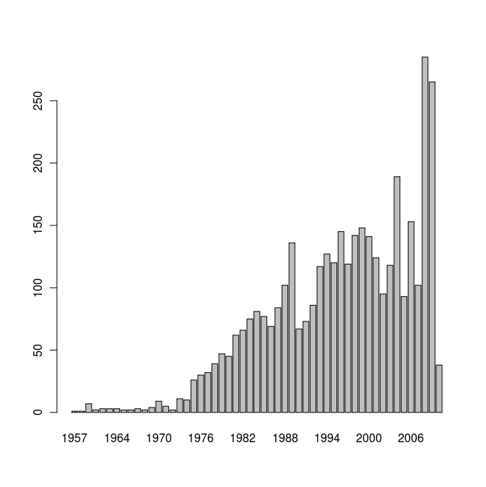Illustration 1: 1945-2010: 'imaginary/ies as article keyword'
There is very little mention of imaginaries before the mid-1950s. One question here is what happened in the 1950s to give voice to the concept at all. One possibility would be the publication of Jean-Paul Sartre's L'Imaginaire: Psychologie phénoménologique de l'imagination (Paris: Gallimard, 1940), but further investigation would be needed to track this down. Secondly, looking at growth in number of publications that use the term 'imaginary,' it becomes steeper first in the early 1970s, then in the 1990s and especially, in the last few years 2006 to date. In some respects, the increasing numbers of publications simply reflects the growth of academic publishing. There are many more articles published in 2009 than in 1970. However, even adjusting (how?) for the general increase in academic publishing over books and journals, there are some variations in the growth of imaginaries that may be genealogically interesting. Interest in the imaginary seems to run through 1950-1960s, but really increase in the mid-1970s. Growth is relatively constant through the 1980s, although which a significant collapse in the late 1980s. Against continuing growth overall, there are years after 2000 when publication drops away markedly, but with a strong resurgence of interest in the last few years.
Who is interested in the concept of imaginaries? The term ranges widely across academic fields. The forums in which work on imaginaries are published suggest something of this. From Arbeiten aus Anglistik und Amerikanistik to Zygon, around 1500 different journals have published work that refers to imaginaries. The list below shows the top 20 journals in the years 1945-2010:

- studi francesi | 44
- tls-the times literary supplement | 42
- french studies | 36
- revue d histoire litteraire de la france | 35
- quinzaine litteraire | 34
- europe-revue litteraire mensuelle | 33
- rlc-revue de litterature comparee | 24
- new york times book review | 23
- revue francaise de psychanalyse | 22
- esprit | 21
- french review | 21
- connaissance des arts | 20
- evolution psychiatrique | 20
- modern language review | 20
- world literature today | 20
- american historical review | 18
- kunstwerk | 18
- cultural studies | 17
- environment and planning d-society & space | 17
- cuadernos hispanoamericanos | 16

As is obvious from this list, in the last fifty years or so, imaginaries have been a concept closely associated with European literature and art, and with French thought in particular. Interestingly, influential and widely read publications such as the Times Literaruy Supplement and the New York Times Book Review figure strongly. Journals such as Cultural Studies , GeoForum and Environment and Planning D(!) are the only representatives of non-literary or non-psycholanalytic disciplines. Even if we break this table down over shorter time windows (I have not included these tables), the most recent time windows still display a literary humanities domination of work on imaginaries. Although social science journals such as American Anthropologist or Environment and Planning A figure heavily, they are swamped by the work on literatures and arts.
Finally, how do people invoke or make imaginaries using the poetic-logical techniques of academic writing? To analyse this, I have taken approximately 4000 article abstracts from Web of Science, and using corpus linguistics approaches, counted some of the different ways imaginaries figure there. TBC …
[TBC: I've done some of this work, but it still needs to tidied up. I think it would be interesting, but maybe all of this is getting way too big for the planned article. It would
- list the different qualifications or species of imaginaries by counting all the occurs of the form either 'imaginary/ies of x' or 'the x imaginary/ies'; and also count the relative weights of singular 'imaginary' vs plural 'imaginaries';
- list the relations of possession and identity associated with imaginaries of the form 'imaginary/ies is/are/has/was/will' in order to see some of the attributions of essence, substance or property;
- identify the main concepts or things associated with imaginary/imaginaries by counting overall keywords in the abstracts.
I see all this as a way of continuing the genealogy of making imaginar/ies, but moving into the literary-inscriptive practices of academic and academic-related texts.

References

Lee, B. & LiPuma, E., 2002. Cultures of Circulation: The Imaginations of Modernity. Public Culture, 14(1), 191-213.

Strathern, M., 2006. Imagined collectivities and multiple authorship. In R. A. Ghosh, ed. Code: Collaborative Ownership and the Digital Economy. Cambridge, MA: MIT, pp. 13-28.

