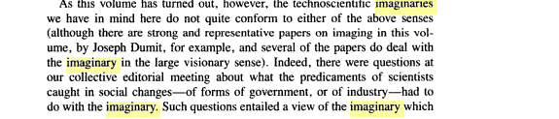
P3

We instead were much more interested in the imaginaries of scientists tied more closely to their current positionings, practices, ambiguous locations in which the varied kinds of science they do are possible at all. This is a socially and culturally embedded sense of the imaginary that indeed looks to the future and future possibility through technoscientific innovation but is equally constrained by the very present conditions of scientific work. 4
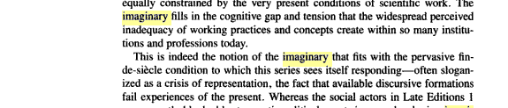
are currently blocked by traumatic political events in even developing imaginaries in which they can invest belief, those of Late Editions 2 are constantly trying to understand the present by borrowing from a cautiously imagined emergent future, filled with volatility, and uncertainty, but in which faith in practices of technoscience become even more complex and interestingly constructed in new locations of doing science. 4
The idea of the imaginary as structures of contingency, then, is what we mostly have in mind in the following chapters. Our interest in the imaginary is in how it is constituted at distinctively ambiguous fin-de-siecle locations of various kinds of scientific practice in their fully embedded social and cultural contexts. 4

p4

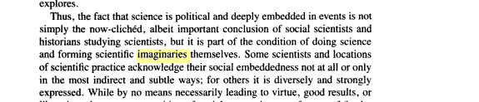
p7

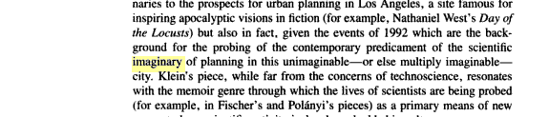
p9

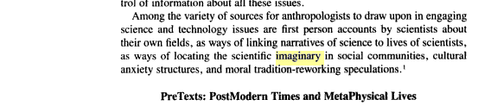
44

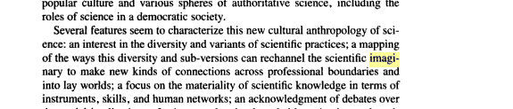
47

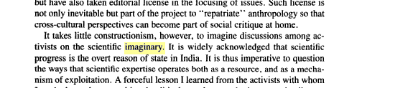
277

