SOCL 923 Critical Methods in Media and Cultural Studies

Essay Question: Nick Couldry wrote in 2000: “Cultural Studies is an expanding space for sustained, rigorous and self-reflexive empirical research into the massive, power-laden complexity of contemporary culture” (Couldry 2000, p1). Critically analyse what he means. Drawing on the various interpretative, textual, visual, observational and participatory methods discussed in the course and the set readings of the course, describe some of the different ways your group research project activities have addressed the challenges of empirically researching contemporary culture. You will need to spend some time in your essay describing what your research was about, but this description should mainly serve to highlight your analysis of this definition of cultural studies. You should pay particular attention in your essay to the key quotes drawn from the weekly readings, and show in your essay that understand them and their implications.

Name: Sijia Wang

ID: 31056476

Introduction

Using a thought-provoking quote from Nick Couldry (2000), this essay is going to explore the relationship between research practices in Media and Cultural Studies.

First of all, a critical analysis of what Couldry means will be expanded upon using academic theories, particular, the theoretical implications of several key terms referred to in the quote, such as ‘self-reflective’, ‘empirical research’, ‘power-laden complexity’ and so on. In order to introduce key methodological issues, the essay also will refer to my group research project to address the challenges of empirically researching contemporary culture. Various research methods will be drawn on in discussions of how different approaches implicated in the group project activities, including textual analysis, visual analysis, observation and participation.

Through an exploration of theoretical and practical participations in the course – Critical Methods in Media and Cultural Studies, useful readings and ‘author meet critics’ sessions help our group members design and process research project appropriately which are presented on our blog. These key readings are important theories for building up arguments of how we demonstrate methodology in practice along with Rose (2011), Clifford (1986), and Back and Nirmal (2012) etc. Also, the authors such as Adam Fish, Imogen Tyler and Graeme Gilloch are from the Sociology department of Lancaster University.

Finally, there is a brief conclusion.

* What Nick Couldry means

“Cultural Studies is an expanding space for sustained, rigorous and self-reflexive empirical research into the massive, power-laden complexity of contemporary culture” (Couldry, 2000, p.1).

Obviously, Couldry tries to define a term of cultural studies in a sentence. To identify what he means, it is necessary to use as a starting point explanations of some key words in the quote: what does he mean by “self-reflexive”, “empirical research”, and “power-laden complexity”? Firstly, Abercrombie and Longhurst (2007) describe ‘reflexivity’ (p.301): (1) “theories refer to themselves, and (2) the way in which, particularly in modern societies, people constantly examine their own practices and in the light that examination, alter them”. In a word, “self-reflexive” is self-examination of the relationship of an individual’s (or group’s) performance and behaviour.

Couldry (2000) expands the meaning as a broader process and claims that cultural studies enable an equal space. Each person has the right to be heard as multiple voices and reflections are valuable for culture. In the process of reflectivity, questions are narrowed down on as to we are imagined and where we are represented. Moreover, thinking about individual stories also plunges people immediately into the web of relationships out of which an individual is formed. The self-critique of cultural studies thus begin to discover and play with the identification of ourselves, in order to consider culture differently and radically (Hall, 1992). Consequently, expressions of such stories function in terms of “a reflective positioning of oneself in history and culture” (Ang, 1994, p4). Therefore, it is also a process of individuation thinking of an individual’s relations to culture.

As a result, culture in relation to issues of power is contained in cultural studies, which is what the phrase -“power-laden complexity” relates. As most cultural studies writers agree, studying culture and theorising power is fundamental to defining cultural studies as a distinctive area of study. Recognising the complex and contested nature of culture, the power is driven by massive factors like economics, politics and so on. Such different forms of social discrimination affect issues such as: “who is represented and how, who speaks and who is silent, what counts as ‘culture’ and what does not” (Couldry, 2000, p.2).

Such a discipline, critique of cultural studies assists in the expansion of the range of cultural production deemed worthy of academic study, which also refers to experiences and pleasure outside the cultural elite. Cultural studies have come “to be applied to almost any form of theoretically-influenced textual study, from literary analysis to art history” (ibid, p.5).

To analyse various cultural complexities, having the right investigative tools is significantly necessary; the tool of “method is the route down which you go to pursue something, without some agreement about that route, and the issues which need to be resolved in analysing culture, it is difficult to see how cultural studies can function as a space where people – across many dimensions of difference – exchange and see reflected their experiences of culture” (ibid, p.8). In consequence, proper research approaches are utilised to think about and to research cultural complexity in a manageable way. Through more precise and systematic on methods, cultural analysis avoids the risk of being merely reactive (ibid).

* Group Research Project

As an example to understand researching cultural studies in practice, the research question of our group project is how we understand the relationship between celebrities’ production of ‘selfies’ and the followers’ response on Instagram. Based on production and consumption theories as a classical part of cultural studies, the question specifically focuses on quite a recent phenomenon on social networking site called ‘selfies’. Miley Ray Cyrus[1] (known as Miley Cyrus) and Taeyeon Kim[2] (known as Taeyeon) are particular celebrities we chose to follow through their Instagram accounts (“*mileycyrus*” and “*taeyeo_ss”*). With attached captions and photos, we try to figure out the meanings the celebrities aim to convey to the public. At the same time, an analysis of a large amount of comments under particular selfies is going to examine how audiences read and respond to the released information in selfies.

Selfies are typically taking photos of oneself with a hand-held camera. Researching such a self-portrait is a process emphasising self-examination of an individual’s or a particular group’s behaviour. Writing a blog is also a self-reflective way of how we examine outcomes of learning cultural studies. Additionally, our research project is committed to investigating the links between popular culture and media power. From perspectives on consumer culture, our explorations take as an angle celebrities’ selfies as one of the commodities of media production. Thus, the project began with a democratic critique of a large scale intersection including gender, popular culture, cyber culture and other issues, which are absolutely essential in expanding the range of studying cultural experience. Further, Instagram as a space offers equality for multiple voices and forces, so that massive complexities are questioned regarding whether followers’ purchase behaviour is influenced by these celebrity commodities. In addressing a central issue of complexity in cultural studies, recognisable research methods and methodological debates are important to be conducted to collect empirical materials in our research practice.

As effective tools, research approaches help us to develop a manageable way of investigating cultural complexity. As a consequence, textual analysis, visual analysis and other methods are combined for multi-purpose use. Along with methodological debates from Mitchell (2002), Rose (2012), Clifford (1986) and Back & Puwar (2013), empirical materials are described for understanding cultural production no matter whether a text, or a photo.

Among various options, textual analysis and visual analysis are the most important approaches in our research project. Before starting research in practice, a large amount reading about relevant academic work on the topic was necessary. In a vast textual universe, textual analysis is a key way of helping us find a criterion for isolating complexity in text fields and only extracting useful information for manageable analysis (Cloudy, 2000). However, Instagram is an online photo/video-sharing based social networking service, which means most of the resources on the page are visual materials. Through a special task called ‘showing seeing’, we attempt to write up an example but assume that audience does not have any familiarity with normal visible elements such as colour, line, eye contact, cosmetics, clothing, facial expressions, mirrors, or glasses, much less with photography, video or other so-called ‘visual media’. We have to deal with the problems of describing the form and materials we see with a society that has no concept of visual culture. In such situations, visual culture is thus made to seem strange, exotic, and in 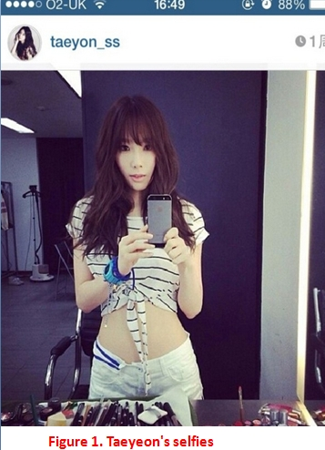need of explanation (Mitchell, 2002).

There is an example how we describe: when you look straight at Figure 1, there is a female human being. This young woman is standing in front of a mirror (an object reflects light in way that preserves much of its original quality subsequent to its contact with the mirror). With long hair, she wears a t-shirt and short jeans (clothes like many people wear in summer), but her waist is bare. Also, she holds a mobile phone (brand: iphone) taking a photo of her own image shown in a mirror in front of her. It is quite challenging to describe selfies in this exercise. Even if the description is not detailed enough to meet seeing requirements, the problems confirm that visual elements are obviously important in explanation of the selfies phenomenon. As primary materials, photos are filled with various visual notions for analysis of celebrities’ bodies, clothes, facial expressions, gestures and other accessories. Formation of selfies as commodities captures of issues from these elements to attract followers’ attention.

Therefore, visual analysis plays a dominate role in research practices. “This approach would treat visual culture and visual images as go-betweens in social transactions, as a repertoire of screen images or templates that structure our encounters with other human beings” (Mitchell, 2002, p.175). “Visualities are one practice among many, and in their routinization and place-specificity they make certain sorts of things visible in particular ways” (Rose, 2012, p.549). The visual analysis in empirical research thus enables different ways of seeing, bound up in different, more-or-less conscious, more-or-less elaborate, more-or-less consistent practices.

Generally, celebrities’ selfies are uploaded with captions, and then we usually analyse resources by a mixed use of textual and virtual analysis. Meanwhile, comparisons between flows of meaning in texts and overtone in photos are made to identify how celebrities use various media functions to invent themselves as fashionable commodities. Further, textual analysis has an emphasis on following responses to generalise most audiences’ orientation on their stars’ selfies. According to associated text-reader relationship, explanations of textual environment comprising complex patterns of flows are worth looking at: “flows of meanings, texts and potential readers” (Couldry, 2000, p.87).

For example, (Figure 2[3]), Taeyeon says that she received a gift from a Singer named Kim BumSoo[4], because her Today’s attending in Kim’s concert.

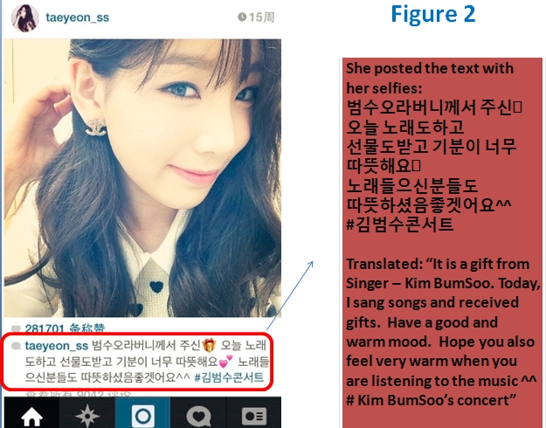In a word, she was invited by Kim BumSoo to attend his concert as a performing guest. By informing the public, the message aimed to rouse public attention and tried to attract more people to join in Kim’s concert. However, we found that a different meaning is conveyed through what she doing, the certain objects she is deploying, her bodily gestures and any other issues cited in her selfies attached with the above caption. As an eye-catching Chanel logo shown in photo, the brand product is the big object Taeyeon tried to highlight. Sweeping her to one side, she faces the left side and turns the Chanel earring on her right ear straight to camera. It can be seen that implications consist of visual notions in selfies showing a way of doing things, certain objects, knowledge, and emotions which may not also be included in its textual environment. In many of the cases we found on Instagram, the meaning of the caption and the presentation of selfies are not always consistent with each other. This typical example indicates a combination of textual analysis and visual analysis is a suitable methodological approach to investigate celebrities’ selfies on Instagram.

Owning to digital tools and devices applied on Instagram, research practices are being extended by digital culture. In such a hyper-connected world, Back & Puwar (2013) argue that new possibilities to re-imagine observation and the generation of alternative forms will be afforded as variable research resources. In consequence, there may be a massive accumulation of digital materials in the hands of corporations to generate predictions that is not approached as a threat, which is known as an ‘empirical crisis’ (Savage and Burrows, 2007). In order to take advantage of the analytic and empirical capacities embedded in online media, recognisable methods “may be the potential for simultaneity in research and the possibility of re-ordering the relationship among evidence gathering, analysis and circulation” (Back & Puwar 2013, p.7).

Because culture is not an object like something that physically exists. “Culture, and our views of 'it,' are produced historically and actively contested” (Clifford, 1986, p18). Hence, our third approach is based on concepts of ethnography to re-examine celebrity’s selfies. In particular, we will employ Suchman’s (2012) ideal of ‘configuration’ to examine how celebrities might be reconfigured, or configured together differently in contemporary technological discourses and practices. Regarding Suchman’s statement that (2012, p.57) “configuration orients us to the entanglement of imaginaries and artifacts that comprise technological projects”, there are some different entanglements of imaginaries and artifacts that out group members figure from further analysis of famous people’s selfies. Take some pairs for examples, the evidence is expected to find in the production of celebrity’s selfies itself and the feedback from audiences.

Going through Miley Cyrus’s photo gallery, Miley Cyrus’s and Taeyeon’s selfies photo in some degree present issues as entanglements of imaginaries and artifacts of their daily activities. In Figure 3, her fashion attitudes and taste preferences usually stand out, such as changes in her pixie hairstyle and her growing collection of tattoos. Such edgy clothes, bold colours, and unique accessories significantly appeared as typical Miley Cyrus styles. A large number of audiences perceive her as extraordinary, fantastic and distinctive. Successfully having these kinds of characteristics, her music productions (e.g. music videos) often involve issues like these, which catch public attention and lead them to discuss her new albums. From the perspectives of production and consumption, the particular images people widely recognise as Miley Cyrus are produced as selling points of her music, which may be largely consumed 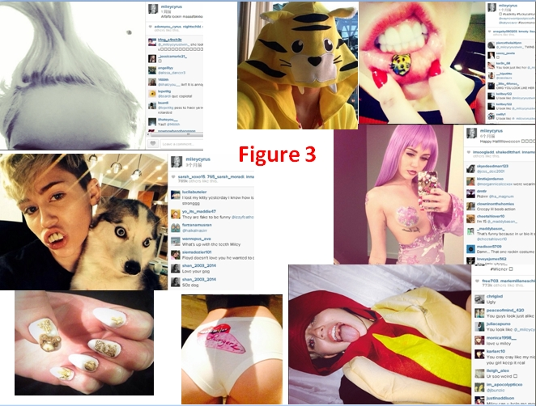by her supporters.

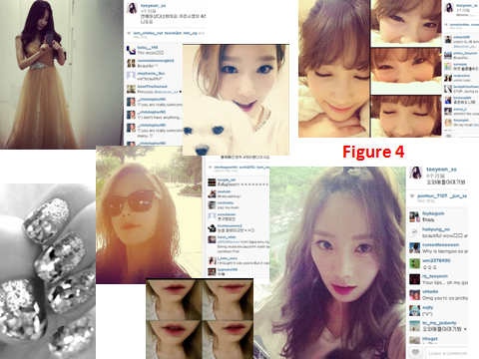

Similarly, Taeyeon satisfies very classical stereotypes of the beautiful female celebrity, who looks feminine, innocent and thin. Using her as a role model, many ordinary people will strongly desire such unattainable beauty standards, which have been built up by the media for long time. The huge influence of such standpoints heavily impacts the societal perceptions of female body images. As in Figure 4, a series of Taeyeon’s selfies shows her in good shape looking cute, sexy, elegant and other ideal features. Looking for more evidence, we were surprised to find Chanel collections are popular accessories in her photo gallery. Like in Figure 2 (cited on p.10), her bag, jewellery and beauty products are presented directly on her Instagram page. Under the selfies, there are more than 9,045 comments and 282,077 users like the photo. Among the large amount of responses, most followers made compliments about her Chanel earrings and how beautiful she is. Obviously, Kim failed to attract public attention on his concert to create consume opportunities of his music productions via storytelling in Taeyeon’s selfies. However, the consumption and production relationship between Taeyeon and Chanel is conveyed to the public successfully. Finally, as she is the face of Chanel, the fashion brand utilises her popularity and appropriate images. To promote Chanel collections, the brand hitches its fortunes with famous faces (Figure 5). It is not only Taeyeon; other members in the group also represent Chanel in fashion shows, magazines, and public events. Consequently, the intersection of celebrity and luxury branding is a significant strategy for consumption development through social media platforms.



Through certain objects and specific poses represented on Instagram, both Taeyeon and Miley Cyrus set up entanglements of imaginaries and artifacts by some technological devices such as smartphones, laptops, apps and cameras. Exerting the power of media, media effect of commodity can sharp public configuration on celebrities and commune celebrity’s images as productions.

Conclusion

During the course, we have learnt how complex Media and Cultural Studies is and how important research methods are in study of cultural complexity. This discipline refers to a range of different aspects, and we should maintain critical attitudes in study of cultural phenomenon.

Hence, the significance of smart methodological approaches is obvious in the design process, which determines whether we would conduct reasonable and comprehensive investigations. With applications of appropriate tools, it is manageable for data collection and further analysis to remain true of democratic vision in cultural studies. Without these commitments to methodological debates and recognisable approaches, Grossberg (1997) claims that cultural studies risks being no more than a trail of political interventions by authoritative voices.

Therefore, our group has utilised the right research methods and has associated these to relevant disciplines (e.g. gender and women studies, media production, consumer culture etc.) addressing the question of experience in all its complexity. This paper conducts a critical evaluation of different methodological approaches: why and how we apply them in research project. Through discussions of examples show that what empirical materials we can collect and what analysis we can explore via using particular methods.

Nevertheless, our group also foresees problems we may face in further research. Even though we had a clear plan, in reality we had issues such as: We did not have significant sources to indicate that the celebrities’ selfies directly influence followers’ consumption choices. The difficulty may lead to deviation on questions such as, how much does a selfie really reveal about its subject? To face these potential problems, we need other suitable research methods to identify the universal phenomenon of female celebrities’ selfies on Instagram.

In the process of developing our research group project, I really enjoyed the practice of designing main methods, learning practical techniques, and selecting of example cases. Working in a 3-member group, we got on well with each other and carried out a good distribution of tasks. The submission of the essay has helped me to review the module content and summarise the learning outcome of our research project, which has also assisted me in developing critical thinking and practical abilities in other studies. In further study of contemporary cultural phenomenon, self-reflexive empirical research is necessary to be sustained to explore and understand its massive and power-laden complexities.

**References:**

Ang, I. (1994) ‘On not Speaking Chinese’, *New Formations*, 24, pp.1-18.

Abercrombie, N. and Longhurst, B. (2007) *Dictionary of Media Studies*, London: Penguin Books Ltd.

Back, L. and Puwar, N. (2012) ‘A Manifesto for Live Methods: Provocations and Capacities’, In *The Sociological Review,* 60, pp.6–17.

Clifford, J. (1986) ‘Introduction: Partial Truths’, In Clifford, J. and Marcus, G. (eds), *Writing Culture: The poetics and politics of ethnography,* Berkeley: University of California, pp. 1-26.

Couldry, N. (2000) 'Introduction', *Inside Culture: Re-Imagining the Method of Cultural Studies*. London: Sage Publications Ltd.

Mitchell, W.J.T. (2002) ‘Showing seeing: a critique of visual culture’, *Journal of Visual Culture,* 1 (2), pp.165-181.

Rose, G. (2012) ‘The Question of Method: Practice, Reflexivity and Critique in Visual Culture Studies’, In *The Handbook of Visual Culture*, Ian, H., Barry, S., Michael, G., Gunalan, N., and Catherine, M. S. (Eds), London: Berg, pp.542–558.

# Suchman, L. (2012) ‘Configuration’, in Lury, C. and Wakeford, N. (Eds) *Inventive Methods: The Happening of the Social,* New York: Routledge, pp.48-60.

# Celebrities’ selfies available from:

# Taeyeon Kim: <http://instagram.com/taeyeon_ss>.

# Miley Cyrus: <http://instagram.com/mileycyrus>.

# (Accessed at 22nd April 2014)

1. Miley Ray Cyrus: an American actress and singer. She has 348posts and 10 million followers so far on Instagram.
2. Taeyeon Kim: a South Korean singer as the leader of the South Korean girl group named Girls' Generation. She has 563 posts and 2.1 million followers so far on Instagram.

   (Girls' Generation’s immense popularity in native South Korea has earned a title of "the Nation's Girl Group".)
3. The Korean caption is translated in English by me.
4. Kim BumSoo is a South Korean R&B and soul singer. 