# SISTEM PENGELOLAAN STOK MASUK GUDANG

TI-415

## MEET OUR TEAM

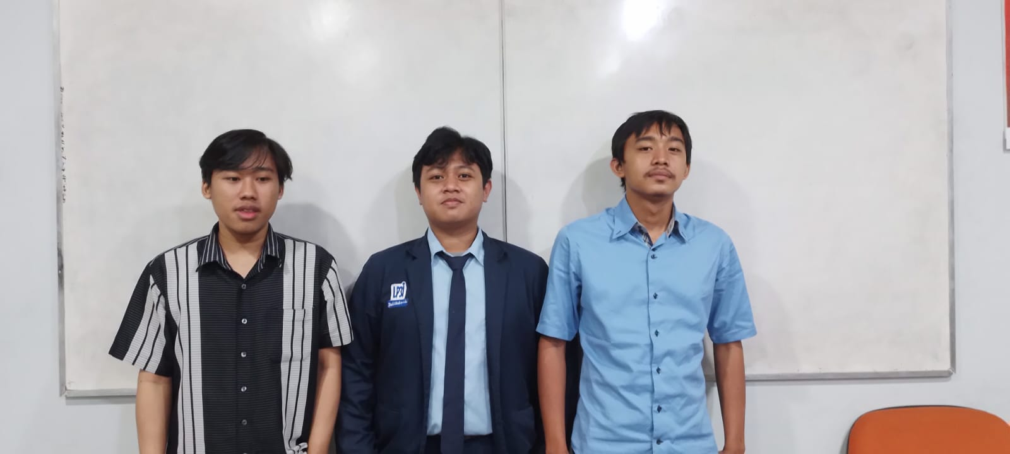



**Syuja Fadhlurrahman**

(200441180044)

**Muhammad Rian Basari**

(200441180007)

**Dafit Syahrul Dharmawan**

(200441180037)