BangBuy Customer Journey and Checkout Architecture
  - From the home page to the completed order
10 November 2026
Customers can browse BangBuy, select products and check out as a guest or with an account. Add to cart leads through a confirmation step and the cart; Buy now takes the chosen variant straight to checkout. This guide explains what customers see, the decisions they make and the architecture that saves and verifies their purchase.
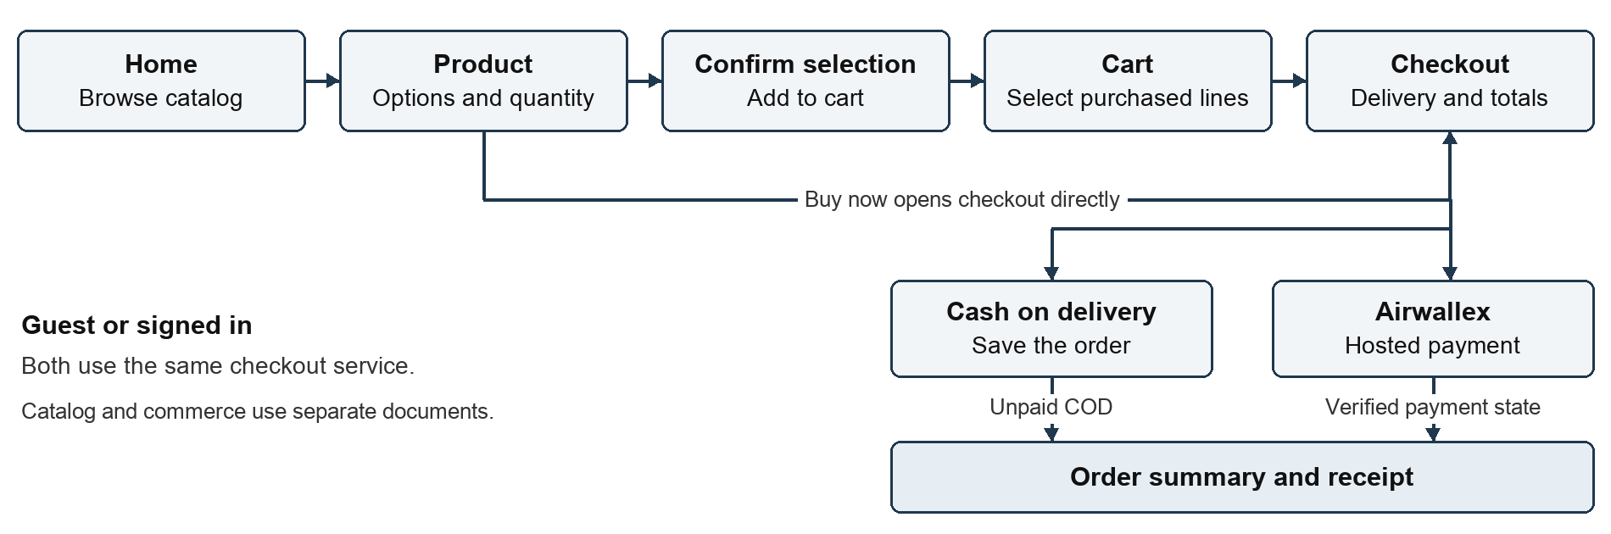

What checkout completion means
For Cash on Delivery, checkout completes when the order is saved and its summary opens. Payment starts UNPAID and is payable on delivery. For Airwallex, BangBuy saves and reserves the order before opening hosted payment; online payment is confirmed only after server verification.
The order page can therefore exist while payment is pending, failed or under review. Order status, payment status and delivery progress are separate concepts.

Routes and language
Examples use logical routes such as /products, /cart and /checkout. Navigation adds the selected language prefix, for example /en/checkout or /bn/checkout. API routes stay under /api. The language selector follows published language settings. Storefront and commerce hostnames come from deployment configuration.

How customers discover and select products

Home page
At /, customers see the BangBuy header, category navigation and links for search, account, wishlist and cart. The public header does not show personal account details or historical cart and wishlist counts. The page contains promotional banners, a category scroller and category sections with product cards and View All links. [1]

Search and catalog results
The search icon opens the private commerce /search page. Its search box supports product names, codes, models and categories, with product matches, category matches, suggestions and a link to all results. Customers can also enter the catalog through /products, /categories/<path> or /brands/<slug>. [2]
Results offer grid or list display, sorting and filters for category, brand, manufacturer, price, rating and stock. Filters use a drawer on smaller screens. Additional products appear through further catalog navigation or loading. No-results states offer revised search or filter reset; request failures offer retry.

Product detail
At /products/<slug>, customers see breadcrumbs, a gallery, product name and code, rating, price and available discount. Applicable catalog details include brand, manufacturer, model, series, GTIN and condition. Description, specifications, reviews and related products appear when available. [3]
Customers choose the required variant options and quantity. A purchase needs an active variant with sufficient stock. Product records supply prices; variants identify inventory choices. Missing or unpublished products show a not-found state; an old slug can redirect to the current product URL.
Action | Next customer experience
Add to cart | Open the commerce confirmation page with the selected product, variant and quantity.
Buy now | Open checkout for that selection without changing the existing cart.
Options | Open product detail to choose the required variant before purchasing.
Wishlist | Open commerce confirmation before saving the product for later.

An unavailable purchase selection cannot proceed. The application checks stock again when adding a cart item and when the order is submitted. A viewable out-of-stock product may still be saved to a wishlist.

How selection reaches the cart

Confirm the selection
Public Add to cart and wishlist actions navigate to /shopping-handoff with only the action, product ID, variant ID and quantity. The customer sees a confirmation heading, product and variant, quantity and price, then chooses Confirm selection. Opening the link alone does not change a private cart or wishlist. [4]
Cart confirmation rechecks the selection and saves it to the guest browser cart or the signed-in account cart. Wishlist confirmation saves the product for later. Success opens /cart or /wishlist. A failure keeps the customer on the confirmation screen with an alert. Buy now instead opens /checkout?buy=<selection> and skips cart mutation.

Review the cart
At /cart, customers see product images, names, selected options, prices, stock and quantity controls. They can select purchased lines, remove items, save items for later, apply a promo code or continue shopping. Only selected active items with stock proceed. Checkout waits while quantity changes synchronize. An empty cart links back to shopping. [5]
Guest carts and wishlists live in browser local storage on the commerce origin and are reflected in Redux state. Account carts live on the server. Signing in merges eligible local cart and wishlist contents into the account and refreshes the browser from the server.
Entry path | Purchase scope | Cart after order creation
Buy now | Chosen product and variant | Existing cart is preserved.
Selected cart lines | Selected exact variants | Purchased lines are removed; other lines stay.
Full account cart | The saved cart used by checkout | Purchased cart contents are cleared.

Cart cleanup occurs after the order is created, before hosted online payment is completed. A failed payment can leave a reserved order to continue paying from its order page. The customer should return to that order rather than create another purchase.

Guest or account checkout
Guests can continue without creating an account. Checkout provides an optional sign-in link. Account customers can use saved profile details and later find orders in their account; a guest order does not create a login or automatically attach to an account with the same contact details.

What customers see at checkout

Delivery details and purchased items
The checkout screen shows the items being purchased, a delivery form, payment choices and an order summary. Signed-in customers have saved profile details filled into blank fields. Their account email is read-only and comes from the account on the server. If profile loading fails, the screen allows manual delivery entry and retry. [6]
Field | Requirement | What the customer enters
Full name | Required | Recipient name.
Phone number | Required | A valid delivery contact number.
Delivery address | Required | House, road and area.
Delivery area | Required | Inside Dhaka or outside Dhaka.
Email | Optional for guest COD and Airwallex | Contact email; signed-in checkout uses the account email.
City and postal code | Optional | Additional delivery location details.
Additional note | Optional | Delivery instructions or order notes.

Totals and promotions
The summary asks the customer to choose a delivery area before completing the quote. The server returns current items, subtotal, promotion discount, delivery charge, tax and total. Changing items or delivery area refreshes that preview. Promo codes can be applied or removed; invalid codes show a reason.
Canonical accounting amounts are BDT. Supported display currencies are BDT, AUD, EUR, GBP, USD and CNY. COD identifies the BDT amount due when the display is in another currency. Airwallex shows its processing amount and currency when they differ from the storefront display.

Payment choice and submission
Cash on delivery is the default. Airwallex secure payment appears when the provider is enabled and a valid payment quote is available. SSLCommerz is retained in the backend but its customer picker entry is currently hidden. PAYPAL and ONLINE schema values are not visible payment options. [7]
The customer reviews the quote and selects Place order or Pay securely with Airwallex. The button shows progress and prevents concurrent submission. Missing fields, invalid contacts, stale quotes or stock conflicts show errors so the customer can correct and retry.

How payment and checkout finish

Cash on Delivery
BangBuy saves the order, removes the purchased cart lines as applicable and opens /orders/<id>?just-placed=1. The page confirms the order was placed. Its initial order status is PENDING and payment status is UNPAID; no online payment is required. [6]

Airwallex hosted payment
BangBuy first creates the reserved order and inventory movements, then initiates or reuses its authorized provider payment attempt. Hosted checkout collects card or wallet details with Airwallex. BangBuy does not collect card details in its delivery form. If the hosted screen fails to launch, the customer is taken to the existing reserved order. [7]
The provider returns the customer to /orders/payment-return?orderId=<id>. The status screen reads authorized server payment records every 2.5 seconds for up to 60 seconds. If confirmation remains outstanding, it offers manual refresh and access to the order. A return URL or payment flag cannot mark an order paid.
Server result | What the customer sees or does
Verified successful payment | Payment confirmed. A non-review pending order advances to PAYMENT_CONFIRMED and payment becomes PAID.
Pending or delayed | A confirmation or delay message, with refresh and access to the order.
Review required | A payment review message while the order waits for investigation.
Failed or cancelled attempt | The existing order remains accessible. Eligible Airwallex orders offer Continue to secure payment.
Receipt access denied | An unavailable order message; an order number alone cannot grant access.

Order summary and receipt
The order page shows order number and date, separate order and payment statuses, delivery details, purchased items, totals and a fulfillment tracker. Customers can download a PDF receipt or continue shopping. The receipt describes the saved order and its payment state; its existence does not prove payment. Receipt PDFs currently use English. [8]
Guests need the original browser cookies to reopen an order. Account customers use their account session. Current order notification delivery writes server logs; this checkout flow does not send confirmation email or SMS.

Application architecture
BangBuy is one Next.js 16 application with React interfaces, API route handlers and shared server services. Prisma connects those services to PostgreSQL. The browser manages interaction; the server owns pricing, inventory, order access and payment verification. [9]
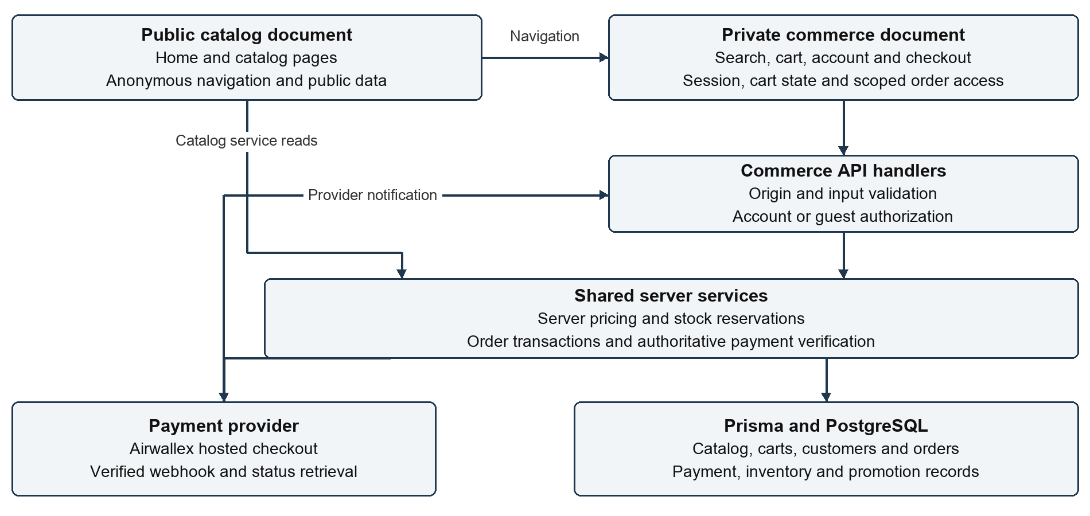

Public catalog and private commerce
Independent root layouts render the public catalog and the private commerce experience. The public root uses anonymous providers and does not hydrate customer account or historical cart state. The private root supplies account session, Redux persistence and cart hydration. Search, contact, authentication, wishlist, cart, checkout and order pages belong to commerce.
With distinct configured HTTPS origins, cross-boundary links replace the document and navigate to the appropriate host. The proxy enforces known hosts, routes private pages to commerce and limits public APIs to anonymous catalog and language operations. Private mutations require the commerce origin, with narrow exceptions for verified payment callbacks. Private content uses no-referrer protection. [4, 9]

How the server saves an order
Both guest and account checkout use the same pricing and order service. A preview calculates the purchase without creating an order or reserving stock. Provider network requests run outside the reservation transaction. [10]

1 Preview current items
The browser posts explicit selected items, or account checkout prices its saved cart. The server reads current products, exact variants, store settings, delivery rules and promotions. A successful preview also establishes an HttpOnly guest checkout identity.

2 Validate the request
The API checks request origin, rate limits, JSON content type, body size and field validation. Customer identity comes from the account session or established guest checkout cookie. Client-supplied totals never determine the price.

3 Deduplicate the attempt
Every submission carries a UUID idempotency key. The server scopes it to the customer identity and compares a fingerprint of the purchase. A PostgreSQL transaction advisory lock serializes matching attempts. Identical retries return the existing order; changed choices with the same key are rejected.

4 Recheck and reserve inventory
The transaction locks relevant catalog rows, recalculates prices and promotions, and decrements stock only where enough remains. It records inventory movements. A preview alone cannot guarantee that stock will still be available at submission.

5 Save related records together
The transaction creates any guest contact profile, order and item snapshots, status history, promotion usage and reserved payment attempt. Applicable saved-cart lines are removed in the same transaction. Failure rolls these writes back together.

6 Commit and continue
After commit, the application refreshes affected catalog caches. COD opens the order summary. Airwallex continues to authorized payment initiation and hosted checkout. Customer order access is established independently from the payment outcome.

Money calculation
The subtotal is the sum of quantity times effective product price, using a valid lower discount price when present. A validated promo reduces merchandise value. Tax applies to discounted merchandise. Delivery uses configured inside or outside Dhaka fees, with free shipping governed by the configured threshold.
Total = discounted merchandise subtotal + delivery charge + tax. The order stores its BDT accounting amounts, display currency and exchange-rate snapshot. Airwallex also stores a frozen payment amount, currency and quote so later display-rate changes cannot rewrite the payment obligation.

Data ownership and payment verification
Record | Role in the purchase
User and CartItem | Account identity and saved cart lines for exact variants.
GuestCustomer | Contact profile created for a guest order; not a login account.
Product and ProductVariant | Catalog price, availability, variant choices and stock.
Order and OrderItem | Delivery and item snapshots, quantities and saved currency amounts.
PaymentTransaction and events | Provider attempts, identifiers, money, transitions and review state.
AirwallexWebhookEvent | Unique verified notification with durable processing and retry state.
PromoCodeUsage and InventoryLog | Promotion consumption and stock movements.
OrderStatusHistory | Durable order lifecycle changes.

Who can read an order
The order API authorizes the account owner, an authorized administrator or a scoped guest credential. Each guest order gets a separate unguessable HttpOnly cookie; only its digest is stored on the order. Its browser lifetime is 30 days, with Secure in production. Order IDs, email addresses and phone numbers alone do not grant access. The receipt discards browser snapshots and fetches authorized server records. [11]
Clearing cookies or changing browsers loses guest access. There is no contact-based recovery or automatic order claiming. Account history, profile and customer self-cancellation still require login.

What makes online payment authoritative
Airwallex authenticates webhook requests and stores unique events before acknowledging them. Reconciliation retrieves the current provider intent and uses the same authoritative verification transaction as owner-scoped status polling. Verification checks order and payment identity, amount, currency, frozen quote and permitted transitions. A mismatch or uncertain outcome requires review. [12]
Verified non-review success marks payment PAID and advances a PENDING order to PAYMENT_CONFIRMED. Failed or cancelled Airwallex attempts can retain stock reservations and promotion usage for retry. SSLCommerz has separate callbacks, IPN and reconciliation rules; verified unsuccessful pending orders can cancel and restore stock and promotions.

After checkout
Fulfillment later moves through preparation, packing, shipping, transit and delivery. Cancellation, return and refund are branch states. These processes appear in order history and the tracker; they are not further checkout steps. [13]

Implementation references
Entry points below identify the implementation reviewed on 10 November 2026. Routes are customer paths; folder groups in parentheses organize source code and are not URL segments.
Source shorthand: public = app/(shop); commerce = app/(private-commerce)/(shop). References describe the application implementation and do not establish which revision is deployed.
Ref | Area | Source entry points
1 | Home and public header | public/page.tsx; public/components/Categories.tsx; components/layout/PublicNavbar.tsx
2 | Search and results | commerce/search/page.tsx; components/layout/SearchBar.tsx; public/products/components/ProductsExplorer.tsx
3 | Product detail and actions | public/products/[slug]/page.tsx; public/products/[slug]/components/ProductActions.tsx
4 | Selection and origin boundary | lib/security/shopping-handoff.ts; lib/security/surfaces.ts; commerce/shopping-handoff/page.tsx and selection.tsx; proxy.ts
5 | Cart and account merge | commerce/cart/page.tsx; components/layout/StoreHydrator.tsx; features/cart/storage.ts
6 | Checkout screen and fields | commerce/checkout/page.tsx; checkout/components/CustomerForm.tsx and OrderSummaryCard.tsx within commerce
7 | Payment selection and UI | commerce/checkout/components/PaymentMethodPicker.tsx; lib/airwallex/components/AirwallexPayButton.tsx and AirwallexPaymentStatus.tsx
8 | Order page and PDF | commerce/orders/[id]/components/OrderSummaryClient.tsx; features/orders/pdf.ts
9 | Layouts and API entry points | public/layout.tsx; app/(private-commerce)/layout.tsx; components/layout/PublicProviders.tsx; app/providers.tsx; app/api/checkout/route.ts and preview/route.ts
10 | Pricing and order transaction | lib/services/checkout.service.ts; lib/validations/checkout.validation.ts; features/checkout/idempotency.ts
11 | Identity and order access | lib/orders/guest-access.ts; lib/orders/checkout-customer.ts; app/api/orders/[id]/route.ts; prisma/schema.prisma
12 | Authoritative payment services | lib/airwallex/services/airwallex-payment-verification.service.ts, airwallex-payment-event.service.ts and airwallex-payment-status.service.ts; lib/payments/core/payment-status.service.ts
13 | Fulfillment and notifications | lib/orders/status.ts; lib/orders/notifications.ts; docs/guest-checkout.md

