**Rian Hayden URL Shortener Application**

This is a document outlining all the technologies used in my application and how the application can be run.

It is a Spring Boot application written in Java that uses the Web and Redis dependencies.

It also uses a Guava hashing function murmur3, this function can create unique ids from Strings which is exactly what we want to make short urls, this also encrypts the data.

I have also installed a Debis server on my machine that the application sends and retrieves data from.

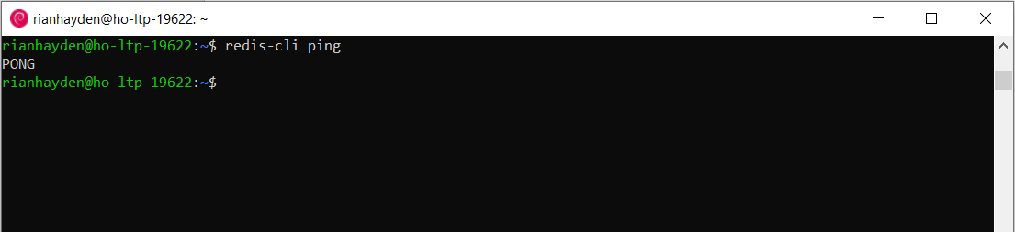

In order to run the application, you have to have a Debis server instance running, and then run the application through IntelliJ.



Once the application is running, the user can do a postman call to the endpoint with any url in the request body and it will return a unique id, which can be used as a short url.

Here is result of testing the application through Postman:

Request body:

