ACME Company Report 2023

Executive Summary

This report provides a data‑driven assessment of ACME’s customer distribution, product performance, payment behavior, and inventory management. All insights are derived from SQL‑extracted datasets and Excel‑based forecasting models. The dataset used for this analysis is a fictional training dataset designed to simulate realistic business conditions.

Because 2023 data was incomplete, a 20% uplift was applied to approximate year‑end totals. Linear forecasting was used to project 2024 performance, and inventory efficiency was evaluated using grouped bar charts and a log‑log scatterplot to accommodate wide variation in product volumes.

The analysis highlights strong regional growth opportunities, clear product winners and underperformers, stable payment preferences, and significant inefficiencies in ACME’s inventory strategy.

Key Insights
ACME’s customer growth is concentrated in Quebec and Manitoba, while Alberta and New Brunswick show consistent declines. Product performance is polarized: the top five products continue to grow and are projected to generate higher revenue in 2024, while the bottom five products show declining demand and remain unprofitable.
VISA dominates payment behavior, with ApplePay showing gradual adoption. Inventory management presents the largest operational challenge, with several products significantly overstocked and others at risk of stockouts. The log-log scatterplot highlights clear inefficiencies in inventory allocation, and warehouse analysis shows that Kelowna holds disproportionate stock relative to customer distribution.

Customers by Region
  - Approach
Customer counts and revenue by province were extracted using SQL. After adjusting 2023 data, linear forecasts were generated for 2024 to identify emerging and declining markets.
  - Customer Distribution
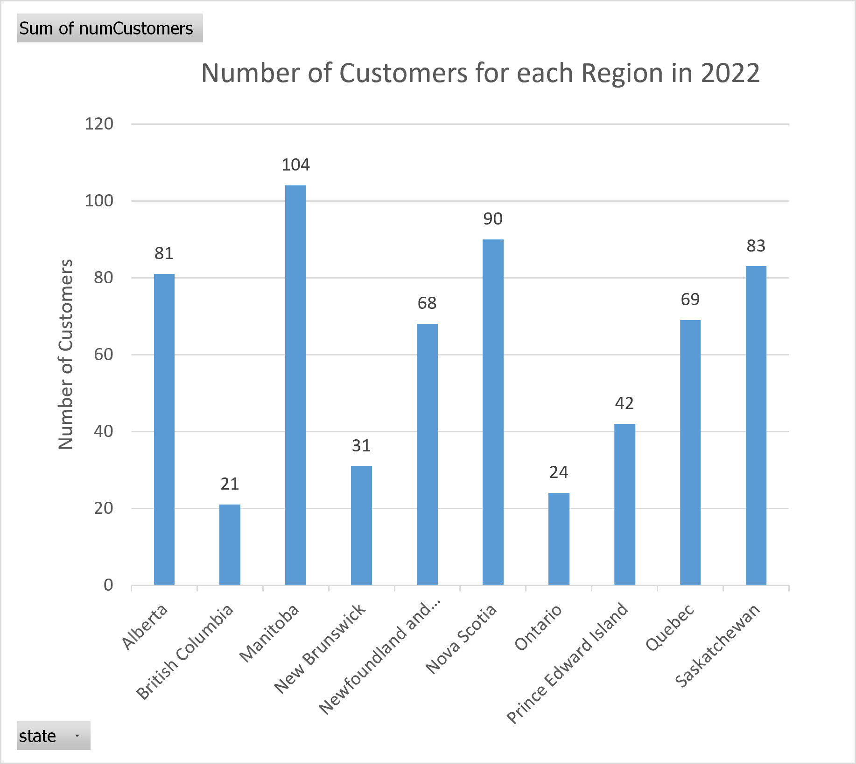
This chart shows that Manitoba, Saskatchewan, and Quebec currently hold the largest share of ACME’s customer base. British Columbia and Ontario remain consistently low, indicating limited market penetration.

  - Customer Trends – Declining Regions
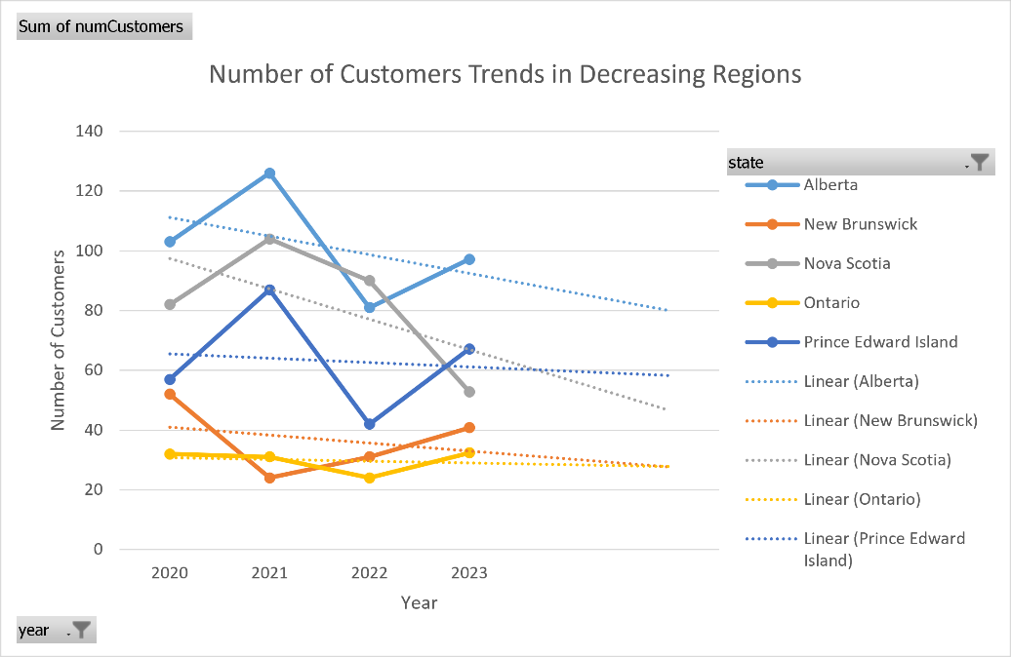
Alberta, New Brunswick, Nova Scotia, Ontario, and Prince Edward Island show steady declines, with Alberta and New Brunswick experiencing the sharpest drops, suggesting potential customer attrition or reduced engagement.
  - Customer Trends – Increasing Regions
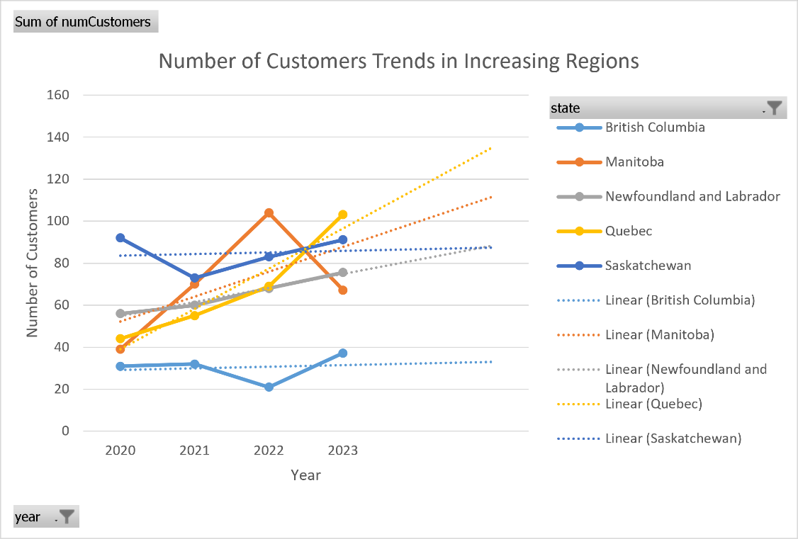
British Columbia, Manitoba, Newfoundland & Labrador, Quebec, and Saskatchewan show consistent growth, with Quebec and Manitoba standing out as the strongest growth markets.

  - Findings
- Quebec and Manitoba show strong upward trends and are projected to grow further in 2024.
- Prince Edward Island, Newfoundland & Labrador, Saskatchewan, and British Columbia remain stable.
- Alberta and New Brunswick show notable declines in customer count.
- Ontario remains consistently low.
- Northern territories (Yukon, NWT, Nunavut) show no customer activity.

  - Recommendation
- Increase marketing and customer retention efforts in Alberta and New Brunswick.
- Prioritize Quebec and Manitoba for future growth initiatives.
- Evaluate whether expanding into northern territories is cost‑effective given their small populations.

Best and Worst Products
  - Approach
  - Top and bottom products were identified using SQL based on historical quantity sold. Products with inconsistent trend directions were removed. Linear forecasts were applied to project 2024 performance.
  - Top 5 Product Trends
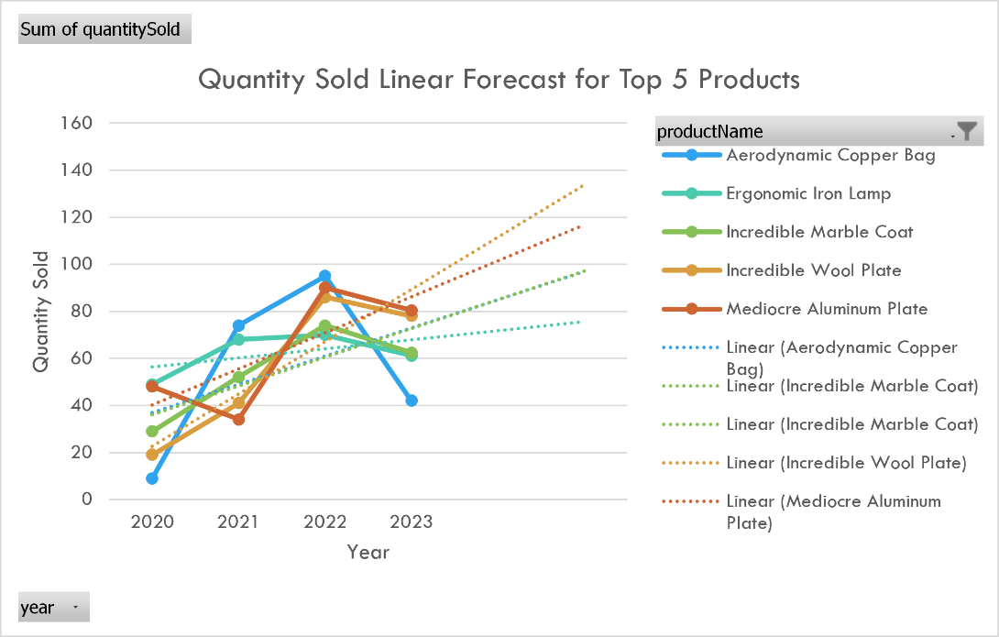
The forecast chart shows consistent upward trajectories for all top products. The Incredible Wool Plate and Mediocre Aluminum Plate show the strongest projected growth into 2024.
  - Bottom 5 Product Trends
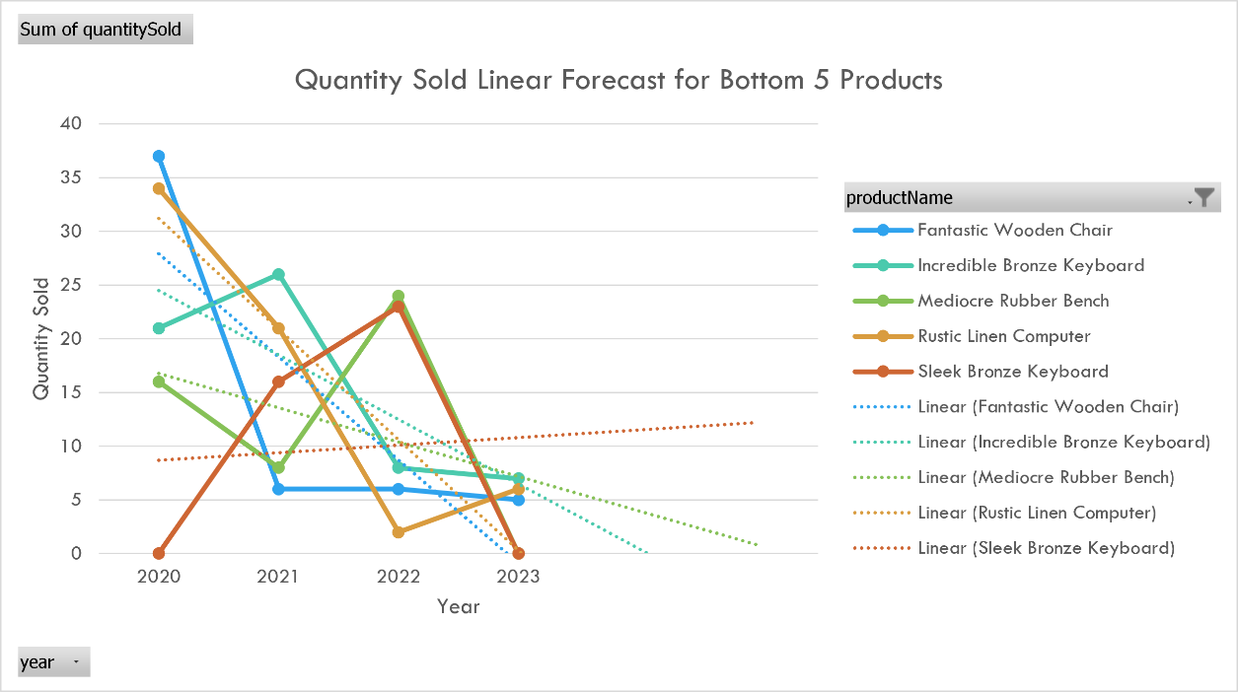
The bottom products show flat or declining trends, with several projected to generate negative revenue in 2024 due to downward linear patterns.
  - Revenue Over Time – Top Products
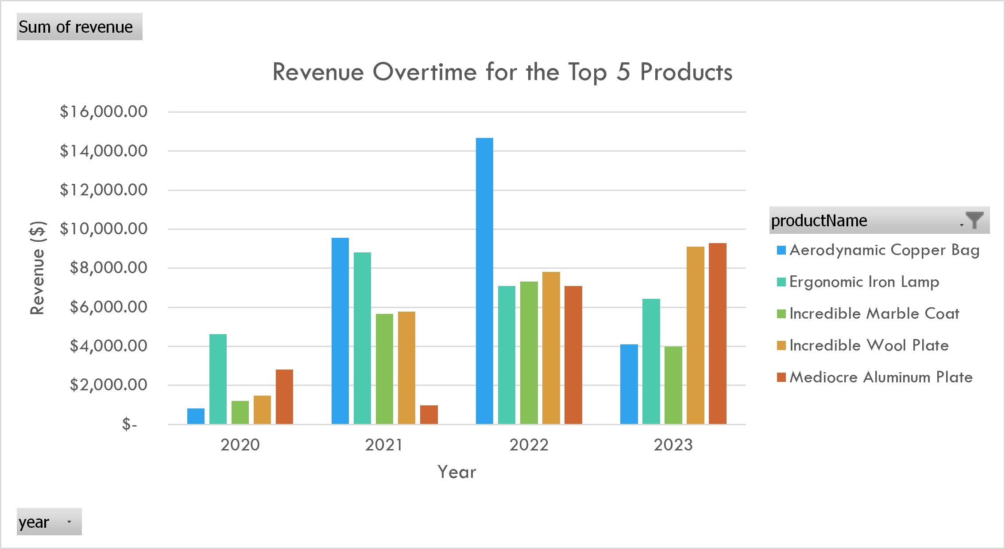
Top products generate significantly higher revenue and show stable year-over-year growth.
  - Revenue Over Time – Bottom Products
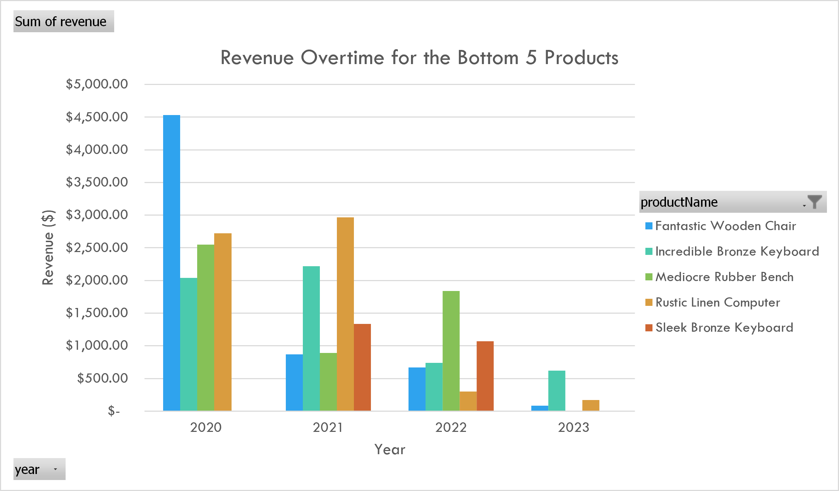
Bottom products contribute minimal revenue and show no signs of recovery.
  - Findings
- Top 5 products (Ergonomic Iron Lamp, Aerodynamic Copper Bag, Incredible Marble Coat, Incredible Wool Plate, Mediocre Aluminum Plate) show consistent growth and strong projected 2024 revenue.
- Bottom 5 products show declining or negative projected revenue, with some forecasted to generate negative sales due to linear trend behavior.
- These products are unlikely to recover without intervention.
  - Recommendation
- Promote top products through reviews, bundles, and targeted advertising.
- Discount, rebrand, or discontinue bottom products to reduce warehouse costs.
- Consider liquidation strategies for products forecasted to generate negative revenue.

Payment Methods
  - Approach
Payment method usage was extracted using SQL. For customers with multiple payment methods, the lowest paymentTypeID was used as the primary method. Linear forecasting was applied to project 2024 usage.
  - Payment Method Trends
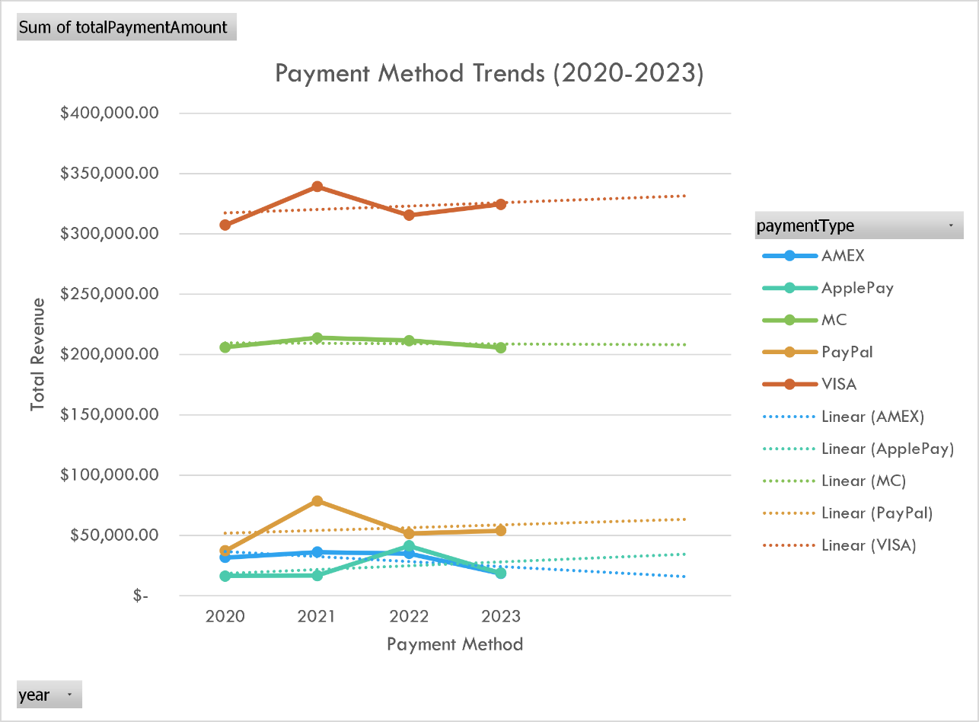
VISA remains the dominant payment method across all years. ApplePay shows steady growth, reflecting increasing customer adoption. AMEX remains the least used and shows no upward trend.

  - Total Revenue by Payment Method
  - 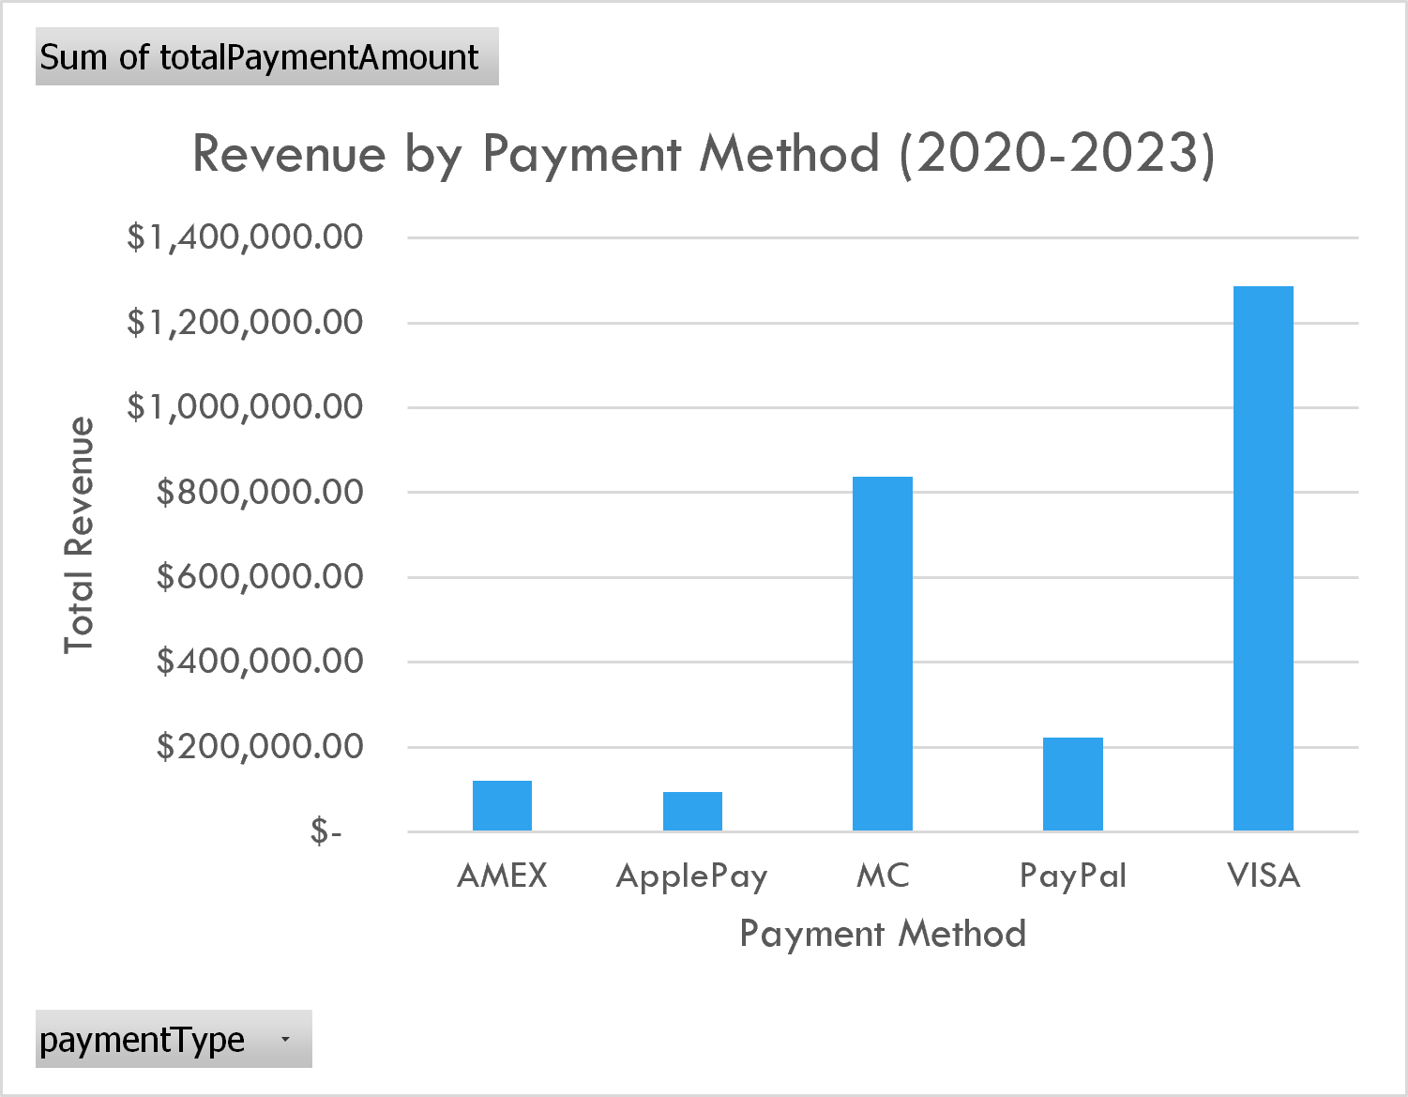
VISA generates the highest revenue by a wide margin. PayPal and MC contribute moderate amounts, while ApplePay remains small but growing.
  - Findings
- VISA dominates, accounting for over half of all revenue.
- PayPal and MC remain stable.
- ApplePay shows consistent growth and may become more significant.
- AMEX remains the least used and shows no upward trend.
  - Recommendation
- Reevaluate the cost of supporting AMEX and PayPal if processing fees outweigh revenue.
- Continue supporting ApplePay and reassess in 2024 as adoption increases.

Inventory Management
  - Approach
Two SQL queries were used: product-level inventory vs sold quantities and warehouse-level inventory totals. A log-log scatterplot was used due to wide variation in product volumes. Products were categorized into overstock, healthy, and stockout-risk groups.
  - Overstocked Products
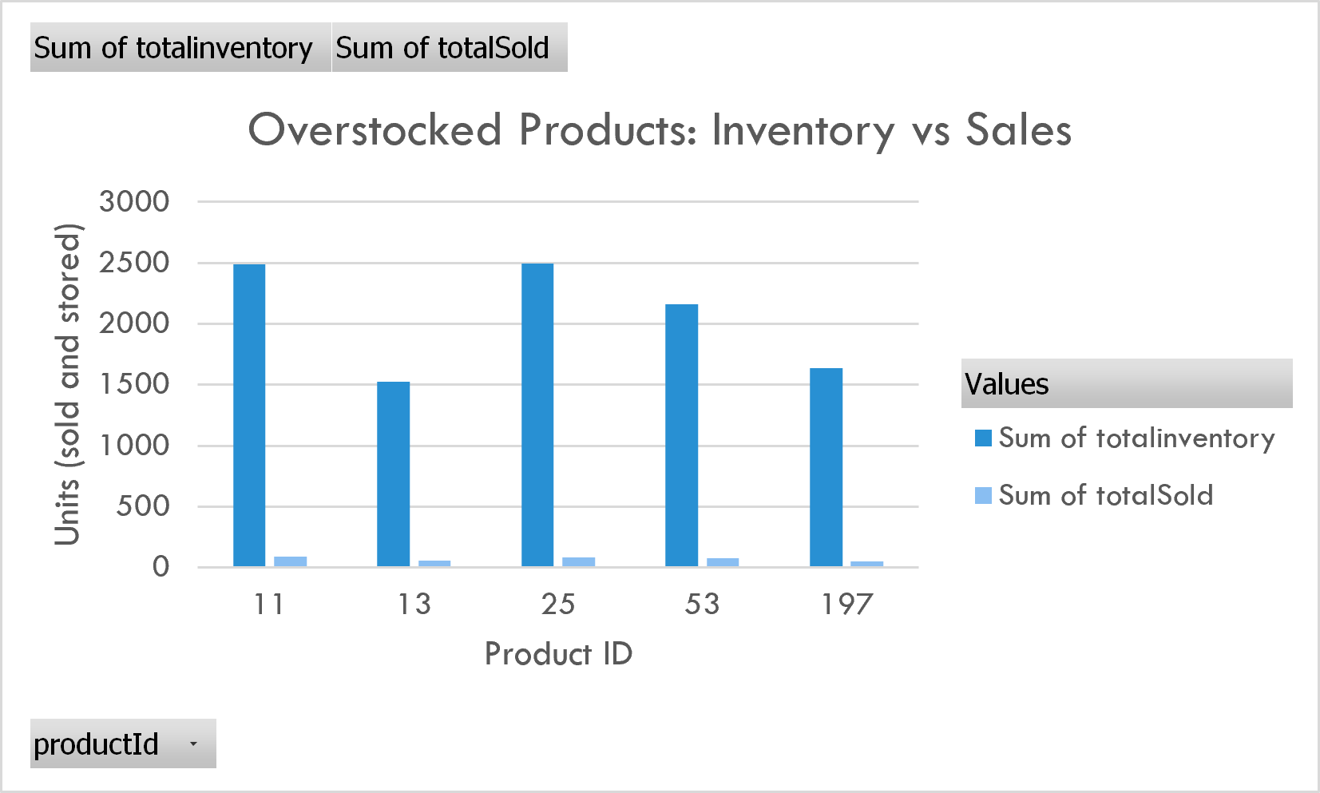
Inventory levels are 20–30× higher than units sold for several products, tying up warehouse space and capital.
  - Stockout-Risk Products
  - 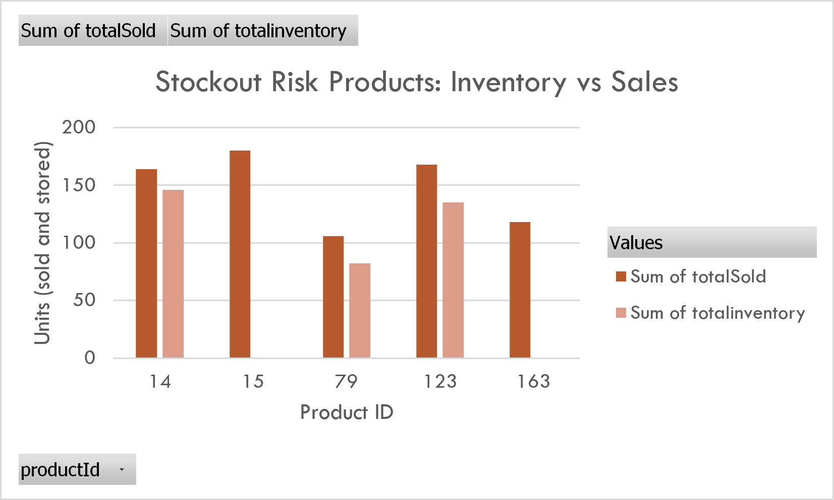
These products have sales that meet or exceed inventory levels, indicating potential missed revenue if stock is not replenished.
  - Healthy Inventory Products
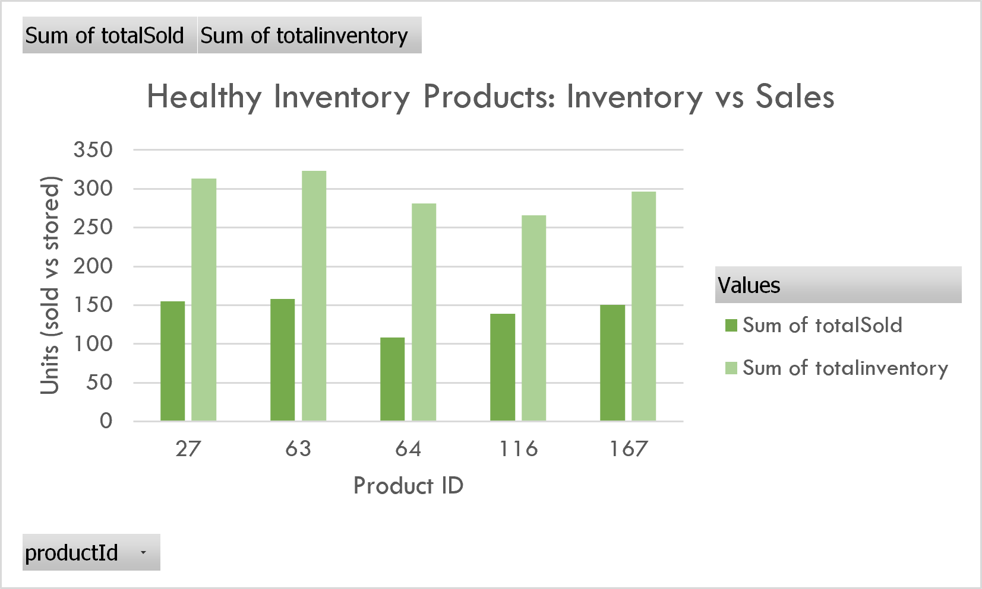
Healthy products show balanced inventory and demand, with inventory ratios close to 1–2.
  - Inventory Efficiency Overview
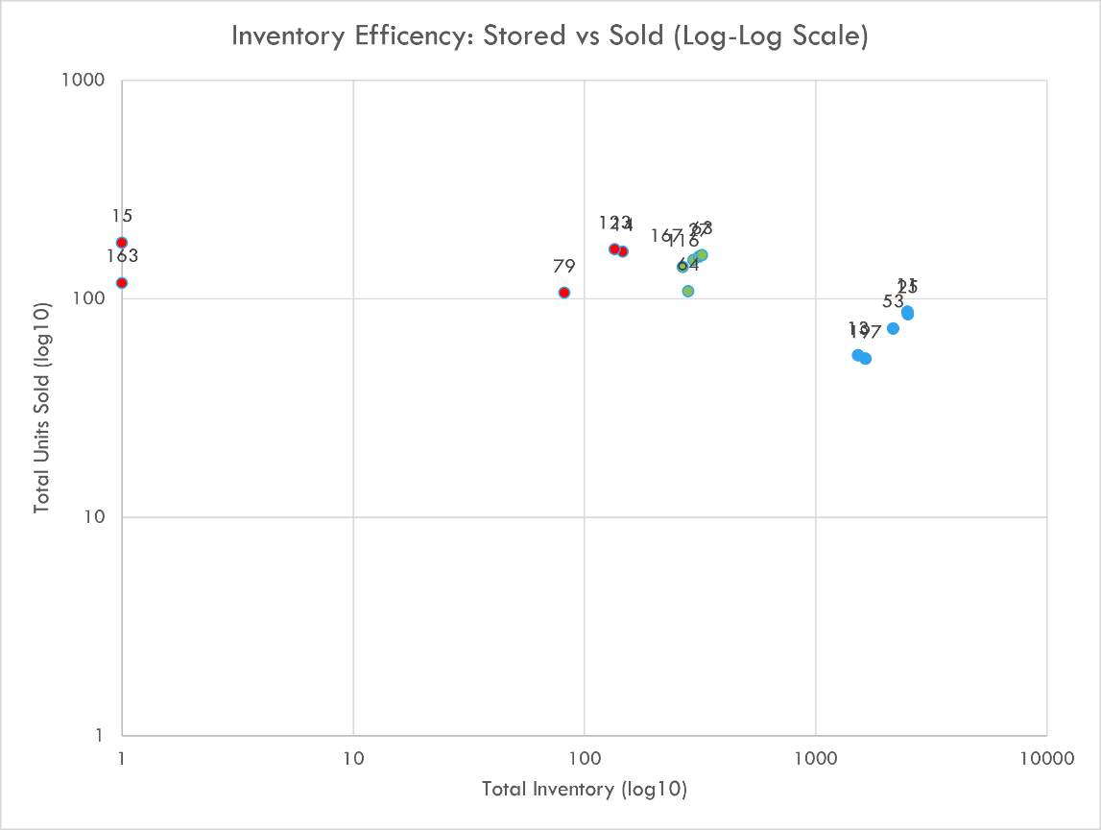
The log-log scale allows meaningful comparison across products with vastly different volumes and clearly separates overstocked, healthy, and stockout-risk items. The scatterplot clearly separates products into three clusters:
- Overstock: High inventory, low sales (blue markers)
- Healthy: Near the diagonal (green markers)
- Stockout-risk: Low inventory, relatively high sales (red markers)
This visual provides a high-level view of ACME’s inventory health.
  - Warehouse Inventory Levels
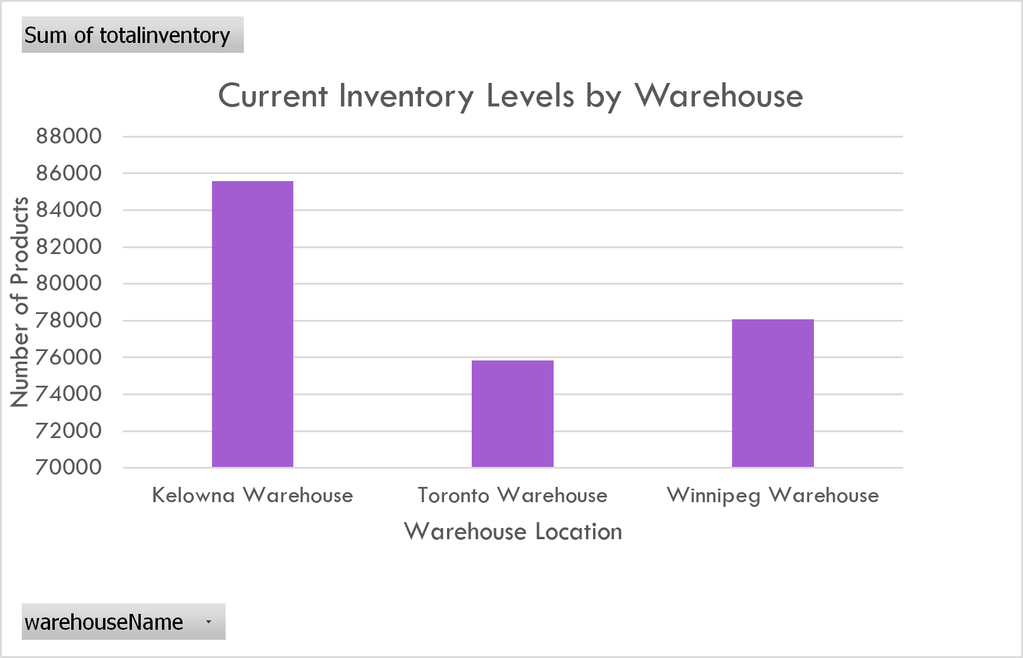
Kelowna holds the highest inventory despite being geographically distant from most customers. Toronto and Winnipeg are better positioned relative to customer distribution.
  - Findings
- Many products have inventory levels 10–30× higher than units sold.
- Several products are at stockout risk, with sales exceeding inventory.
- Only a small subset of products fall into the healthy category.
- Warehouse distribution is even, but customer distribution is not.
- Kelowna holds high inventory despite being far from most customers.
  - Recommendation
- Reduce excess inventory through promotions or liquidation.
- Replenish stockout-risk products to avoid missed revenue.
- Consider temporarily closing the Kelowna warehouse to reduce operating costs.
- Adopt a leaner inventory strategy with more frequent replenishment cycles.

Limitations
The 2023 dataset was incomplete and required a 20% uplift to approximate year-end totals. Linear forecasting cannot account for sudden market shifts or seasonality beyond historical patterns. Product-level analysis did not include profitability or cost data, limiting recommendations to sales and inventory metrics. The assumption that customers with multiple payment methods default to the lowest paymentTypeID may not reflect actual behavior. The log-log scatterplot improves visibility across product volumes but reduces detail for very low-volume items.

Methods
SQL was used to extract customer, product, payment, and inventory data. After cleaning and adjusting the 2023 dataset, linear forecasting models were applied to project 2024 performance. Inventory efficiency was evaluated using grouped bar charts and a log-log scatterplot to accommodate wide variation in product volumes. All visuals were created in Excel for transparency and consistency.

Next Steps

Future analysis could include customer segmentation, profitability modeling, and shipping‑time analysis to understand regional declines. Implementing an inventory turnover dashboard would support real‑time monitoring. Integrating datasets into a BI tool such as Power BI or Tableau would streamline reporting and enable interactive exploration.

Summary Report
ACME’s strongest opportunities lie in expanding into growing regions (Quebec, Manitoba), optimizing product offerings, and addressing significant inefficiencies in inventory management.
  - Customer Insights
- Quebec and Manitoba show strong growth potential.
- Alberta and New Brunswick require targeted retention strategies.
  - Product Insights
- Top products are reliable revenue drivers.
- Bottom products should be discounted or discontinued.
  - Payment Insights
- VISA dominates; ApplePay is rising.
- AMEX and PayPal may not be cost-effective.
  - Inventory Insights
- Overstocking is a major operational issue.
- Stockout-risk products need immediate attention.
- Warehouse strategy should be restructured to reduce costs.

