Comparing the Generation of Renewable and Nonrenewable Energy Overtime

Introduction
In recent years, Canadians have faced increasing pressure to reduce emissions and transition toward cleaner energy sources. Renewable energy refers to power generated from natural sources that replenish faster than they are consumed, such as wind, solar, and hydro. Non‑renewable energy lacks this characteristic, making it unsustainable in the long term.
This report analyzes how electricity generation from renewable and non‑renewable sources changed in Canada between 2005 and 2016. The goal is to:
- evaluate long‑term trends
- compare variability between energy types
- determine whether production shifted across two time periods
- assess whether renewable and non‑renewable means differ significantly
These findings are relevant to citizens, journalists, and policymakers interested in understanding how government policies, technological advancements, and environmental conditions influenced national energy production during this period.

Data Description & Preparation
The dataset used in this analysis was obtained from the Government of Canada’s Open Data Portal in CSV format. It includes the following variables:
- Region
- Source (Hydro, Wind, Biomass, Solar, Nuclear, Coal, Natural Gas, Oil & Diesel)
- Year (2005-2016)
- Data (energy generated in GWh)
- Unit (GWh)
To focus on national trends, the dataset was filtered to include only the Canada region. Energy sources were grouped into two categories:
- Renewable: Hydro, Wind, Biomass, Solar
- Non‑renewable: Nuclear, Coal, Natural Gas, Oil and Diesel
Annual totals were calculated for each category, producing two summary datasets:
- renewYearly: total renewable energy per year
- nonrenewYearly: total non‑renewable energy per year
A bar plot was created to introduce the data visually, showing side‑by‑side yearly comparisons of renewable and non‑renewable generation.
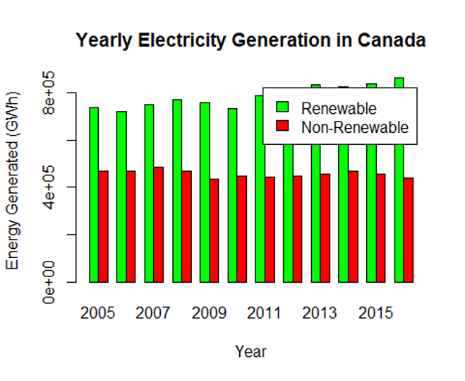
Figure 1. Bar plot of yearly renewable vs non-renewable generation.

Methods
The analysis used several statistical techniques:

Maximum Likelihood Estimation (MLE)
MLE was used to estimate the mean and standard deviation of annual renewable and non-renewable energy generation, assuming a normal distribution.

Confidence Intervals

95% confidence intervals were constructed for both the mean and standard deviation of each energy category.

Hypothesis Testing
Two-sample t-tests were used to compare:
- renewable vs non-renewable means
- early period (2005–2010) vs late period (2011–2016)

Visualization
Several charts were created to support interpretation:
- time-series scatter plot with trendlines
- bar plot of yearly totals
- boxplots comparing distributions
These visualizations help illustrate the statistical findings and highlight meaningful trends.

Results

Point Estimation
MLE estimates for renewable energy:
- Mean: 783,872.7 GWh
- Standard deviation: 45,147.66 GWh
MLE estimates for non‑renewable energy:
- Mean: 456,391.4 GWh
- Standard deviation: 14,517.84 GWh
Renewable energy production is both higher on average and more variable than non‑renewable production.

Time Series Analysis
A time‑series plot of annual energy generation from 2005–2016 shows:
- Renewable energy: clear upward trend
- Non‑renewable energy: relatively stable over time
Trendlines and horizontal MLE mean lines reinforce these patterns.
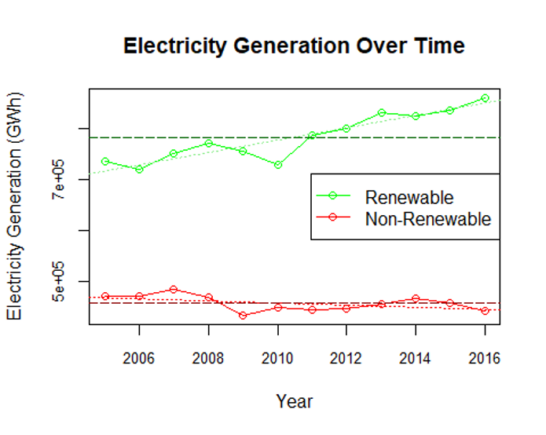
Figure 2. Time series plot with trendlines.

Confidence Intervals
Renewable Energy
- Mean CI: [758,328.4, 809,416.9]
- SD CI: [31,982.38, 76,655.22]
Non‑Renewable Energy
- Mean CI: [448,177.3, 464,605.4]
- SD CI: [10,284.37, 24,649.53]
These intervals confirm:
- renewable energy production is higher
- renewable energy is more variable
- non‑renewable energy is more stable and predictable

Hypothesis Testing

Renewable vs Non‑Renewable Means
- p‑value: 4.824e‑12
- Conclusion: The means differ significantly.
- Renewable energy is consistently higher and more variable.
A boxplot visually confirms the separation between the two distributions.
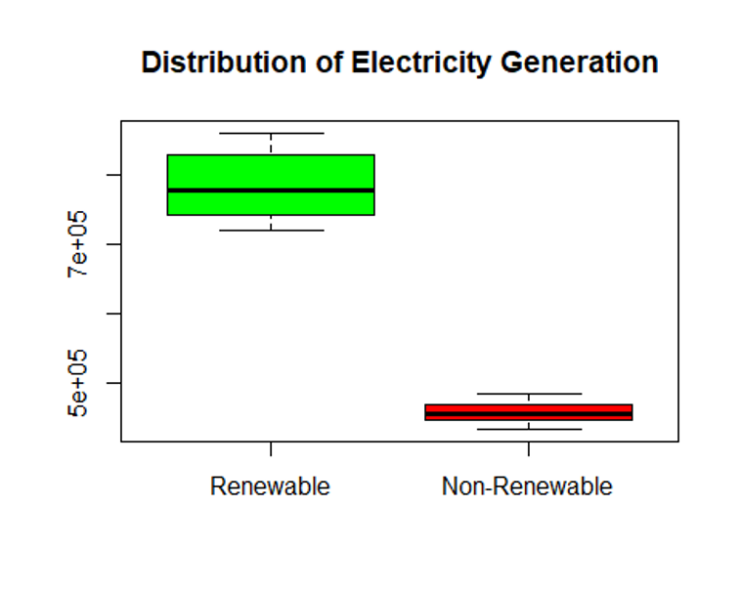
Figure 3. Boxplot comparing renewable vs non-renewable distributions

Period Comparison: 2005–2010 vs 2011–2016
Renewable Energy
- p‑value: 0.0001997
- Conclusion: Renewable energy increased significantly in the later period.
- Mean increased from 743,948.6 GWh to 823,761.4 GWh.
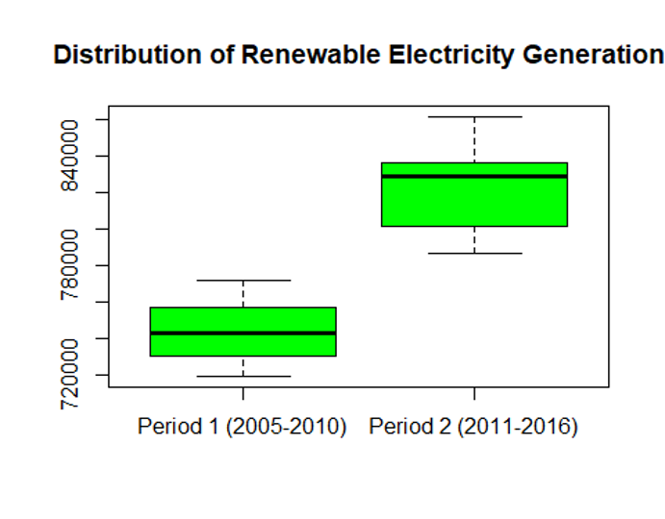
Figure 4. Boxplot comparing renewable energy from 2005-2010 vs 2011-2016
Non‑Renewable Energy
- p‑value: 0.2465
- Conclusion: No significant change between periods.
- Production remained stable.
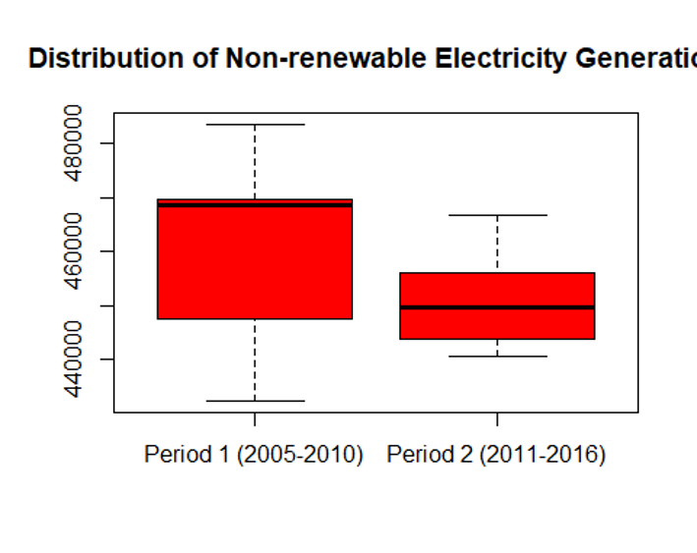
Figure 5. Boxplot comparing non-renewable energy from 2005-2010 vs 2011-2016

Discussion
The analysis reveals several important insights:
- Renewable energy production is substantially higher than non-renewable production across all years.
- Renewable energy shows greater variability, largely due to weather-dependent sources such as wind and solar.
- Non-renewable energy remains stable and predictable, reflecting the reliability of fossil fuel–based systems.
- Renewable energy production increased significantly in the later years, while non-renewable production did not change meaningfully.
These findings suggest that Canada made measurable progress toward cleaner energy generation during the study period. However, renewable energy’s variability highlights the continued importance of maintaining reliable non-renewable sources, especially during periods of high demand or adverse weather conditions.

Conclusion
From 2005 to 2016, Canada experienced:
- rising renewable energy production
- stable non‑renewable production
- significant differences in variability and long‑term trends
Overall, the country appears to be moving in a positive direction toward sustainable energy generation. Future work should incorporate more recent data, as energy policies, technologies, and climate conditions have evolved significantly since 2016.

References
- Secretariat, T. B. of C., & Secretariat, T. B. of C. (n.d.). Open Government Portal. Open.canada.ca. https://open.canada.ca/data/en/dataset/2cdf43fc-d4aa-4604-9f21-29777d955810/resource/b751e0dc-1a00-417a-9f04-b4777adb521f

