select * from crime_scene_report
where city = 'SQL City' and date = 20180115

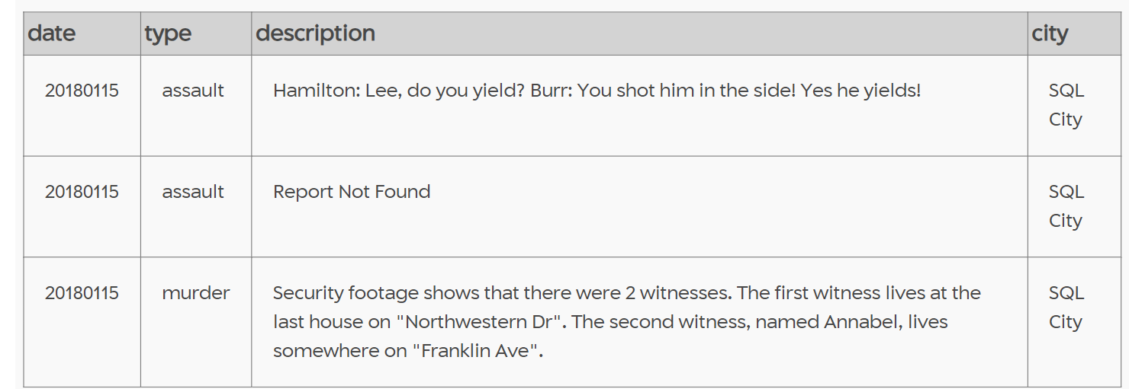

select * from person
where address_street_name = 'Franklin Ave' AND name like 'annabel%'
ORDER BY address_number desc
limit 1
Testemunhas
1- Annabel Miller
2-morty schapiro
Depoimentos:
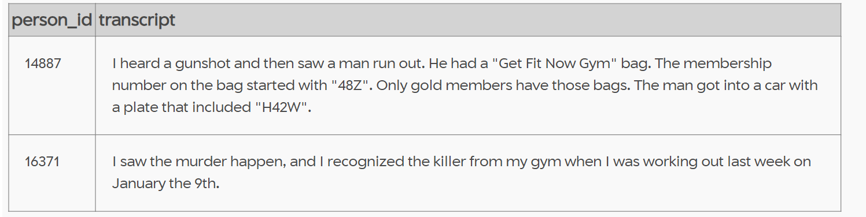

select * from get_fit_now_member
where membership_status = 'gold' and id like '48z%'
Suspeitos:
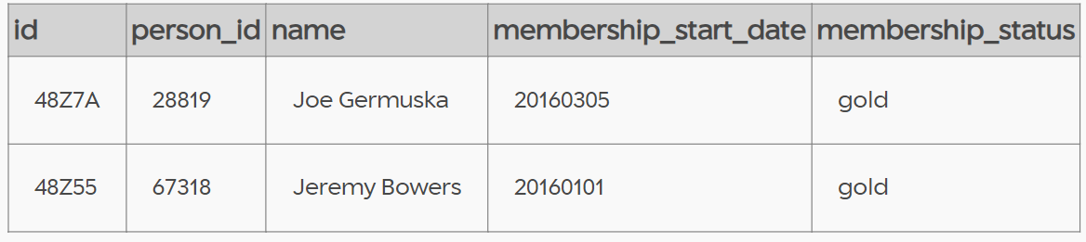

Pesquisa no dia do check in
select * from
get_fit_now_check_in
where membership_id in ('48Z7A','48Z55')
and check_in_date = 20180109
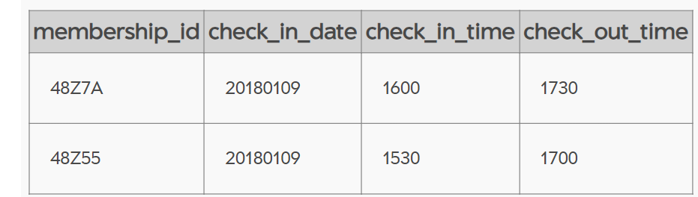

Pesquise nos eventos
select * from facebook_event_checkin
where person_id in (14887,16371)
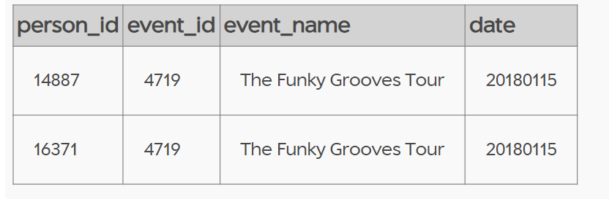

select * from facebook_event_checkin
where event_name = 'The Funky Grooves tour'
assassino jeremy
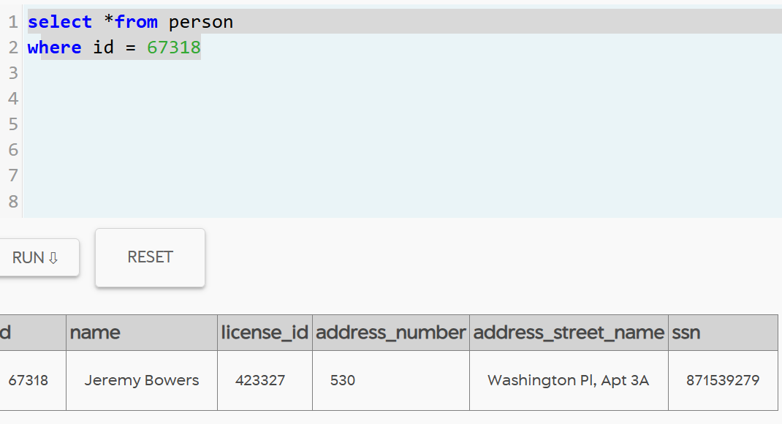
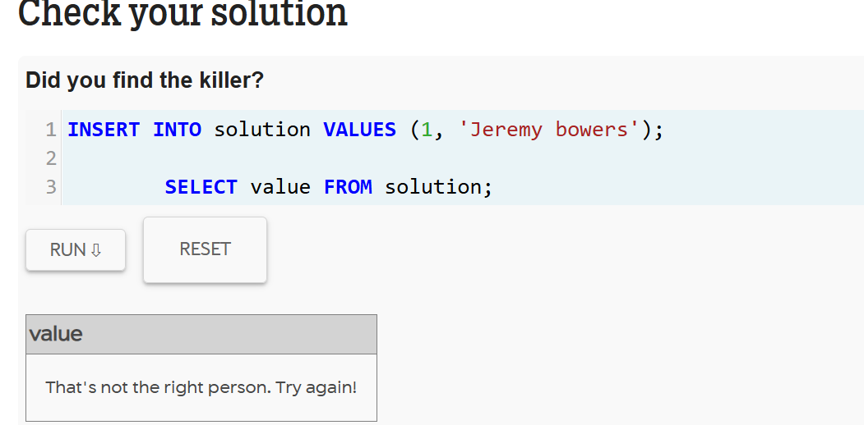

depoimento do jeremy
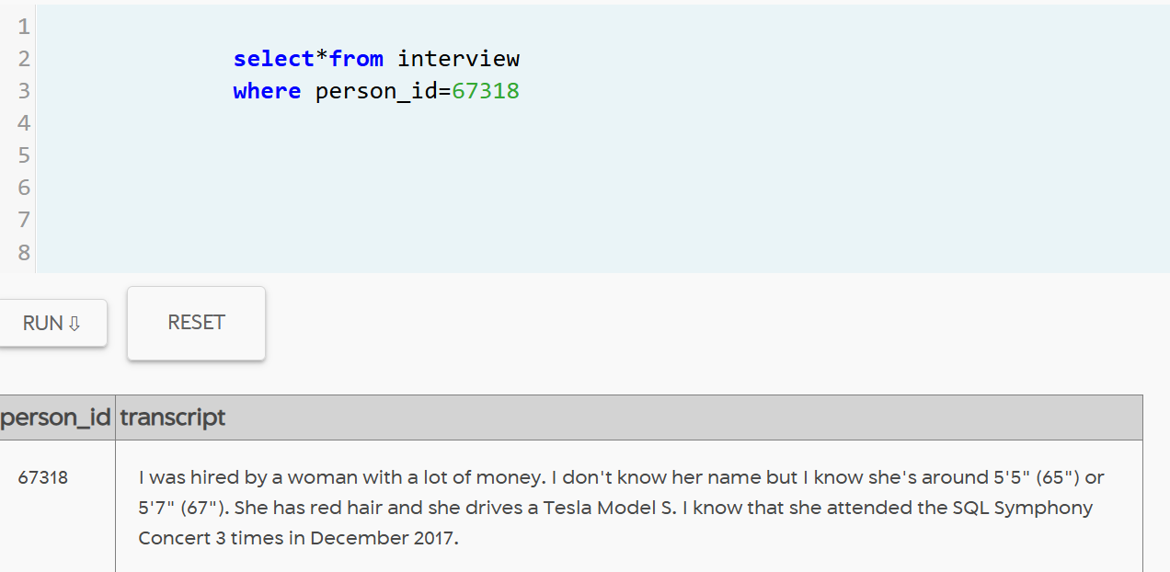
modelo de carro
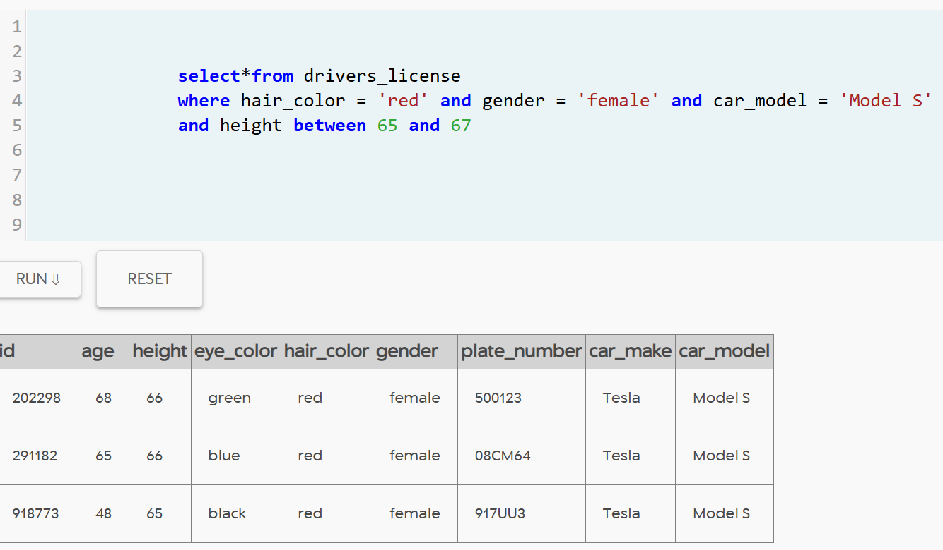
suspeitas :
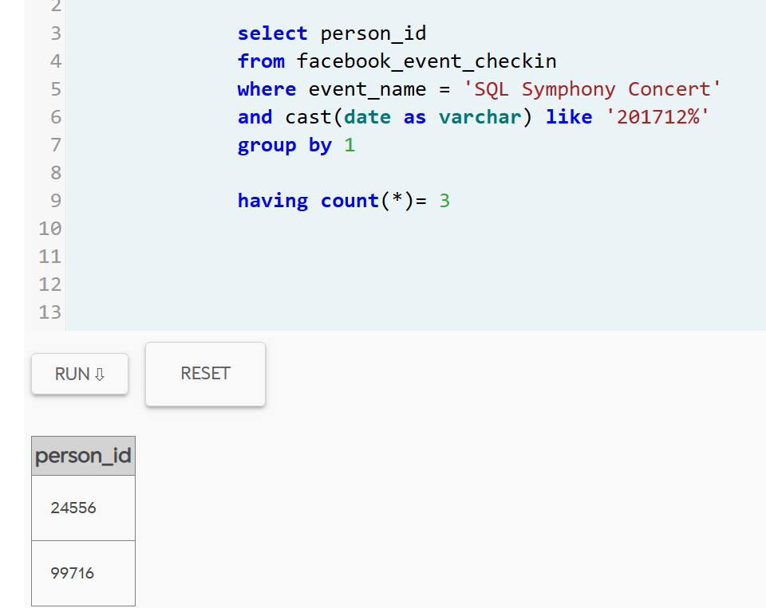select * from person
where
id in (select person_id from facebook_event_checkin where event_name = 'SQL Symphony Concert'
and cast (date as varchar ) like '201712%'
group by 1
having count (*) = 3)
and id in (select person.id=person.license_id
where hair_color = 'red' and gender = 'female'and car_model='Mode S'and height between 65 and 67)

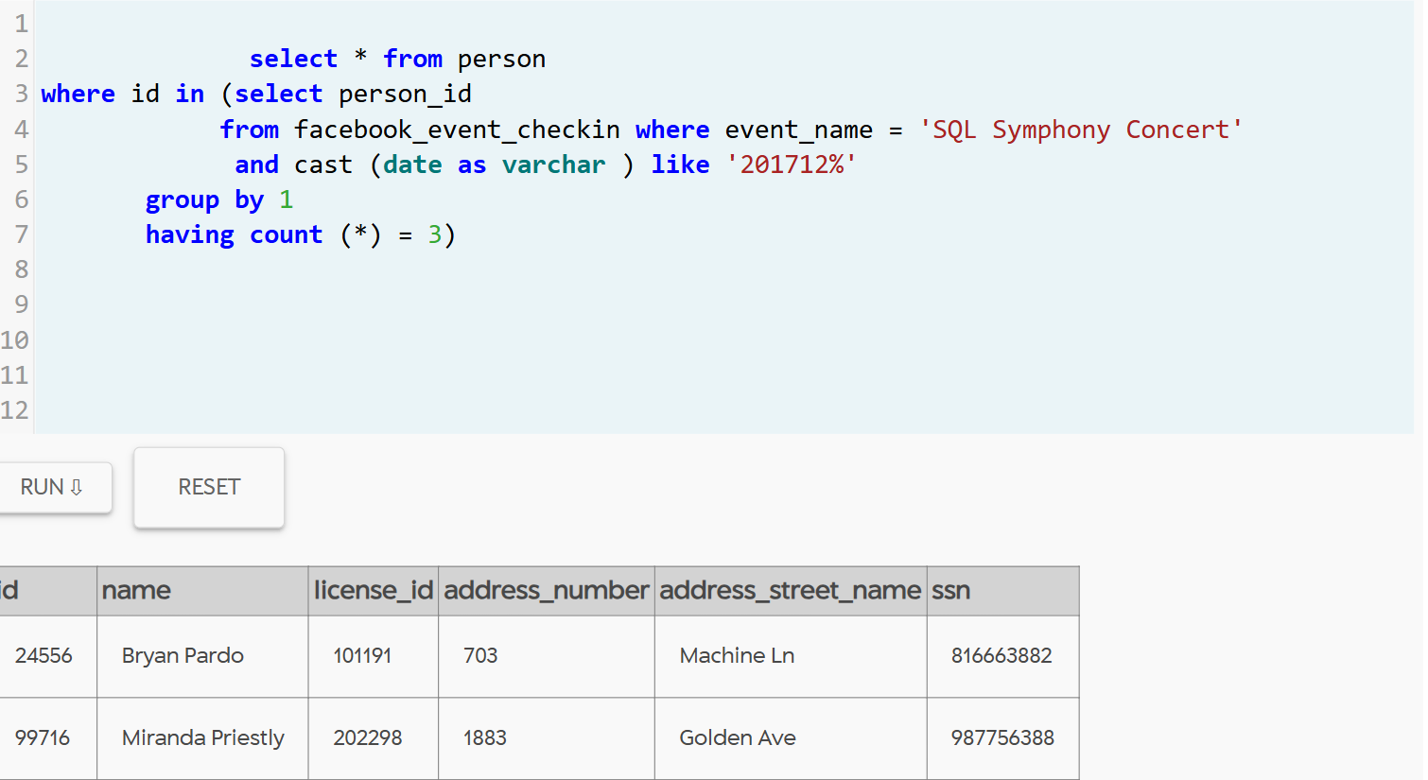
compara com drivers_license resultado = Miranda priestly

