CEBU INSTITUTE OF TECHNOLOGY
UNIVERSITY

COLLEGE OF COMPUTER STUDIES

Software Design Description
for
Student, Transferee Enrollment Processing System

Signature

Development Team:

Lauren Brian L. Sy
Project Leader/Developer

Ronnelo A. Mernilo
Web Programmer/Backend Design

Rian Christopher F. Segarra
Documentation Officer/CSS Design

Change History
- Inputting ER Diagrams, Class Diagrams, and Sequence Diagram.
- Adding User Interfaces

Preface

This document contains the specific requirements of the software – Student, Transferee Enrollment Processing System. This software was inspired by our Project leader, Lauren Brian L. Sy. Base on his experience, he wants to improve the relationship-treatment between the School (Requirements and Paper works) and the Student.

Student, Transferee Enrollment Processing System or should we say STEPS, is a Web Application that could be used by the Student and School Admins. It helps the students know the steps that they should do such as: “What am I going to do first?”, “What should I bring?”, “Where am I going next?” etc. while the School Admins could let their works gets lighter because they’re just going to wait for the student to come to their place/building.

You will find this in this document the categorized list of all necessary specifications vital to the development of our software, resembling as its skeleton.

-STEPS Development Team

Table of Contents

Signature 2
Change History 3
Preface 4
Table of Contents 5
List of Figures 6
List of Tables 7
1. Introduction 8
1.1. Purpose 8
1.2. Scope 8
1.3. Definitions and Acronyms 8
2. References 9
3. Decomposition Description 10
3.1. Module Decomposition 10
3.1.1. Module 1 Description 10
3.1.2. Module 2 Description 10
3.2. Concurrent Process Decomposition 10
3.2.1. Process 1 Description 10
3.2.2. Process 2 Description 10
3.3. Data Decomposition 10
3.3.1. Data Entity 1 Description 10
3.3.2. Data Entity 2 Description 10
4. Dependency Description 11
4.1. Inter-module Dependencies 11
4.2. Inter-process Dependencies 11
4.3. Data Dependencies 11
5. Interface Description 12
5.1. Module Interface 12
5.1.1. Module 1 Description 12
5.1.2. Module 2 Description 12
5.2. Process Interface 12
5.2.1. Process 1 Description 12
5.2.2. Process 2 Description 12
6. Detailed Design 13
6.1. Module Detailed Design 13
6.1.1. Module 1 Detail 13
6.1.2. Module 2 Detail 13
6.2. Data Detailed Design 13
6.2.1. Data Entity 1 Detail 13
6.2.2. Date Entity 2 Detail 13

List of Figures

List of Tables

Introduction

Purpose
This document includes a detailed description of the Students, Transferee Enrollment Processing System. This helps the student to have a guideline during his/her Enrolling Processes. It helps the students to be aware what should happen step by step. STEPS tell you what you’re going to do next and have a specific feature such as Newsfeed and Event calendar date.

Scope
The primary goal is to efficiently save the time of every each student and administrators that manages the enrollment processes. It gives Student Monitoring which is for offices to keep track on transferee student’s status, Enrollment Guidance that will guide transferee students along the process, a Web Portal that could put into student and administrators, Newsfeed, and Event Calendar. This System is not part of the Accounting Processes which handles Finances such as tuition fee or the entrance examination fee that is needed also for enrollment processes. However, we can still see the status of the student if they have already paid if they’ve showed the receipt.

Reference Material

1.4 Definitions and Acronyms

System Overview
STEPS is a system that provides a new student a knowledge on what things that are going to be done first. In Design, we’ve managed to place all the necessary steps on what should happen and knowing the flow of the program.

System Architecture

Architectural Design
Admin Login/Logout Class Diagram

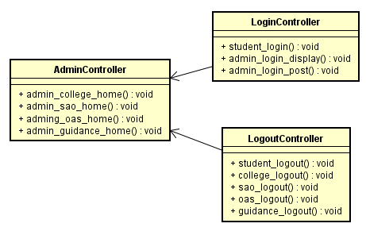

Admin SAO Class Diagram
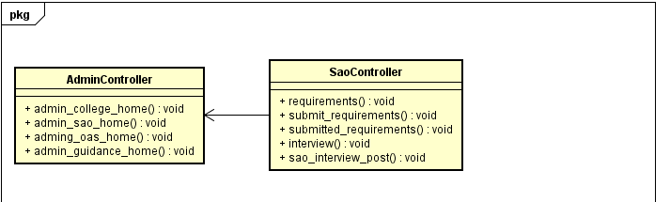

Admin OAS Class Diagram
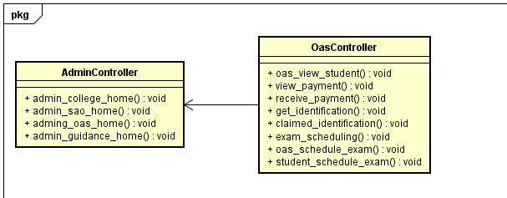

Admin Guidance Class Diagram
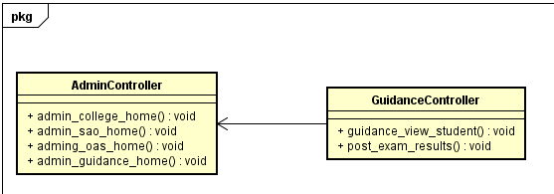

Student Login/Logout Class Diagram
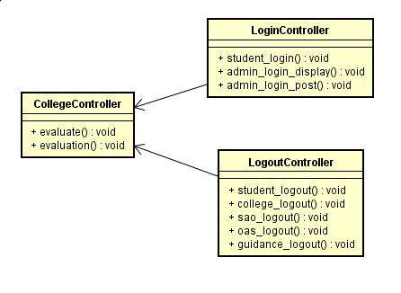

Data Design

Data Description
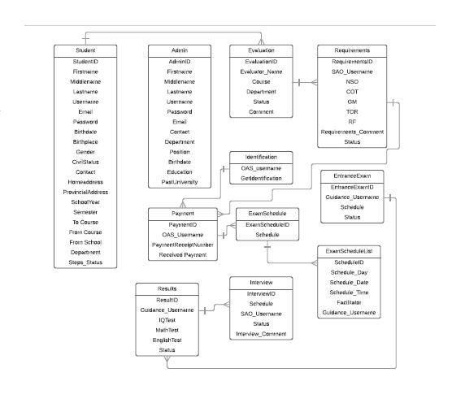

Data Dictionary

Component Design

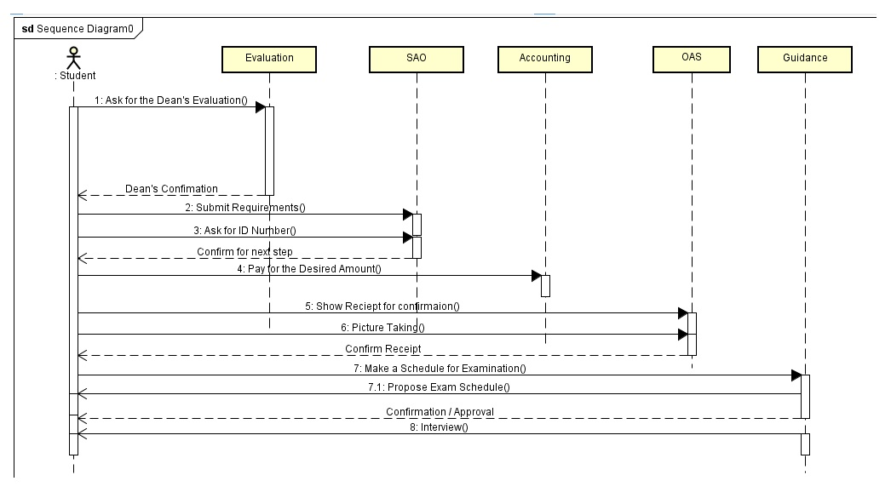

Human Interface Design

Overview of User Interface

Requirement Matrix

Appendices

