CEBU INSTITUTE OF TECHNOLOGY
UNIVERSITY

COLLEGE OF COMPUTER STUDIES

Software Requirements Specifications
For
Student, Transferee Enrollment Process System

Signature

Development Team:

Lauren Brian L. Sy
Project Leader/Developer

Ronnelo A. Mernilo
Web Programmer/Backend Design

Rian Christopher F. Segarra
Documentation Officer/CSS Design

Change History

Preface

This document contains the specific requirements of the software – Student, Transferee Enrollment Processing System. This software was inspired by our Project leader, Lauren Brian L. Sy. Base on his experience, he wants to improve the relationship-treatment between the School (Requirements and Paper works) and the Student.

Student, Transferee Enrollment Processing System or should we say STEPS, is a Web Application that could be used by the Student and School Admins. It helps the students know the steps that they should do such as: “What am I going to do first?”, “What should I bring?”, “Where am I going next?” etc. while the School Admins could let their works gets lighter because they’re just going to wait for the student to come to their place/building.

You will find this in this document the categorized list of all necessary specifications vital to the development of our software, resembling as its skeleton.

-STEPS Development Team

Table of Contents
Signature 2
Change History 3
Preface 4
Table of Contents 5
List of Figures 6
List of Tables 7
1. Introduction 8
1.1. Purpose 8
1.2. Scope 8
1.3. Product Overview 8
1.3.1 Product perspective 8
1.3.2 Product Functions 8
1.3.3 User Characteristics 8
1.3.4 Limitations 8
1.4. Definitions 8
2. References 9
3. Specific Requirements 10
3.1. External interfaces 10
3.2. Functions 10
3.3. Usability requirements 10
3.4. Performance requirements 10
3.5. Logical database requirements 10
3.6. Design constraints 10
3.7. Software system attributes 10
3.8. Supporting information 10
4. Verification 11
5. Appendices 12

List of Figures

[Figure 3.2.1] Use Case1(Student User Case)
[Figure 3.2.2] Use Case 2 (Admin User Case)

List of Tables
[Table 1.4] Definitions.

Introduction

Purpose

This document includes a detailed description of the Students, Transferee Enrollment Processing System. This helps the student to have a guideline during his/her Enrolling Processes. It helps the students to be aware what should happen step by step. STEPS tell you what you’re going to do next and have a specific feature such as Newsfeed and Event calendar date.

Scope

The primary goal is to efficiently save the time of every each student and administrators that manages the enrollment processes. It gives Student Monitoring which is for offices to keep track on transferee student’s status, Enrollment Guidance that will guide transferee students along the process, a Web Portal that could put into student and administrators, Newsfeed, and Event Calendar.

Product Overview

1.3.1 Product perspective
Students, Transferee Enrollment Processing System is a software that puts his enrollment processes into a step-by-step management that could let the student track their statuses where they should go or what they should do. By this, it could possibly save time and lets the student have an easier way of managing their enrollment processes.

1.3.2 Product Functions
Although the software is used in a variety of ways, its main purpose is to facilitate every student enrollee who doen not have a single knowledge on what they should do during enrollment.

Students, Transferee Enrollment Processing System caters the following primary functions:

- Task Management: Gives every student a Task so that they are going to have knowledge about the things they should comply when they’re enrolling.
- Student Monitoring: For offices to keep track on transferee student’s status.
- Enrollment Guidance: This feature will guide transferee students along the process.
- Web Portal: A portal for both students and offices.

1.3.3 User Characteristics
The users should be an enrollee student and a working administrator. The users could be a student, the head from SAO, OAS, Guidance Counselor, etc. that would make a position to be an interaction with both student and administrators.

1.3.4 Limitations
The limitation of this Software is that This System is not part of the Accounting Processes which handles Funds such as tuition fees, the entrance examination fee, etc. that is needed also for enrollment processes. However, we can still see the status of the student if they have already paid if they’ve showed the receipt and proceed to the next step.

Definitions
Terms | Definition
STEPS  (Student, Transferee Enrollment Processing System) | A step-by-step assisting system that helps an enrollee student to have a better experience when enrolling.
Administrators | The operators who manages the status of a student on where they should go and what they should do.  (For example: SAO, OAS, Guidance, etc.)
Students | New Enrollee Student.

References

Specific Requirements

External interfaces

User interfaces

The software is viewed through web-based user interface using browsers like Mozilla Firefox, Google Chrome and Microsoft Internet Explorer. The following images are the revised user interface design.

Student Login

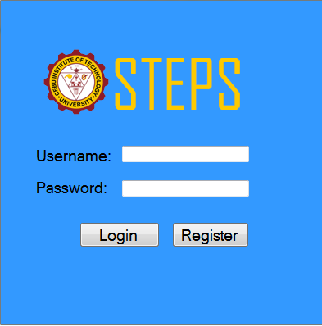

User Registration
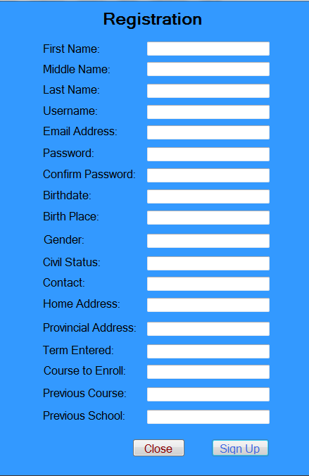

The Procedures of Enrolling Process

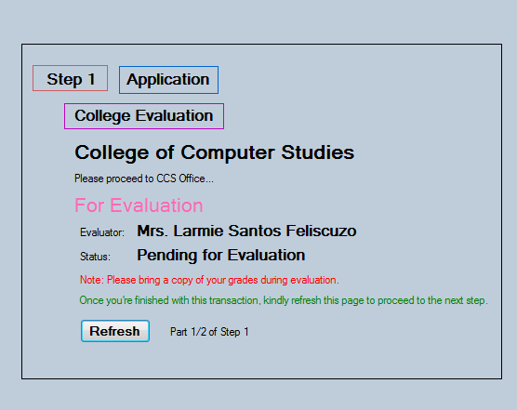

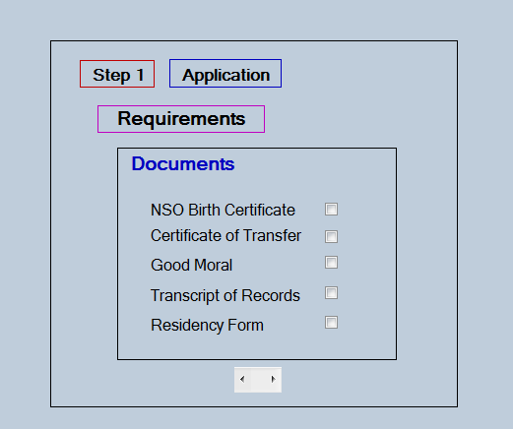

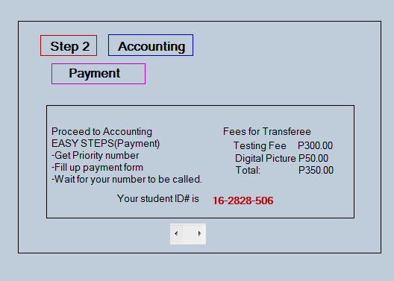

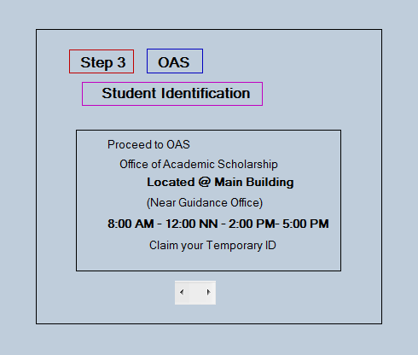

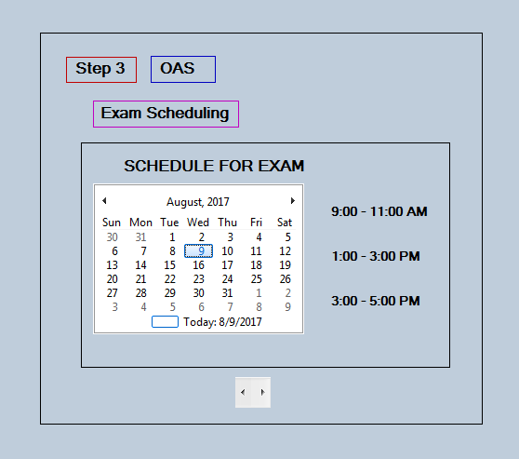

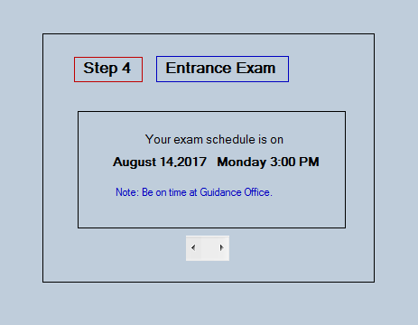
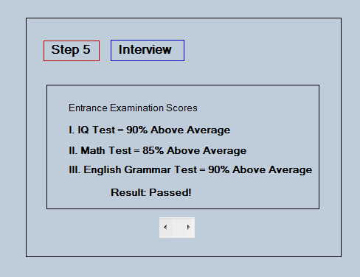

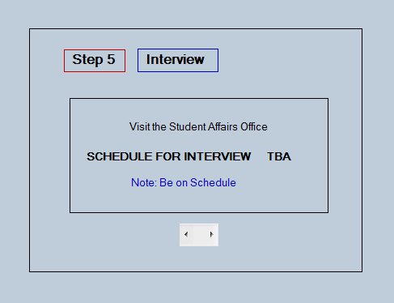

Admin Login

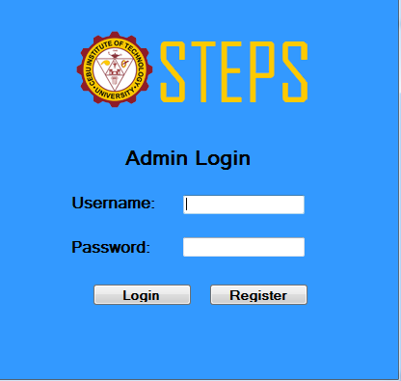

Admin Registration

College Department Office

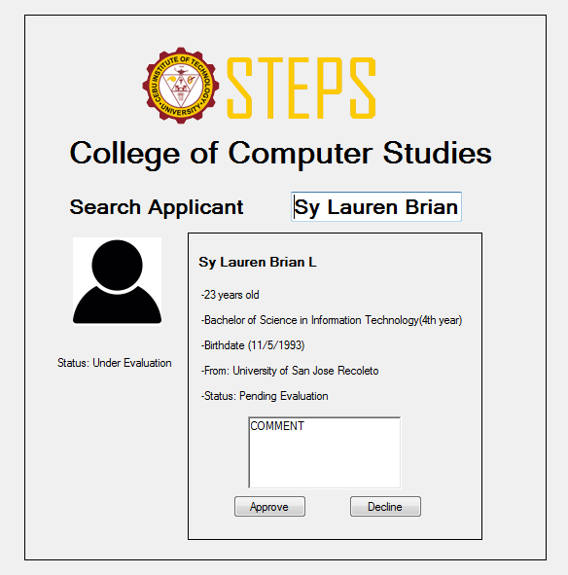

Student Affairs Office

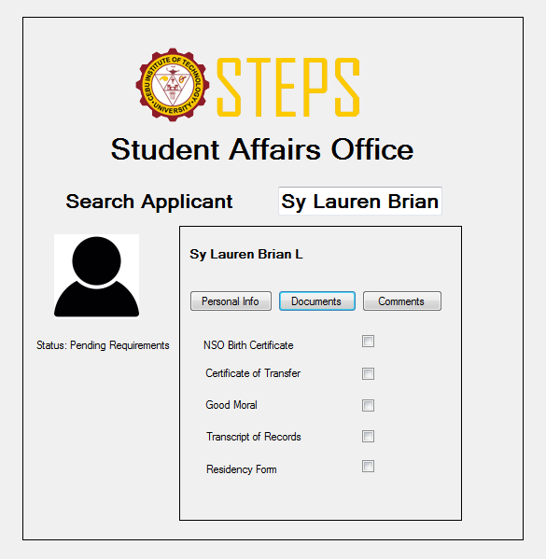

Office of Academic and Scholarship

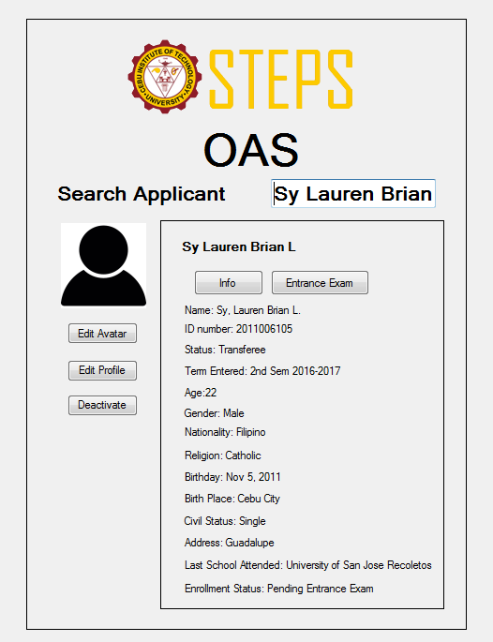

Guidance Office

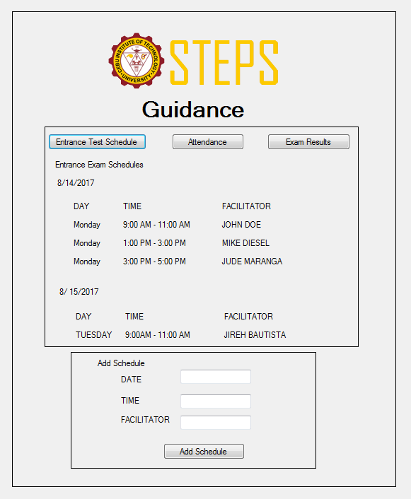

Functions

Use case 1(Student User Case)

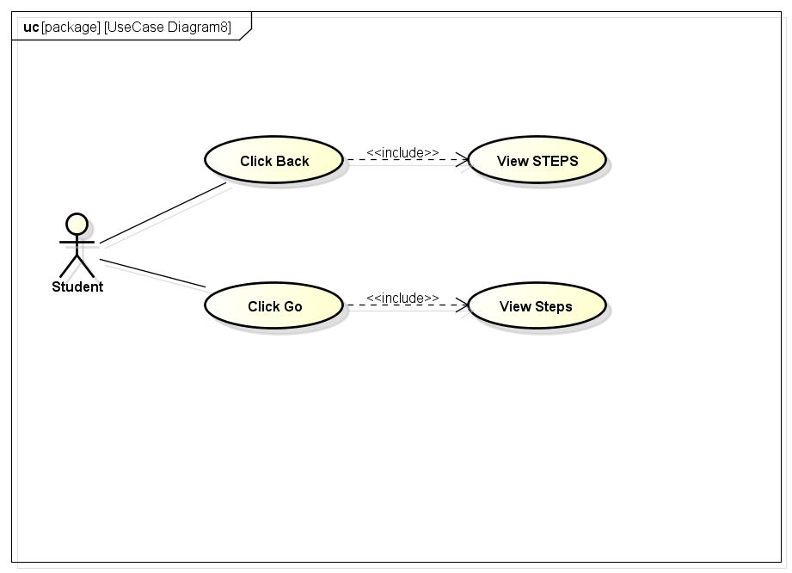
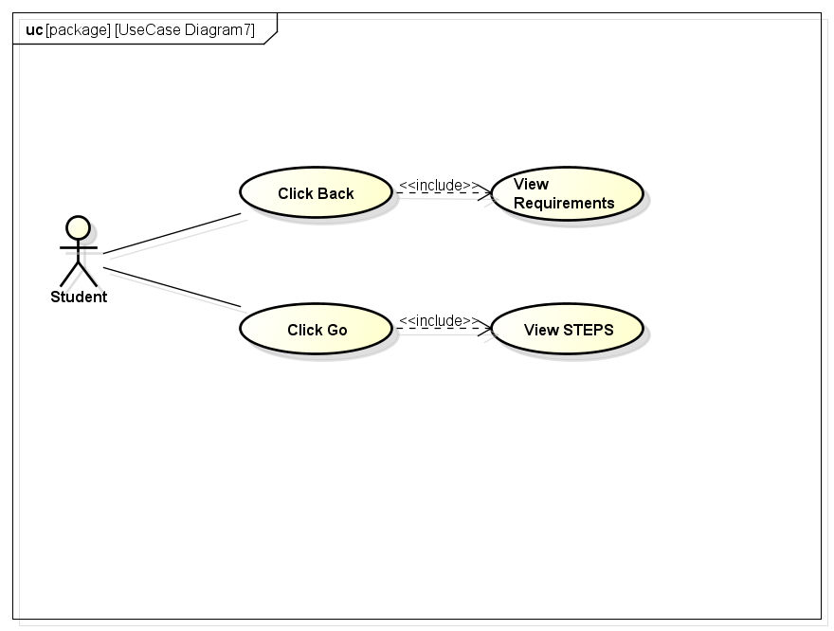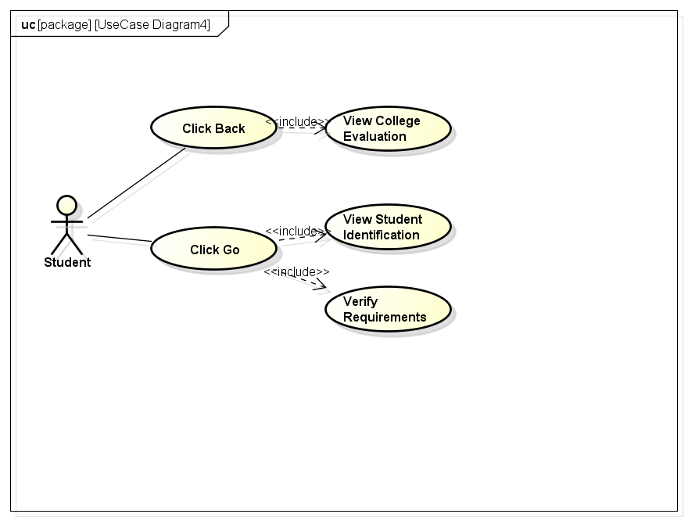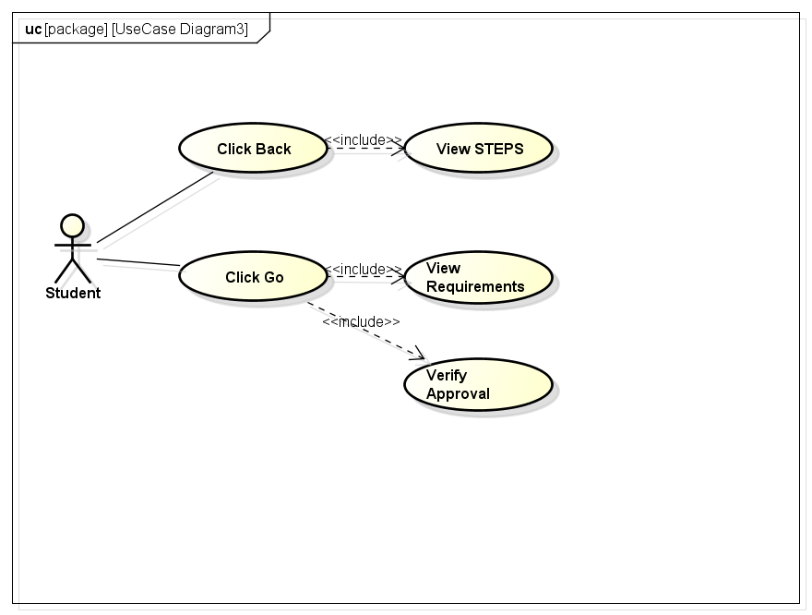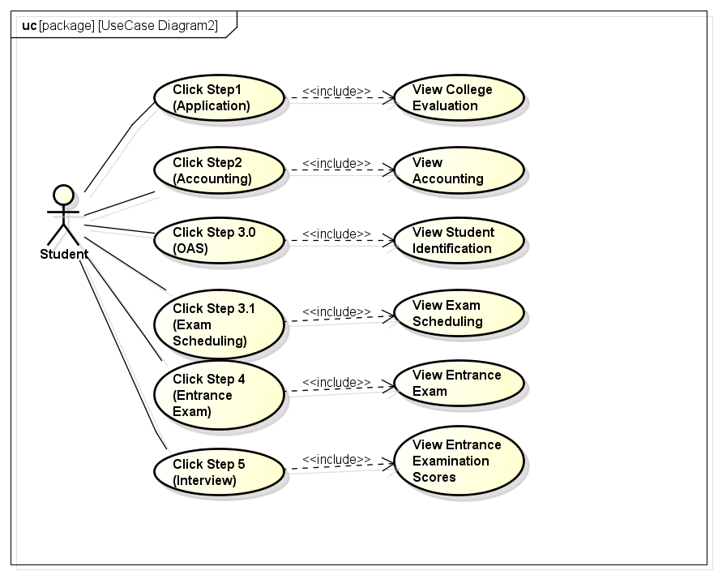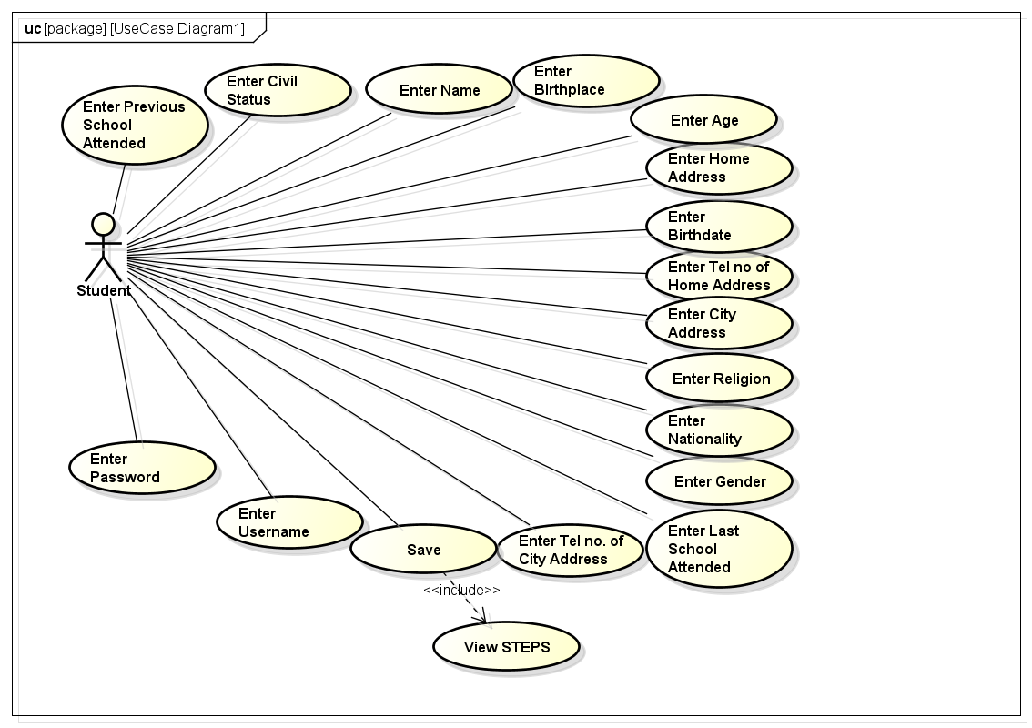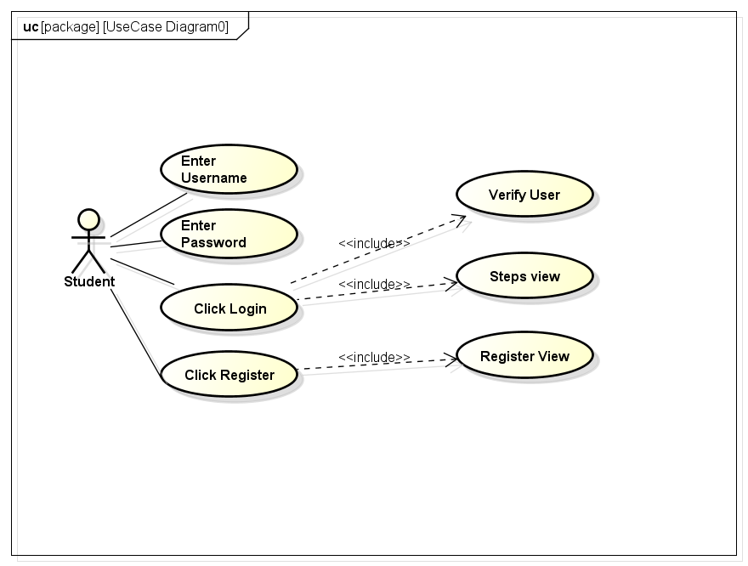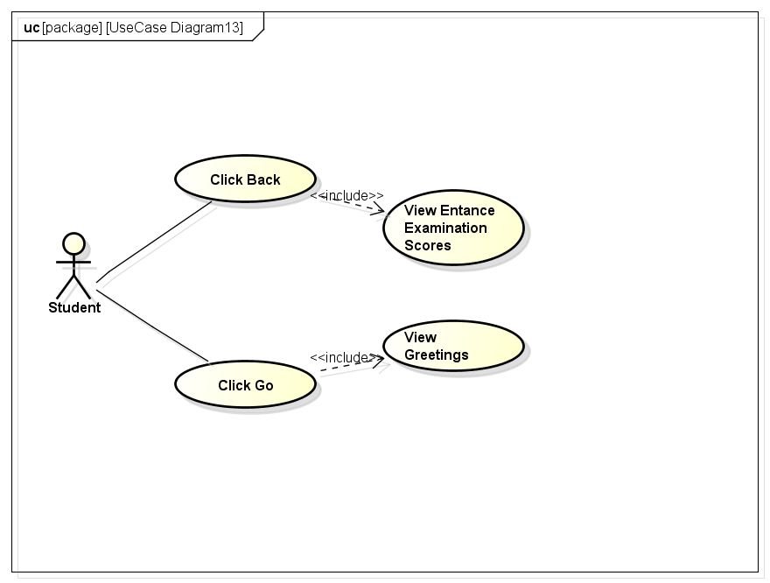
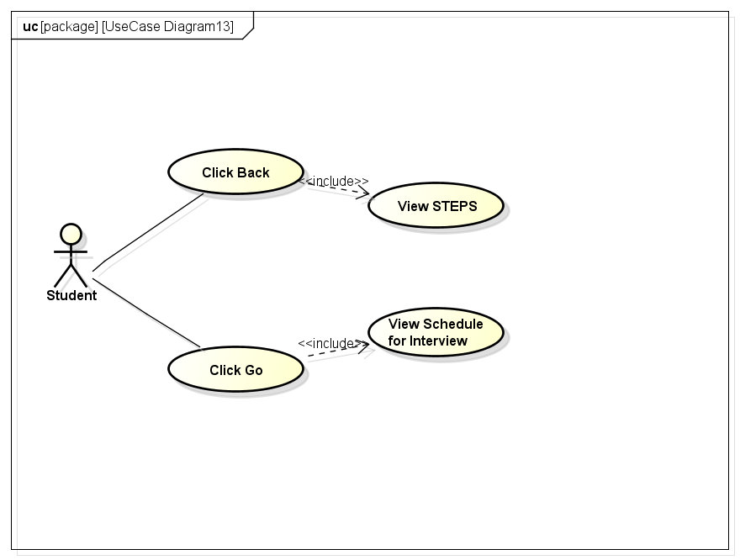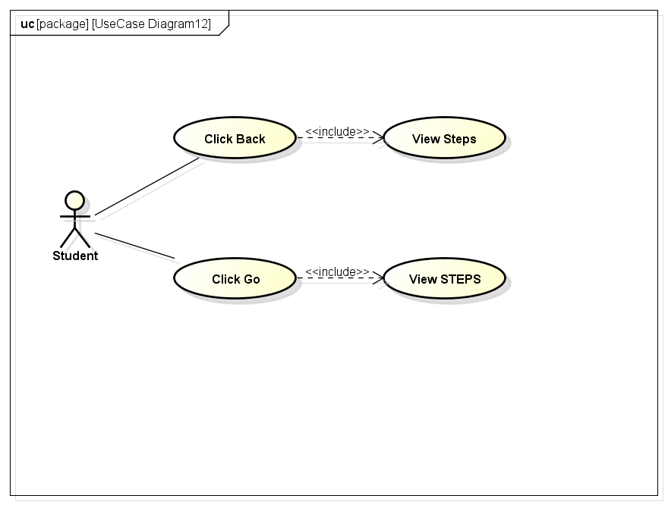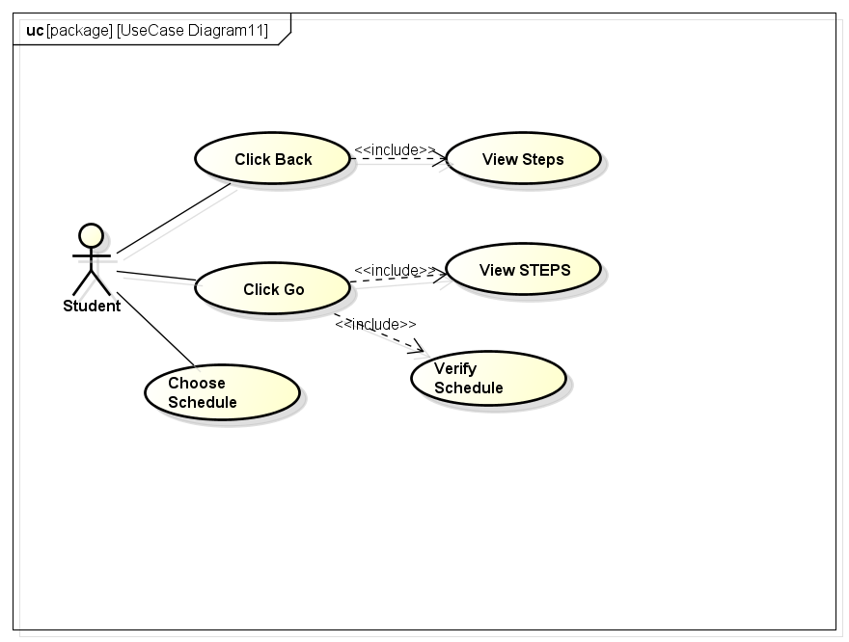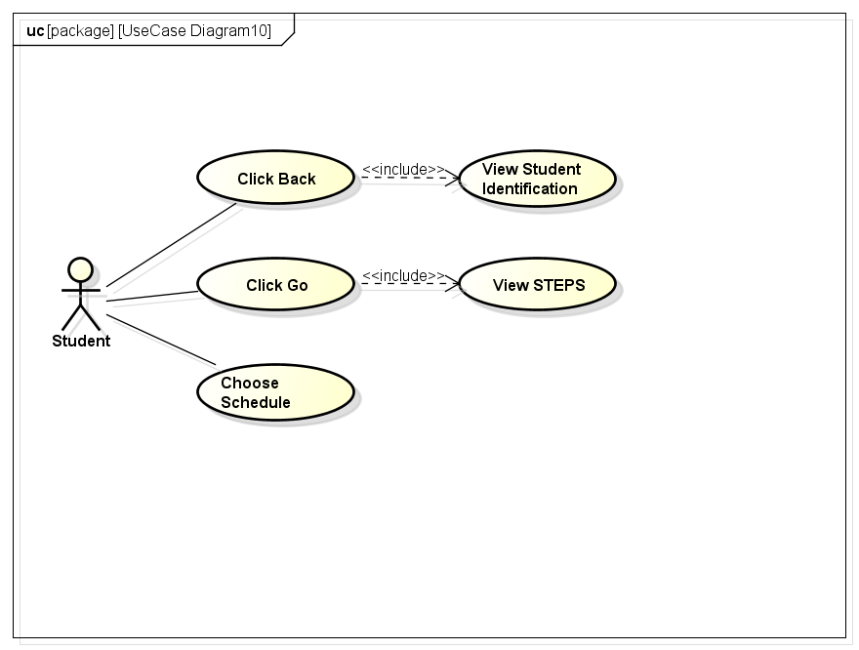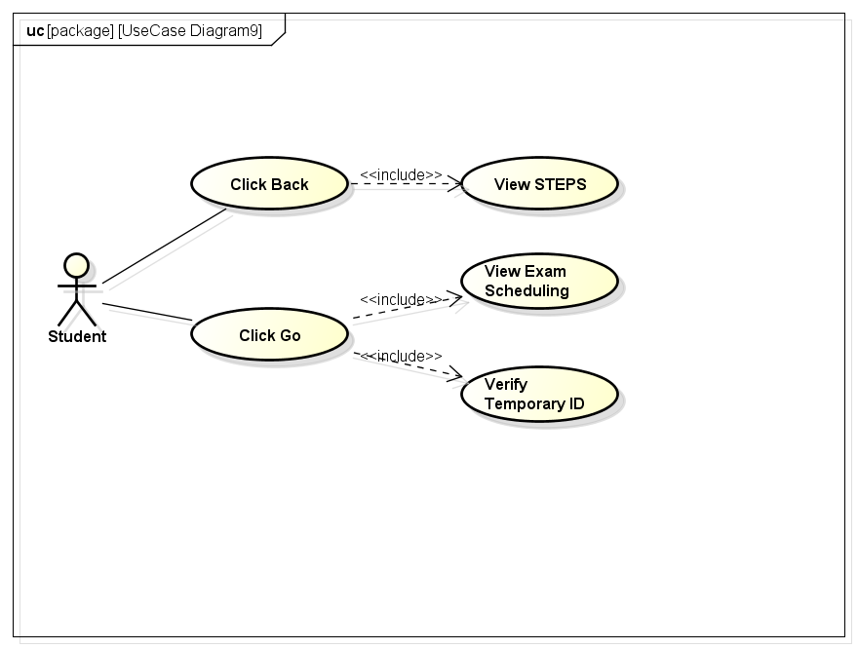

3.2.2. Use case 2 (Admin Use Case)

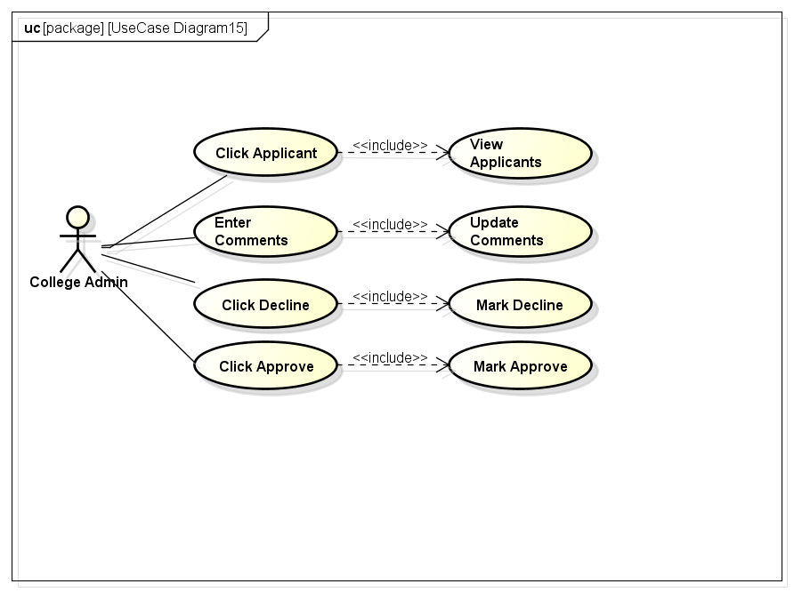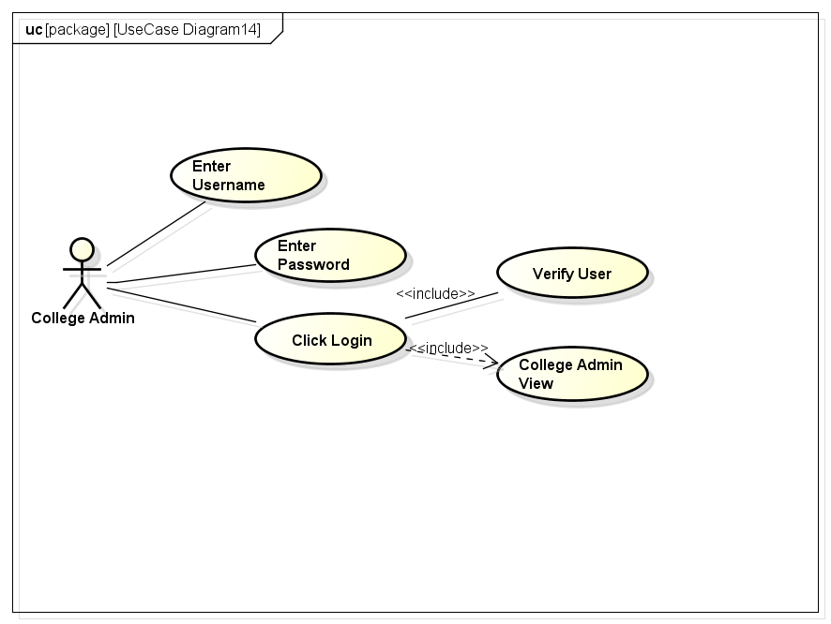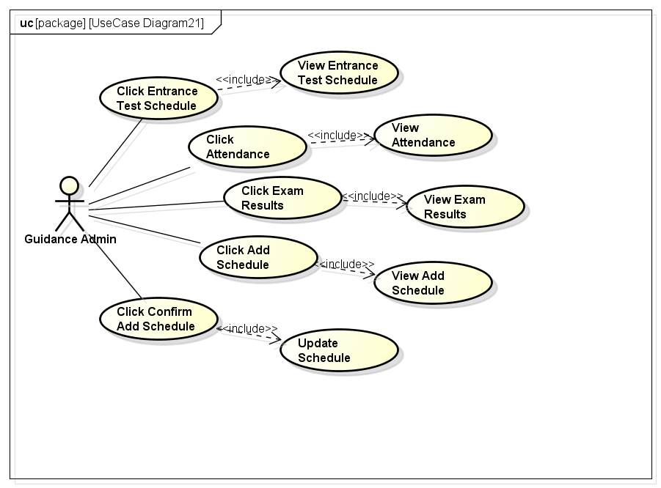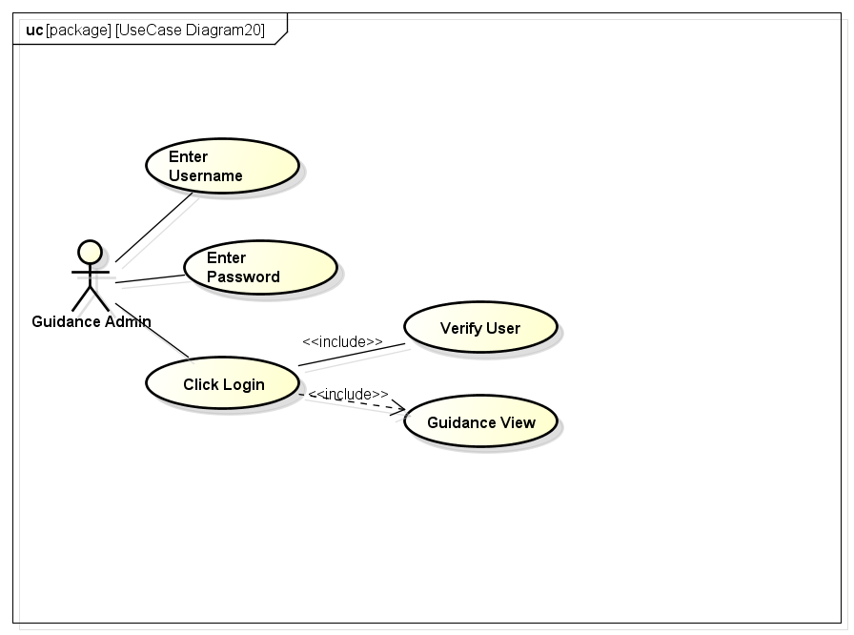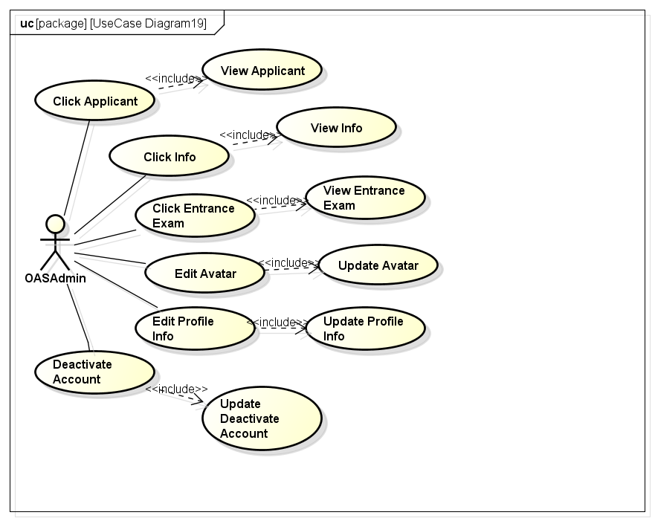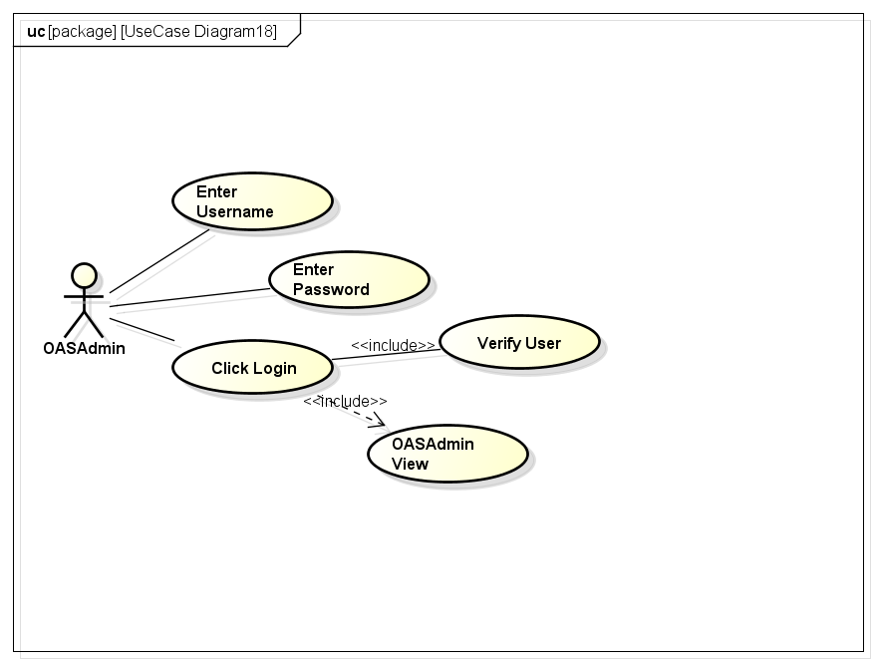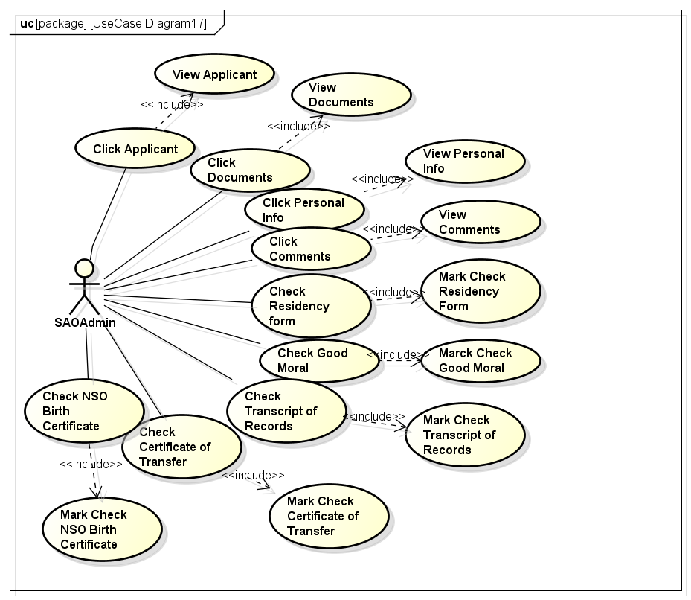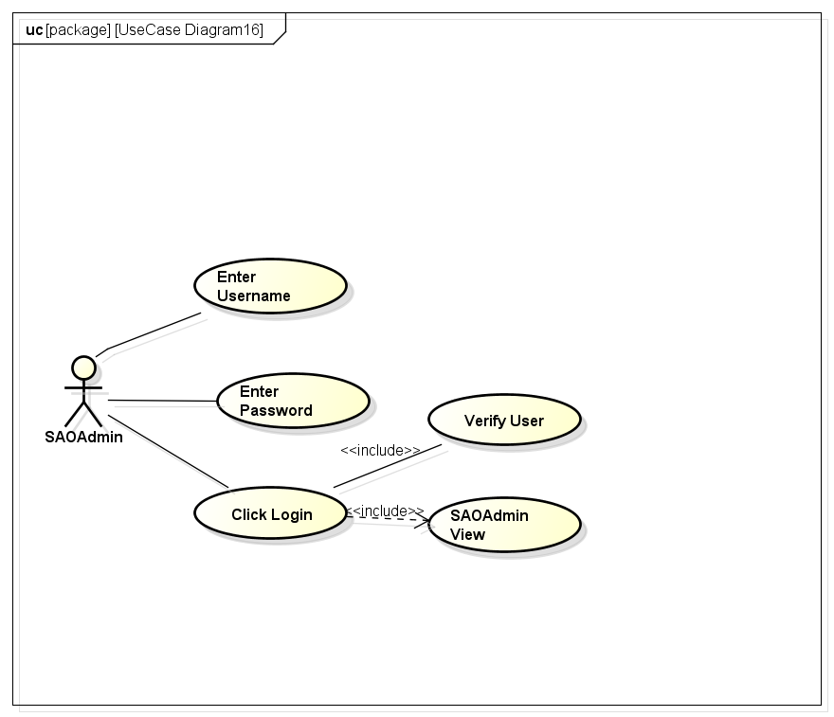

Usability requirements
Define usability (quality in use) requirements. Usability requirements and objectives for the software system include measurable effectiveness, efficiency, and satisfaction criteria in specific contexts of use.

3.4. Performance requirements
This subsection should specify both the static and the dynamic numerical requirements placed on the soft- ware or on human interaction with the software as a whole. Static numerical requirements may include the following:
- The number of terminals to be supported;
- The number of simultaneous users to be supported;
- Amount and type of information to be handled.
Static numerical requirements are sometimes identified under a separate section entitled Capacity.
Dynamic numerical requirements may include, for example, the numbers of transactions and tasks and the amount of data to be processed within certain time periods for both normal and peak workload conditions.
All of these requirements should be stated in measurable terms. For example,
95% of the transactions shall be processed in less than 1 s.
rather than,
An operator shall not have to wait for the transaction to complete.
NOTE—Numerical limits applied to one specific function are normally specified as part of the processing subparagraph description of that function.

3.5. Logical database requirements
This should specify the logical requirements for any information that is to be placed into a database. This may include the following:
a) Types of information used by various functions;
b) Frequency of use;
c) Accessing capabilities;
d) Data entities and their relationships;
e) Integrity constraints;
f) Data retention requirements.

3.6. Design constraints
This should specify design constraints that can be imposed by other standards, hardware limitations, etc.

3.7. Software system attributes
Specify the required attributes of the software product. The following is a partial list of examples:
a) Reliability - Specify the factors required to establish the required reliability of the software system at time of delivery.
b) Availability - Specify the factors required to guarantee a defined availability level for the entire system such as checkpoint, recovery, and restart.
c) Security - Specify the requirements to protect the software from accidental or malicious access, use modification, destruction, or disclosure. Specific requirements in this area could include the need to:
1) Utilize certain cryptographic techniques;
2) Keep specific log or history data sets;
3) Assign certain functions to different modules;
4) Restrict communications between some areas of the program;
5) Check data integrity for critical variables;
6) Assure data privacy.
d) Maintainability - Specify attributes of software that relate to the ease of maintenance of the software itself. These may include requirements for certain modularity, interfaces, or complexity limitation. Requirements should not be placed here just because they are thought to be good design practices.
e) Portability - Specify attributes of software that relate to the ease of porting the software to other host machines and/or operating systems, including:
1) Percentage of elements with host-dependent code;
2) Percentage of code that is host dependent;
3) Use of a proven portable language;
4) Use of a particular compiler or language subset;
5) Use of a particular operating system.

Verification
Provide the verification approaches and methods planned to qualify the software. The information items for verification are recommended to be given in a parallel manner with the information items in Section 3

Appendices

The appendixes are not always considered part of the actual SRS and are not always necessary. They may include
a) Sample input/output formats, descriptions of cost analysis studies, or results of user surveys;
b) Supporting or background information that can help the readers of the SRS;
c) A description of the problems to be solved by the software;
d) Special packaging instructions for the code and the media to meet security, export, initial loading, or other requirements.
When appendixes are included, the SRS should explicitly state whether or not the appendixes are to be considered part of the requirements.

